Proposal

# Purpose

The overall purpose of our application is to create a mini social media site where users can sign up entering their personal information. The web app will almost be similar to Facebook but with minor differences. Users will be able to give likes/ratings to other users, make posts and comment on others posts. The target audience of this application will be those who are looking for a social media platform to chat and share information with their friends.

# Interactions and Data

The interactions for this application will have multiple views, such as: login/signup view, viewing user profile view, writing new post view and a news feed view to see all posts from all users. Users will be able to edit their own information, look at profile of others and to give them a poke/like/score. There will be a way to search for users and display all the users on the system. In addition, Users will be able to make posts and comment on the posts of others which will then be displayed on that user’s profile. Posts will also include information about the user who wrote the as well. Users will be able switch between all these view through a navigation menu.

The data that will be stored in our application is the list of all users. In this user object (JSON object possibly) we will store all the information on the user’s personal information along with a list of post objects. This list will be all the posts that have been sent to this user and they will be stored directly in the object of the user as a list, such that they can be accessed efficiently when loading a user’s profile page.

# Sketches

## Login View

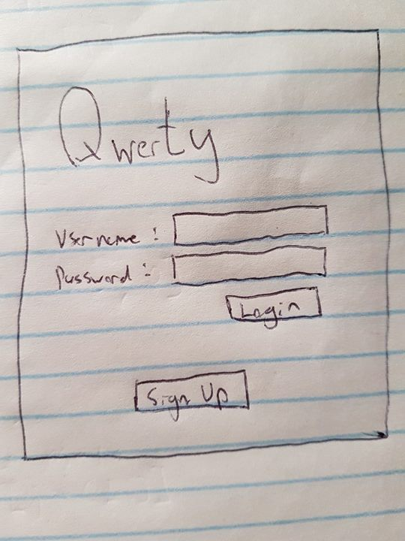

## News Feed

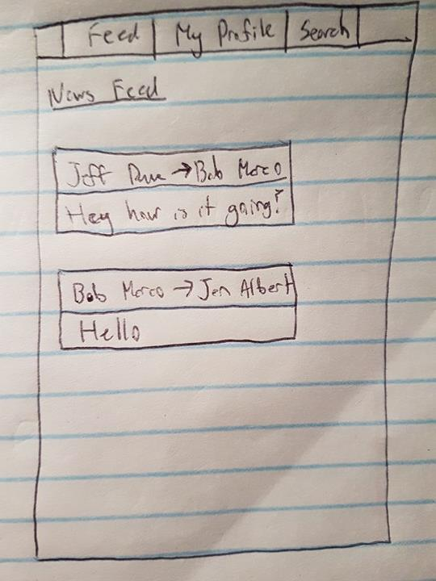

## Profile View

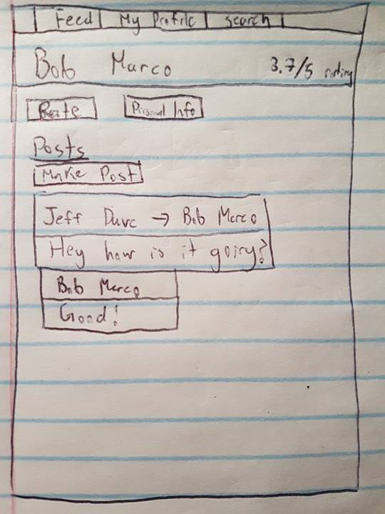

## New Post View

