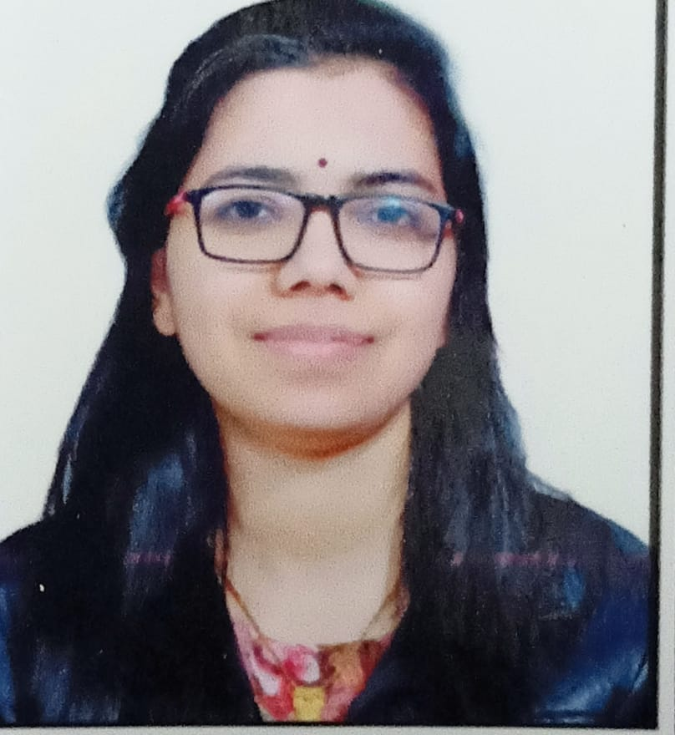
Pragya Singh Kushwah
Mob: 91- 8103084226
Address:- 202 Anand Nagar Chitawad Road, indore (M.P)
E-Mail:- pragyachouhan76666@gmail.com

Career Objective:

Enthusiastic and motivated to work in a web development company with loyalty, technical skills and soft skills to gain experience and knowledge that I can contribute towards the growth of the company.
Technical Skills:

- Language & Framework : PHP, CodeIgniter, Laravel.
- CMS : Word-press.
- Database : Concepts of DBMS, MS-SQL.
- Web Technologies : HTML, CSS, JavaScript, Jquery, Bootstrap, Ajax, Gsap.
Projects:

- Lawyers service website based on laravel having social login, Paypal integration, with 4 types of users login type, searching services, notification, cms control and chat system between lawyer and customer and full admin controlling system.

- Real Estate Site based on codeigniter having full functionality of property searching, listing with admin controlling system.

- Portfolio based core PHP website with GSAP animation and admin controlling system(admin-panel).

- Roopmakeovers.com based on core PHP having booking appointments and portfolio management system with admin panel.

- Relydoctors.com a dental site based on core PHP having booking patient and Doctors Consultation system.

- Pghhinfrastructure.com project having electric pole management system with 3 types of user like (technician, engineers and admin) control based on codeigniter with admin panel.

- E-commerce website based on wordpress , woo-commerce plugin with custom fontend designing.

- Wordpress based websites with custom designing and contact form system.

- Laravel based social media website like facebook with admin control (talentraters.com)
Work Experience( 2+ years ):

Web Developer - Oct 2021 to present
Akkode it solution, Indore
Worked as a senior php developer on Laravel, Codeiginiter, PHP .

Web Developer - Nov 2020 to sep 2021
Online Chalo.in, Indore
Worked as a software developer on Codeiginiter, PHP, MySQL, Wordpress and many other technologies(html, css, js, jquery, bootstrap, gsap).

Web Developer - Aug 2017 to Feb 2019
GreenDays Infotech, Indore
Worked as a software developer on Codeiginiter, PHP, MySQL, Wordpress and many other technologies.

Academic Profile:

Qualification:
- B.E (CSE) from Indore Institute of Science and Technology (IIST) with 7.74 aggregate percentage in 2017.
- 12th from Shri Vaishnav Kanya Vidhyalay (S.V.K.V) with 68.6% in 2013.
- 10th from Shri Vaishnav Kanya Vidhyalay (S.V.K.V) with 80.6% in 2011.

Personal Profile:

Date of Birth : 10th Oct 1996
Husband Name : Mr. Atul Singh Kushwah
Father’s Name : Mr. Santosh Singh Chauhan
Language Known : Hindi, English.
Hobbies & Interests : Learning new things, Listening music.
Permanent Address : 202, Anand Nagar Chitawad Road Indore (M.P) - 452001
Declaration
I hereby vouch that all the information provided here are authentic to the fullest of my knowledge.

Date:
30-11-2021 Pragya Singh Kushwah

