Predicted Addictive Reward Patterns
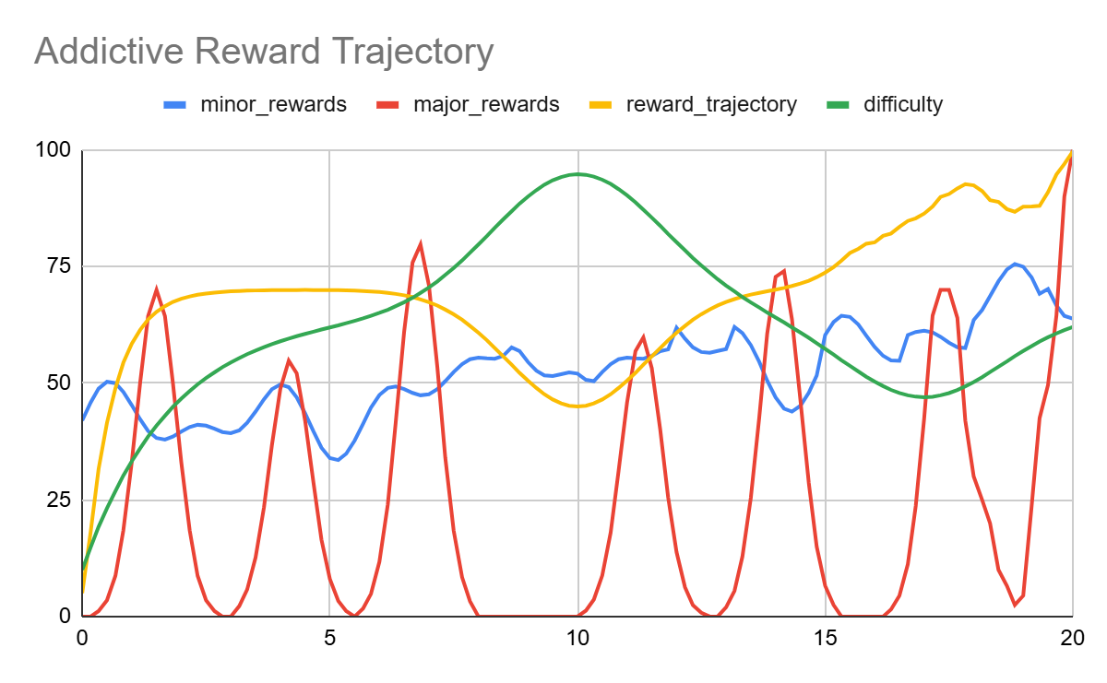
Minor Reward: Minor rewards are small, relatively consistent reinforcers whose primary function is to maintain player engagement and motivation throughout the session. They tend to be frequent and low reward. Examples include coins, experience points, and common consumables or tools. Crucially, minor rewards remain present even during high-difficulty stretches. This serves the specific purpose that when a player is struggling and not receiving major rewards, a steady stream of minor rewards sustains the perception that progress is still happening, producing a near-miss effect that discourages quitting. While their frequency is fairly stable [$a$], the amount and type of minor reward vary moment to moment [ϵ(t)] to prevent habituation. In Skinnerian terms, minor rewards most closely resemble a fixed-interval schedule, though with enough moment-to-moment variability to resist full adaptation. A slight upward trend [bt] in minor reward magnitude over time is also expected as players become habituated, as the game must gradually increase the reward signal to maintain the same motivational effect. Minor rewards can be thought of as orienting rewards whose goal is not to drive the player forward so much as to keep them present, interested, and reinforced.
$$f(t)=a+bt+ϵ(t)$$

Major rewards: Major rewards are high-magnitude, lower-frequency payoffs that require meaningful effort and build-up to achieve. Their greater rarity and the effort required to earn them make them feel more satisfying, as the sense of having earned them is itself part of the reward. Examples include leveling up, winning a round, unlocking a treasure chest, or receiving a rare/powerful item. The temporal pattern of major rewards should resemble a sine wave [sin(ωt+ϕ)]. Importantly, the first major reward should occur relatively early in the session. This functions as a hook, giving the player an early preview of the peak experience the game can offer and establishing what they are working toward. In Skinnerian terms, major rewards follow a variable ratio or partial reinforcement schedule [A(t)], meaning the player cannot predict exactly when the next major reward will arrive, which is precisely what makes them so motivationally potent. Partial reinforcement schedules produce the most persistent behavior and the greatest resistance to extinction. The most addictive games deliberately introduce a lull, a period of increased difficulty during which major rewards become scarce. This serves three functions simultaneously: it creates a partial-reinforcement condition, increases the perceived effort invested, and makes the eventual major reward feel significantly more earned and therefore more satisfying.
$$f(t)=A(t)⋅sin(ωt+ϕ)$$

Difficulty: Difficulty represents the amount of effort a player must expend to receive a reward. Operationally, it can be measured as the frequency of punishments or setbacks occurring within a given time window (though this is open to further discussion). The difficulty curve should take an inverted-U shape. It starts low to allow new players to orient themselves and experience early success, rises through the middle of the session to create challenge and maintain engagement, then eases as players accumulate skills, level up, and become more capable. However, difficulty should rise again slightly near the end to create a final challenge worthy of the ultimate major reward (usually winning). Note that difficulty and reward trajectory are typically inversely related (as difficulty peaks, overall reward density drops, and vice versa).
$$f(t)=-a(t){}^{2}+c$$

Reward Trajectory: The overall reward trajectory, the combined sense of how rewarding the game feels at any given moment, should follow a U-shape. Rewards begin high and require little effort, hooking the player quickly and establishing the game's value proposition. The curve then dips during the mid-session difficulty lull, creating a zone of reduced reward that sustains challenge and prevents habituation. Rewards escalate sharply toward the end as the player overcomes the final difficulty spike and achieves the game's primary objective.
As noted above, reward trajectory and difficulty are typically mirror images of one another: when difficulty is at its peak, the reward trajectory is at its trough, and the climactic win arrives precisely when difficulty has been pushed to and just past its limit.
$$f(t)=a(t){}^{2}+c$$

Audio Visual Pipeline
Example Video: screen-20260119-142333.mp4
