**Operating Systems Assignment**

**Name:-**Taher Fakhruddin Makadam

**USN:-**1MS14MCA50

1. Define the essential properties of the following types of operating systems:-

a. Batch  
b. Interactive  
c. Time sharing  
d. Real time  
e. Network  
f. Parallel  
g. Distributed  
h. Clustered  
i. Handheld

Answer:-

a. **Batch processing: -** Jobs with similar needs are batched together and run through the computer as a group by an operator or automatic job sequencer. Performance is increased by attempting to keep CPU and I/O devices busy at all times through buffering, off-line operation, spooling, and multi-programming. Batch is good for executing large jobs that need little interaction; it can be submitted and picked up later.

b. **Interactive System: -** This system is composed of many short transactions where the results of the next transaction may be unpredictable.  
Response time needs to be short (seconds) since the user submits and waits for the result.

c. **Time sharing: -** This systems uses CPU scheduling and multiprogramming to provide economical interactive use of a system. The CPU switches rapidly from one user to another. Instead of having  
a job defined by spooled card images, each program reads its next control card from the terminal, and output is normally printed immediately to the screen.

d. **Real time operating system: -** Often used in a dedicated application, this system reads information from sensors and must respond within a fixed amount of time to ensure correct performance.

e. **Network: -** Provides operating system features across a network such as file sharing.

f. **Parallel: -** Used in systems where there are multiple CPU’s each running the same copy of the operating system. Communication takes place across the system bus.

g. **Distributed systems: -**This system distributes computation among several physical processors. The processors do not share memory or a clock. Instead, each processor has its own local memory. They communicate with each other through various communication lines, such as a high-speed bus or local area network.

h. **Clustered system: -**A clustered system combines multiple computers into a single system to perform computational task distributed across the cluster.

i. **Handheld System: -** A small computer system that performs simple tasks such as calendars, email, and web browsing. Handheld systems differ from traditional desktop systems with smaller memory and display screens and slower processors.

2. List five services provided by an operating system, and explain how each

Creates convenience for users. In which cases would it be impossible for

User-level programs to provide these services?

Answer:-

The five services are:

a. **Program execution**:- The operating system loads the contents (or

sections) of a file into memory and begins its execution. A user level

program could not be trusted to properly allocate CPU time.

b. **I/O operations**:-Disks, tapes, serial lines, and other devices must be

communicated with at a very low level. The user need only specify

the device and the operation to perform on it, while the system

converts that request into device- or controller-specific commands.

User-level programs cannot be trusted to access only devices they

should have access to and to access them only when they are otherwise

unused.

c. **File-system manipulation**:- There are many details in file creation,

deletion, allocation, and naming that users should not have to perform.

Blocks of disk space are used by files and must be tracked.

Deleting a file requires removing the name file information and

freeing the allocated blocks. Protections must also be checked to

assure proper file access. User programs could neither ensure adherence

to protection methods nor be trusted to allocate only free

blocks and deallocate blocks on file deletion.

d. **Communications**:-Message passing between systems requires messages

to be turned into packets of information, sent to the network

controller, transmitted across a communications medium, and reassembled

by the destination system. Packet ordering and data

correction must take place. Again, user programs might not coordinate

access to the network device, or they might receive packets

destined for other processes.

e. **Error detection**. Error detection occurs at both the hardware and

software levels. At the hardware level, all data transfers must be

inspected to ensure that data have not been corrupted in transit. All

data on media must be checked to be sure they have not changed

since they were written to the media. At the software level, media

must be checked for data consistency; for instance, whether the

number of allocated and unallocated blocks of storage match the

total number on the device. There, errors are frequently process independent

(for instance, the corruption of data on a disk), so there

must be a global program (the operating system) that handles all

Types of errors. Also, by having errors processed by the operating

System, processes need not contain code to catch and correct all the

Errors possible on a system.

3. What is the main advantage for an operating-system designer of using a virtual-machine architecture? What is the main advantage for a user? 

Answer:-

Designer:-

* The system is easy to debug, and security problems are easy to solve.
* Virtual machines also provide a good platform for operating system research since many different operating systems may run on one physical system and system bugs will not crash machine and cause downtime.

User:-

* The user is able to run many operating systems on a single operating system this provides the user an option to try out and use different operating systems without having to install each one of them separately.
* Testing can be accomplished concurrently on the same system.
* Installing each operating system separately is time consuming thus by using virtual machine

The user can save time.

4. Explain VMware Architecture with a neat diagram?

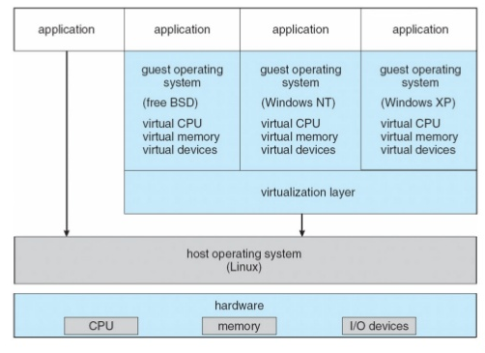

* VMware is a popular commercial application that abstracts Intel 80X86 hardware into isolated virtual machines.
* VMware runs an application on a host operating system such as windows or Linux and allows this host system to concurrently run several different guest operating systems as independent virtual machines.
* In the above diagram Linux is running as the host operating system and FreeBSD, Windows NT and Windows XP are running as guest operating systems.
* The virtualization is the heart of VMware, as it abstracts the physical hardware into isolated virtual machines running as guest operating systems.
* Each virtual machine has its own virtual CPU, memory, disk drives, network interfaces etc.