**Data Mining Assignment**

**Karthik Naidu (1MS14MCA18)**

**Taher Fakhruddin Makadam(1MS14MCA50)**

Use the similarity matrix in table to perform single and complete link hierarchy clustering. Show your results by drawing a dendrogram. The dendrogram should clearly show the order in which the points are merged.

|  |  |  |  |  |  |
| --- | --- | --- | --- | --- | --- |
|  | P1 | P2 | P3 | P4 | P5 |
| P1 | 1.00 | 0.10 | 0.41 | 0.55 | 0.35 |
| P2 | 0.10 | 1.00 | 0.64 | 0.47 | 0.98 |
| P3 | 0.41 | 0.64 | 1.00 | 0.44 | 0.85 |
| P4 | 0.55 | 0.47 | 0.44 | 1.00 | 0.76 |
| P5 | 0.35 | 0.98 | 0.85 | 0.76 | 1.00 |

**Solution:-**

**Dendogram:-** A dendrogram (from Greek dendro "tree" and gramma "drawing") is a tree diagram frequently used to illustrate the arrangement of the clusters produced by hierarchicalclustering. Dendrograms are often used in computational biology to illustrate the clustering of genes or samples.

**Single Link Clustering:-** In single-link clustering or single-linkage clustering , the similarity of two clusters is the similarity of their *most similar* members.This single-link merge criterion is *local*. We pay attention solely to the area where the two clusters come closest to each other. Other, more distant parts of the cluster and the clusters' overall structure are not taken into account.

**Complete link clustering:-** In complete-link clustering or complete-linkage clustering , the similarity of two clusters is the similarity of their *most dissimilar* members. This is equivalent to choosing the cluster pair whose merge has the smallest diameter. This complete-link merge criterion is non-local; the entire structure of the clustering can influence merge decisions. This results in a preference for compact clusters with small diameters over long, straggly clusters, but also causes sensitivity to outliers. A single document far from the center can increase diameters of candidate merge clusters dramatically and completely change the final clustering.

1. **Single link:-**

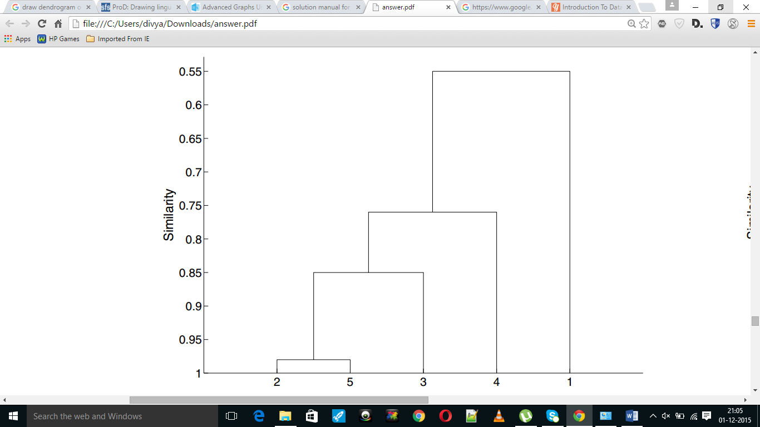

1. **Complete link:-**

