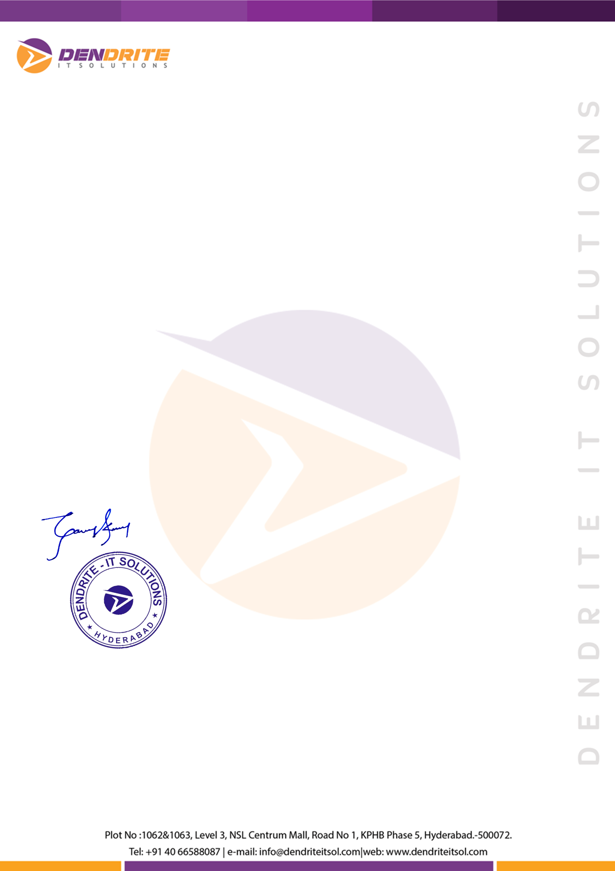

# Ref: HRD/DIS/EXP/6716

**Date: June 10, 2019**

**Name : Syed Asadulla**

**Emp Id : DI/S-6716**

**Designation : Associate Technical support Engineer**

# TO WHOMSOEVER IT MAY CONCERN

This is to certify that **Mr. Syed Asadulla** had been associated with our organization as

**Associate Technical support Engineer** for the period from **Dec 28, 2020** to **June 10, 2019.**

We found **Mr. Syed Asadulla** is effective in discharging responsibilities assigned to him.

We have found him to be self starter who is motivated, duty bound, and a highly committed team player with strong conceptual knowledge.

Please feel free to contact us if you have specific questions regarding his employment. We at **Dendrite IT Solutions,** wish him all success in his future endeavors.

Best Regards,

# For Dendrite IT Solutions.

**Ganesh Kumar HR-Manager**