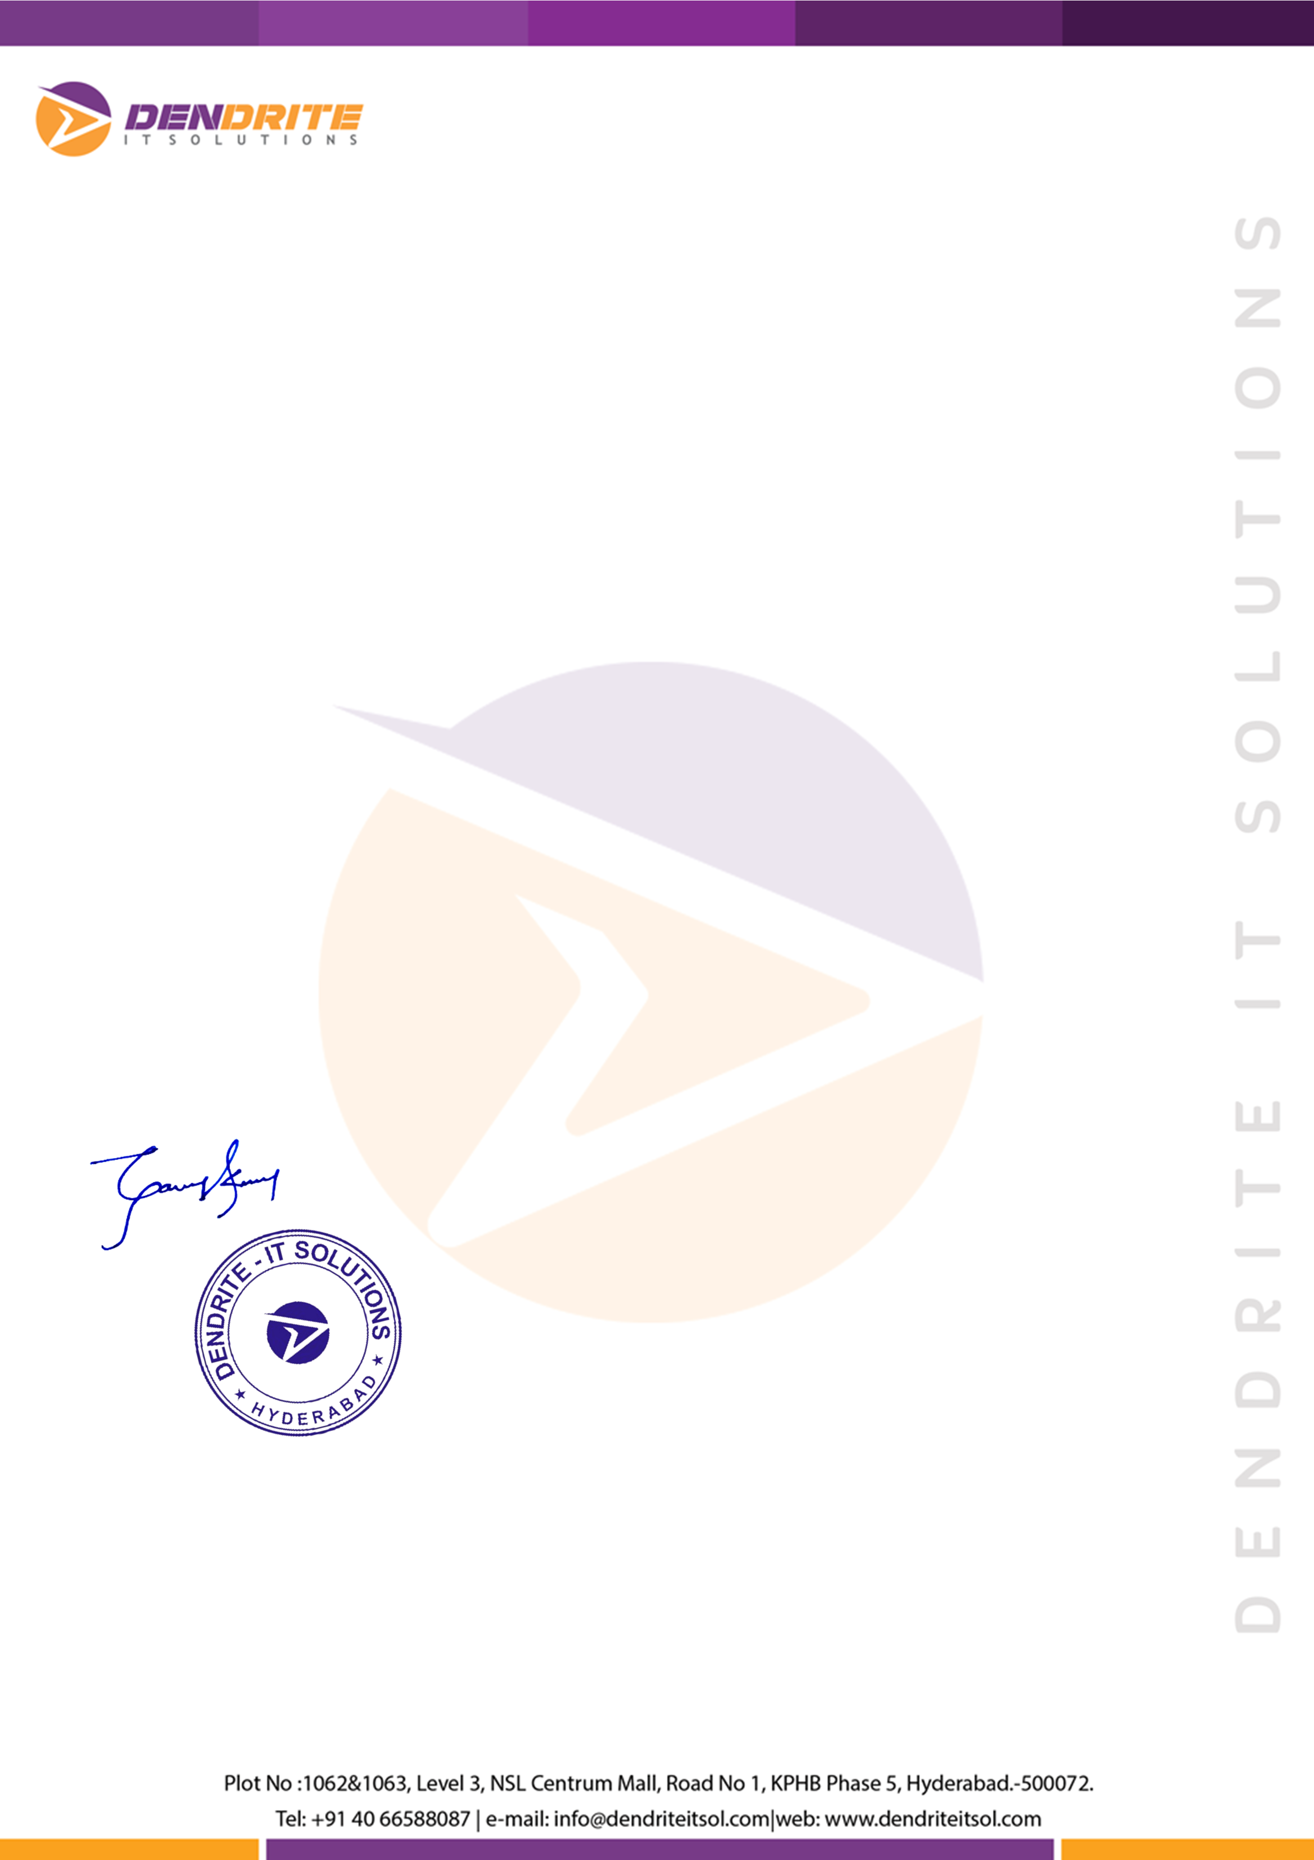\

# Ref: HRD/DIS/REL/6716

**Date: June 10, 2019**

**Name : Syed Asadulla**

**Emp Id : DI/S-6716**

**Designation : Associate Technical support Engineer**

# Relieving Letter

Dear **Syed Asadulla,**

This has reference to your resignation letter dated **April 10, 2019**. We hereby inform you that it has been accepted. You are being relieved of your duties from the closing hours of **June 10, 2019.**

Accounts department has been instructed to settle your account. You will hear very shortly from the department.

You will hand over charges to your superior or any other officer that the Company may designate. Your exit formalities shall be done in accordance with the laid down process of the Company.

You have been an integral part of our growth and we appreciate your contribution during this journey.

Best Regards,

# For Dendrite IT Solutions,

**Ganesh Kumar HR-Manager**