**A.I BASED AND CONTROLLED SMART AGRICULTURAL FIELD**

Authors:

Husain Saleem, Hamza Siddiqui, Syed Tahir Abbas Haider Naqvi, and Muhammad Osama

Year of Publication: 2023

##### **ABSTRACT**

*This abstract represents an overview of an AI-based smart agriculture system that uses sensor technology for real-time field monitoring and supports both automated decision-making and human user control. The system makes use of a network of sensors to collect current information on a range of factors, such as temperature, humidity, soil moisture, and crop health and sends it to the database so that it can be shown on the website. With the help of these sensors, the field is continuously monitored, giving users knowledge of the factors influencing crop growth. AI algorithms are used to interpret and analyze the data that has been acquired, giving the system the ability to automatically decide how best to allocate resources like water and pesticides. To deliver timely and accurate treatments, AI algorithms consider elements such as crop water requirements, illness detection, and insect infestations. Users can take an active role in decision-making because of the system's manual user control features. Users have the option to override automated judgments and make human adjustments depending on their knowledge and preferences through a user interface. This feature offers flexibility and gives users the ability to modify the system's operations to suit their own requirement*

##### **1 INTRODUCTION**

The fusion of artificial intelligence (AI) and sensor technology has emerged as a revolutionary force in the field of agriculture in a time of extraordinary technical developments and growing agricultural difficulties. This introduction provides a thorough overview of a ground-breaking artificial intelligence (AI)-based smart agriculture system, the result of creative efforts to harness real-time field monitoring, automated decision-making, and human user control. This technology, which is poised to change the way that modern farming techniques are carried out, is based on a dynamic synergy of cutting-edge sensors, AI algorithms, and user-guided interventions.

This innovation's AI-driven analytical capabilities are what really set it apart. Intelligent AI algorithms expertly understand and analyze the information as it comes in, opening up a world of possibilities for automated decision-making. The ability of this system to autonomously distribute essential resources—such as water and pesticides—in accordance with exact criteria is a noteworthy aspect of its prowess. A complex interaction of variables, such as crop water needs, disease detection, and insect infestations, directs this resource optimization. The end result is a comprehensive approach to farming where efficiency, precision, and sustainability all work together to produce the best outcomes.

**BACKGROUND**

As environmental dynamics change, modern agriculture is under increasing pressure to boost production and sustainability. In order to address these complexities, traditional methods frequently fall short, demanding creative alternatives. In this context, a paradigm shift for smart agriculture has been brought about by the convergence of AI and sensor technology. With real-time data capture, automated insights, and user-guided control provided by this synergy, resources may be allocated more effectively and informed decisions can be made. This innovative technology shows potential for improving agricultural efficiency and resilience while considering the nuanced experience of farmers by including several elements such as temperature, humidity, soil moisture, and crop health.

##### **2 LITERATURE REVIEW**

This article represents, brilliant agribusiness checking expects to give the agrarian business a high-level mechanical foundation that might incorporate web of things (IOT), distributed computing, and man-made consciousness (simulated intelligence) in handling the information got from numerous sensors sent in-ground gadgets, (un)manned aeronautical vehicles (UAVs) and satellites. The examination in simulated intelligence has gone through a prospering stage over the most recent couple of many years where independent frameworks have accomplished close ideal correctness’s in fields like language handling, text acknowledgment, picture understanding, and voice ID, to give some examples. All in all, the analysts have been enormously effective in creating managed order models with negligible human association. As of late, the center has moved to planning strong and versatile man-made intelligence grouping models that can work under a serious shortage of preparing information, loud conditions, or in a circumstance when the likelihood circulation of the test tests is dissimilar from the ones in the preparation set. A ton of these can be credited to the coming of profound learning-based acknowledgment models through which the ongoing age of man-made intelligence calculations are more than fit for taking care of oddities and differences, in reality, unstructured information. Attributable to these advancements in the new past, this section is committed to another feature in man-made intelligence research where multi-modular information from various sensors is dissected, handled, and coordinated into a framework for the advancement of an improved multi-sensor grouping mode [1].

Agriculture has seen numerous unrests, whether the taming of animals and plants a couple quite Previously, the effective use of yield turns and various advancements in agricultural practice two or quite a while ago, or the "green upheaval" with precise reproduction and the widespread use of man-made pesticides and composts years and years past. We suggest that the fourth transition in horticulture is being caused by the drastically increased use of information and communication technology (ICT) in the agricultural sector. For farming, autonomous mechanical vehicles have been developed, such as mechanical weeders, the use of compost, or the collecting of natural products. The improvement of automated Modern Ranch board guiding is made possible by the development of independent-flight aeronautical vehicles and lightweight, robust hyper spectral depiction cameras that can be used to determine biomass improvement and treatment state of yields. Additionally, choice tree models are now readily available and allow ranchers to distinguish between plant diseases based on optical data. The virtual wall moves forward. Permit dairy cows to gather together the executives so they can observe remote indications and actuators or sensors connected to the animals. Shop growing can provide a coordinated way out of areas of strength for the by and market division that is depicted as being secured in improvements and practices. By extending technologies, yield, and domesticated animal creation frameworks, and organizations across all entertainers of the agro-food sector, it offers a path toward sustainable farming. By transforming spatially express big information into facts and suggestions for ranchers, plans of action could gain more respect. [2].

Savvy cultivating (SF) incorporates the synthesis of communications and data innovations into hardware, equipment, and sensors for utilization in horticulture creation frameworks. This turn of events is anticipated to be accelerated by new developments, such as the Web of Things and distributed computing, which will present more robots and artificial intelligence for development. As a result, this paper has two main goals: to present the logical information about science fiction that is available in the overall logical writing in light of the key factors of advancement by country and over time, as well as to present the current state of science fiction in Brazil from the perspective of experts in this field. The investigation involved conducting semi-organized interviews with the market and subject matter experts in Brazil and using an information mining program to generate a bibliometric overview. One of the major factors limiting the development of SF was acknowledged to be coordination amongst the several accessible frameworks. The knowledge, capability, and skills of ranchers to grasp and manage SF devices are another limiting factor. These limitations revealed a market and an opportunity for businesses to look into and help with solving these problems, and science can reinforce this cycle. South Korea, China, the US, and Germany [3].

Farming is by its inclination a muddled logical field, connected with an extensive variety of mastery, abilities, strategies, and cycles that can be really upheld by modernized frameworks. There have been numerous endeavors toward the foundation of a mechanized agribusiness system, proficient to control both the approaching information and the comparing processes. The new advances in the Data and Correspondence Advances (ICT) space have the capacity to gather, process, and break down information from various sources while emerging the idea of agribusiness knowledge. The flourishing climate for the execution of various horticulture frameworks is legitimate by a progression of innovations that offer the possibility of working on rural efficiency through the concentrated utilization of information. The idea of large information in farming isn't solely connected with huge volume, yet additionally to the assortment and speed of the gathered information. Large information is a vital idea for the future improvement of farming as it offers phenomenal capacities and it empowers different devices and administrations proficient to change its ongoing status. This overview paper covers the cutting-edge farming frameworks and large information models both in examination and business status with an end goal to connect the information hole between horticulture frameworks and the abuse of enormous information. The initial segment of the paper is given to the investigation of the current horticulture frameworks, giving the important foundation data to their development until they have arrived at the ongoing status, ready to help various stages and handle different wellsprings of data [4].

Environment shrewd farming (CSA) addresses the test of fulfilling the developing need for food, fiber, and fuel, in spite of the changing environment and fewer open doors for agrarian extension on extra terrains. CSA centers around adding to monetary turn of events, destitution decrease, and food security; keeping up with and improving the efficiency and versatility of regular and horticultural biological system capabilities, accordingly fabricating normal capital, and lessening compromises associated with meeting these objectives. Ebb and flow holes in information, work inside CSA, and plans for interdisciplinary exploration and science-based activities distinguished at the 2013 Worldwide Science Gathering on Environment Brilliant Agribusiness (Davis, CA, USA) are depicted here inside three subjects: homestead and food frameworks, scene and local issues and institutional and strategy perspectives. The initial two subjects contain crop physiology and hereditary qualities, relief and transformation for domesticated animals and farming, hindrances to reception of CSA rehearses, environment risk the board and energy and biofuels and demonstrating variation and vulnerability, accomplishing multi-functionality, food, and fishery frameworks, woods biodiversity and biological system administrations, country movement from environmental change and measurements planning research that scaffolds disciplines, incorporating partner contribution to connect science, activity, and administration straightforwardly. Notwithstanding interdisciplinary examination among these subjects, objectives incorporate creating models that incorporate variation and change at either the homestead or scene level; limit ways to deal with look at multifunctional answers for agronomic, biological and financial difficulties; situations that are approved by direct proof and measurements to help ways of behaving that encourage versatility and regular capital [5].

The Greenhouse is a flexible plastic structure mainly designed for the production of the goods contained. Numerous environmental elements, including moisture temperature, and others, have been disregarded since the majority of traditional greenhouses, particularly in dry places. With the aid of a quad copter, automated technology is used in agriculture to meet the enormous demands of the rapidly-evolving food processing industry. In order for farmers to recover productivity, less expensive technologies have been critical for the development of remote sensing in the greenhouse environment. A structure with a light source that can maintain temperature regulation, the necessary moisture, and light absorption for the healthy development of a production facility is known as a greenhouse. Agricultural production is a system that involves the detection, measurement of crops. It is a technique for identifying greens, and at this time, messages are being sent to the server. The farmer must act in light of the information received. Numerous sensors are used in the servant to measure temperature, ammonium levels, and moisture. This implies that variables related to greenhouses, including CO2, soil moisture, temperature, and light, may be tracked. In greenhouse crops, the unpredictable environment can impact plant growth and decrease output as culture progresses. By implementing IOT advancements in artificial intelligence applications for specific greenhouse factors governing temperature range, water flow, and light radiation, this difficulty can be overcome. With the introduction and this method having been involved in the ongoing development of artificial intelligence, this agricultural instability may steadily worsen. The right machine learning method for commercial crop prediction uses high-resolution remote sensing data and real-time crop yield sampling from the agricultural output. Machine learning is used in the agriculture sector to improve crop yield and quality. This agricultural technology is used by seed sellers to analyze data and create better crops. In many supply networks, agricultural products are used as raw materials to make higher-value consumer goods. This development was meant to pave the way for the application of cutting-edge technologies to agricultural production. To achieve sustainable development, manufacturing needs worldwide prospects for agriculture smart production technology. As a result, the suggested effort thoroughly examined industry-related research publications on artificial intelligence and machine learning. As a result of substantial research and development in artificial intelligence, a variety of AI-based strategies, including machine learning, have been created to achieve sustainable manufacturing [5].

##### **3 METHODOLOGIES**

Farmers used to manipulate uncertainties to evaluate the soil's maturity and the type of crops that were to be planted. Not considering the moisture content of water, particularly in light of the meteorological circumstances that farmers fear. Today, technology has progressed to the point that work that formerly took an hour to complete takes only 60 seconds with the aid of Artificial Intelligence. People's major source of income is agriculture. Over the last ten years, agricultural development has been inadequate. Water waste, poor soil fertility, fertilizer overuse, climate change, and disease are some of the variables that may contribute to this. Agriculture consumes 85 percent of all freshwater resources on the planet.

Agriculture must develop at the same time that the rest of the world embraces contemporary technology. Agriculture could be modernized thanks to new technologies like the Internet of Things and Cloud, as well as the Wireless Sensor Network. A.I allows users to take advantage of the cloud's nearly infinite capabilities and resources. The cloud can be a cost-effective way to manage A.I service. We are creating an A.I -based smart agricultural system that will detect the humidity level, moisture level, and many other parameters utilizing sensors and Arduino UNO in order to precisely determine the state of agriculture.

**Raspberry pi:**

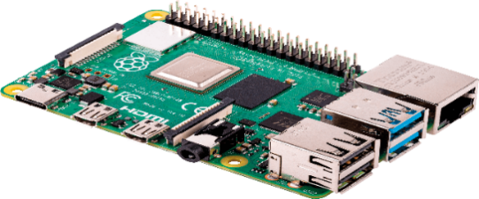

**Fig 1.1 (Raspberry pi)**

Fig 1.1 Elaborates that the Raspberry Pi is a small, low-cost computer that can be used for a variety of projects. It is often used in education and DIY projects, such as building home automation systems, creating media centers, and running retro gaming software. In terms of AI-based and controlled smart agriculture, the Raspberry Pi can be used to control and monitor various aspects of the agricultural field, such as soil moisture levels, temperature, and weather conditions. This information can then be used to optimize irrigation and fertilization, as well as predict crop yields. Additionally, the Raspberry Pi can be used to control and monitor drones or other autonomous vehicles that are used for crop spraying or other tasks. Image processing is also another area where Raspberry Pi could be used in smart agriculture. By capturing images of plants and analyzing them, it's possible to detect various types of plant diseases and pests. This can be done by training a machine learning model on a dataset of images of healthy and diseased plants. The model can then be deployed on the Raspberry Pi and used to analyze new images of plants in the field. This can help farmers detect plant diseases early on and take appropriate action to prevent significant damage to their crops. Overall, the Raspberry Pi's low cost, flexibility, and powerful computing capabilities make it a popular choice for a wide range of agricultural applications, including precision farming, precision irrigation and plant disease detection using image processing.

**Soil Moisture Sensor:**

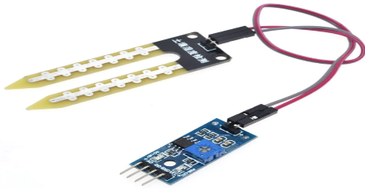

**Fig 1.2 (Soil Moisture Sensor)**

Fig 1.2 involved that the Measuring soil moisture is vital for agricultural applications, to assist farmers manage their irrigation systems more efficiently. Farmers who know the exact soil moisture conditions on their fields can not only use less water to grow a crop, but they can also increase yields and crop quality by better managing soil moisture throughout important plant growth phases. Soil monitoring has become one of the most difficult agricultural fields for both manufacturers and farmers to master. Moisture content, wetness, fertilizer application, and temperature changes are all monitored in the soil. Soil humidity and moisture sensors are used in the moisture environment management system. The results of a soil monitoring test report assist farmers in enhancing crop output by recommending a suitable fertilizer method. Both analogue and digital outputs can be read by the sensor.

**Soil pH Sensor:** 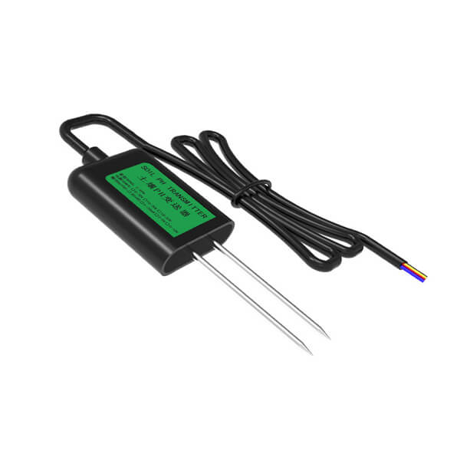

**Fig 1.3 (Soil pH Sensor)**

Fig 1.3 demonstrates that in an AI-based and controlled smart agricultural field, a soil pH sensor can be used to measure the acidity or alkalinity of the soil. The pH level of the soil is an important factor in determining the health and growth of plants. The pH level can affect the availability of nutrients in the soil and can also indicate the presence of certain diseases or pests. A soil pH sensor typically consists of a probe that can be inserted into the soil, and a circuit board that processes the data and sends it to a microcontroller or computer. The sensor measures the voltage difference between the pH-sensitive electrode and a reference electrode, and converts it into a pH value. When using a Raspberry Pi to control and monitor the smart agricultural field, the soil pH sensor can be connected to the Raspberry Pi's general-purpose input/output (GPIO) pins. The specific pin number will depend on the sensor used, but common pins used for this purpose are pin number 4 (5V) and 6 (Ground) and Analog or I2C pins for data transfer. It's always best to consult the sensor's datasheet or the manufacturer's documentation for specific pin connections and usage instructions.

**Temperature/Humidity Measure Sensor (DHT11 Sensor):** 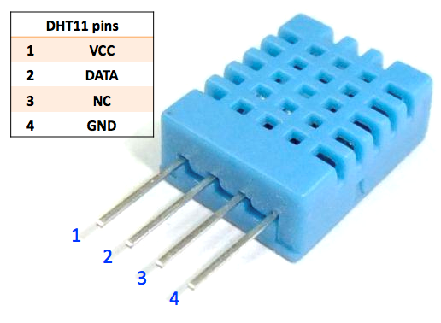

**Fig 1.4 (Temperature/Humidity Measure Sensor (DHT11 Sensor)**

Fig 1.4 elaborate that the temperature Sensors quantify the amount of heat energy or even coldness produced by an object or system, allowing us to "sense" or detect any physical change in that temperature and produce an analogue or digital output. Humidity refers to the amount of water vapor in the air. Humidity in the air has an impact on a variety of physical, chemical, and biological processes. Humidity can have an impact on the business cost of products, as well as the health and safety of people in industrial settings.

**Light Dependent Sensor (LDR):**

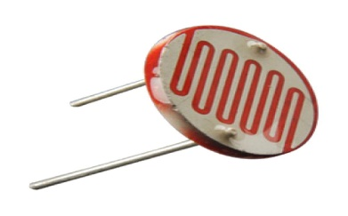

**Fig 1.5 (Light Dependent Sensor)**

Fig 1.5 Explains that the LIGHT DEPENDENT SENSOR LDRs (light dependent resistors) or photo resistors, are electronic components that are frequently employed in electronic circuit designs when the presence or level of light must be detected. LDRs are distinct from other types of resistors, such as carbon film resistors, metal oxide film resistors, and metal film resistors, which are commonly used in electrical circuits. They were created expressly for their light sensitivity and the resulting resistance change. The light delight-dependent, LDR, photoresist or, or even photocell, photocell, or photoconductor are all names for these electrical components. Although other electrical components such as photodiodes or phototransistors can be employed, LDRs or photo-resistors are especially useful in many electronic circuit designs. For variations in light level, they produce a considerable shift in resistance.

**Submersible Mini Water Pump:  
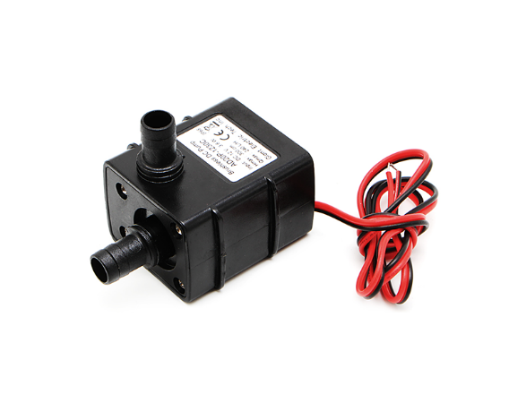**

**Fig 1.6 (Submersible Mini Water Pump)**

Fig 1.6 intricate that in an AI-based and controlled smart agricultural field, a 12V water pump can be used to pump water from a source, such as a well or a reservoir, to the fields for irrigation. The water pump can be controlled and monitored by a Raspberry Pi or other microcontroller, which can be programmed to turn the pump on and off based on various factors such as the soil moisture level, the weather conditions, and the crop's water requirements. To connect a 12V water pump to a Raspberry Pi, a relay module can be used. The relay module is an electronic switch that allows the Raspberry Pi to control the flow of electricity to the water pump. The relay module connects to the Raspberry Pi's general-purpose input/output (GPIO) pins, and can be controlled using software commands.

Implement AI algorithms to analyze the collected data and determine the optimal water and pesticide requirements for the crops. Develop control logic that automatically triggers the water sprinklers and pesticide dispensers based on the analysis results. Integrate the control logic with the actuators in the field to enable automated water and pesticide provision to the plants. Manual Control Interface: Create a user interface in the web application to allow manual control of water and pesticide dispensing. Provide options for users to adjust water quantity and schedule irrigation manually. Enable users to manually trigger pesticide dispensing when required. By implementing the above steps, you can create an AI-based smart agriculture system that collects real-time data on temperature, humidity, soil pH, and plant diseases. The system will transmit the data to a database and display it on a live website. Additionally, the system will automate the provision of water and pesticides to the plants based on AI analysis, while also allowing manual control for users. This integrated approach will enhance crop monitoring, optimize resource utilization, and enable efficient decision-making for sustainable agriculture.

##### **4 ALGORITHMS**

For the purpose of detecting plant diseases by picture recognition, several methods are frequently utilized. These algorithms include, among others:

**Convolutional neural networks (CNNs)**

CNNs are a popular alternative for detecting plant diseases since they are very good at image recognition tasks. For more accuracy, you can start with a simple CNN architecture before moving on to more complex ones like VGG, ResNet, or Inception.

**Transfer Learning**

Apply pre-trained CNN models (such as Mobile Net, InceptionV3, and ResNet) to your dataset of plant diseases and refine them. Transfer learning can speed up training considerably and improve performance, particularly if you have little data.

**Random Forest**

The flexible algorithm Random Forest is capable of both feature selection and classification. If you want to extract pertinent information from your photographs before classification, it can be especially helpful.

**Support vector machines (SVMs)**

SVMs are useful for binary classification jobs and can be effective if your goal is to tell healthy plants apart from sick ones.

**Quicker or Faster R-CNN**

Object identification methods like Fast R-CNN or Faster R-CNN may be suitable if you want to not only categorize but also locate the disease-affected areas in the photos.

**Mask R-CNN**

Consider utilizing Mask R-CNN if precise disease-affected region segmentation is required. This algorithm is capable of both classification and detailed segmentation masks.

**Ensemble Techniques**

To increase accuracy and resilience, combine various models, such as CNNs and SVMs, in an ensemble method. Individual model flaws can be reduced using ensemble techniques like bagging or boosting.

**YOLO (You Only Look Once)**

A real-time object identification program called YOLO has the ability to instantly identify and categorize diseases in photos. If you require quick processing for real-time applications, it might be helpful.

**Mobile Net**

Mobile Net is a lightweight architecture that can offer respectable accuracy if you're aiming for on-field deployment or mobile apps with constrained processing resource

**Dataset and Network for Disease Diagnosis Training:**

The images presented in this report were obtained from the Plant Village dataset, available at https://www.kaggle.com/datasets/arjuntejaswi/plant-village. This dataset is comprised of a set of 20,639 leaf images, which have been classified into 15 labels based on whether they are healthy or diseased, and the type of disease present . To train our machine learning model for plant disease diagnosis, we split the dataset into three subsets - training, validation, and testing - using a 70:30 ratio. We chose a network architecture that primarily utilized convolutional blocks without any complex layers such as residual connections, to facilitate easier interpretation of the intermediate layers.

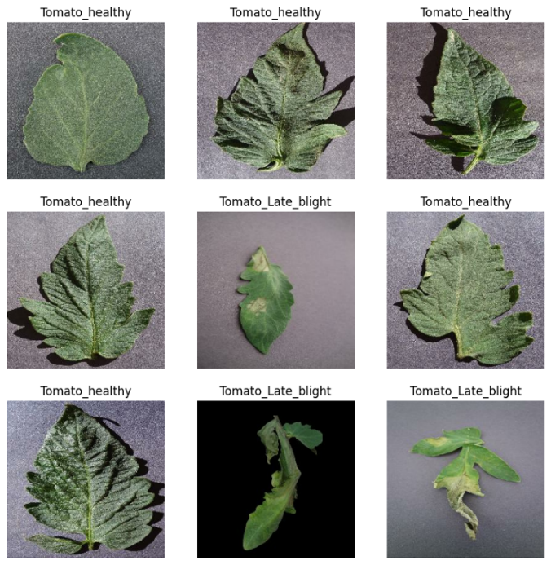

**Fig 4.1 (Plant’s Types of diseases)**

Fig 4.1 Represents For the test phase of the study, we used the network weights corresponding to the lowest validation loss (50th epoch) to evaluate the accuracy and loss values of the training, validation, and test datasets. The resulting confusion matrix indicated that there was no significant imbalance in the accuracy of any class, as shown in

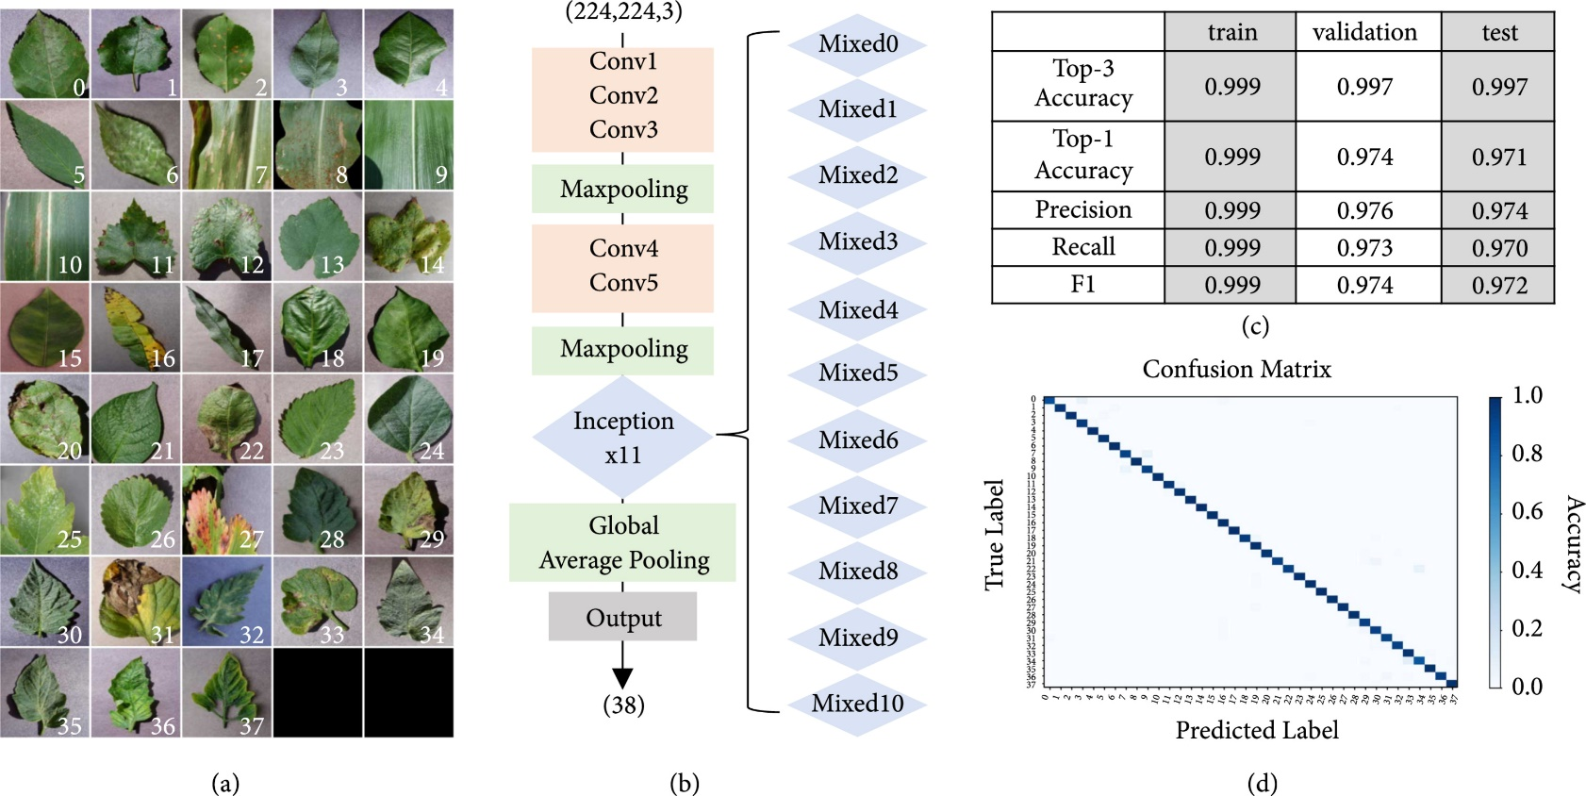

**Fig 4.2 (Confusion Matrix)**

Fig 4.2 Demonstrate the confusion matrix is a table used to evaluate the performance of a machine learning algorithm in classification problems. It shows the number of true positives, false positives, true negatives, and false negatives for each class.

##### **6 CONCLUSION**

The use of artificial intelligence (AI) in agriculture is referred to as "smart farming" or "smart agriculture." In the automation of smart farming, A.I. uses sensors and RFIDs to gather data, controllers to analyze that data, and actuators to finish the automation process. Pakistan is unable to fully benefit from the agriculture sector due to outdated farming practices and a dearth of modern technologies. Major food staples including potatoes, onions, chilies, and tomatoes have also gained economic significance recently as a result of rising demand and price hikes. Pakistan imports agricultural goods from foreign nations due to these factors. The top ten onion-producing districts in Pakistan are Swat and Dir in the Malaccan Division of Khyber Pakhtunkhwa Province. Onion bolting or flowering, on the other hand, is a problem that farmers deal with because it results from changes in the environmental circumstances that affect the onion crop. A longer photoperiod and cold temperatures promote onion flowering and bolting. The aforementioned problem with growing onions must be solved by technology-based smart farming and an efficient monitoring system. The plan should enable the farmer to identify bolting early and take preventative action to stop it, increasing onion yield.