THESIS PROJECT REPORT
Reinforcement Learning-Based Path Planning for a Mobile Robot
Comparative Analysis Using PPO and A*

Name: Tahir Berk Topçu
Student ID: 2018556065

Abstract
This study develops a reinforcement learning (RL)-based navigation and path planning approach for a mobile robot in a 2D simulated environment with obstacles and compares it to a classical A* planner. The RL agent is trained using Proximal Policy Optimization (PPO) with a reward design that prioritizes safe goal reaching while penalizing collisions and unnecessary motion. During evaluation over 64 episodes, the learned policy achieved a 100% success rate with 0% collision and 0% timeout. The average number of steps was 479.64 (std 2.61) and the average traveled path length was 50.62 (std 1.44). In the same scenario, A* produced a path length of 28.97 (49 visited nodes, segment length 0.604). Overall, the RL policy is robust and safe but less path-efficient: the RL/A* path length ratio is 1.75 (RL minus A* difference 21.65). This report presents the project scope, methodology, experimental setup, evaluation metrics, and a detailed analysis of the results.

Keywords
Reinforcement learning; PPO; mobile robot; path planning; A*; navigation.

1. Introduction
Autonomous navigation is a fundamental problem in mobile robotics. A robot is expected to travel from a start position to a goal position without collisions and ideally with a short and efficient trajectory. Classical methods such as A* and Dijkstra typically rely on an explicit map representation and hand-crafted heuristics. While these planners are powerful, they can struggle to adapt in dynamic, uncertain, or partially observable environments.
Reinforcement learning (RL) enables an agent to learn a control policy through interaction with the environment. Instead of depending only on a static map, the agent can make decisions using sensor observations and feedback. In this work, a PPO-based RL agent and an A* planner are evaluated on the same task to assess safety and path efficiency.

2. Project Description and Objectives
Project title: Reinforcement Learning-Based Path Planning for a Mobile Robot.
The goal of the project is to design an RL agent that navigates a mobile robot to the target while avoiding obstacles in a simulated environment, and to compare its performance with classical planners (A*, RRT). In this report, the focus is on the comparison with A*.
Main objective:
To design and implement a simulation-based reinforcement learning system that enables a mobile robot to plan safe and efficient paths in an obstacle-filled environment.
Specific objectives:
- Implement a simulation environment for robot motion and obstacle interaction.
- Develop an RL agent for autonomous navigation (DQN or PPO; PPO in this work).
- Design a reward function that balances path efficiency and safety.
- Evaluate and compare performance against classical algorithms (A*, RRT).
- Visualize learned paths and training/testing metrics.

2.1 Scope and Limitations
- The work is limited to simulation-based environments (no physical robot implementation).
- The environment may be static or partially dynamic (moving obstacles optional).
- The focus is on 2D path planning.
- No hardware testing or real-world deployment is performed.
- Multi-agent cooperation or swarm behaviors are outside the scope.
- Sensor noise and real-world uncertainties are simulated rather than physically modeled.

3. Theoretical Background

3.1 Classical Path Planning: A*
A* is a heuristic search algorithm used to find a minimum-cost path on a graph or grid. It evaluates nodes using the cost function f(n) = g(n) + h(n), where g(n) is the accumulated cost from the start to node n and h(n) is a heuristic estimate of the remaining cost to the goal. With an admissible and consistent heuristic, A* can find an optimal path while expanding fewer nodes than uninformed search. In this work, A* serves as a baseline planner that is assumed to have full access to the environment map.

3.2 Reinforcement Learning and PPO
In reinforcement learning, an agent selects an action based on the current state and receives a reward signal from the environment. The objective is to learn a policy that maximizes the expected long-term return. Proximal Policy Optimization (PPO) is a policy-gradient method that improves training stability by limiting the size of policy updates through a clipping mechanism. PPO is widely used in robotics and navigation tasks for both discrete and continuous action spaces.

4. Methodology and Implementation
This section describes the simulation environment, agent design, reward-function approach, and evaluation procedure. The overall methodology from the project specification can be summarized as follows:
- Problem definition and literature review (RL-based navigation and classical planners).
- Environment design (a simulator such as PyBullet/OpenAI Gym; define start, goal, and obstacle distributions).
- Agent and reward design (state definition, action space; reward balancing progress and safety).
- RL model development (DQN or PPO; training using Stable-Baselines3/PyTorch).
- Testing and comparison (evaluate against A* or RRT in identical environments).
- Visualization and analysis (learning curves, trajectories, convergence plots).
- Reporting and presentation (documentation and discussion of results).

4.1 Simulation Environment
Experiments were conducted in a 2D navigation environment with a start position, a goal position, and static obstacles. As defined in the project scope, the environment can be extended to support partially dynamic obstacles; however, the metrics reported here are obtained from a standard/static evaluation scenario.

4.2 Agent State and Action Space
Following the specification, the agent state includes components such as robot position, distance to the goal, and obstacle sensor readings (e.g., distance sensors or LiDAR-like measurements). The action space is defined as a simple discrete set: move forward and turn left/right. While this simplified action set makes learning easier, it can limit path efficiency by restricting fine-grained maneuvers.

4.3 Reward Function Approach
The reward function is designed to encourage progress toward the goal while strongly penalizing collisions. A typical design includes: (i) positive reward for decreasing the goal distance, (ii) a large negative reward for collision, and (iii) a small step or energy penalty to discourage unnecessary motion. In this project, the RL agent learned to reach the goal without collisions, but it did not produce paths as short as A*. This suggests the reward structure and/or action space may prioritize safety over path optimality.

4.4 Training and Evaluation Workflow
The agent was trained over multiple episodes by collecting interaction data. The evaluation set used in this report contains 64 episodes. Since the step count in logs converges near 480, the environment likely enforces a maximum step limit (timeout threshold). In the evaluation phase, the RL agent and the A* planner were tested on the same start-goal scenario, and metrics such as success/collision/timeout, steps, and path length were recorded.

5. Evaluation Metrics
- Success rate (success_rate): fraction of episodes that reached the goal.
- Collision rate (collision_rate): fraction of episodes that ended with a collision.
- Timeout rate (timeout_rate): fraction of episodes that ended due to the maximum step limit.
- Number of steps (steps): time steps required to reach the goal.
- Path length (path_length): total length of the traveled trajectory.
- Episode reward (episode_reward / mean_reward): total/average reward for the RL agent.
- RL/A* ratio: RL path length divided by A* path length.

6. Experimental Results
Table 1. Evaluation summary (RL and A* metrics).
Parameter / Metric | Value
Number of evaluation episodes | 64
Success rate | 1.0000
Collision rate | 0.0000
Timeout rate | 0.0000
RL mean steps | 479.64 (std 2.61)
RL mean path length | 50.62 (std 1.44)
RL mean reward | 5.64 (std 1.44)
A* path length | 28.97
A* visited nodes | 49
A* segment length | 0.604
RL / A* path length ratio | 1.75
RL - A* path length difference | 21.65
RL mean step length | 0.1055

According to Table 1, the RL agent reached the goal in all episodes (100% success) with no collisions and no timeouts, indicating strong safety performance. However, in terms of path efficiency (shorter route), A* performs significantly better.
Table 2. RL (PPO) vs A* comparison.
Metric | RL (PPO) | A*
Success rate | 1.0 | 1.0
Collision rate | 0.0 | 0.0
Timeout rate | 0.0 | 0.0
Average steps | 479.64 | N/A
Average path length | 50.62 | 28.97
Path length std | 1.44 | 0.0
Average reward | 5.64 | N/A
RL/A* path ratio | 1.75 | 1.0
RL - A* path length difference | 21.65 | 0.0

6.1 Path Length Analysis
RL path lengths show a very narrow distribution. In most episodes, the traveled path length is approximately 50.8. A shorter path (~39.2) is observed in the first episode, and the policy then converges to a stable behavior. This suggests a near-deterministic policy or low-variance decision structure.
Additional statistics: RL path length ranges from 39.21 to 50.81. The RL/A* ratio ranges from 1.354 to 1.754.

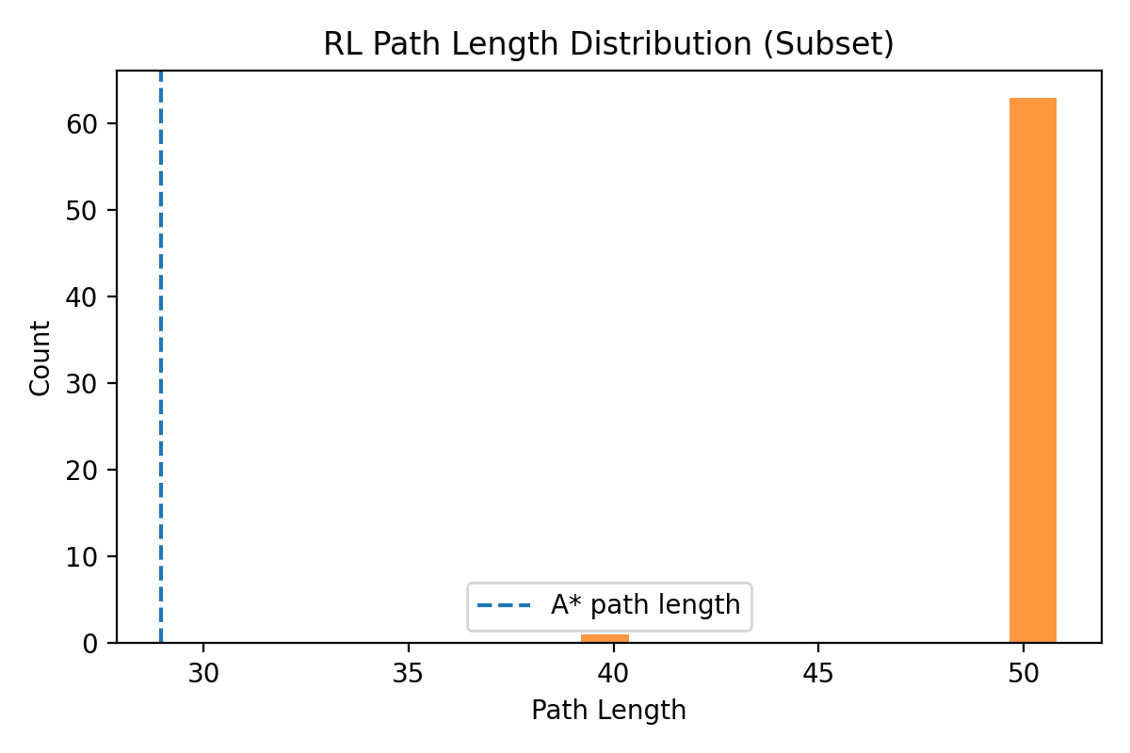
Figure 1. RL path length distribution (subset) with A* reference line.

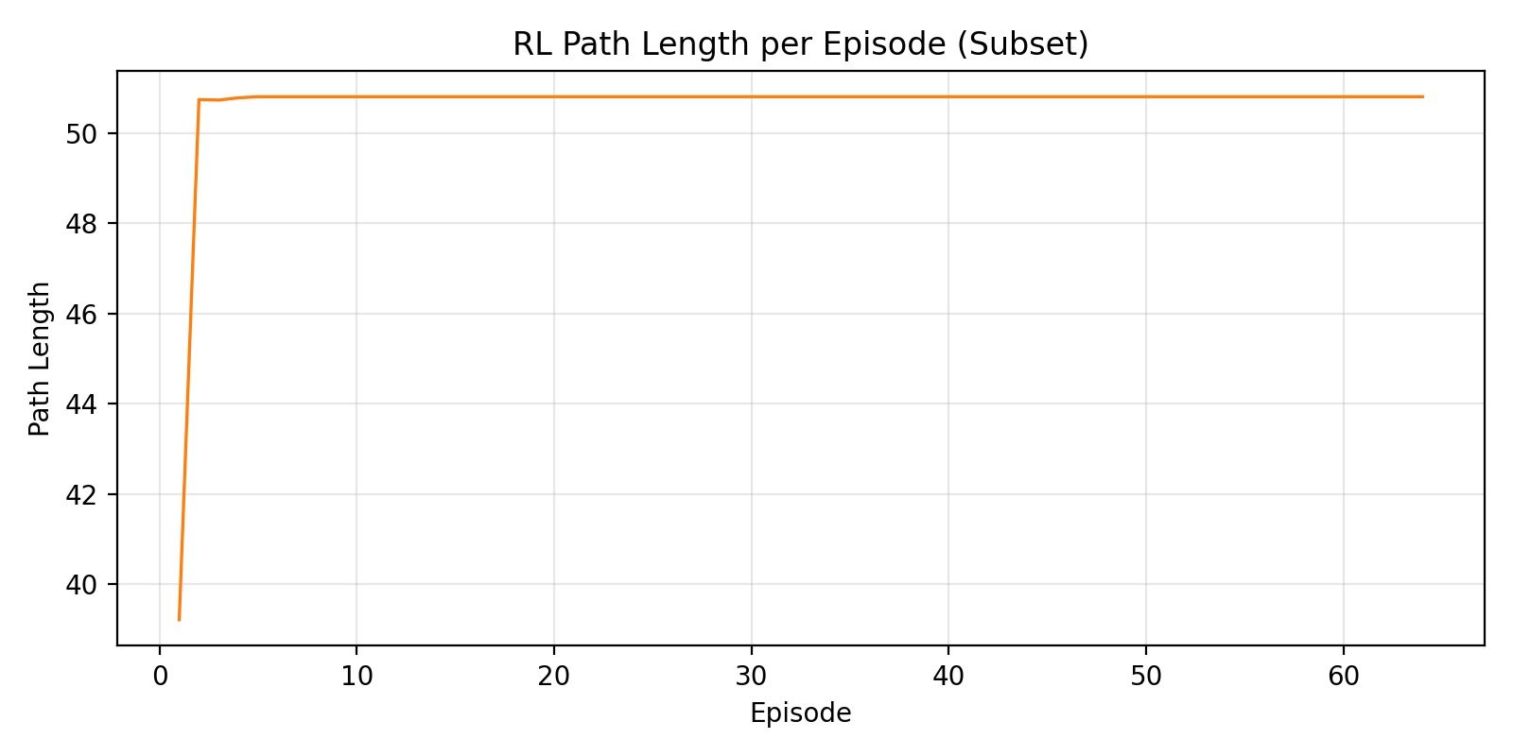
Figure 2. RL path length per episode (subset).

6.2 RL / A* Ratio Analysis
The RL-to-A* path length ratio rises to approximately 1.75 after the first episode and remains almost constant. This indicates that the RL agent travels roughly 75% longer paths than A* in the evaluated scenario. In other words, the policy is safe and reliable but does not learn near-optimal (short) routes comparable to the classical planner.

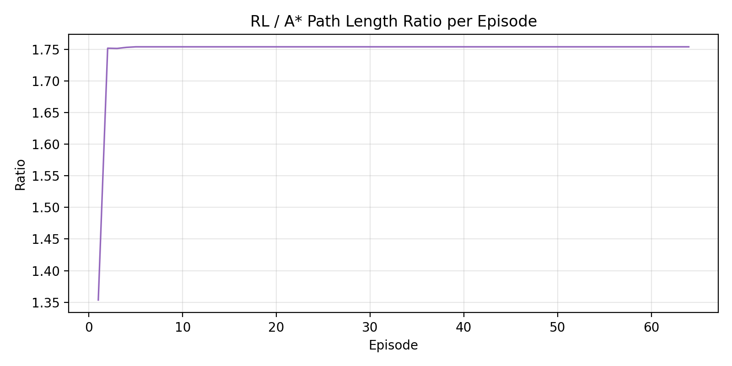
Figure 3. RL / A* path length ratio per episode.

6.3 Step Count and Convergence
Step-count metrics show that the behavior converges toward a limit. In most episodes, the number of steps is around 480. This likely reflects a maximum step limit in the environment or a policy that reaches the goal near that horizon. Since path length is nearly constant, the average movement per step also stabilizes (mean step length: 0.1055).

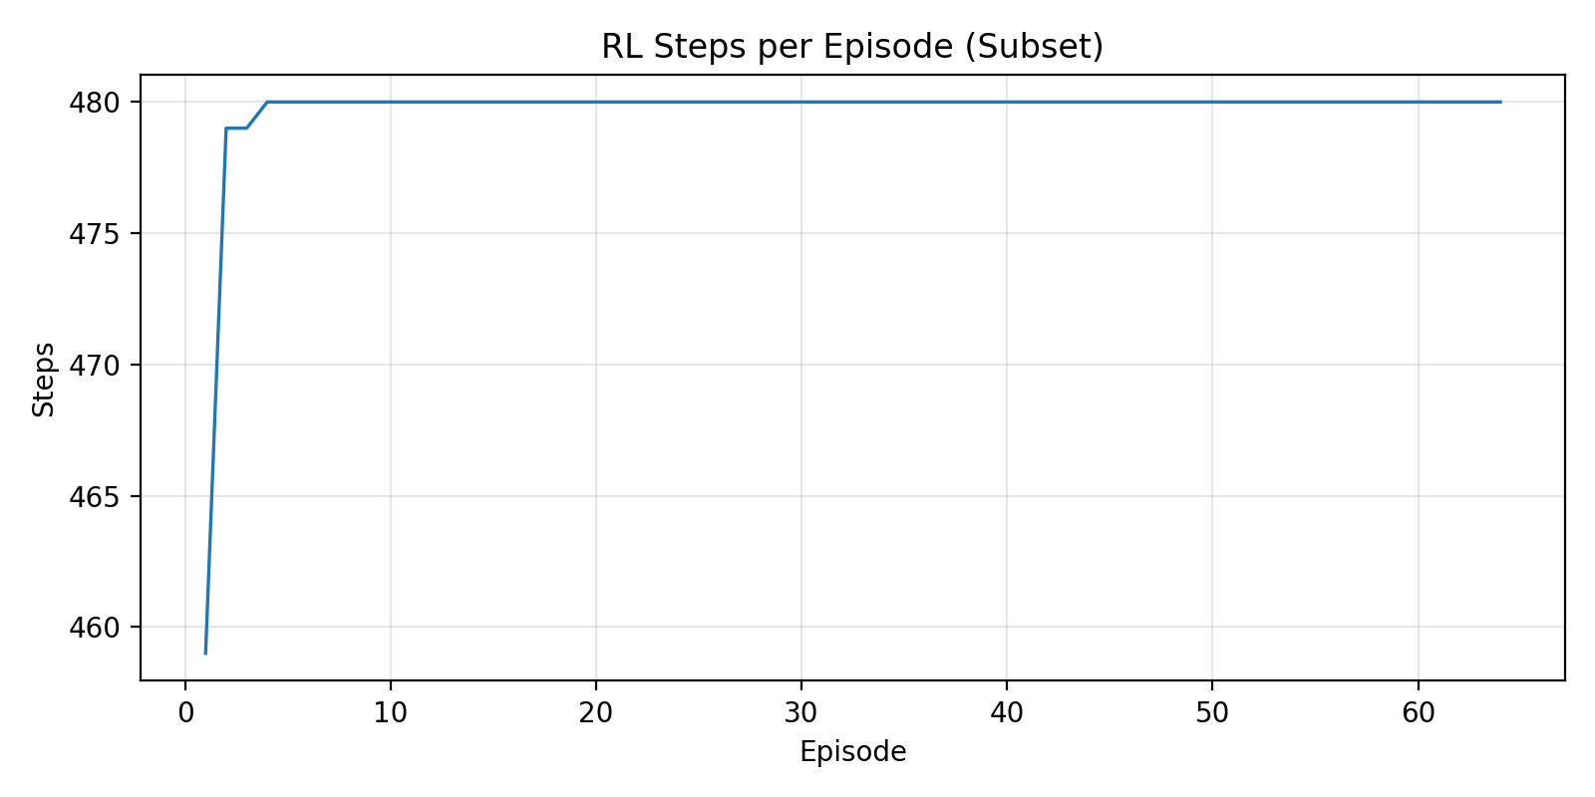
Figure 4. RL steps per episode (subset).

6.4 Average Path Length: RL vs A*
The following comparison directly shows the average path efficiency of the two methods. A* is naturally advantageous for producing short paths because it uses global map information to search for a near-optimal route. The RL agent, which makes policy-based decisions from local observations, can follow longer but safer trajectories.

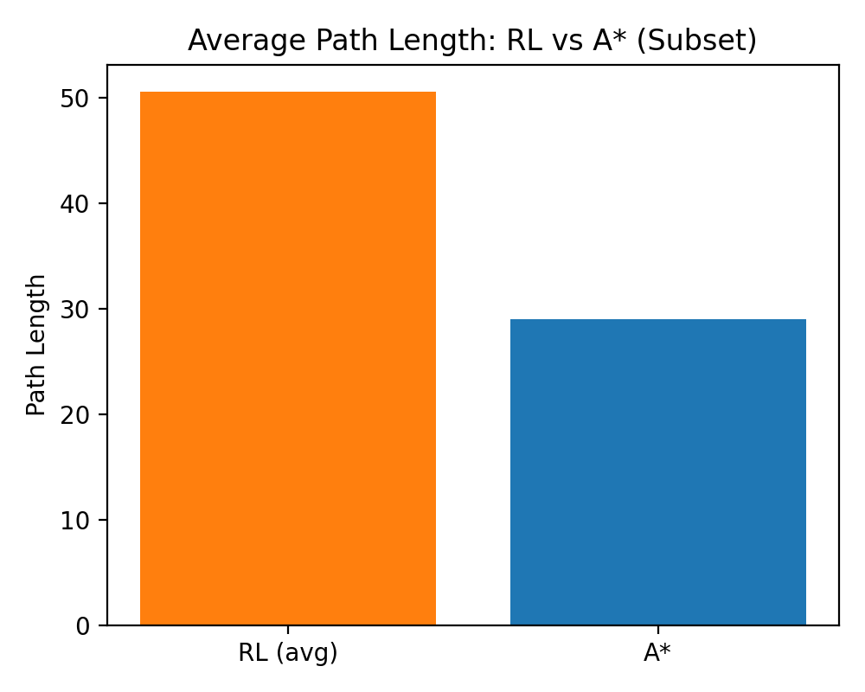
Figure 5. Average path length: RL vs A* (subset).

7. Discussion
The results indicate that the RL policy is very strong in terms of safety and task completion: all 64 episodes were successful with no collisions and no timeouts. However, path length is significantly larger than A* (RL/A* ~ 1.75).
Possible reasons for this gap include:
- The reward function may reward safety (collision avoidance) more strongly than path shortness.
- The action space may be too coarse/discrete (forward, left, right), limiting fine maneuvers that shorten paths.
- The agent may rely only on local sensor observations (without a global map), producing detours.
- Episode step limits or termination conditions may shape behavior (steps saturating near 480).
- Limited diversity of maps/obstacle configurations during training may cause convergence to a single behavior.
Overall, the study suggests RL can be used as an alternative or complementary approach to classical planners, especially in dynamic or partially observable environments where reactive decisions are valuable. To improve path optimality, reward design and algorithm settings must be tuned more carefully.

8. Improvement Suggestions and Future Work
- Add a stronger penalty related to path length or energy usage (e.g., per-step cost or explicit path-length penalty).
- Enrich the action space (continuous velocity/omega commands or finer turning angles).
- Apply curriculum learning by gradually increasing obstacle density and task difficulty.
- Use imitation learning: initialize the policy from A* (expert) demonstrations and fine-tune with RL.
- Evaluate robustness under dynamic obstacles and sensor noise.
- Investigate sim-to-real transfer and hardware validation (outside the current scope, but a natural next step).

9. Conclusion
In this thesis project, a PPO-based RL agent for mobile robot navigation was developed and compared with an A* planner. Experimental results show that the RL policy is strong in safety and task completion (100% success, 0% collision). However, A* produces significantly shorter paths. Therefore, while RL provides adaptive decision-making advantages in uncertain or dynamic environments, additional improvements (reward shaping, action-space design, hybrid approaches) are required to reach the path-efficiency level of classical planners.

References
[1] Sutton, R. S., & Barto, A. G. (2018). Reinforcement Learning: An Introduction (2nd ed.). MIT Press.
[2] Hart, P. E., Nilsson, N. J., & Raphael, B. (1968). A formal basis for the heuristic determination of minimum cost paths. IEEE Transactions on Systems Science and Cybernetics, 4(2), 100-107.
[3] Schulman, J., Wolski, F., Dhariwal, P., Radford, A., & Klimov, O. (2017). Proximal Policy Optimization Algorithms. arXiv:1707.06347.
[4] Mnih, V., et al. (2015). Human-level control through deep reinforcement learning. Nature, 518, 529-533.
[5] LaValle, S. M. (1998). Rapidly-exploring random trees: A new tool for path planning. Technical Report.
[6] Stable-Baselines3 Documentation. (RL algorithms library for Python).

Appendix A. Episode-Level Sample Logs
Below are the key metrics for the first 10 episodes selected from the evaluation set (success, collision, timeout, steps, path_length, episode_reward).
Table A1. Metrics for the first 10 evaluation episodes.
Episode | Success | Collision | Timeout | Steps | Path Length | Reward
1 | 1 | 0 | 0 | 459 | 39.2126 | 17.0731
2 | 1 | 0 | 0 | 479 | 50.7458 | 5.4410
3 | 1 | 0 | 0 | 479 | 50.7346 | 5.4684
4 | 1 | 0 | 0 | 480 | 50.7838 | 5.4779
5 | 1 | 0 | 0 | 480 | 50.8087 | 5.4534
6 | 1 | 0 | 0 | 480 | 50.8087 | 5.4534
7 | 1 | 0 | 0 | 480 | 50.8087 | 5.4534
8 | 1 | 0 | 0 | 480 | 50.8087 | 5.4534
9 | 1 | 0 | 0 | 480 | 50.8087 | 5.4534
10 | 1 | 0 | 0 | 480 | 50.8087 | 5.4534

