

**Name: Tahir Hussain Bhutto**

**Roll No BSIT-23F-009**

**Section: A**

**Lab Title: 4**

**Objective: To get Familiar with Logical operators and Conditional Structure and Loops**

* Write a Python function to check if a number is even or odd.

def check_even_odd(number):  
    if number % 2 == 0:  
        return f"{number} is Even"  
    else:  
        return f"{number} is Odd"  
  
  
print(check_even_odd(10))  
print(check_even_odd(7))

**OUTPUT**

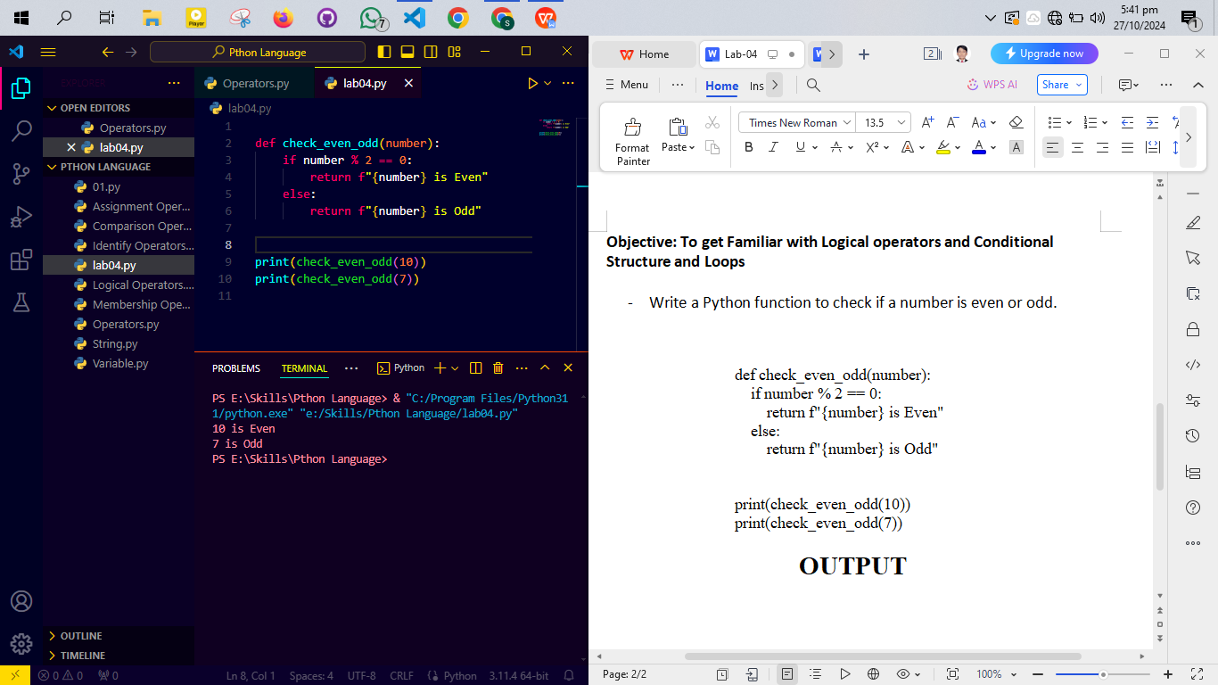

* Write a Python function to find the maximum of three numbers.

def find_maximum(a, b, c):  
    if a >= b and a >= c:  
        return f"The maximum number is {a}"  
    elif b >= a and b >= c:  
        return f"The maximum number is {b}"  
    else:  
        return f"The maximum number is {c}"  
  
  
print(find_maximum(10, 20, 30))  
print(find_maximum(50, 20, 30))

**OUTPUT**

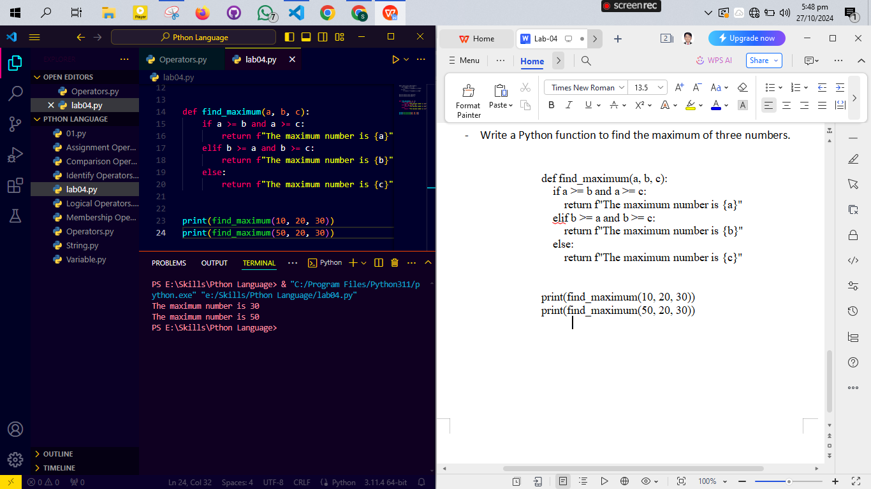

* Make starred shapes using Loops

def print_star_triangle(rows):  
    for i in range(1, rows + 1):  
        print("* " * i)  
  
print_star_triangle(5)

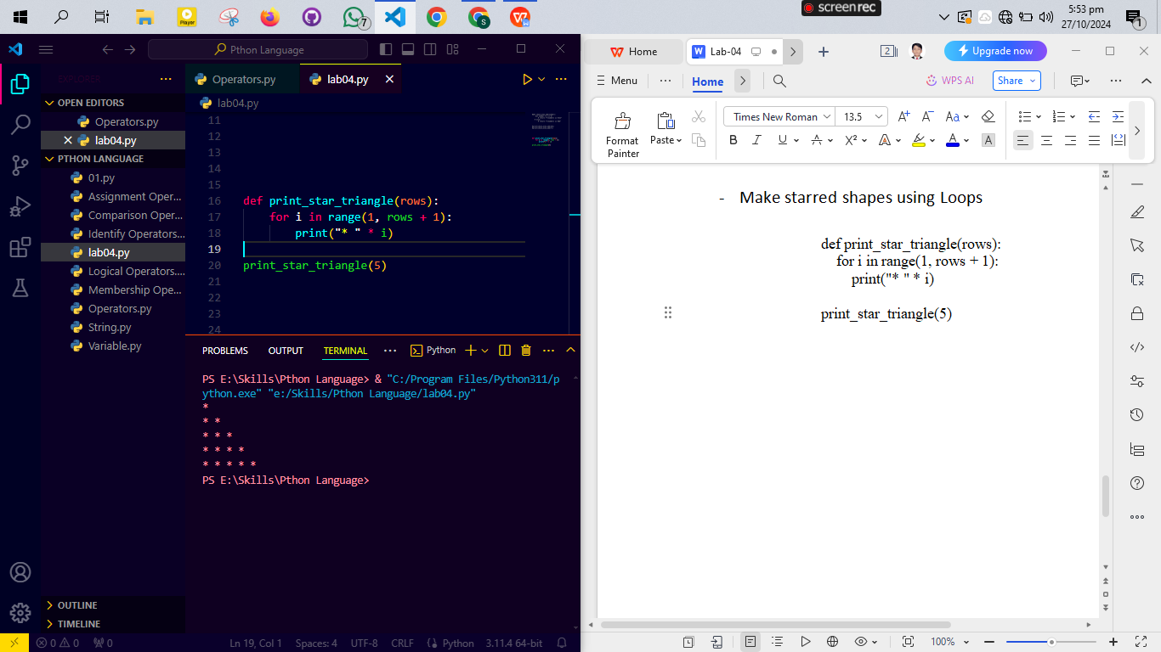

**OUTPUT**