MICROSOFT ENTRA ID
SC-300 Hands-On Lab Project
Building a mid-size company's identity infrastructure from scratch —
users, groups, RBAC, Conditional Access, PIM, and Identity Protection.
Scenario: NorthBridge Technologies Inc.
A fictional Canadian tech company · 50 employees · 6 offices

Why I Built This
While studying for the Microsoft SC-300: Identity and Access Administrator certification, I wanted to go beyond reading exam objectives and actually build the infrastructure they describe. This post documents a self-built lab simulating the identity environment of a mid-size company — created entirely on a free-tier Microsoft Entra ID tenant, with a short free trial of Entra ID P2 to unlock premium features like Conditional Access, PIM, and Identity Protection.
Everything below was built, broken, debugged, and verified by hand inside the real Entra admin center — not simulated. Where I hit real errors, I've documented exactly what went wrong and how I fixed it, since that's often more useful than a clean walkthrough.
Tenant snapshot
Domain: tahirshaik.onmicrosoft.com · Tenant type: Workforce · Base license: Entra ID Free · Trial upgrade: Entra ID P2 (1 month, cancelled before billing)

What this lab covers
- 50 users, created via bulk CSV import, across 9 departments
- 6 Security groups for department- and role-based access
- Built-in RBAC role assignments mapped to real job titles
- A full app registration with client secrets, API permissions, and admin consent
- Two Conditional Access policies, tested in Report-only before going live
- Privileged Identity Management — converting standing admin access to Just-In-Time
- Identity Protection's risk-based sign-in detection, built the modern way (via Conditional Access)

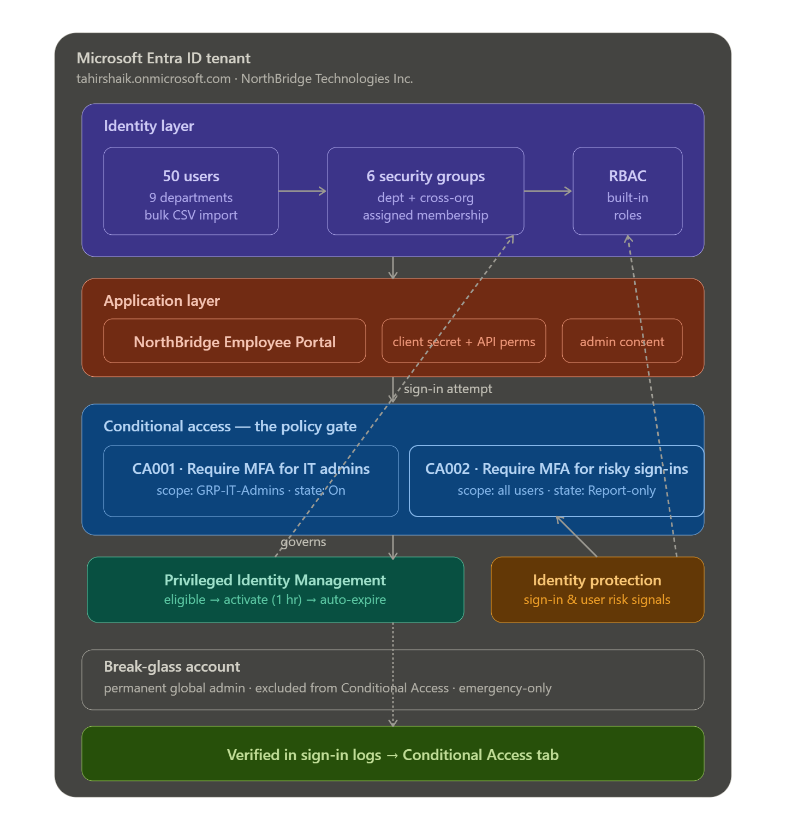

1. Setting Up the Lab Environment
Every Microsoft account with a free Outlook/Hotmail email automatically gets a free Entra ID tenant — you don't need to create one from scratch. Mine appeared as a "Default Directory" the moment I signed into the Entra admin center.

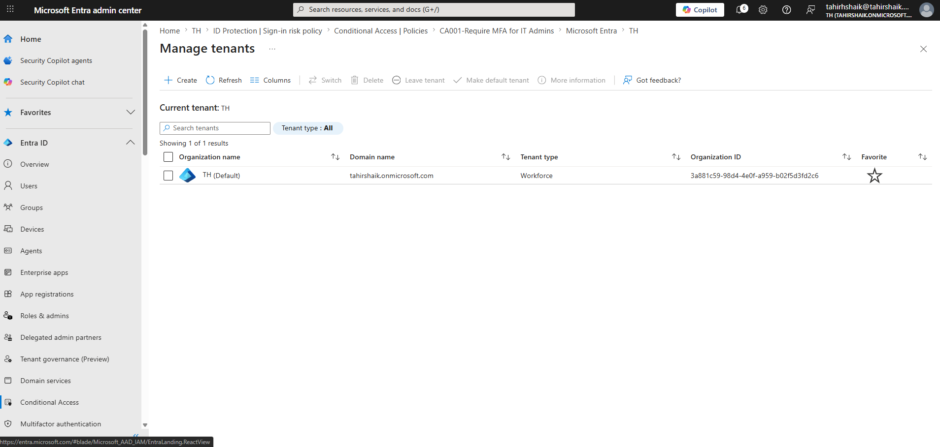

Why I needed Entra ID P2
The Free tier doesn't support full Conditional Access, Identity Protection, or Privileged Identity Management — three of the most heavily tested SC-300 topics. To unlock them without paying anything, I activated a no-cost 1-month Entra ID P2 trial.
⚠ Cost warning
The P2 trial requires payment details on file and will auto-convert to a paid subscription if not cancelled. I requested only 1 license (for my own admin account, not all 50 users) and set a reminder to cancel before the renewal date.

Free alternative worth trying first
The Microsoft 365 Developer Program offers a fully free 90-day E5 sandbox tenant — no credit card required — which includes the same P2-level features. I'd recommend trying this route first; I ran into trouble completing its signup flow and used the P2 trial instead, but it remains the safer no-card option.

2. Creating 50 Users
To make the lab feel like a real organization rather than a handful of test accounts, I generated 50 fictional employees spread across 9 departments — modeled as "NorthBridge Technologies Inc.," a Canadian tech company with offices in Toronto, Vancouver, Montreal, Edmonton, Winnipeg, and Halifax.
Department | Headcount | Example Roles
Engineering | 10 | CTO, Eng Manager, Software/DevOps/QA/Security Engineers
Sales | 7 | Sales Director, Account Executives, SDRs, CSM
Finance | 5 | CFO, Finance Manager, Accountants, Analysts
IT | 5 | IT Manager, SysAdmin, Cloud Architect, Security Analyst
Marketing | 5 | CMO, Content Strategist, SEO, Social Media, Design
Human Resources | 4 | HR Director, HRBP, Recruiter, Coordinator
Operations | 4 | COO, Project Manager, Business Analyst, Office Manager
Legal | 3 | General Counsel, Compliance Officer, Legal Assistant
Support | 2 | Support Team Lead, Support Specialist

Method: bulk CSV import
Rather than creating 50 users by hand, I used Entra's native Bulk create feature to simulate a realistic onboarding process:
- Entra admin center → Users → Bulk operations → Bulk create
- Downloaded Microsoft's official CSV template directly from the portal
- Populated it with realistic Canadian profile data — cities, provinces, postal codes, area-code-correct phone numbers
- Uploaded and submitted — Entra auto-generated temporary passwords, forced reset on first login

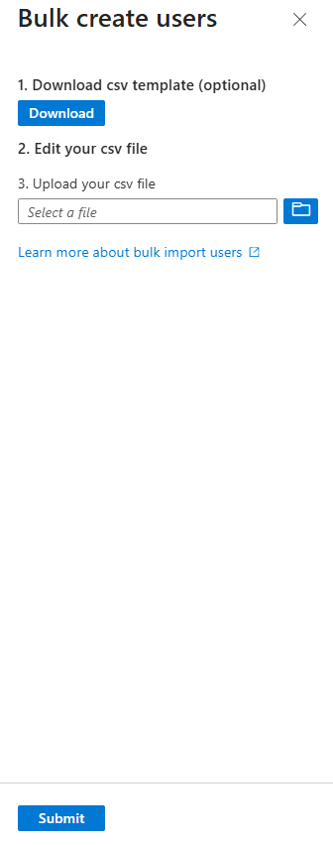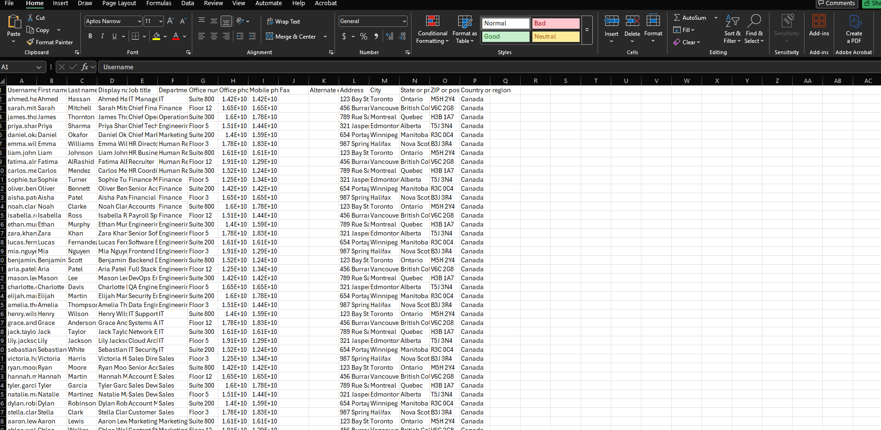

💡 Lesson learned
Entra's bulk import only accepts .csv, not .xlsx — and the required column headers are exact and change between Microsoft template versions. Always re-download the current template from the portal itself rather than reusing an old one; mismatched headers are the #1 cause of bulk upload failures.

3. Organizing Access with Groups
With 50 users in place, managing access individually doesn't scale — this is exactly the problem Security groups solve. I created 6 groups to mirror how a real IT team would structure access.
Group Name | Purpose | Approx. Members
GRP-IT-Admins | IT staff — used for Conditional Access & PIM testing | 5
GRP-Engineering | Engineering department | 10
GRP-Finance | Finance department | 5
GRP-Sales | Sales department | 7
GRP-Managers | All directors/managers (cross-department) | ~12
GRP-AllEmployees | Entire organization | 50

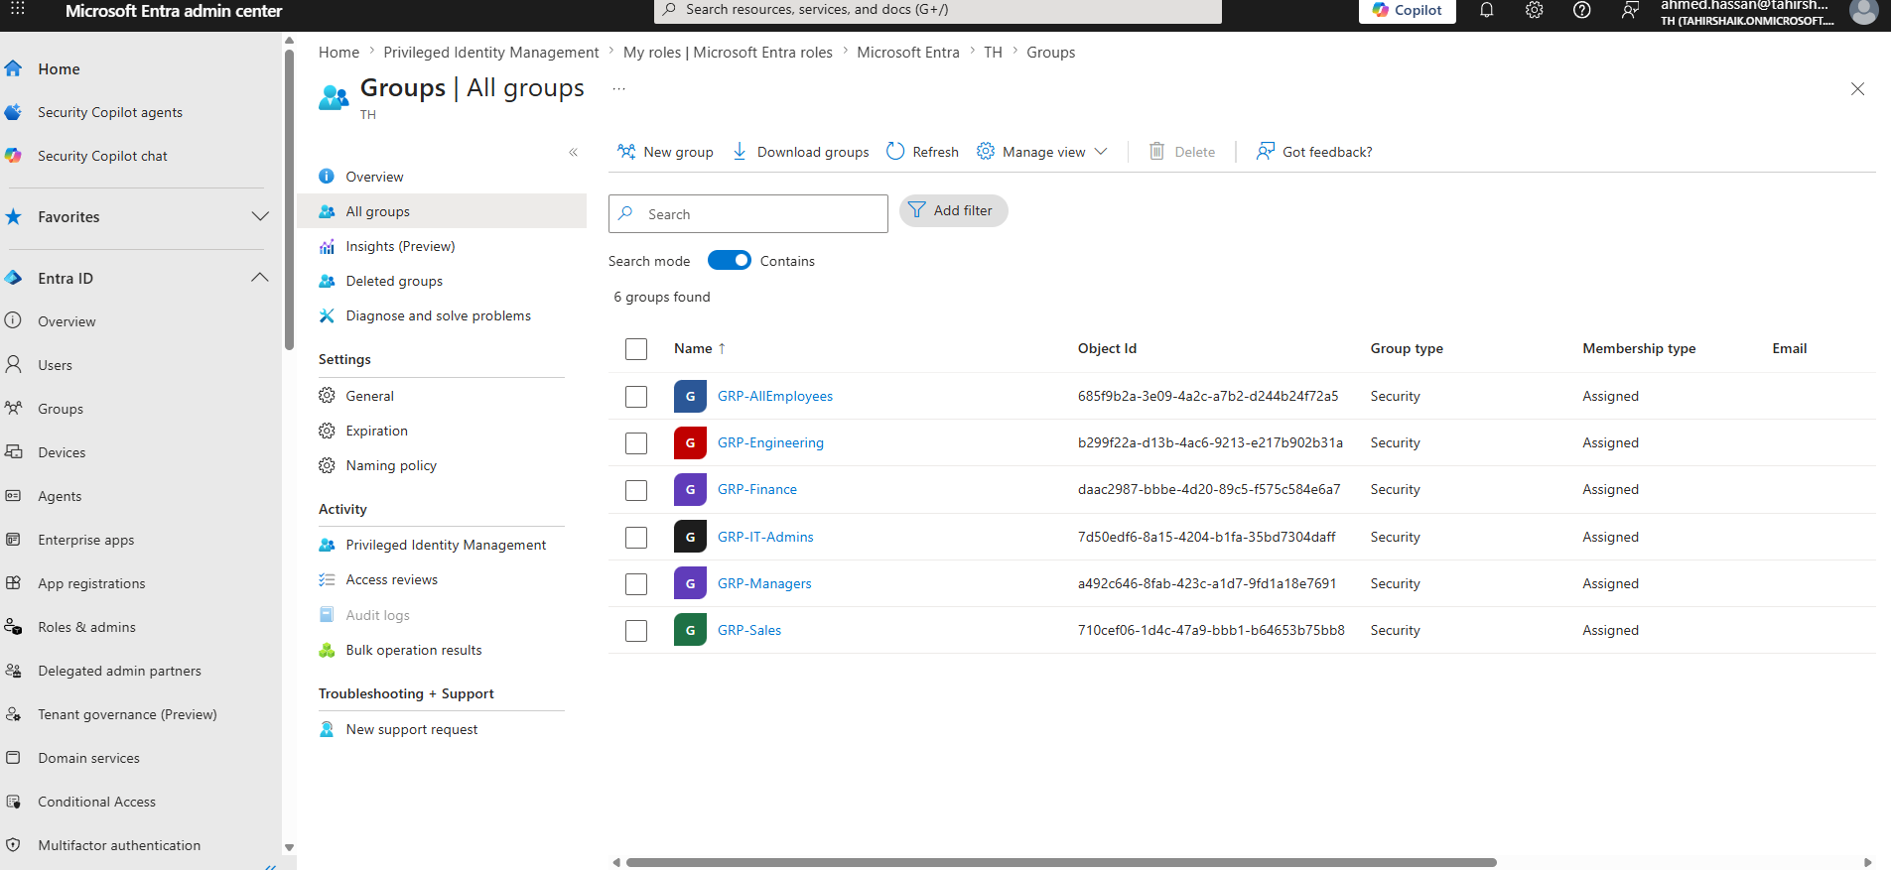

Configuration decisions
- Group type: Security — not Microsoft 365, since no email/Teams/SharePoint collaboration was needed, only access control
- Membership type: Assigned (manual) — Dynamic membership rules require P1/P2 licenses assigned to the users themselves, not just present on the tenant
- Owner: my admin account, to practice delegated group management
💡 Lesson learned
Choosing "Microsoft 365" as the group type forces a mandatory group email address field that has nothing to do with access control. If you only need a group for permissions/policies, always choose Security group type — it skips the email requirement entirely.

4. Role-Based Access Control (RBAC)
I assigned Microsoft's built-in directory roles to specific users based on their simulated job responsibilities — a practical demonstration of the least-privilege principle: give people exactly the access their role requires, nothing more.
User | Job Title | Assigned Role
Ahmed Hassan | IT Manager | User Administrator
Priya Sharma | CTO | Global Reader
Lily Jackson | Cloud Architect | Cloud App Security Administrator
Sebastian White | IT Security Analyst | Security Reader
Penelope King | General Counsel | Compliance Administrator
Elijah Martin | Security Engineer | Security Administrator

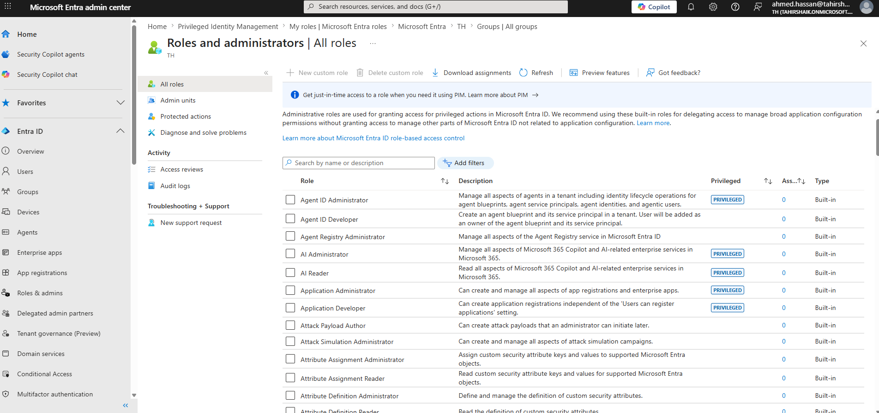

All assignments used Microsoft's built-in roles, which is sufficient for the SC-300 fundamentals. Custom roles — built from individually selected permissions — are a Premium feature I'm planning as a future extension of this lab.

5. Registering an Application
To understand how organizations connect their own apps to Entra ID for single sign-on, I registered a fictional internal app: the "NorthBridge Employee Portal."
Setting | Value
Name | NorthBridge Employee Portal
Supported account types | Single tenant (this organizational directory only)
Redirect URI | https://localhost (Web platform)

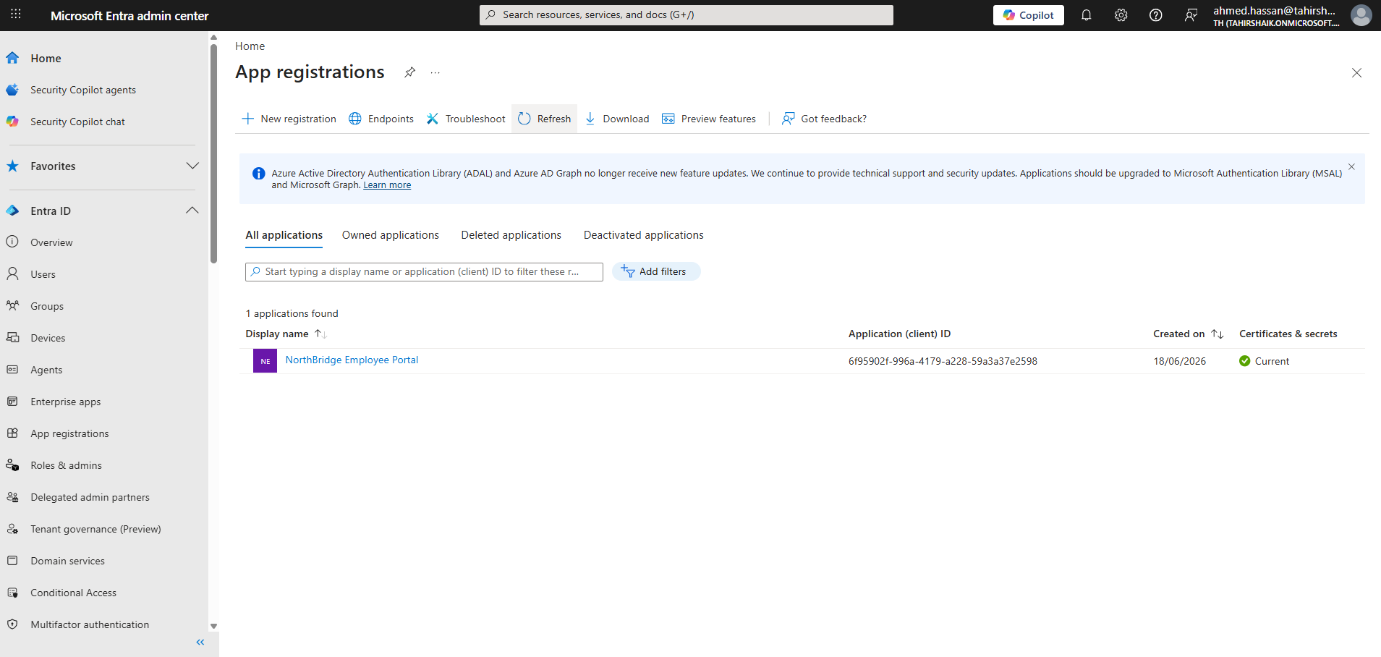

Client secret
A client secret was generated under Certificates & secrets — this acts as the application's own credential when it authenticates to Entra ID, conceptually similar to a password, but for the app itself rather than a user.

API permissions (Delegated)
Permission | Purpose
User.Read | Read the signed-in user's own profile (granted by default)
User.ReadBasic.All | Read basic profile info of other org members
profile | Access basic profile claims (name, photo)
Delegated permissions were used — not Application permissions — because the portal acts on behalf of the signed-in employee. It has no need to act autonomously in the background.

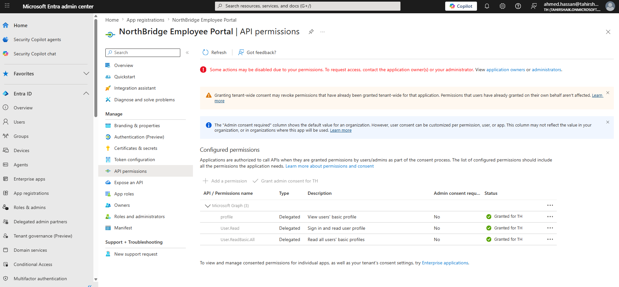

Admin consent
Consent was granted tenant-wide so individual employees aren't shown a permission-approval prompt on every login — standard practice for internal, trusted apps.

The authentication flow this demonstrates
Employee clicks "Sign in" on Employee Portal
|
v
App redirects to Entra ID for authentication
|
v
Entra ID validates credentials (+ MFA if required by policy)
|
v
Entra ID issues a token confirming identity + permitted claims
|
v
Employee is signed in to the Employee Portal (SSO)

6. Conditional Access
Conditional Access is Entra's "if this, then that" policy engine — the modern, recommended replacement for legacy per-user MFA and Security Defaults. I built two policies, both tested safely before going live.

Policy 1 — CA001-Require MFA for IT Admins
Setting | Value
Users (Include) | GRP-IT-Admins only
Target resources | All cloud apps
Grant control | Require multifactor authentication
State | Report-only -> tested -> switched to On
Logic: If a member of GRP-IT-Admins signs in to any cloud app, require MFA.

Policy 2 — CA002-Require MFA for Risky Sign-ins
Setting | Value
Users (Include) | All users
Target resources | All cloud apps
Condition | Sign-in risk: Medium and above
Grant control | Require multifactor authentication
State | Report-only
Logic: If a sign-in looks risky (unfamiliar location, leaked credentials, anonymous IP), require MFA.

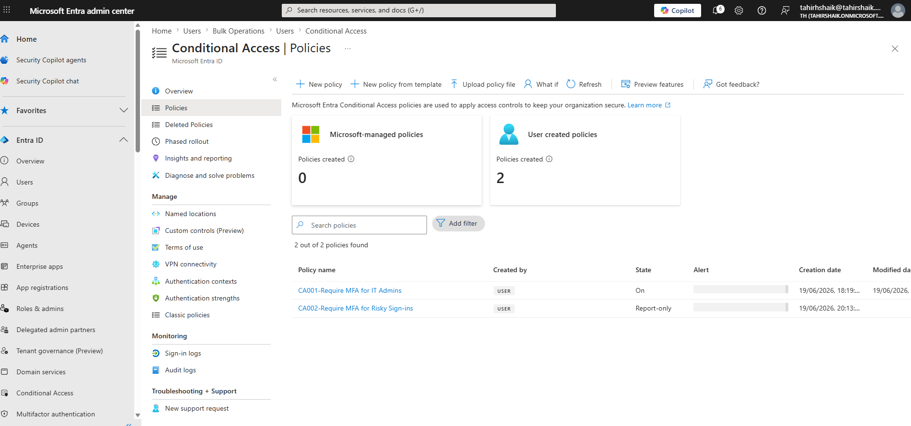
— screenshot of the Conditional Access policy list (CA001 + CA002) —

💡 Lesson learned
Microsoft is retiring the standalone Identity Protection "Sign-in risk policy" / "User risk policy" pages (read-only as of 2026, full retirement October 2026). Risk-based policies should now be built inside Conditional Access as a policy condition instead.

Testing methodology: Report-only before On
Every policy was tested safely before enforcement — this is one of Microsoft's most important recommended practices, and a frequent SC-300 exam scenario:
- Build the policy, set State = Report-only
- Trigger a real sign-in matching the policy's conditions
- Check Entra ID -> Monitoring & health -> Sign-in logs -> open the sign-in event -> "Conditional Access" tab
- Confirm: Policy Name | Grant Controls | Result: "Report-only: Success"
- Once confirmed correct, switch State = On

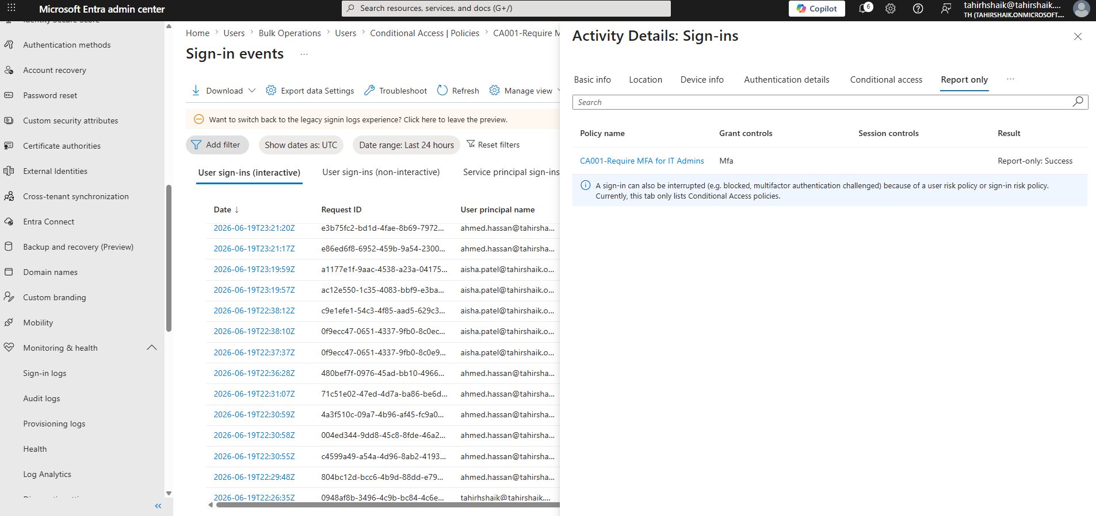— screenshot of the Sign-in log Conditional Access tab showing Report-only: Success —

Why this matters
This avoided the real risk of a misconfigured policy locking out actual users — testing logic safely before enforcement is a core Zero Trust and SC-300 best practice.

MFA layers — what controls what
One of the most confusing (and exam-relevant) discoveries in this lab: MFA prompts can come from several independent, overlapping layers.
Layer | Forces MFA registration? | Controlled by
Per-user MFA (legacy) | Yes, if enabled | Admin (legacy)
Security Defaults | Yes (all-or-nothing) | Admin (toggle)
Registration Campaign | Optional nudge | Admin
Conditional Access | Only if policy specifies | Admin (recommended)
Microsoft Mandatory MFA (2024-2026 rollout) | Yes | Microsoft — postponable, not avoidable
The sign-in log's Conditional Access tab is the definitive way to determine exactly which layer triggered a given MFA prompt — I used this directly to debug an unexpected MFA prompt during testing.

7. Privileged Identity Management (PIM)
PIM converts standing (permanent) admin access into Just-In-Time (JIT) access — a core Zero Trust principle, and one of the highest-value SC-300 topics I tackled.

Before PIM
Ahmed Hassan had User Administrator as a permanent, Active role assignment — meaning the privilege existed 24/7, whether in use or not. This is exactly the kind of standing access that makes compromised admin accounts so dangerous.

After PIM
I removed the standing assignment and replaced it with an Eligible assignment instead:
Setting | Value
Role | User Administrator
Member | Ahmed Hassan
Assignment type | Eligible (not Active)
Duration | Permanently eligible

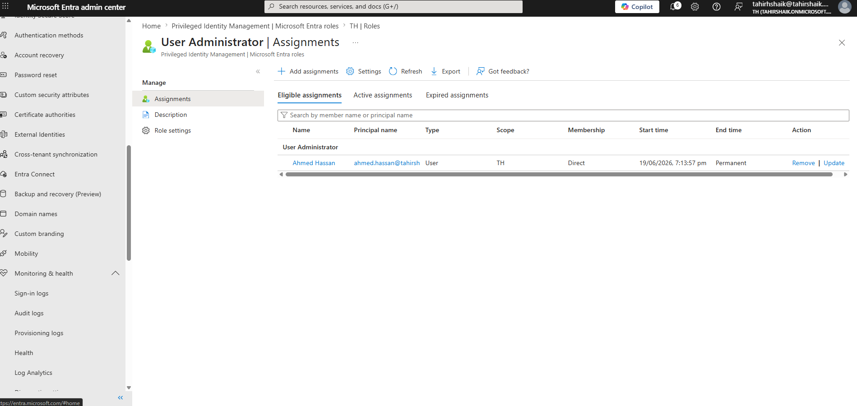— screenshot of PIM Eligible assignments showing Ahmed Hassan —

Self-service activation — tested end-to-end
- Signed in as Ahmed, navigated to Privileged Identity Management -> My roles -> Microsoft Entra roles
- Clicked Activate next to User Administrator
- Provided a justification reason (and MFA, since CA001 was already live)
- Role became Active for a fixed window

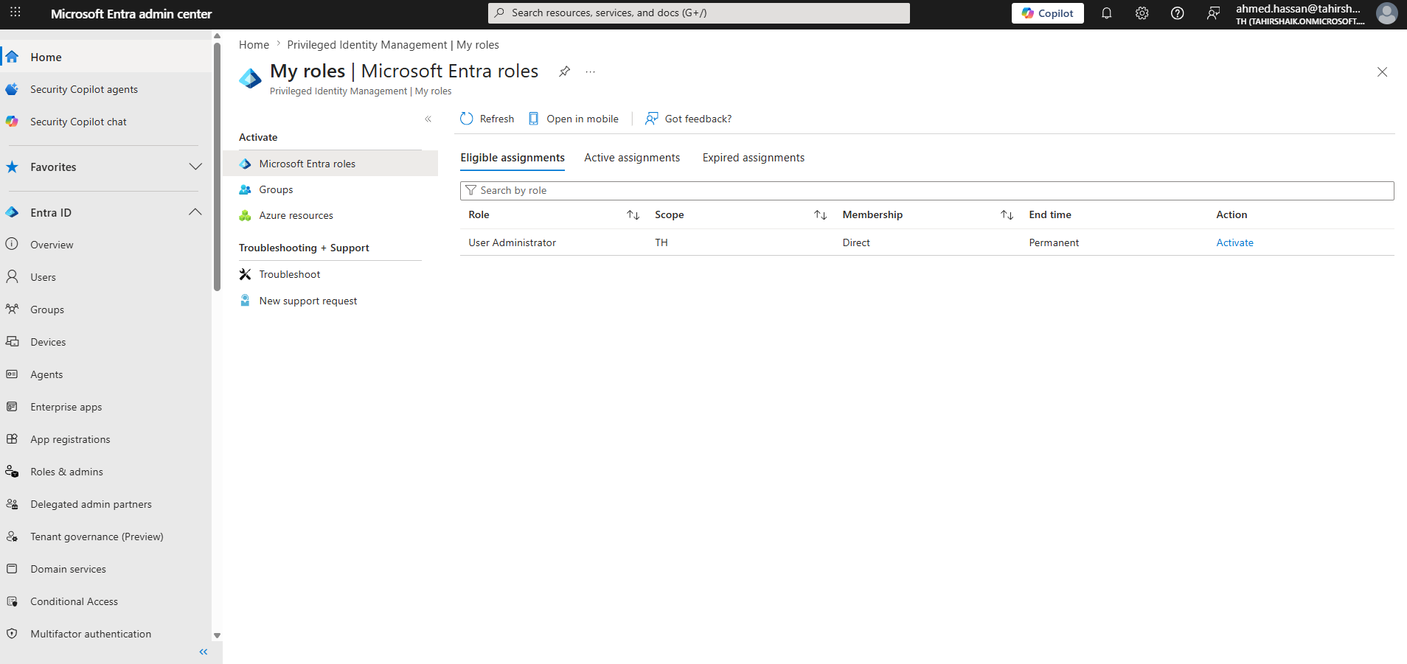— screenshot of Ahmed's 'My roles' page with the Activate button —

Verified in the admin's Active assignments tab:
Principal | State | Start time | End time
Ahmed Hassan | Activated | 19/06/2026, 7:31 PM | 19/06/2026, 8:31 PM (auto-expiry)

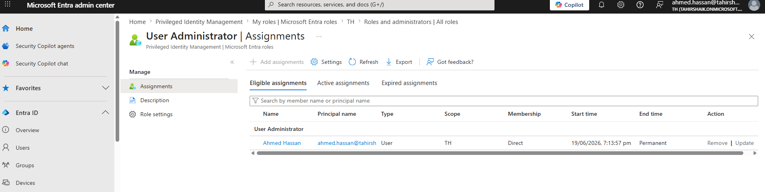

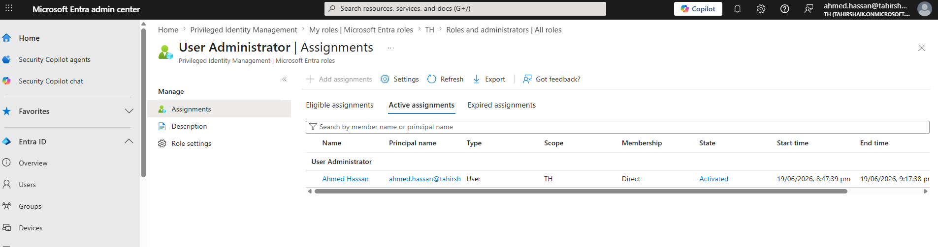
— screenshot of the Active assignments tab with the auto-expiry timestamp —

After expiry, Ahmed automatically reverts to Eligible only — no manual revocation required. This is the entire point of PIM: temporary, justified, auditable access instead of permanent standing privilege.

Break Glass Accounts — a key design realization
Partway through this exercise I asked myself: if PIM is supposed to eliminate standing privileged access, why is my own Global Administrator account still permanent? The answer turned out to be an intentional, documented security pattern — not an oversight.
The Break Glass principle
Even in fully PIM-adopted organizations, 2+ "break glass" accounts are deliberately kept as permanent Global Administrators, excluded from Conditional Access, with credentials stored offline — so that if PIM or Conditional Access ever misconfigures and locks everyone out, these accounts can still restore access.

Practice | Reason
2+ accounts, not 1 | Redundancy if one is compromised/unavailable
Permanent (not PIM-eligible) | Must work even if PIM service is down
Excluded from Conditional Access | Must work even if CA policy misfires
Credentials stored offline | Not phishable
Sign-in alerts configured | Should almost never be used — any use is notable

8. Identity Protection
Identity Protection uses Microsoft's threat intelligence and behavioral signals to detect two types of risk:
Risk Type | Detects
User risk | This identity may be compromised (e.g. credentials found in a leak)
Sign-in risk | This specific sign-in attempt looks suspicious (impossible travel, anonymous IP, unfamiliar device)
In this lab, sign-in risk detection was implemented via Conditional Access (CA002, see Section 6), reflecting Microsoft's 2026 platform direction of consolidating risk policies into the Conditional Access engine rather than the legacy standalone pages.

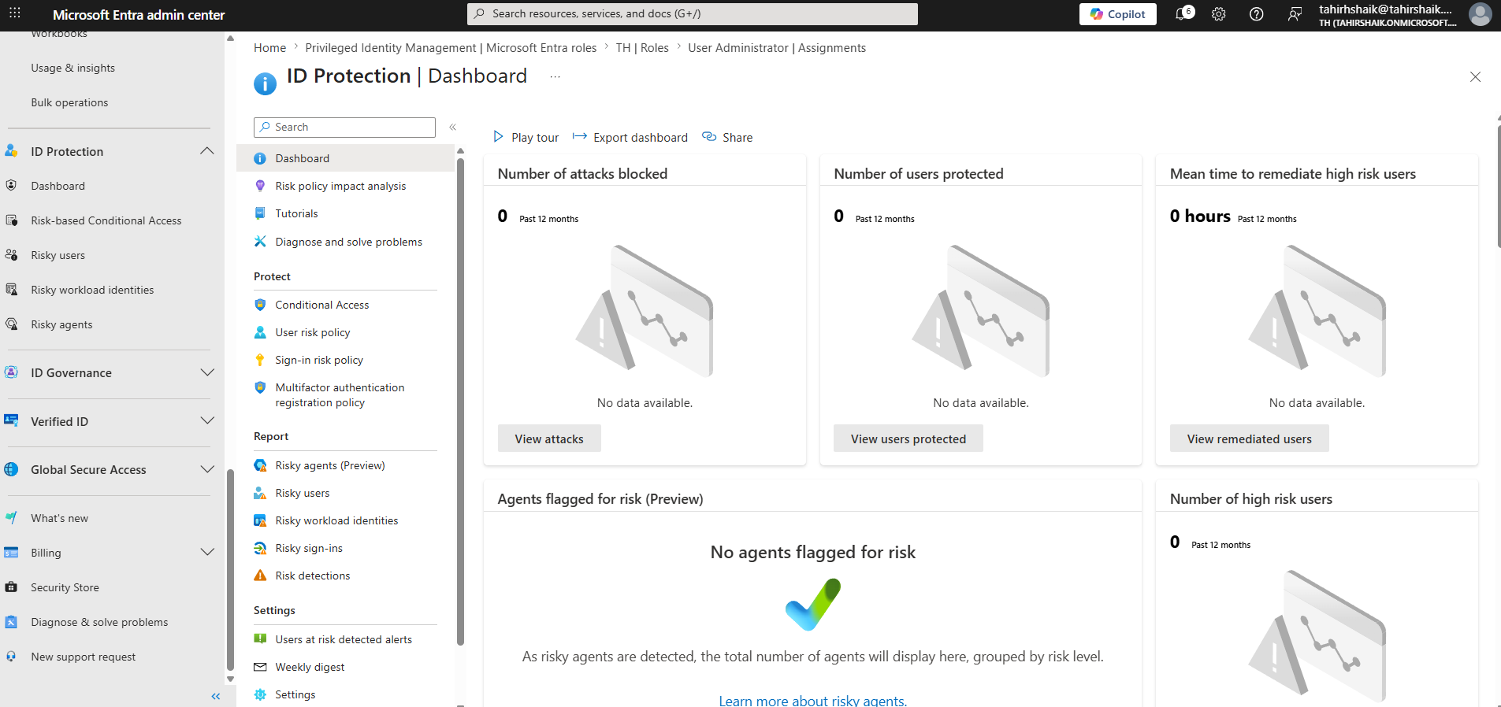— screenshot of the Identity Protection dashboard —

Expected result, not a bug
With a brand-new tenant and no real-world malicious traffic, the Identity Protection dashboard correctly showed 0 risk detections across all metrics. Risk detection depends on accumulated behavioral signals and global threat intelligence that a fresh lab tenant simply hasn't generated yet.

Key Concepts I Took Away
A condensed list of conceptual takeaways from this build — these are the notes I'm using for my own exam revision.
- Tenant types: Workforce (employees/internal) vs. External (B2B/B2C customer-facing) — choose based on who you're managing.
- Bulk operations are CSV-only, with exact column headers required — always re-download the template, it changes.
- Security groups are for access control (no email needed); Microsoft 365 groups are for collaboration (email required).
- Dynamic group membership requires P1/P2 licenses assigned to users, not just enabled on the tenant.
- Delegated permissions act as the signed-in user; Application permissions act as the app itself, with no user context.
- Admin consent approves API permissions tenant-wide so individual users aren't prompted.
- Report-only mode is the safe way to test any Conditional Access policy before enforcing it.
- MFA prompts can come from several independent layers — the sign-in log is the source of truth for which one fired.
- PIM's core distinction is Eligible vs. Active; activation is time-bound and self-service.
- Break glass accounts are a deliberate, documented exception to "everything must be governed" — required for resilience.
- Identity Protection's risk policies are migrating into Conditional Access as of 2026.

Issues I Hit (and How I Fixed Them)
A real troubleshooting log from this build. I'm including this because understanding why something breaks is often more valuable than a clean, error-free walkthrough.
Issue | Root Cause | Fix
"Microsoft Entra ID" tenant type greyed out | Required a paid license for the "Workforce (legacy)" creation flow | Used the already-existing free "Default Directory" tenant instead of creating a new one
Excel upload rejected by Bulk Create | Entra's bulk import only accepts .csv | Re-exported data as CSV with utf-8-sig encoding
Bulk upload errors despite a correct-looking CSV | Custom column headers didn't match Microsoft's exact template | Downloaded Microsoft's official template first and matched headers exactly
"Group email address" field blocking group creation | Had selected "Microsoft 365" group type instead of "Security" | Restarted group creation, selected Security type (no email needed)
P2 trial tried to auto-assign 26 paid licenses | "Assign licenses" during bulk creation defaults to licensing everyone | Selected "Don't assign any licenses" — only the admin account needs P2
Forgot bulk-generated user passwords | Microsoft's template has no password column — passwords are auto-generated, shown once | Used admin password reset to generate a new temporary password
MFA prompt appeared despite Conditional Access being Report-only | Multiple independent layers can trigger MFA registration | Checked sign-in log Conditional Access tab; identified Microsoft's mandatory MFA rollout as the real cause
Sign-in risk policy page had no "Report-only" option | Legacy ID Protection risk policy pages are read-only, retiring Oct 2026 | Rebuilt the same logic as a Conditional Access policy (CA002) instead
PIM "Activate" button missing from the role assignment page | That page is the admin management view, not self-service | Navigated to Privileged Identity Management -> My roles instead

How This Maps to the SC-300 Exam
Exam Domain | Covered By
Manage Microsoft Entra identities | Users (bulk creation), Groups, RBAC role assignment
Manage access to applications | App Registration, API permissions, Admin consent, SSO concepts
Plan and implement identity governance | PIM (eligible/active roles), Break Glass account design
Implement and manage authentication | Conditional Access, MFA layering, Authentication Methods
Plan, implement, and administer Conditional Access | CA001, CA002 — Report-only testing methodology, sign-in log verification
Manage identity protection | Identity Protection dashboard, risk-based Conditional Access

What's Next
- Build a User Risk Policy (force secure password reset on high-risk users) to complete the risk-policy pair
- Set up Access Reviews for periodic recertification of GRP-IT-Admins membership
- Create a second break-glass admin account, exclude it from Conditional Access, and convert the daily-use account to PIM-eligible
- Explore Custom Roles (granular permission sets beyond built-in roles)
- Document Entra Connect / hybrid identity concepts — conceptual only, no on-prem environment available

A note on the data
This is a personal study lab using fictional data (NorthBridge Technologies Inc.) for SC-300 exam preparation. No real organization, employee, or customer data is used. The Entra ID P2 trial used for premium features was cancelled before any billing occurred.

