TECHNICAL DESIGN DOCUMENT · v2.0
Daily Production Module
Grouped Summary Screen, Shift Enum, and Modal-Based Entry — Revised Design
TKT Textiles & Knitting — Factory Management System
Prepared for: Tahir Hassan, Engineering
Date: 30 July 2026 · Status: For Review · Version: 2.0 (supersedes v1.0)

1. Executive Summary — What Changed Since v1.0
The original Daily Production design (v1.0) built a flat entry list: one row per submission, edited and cancelled inline. This revision replaces that with what the updated requirements actually describe: a grouped daily summary (one row per Machine + Operator + Party + Shift combination, totals computed live from detail rows) and a modal-driven entry workflow built for fast, repeated, keyboard-first data capture on the factory floor.
Area | v1.0 | v2.0 (this document)
Landing screen | Flat list of entries, one row per submission, with per-row Edit/Cancel | Grouped summary for a selected date — SUM(RollWeight) per Machine/Operator/Party/Shift; no per-row actions
Shift | Not present | New required field, genuine Postgres ENUM ('Morning', 'Night')
Entry creation | Full page (/daily-production/new) with a react-hook-form field-array grid | Modal dialog on the landing screen; roll weights entered one at a time via textbox + Add
Multiple entries, same combination | Open question — flagged as needing a business decision | Explicitly required and expected: “Save & Add” exists specifically to create a second entry for the same machine/operator/party/shift without re-selecting anything
Roll entry UX | N pre-rendered input rows, add/remove via field array | Single input, Enter-to-add, running list above the input, remove per row

Stack note: the requirements ask for “Entity Framework models” and .NET-flavored artifacts. This codebase (TKT-Textiles-Knitting) is Node.js/Express + Drizzle ORM on PostgreSQL, not ASP.NET Core/EF Core — there is no .csproj, no DbContext, anywhere in this repository. Building EF Core models here would produce code that cannot run against this project. Section 3 below gives the Drizzle equivalent of an EF Core model (a typed schema file plus a migration) — same role, same guarantees (typed columns, FK constraints, generated migrations), different ORM vocabulary. If a separate .NET service actually exists elsewhere and this was the wrong repository context, say so and the EF Core translation can be produced directly.

2. Assumptions, Risks, Dependencies, Open Questions

2.1 Assumptions
- The summary grid is scoped to a single Production Date — no date-range view is requested at this landing screen (that already exists conceptually via the Transactions report pages).
- “Shift” has exactly two values today. Modeled as a genuine Postgres ENUM type per the explicit requirement, not a text + CHECK constraint (which is what v1.0 used for status — kept as-is, since only Shift was called out as needing enum storage).
- Multiple header rows sharing the same (date, machine, operator, party, shift) are correct and expected — “Save & Add” is the workflow that produces them. No uniqueness constraint is placed on that combination (see Section 3.4).
- Still no authentication layer in this codebase. “Entered By” remains a free-text field remembered in the browser, exactly as in v1.0 — unchanged assumption, restated here because it still governs createdBy/updatedBy handling.

2.2 Risks
- Enum extensibility: adding a third shift (e.g., "Afternoon") later requires an ALTER TYPE shift ADD VALUE migration. Postgres allows this online but the new value cannot be used inside the same transaction that adds it — a minor operational gotcha for whoever runs that future migration, not a blocker today.
- Grouped totals hide entry-level detail: because the summary aggregates across possibly-several header rows, there is currently no drill-down from a summary row back to the individual entries that produced it. If a supervisor needs to correct one bad entry within a combined total, there's no UI path to find it — flagged in Section 8 as a near-term follow-up.
- Duplicate-submission risk moved, not eliminated: the modal disables Save/Save & Add while a request is in flight (Section 6.3), which stops double-clicks and double-Enters. It does not stop a supervisor from genuinely re-entering the same physical rolls twice under two different “Save & Add” batches — that's indistinguishable from two real shifts of production at the data layer. Only a human reading the summary total would notice.

2.3 Dependencies
- Unchanged from v1.0: machine_master, machine_operator_master, party_master must be populated; frontend reuses the existing generated lookup hooks for these three dropdowns.

2.4 Open Questions
- Should the summary grid support drill-down (click a row → see the contributing header entries and their individual roll lists)? Not built in this pass — flagged in Section 8.
- Is a running daily grand total across all machines/shifts (shown at the bottom of the grid) sufficient, or is a separate shift-wise subtotal (Morning total vs Night total) also wanted? Only the grand total is implemented today.
- Should “Add New” default its Production Date to the date currently selected in the landing-screen filter, rather than always to today? The requirement explicitly says default to today, which is what's implemented — but if a supervisor is reviewing yesterday's summary and clicks Add New, today's date might not be what they expect. Worth a product decision.

3. Database Design
Both tables from v1.0 are retained and extended in place — this is an additive migration (0003_tearful_klaw.sql), not a rebuild. No existing column was renamed or dropped.

3.1 Entity Relationship Diagram
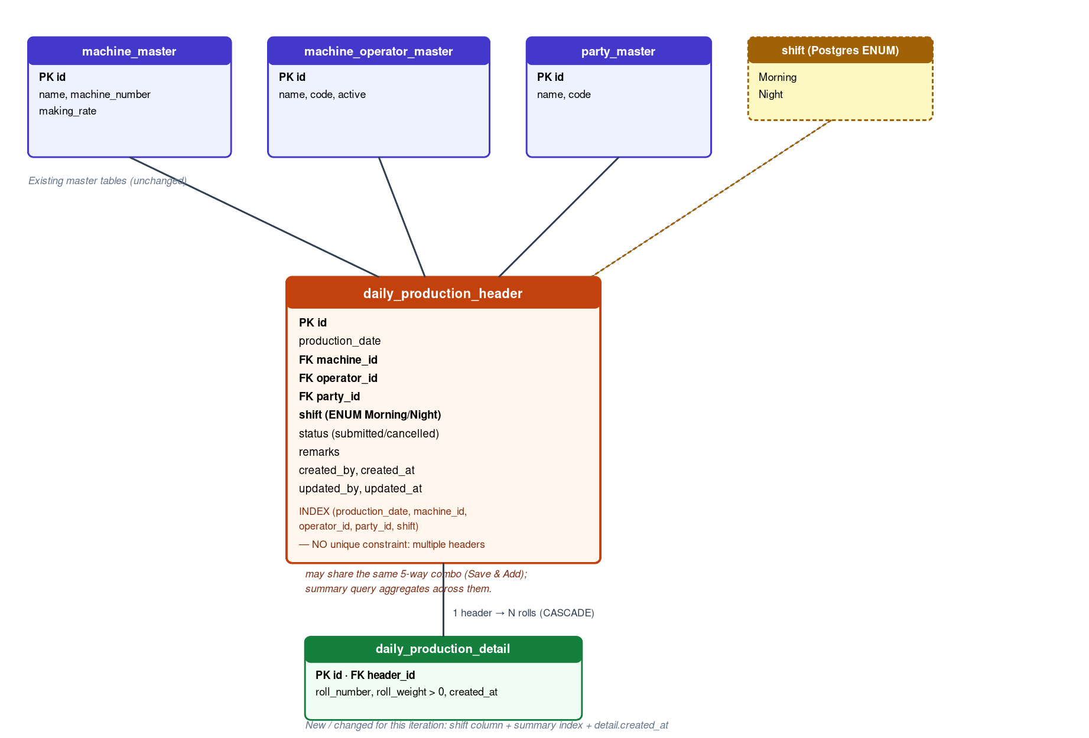

3.2 daily_production_header — changes in this revision
Column | Type | Constraints | Notes
shift | shift (Postgres ENUM) | NOT NULL | New. CREATE TYPE shift AS ENUM ('Morning', 'Night')
(new index) | — | INDEX (production_date, machine_id, operator_id, party_id, shift) | Serves the summary query's WHERE + GROUP BY directly

All other header columns (id, production_date, machine_id, operator_id, party_id, status, remarks, created_by, created_at, updated_by, updated_at) are unchanged from v1.0.

3.3 daily_production_detail — changes in this revision
Column | Type | Constraints | Notes
created_at | timestamp | NOT NULL, DEFAULT now() | New — matches the requirement's explicit “CreatedDate” column on the detail table

id, header_id, roll_number, roll_weight (with its > 0 CHECK constraint), and remarks are unchanged.

3.4 Why no uniqueness constraint on (date, machine, operator, party, shift)
This is the key structural decision in this revision. The requirements settle an open question from v1.0: multiple production entries for the same machine/operator/party/shift on the same day are not duplicates to reject, they're the normal outcome of the “Save & Add” workflow (Section 6.4). The summary grid's job is precisely to reconcile N header rows sharing that combination back into one total. Enforcing uniqueness at the database level would make the requested workflow impossible; leaving it open and aggregating in the summary query is the correct normalization choice given what the UI is asked to do.

3.5 Full Migration SQL (0003_tearful_klaw.sql, generated via drizzle-kit)
CREATE TYPE "public"."shift" AS ENUM('Morning', 'Night');--> statement-breakpoint
ALTER TABLE "daily_production_detail" ADD COLUMN "created_at" timestamp DEFAULT now() NOT NULL;--> statement-breakpoint
ALTER TABLE "daily_production_header" ADD COLUMN "shift" "shift" NOT NULL;--> statement-breakpoint
CREATE INDEX "daily_production_header_summary_idx" ON "daily_production_header" USING btree ("production_date","machine_id","operator_id","party_id","shift");

Migration caveat for a live database
ALTER TABLE daily_production_header ADD COLUMN shift NOT NULL has no DEFAULT. If this migration is ever run against a database that already has daily_production_header rows (e.g., a staging environment where v1.0 was deployed and used), the ALTER will fail until either a DEFAULT is supplied or existing rows are backfilled first. Not a concern for a fresh environment; worth a one-line follow-up migration if v1.0 was ever actually deployed.

4. API Endpoints
Method | Path | Purpose
GET | /api/daily-production?date=YYYY-MM-DD | Production summary for the selected date — grouped by Machine + Operator + Party + Shift, SUM(rollWeight) + roll count. Defaults to today if date is omitted. Requirement #8, item 1.
GET | /api/daily-production/:id | Single header + its roll list. Not called by the current UI; reserved for the future drill-down/edit screen (Section 8).
POST | /api/daily-production | Create one header + its rolls in a single DB transaction. Backs both Save and Save & Add — each is one independent call. Requirement #8, item 2.
PUT | /api/daily-production/:id | Update header + replace rolls. Future support per requirement #8, item 3 — implemented, not yet wired to any UI.
POST | /api/daily-production/:id/cancel | Soft-delete (status → 'cancelled'). This is the “Delete production entry (future support)” from requirement #8, item 4 — see Section 4.4 for why it's soft, not hard, delete.
GET | /api/lookups/machine-master | Requirement #8, item 5 — pre-existing, reused as-is.
GET | /api/lookups/party-master | Requirement #8, item 6 — pre-existing, reused as-is.
GET | /api/lookups/machine-operator-master | Requirement #8, item 7 — pre-existing, reused as-is.

4.1 GET /api/daily-production — Response Shape
{
"productionDate": "2026-07-30",
"rows": [
{
"machineId": 4, "machineName": "Machine 4",
"operatorId": 12, "operatorName": "Karim Uddin",
"partyId": 3, "partyName": "ABC Textiles",
"shift": "Morning",
"rollCount": 18,
"totalProduction": "412.750"
},
{
"machineId": 4, "machineName": "Machine 4",
"operatorId": 9, "operatorName": "Rafiq Islam",
"partyId": 3, "partyName": "ABC Textiles",
"shift": "Night",
"rollCount": 15,
"totalProduction": "339.200"
}
]
}

4.2 POST /api/daily-production — Request Body
{
"productionDate": "2026-07-30",
"machineId": 4,
"operatorId": 12,
"partyId": 3,
"shift": "Morning",
"remarks": null,
"createdBy": "Tahir Hassan",
"rolls": [
{ "rollWeight": "23.50" },
{ "rollWeight": "24.10" },
{ "rollWeight": "22.80" }
]
}

4.3 Validation Rules
Field | Rule | Enforced at
productionDate | Required, YYYY-MM-DD | Client (Zod + DatePicker) + server (Zod regex)
machineId / operatorId / partyId | Required, positive integer, must exist | Client (required Select) + server (Zod + FK constraint)
shift | Required, must be 'Morning' or 'Night' | Client (required Select, only these two options rendered) + server (Zod z.enum) + database (Postgres ENUM type — an invalid value cannot be stored no matter what bypasses the API)
rolls | At least one entry | Client (Add-button-built array, Save blocked with an inline error if empty) + server (Zod min(1))
rolls[].rollWeight | Required, numeric, > 0 | Client (parsed before Add is allowed to push the row) + server (Zod coerce.number().positive()) + database CHECK (roll_weight > 0)
createdBy / updatedBy (“Entered By”) | Required, non-empty | Client (Zod min(1)) + server (Zod min(1))

4.4 Why the summary query uses INNER JOIN, not LEFT JOIN
The summary endpoint joins daily_production_header to daily_production_detail with an INNER JOIN. Because the business rule requires at least one roll per header, a header with zero detail rows should never exist — the inner join is a defensive expression of that invariant: if it were ever violated (e.g., by a direct DB edit bypassing the API), that header simply drops out of the summary silently rather than showing a misleading zero-total row.

5. Backend Logic — Summary Query Excerpt
Full source: backend/src/routes/daily-production.ts. This is the query that drives the entire landing screen — everything else in the module exists to populate or react to it.
router.get("/daily-production", async (req, res) => {
const date = typeof req.query.date === "string" && req.query.date
? req.query.date
: todayIso();

const rows = await db
.select({
machineId: header.machineId,
machineName: machine.name,
operatorId: header.operatorId,
operatorName: operator.name,
partyId: header.partyId,
partyName: party.name,
shift: header.shift,
rollCount: sql`count(${detail.id})::int`,
totalProduction: sql`coalesce(sum(${detail.rollWeight}), 0)`,
})
.from(header)
.innerJoin(detail, eq(detail.headerId, header.id))
.leftJoin(machine, eq(header.machineId, machine.id))
.leftJoin(operator, eq(header.operatorId, operator.id))
.leftJoin(party, eq(header.partyId, party.id))
.where(and(
eq(header.productionDate, date),
eq(header.status, "submitted"),
))
.groupBy(
header.machineId, machine.name,
header.operatorId, operator.name,
header.partyId, party.name,
header.shift,
)
.orderBy(machine.name, header.shift);

res.json({ productionDate: date, rows });
});

6. Frontend Component Structure

6.1 Files
File | Role
frontend/src/pages/daily-production/index.tsx | Landing screen — Production Date filter (defaults today, refetches on change via query key), summary Table, grand-total footer row, “Add New” button that opens the dialog.
frontend/src/pages/daily-production/add-production-dialog.tsx | The Add Production modal — header fields + roll-weight capture grid + Save / Save & Add. Self-contained: owns its own form state and resets fully on every open.
frontend/src/hooks/use-daily-production.ts | Hand-written query/mutation hooks (interim, pending codegen — Section 8) — summary query, create/update/cancel mutations, all typed with the shift field.

6.2 Landing Screen Behavior
- The date filter is a plain <input type="date"> bound to component state; changing it changes the query key passed to useGetDailyProductionSummary(date), which is what triggers TanStack Query to refetch — no manual “reload” button or effect needed.
- The grid has no per-row action column in this revision (unlike v1.0's list, which had Edit/Cancel per row) — a summary row is an aggregate across potentially several header entries, so there's no single header to edit from it. See Open Question 2.4 on drill-down.

6.3 Add Production Dialog — State Machine
The dialog manages two independent pieces of state: a react-hook-form instance for the five header fields (Production Date, Machine, Operator, Party, Shift, Entered By), and a plain React array (rolls: {key, weight}[]) for the roll-weight list — deliberately not a react-hook-form field array this time, because the requirement's interaction model (type → Enter/Add → row appears above → input clears and refocuses) is a queue-like append/remove pattern, not a form of N simultaneously-editable rows. A plain array with a single controlled input is a closer match and noticeably simpler.
Step | What happens
Dialog opens | useEffect keyed on the open prop resets both the header form (to today + empty selects + remembered “Entered By”) and the rolls array to empty — regardless of how the previous session ended.
User types a weight, presses Enter or clicks Add | Value is parsed and validated (> 0); on success it's appended to rolls with a fresh key, the input is cleared, and focus returns to it via requestAnimationFrame.
User clicks the trash icon on a row | That row is filtered out of rolls by key. No confirmation needed — nothing has been persisted yet.
User clicks Save | form.trigger() validates the five header fields; if rolls.length === 0 an inline error is shown and nothing is submitted. Otherwise the create mutation fires; on success the dialog closes and the summary query is invalidated.
User clicks Save & Add | Identical validation and mutation call as Save. On success: the summary query is invalidated (background refresh — the landing screen updates without the modal closing), only the rolls array and the roll-weight input are cleared, the header form (date/machine/operator/party/shift/enteredBy) is left untouched, and focus returns to the roll-weight input so the next batch can start immediately.

6.4 Duplicate-Submission Guard
Both Save and Save & Add are disabled whenever the create mutation is isPending, and doSave() itself early-returns if a save is already in flight. A local pendingAction state ("save" | "saveAndAdd" | null) tracks which button triggered the in-flight request purely so the correct button shows its own spinner — the disable logic applies to both regardless of which one is spinning.

7. UI/UX Requirement Checklist
Suggestion | Status | Notes
Keyboard-first entry (Enter adds a roll weight) | Implemented | onKeyDown handler on the roll-weight input calls the same handler as the Add button
Auto-focus back to the Roll Weight textbox after adding | Implemented | requestAnimationFrame(() => rollInputRef.current?.focus()) after both Add and Save & Add
Running total of all roll weights before saving | Implemented | Displayed above the roll grid, recalculated on every add/remove
Show total number of rolls entered | Implemented | "N roll(s) entered" label next to the running total
Prevent accidental duplicate submissions | Implemented | Save/Save & Add disabled while the mutation is pending (Section 6.4)
Confirmation messages after Save and Save & Add | Implemented | Distinct toast copy for each — Save closes the modal, Save & Add's toast reflects that the modal stays open for the next entry
Loading indicators during save | Implemented | Spinner rendered inside whichever button triggered the in-flight request
Ability to delete or edit a roll weight before saving | Partially implemented | Delete: yes, per-row trash icon. Edit-in-place: no — a roll must be deleted and re-added rather than edited inline. Flagged as a fast-follow in Section 8.
Responsive design for tablet and desktop | Partially implemented | Built with the same Tailwind grid utilities as the rest of the app, which already targets tablet+desktop breakpoints; not separately tested on an actual tablet viewport in this pass.

8. Level of Effort (this revision) & Follow-Ups
Task | Estimate | Notes
Shift enum + schema changes + migration | 0.25 day | Small, additive migration
Rewrite summary endpoint (grouped query) + validation updates | 0.5 day | Replaces the v1.0 flat list endpoint
Rewrite landing screen (date filter + summary grid) | 0.5 day
Build Add Production modal (Save / Save & Add, roll queue UX) | 1.5 days | The bulk of this revision's effort — new interaction model, not a reskin of the v1.0 form
Remove superseded full-page form + routes | 0.25 day
QA: manual pass on Save vs Save & Add, duplicate-submit guard, shift enum rejection of invalid values | 0.5 day | Not yet performed against a live database — see Section 9
Total | 3.0 days

Suggested Follow-Ups (not built in this pass)
- Drill-down from a summary row to its contributing header entries, with per-entry edit (wires up the already-implemented PUT and cancel endpoints to a UI).
- Inline edit of a roll weight already added to the modal's queue, instead of delete-and-re-add.
- Shift-wise subtotals (Morning vs Night) alongside the grand total, pending the product answer to Open Question 2.4.
- Regenerate the @workspace/api-client-react client from an updated OpenAPI/zod spec and retire the hand-written hooks in use-daily-production.ts (same debt noted in the v1.0 document, still outstanding).

9. As-Built Summary — Files Changed This Revision

9.1 Backend
- backend/src/db/schema/daily-production.ts — added shiftEnum, header.shift, detail.createdAt, summary index
- database/migrations/0003_tearful_klaw.sql — generated via `npm run db:generate`
- backend/src/routes/daily-production.ts — GET /daily-production rewritten as grouped summary; shift added to create/update validation

9.2 Frontend
- frontend/src/hooks/use-daily-production.ts — rewritten: summary hook replaces flat-list hook; shift added throughout
- frontend/src/pages/daily-production/index.tsx — rewritten as the grouped summary landing screen
- frontend/src/pages/daily-production/add-production-dialog.tsx — new modal component
- frontend/src/pages/daily-production/form.tsx — removed (superseded by the modal; update/cancel endpoints remain available server-side for a future edit UI)
- frontend/src/App.tsx — /daily-production/new and /daily-production/:id/edit routes removed

9.3 Verification Performed
- `npx drizzle-kit generate` — clean additive migration, no manual SQL authored
- `npx tsc --noEmit` in backend — zero errors
- `npx tsc --noEmit` in frontend — zero errors attributable to this feature (pre-existing, unrelated errors in pages/reports/* remain and predate this work)
- Not yet performed: running the migration against a live database, end-to-end Save/Save & Add against a running backend, and the manual QA pass listed in Section 8.

