Run power shell as an administrator

Then issue command Set-ExecutionPolicy RemoteSigned

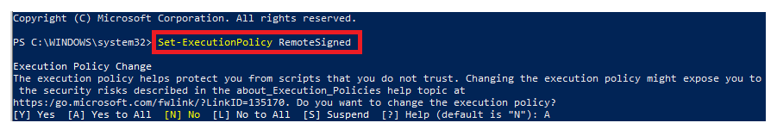

When running the shell script from **cmd prompt** then run it as

C:\WINDOWS\system32>powershell.exe -Command "& 'C:\Data\IIS-Tasks.ps1'" -ExecutionPolicy RemoteSigned

To run the file via power shell:

& 'C:\Data\2020 IIS Tasks App Pools Sites\IIS-Tasks.ps1'

At the top of the shell script there is an array hash table in which to create the app pools and the sites. This could very easily be moved out to an external file and then read from there.

Each hash table has two parts

* Top is the application pool
* And bottom is the application\virtual directory part. The application\virtual directory will be created under the default web site

$hashTableArray = @(

@{

#app pools

appPoolName = "AppPools.AppPools1AP"

appPoolDotNetVersion = "No Managed Code"

appPoolManagedPipelineMode = "Classic"

appPoolStartMode = "AlwaysRunning"

appPoolUserName = ""

appPoolPassword = ""

appPoolRecreateIfPresent = $true #$true and $false

#application / virtual directories

isApplication = $true

name = "Services.Service1"

physicalPath = "C:\inetpub\wwwroot\Services\Service1"

},

@{

#app pools

appPoolName = 'AppPools.AppPools2AP'

appPoolDotNetVersion = 'v4.0'

appPoolManagedPipelineMode = "Integrated"

appPoolStartMode = "AlwaysRunning"

appPoolUserName = ""

appPoolPassword = ""

appPoolRecreateIfPresent = $true #$true and $false

#application

isApplication = $true

name = "Services.Service2"

physicalPath = "C:\inetpub\wwwroot\Services\Service2"

}

)

Hash table properties

|  |  |  |
| --- | --- | --- |
| Property | Targets | Description |
| appPoolName | AppPool | The name of the app pool, cannot be empty |
| appPoolDotNetVersion | Possible values: v2.0 | v4.0 | No Managed Code |
| appPoolManagedPipelineMode | Possible values: Classic | Integrated |
| appPoolStartMode | Possible values: OnDemand | AlwaysRunning |
| appPoolUserName | User must be present on the server |
| appPoolPassword | User must be present on the server |
| appPoolRecreateIfPresent | $true: if present then it will be deleted  $false: if present then no action taken |
| isApplication | Application  Or Virtual directory | $true: will be treated as application  $false: will be treated as virtual directory |
| isRecreateIfPresent | $true: if present then it will be deleted  $false: if present then no action taken |
| name | The application/virtual dir name |
| physicalPath | The application physical path |

Running the file from Power Shell

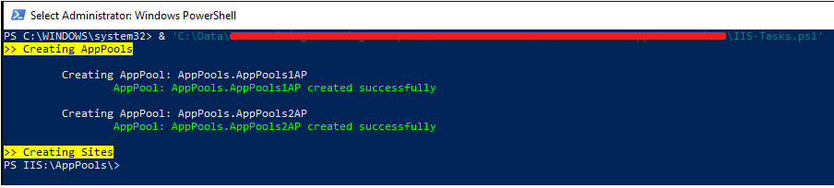

And the app pools got added.

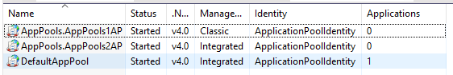

When recreating the app pool with recreate flag false then the output will be following

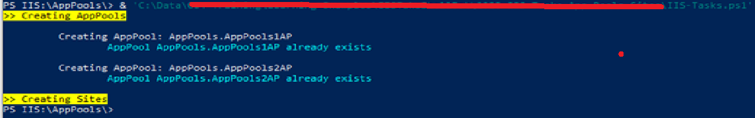

When passing recreateIfPresent = true flag

