002_ReactEsseantials_Components_JSX_Props_State_etc

# Branch

<https://github.com/tahirjadoon/2025-React-NextJs-Redux/tree/feature/002_ReactEsseantials_Components_JSX_Props_State_etc>

# Basic project

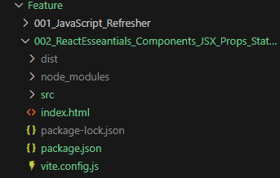

## Commit

Commit has been added as “02 Project basic setup”

You can follow above commit or a separate folder called “basic project” has been added as well.

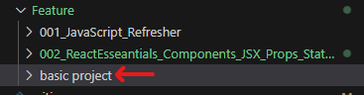

## Running basic project

folder feature/002_ReactEsseantials_Components_JSX_Props_State_etc

>npm install

>nom run dev

