CallMindVoice: an AI Voice Agent and its Financial Management
Full explanation of the project: what it is, how it works, what is connected to what, and how its money is planned and controlled
Student | Muhammadjon Tahirjanov
Program | ITPU Master's Degree [specialization, years]
Internship | EPAM Systems, Inc., 7 September – 23 October 2026
Project | CallMindVoice (working name "Ovoz"), a team project of 7 people
My role | Project manager, focus on finance
Technical mentor | [name]
Scientific advisor | [name]
Thesis topic | Comparative Research on the Effectiveness of AI-Driven Intelligent Agent Systems and Traditional Approaches in Financial Management of IT Projects
Document date | 16 October 2026 (version 1)
How to read this document. It uses simple English. Hard words are explained in the glossary at the end (section 14). If you only have one minute, read section 1.
Contents
If the contents list is empty, right-click it in Word and choose Update field.

1. The project in one minute
- What: CallMindVoice, an AI voice agent that answers customer phone calls in Uzbek, Russian and English, using only the company's own documents.
- My role: project manager (PM), responsible for finance: how much the project costs, where the money goes, and whether the product pays back.
- The problem: in an AI product every call costs money (phone minutes, AI, speech). Without control, the costs grow with every call, the team spends more hours than planned, and the customer cannot see the value.
- The solution: finance is built into the system. Every call is measured in minutes, every minute has a known cost, cheap engines are used first, and the console shows cost, savings and invoices in UZS.
- Budget so far (estimate): planned about 74.1 million UZS, actual about 76.0 million UZS, so about 2.5% over budget. AI and telephony were about 1.9 million UZS below plan.
- Result so far: the MVP was ready on 16 October 2026. It works end to end: call, search, answer or hand-over, record and billing.

2. The internship and my role

2.1 The internship
The internship is part of my master's program. It lasts from 7 September to 23 October 2026. I work as the project manager of a real team project and study one area of project management: finance.
The internship is finished with three things:
- a progress video: project status and the plan for the remaining period;
- an internship report, submitted by 23 October 2026;
- a feedback form from the company supervisor (mentor).

2.2 The CallMindVoice project
CallMindVoice is a multi-tenant SaaS platform: one system serves many companies, and each company sees only its own data. The target customers are clinics, banks, insurance companies and state service operators in Uzbekistan.
- A company uploads its documents: price lists, FAQs, policies.
- The system answers incoming calls from these documents and names the source.
- When it is not sure, it hands the call to a human operator with a summary and the full transcript.
The team has seven people: two AI engineers (speech; search and AI), two backend engineers (platform; telephony), one frontend engineer, one QA/DevOps engineer, and me. All tasks are given and tracked in our own Jira-like task manager.

2.3 My role: project manager for finance
As a project manager, I did five things:
- I split the budget into four cost groups: team, servers, AI services and telephony.
- I estimated the cost of every sprint from the task estimates (story points → hours → money).
- I compared the planned and the actual cost at the end of every sprint.
- I made sure that the product itself measures and prices every call, so costs are visible in real time.
- I compared the traditional way (Excel, monthly reports) with the AI-driven way for my research.

3. The problem

3.1 What is financial management of an IT project?
Financial management means: planning how much the project will cost (the budget), checking what it really costs (cost control), and making sure the result is worth the money (ROI). When nobody controls the money, the project runs over budget, and the customer stops trusting it.

3.2 Three finance risks in an AI voice project
Risk | What it means | Example | Result
1. Running costs grow with every call | Phone minutes, speech and AI are paid per minute. More calls means more cost. | A busy clinic with thousands of call minutes a month. | The product can lose money on each call.
2. Team hours grow | Hard tasks take longer than planned. | The voice speed work in Sprint 3 took more hours. | The budget is overspent.
3. The value is not visible | The customer pays every month but cannot see what it saves. | "Why do we pay for this?" | The customer leaves.

3.3 Why a spreadsheet alone does not solve it
Many teams keep the budget in Excel. Excel is like a notebook: it stores the numbers, but it does not measure anything by itself.
Situation | What Excel does | What CallMindVoice adds
A call is made | Nothing. Someone must count the minutes later. | Measures the minutes and multiplies them by the cost per minute at once.
The AI service fails or is expensive | Nothing. | Uses the free local engine first; a paid AI is used only with a key, and on any error the system falls back to the free engine.
The customer asks "what do we save?" | A person must build a report. | The analytics page shows cost, operator hours saved and money saved.
The end of the month | A person prepares the invoice. | Usage is collected every day (usage_daily) and invoices are made from it (invoices).

3.4 Honest note
The project budget numbers in this document (section 7) are estimates at market rates, not an accounting report: about 20 hours per person per week, 90,000 UZS/hour for a developer, 100,000 UZS/hour for the PM, 1 USD ≈ 12,700 UZS. The unit costs (cost per minute, prices, operator cost) are taken from the project code (src/lib/engine/calls.ts and src/lib/catalog.ts). They are the team's assumptions, not yet checked with a real customer.

4. The solution: how CallMindVoice works and controls cost

4.1 The idea in one sentence
Every call is measured and priced, cheap engines are used first, and a human operator takes over only when the AI is not sure.

4.2 How one call works: four steps
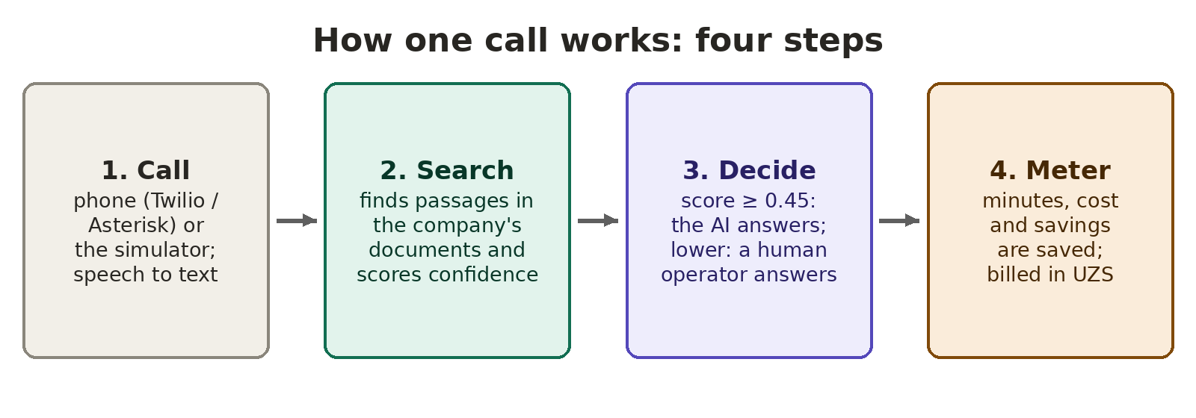
Figure 1. The four steps of one call
Step | Who does it | What happens
1. Call | Phone system or simulator | The call comes through Twilio or an Asterisk phone system. Without them, a built-in simulator makes test calls. Voice detection cuts the audio into phrases; two speech-to-text models (Kotib for Uzbek and Whisper) run in parallel.
2. Search | Program code | The question is matched with the company's documents by keyword search (BM25) and meaning search (vectors) together. The code gives a confidence score.
3. Decide | AI or a person | If the score is 0.45 or more, the language model writes the answer only from the found passages, and it is spoken in Uzbek. If it is lower, or the caller asks for a person, the call goes to an operator.
4. Meter | Program code | The transcript, sources, latency, minutes and cost are saved. Daily usage goes to usage_daily; invoices are made in UZS.

4.3 The finance features
Feature | What it does | Where in the code
Cost per minute | Knows what one minute costs us: telephony $0.018 + speech-to-text $0.004 + AI $0.002 + text-to-speech $0.003 + platform $0.005 = $0.032 (about 406 UZS). | src/lib/engine/calls.ts (RATE_CARD)
Operator cost model | Compares with a human: a full operator seat costs $650/month, 22 days × 8 hours × 65% busy time = 6,864 call minutes, so about $0.095 per minute (about 1,203 UZS). | src/lib/engine/calls.ts (OPERATOR_ASSUMPTIONS)
Saving per AI minute | Operator cost minus our extra cost (telephony is paid in both cases): about $0.081 per minute that the AI handles alone. | calls.ts (SAVING_PER_DEFLECTED_MINUTE)
Plans and prices | Prepaid balance: 1,000 UZS per AI talk minute. Plans: Trial (500 min free), Pay as you go, Start $199 (4,000 min), Pro $890 (25,000 min), Enterprise $2,490 (80,000 min). | src/lib/catalog.ts (UZS_RATES, PLANS)
Cheap engines first | A free local AI engine and local embeddings; Claude or Gemini only with a key; automatic fallback on errors. | src/lib/llm/, src/lib/rag/embed.ts
Cached audio | Greetings and holding phrases are stored as ready audio and not created again for every call. | src/lib/speech/tts.ts
Call simulator | The team tests calls without paying for phone minutes. | src/lib/engine/simulator.ts
Analytics | Shows minutes, cost, operator hours saved and money saved. | src/lib/analytics.ts

4.4 What stays with people
- The PM sets the budget, the plan and the priorities.
- The company sets its own confidence threshold and chooses its plan.
- A human operator takes every call that the AI is not sure about.
- Every change in the console is saved in the audit log (who, what, when).

5. What is connected to what
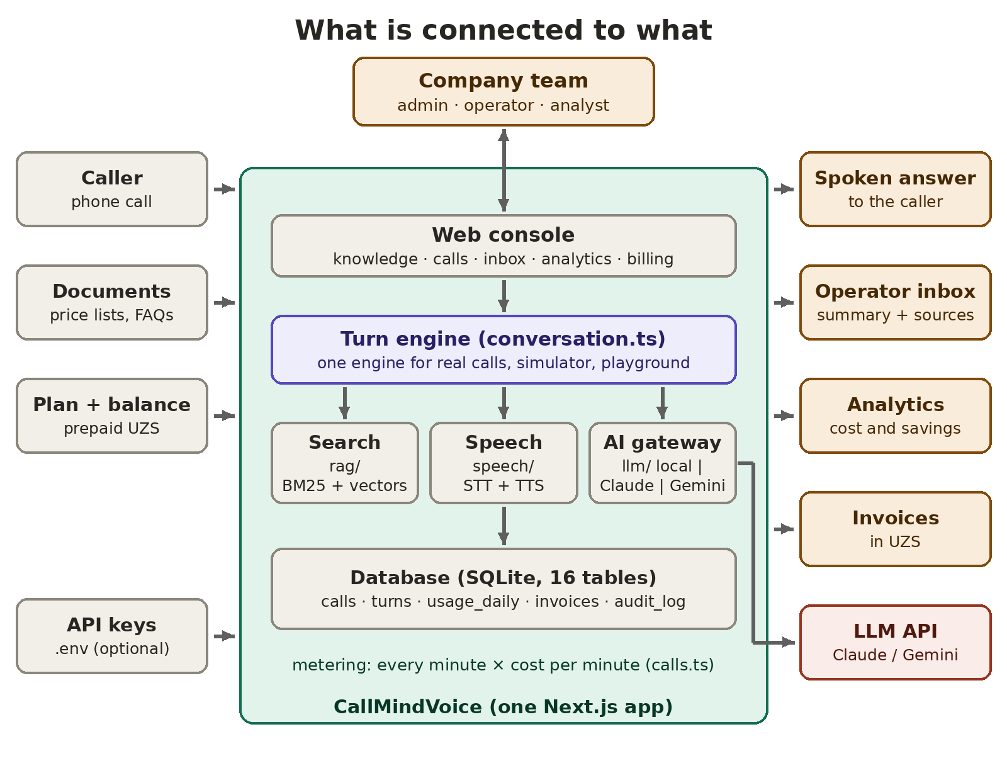
Figure 2. The parts of the system and how they are connected

5.1 The parts of the system
Part | What it does | Connected to | Where in the folder
Web console | The screens for the company team: knowledge, agent, playground, live calls, inbox, analytics, numbers, team, billing, developers, settings. | Company team; turn engine | src/app/app/
Turn engine | Runs one turn of a conversation. Real calls, the simulator and the playground all use it. | Search, speech, AI gateway, database | src/lib/engine/conversation.ts
Search (RAG) | Splits documents into passages, indexes them, finds the best ones and scores confidence. | Turn engine; documents | src/lib/rag/
Speech | Speech-to-text and text-to-speech, voice detection, cached phrases. | Turn engine; phone | src/lib/speech/, src/app/api/speech/
AI gateway | Chooses the answer engine: local, Claude or Gemini, with fallback. | Turn engine; LLM API; keys | src/lib/llm/
Telephony | Twilio webhook and the Asterisk bridge (a small separate service). | Phone network; turn engine | src/lib/telephony/, telephony-bridge/
Call accounting | Starts and ends calls, counts minutes and cost, writes daily usage. | Turn engine; database | src/lib/engine/calls.ts
Analytics | All the numbers for the dashboards, including cost and savings. | Database; console | src/lib/analytics.ts
Database | SQLite with 16 tables, e.g. calls, turns, usage_daily, invoices, audit_log. | All parts | src/lib/db.ts, data/
Developer API | REST API with API keys and signed webhooks for other systems. | Outside systems | src/app/api/v1/

5.2 Inputs (what goes in)
Input | What it is | Where it comes from
Phone call | The caller's voice. | Twilio, Asterisk, or the simulator.
Documents | PDF, DOCX, TXT, MD, CSV, JSON, HTML files, web pages, FAQs. | The company uploads them in the console.
Plan and balance | The chosen plan and the prepaid balance in UZS. | The billing page.
API keys | Optional keys for Claude, Gemini, OpenAI embeddings, Twilio. | The file .env on the server. Never share it.

5.3 Outputs (what comes out)
- A spoken answer to the caller, with the source passages saved.
- An operator inbox item when the call is handed over: summary, transcript and sources.
- Analytics: answered by AI vs operator, latency, cost, hours and money saved, unanswered questions.
- Usage and invoices in UZS, and the audit log.

5.4 The LLM
By default the system uses a local answer engine, which costs nothing per call. When a key is set, it uses Claude or Gemini through the internet (an API), with settings for a fast reply. On any error it falls back to the local engine. The answer is always limited to the passages found in the documents.

6. Example: one call from start to end, with its cost
This example uses the built-in clinic knowledge base. The confidence score is the one measured in the project README; the cost uses the numbers from section 4.3 and an average call of 3.3 minutes (the value used in the code).
- A caller asks in English: "How much is a consultation?"
- Search: the system finds the Uzbek passage "Qabul narxlari" (consultation prices) with a confidence of 0.51.
- Decide: 0.51 is above the threshold of 0.45, so the AI answers from the passage and names the source.
- Meter: the call lasts about 3.3 minutes. Our cost: 3.3 × $0.032 ≈ $0.11 (about 1,340 UZS). The company pays 3.3 × 1,000 = 3,300 UZS from its balance.
- The comparison: a human operator for the same call would cost 3.3 × about 1,203 ≈ 3,970 UZS. So the company saves money, and we still have a margin.
- If the question had been harder (for example a score of 0.40), the call would have gone to an operator with a summary, and no AI answer would be guessed.

7. The project budget (estimate)
The budget was split into four cost groups. At the end of every sprint the planned cost was compared with the actual cost. All numbers are estimates (see section 3.4).
Cost group | What it includes | Planned (UZS) | Actual (UZS) | Variance (UZS)
Team | PM 110→115 h; 6 developers 660→696 h | 70,400,000 | 74,140,000 | −3,740,000 (+5.3%)
Servers | VPS (~$60), nginx/Caddy, HTTPS, backups | 800,000 | 760,000 | +40,000
AI services | Claude/Gemini test use | 1,900,000 | 760,000 | +1,140,000
Telephony | Twilio test minutes | 1,016,000 | 320,000 | +696,000
Total |  | 74,116,000 | 75,980,000 | −1,864,000 (−2.5%)

Indicator | Value and meaning
Budget variance | −2.5%: a little over budget. The team needed more hours for the voice speed work in Sprint 3.
Savings | AI and telephony were about 1.9 million UZS below plan, thanks to the free local engine and the call simulator.
CPI (cost performance index) | About 0.93: about 95% of the planned scope was delivered (EV ≈ 70.4 million UZS, AC ≈ 76.0 million UZS).
Effect of AI coding assistants | Without them, developers would need about 20% more time (~139 hours), so about 12.5 million UZS was saved.
ROI for a customer (example) | A clinic pays 2.5 million UZS a month and saves one operator salary of 6 million UZS: ROI = (6 − 2.5) / 2.5 = 140% a month.

8. Safety and privacy
- Each company sees only its own data. Every company table has a tenant_id, and every query filters on it. Roles: owner, admin, operator, analyst.
- Passwords and sessions are protected: scrypt password hashing; signed httpOnly session cookies with 30-day expiry.
- Keys are secret. API keys are stored only as hashes and shown once; service keys live only in .env.
- Webhooks are signed: incoming Twilio webhooks are checked (HMAC-SHA1); outgoing webhooks are signed (HMAC-SHA256).
- Data stays local with the local engines: no document text leaves the server.
- Audit log: who changed what, and when.

9. How to run it
- Install Node.js 22.5 or newer.
- In the project folder, run: npm install
- Run: npm run dev, and open http://localhost:3000 in the browser.
- Click Start free, sign up, and follow the four-step setup. Click Load starter knowledge to get a sample clinic knowledge base.
- In the console, press Simulate a call, then Backfill 30 days to fill the analytics with demo data (it is labelled "demo").
- Open Analytics to see the minutes, cost and savings, and Billing to see the plan, balance and invoices.
For a server: npm run build and npm start, behind nginx or Caddy with HTTPS. No API keys are needed; every engine has a free local version.

10. Testing and results

10.1 What was checked
What was checked | Result
Type check of the whole code (npm run typecheck) | Used as the main automatic check
Search on the clinic knowledge base, 4 questions in 3 languages | All 4 found the right passage; confidence 0.47–0.84
Full call path with the simulator | Works: call → search → answer or hand-over → record → analytics
Voice reply speed target | Under about 800 ms to the first audio (the design target of Sprint 3)
MVP status | Ready on 16 October 2026
Honest note. The project has no automatic test suite yet; checks were the type check, the measured search examples and manual call scenarios with the simulator. The money numbers in section 7 are estimates. The next step is a pilot with a real clinic, to check the real cost per call and the real savings.

11. Traditional vs AI-driven financial management
This section connects the project with my research topic.
Stage | Traditional approach | AI-driven approach | Example in CallMindVoice
Cost estimation | Expert judgement; hours × rate in Excel | Cost is predicted from the data of past sprints | Story points were turned into hours and money; AI assistants sped up estimation
Budgeting | The budget is made once at the start | The budget is updated every sprint from real data | Planned and actual cost compared at the end of every sprint
Cost control | Monthly reports; problems are found late | Real-time tracking and early warnings | Every call is metered; usage is written every day
Cost optimisation | A person decides which service is cheaper | The system chooses the cheaper engine by itself | Local engine first, fallback, cached audio, simulator
Labour cost | Work is split by the PM's experience | AI assistants write routine code | About 12.5 million UZS of hours saved (estimate)
Value (ROI) | Measured at the end of the project | Cost and savings are calculated all the time | Analytics shows money saved per AI-handled minute
Main finding: AI-driven systems make financial management faster and more accurate, because the costs are measured all the time and cheaper options are chosen automatically. But the budget, the priorities and the final decisions still belong to people.

12. Limits and next steps
Limit today | Next step
The budget numbers are estimates. | Replace them with real hours and real bills.
Unit costs are the team's assumptions. | Check the real cost per call in a pilot with a clinic.
Plan changes are recorded but not charged. | Connect Payme, Click or Stripe.
Only 3 of 11 industry starter packs have real content. | Replace the sample content before pilots.
Scanned PDFs cannot be read (no OCR). | Add OCR.
One server only (SQLite, in-process events). | Move to Postgres + pgvector and Redis when needed.
No automatic test suite. | Add tests for search, billing and cost calculation.

13. Where to find everything
Folder / file | What is inside
github.com/Kaizen-is/CallMindVoice | The project repository.
README.md | What is built, how to run, engines, security.
PROJECT_BRIEF.md | Project brief for developers and AI assistants: what is real, what is simulated, known defects.
src/app/ | The website, the console and the APIs.
src/lib/engine/calls.ts | Call accounting: cost per minute, operator cost model, savings.
src/lib/catalog.ts | Plans, prices in USD and UZS.
src/lib/analytics.ts | All dashboard numbers, including cost and savings.
src/lib/rag/, src/lib/llm/, src/lib/speech/ | Search, AI answer engines, speech.
telephony-bridge/ | The separate Asterisk bridge service.
data/ | The database and uploads on the server (back it up).

14. Glossary (simple words)
Word | Meaning
Budget | The planned amount of money for the project.
Cost control | Checking the real costs against the budget.
Variance | The difference between the planned and the actual cost.
CPI | Cost performance index: the value of the work done divided by the real cost. Below 1 means over budget.
EV / AC | Earned value (value of the work done) / actual cost.
ROI | Return on investment: (money saved − money spent) / money spent.
Cost per minute | What one minute of a call costs us.
Deflection | A call that the AI handles alone, without an operator.
Multi-tenant | One system that serves many companies, each with its own data.
RAG | Retrieval-augmented generation: the AI answers only from found passages.
BM25 / vectors | Keyword search / meaning search.
Confidence score | A number that shows how sure the system is about the answer.
STT / TTS | Speech-to-text / text-to-speech.
LLM | Large language model: a program that understands and writes text.
API | A way for one program to talk to another over the internet.
Fallback | Using a backup option when the main one fails.
Story points | A number for the size of a task.
MVP | Minimum viable product: the first working version.
Audit log | A list that saves who changed what, with the time.

