
Learning Objectives:
-Network
-Protocols
-SMB Enumeration and some commands
-Reconnaissance
-Anonymous/Guest Access

- In this machine we will explore dancing room and smb protocol in generall.

-Let we start with default nmap port scan

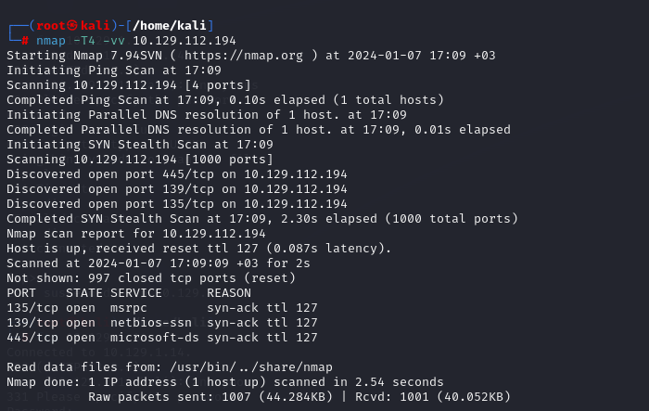

***Now we do version scan and learn version of smb :

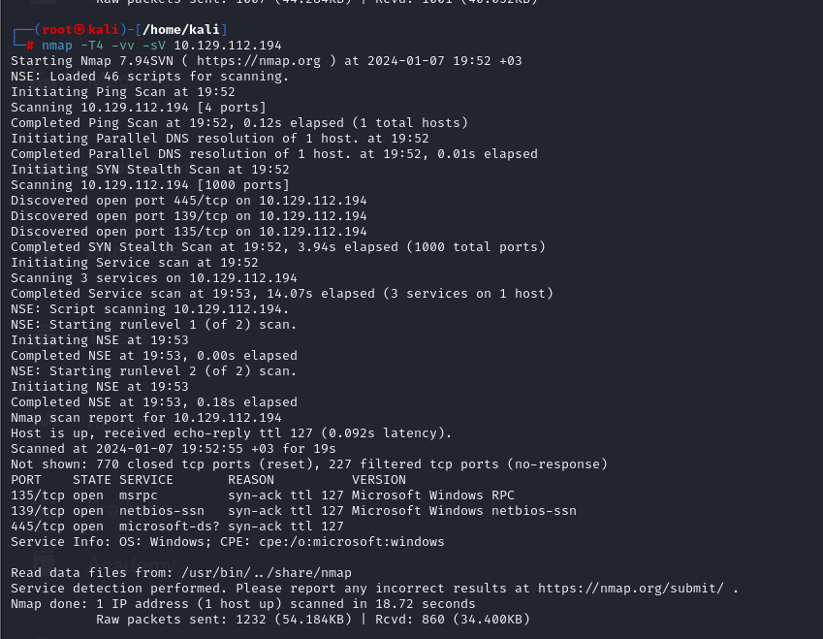

-What is the service name for port 445 that came up in our Nmap scan?
* microsoft-ds

-What is the 'flag' or 'switch' that we can use with the smbclient utility to 'list' the available shares on Dancing?
* We learn commands with smbclient --help -L

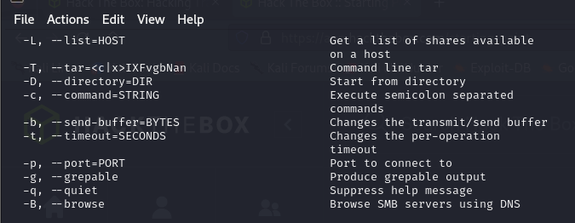

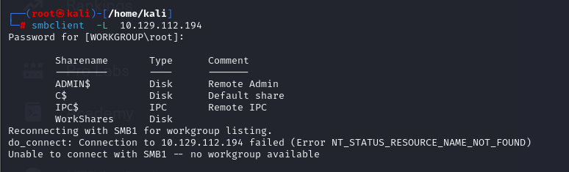

- Now we found a share without $ as WorkShares and try to connect it with blank password: -----
- smbclient \\\\10.129.85.10\\WorkShares

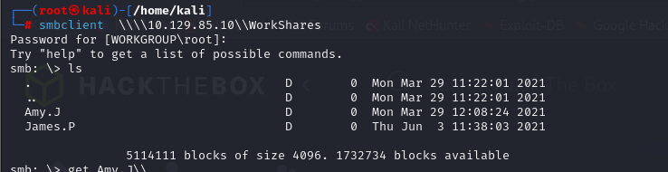
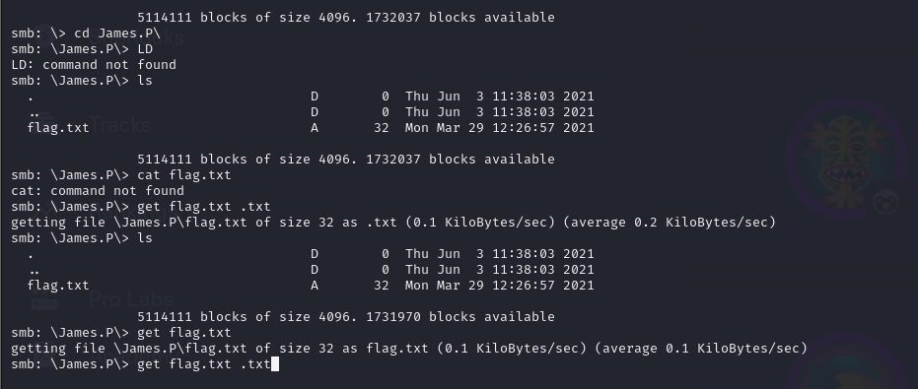

-We navigate through directories and found flag.txt and download it with get

-Yes, we learned flag

