**LAB ASSIGNMENT- 1**

TASK1:

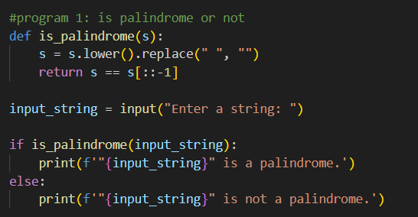

OUTPUT:



TASK2:

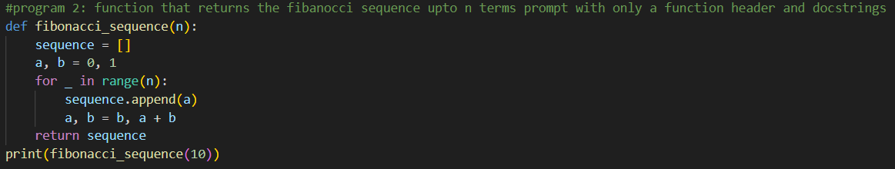

OUTPUT:



TASK3:

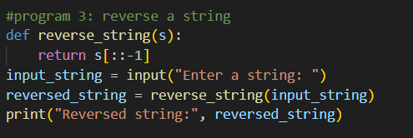

OUTPUT:



TASK4:

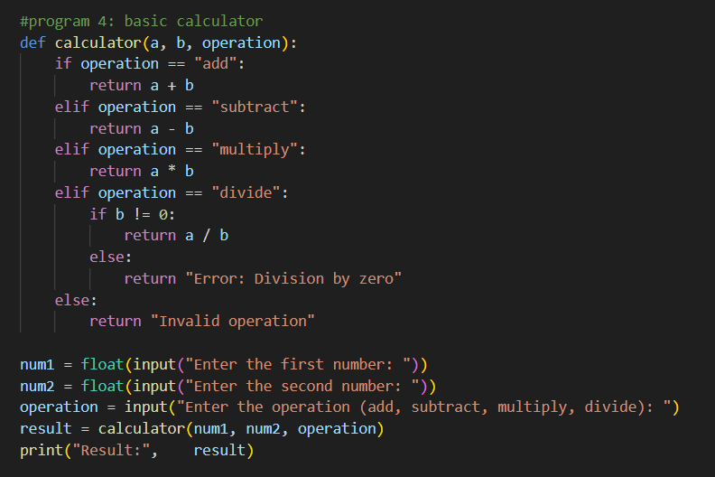

OUTPUT:

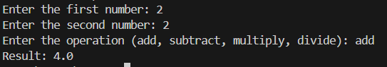

TASK5:

