**LAB ASSIGNMENT- 4.1**

TASK1: write a python program to gigve validation for an indian number or no by taking user input using functions

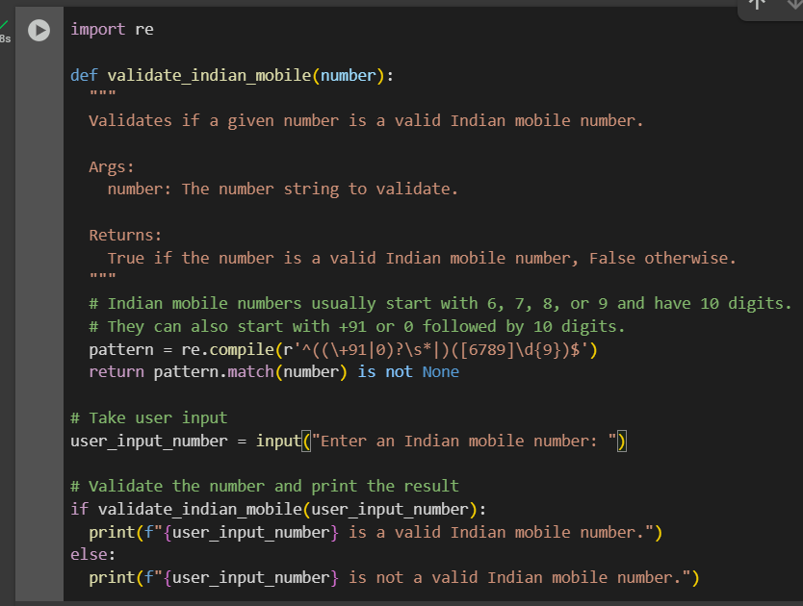

OUTPUT:



EXPLAINATION:

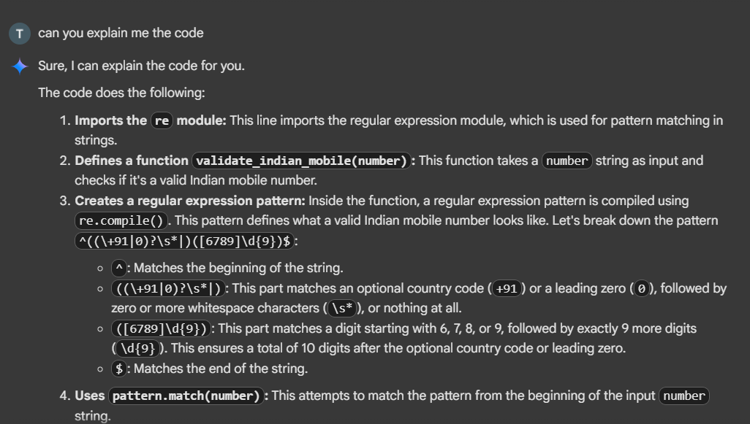

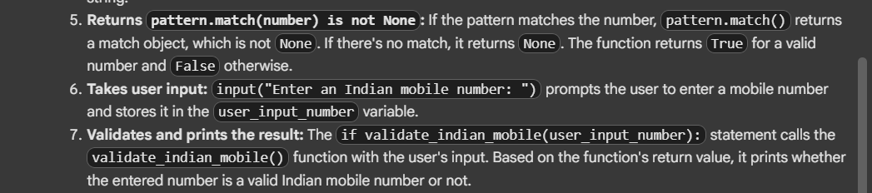

TASK2: write a python program that calculates factorial of a number using functions

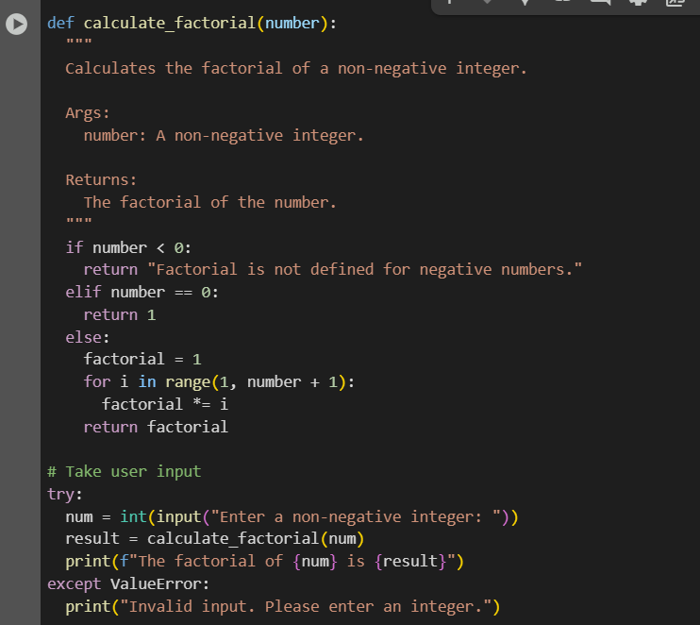

OUTPUT:



EXPLAINATION: 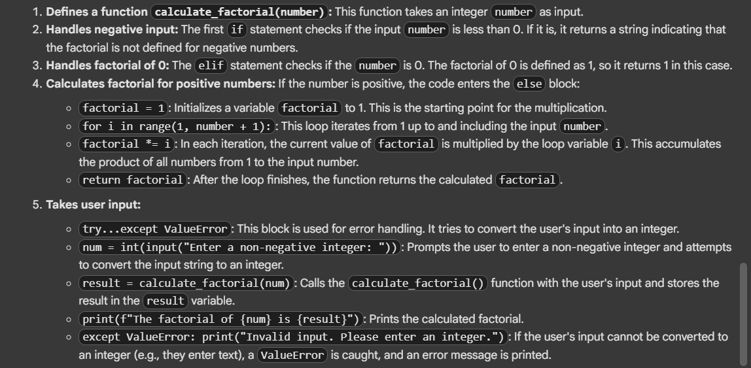

TASK3: write a python program that parses a nested dictionary representing student information like fullname beanch and sgpa of{(SANA KHAN, CSE, 9.4),(TAIF AHMED,CSE,10),(AMIRA,ECE,8.9)} using functions

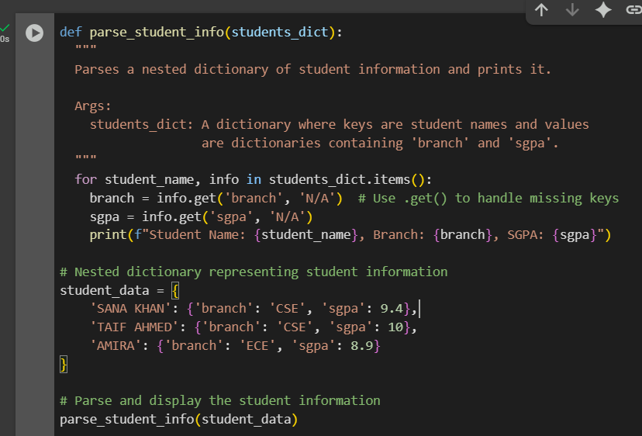

OUTPUT:

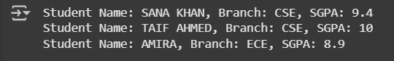

EXPLAINATION:

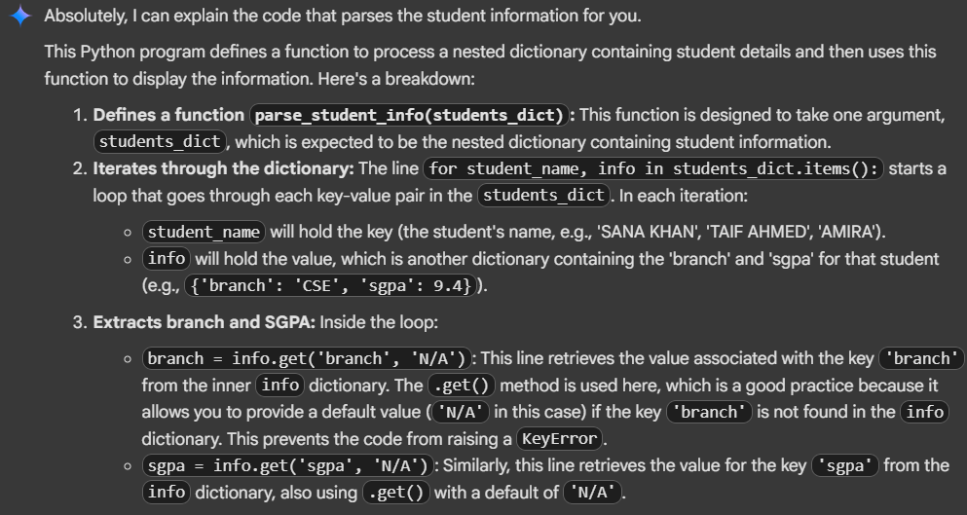

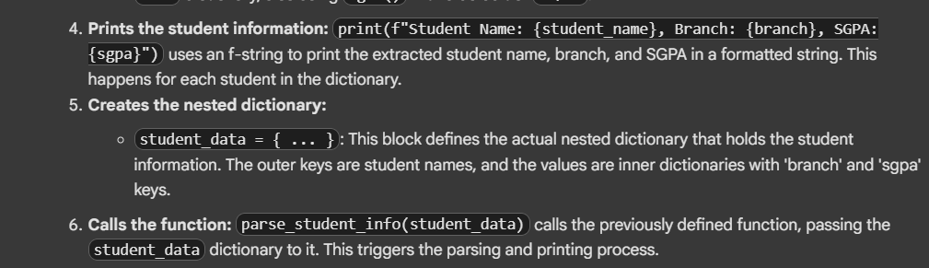

TASK4: write a python program that parses a nested dictionary representing student information like fullname beanch and sgpa of{(SANA KHAN, CSE, 9.4),(TAIF AHMED,CSE,10),(AMIRA,ECE,8.9)} using functions

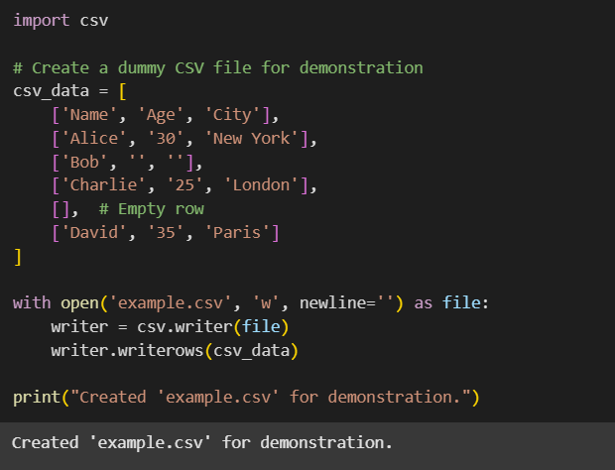

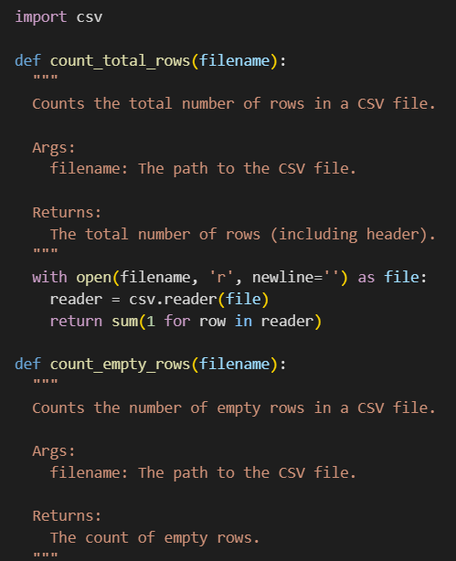

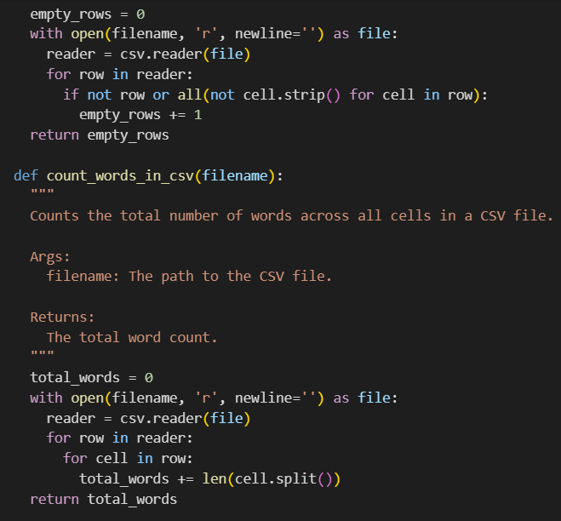

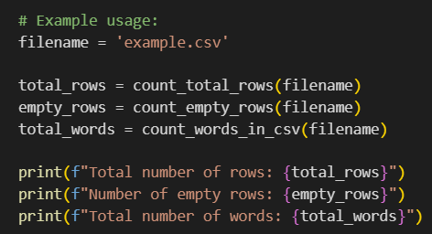

OUTPUT:

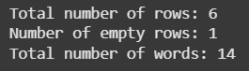

EXPLAINATION:

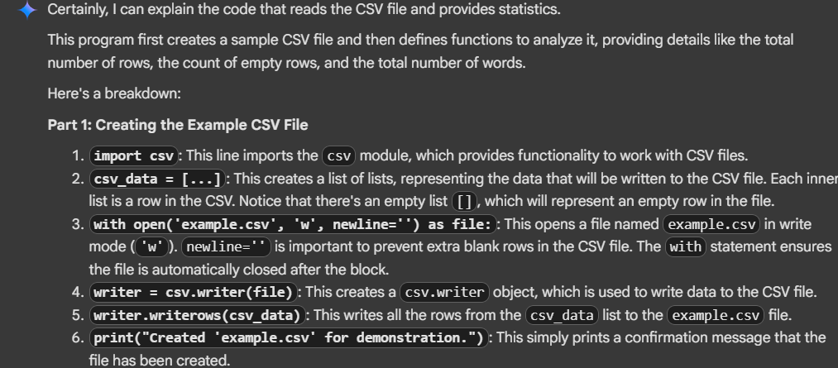

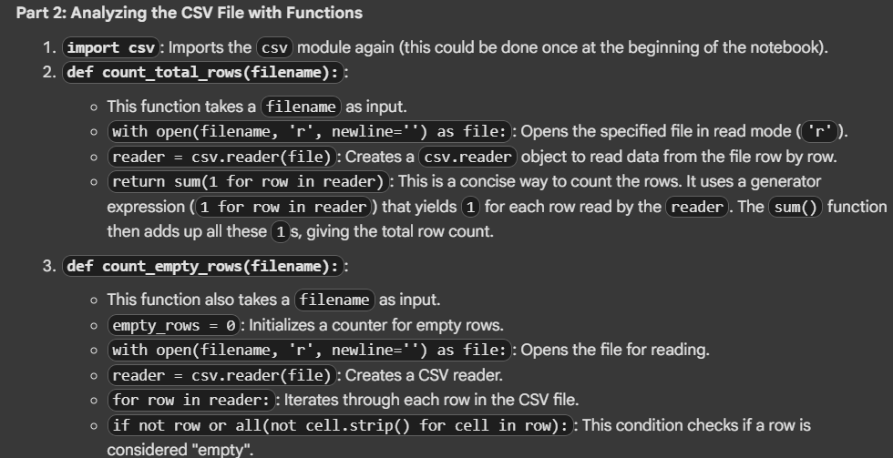

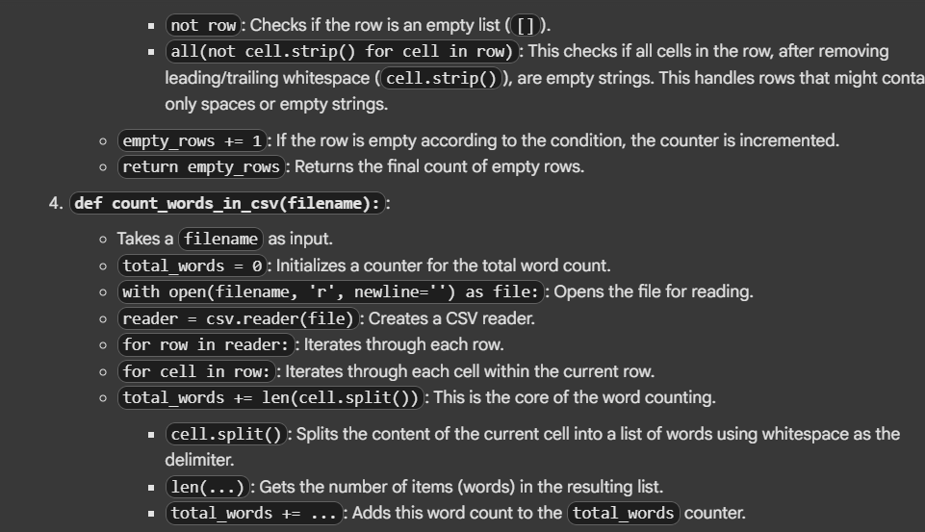

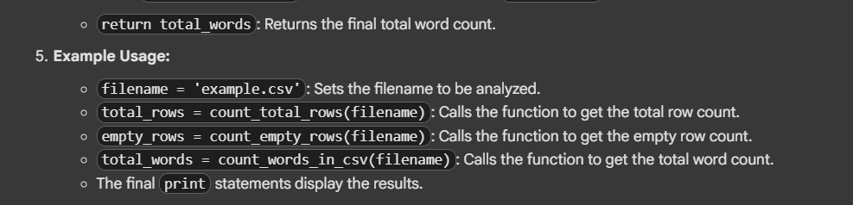

TASK5:

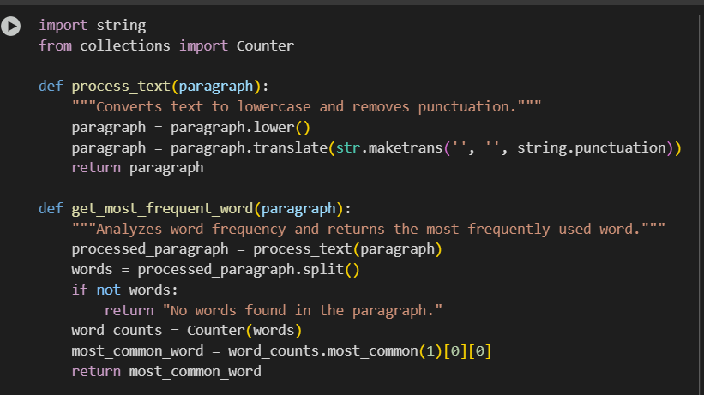

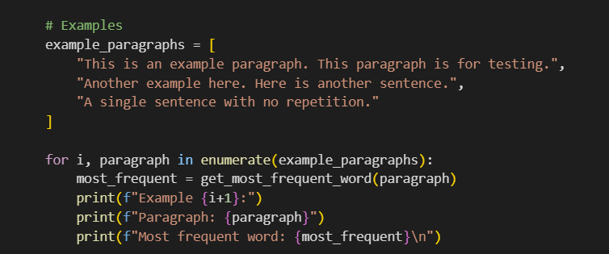

OUTPUT:

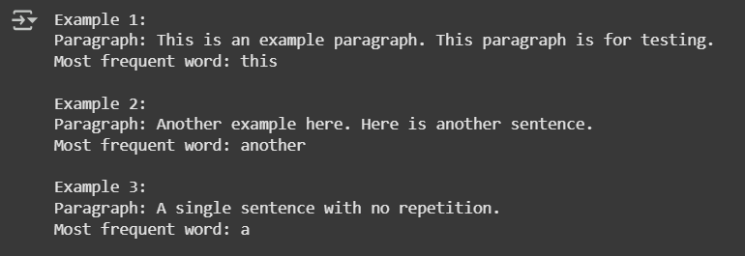

EXPLAINATION:

