Collecting Landing Pages by Source/Medium data

Website/SEO Assignments

NAME: Tahiya Rahman

# About the Data

The purpose of the paper is to find out the trends in User Acquisition, Behavior and Conversion through all the Sources/Mediums by Landing pages for the week of April 2nd to April 9th, 2023.

Data Changes with Time:

April 2nd, 2023 - April 9th, 2023 —-----------------------------------------------------------------------------------------------

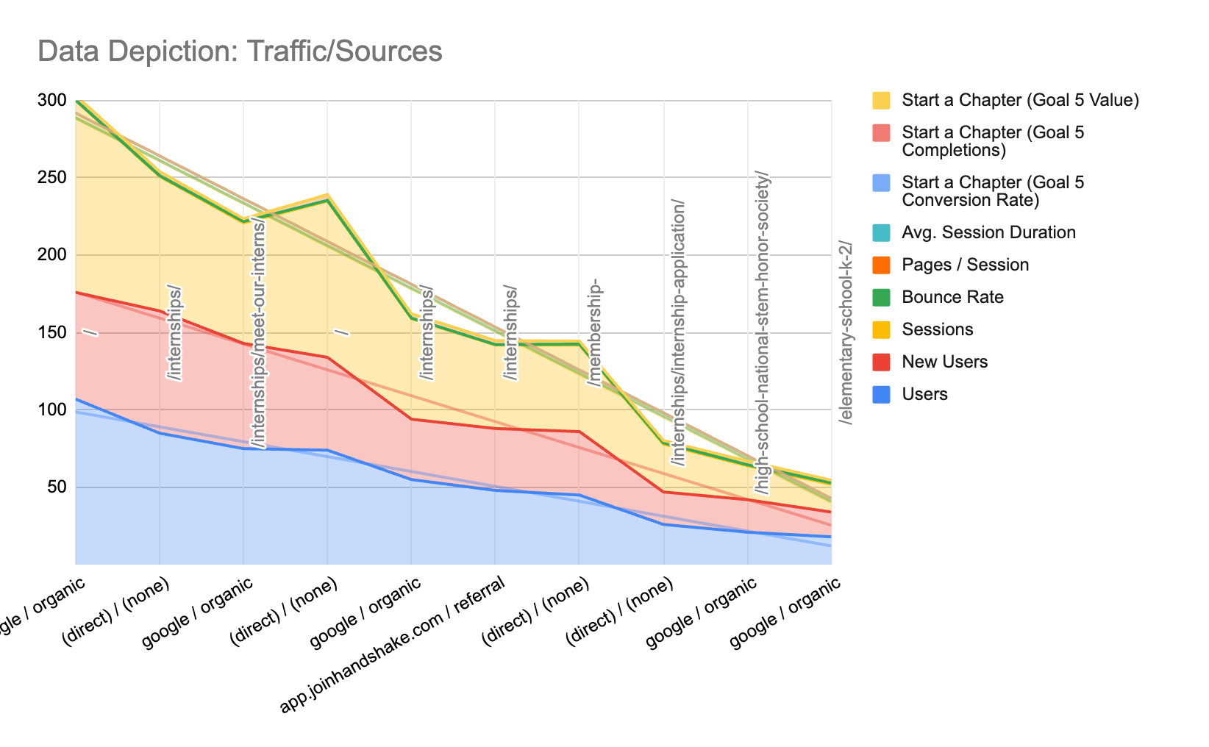

* Direct & Organic search with internships pages visually tells that the session has a higher rate from the users and the new users. As data shown, more users are creating from within the google organic searches and a shown a steph downward to other high school/elementary schools.

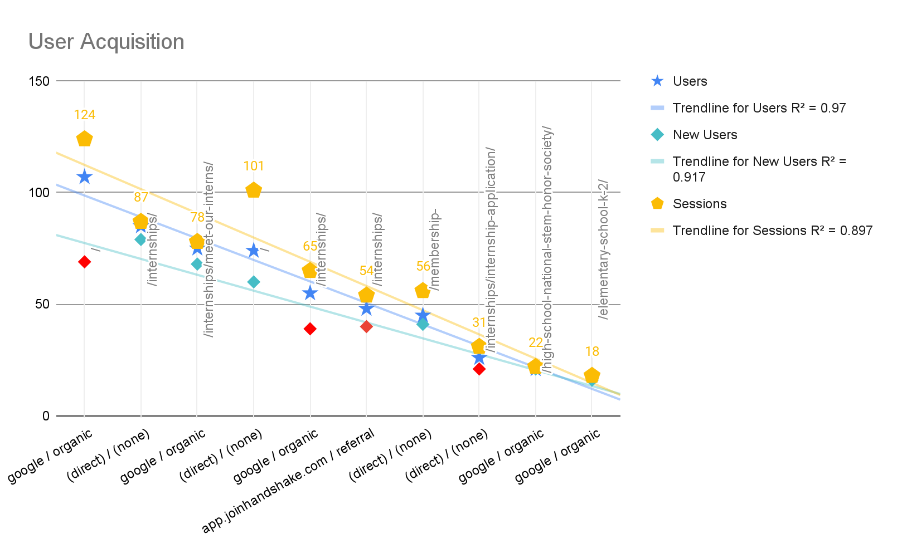

* From the user acquisition data which includes the concentrated data for users, new users and session. The data showed a similar trend like the first data visualization. The sessions tend to be much higher than other metrics.
* Data above the trendline is another factor to consider. The purpose of the trendline is to understand that there is data that can be considered in the business decisions. Here, for instance, the data above the landline is good for a count in business decisions.
* Google/Organic data has the most sessions from users and also generates new users. But if we observe the new users trend, there are some contradictory drops. The drops are shown with red diamond marks.

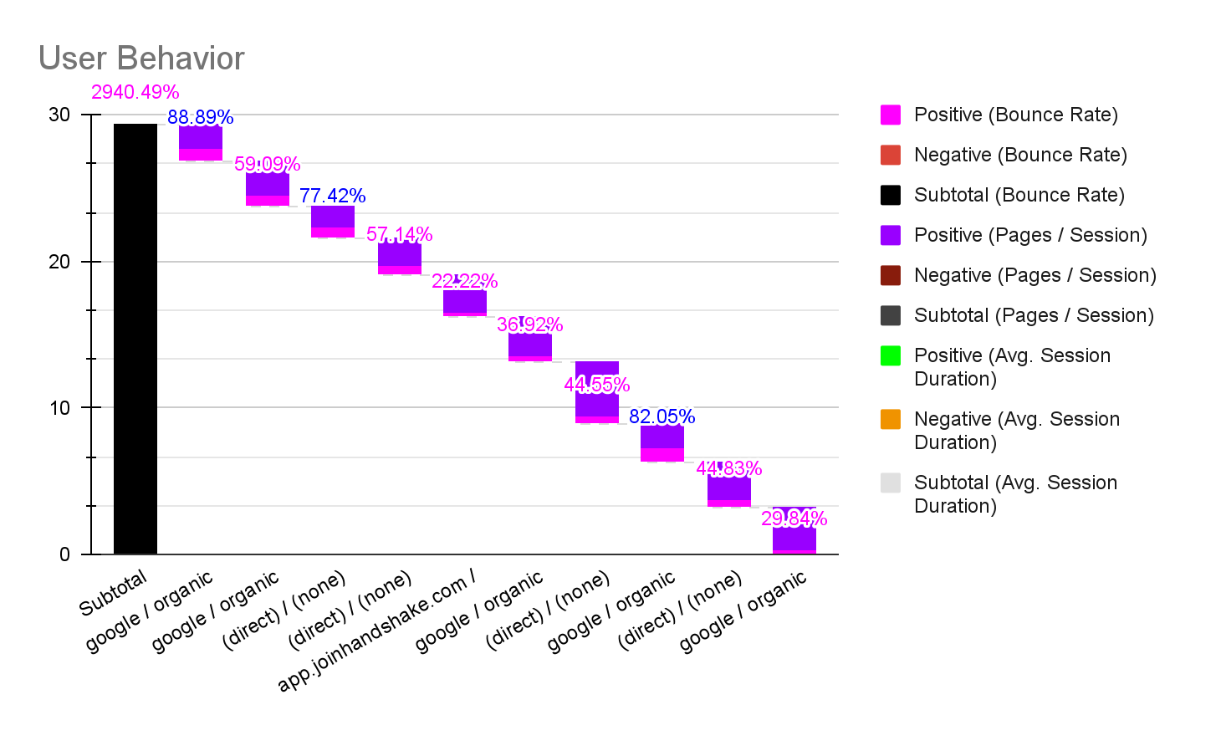

* The user behavior data also has a similar trend like the acquisition and conversion combinations, where google organic search has the highest rate.

# What NSTEM Should Continue Doing

* NSTEM Should introduce more subjects and create more referral links to increase the commonality between the channels. So, there will be more audience who can engage through different channels and thus NSTEM can increase its positive exposure and reliability.

# Ways to Improve the Website

* NSTEM can make improvements through Multi Channel Funnel Reporting (MCF).
* Create Custom Reporting about NSTEM audiences and sessions.
* Can create more segmentation for the audience base to get more insights.

# Data that Stands Out

From the analysis, the user acquisition is more Organic search and Direct search driven for NSTEM users. In general, the users are more protective towards finding the landing page for the NSTEM website and the internships pages.

**Conclusion**

In conclusion, by creating the correlation and commonalities between other landing pages or creating more ads of links the user can be more benefited to understand and purchase NSTEM chapter.

Google Sheets:

<https://docs.google.com/spreadsheets/d/1g5rRqyP9gX03e1-WsEI51R5W9Dd4vTzdrMmLSDjNlpc/edit?usp=sharing>