Tahjdriana Johnson
08/04/2026
CMST 386 6980
Principles of Web Design and Technology II
Professor Allen
Project 4 Reflection
Since my project was about movies, developing a relevant favicon was easy. I chose popcorn because everyone associates movies with popcorn. For my CSS3 transition, I chose to make the hover effect on the cat-boxes take 0.5 seconds to complete to give a fade in effect rather than the cat-boxes turning black immediately. I chose it because it was something simple and gave a subtle flair. I believe it attracts the user because it isn’t so distracting. When choosing a hero image for the background of my site, I struggled with finding the right image in the right size. I wanted to do Spider-Man: A Brand New Day but even with me re-sizing the image, the proportions still weren’t correct so I chose the Odyssey image instead. I faced several issues while completing this project, especially with the privacy policy. I used Termly and tried to copy the HTML that they generated into my privacy policy page but they had so many structural errors. I end up copying the privacy policy plain text into the word document and adding the html codes to that based on how it looked on the document. It went much faster when I did it that was. I also had issues with getting the search bar where I wanted it on the screen and getting it connected to duckduckgo. I also had trouble figuring out what images to hyperlink without having to create a whole new extra page. As a result, I linked the Alien picture in the Horror section to the Alien movie description page. Then, I added a creator’s fave category to the home page and linked that Alien photo to the Alien movie description page too. Alien is actually one of my favorite movies. This did take an incredibly long time. Every time I thought I was almost finished, another hour passed and I thought I was almost finished again. One thing that I did do that helped me from the start was I did a base page for the pages where I knew I was going to repeat the exact same layout multiple times. I made sure everything looked exactly how I wanted on the base page and the CSS for all the factors were done. Then, I copied and pasted that base layout and added the main content. I was also confused with the XML process. I hope what I included below was what was needed.

XML Site Map and URL
https://cmst386-umgc-tjohnson566.azurewebsites.net/project4/sitemap.xml
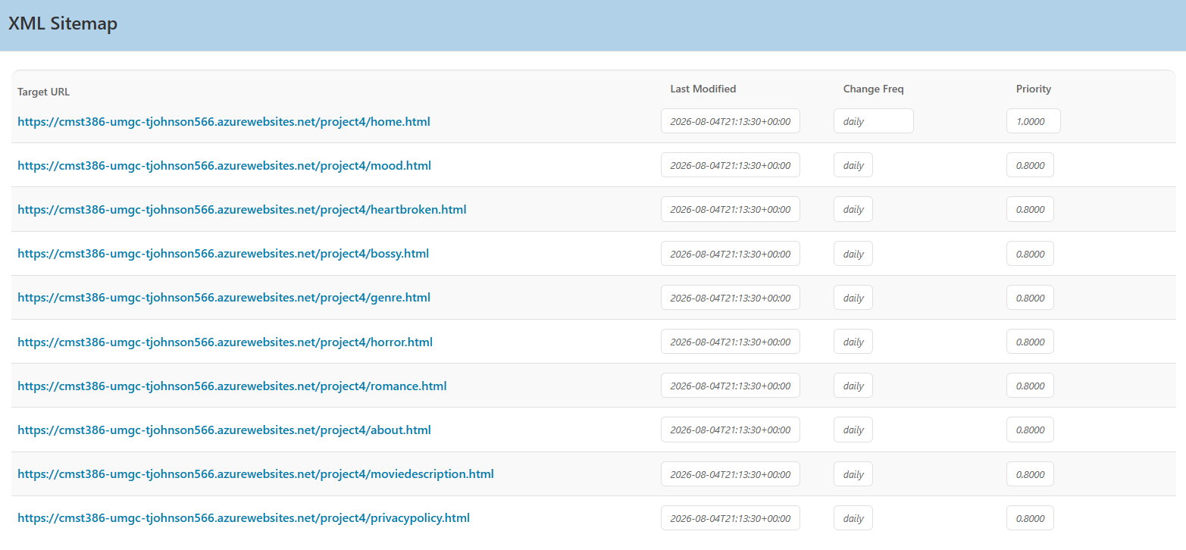
XML Copied from the generator output
<?xml version="1.0" encoding="UTF-8"?>
<?xml-stylesheet type="text/css" href="https://www.xml-sitemaps.com/css/sitemap.css"?>
<urlset xmlns="http://www.sitemaps.org/schemas/sitemap/0.9" xmlns:xhtml="http://www.w3.org/1999/xhtml">

<url>
<loc>https://cmst386-umgc-tjohnson566.azurewebsites.net/project4/home.html</loc>
<lastmod>2026-08-04T21:13:30+00:00</lastmod>
<changefreq>daily</changefreq>
<priority>1.0000</priority>
</url>
<url>
<loc>https://cmst386-umgc-tjohnson566.azurewebsites.net/project4/mood.html</loc>
<lastmod>2026-08-04T21:13:30+00:00</lastmod>
<changefreq>daily</changefreq>
<priority>0.8000</priority>
</url>
<url>
<loc>https://cmst386-umgc-tjohnson566.azurewebsites.net/project4/heartbroken.html</loc>
<lastmod>2026-08-04T21:13:30+00:00</lastmod>
<changefreq>daily</changefreq>
<priority>0.8000</priority>
</url>
<url>
<loc>https://cmst386-umgc-tjohnson566.azurewebsites.net/project4/bossy.html</loc>
<lastmod>2026-08-04T21:13:30+00:00</lastmod>
<changefreq>daily</changefreq>
<priority>0.8000</priority>
</url>
<url>
<loc>https://cmst386-umgc-tjohnson566.azurewebsites.net/project4/genre.html</loc>
<lastmod>2026-08-04T21:13:30+00:00</lastmod>
<changefreq>daily</changefreq>
<priority>0.8000</priority>
</url>
<url>
<loc>https://cmst386-umgc-tjohnson566.azurewebsites.net/project4/horror.html</loc>
<lastmod>2026-08-04T21:13:30+00:00</lastmod>
<changefreq>daily</changefreq>
<priority>0.8000</priority>
</url>
<url>
<loc>https://cmst386-umgc-tjohnson566.azurewebsites.net/project4/romance.html</loc>
<lastmod>2026-08-04T21:13:30+00:00</lastmod>
<changefreq>daily</changefreq>
<priority>0.8000</priority>
</url>
<url>
<loc>https://cmst386-umgc-tjohnson566.azurewebsites.net/project4/about.html</loc>
<lastmod>2026-08-04T21:13:30+00:00</lastmod>
<changefreq>daily</changefreq>
<priority>0.8000</priority>
</url>
<url>
<loc>https://cmst386-umgc-tjohnson566.azurewebsites.net/project4/moviedescription.html</loc>
<lastmod>2026-08-04T21:13:30+00:00</lastmod>
<changefreq>daily</changefreq>
<priority>0.8000</priority>
</url>
<url>
<loc>https://cmst386-umgc-tjohnson566.azurewebsites.net/project4/privacypolicy.html</loc>
<lastmod>2026-08-04T21:13:30+00:00</lastmod>
<changefreq>daily</changefreq>
<priority>0.8000</priority>
</url>
</urlset>

Project Validation Screenshots
https://cmst386-umgc-tjohnson566.azurewebsites.net/project4/home.html

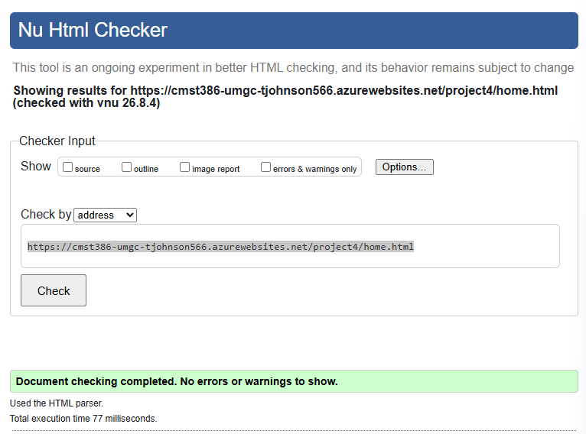
https://cmst386-umgc-tjohnson566.azurewebsites.net/project4/mood.html
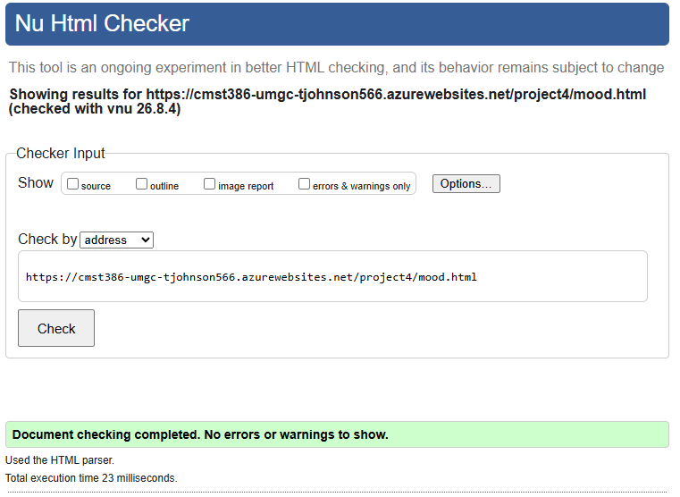
https://cmst386-umgc-tjohnson566.azurewebsites.net/project4/heartbroken.html
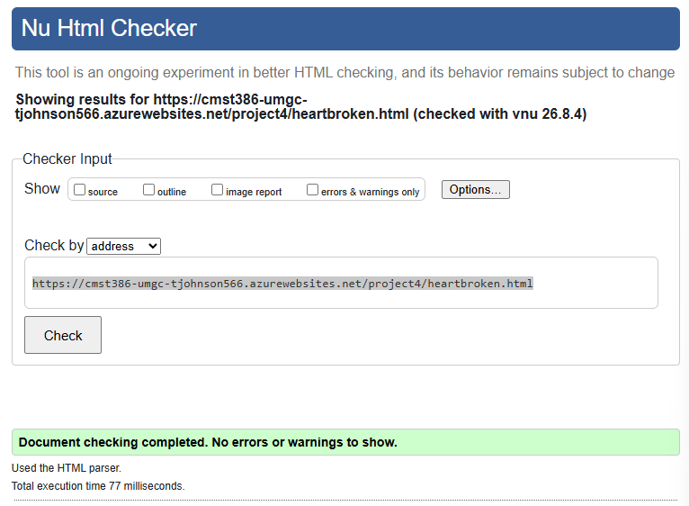
https://cmst386-umgc-tjohnson566.azurewebsites.net/project4/bossy.html
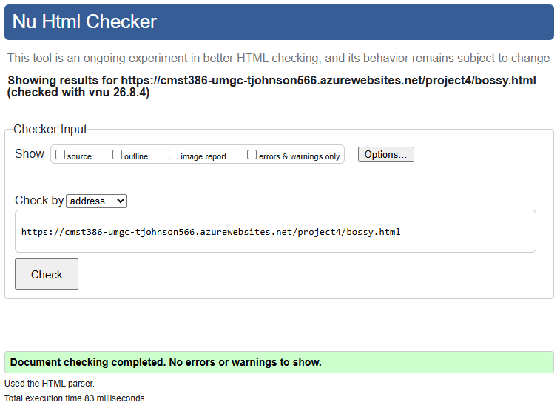
https://cmst386-umgc-tjohnson566.azurewebsites.net/project4/horror.html
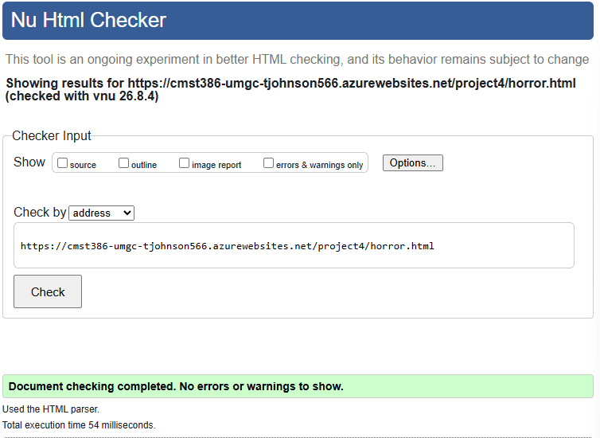
https://cmst386-umgc-tjohnson566.azurewebsites.net/project4/romance.html
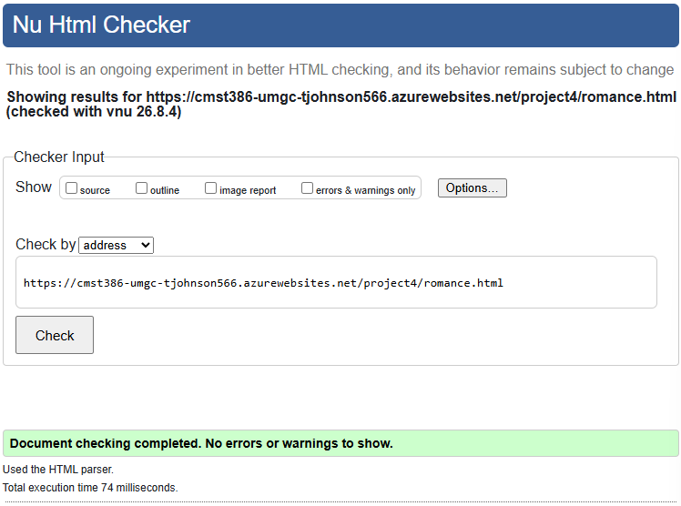
https://cmst386-umgc-tjohnson566.azurewebsites.net/project4/moviedescription.html
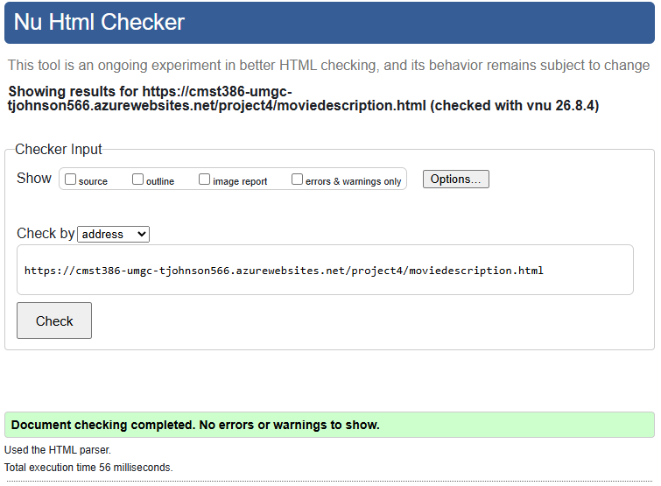
https://cmst386-umgc-tjohnson566.azurewebsites.net/project4/genre.html
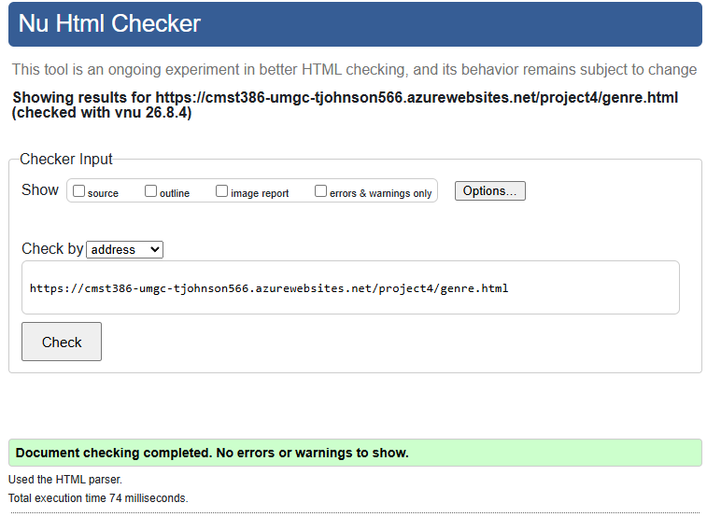
https://cmst386-umgc-tjohnson566.azurewebsites.net/project4/privacypolicy.html
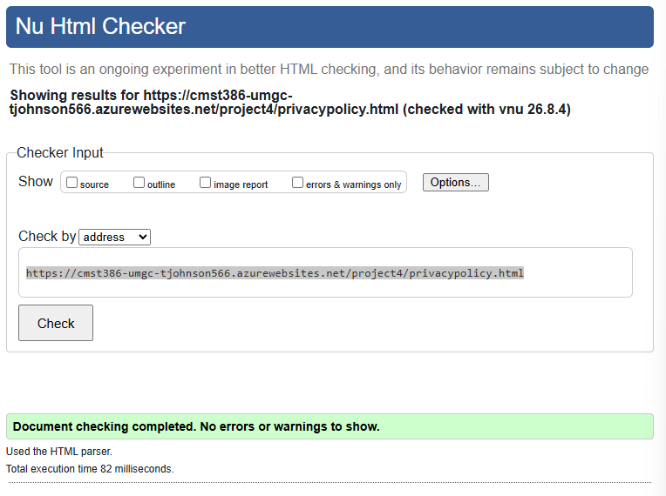
https://cmst386-umgc-tjohnson566.azurewebsites.net/project4/about.html
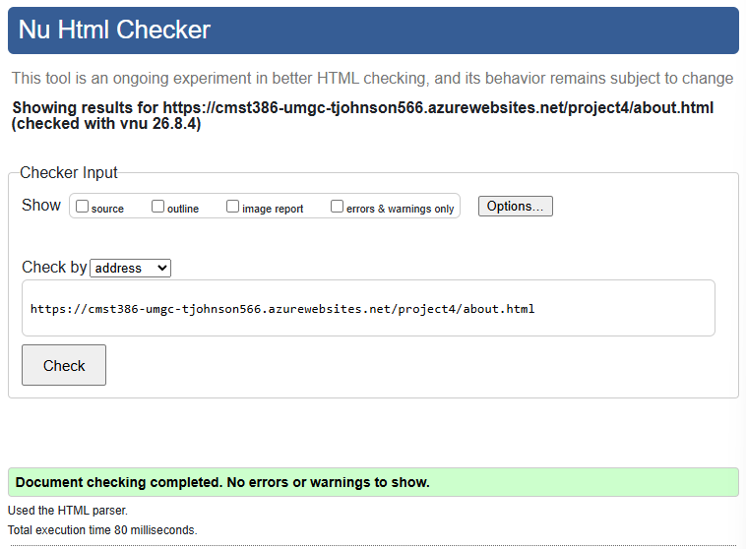
https://cmst386-umgc-tjohnson566.azurewebsites.net/project1/index.html
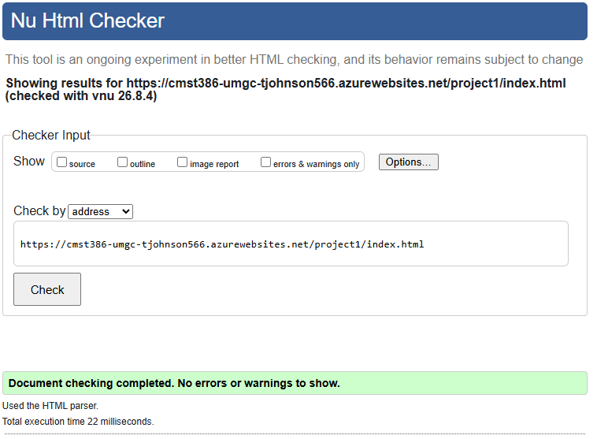
https://cmst386-umgc-tjohnson566.azurewebsites.net/project4/style.css
