PORTFOLIO

**COMPUTER SCIENCE AND ENGINEERING**

Submitted by:

Name: Tahkeem ul Haq

Registration number: 12406650

Roll No.: 46

Section: K24-CT



**LOVELY PROFESSIONAL UNIVERSITY**

**DECLARATION**

I, Tahkeem Ul Haq, a student of Bachelor of Technology under CSE discipline at Lovely Professional University, Punjab, hereby declare that all the information furnished in this project report is based on my own work and is genuine

TAHKEEM UL HAQ

12406650

| **Platforms**  **For profile**  **Creation** | **Link to student profile** |
| --- | --- |
| Quora | <https://www.quora.com/profile/Tahkeem-Zarga> |
| Figma | <https://www.figma.com/@tahkeemulhaq> |
| Stack  overflow | <https://stackoverflow.com/users/28012527/tahkeem-zargar?tab=profile> |
| Hacker  Rank | <https://www.hackerrank.com/profile/zargartahkeem> |
| Geeks  For geeks | <https://www.geeksforgeeks.org/user/zargartwgtp/> |
| Github | <https://github.com/tahkeemulhaq> |
| Linkedin | <https://www.linkedin.com/public-profile/settings?lipi=urn:li:page:d_flagship3_profile_self_edit_contact-info;h8ROhLDuSmepgdzpuhZi3w==> |

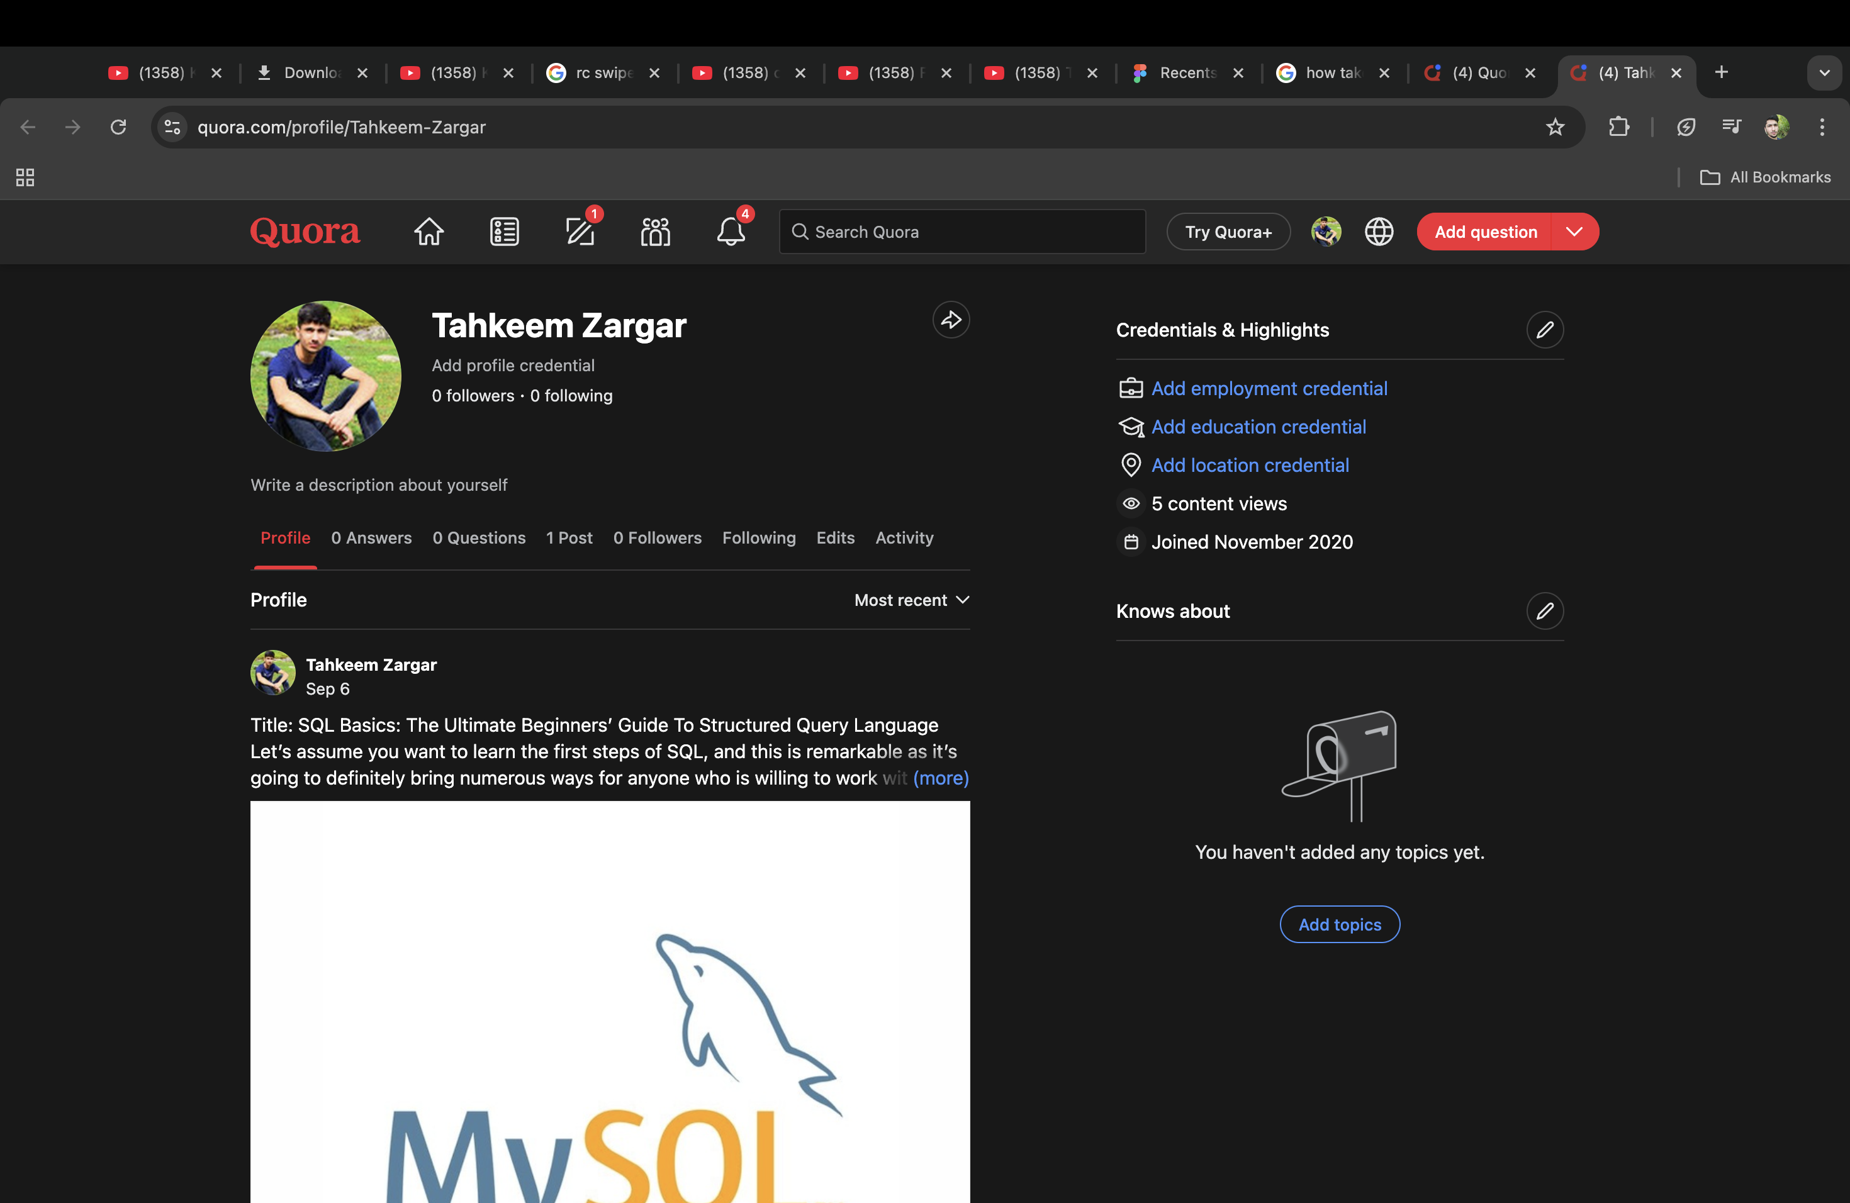

SCREENSHOTS

2. Figma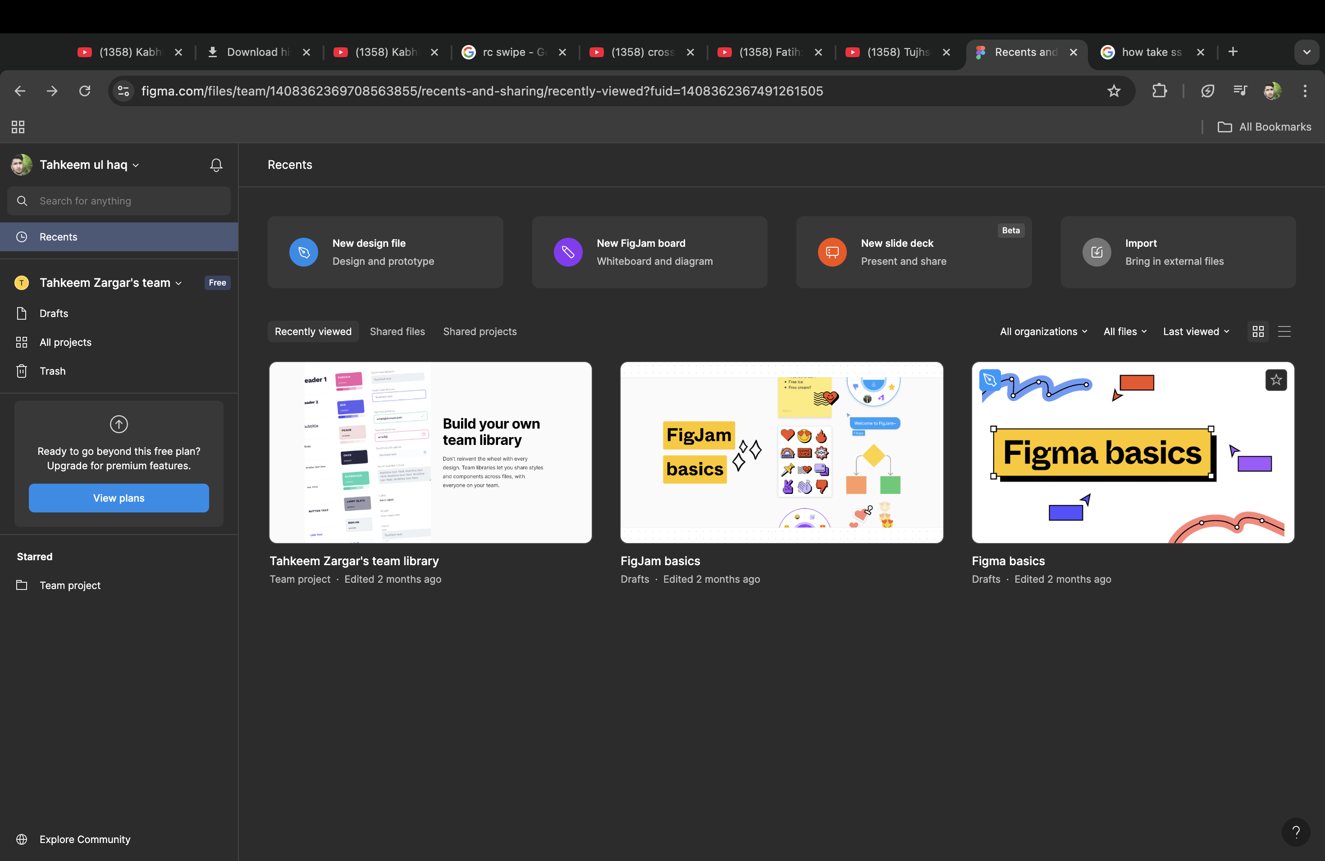

3. Stack overflow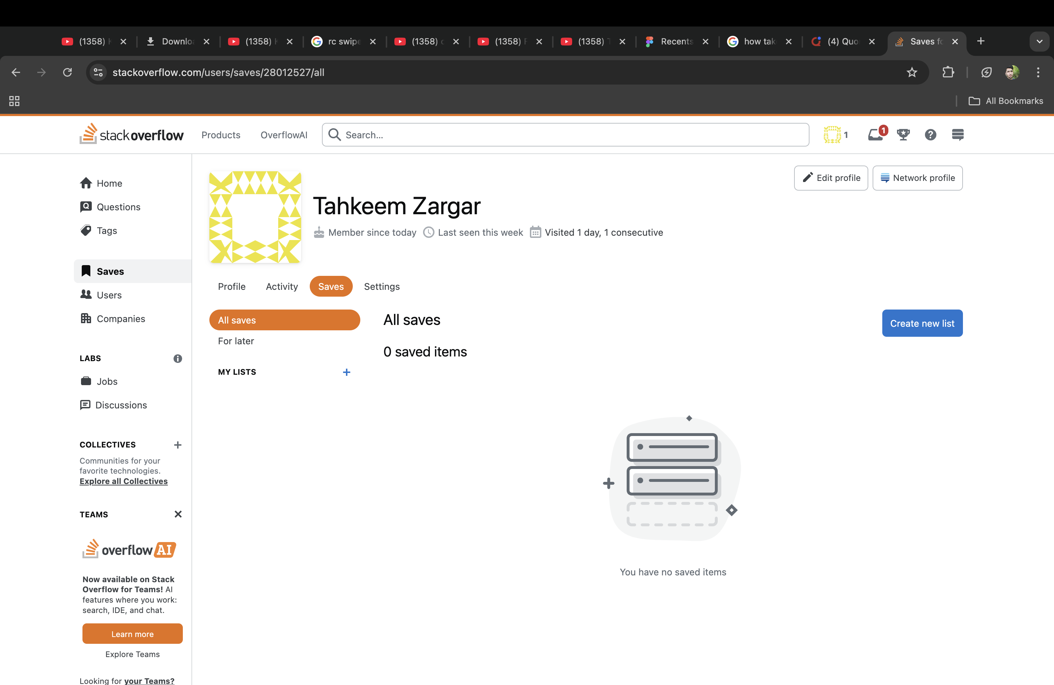

4. Hacker Rank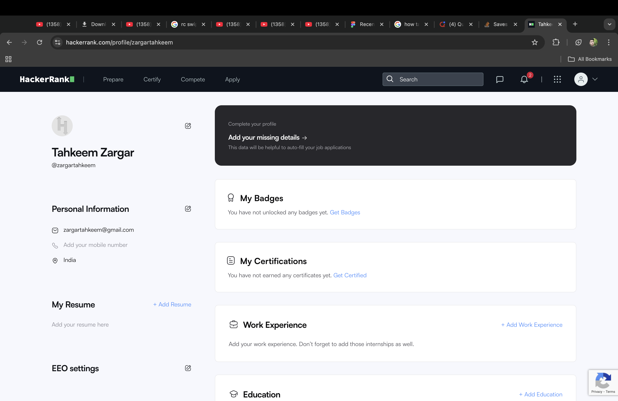

6. Geek for geeks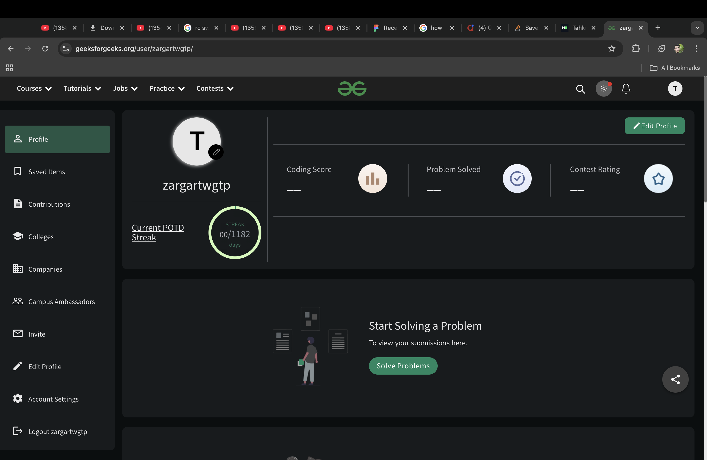

7. Github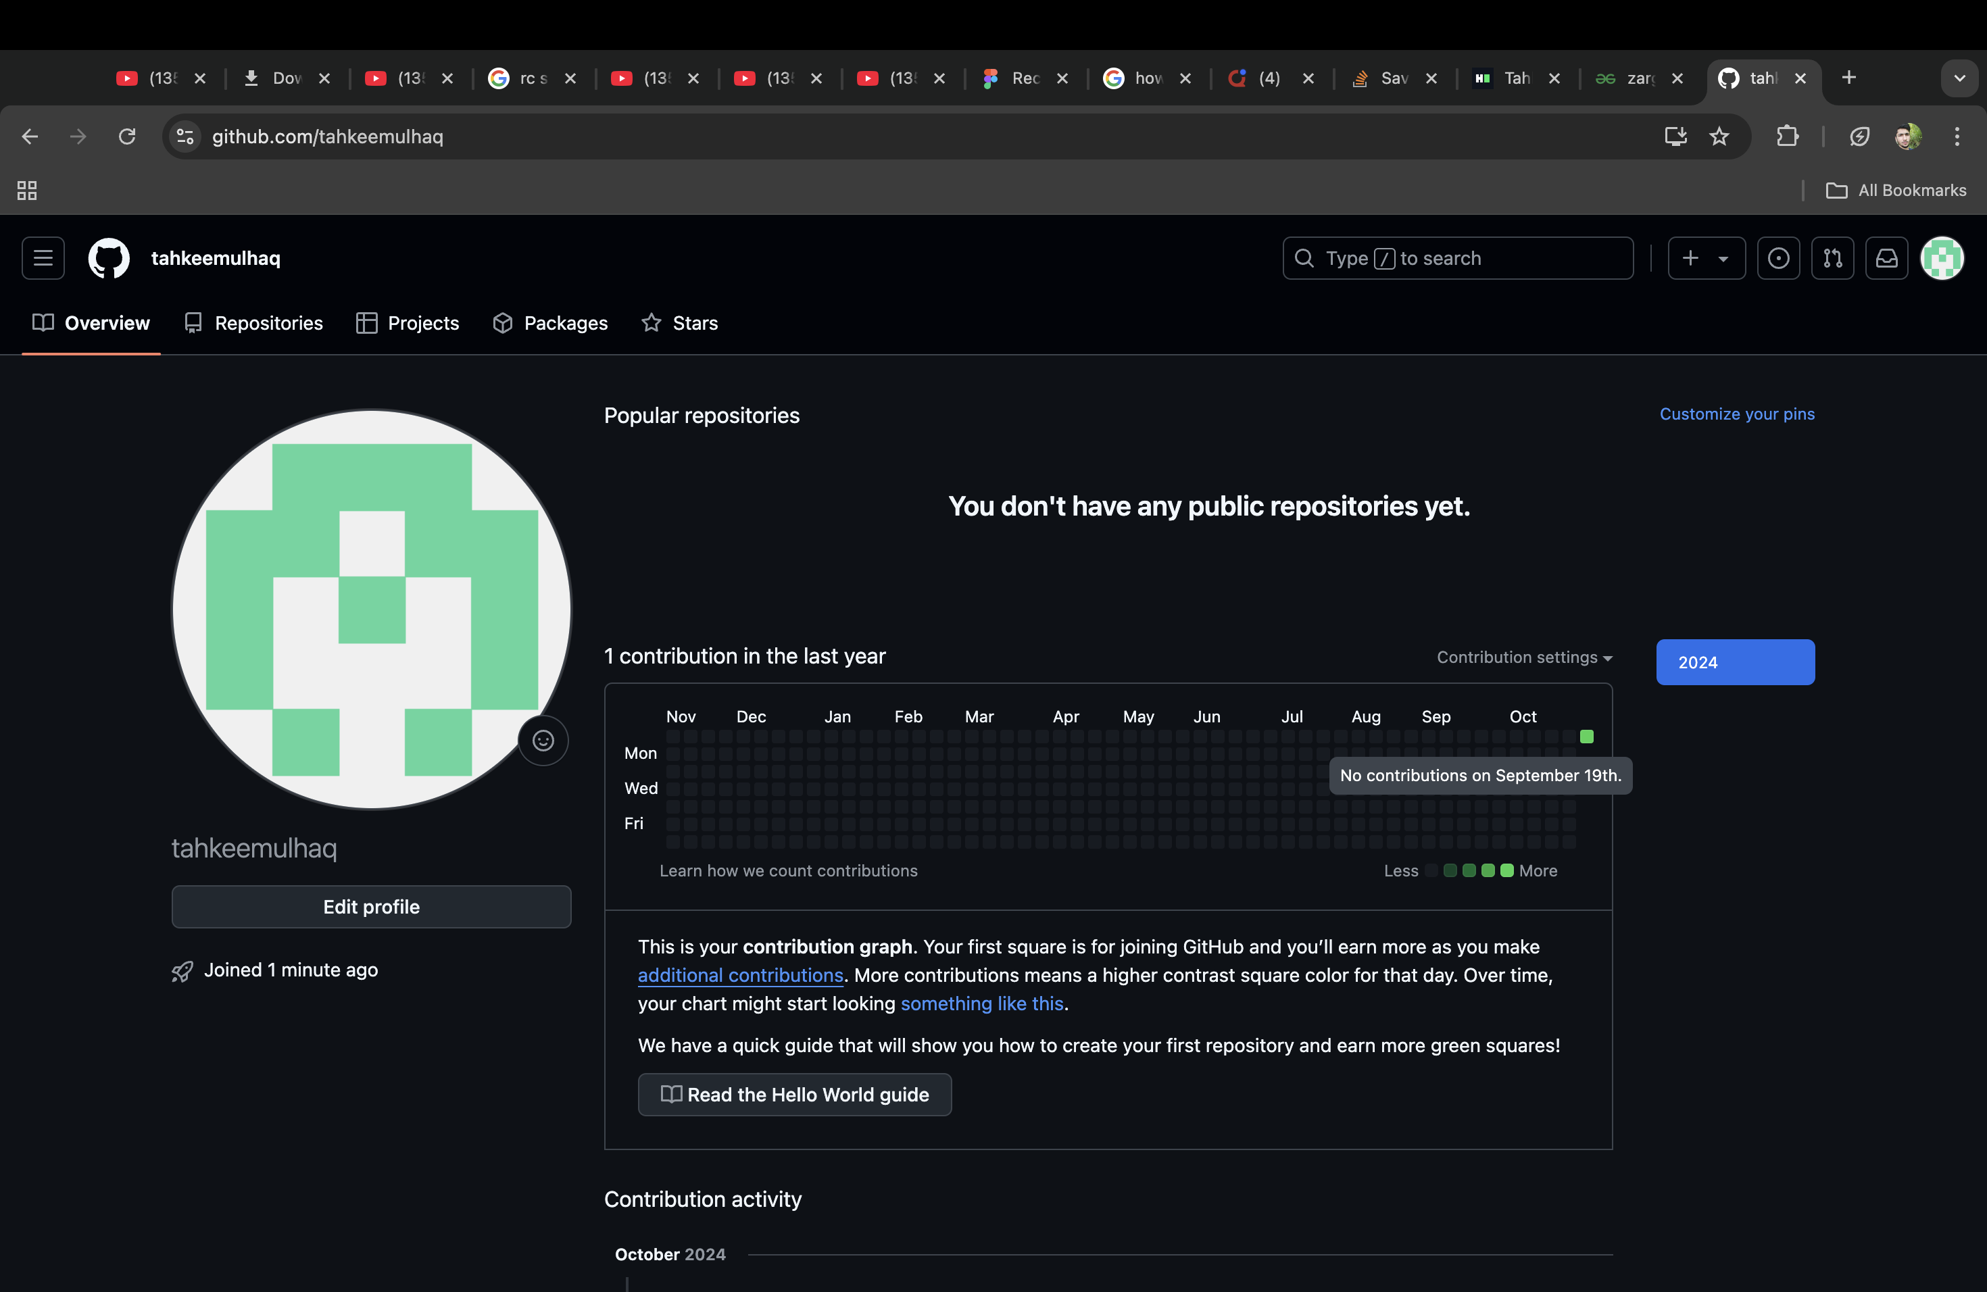

8. Linkden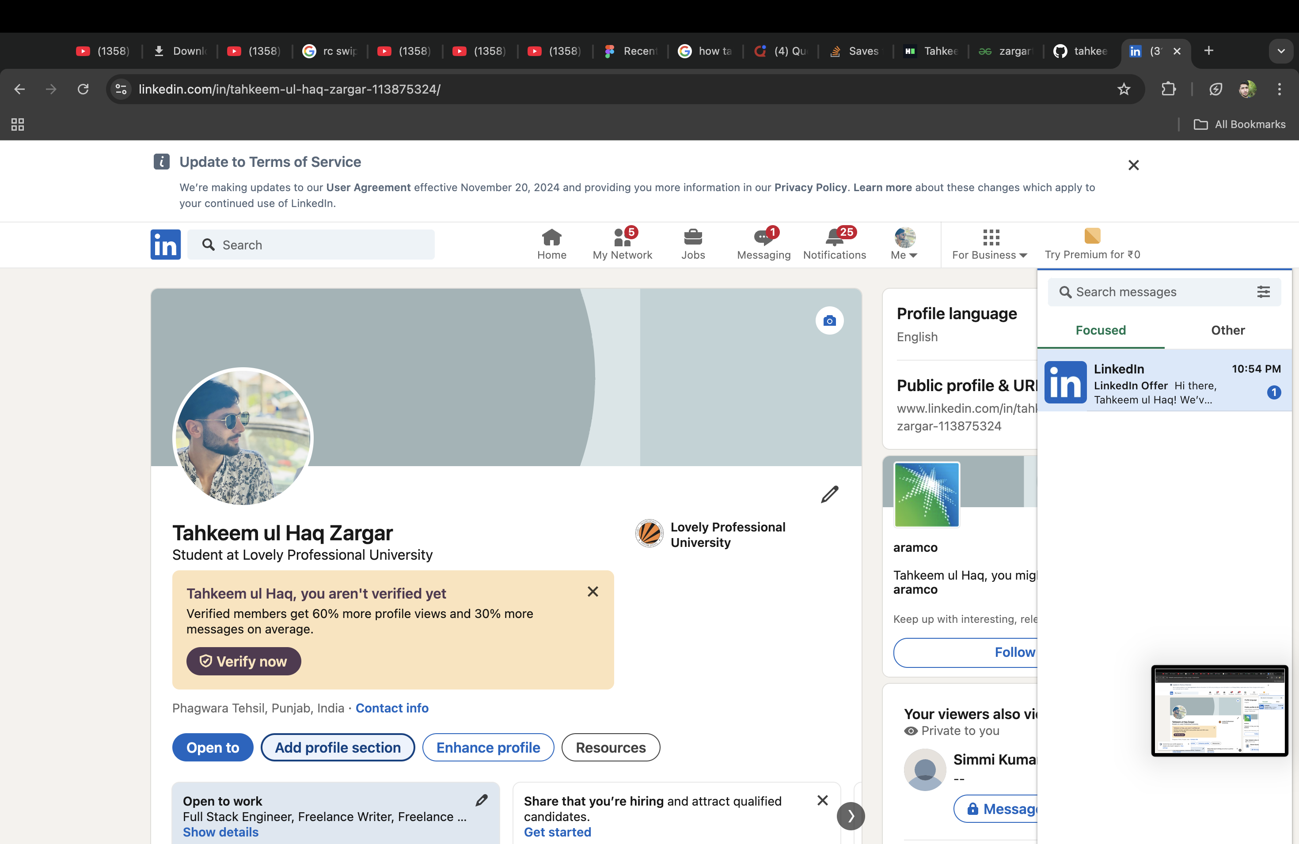

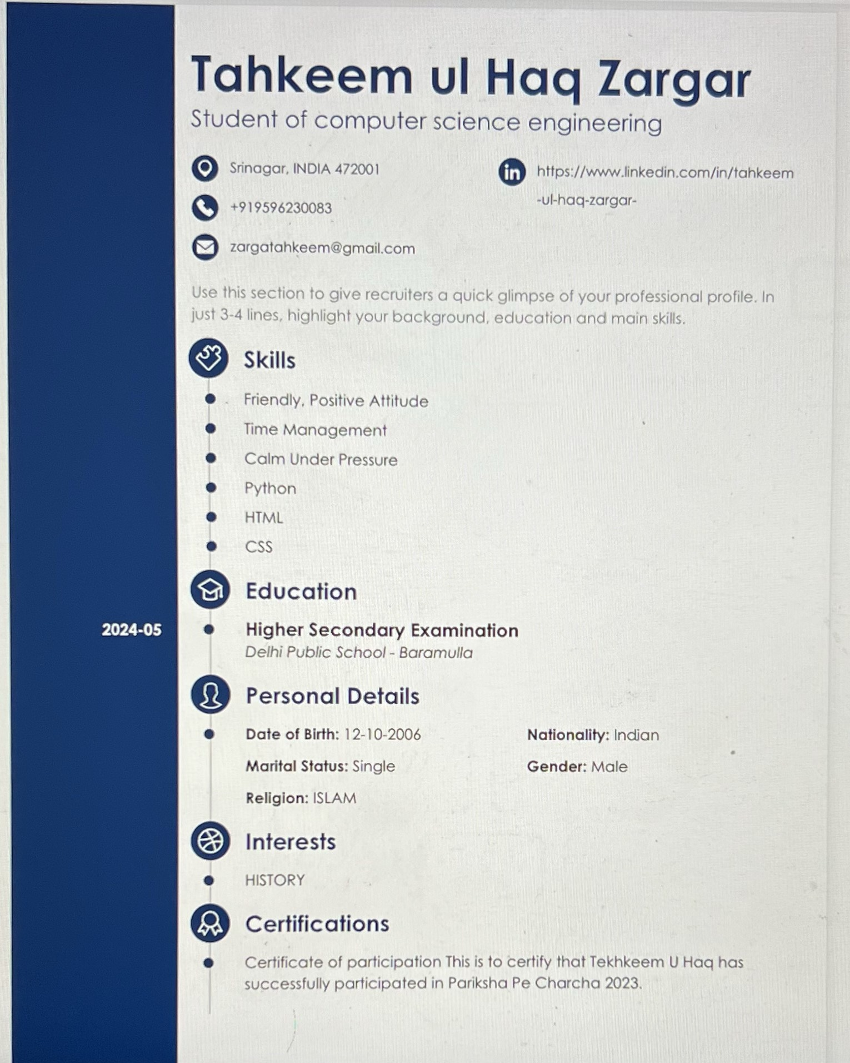

My CV