# Hacker News Search Client

Hacker News (<https://news.ycombinator.com/)> is a great site run by the famous venture capital firm Y Combinator. It allows people to submit articles and comment on them. It also provides a nice web interface to search through its history or articles.

Your task is to build a web app that allows the user to search for articles on a topic and display the results.

Details of the Search API can be found here. <https://hn.algolia.com/api>

A mockup of how this app may look like is shown below.

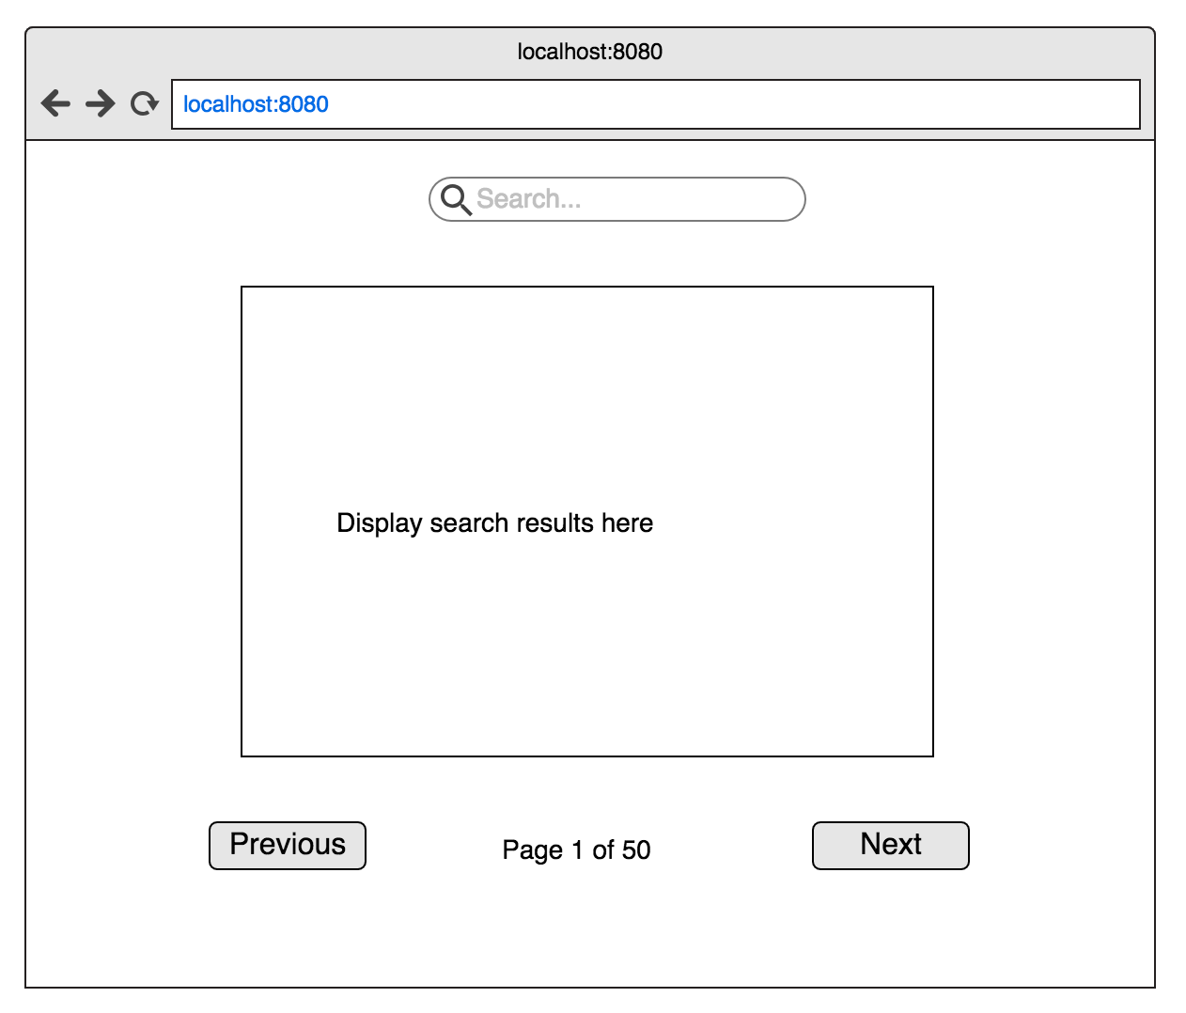

As the user enters text in the search input, query the search API.

The results are returned in a paged format, provide buttons to navigate forward and backwards through the results.

Note that your UI doesn’t have to look exactly like the above, any style is up to your implementation.

You may choose to use any Javascript and CSS framework you like to implement this app. It is acceptable to use a specific framework’s tooling to bootstrap the application build tooling.