Link to this document

goo.gl/dxtQ6G

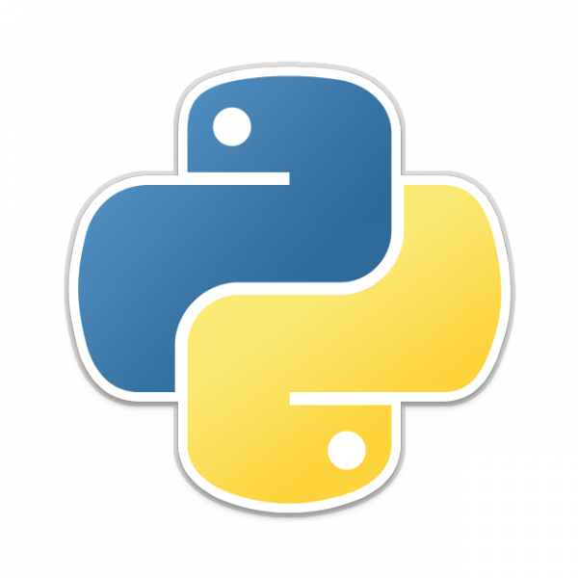

**Welcome to Pydot.**

Before we start learning Python, here are some things to do



**Connect to the Internet.**

Wi-Fi passwords are being handed out

If you haven’t received one yet, please let us know

***Everyone will get unique password. Please look for the wifi password sheet.***

***FYI: You can find the password sheet, at the lecture table.***

***Fill in your name and get your password.***

WIFI SSID :

NUS-ISS@JTC



**Join Slack.**

We’ll be communicating through Slack

If you want a new/different email to be added to Slack,

Add it to: [goo.gl/B67RVS](https://docs.google.com/spreadsheets/d/1Z2qzBWq_bEhHRKX5OXniMLSGm7mrZlJeo4rOFPcSNCI/edit?usp=sharing)

<https://join.slack.com/t/17pydot4/shared_invite/enQtMjUzOTc5MjA1NzQ2LWY3YWM5ZTgzYmU5NzU2YTAzMWM0ZmFlNzMxY2IxNjg5NDQzMDk0MGRlODc1MDIzN2M3OTkyMTFmMzU2YzI0M2E>



**Download Anaconda.**

[https://www.anaconda.com/download](https://www.anaconda.com/download/#macos)

Make sure you download **Python 2.7 Version 64-Bit**

Let us know if you have any questions



**Fill Out The Course Intent/Expectation Form**

We want to hear from you and what you want

Access the form here: [goo.gl/jxf2gM](https://docs.google.com/forms/d/e/1FAIpQLSdtUwRPqpi5TRsuM9IH0rf38Zl1d3aLeeHrpEWcrqk5m84lWw/viewform)