Step 1: Install Livewire  
composer require livewire/livewire

Step 2: running a livewire command,  
php artisan make:livewire book-list

Step 2 korle ekta php file and ekta view file create hobe,

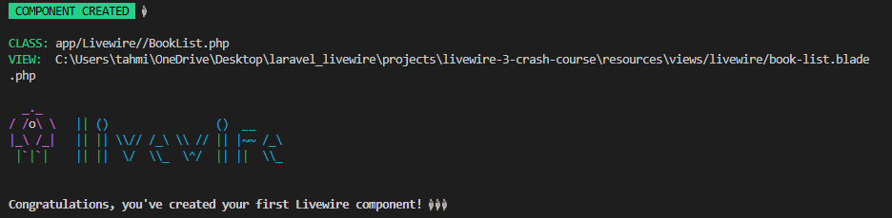

Step 3: just simply render korano holo javabe, from **book-list.blade.php**,

<div>  
 <header class="flex justify-between">  
 <div>  
 <h2>Hi</h2>  
 <p>Here's is a list of your book reviews...</p>  
 </div>  
 </header>  
</div>

Now from welcome.blade.php, use the livewire blade snippet like this,

<main>  
 <h2>Welcome to the Livewire Crash Course!</h2>  
 <livewire:book-list></livewire:book-list>  
</main>

Passing data to the view,

Here **Booklist.php** works like controller, where we can pass values through it,

class BookList extends Component  
{  
  
 public $name = "Mario";  
  
 public function render()  
 {  
 return view('livewire.book-list',  
 [  
 'books' => Book::*all*()  
 ]);  
 }  
}

Now from **book-list.blade.php**,

<div>  
 <header class="flex justify-between">  
 <div>  
 <h2>Hi {{ $name }}</h2>  
 <p>Here's is a list of your book reviews...</p>  
 </div>  
 </header>  
  
 <ul class="list">  
 @foreach($books as $book)  
 <li wire:key="{{ $book->id }}">  
 <h3>{{ $book->title }}</h3>  
 <h4>{{ $book->author }}</h4>  
 <p>Rating: {{ $book->rating }}/10</p>  
 </li>  
 @endforeach  
 </ul>  
</div>

* wire:key hocche value gular track thik rakhar jonno, like amra vue js e use kortam :key=”id”.

-------------------------------------------------------------------------------------------------------------------------------

**Livewire Actions**

Step 1: For an example, from BookList.php,

class BookList extends Component  
{  
  
 private $name = "Mario";  
 public $count = 0;  
  
  
 public function increment(){  
 $this->count++;  
 }  
  
 public function decrement()  
 {  
 $this->count--;  
 }  
  
 public function render()  
 {  
 return view('livewire.book-list',  
 [  
 'books' => Book::*all*(),  
 'name' => $this->name,  
 ]);  
 }  
}

Now from **book-list.blade.php**, call the functions,

<div>  
 <p>Count: {{ $count }}</p>  
 <button wire:click="increment">Increment</button>  
 <button wire:click="decrement">Decrement</button>  
</div>

**Example steps**, deleting a book from database,

From **book-list.blade.php**,

<ul class="list">  
 @foreach($books as $book)  
 <li wire:key="{{ $book->id }}">  
 <h3>{{ $book->title }}</h3>  
 <h4>{{ $book->author }}</h4>  
 <p>Rating: {{ $book->rating }}/10</p>  
 <button wire:click="deleteBook({{ $book->id }})">Delete</button>  
 </li>  
 @endforeach  
</ul>

Now from **BookList.php**,

public function deleteBook(Book $book)  
{  
 $book->delete();  
}