**Step 1**: composer require phpunit/phpunit –dev

**Step 2**: root directory te **phpunit.xml** naam e ekta folder create kora holo,

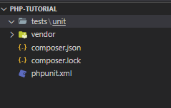

Now from phpunit.xml, code snippet,

<?xml version="1.0" encoding="UTF-8" ?>

<phpunit bootstrap="vendor/autoload.php" colors='true' verbose='true' stopOnFailure="true">

    <testsuites>

        <testsuite name="unit">

            <directory>

                tests

            </directory>

        </testsuite>

    </testsuites>

</phpunit>

1. Color means output er shomoy “Code Execution” line gula color er shathe show korbe
2. Verbose means aro kichu information shoho show korbe
3. stopOnFailure mane hocche first ekta error pelei okhane execution off hoye jabe
4. Directory mane hocche kon directory er moddhe ase

**Step 3** : from **cmd** run, vendor/bin/phpunit

Output will look like this,

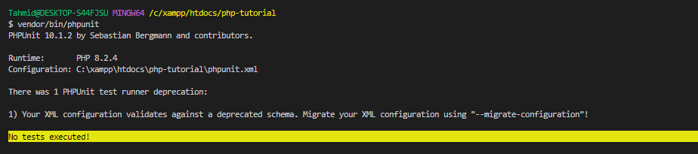

A simple code snippet from **test/unit/FirstTest.php**,

<?php

use PHPUnit\Framework\TestCase;

class FirstTest extends TestCase{

    public function testMultiplicationOfTwoNumber(){

        $a = 20;

        $this->assertEquals($a,20);

    }

}