

**EECE 304**

**Digital Electronics Lab**

**Password Based Room Security**

**And Home Automation System**

**Group No:** 02

**Group members:**

1. Alif Tahmid Priyom (202116006)
2. Azmain Shahriear Sabab (202116015)
3. K. M. Taskin Zaman Kafi (202116029)
4. Mahmuda Akter (202116034)
5. Md Abrar Shahriar Kabir (202116043)
6. Sub Lt Taushif (202116133)
7. Lt Usha (201916073)
8. Lt Jamil (201916077)

**Project name:**

Password based room security and home automation system

**Objective:**

Our objective in this project is to develop a security system that can protect a room from unauthorized access. The system will be able to automate various tasks such as turning on/off lights, controlling the temperature via turning on/off the fan/air conditioner etc. The system will be designed to send alerts to the owner in case of unauthorized access attempts or other security breaches.

**Theoretical background:**

Due to the advancement of science and technology throughout the world, there is a consequent increase in the rate and sophistication of crime. As a result, it is necessary to ensure security of oneself and one’s valuable belongings. Even with the use of mechanical locks, the crime rate still has increased due to the fact that these locks are easily broken. Consequently, there is a need for other types of locks, especially electronic ones.

This project is based on the design of an electronic combination lock with a keyboard to be mounted on the door for keying in the passcode. The code unit, which operates with a binary switch keyboard was designed to control an electromagnetic door lock with a 7–digit code.

Also, in this project, we have added the invalid entry counting process, which will not allow an intruder to input an invalid passcode more than 3 times. Moreover, we have also included an automation system, which will turn the lights on/off and control the room temperature by switching on/off the fan/air conditioners.

**Equipment required:**

1. 10-to-4 line priority encoder (6)
2. 7 segment BCD display (3)
3. JK flip-flop with set and reset (3)
4. Motion sensor (PIR sensor - 1), Temperature sensor (LM35 - 1)
5. Potentiometer (2)
6. LM356n Op-Amp (1)
7. 2 input XNOR gate (12)
8. AND gates (8-input*1, 5-input*1, 3-input*1, 2-input*6)
9. OR gates (2-input*1)
10. NOT gates (29)
11. Voltage regulator IC (7805 - 1), Relay (1)
12. Resistor (4), LED (9), DC power supply (3)

**Procedure/Methods:**

1. At first, the system will ask the house owner to set a passcode. For this, we will need to set a passcode for our house in “Owner passcode” box.
2. Then, every time someone tries to enter the house, he/she will need to enter a passcode in “Enter passcode” box and press “Press ENTER” button. If the passcode matches with our original passcode, the “Pass OK” green LED will enlighten.
   1. When the passcode is correctly given and the system detects movement from the motion sensor, the “Light/Fan” will switch on.
   2. When the passcode is correctly given and the system detects that the room temperature is more than a present temperature through the temperature sensor, the “AC” will switch on.
3. If the passcode doesn’t match our original passcode, the “Pass wrong” red LED will enlighten, indicating that a wrong passcode was given.
4. Now, if there is a situation, when there is an intruder in the room, the motion sensor detects movement in the room, and the “Pass OK” switch is not on, our system will trigger the “Intruder alert!!!” LED.
5. Again, if someone tries to enter our room by brute force, he/she will enter a wrong passcode multiple times. For informing the owner about this incident, we have added a counter, that will allow a person to enter wrong passcode maximum 5 times.
   1. When a user enters wrong passcode 5 times, the counter will trigger the “System locked” switch, which will instantly lock the system.
   2. The system will only reset if the “System reset” switch is triggered, which is only available to the actual owner.
   3. After system is reset, the system will work like a fresh system, which will then again function normally as it previously did.

**P.S:** “Press ENTER” button has to be pressed every time when someone tries to enter a passcode and try to enter the room.

**Circuit Diagram:**

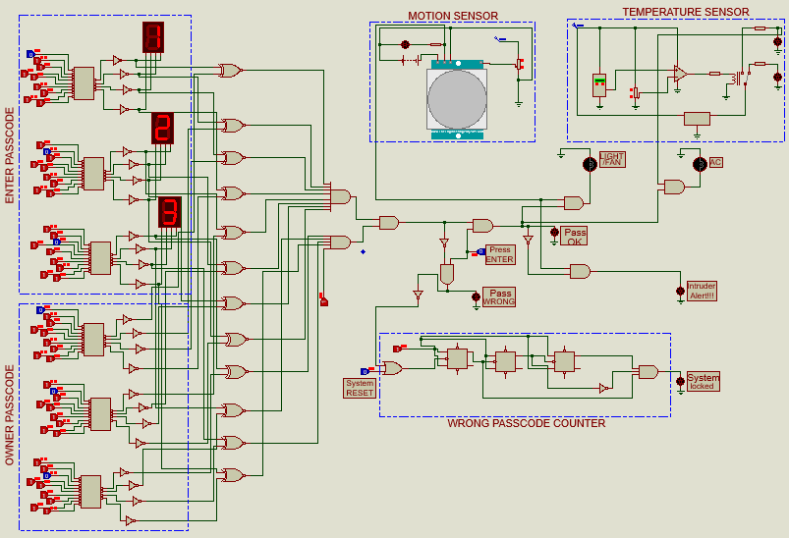

Function of blue boxes:

* Owner Passcode: Lets the owner set a 3 – digit decimal passcode for protecting him room from intruders.
* Enter Passcode: Lets a person enter a passcode, so that he can enter the room with permission of the owner.
* Motion Sensor: Detects if there is any motion inside the room
* Temperature sensor: Detects if the temperature of the room is higher than the normal room temperature.
* Wrong Passcode Counter: Counts how many times a wrong passcode has been given, so that the system can lock itself before someone harms it.

**Experimental Data:**

|  |  |  |  |  |  |  |  |  |  |  |  |
| --- | --- | --- | --- | --- | --- | --- | --- | --- | --- | --- | --- |
| Trial no. | Owner passcode | Enter passcode | Pass ok | Pass wrong | Motion sensor | Light  /Fan | Temp  sensor | AC | Alert | System locked | System reset |
| 1 | 123 | 123 | 1 | 0 | 0 | 0 | 0 | 0 | 0 | 0 | 0 |
| 2 | 123 | 123 | 1 | 0 | 1 | 1 | 0 | 0 | 0 | 0 | 0 |
| 3 | 123 | 123 | 1 | 0 | 0 | 0 | 1 | 1 | 0 | 0 | 0 |
| 4 | 123 | 123 | 1 | 0 | 1 | 1 | 1 | 1 | 0 | 0 | 0 |
| 5 | 123 | 234 | 0 | 1 | 0 | 0 | 0 | 0 | 0 | 0 | 0 |
| 6 | 123 | 345 | 0 | 1 | 0 | 0 | 0 | 0 | 0 | 0 | 0 |
| 7 | 123 | 235 | 0 | 1 | 0 | 0 | 0 | 0 | 0 | 0 | 0 |
| 8 | 123 | 348 | 0 | 1 | 0 | 0 | 0 | 0 | 0 | 1 | 0 |
| 9 | 123 | 348 | 0 | 1 | 0 | 0 | 0 | 0 | 0 | 1 | 1 |
| 10 | 123 | - | 0 | 0 | 1 | 0 | 0 | 0 | 1 | 0 | 0 |

**Result:**

1. Passcode entered correctly (“Pass OK” LED on):

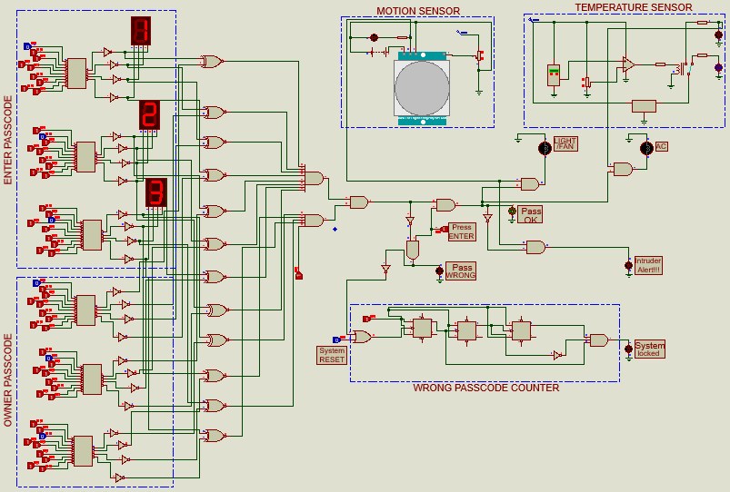

2. Passcode entered correctly, motion sensed (“Pass OK”, “Light/Fan” LED on):

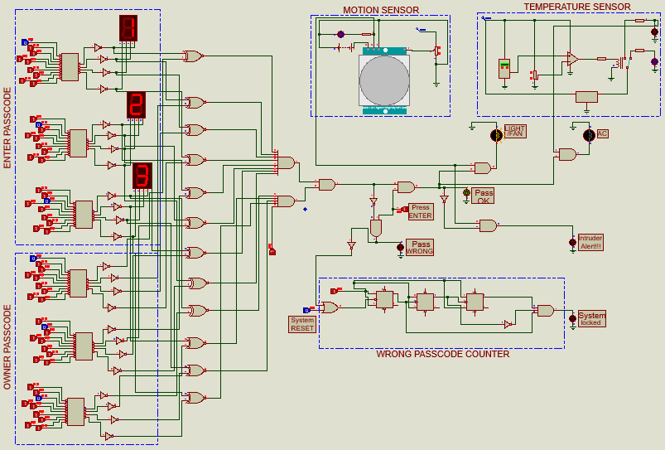

3. Passcode entered correctly, high temp (“Pass OK”, “AC” LED on):

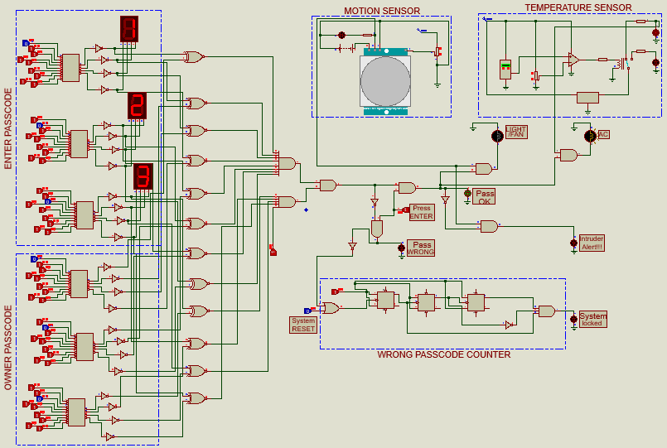

4. Passcode entered incorrectly (“Pass WRONG” LED on):

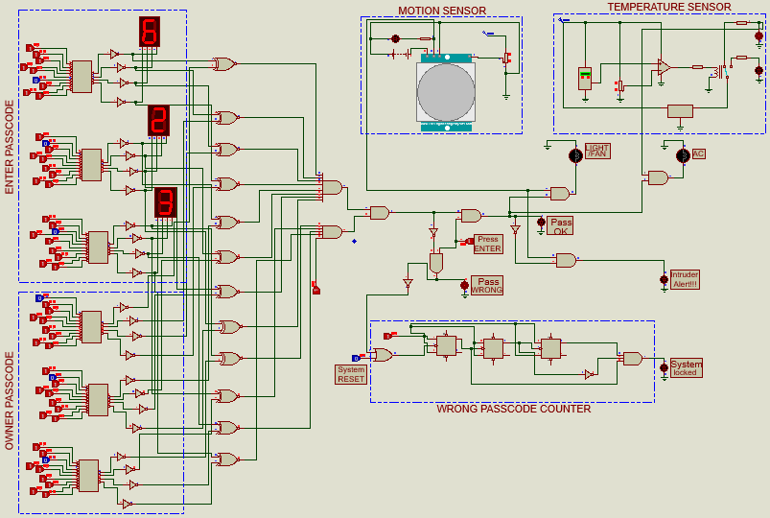

5. Passcode entered incorrectly for 5 times (“Pass WRONG”, “System locked” LED on):

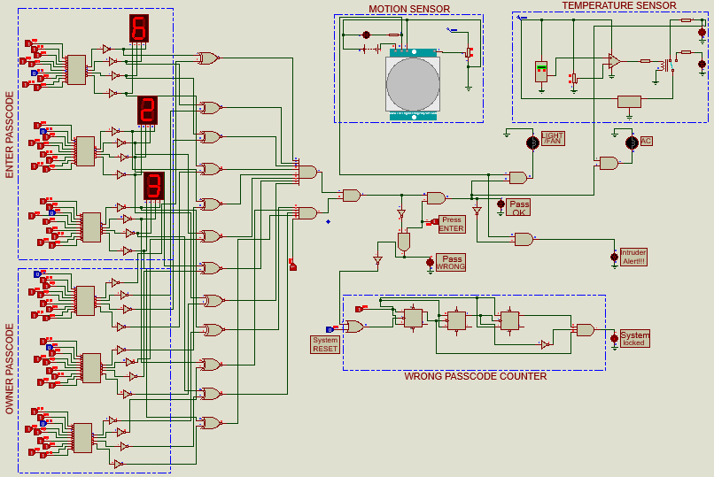

6. No pass given, but motion detected [Theft condition] (“Intruder Alert” on):

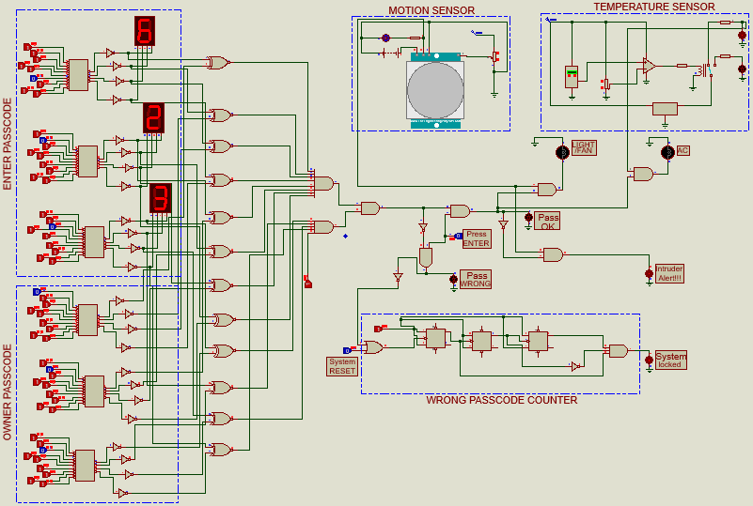

**Discussion:**

* This project consists of sensing element (Motion detector) and automated control system (Automated Air conditioning), which works only for specified logics provided by the lock.
* As a protective system we use sequential circuit (Memory Device), counter. Which will allow 4 consecutive password trials and lock the system after 5 wrong trials. There is a specified system reset key to functionalize the system again.
* When the door is unlocked as well as motion is detected, the fan and light will be turned on automatically also if the temperature is above a specified degree, then the ac will be turned on automatically.
* There is also an intruder detection system implemented along with the lock.
* The enter pass button is actually the Lock/Unlock button. When someone is leaving the room and entering the room, will press the same switch.