Learning Objectives:
- Explore the Architecture of an 31-bit Processor – Dive deep into its design principles and operational flow.
- Build Core CPU Components – Implement and integrate vital elements like the ALU, registers, and the control unit to bring the processor to life.
- Create a Custom Instruction Set – Design and execute your own instruction set within Logisim for practical simulation.
- Master Data Flow and Memory Operations – Gain hands-on experience with data transfer, instruction processing, and memory management.
- Decode and Execute with the Control Unit – Understand how the control unit orchestrates instruction decoding and execution.
- Simulate a Full CPU Cycle – Experience the entire process from instruction fetch to execution and result write-back.
Introduction:
A Central Processing Unit (CPU) serves as the brain of any computing system, responsible for interpreting instructions and executing arithmetic as well as logical operations. In this project, we designed and implemented an 31-bit CPU using Logisim, incorporating several key components:
- Arithmetic Logic Unit (ALU) – Executes arithmetic and logical computations on 31-bit data.
- Registers – Provide temporary storage for data and instructions during processing.
- Memory – Holds both instructions and data required for execution.
- Control Unit – Interprets instructions and coordinates operations by generating precise control signals.
Each component plays a crucial role in ensuring efficient data processing and smooth execution of instruction
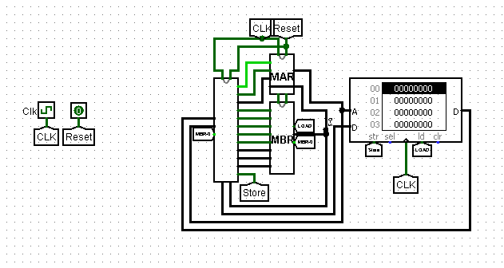

The CPU design includes:
- An 31-bit data bus and address bus for handling memory and computation.
- Registers such as o MBR(Memory Buffer Register)
- MAR(Memory Address Register)
- PC(Program Counter)
- IR(Instruction Register)
- CPL
- PLR(Parallel Load Register)
- An ALU capable of performing fundamental operations.
- A control unit that processes and executes instructions using predefined control signals

31 Bit Memory Buffer Register (MBR):
The MBR acts as a temporary buffer for data retrieved from memory before it is processed by the ALU or written back to memory. It functions as an interface between the CPU and memory, ensuring seamless data transfer.
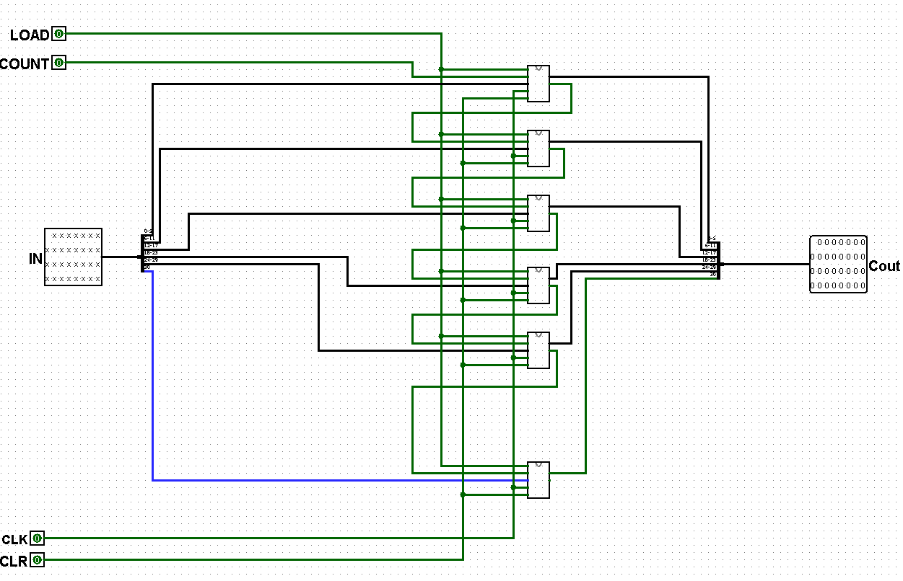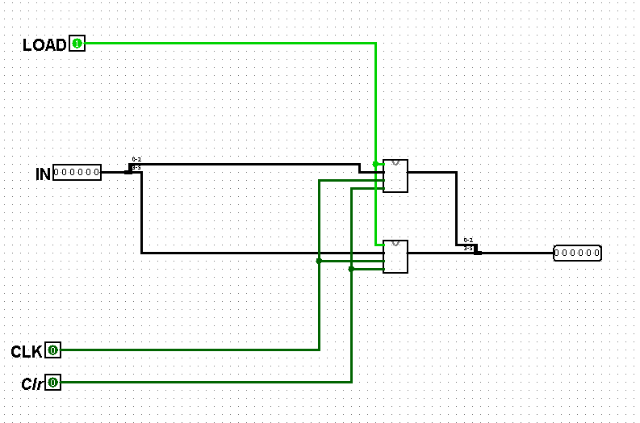
MBR MAR
6 Bit Memory Address Register (MAR):
The MAR holds the address of the memory location that the CPU intends to access, whether to read data into the CPU or write results back to memory. It ensures accurate delivery of memory addresses during instruction execution, guaranteeing that the correct data is fetched or stored.
Program Counter (PC):
The Program Counter (PC) holds the address of the next instruction to execute. It automatically increments after each instruction, enabling sequential program flow. During jump or branch operations, however, the PC can be updated to redirect the program’s execution path.
4 Bit Instruction Register (IR):
The IR holds the current instruction being executed. After fetching an instruction from memory, the control unit decodes it to determine what operation needs to be performed, such as a data transfer, arithmetic operation, or jump.
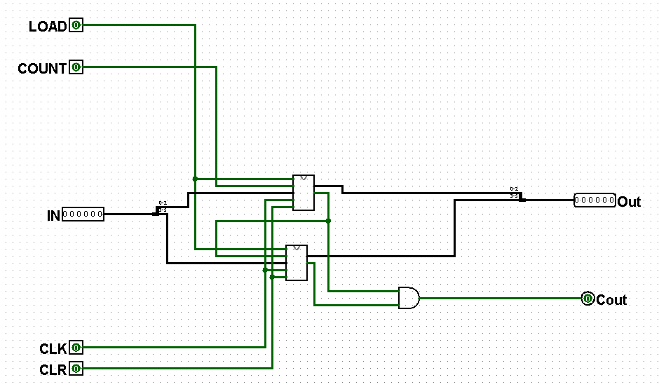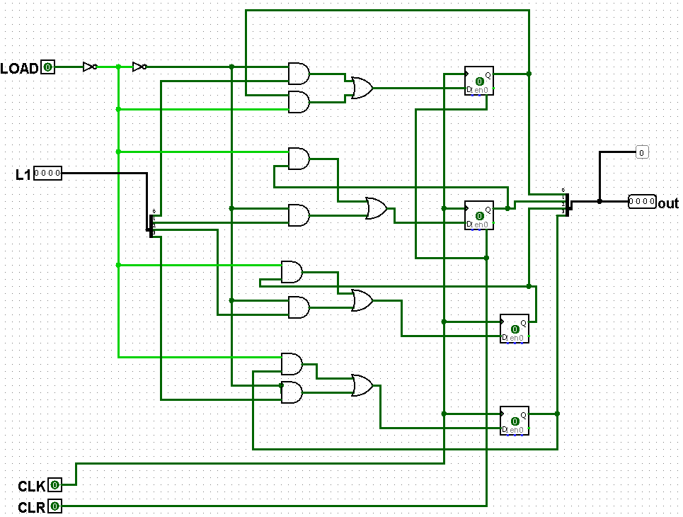
PC IR

3 Bit Parallel Counter:
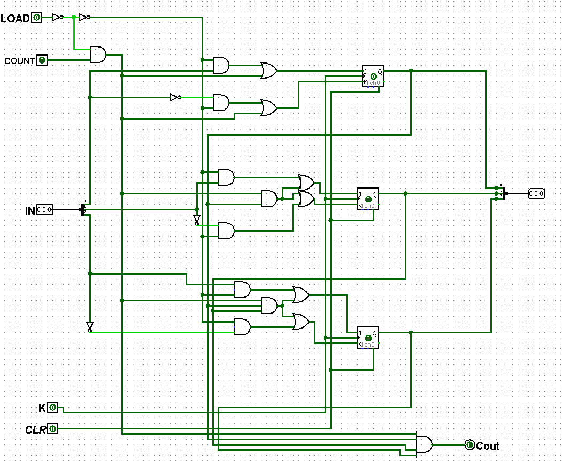
ALU:
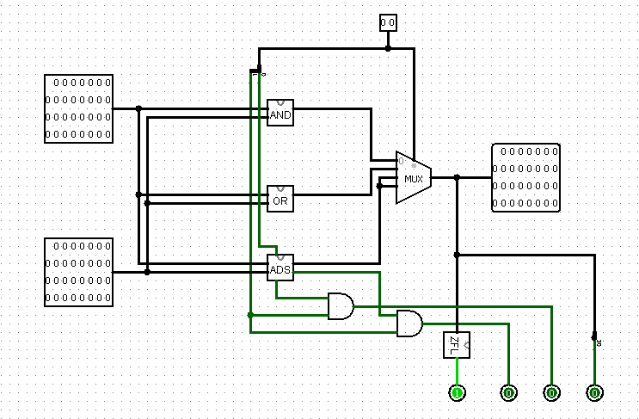
Arithmetic Operations:
The ALU is capable of performing addition (ADD) and increment (ISZ) operations. These operations allow the CPU to process numerical data, perform calculations, and adjust program counters.
Logical Operations:
The ALU can also perform logical operations, such as AND . This operation allows the CPU to perform bitwise logical conjunction, a fundamental operation in programming and computing.
Data Transfer Operations:
The ALU is involved in data transfer operations like LOAD , which moves data from memory to a register, and STORE, which saves data from a register into memory. These operations are critical for maintaining data flow between the CPU and memory.
Control Unit :
The control unit is the "brain" of the CPU, managing the execution of instructions by generating appropriate control signals. It oversees the entire instruction cycle and ensures that operations are executed in the correct sequence
Instruction Fetching: The control unit starts the process by fetching the next instruction from memory and storing it in the IR. This step initiates the process of instruction execution.
Decoding: Once the instruction is fetched, the IR is decoded by the control unit. The decoder determines the type of operation (e.g., arithmetic, logical, data transfer) and identifies the operands involved in the operation.
Execution: After decoding, the control unit sends appropriate signals to the ALU and other components to perform the required operation. It might involve performing arithmetic operations, logical comparisons, or accessing memory.
Memory Access: If the instruction involves memory, the control unit coordinates with the MAR and MBR to read from or write data to the specified memory location. The memory system plays a critical role in storing intermediate results or final outputs of computations.
Program Flow Control: Finally, the PC is updated to point to the next instruction in the program, ensuring continuous execution.
Instruction Set:
The computer supports several fundamental instructions that allow it to perform basic computational and data manipulation tasks:

INSTRUCTION | OPCODE(HEX) | INSTRUCTION | OPCODE(HEX)
AND | 00 | BUN | 05
ADD | 01 | LOAD | 06
STORE | 02 | HALT | 07
ISZ | 03 | EO(defining Even-Odd) | 08
BSB | 04 | RS(Right Shift) | 09
CMP(Define Max value) | A

Control Unit:
The Control Unit (CU) is responsible for decoding instructions and generating signals to direct data movement between different components. It follows a finite state machine (FSM) approach, ensuring that each instruction is executed in multiple steps.
Control Unit and Instruction Execution Process
The execution of an instruction follows a structured process, ensuring smooth operation.
Instruction Fetch: The Program Counter (PC) holds the memory address of the next instruction. This address is sent to the Memory Address Register (MAR), and the instruction is fetched into the Instruction Register (IR).
Instruction Decode: The Control Unit (CU) decodes the instruction by identifying the opcode, source registers, and destination registers. Based on this decoding, the CU determines which operation needs to be performed.
Instruction Execution: If the instruction involves arithmetic or logical operations, the ALU performs the required computation. For memory-related instructions, the LOAD/STORE mechanism handles data transfer between registers and memory. If the instruction is ISZ, the selected register is incremented, and if the result is zero, the next instruction is skipped.
Write Back and PC Update: After execution, the result is written back to the appropriate register or memory location. The Program Counter (PC) is updated to point to the next instruction, ensuring continuous execution

Sample Code to Run on RAM:
v2.0 raw
6000004 1000005 2000008 7000000 4 5
Explanation of Instructions
- 06 → Load memory 000004
- 01 → Add the value of memory 000005
- 02 → Store the addition to memory 000008
- 07 → Halt the program

Discussion:
This project offered an in-depth exploration of computer architecture fundamentals through the design and implementation of a working 31-bit CPU. Using Logisim, we methodically constructed the CPU’s components and observed how they collaborate to carry out instruction execution. A significant challenge involved coordinating the control signals precisely among the ALU, registers, and memory to maintain smooth operation. Troubleshooting required carefully following the data paths across registers and monitoring the control unit’s signals to ensure correct instruction processing. Successfully implementing the AND operation highlighted the ALU’s ability to perform logical functions effectively. Additionally, the correct execution of LOAD and STORE instructions validated the accuracy of data transfers between memory and registers. Overall, this hands-on project deepened our understanding of the instruction cycle, CPU architecture, and digital logic, bridging the gap between theory and practical design.

Conclusion:
Building an 31-bit computer in Logisim offered practical insight into processor architecture and digital system design. This project deepened the understanding of:
- Instruction execution cycles and the way a CPU handles data processing.
- The interaction between registers and memory within a computing system.
- The ALU’s role in performing both arithmetic and logical operations.
- The control unit’s logic, which coordinates and manages CPU activities.
In summary, this project successfully demonstrated a functional 31-bit CPU model, emphasizing the critical role of organized data flow and control logic in computer architecture.

References:
- Logisim Documentation
- Class Lecture
- Class Slide

