Project Report

Project Title : icpX
Author : Md Taki Tahmid Saad
Roll : 2207022
Group : A1
Year : 2nd
Term : 2nd
Date : January 14, 2026

Table of Contents
- Abstract
- Introduction
- Objectives
- Methodology and Implementation
4.1 Architecture and Data Flow
4.2 Technical Stack – Android
4.3 Technical Stack – Desktop
4.4 Core Features
4.5 Cloud Synchronization
4.6 User Interface Design
- Results and Usage Scenarios
5.1 Desktop Application Interface
5.2 Android Application Interface
5.3 Promoting Consistency in Competitive Programming
- Conclusion
- References

- Abstract:
icpX is a cross-platform application developed to support competitive programmers by addressing the common challenge of maintaining consistency in practice. The application provides a unified experience across Android mobile devices and Windows desktop environments, enabling users to track, manage, and analyze their problem-solving progress. Key features include seamless integration with the Codeforces platform, cloud-based data synchronization via Firebase, built-in rating calculations, contest scheduling, offline problem statement viewing, and detailed performance analytics through charts and heatmaps. By introducing a gamified 24-hour target system with virtual rating incentives and penalties, icpX encourages regular practice while minimizing distractions. The application is built with modern technologies including JavaFX for desktop, Android-native development for mobile, SQLite for local storage, and Firebase for authentication and cloud services.
- Introduction
Competitive programming demands consistent practice to achieve and maintain high performance. However, many programmers struggle with irregular training schedules, lack of structured goal-setting, and fragmented progress tracking across devices. These issues often lead to stalled improvement and reduced motivation.
icpX was developed to solve these problems by providing a dedicated, cross-platform tool that centralizes all aspects of competitive programming practice. The application offers a unified experience on both Android and desktop platforms, allowing users to access their data from any device through cloud synchronization. With direct integration to Codeforces, built-in analytics, and innovative consistency-promoting mechanisms, icpX aims to elevate the training experience and help programmers achieve sustained progress.

- Objectives
The primary objectives of icpX are:
  - To provide a comprehensive platform for tracking and managing competitive programming problems and goals.
  - To enable seamless cross-platform access (Android and Desktop) with real-time data synchronization.

  - To integrate directly with Codeforces for automatic problem fetching, contest schedules, and rating tracking.
  - To offer rich analytical tools including rating graphs, heatmaps, and performance statistics.
  - To promote daily consistency through a gamified 24-hour target system with virtual rating rewards and penalties.
  - To support offline functionality, particularly for viewing problem statements.
  - To deliver an intuitive, modern user interface on both platforms using Material Design (Android) and JavaFX (Desktop).

- Methodology and Implementation
  - Architecture and Data Flow
icpX follows a clean, modular architecture. The desktop version employs the Model-View-Controller (MVC) pattern, with Data Access Objects (DAOs) handling database operations and dedicated service classes managing API integrations. Both platforms utilize local SQLite databases for offline persistence and Firebase Firestore for cloud storage. Data synchronization is handled both automatically and on-demand, ensuring consistency across devices.
The application features:
- Secure user authentication via Google OAuth and Firebase Auth (with BCrypt hashing for additional security).
- Codeforces API integration for problem import, contest data, and rating information.
- Built-in rating calculation system to simulate rating changes based on daily target performance.
- WebView component for offline problem statement viewing.
  - Technical Stack – Android
- Build System: Gradle
- Backend Services: Firebase Authentication, Firestore
- Background Tasks: WorkManager for reliable synchronization
- Local Database: SQLite
- UI Framework: Native Android with Material Design guidelines
- Architecture: Modular code structure for maintainability

4.3 Technical Stack – Desktop
- UI Framework: JavaFX
- Build System: Maven
- Local Database: SQLite
- Architecture: MVC pattern with FXML declarative views
- Authentication: Google OAuth
  - Core Features
- Problem and Target Management: Users can add, edit, delete, and track problems ("targets") manually or automatically from Codeforces.
- History and Statistics: Interactive dashboard with solved problem history, rating charts, performance heatmaps, and detailed statistics.
- Contest Management: View upcoming, running, and past contests; import problems directly from contests.
- Friends System: Add friends, monitor their icpX ratings and progress.
- Offline Support: Cached problem statements viewable via built-in WebView.
  - Cloud Synchronization
Data consistency is maintained through a combination of local SQLite storage and cloud-based Firebase Firestore. Synchronization can be triggered manually or automatically, ensuring that problems, target status, ratings, and Codeforces handles remain identical across all connected devices.
  - User Interface Design
- Android: Modern Material Design with intuitive navigation and responsive layouts.
- Desktop: Rich JavaFX interface with customizable themes and adaptive layouts. Both platforms support personalization through themes and provide clear visual feedback for targets, countdowns, and performance metrics.
- Results and Usage Scenarios
  - Desktop Application Interface
- The desktop version provides a comprehensive interface with dedicated sections:
- Welcome Screen: Account creation and login.
- Target Section: List of active targets, status indicators, and 24-hour countdown timers.
- Dashboard: Rating display, interactive graphs, heatmaps, and quick shortcuts.
- Contests Section: Tabs for upcoming, running, and past contests; direct problem import functionality.
- Friends Section: Friend management and progress observation.
- Settings: Codeforces handle integration, Gmail connection, and full synchronization controls.
  - Android Application Interface
- The mobile version offers similar functionality optimized for touch interaction:
- Target Section: Target list with status and countdown.
- Problem Addition: Via direct links or contest selection.
- WebView: Offline problem statement viewing.
- Contest Section: Same categorization as desktop with direct import.
- Friends Section: View friends’ icpX ratings.
- Settings: Handle management, contest reminders, and sync options.
  - Promoting Consistency in Competitive Programming
- icpX addresses inconsistency through a structured daily target system:
- Users set one or more problems as 24-hour targets.
- Successful completion within the time limit increases the user’s virtual icpX rating.
- Failure to solve within 24 hours results in a rating penalty.
- This gamified approach creates positive reinforcement for daily practice.
- Additional aids include offline problem access, distraction-free reading mode, and seamless cross-device continuity.
- These mechanisms collectively encourage regular engagement and help users build sustainable practice habits.
- Conclusion
icpX successfully delivers a powerful, cross-platform solution tailored to the needs of competitive programmers. By combining robust Codeforces integration, comprehensive analytics, cloud synchronization, and innovative consistency-promoting features, the application provides a complete ecosystem for tracking and improving programming contest performance. The modern interfaces on both Android and desktop platforms ensure accessibility and productivity regardless of the device used.
The project is open-source and available for download:
- GitHub Repository:https://github.com/tahmids55/icpX
- Android APK:
https://drive.google.com/file/d/12H9VhmFxYAX_viQ-16lSGhJNredtCRVm/view?usp=drive_link
- Windows Executable: https://drive.google.com/file/d/1chPj2BqoD5xLwggqrCpw0oqCQovugrdI/view?usp=drive_link
Future enhancements could include support for additional platforms (e.g., AtCoder, LeetCode), advanced recommendation engines, and community features.

- References
- Codeforces API Documentation
https://codeforces.com/apiHelp
- Firebase Documentation (Authentication, Firestore)
https://cloud.google.com/products/firestore
- JavaFX Documentation
https://openjfx.io/
- Android Material Design Guidelines
https://developer.android.com/develop/ui/views/theming/look-and-feel
- GitHub Repository: https://github.com/tahmids55/icpX

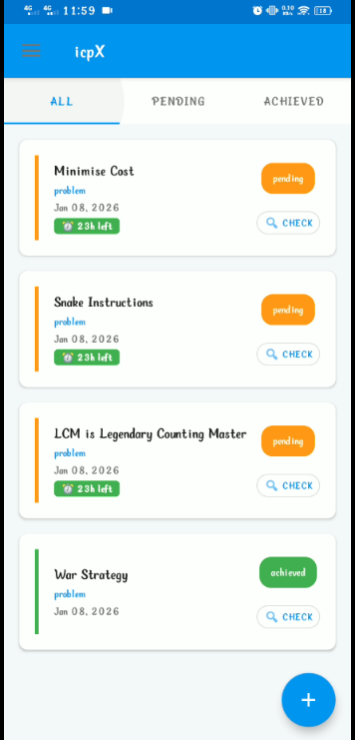
App overview (Android):
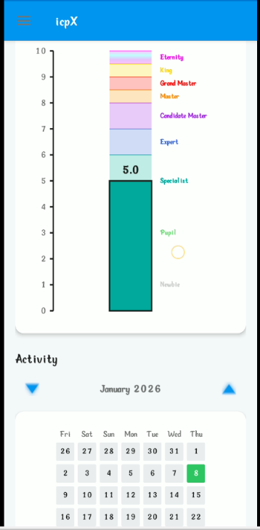
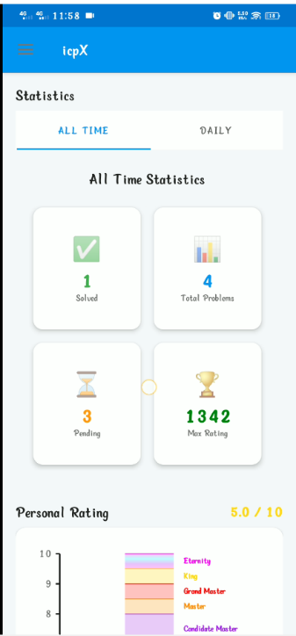

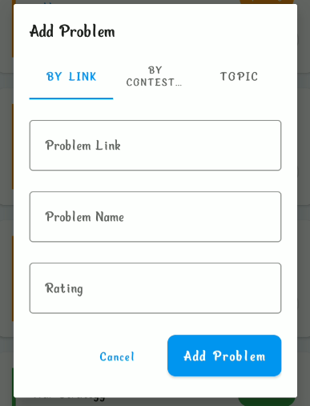
Dashboard Rating and Heatmap Contest Section
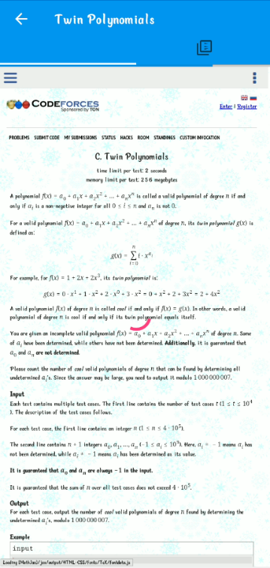
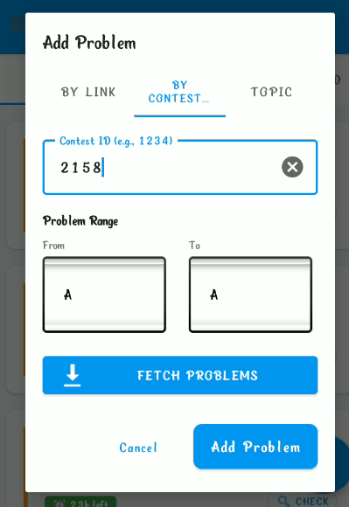

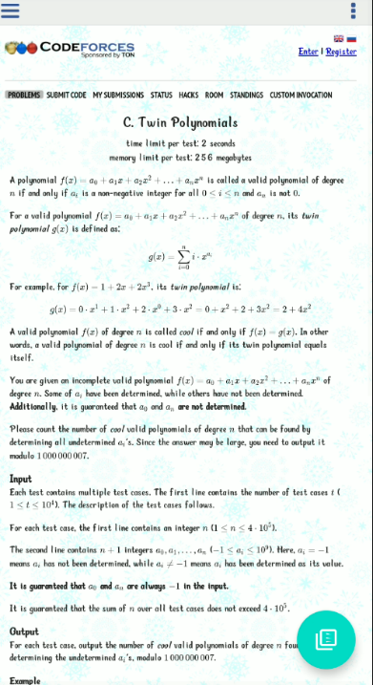
Add Problem (by Link) Add Problem (by ContstID)

Browse Problem
Generated PDF View PDF

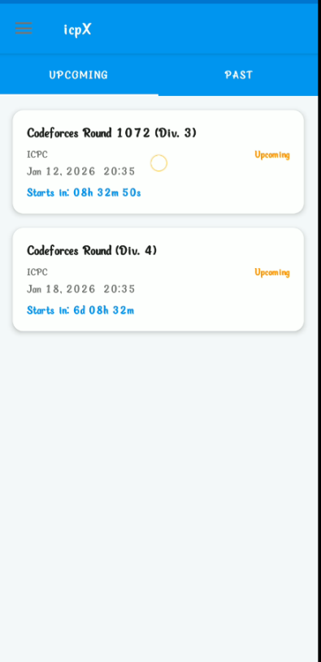

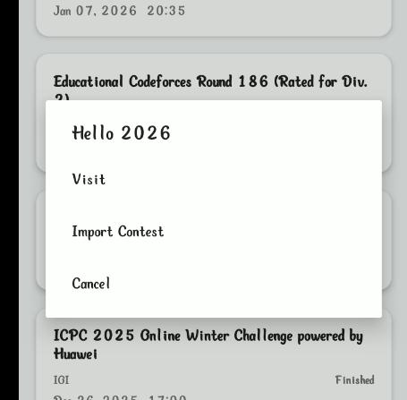
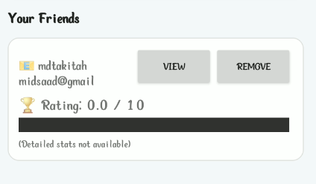

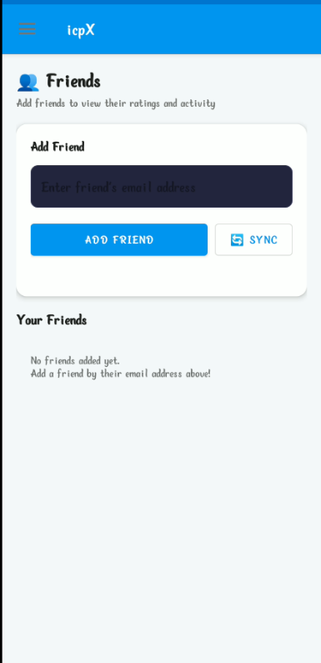
Contest Import Contest Friends Ratting

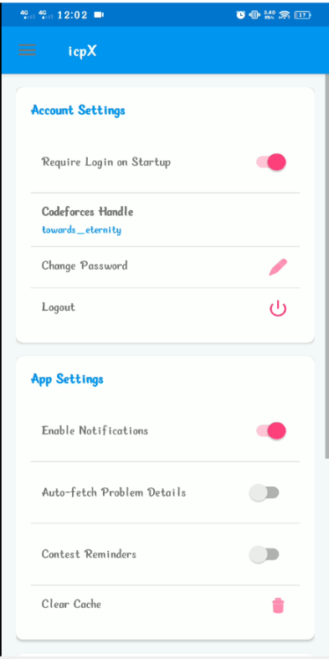

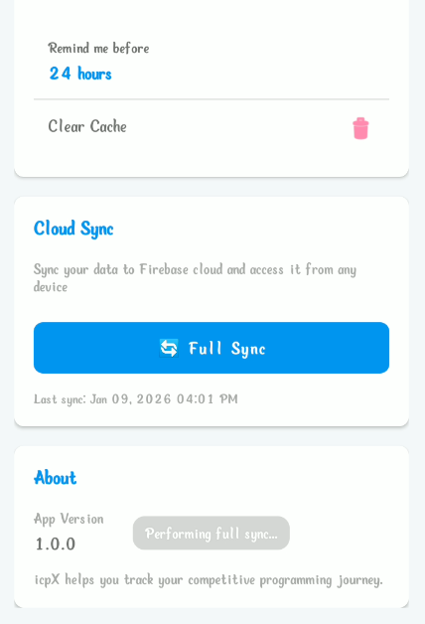

Friends Settings Cloud Feature

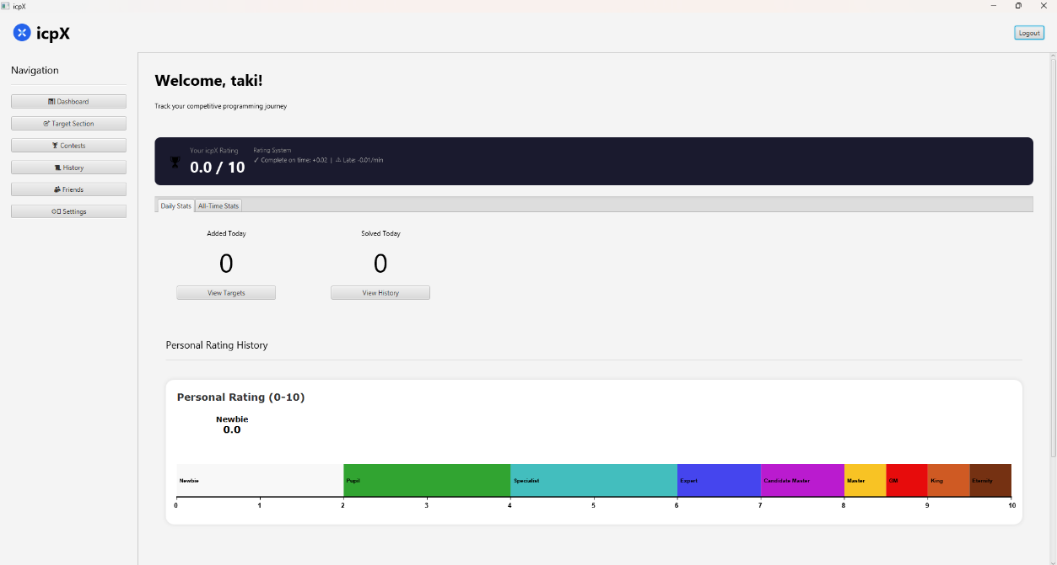
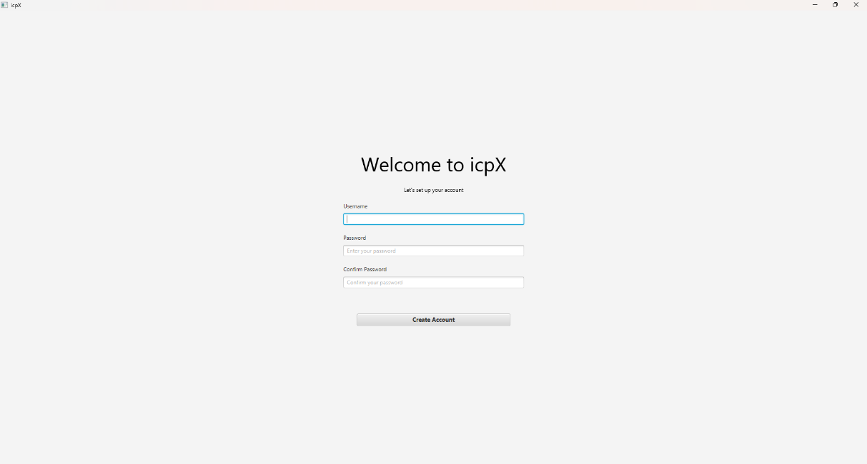
Create Account Screen

Dashboard
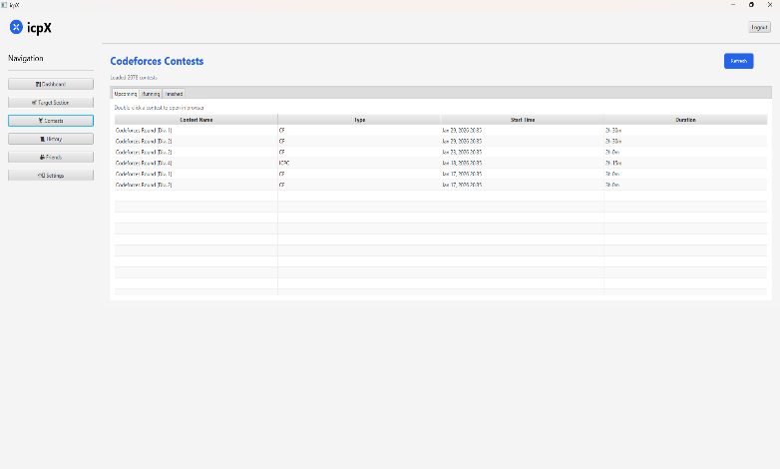

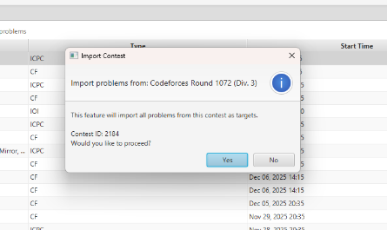

Import Contest Contests

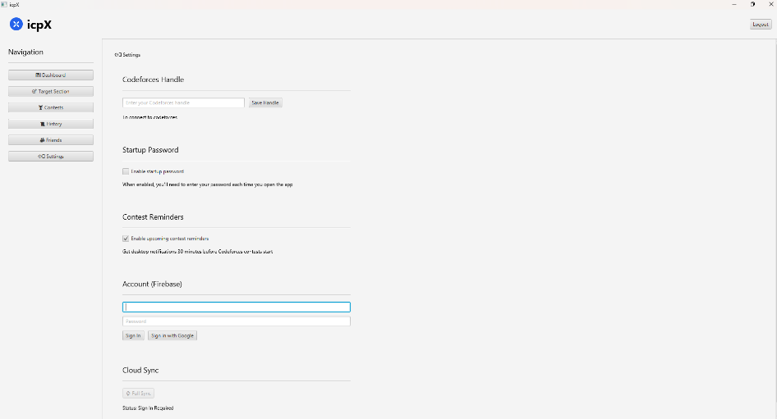

Settings
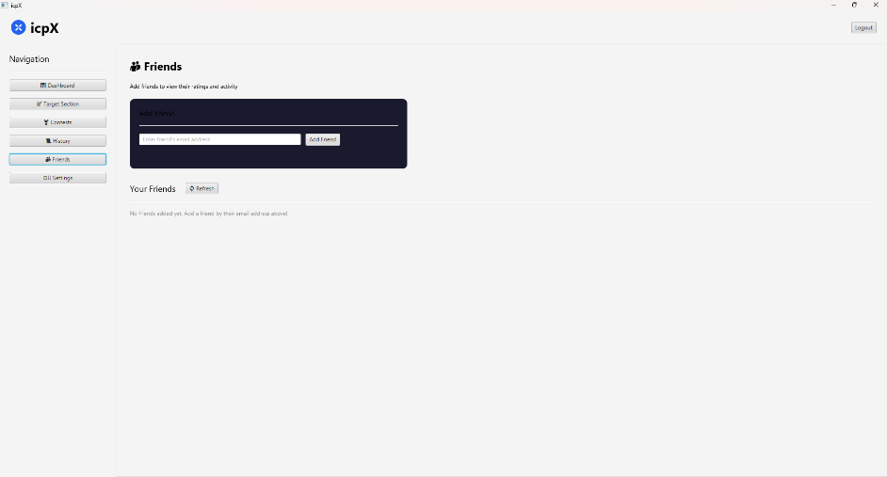

Friends
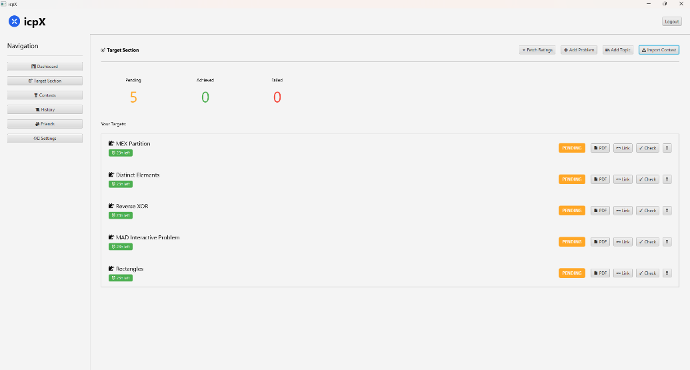

Target Sections

