

**Theory Assignment Report**

**Course Code:** CSE360

**Section:** 05

**Semester: Fall** 2021

**Submitted by:**

Tahmid Asif Sadman (ID:18101166)

Tasfia Binte Morshed (ID:18101173)

**Group Name: Sentinels**

**Submitted to:**

**MD. Tahmeed Abdullah**

Lecturer, Department of Computer Science &

Engineering, School of Data & Sciences, Brac

University.

**Submission Date:** 26th December 2021

**An Arduino based Smart Home Automation System**

**Introduction**

One of the most popular topics recently has been home automation. It is the process of automating a variety of household tasks, such as turning on the lights, various types of alarms, regulating various electrical gadgets, and security systems, to name a few. It is well-liked for its cost-effectiveness, ease of use, gadget availability, and security measures. Home automation systems are fast gaining popularity around the world, with disabled and elderly people among their end-users, yet they are not always accepted due to their complexity and cost. We've put together a home automation project that's both dependable and affordable. We designed this project with the goal of making it as user-friendly as possible while also aiding seniors, individuals with impairments, and those with other issues. To get past the product's license restrictions, this project also uses open-source software. This concept can be used to create a wide variety of home and security-related applications. Arduino is used to control sensors and actuators that monitor a specified location and take action based on variables like temperature, light, and item position. The Arduino may also send out notifications if it detects a problem, which is a function we used for security in our project.

**Application Area:**

* The method we created can be used in a variety of situations. Its primary benefits include increased comfort and security, as well as more effective use of energy and other resources, all of which result in significant cost savings. It also provides excellent tools for assisting and supporting the special requirements of people with impairments, particularly the elderly
* **Personal Safety:** We will use a fingerprint sensor at the door that recalls the owner's fingerprint and matches it every time someone tries to enter the home, providing the utmost level of security for the owner. The sensor sends a signal and a buzzer alerting the owner when someone tries to get in and their fingerprint does not match the one saved. In practice, this method might be used to design a simple security system that is both effective and cost-efficient.
* **Controlling Electrical Devices Easily:** We can easily operate lights, fans, air conditioners, and other electronic items using the proximity sensors based on the characteristics of objects. The lights will automatically activate when a person walks into a room or an office because the Infrared Proximity Sensors will detect the presence of a person close by and turn on all the lights and fans without any human interaction. So because gadgets will turn off immediately when no one or a certain object is present, it has the ability to make the entire system more efficient, organized, and, most importantly, energy-saving.
* **Smart Temperature Sensing System:** This can be inconvenient to manually regulate the temperature now and then. The DHT22 sensor can be used to automatically identify and modify the indoor temperature based on the user's request. It'll come in useful during weather extremes when you need to control the temperature on a frequent basis, and it'll be especially valuable for the elderly since no motion is necessary.
* **Humidity Sensing System:** The DHT22 sensor could also be used to enable automated humidity levels. It can also sense the temperature of the surrounding area. It can be used in a greenhouse as well as in the garden.
* **LPG/Smoke Detection System:** Both smoke and combustible materials are detected by the MQ-6 sensor. It's a low-cost sensor that may be linked to a buzzer to notify the user of a nearby gas leak. Because fire emits smoke, and the detector is sensitive to smoke, it can also warn a person if there is a fire. The device will also notify the local fire station during this process.

**Technology and tools:**

* Arduino Uno board
* Fingerprint sensor
* IR Proximity Sensor
* Temperature and Humidity sensor
* LPG and Smoke sensor (MQ6)
* LED
* Wires
* Breadboard
* Resistor

**Arduino Uno:**

The Arduino Uno is the most popular Arduino model. It is a low-cost accessible circuits platform developed by Arduino and based on the AVR microcontroller Atmega328. The Arduino Uno model we will be using in our project has a USB interface for uploading programming, 6 analog input pins (A0- A5), and 14 digital input/output ports (D0 - D13) for connecting to external electronic circuits. It also contains a Reset switch as well as TX/RX(D1/D0) for transmitting and receiving data.

**Fingerprint sensor :**

Fingerprint sensor modules have increased the accessibility and ease of incorporating fingerprint recognition into projects. This has simplified the process of collecting, comparing, registering, and searching fingerprints. These modules include FLASH memory for fingerprint storage and are compatible with any serial port system that supports TTL signals. To operate this device, a DC voltage source between 3.6 and 6.0V and a current supply of 120mA are required.

**IR Proximity Sensor/ PIR :**

The IR Proximity Sensor is a type of sensor that can detect obstacles. This multifunctional sensor is used in a wide variety of robotic applications where obstacle detection is required. A sensor that is active infrared emits and is able to detect its own infrared rays. A passive infrared sensor detects only the IR Rays emitted by objects. A PIR Sensor is an excellent passive infrared sensor. On IRR Sensors, we have IR transmitter and receiver LEDs. When the angle of the light and the sensor cross paths over a significant distance, the output is HIGH (+5v). When an obstacle is present, the angle of the IR wave is reduced and the receiving LED is unable to detect it. As an outcome, a LOW signal will be generated (0v).

**Temperature and Humidity sensor (DHT22) :**

This device is a humidity and temperature sensor that is widely used. The sensor features high temperature precision and an 8-bit microprocessor that outputs temperature and relative humidity readings as serial data. It is used to determine temperature range of -40 to 80°C with a precision of 0.5°C and humidity in the range of 0-100 percent with a precision of 2-5 percent. This device requires between 3 and 5 volts of power to operate. This device consumes a maximum of 2.5mA of current.

**Programming Language:**

Due to the fact that we are using an Arduino Uno as our mainboard, we will now be developing our system using the unique language based on the Arduino IDE. We'll include the library for each sensor that we're going to use in this project.

**Working Mechanism of sensors:**

**Fingerprint Optical Sensor :**

The optical sensor will cast a bright light across a fingerprint and capture a digital image. The integrated light-sensitive microchip creates the digital photo by converting the ridges and valleys of the fingerprint image to 1's and 0's and going to generate the user's passcode. By comparing this personal code with the one stored in memory, it will send us a boolean 0/1 value. This data can be used to identify unidentified individuals.

**PIR Sensor :**

This sensor is capable of detecting various wavelengths of infrared radiation. Everything releases various degrees of radiation, which increase in proportion to the object's temperature. It has two slots, each of which is made of a sensitive substance. The Fresnel lens is needed to ensure that the PIR's two slots can view beyond a certain distance. When the sensor is turned off, both slots get the same quantity of IR. The ambient quantity radiates from the outside, the walls, and the interior, among other places. When a person passes by, the PIR sensor's first slot is intercepted, resulting in a positive difference between both the two bisects. Additionally, when someone exits the region, the sensor produces a negative difference between the two bisects. Our system will utilize this information to determine the presence of a person.

**Temperature and Humidity sensor:**

Humidity sensors have two electrodes separated by a moisture-absorbing substrate. When the humidity level varies, the conductivity of this substrate or the resistance between the electrodes changes. This data is sent to a microcontroller via an integrated circuit (IC) that measures and processes changes in resistance. Second, this sensor uses a thermistor or a negative temperature coefficient to monitor temperature. Temperature fluctuations alter the resistance of a thermistor. A sintering of semi-conductive materials such as ceramics or polymers results in a substantial change in resistance with a modest temperature change.

**LPG and Smoke sensor (MQ6):**

A stainless-steel mesh encloses a sensor made of aluminum oxide ceramic and tin dioxide (SnO2). Using six wires, a sensor is hooked to the device. The sensing element is heated by two leads, and the output signals are sent by the other four. When sensing material is heated in the air at a high temperature, oxygen is absorbed by the material's surface. The oxygen then attracts donor electrons within the tin oxide, stopping the flow of current. The amount of free electrons increases when smoke or any gas other than oxygen is present. The sensor generates analog voltage readings as a result of this passage of current. Gas concentration influences these voltage values, with higher concentrations yielding higher voltages.

**Connection with Arduino:**

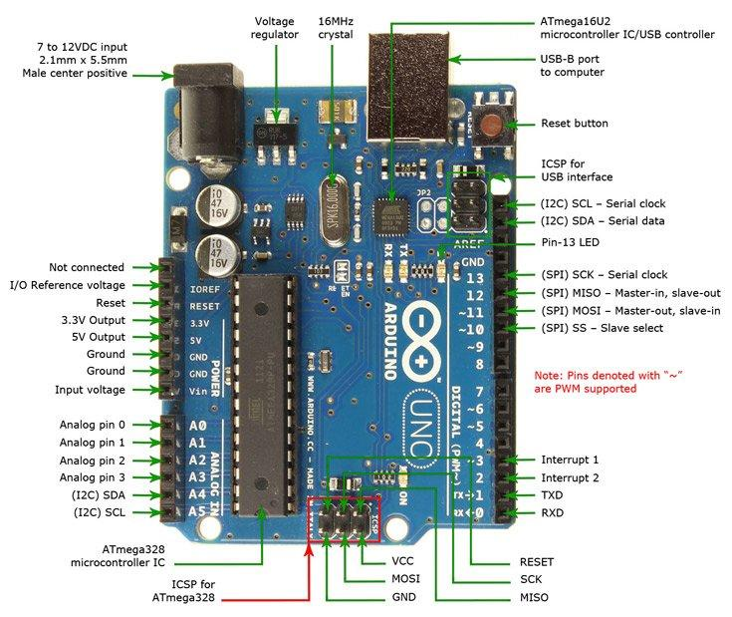

Figure - Arduino Uno and its pins

**The connection of PIR sensor:**

The sensor's VCC and GND pins will be connected to the Arduino's 5V and GND pins, respectively, to complete the circuit. To complete the circuit, we wired the motion sensor's output signal pin to the Arduino's digital pin 7.

**The connection of Fingerprint Optical Sensor:**

Since the fingerprint sensor must communicate serially with the Arduino, it will be attached to the RX(Digital pin 0) and TX(Digital pin 1) pins on the board. Because another sensor will require 5 volts from Arduino, we'll need a separate power source with a resistor.

**The connection of Temperature and Humidity sensor:**

Digital output is provided by the DHT22 sensor. Using the DHT22's digital pin 4, we'll receive data. The sensor's VCC and GND will be connected to the Arduino's GND pin with an additional 5 volts.

**LPG and Smoke sensor (MQ6):**

We will use the Arduino's analog pin (A0) to connect the MQ6 sensor's analog output. Using the Arduino's onboard 5V supply for another sensor necessitates a separate power supply and resistor.

**Circuit Diagram:**

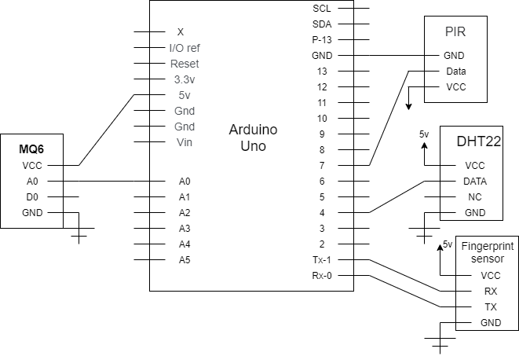

**Data flow from sensors through ICs to I/O devices:**

**PIR sensor:**

When the PIR sensor detects a person in the room, it will send a digital output to the Arduino, which will be processed by the Arduino code, and a signal to turn on the light will be sent. Automatic control of the room's lighting is provided.

**Fingerprint Optical Sensor:**

In order to interact with the Arduino serially, the fingerprint sensor will be linked to the RX (Digital pin 0) and TX (Digital pin 1) pins. Sends an Arduino signal to open the door lock when the fingerprint matches existing fingerprint information. Arduino, on the other hand, will send a signal to the buzzer if it does not match.

**Temperature and Humidity sensor:**

The given sensor will give digital data to the Arduino.

**LPG and Smoke sensor (MQ6):**

We will use the Arduino's analog pin (A0) to link the MQ6 sensor's analog output. As a result, the analog value of the MQ6 will rise when the gas concentration is high, and an Arduino signal will be generated when the DHT22 temperature rises to a certain level.

**Estimated Cost Analysis**

There are some consumers who are put off by the cost of smart home technologies. A completely public software platform, Arduino, is used for this project, which is created with off-the-shelf components. Thus, the total implementation cost is quite modest and accessible to the average person. The projected costs are listed in the table below:

| **Components** | **Price (BDT)** |
| --- | --- |
| Arduino Uno R3 (China) | 650 |
| PIR Sensor | 88 |
| LPG and Smoke sensor (MQ6) | 149 |
| Temperature and Humidity sensor (DHT22) | 450 |
| Fingerprint sensor | 4,100 |
| Wire | 100 |
| Breadboard | 99 |

**Workplan(Gantt Chart):**

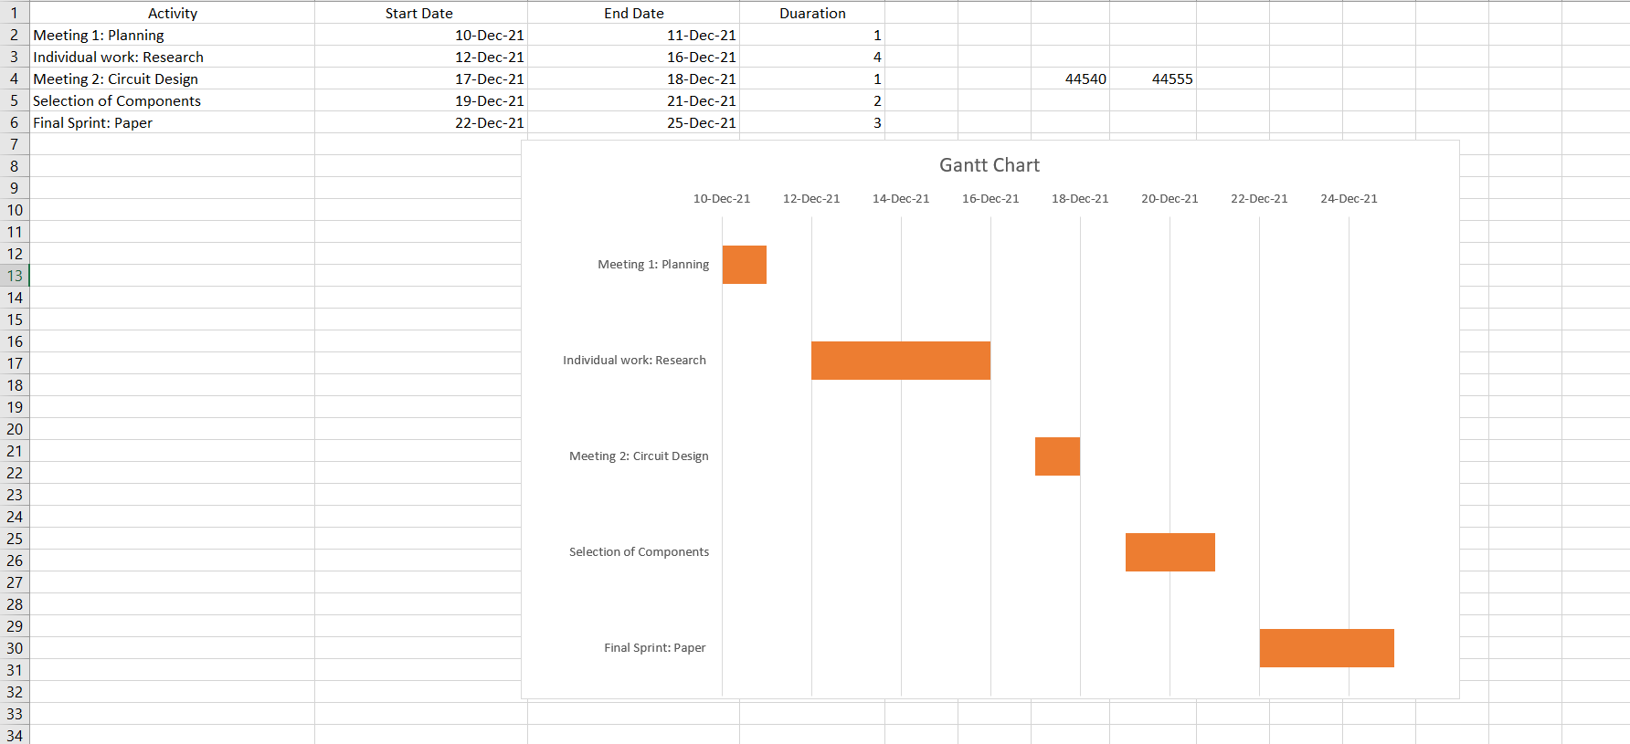

**Conclusion**

A cost-effective and effective smart home solution was shown in this article. It teaches you the fundamentals of automating your home's electrical devices while also keeping you and your family safe. In the future, we hope to make it even better by including more automated methods like machine learning and by making it more accessible and less expensive. In addition, we plan to leverage artificial intelligence to make the system self-aware, making it more reliable, and enabling consumers more access to the information it provides. Raspberry Pie is the next version we plan to release, which will include even more functionality and connectivity. In the case that new sensors or more cost-effective technologies become available, we plan to improve the system as well.

**Reference**

1. Arduino Uno R3 (China), Model: ARD-00028, TechshopBD, Bangladesh https://bdspeedytech.com/index.php?route=product/product&path=10&product_id=1724

2.PIR Motion Sensor

https://store.roboticsbd.com/sensors/23-pir-motion-sensor.html

3. DHT22 Digital Temperature Humidity Sensor Module

https://store.roboticsbd.com/sensors/923-dht22-digital-temperature-humidity-sensor-module-robotics-bangladesh.html

4. Smoke Sensor (MQ-6), Model: SEN-00094, TechshopBD, Bangladesh https://store.roboticsbd.com/sensors/675-mq-6-lpg-gas-sensor-robotics-bangladesh.html

5. What is MQ6 Gas Sensor?, *How MQ6 Gas/Smoke Sensor Works? & Interface it with Arduino*, Last Minute Engineers

https://lastminuteengineers.com/mq2-gas-senser-arduino

tutorial/#:~:text=MQ6%20is%20one%20of%20the,sensors%20in%20MQ%20sensor%20series. &text=MQ6%20Gas%20sensor%20works%20on,anywhere%20from%20200%20to%2010000p pm.

6. FPM10A Optical Fingerprint Reader Sensor Modules (With Shield), Robotics BD https://store.roboticsbd.com/sensors/553-fpm10a-optical-fingerprint-reader-sensor-modules robotics-bangladesh.html

7. Adafruit Fingerprint Sensor, Model: ADFC-751, Electan

https://www.electan.com/fingerprint-sensor-p-7499-en.html