8

CSE251 (Electronic Circuits) Projects

# A. Project Description

As a part of the course CSE251, the students have to choose a project from the list given below:

|  |  |
| --- | --- |
| **SI** | **Project Title** |
| 1 | Sound detector circuit using op-amp 741 |
| 2 | LM386 Audio Amplifier |
| 3 | Digital Thermometer Circuit |
| 4 | 5V Power Supply Voltage Monitoring |

N.B.: The details description of the projects can be obtained in page 3-8.

To complete the project, the students have to complete the following tasks:

1. Designing the circuit of the selected project in a hierarchical style and explain its operation.
2. Simulation of the designed circuit using any of the mentioned simulating software PSpice/ OrCAD/ LTspice/ ADS.
3. Construction of the circuit on the breadboard and demonstration of the project to instructor.
4. Project Report
5. Project Defense

# B. Project Evaluation Rubrics

|  |  |  |
| --- | --- | --- |
|  | **Max.** | **Awarded** |
| **A. Report** |  |  |
| 1. Introduction / Problem statement |  |  |
| 1. Circuit Design |  |  |
| 1. Simulation results (Screen shots) |  |  |
| **B. Circuit Construction and Testing** |  |  |
| 1. Design Style, effectiveness and accuracy |  |  |
| 1. Circuit construction |  |  |
| 1. Accuracy of the circuit outputs |  |  |
| **C. PSpice Simulation** |  |  |
| 1. Compile without errors |  |  |
| 1. Error free during runtime |  |  |
| 1. Accuracy of simulation output |  |  |
| **D. Presentation and Demonstration** |  |  |
| 1. Content of the Presentation |  |  |
| 1. Presentation Skills |  |  |
| 1. Participation/Group Dynamics |  |  |
| **E. Soft Skill: Communication Skill (Psychomotor Domain)** |  |  |
| 1. The ability of present ideas clearly, effectively and confidently in both oral and written forms |  |  |
| 1. The ability to practice active listening skills and provide feedback. |  |  |
| **TOTAL** |  |  |

**CSE251 Project descriptions**

# 1. Sound Detector Circuit using Op-amp 741.

# Background

The circuit diagram of sound detector circuit using op-amp 741 is shown in figure 1. The heart of the circuit is op-amp 741 which is used in order to sense the vibrations of sound waves condenser microphones. Sometimes due to lack of concentration and our ignorance, we are unable to hear anything around us. And, that could lead to unfortunate misfortunes which could have been avoided with appropriate precautions. This circuit called ‘Sound Scanner’ is what detects vibrations of the sound waves and amplifies it to be heard distinctly by human ears. As per the design of the scanner, it works efficiently within the 6 meters limit around the vicinity where it is fixed. This set up can be done in any desirable places like car porches and at the corners of house. As soon as a microphone incorporated in the project detects sound wave vibration, the sound detector circuit using op-amp 741 produces beep sounds to alert people around that area.

# Circuit Diagram

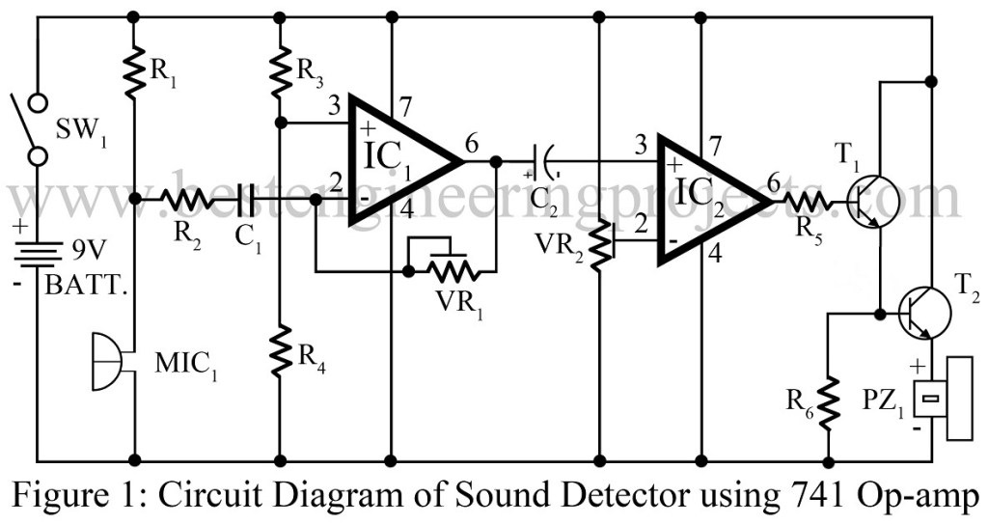

Figure 1: Schematic of sound detector using op-amp 741.

# Equipment List

**Resistors**

R1 = 2.8 KΩ

R2 = 4.7 KΩ

R3, R4, R6 = 10 KΩ

R5 = 1 KΩ

VR1 = 1 MΩ

VR2 = 100 KΩ

**Capacitors**

C1 = 0.47 µF

C2 = 10 µF/16V

**Semiconductors**

IC1, IC2 = LM741C

T1, T2 = BC548

**Miscellaneous**

MIC1 = Condenser Microphone

PZ1 = Piezo Buzzer

SW1 = On/Off Switch

9V battery

# Circuit Description

The circuit diagram of sound detector circuit using op-amp 741 is shown in figure 1. The heart of the circuit is op-amp 741 which is used in order to sense the vibrations of sound waves condenser microphones. The sensitivity of the condenser microphone is adjusted by the value of resistor R1 used in the circuit. Once the microphone detects sound vibrations, it picks them up and converts into electrical signals. The output of microphone is fed as input to the pin 2 of IC1 via coupling capacitor C1. Then the signal undergoes amplification and it is forwarded to IC2(IC 741C) which in this project serves as a comparator device.

The non-inverting pin 3 of IC2 receives input from amplified output signal of IC1 through another capacitor C2. In the same way, an inverting pin 2 of IC2 fetches input signal from a reference voltage passed via voltage controller VR2.

At the final stage, IC2 output is fed as triggering input pulse to Darlington pair transistors T1 and T2. A piezo-buzzer which is connected at the end of transistor T2 i.e. at the emitter terminal is that component responsible to produce beeping sound at the end of operations followed throughout the entire circuit.

The fascinating fact about the project sound detector circuit using op-amp 741 is that it can be designed within a small area on a PCB or Veroboard as well. To attain maximum possible gain of IC1 and sensitivity of IC2, adjust the respective values of potentiometer VR1 and VR2 as stated in the earlier paragraphs.

During practical implementations of the project, if the beeping sound from piezo-buzzer goes on and on and doesn’t stop, set the wiper of VR2 towards the ground line. For faultless circuit, follow the instructions given below:

Fix the piezo-buzzer at a place where people can hear and sensor at appropriate place where you need continuous monitoring. So as to extend the sensitivity of the microphone, connect it using two-core shielded wire and enclose it in a small case. To avoid noises from AC mains, battery supplies are highly recommended for this particular project.

# 2. LM386 Audio Amplifier

Here is a simple audio amplifier circuit built around 8-pin integrated circuit LM386. The prototype is shown in Figure 2 below.

# Circuit Diagram

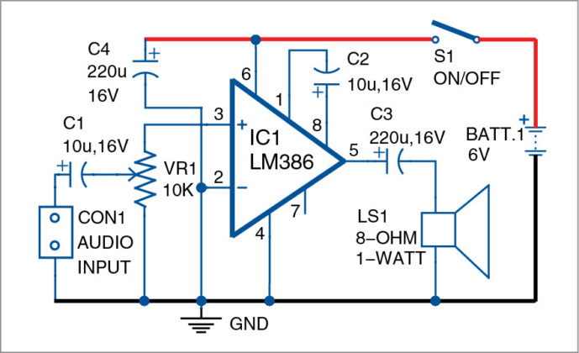

Figure 2: Schematic of LM386 audio amplifier.

# Equipment List

**Resistors**

VR1 = 10 KΩ

**Capacitors**

C1, C2 = 10 µF/16V

C1, C2 = 220 µF/16V

**Semiconductors**

IC1 = LM386 Low power amplifier

T1, T2 = BC548

**Miscellaneous**

CON1 = Two pin connector

LS1 = 8 ohm, one-watt loudspeaker

S1 = On/Off Switch

6V battery

2-pin terminal connector for battery

# Circuit Description

Circuit diagram of the LM386 audio amplifier is shown in Fig. 2. It is built around popular amplifier LM386 (IC1), an 8-ohm, one-watt speaker (LS1), four capacitors and a few other components. A 6V battery is used to power this project.

Four electrolytic capacitors [two 10µF, 16V (C1 and C2) and two 220µF, 16V (C3 and C4)] are used in this circuit. C1 is connected to the middle terminal of 10k potmeter VR1. C2 is connected to pins 1 and 8 of IC1. Pin 5 of IC1 is its output terminal, which is connected to speaker LS1 through C3.

C4 is connected to the positive terminal of 6V battery and ground. Positive side of 6V is connected to pin 6 of IC1 and the other side to ground terminal to pin 4.

Inverting pin 2 of IC1 is connected to ground and non-inverting pin 3 is connected to the input terminal through VR1. Audio input is fed to CON1. VR1 is used to control volume.  
Construction and testing

An actual-size, single-side PCB for LM386 amplifier is shown in Fig. 3 and its component layout in Fig. 4. After assembling the circuit on a PCB, enclose it in a suitable box. Fix connector CON1 on the front panel for input and loudspeaker LS1 at the rear side of the box. Connect VR1 on the front panel for controlling the volume

Before using this project, test it using the 6V battery. Connect the 8-ohm, one-watt speaker to output pin 5 of IC1 through C3. Switch on S1 and keep VR1 to its mid position. Now, take a screw-driver and gently touch it on input terminal pin 3 of IC1. You should hear a humming sound from the speaker. This will confirm that your circuit is working and ready to use.

***Note.***LM386 provides output of 250 milliwatts to one watt depending on supply voltage and load. Refer its data sheet for details.

# 3. Digital Thermometer Circuit.

# Background

This digital thermometer circuit based on Op amp can measure temperatures up to 150°C with an accuracy of ±1°C. The temperature is read on a 1V full scale-deflection (FSD) moving-coil voltmeter or digital voltmeter. Schematic of the project diagram is shown in Figure 3 below.

# Circuit Diagram

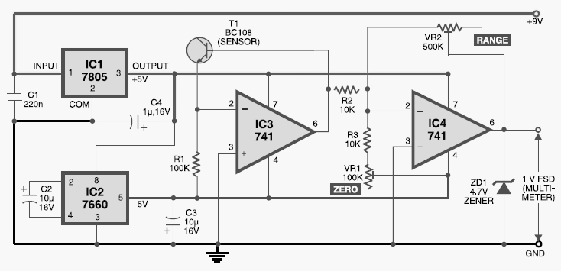

Figure 3: Digital thermometer circuit schematic.

# Equipment List

1. Operational amplifier IC3 & IC4 (IC 741)

2. Voltage regulator IC1 (IC 7805)

3. Voltage regulator IC2 (IC 7660)

4. npn transistor T1 (BC108)

5. Zener diode ZD1 (4.7V)

6. Variable resistors VR1 (0-100K) & VR2 (0-500K)

7. Resistors R1 (100K), R2 (10K) & R3 (10K)

8. Capacitors C1 (220n), C2 & C3 (10u, 16V) & C4 (1u, 16V)

9. DC supply (9V)

# Working Principle

Operational amplifier IC 741 (IC3) provides a constant flow of current through the base-emitter junction of npn transistor BC108 (T1). The voltage across the base-emitter junction of the transistor is proportional to its temperature. The transistor used this way makes a low-cost sensor. The silicon diode can be used instead of transistor. The small variation in voltage across the base-emitter junction is amplified by second operational amplifier (IC4), before the temperature is displayed on the meter. Preset VR1 is used to set the zero-reading on the meter and preset VR2 is used to set the range of temperature measurement.

Operational amplifiers IC3 and IC4 operate off regulated ±5V power supply, which is derived from 3-terminal positive voltage regulator IC 7805 (IC1) and negative low-dropout regulator IC 7660 (IC2). The entire circuit works off a 9V battery. Assemble the circuit on a general-purpose PCB and enclose in a small plastic box. Calibrate the thermometer using presets VR1 and VR2. After calibration, keep the box in the vicinity of the object whose temperature is to be measured.

# 4. 5V Power Supply Voltage Monitoring

# Background

This circuit is a very simple voltage monitoring device for +5V VCC supply lines. For example, it can be used to monitor the power supply of a microcontroller by indicating when the supply level raises above a pre-defined value. The output of the circuit can interface directly to digital logic, reset the microcontroller or turn off the connected microcontroller circuitry before it goes toasted owing to an improper power supply voltage. The ‘proof of concept’ is verified using the eternal single supply dual operational amplifier LM393. A schematic of the project circuit is shown in Figure 4 below.

# Circuit Diagram

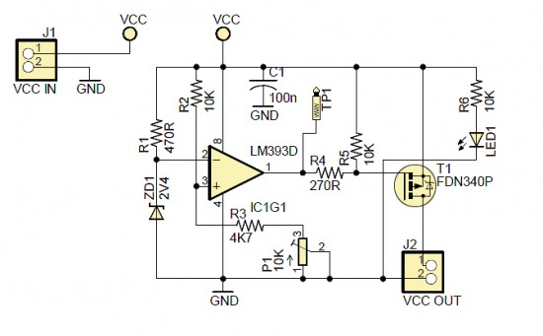

Figure 4: Schematic of 5V power supply voltage monitoring circuit.

# Equipment List

1.Single supply dual operational amplifier (IC 393D)

2. PMOS transistor (FDN340P)

3. Zener diode ZD1 (2.4V)

4. LED

5. Potentiometer P1 (0-10K) & VR2 (0-500K)

6. Resistors R1 (470R), R2, R5 & R6 (10K), R3 (4.7K), R4 (270R)

7. Capacitors C1 (220n)

8. DC supply (+5V)

Note:

* Pin 2 of IC1: +2.4V (fixed)
* Pin 3 of IC1: +2.2V (variable; based on the actual setting of P1)
* TP1 (Pin 1 of IC1): Low (L) – Level

# Working Principle

The LM393 consist of two independent voltage comparators that are designed to operate from a single supply over a wide range of voltages (2V-36V). The outputs can be connected to other open-collector outputs to achieve wired-AND relationships. The comparator compares two voltages, IN1 at the inverting (–) input and IN2 at the inverting (+) input. When IN2 < IN1, the comparator output is pulled Low, i.e. to GND, almost. When IN2 > IN1, the output is driven High, i.e. to nearly the positive rail voltage. The 2.4 V Zener diode (ZD1) and the 470 Ω resistor (R1) form a shunt voltage regulator used to set up a reference voltage (IN1) of 2.4V at the inverting input. The 10K multi-turn preset potentiometer (P1) enables IN2 at the non-inverting input to be set below the 2.4V threshold when the supply voltage (VCC) is at 5V.

The output of the comparator LM393 (IC1) will then be driven Low, consequently the PMOS -FDN340P (T1) is turned on also. Now the input supply is extended to the rest of the circuit through the PMOS. However, when VCC exceeds 5V, IN2 goes above the level of IN1. This causes the comparator output to be driven to the positive supply voltage. This causes the PMOS to turned off.