

**EAST WEST UNIVERSITY**

**Course Name:** Electronics Circuit

**Course Code:** CSE251

**Section No:** 2

**Project Report:** Sound detector circuit using op-amp 741

**Submitted To:**

Surajit Das Barman

Senior Lecturer,

Dept. of Computer Science and Engineering,

East West University.

**Submitted By:**

Shaykh Siddique ID: 2016-1-60-053

Jannatun naym ID: 2016-1-60-119

Noor-e-jannat ID: 2016-1-60-067

**Project Name:** Sound detector circuit using op-amp 741

**Introduction:**

The Sound Detector is a small board that combines a microphone and some processing circuitry. It provides not only an audio output, but also a binary indication of the presence of sound, and an analog representation of its amplitude.

The user can detect sound-waves, whether it comes from skies, the earth, or the seas. Anything that generates noise, sound, sonic waves, or vibrations, the user can detect where ever the source comes from.

Apart from, an operational amplifier (op-amp) is a DC-coupled high-gain electronic voltage amplifier with a differential input and, usually, a single-ended output. In this configuration, an op-amp produces an output potential (relative to circuit ground) that is typically hundreds of thousands of times larger than the potential difference between its input terminals. Operational amplifiers had their origins in analog computers, where they were used to perform mathematical operations in many linear, non-linear and frequency-dependent circuits.

The popularity of the op-amp as a building block in analog circuits is due to its versatility. Due to negative feedback, the characteristics of an op-amp circuit, its gain, input and output impedance, bandwidth etc. are determined by external components and have little dependence on temperature coefficients or manufacturing variations in the op-amp itself.

# Objectives:

* To capable of picking a sound within the 6 meters
* Analyze the sound
* And transform it to a electrical sound

# Circuit Diagram:

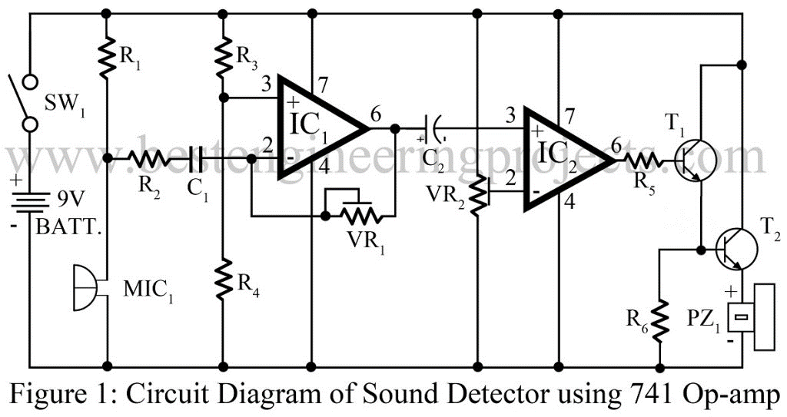

Figure 1: Schematic of sound detector using op-amp 741.

# Equipment List:

**Resistors**

R1 = 2.7 KΩ

R2 = 4.7 KΩ

R3, R4, R6 = 10 KΩ

R5 = 1 KΩ

VR1 = 1 MΩ

VR2 = 100 KΩ

**Capacitors**

C1 = 0.47 µF

C2 = 10 µF/16V

**Semiconductors**

IC1, IC2 = LM741C

T1, T2 = BC548

**Miscellaneous**

MIC1 = Condenser Microphone

PZ1 = Piezo Buzzer

SW1 = On/Off Switch

9V battery

# Circuit Description:

The circuit diagram of sound detector circuit using op-amp 741 is shown in figure 1. The heart of the circuit is op-amp 741 which is used in order to sense the vibrations of sound waves condenser microphones. The sensitivity of the condenser microphone is adjusted by the value of resistor R1 used in the circuit. Once the microphone detects sound vibrations, it picks them up and converts into electrical signals. The output of microphone is fed as input to the pin 2 of IC1 via coupling capacitor C1. Then the signal undergoes amplification and it is forwarded to IC2(IC 741C) which in this project serves as a comparator device.

The non-inverting pin 3 of IC2 receives input from amplified output signal of IC1 through another capacitor C2. In the same way, an inverting pin 2 of IC2 fetches input signal from a reference voltage passed via voltage controller VR2.

At the final stage, IC2 output is fed as triggering input pulse to Darlington pair transistors T1 and T2. A piezo-buzzer which is connected at the end of transistor T2 i.e. at the emitter terminal is that component responsible to produce beeping sound at the end of operations followed throughout the entire circuit.

The fascinating fact about the project sound detector circuit using op-amp 741 is that it can be designed within a small area on a PCB or Veroboard as well. To attain maximum possible gain of IC1 and sensitivity of IC2, adjust the respective values of potentiometer VR1 and VR2 as stated in the earlier paragraphs.

During practical implementations of the project, if the beeping sound from piezo-buzzer goes on and on and doesn’t stop, set the wiper of VR2 towards the ground line. For faultless circuit, follow the instructions given below:

Fix the piezo-buzzer at a place where people can hear and sensor at appropriate place where you need continuous monitoring. So as to extend the sensitivity of the microphone, connect it using two-core shielded wire and enclose it in a small case. To avoid noises from AC mains, battery supplies are highly recommended for this particular project.

# Simulation:

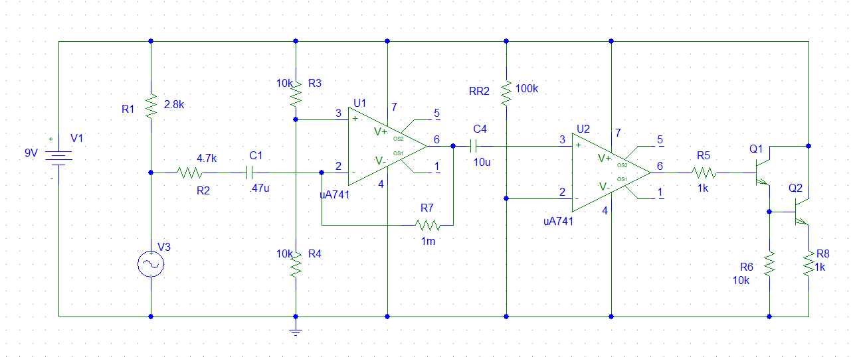

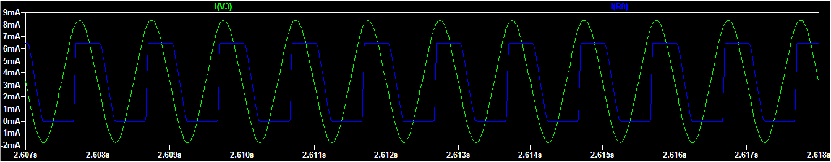

As there comparator amplifier is using so when the input signal from the microphone is equal or less than Zero (0) then the output signal is also zero. Highest value of output signal is also at fix point. 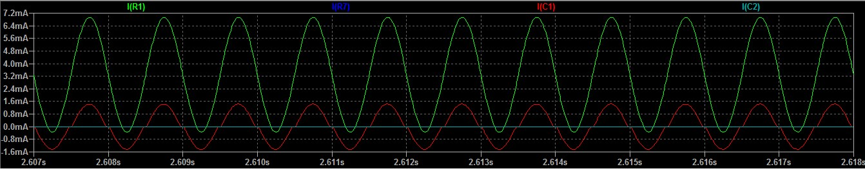

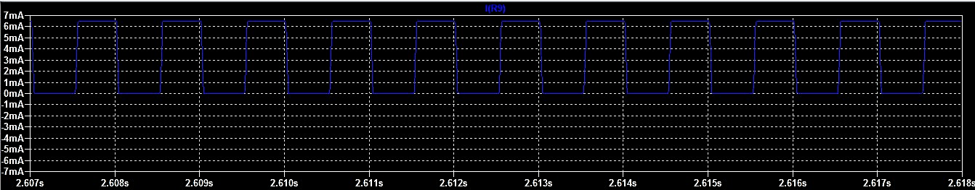

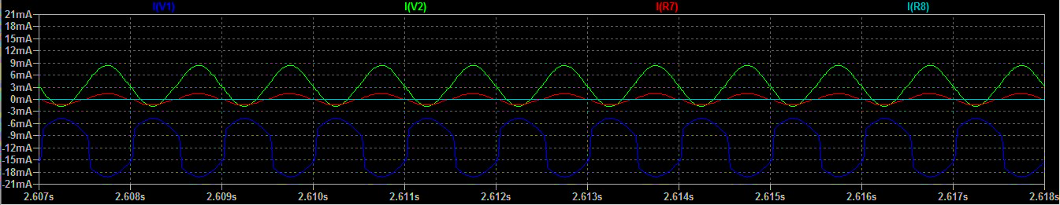

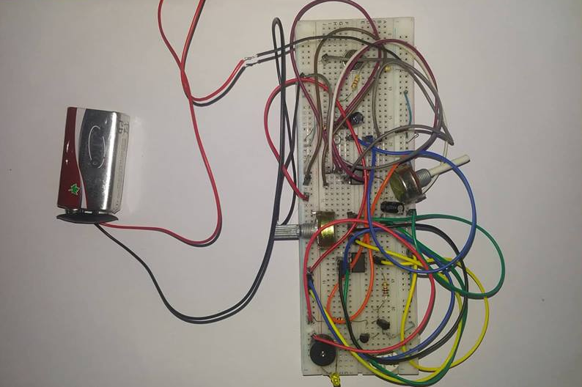

**Conclusion:**

We have made a sound detector circuit in this project which is much efficient .The circuit can easily detect a sound and gives clear output signal. It has so many fruitful applications. It can be easily used in security system, alarming device and etc.