

**EAST WEST UNIVERSITY**

**Course Title:** Database Systems

**Course Code:** CSE301

**Section No:** 3

**Project: Tourism Management System**

**Submitted To:**

Mohammad Rezwanul Huq, PhD

Assistant Professor,

Department of Computer Science and Engineering,

East West University.

**Submitted By:**

Name: Shaykh Siddique

ID: 2016-1-60-053

Name: Ashik Ahmmed

ID: 2016-1-60-098

Name: Tanmay Kirtania

ID: 2016-1-60-071

Department of Computer Science and Engineering,

East West University.

ER Model

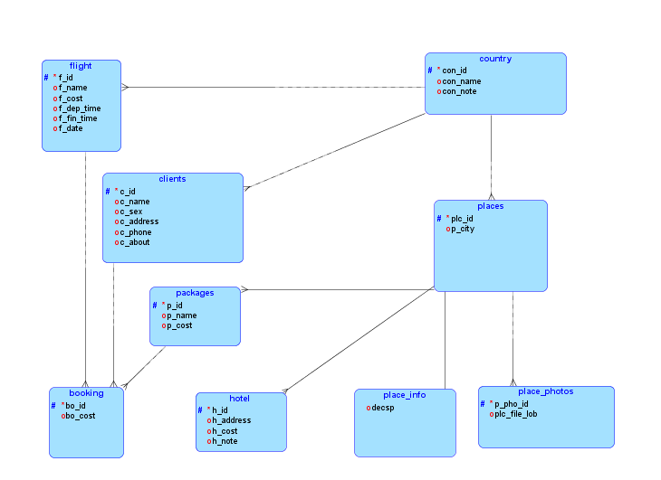

Here we use 9 inter related tables. In the client relation we will store client info as well as packages and flight relation. From the booking relation we can browse any of those information easily. Using these information booking table will store the total cost for the tour.

Reducing Relational Model from ER Diagram