

**EAST WEST UNIVERSITY**

**Course Title:** Database Systems

**Course Code:** CSE301

**Section No:** 3

**Assignment No:** **3**

**Application Name: University Database**

**Application Link: https://goo.gl/moA2EM**

**Submitted To:**

Mohammad Rezwanul Huq, PhD

Assistant Professor,

Department of Computer Science and Engineering,

East West University.

**Submitted By:**

Name: Shaykh Siddique

ID: 2016-1-60-053

Name: Ashik Ahmmed

ID: 2016-1-60-098

Name: Tanmay Kirtania

ID: 2016-1-60-071

Department of Computer Science and Engineering,

East West University.

**University Database**

**Application live link: https://goo.gl/moA2EM**

**Introduction:** This is a simple application over university database management.

**Description:** The application contains seven pages. Including Home page there are **Course and Department** (Master Detail page), **Course** (Form & Report), **Student Ratio** (Chart), **Prerequisite Info** (Form & Report), S**tudent Info** (Form & Report), **Instructor Ratio** (Chart).

Course and Department page is a master detail page which use course and department relations. The page helps us to find out all course information offered by each department.

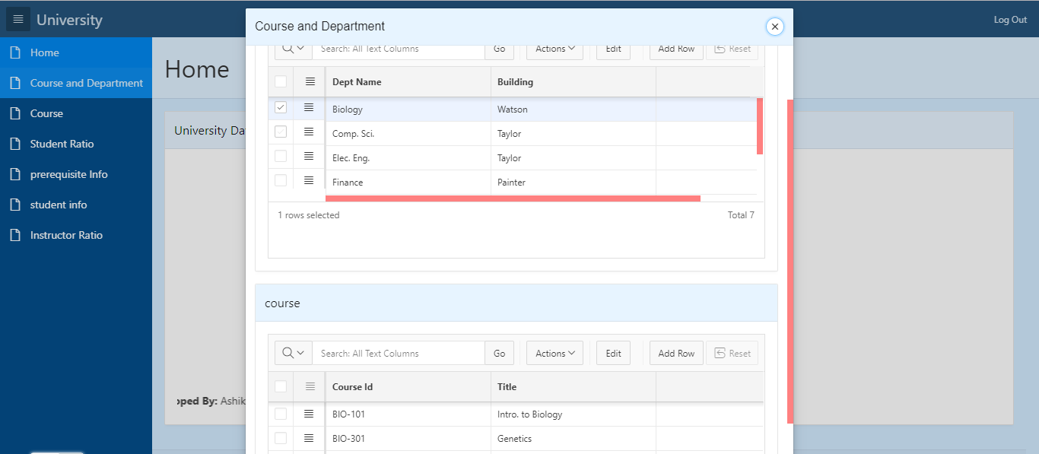

The next course page contain all the course information. Using form and report type page, here admin can insert new course offered by any department. Search bar will also help admin to find any course related information.

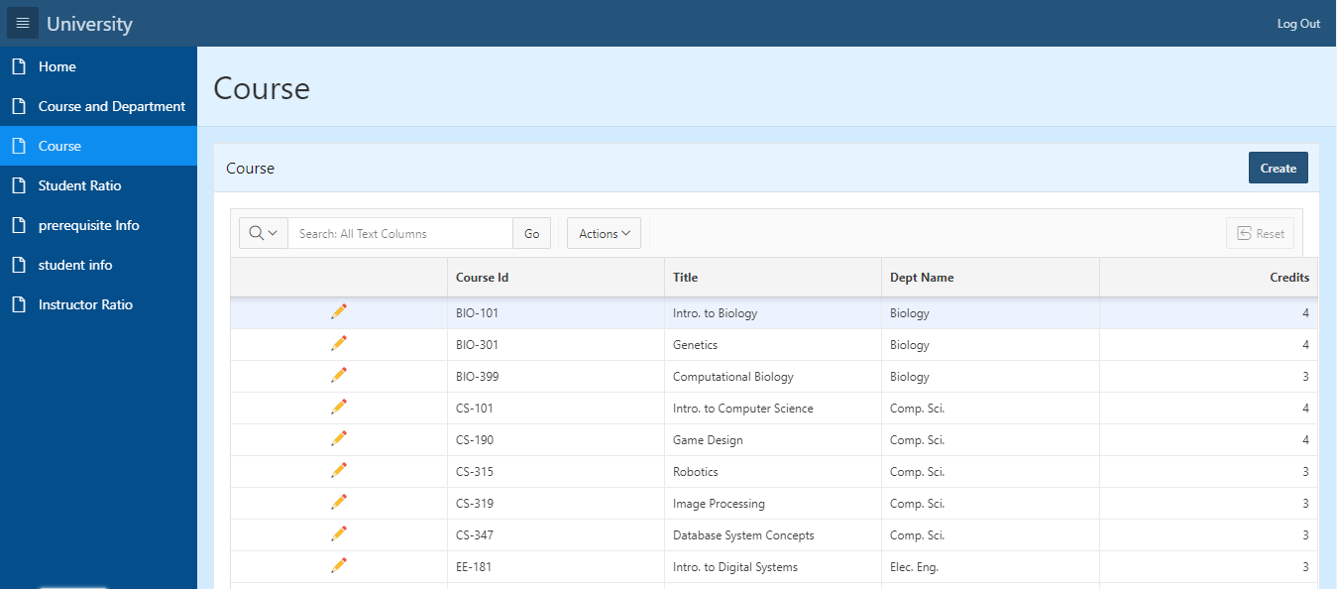

Student Ratio page contains a Pie chart, the percentage of number of student in each department. From the student relation we can find the number of student of each department.

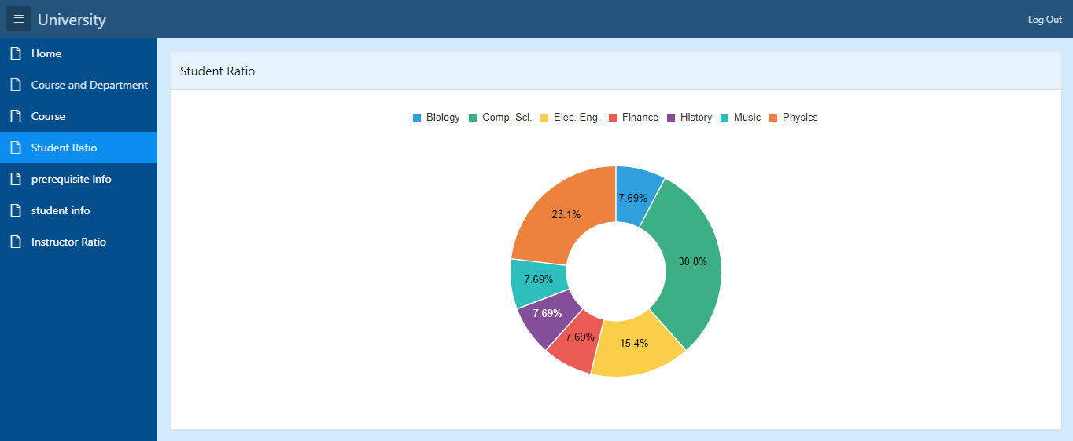

Prerequisite Info contains the prerequisite course information based on course information.

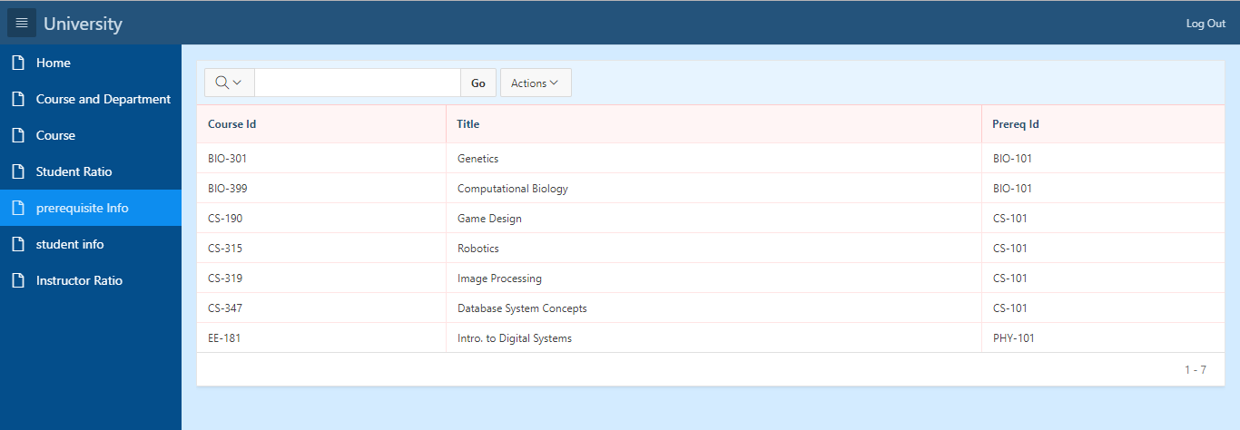

The Student info page is form and report type page which can insert new student information. It can display/find and student information.

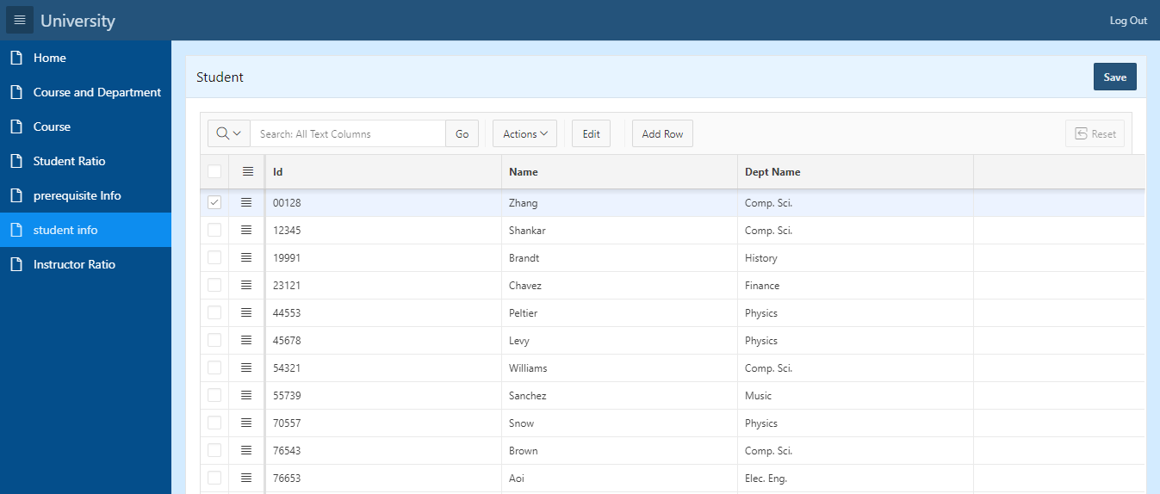

**Using Tools:** Oracle application express is used to develop this online application which is also hosted in apex.oracle.com.

As this is a web application, any operating system with web browser will support this.