Powerpuff Unix Shell

Unix Shell

Department of Computer Science and Engineering, East West University, Dhaka-1212, Bangladesh.

Email: [2016-1-60-053@std.ewubd.edu](mailto:2016-1-60-053@std.ewubd.edu), [2016-2-60-100@std.ewubd.edu](mailto:2016-2-60-100@std.ewubd.edu), [sornaewu@gmail.com](mailto:sornaewu@gmail.com)

[thajibatabassum@gmail.com](mailto:thajibatabassum@gmail.com) , [saikathossen3@gmail.com](mailto:saikathossen3@gmail.com) ,

*A****bstract—This document is on project named Powerpuff Unix Shell. This unix shell is developed with C.***

***Keywords—unix shell; shell; system programming; operating system***

# **Introduction**

A **Shell** provides us with an interface to the Unix system. It gathers input from you and executes programs based on that input. When a program finishes executing, it displays that program's output.

Shell is an environment in which we can run our commands, programs, and shell scripts. There are different flavors of a shell, just as there are different flavors of operating systems. Each flavor of shell has its own set of recognized commands and functions.

## **Software description and facilities**

This Software is just a sample Unix Shell. Here we can execute some Linux Command.

Such as.:

* “ CD path ” changes the current working directory.
* “ ls ” on its own lists the current working directory.
* “ mkdir ” is used to create new directories.
* “ touch ” to create, change and modify timestamps of a file.
* “ cat ” displays the contents of its inputs.
* “ echo ” to display a line of text/string on standard output or a file.
* “ cp ” is used to copy files and directories.
* “ clear ” clear the terminal screen.
* “ exit ” to close a terminal window.

cd command expect one parameter, only a path. ls command doesnot expect any parameter. cp command expect two parameter, one is source and another is destination. mkdir, touch echo can work with as many parameter as given. For multiple commanding semicolon(;) is single command syntex finisher.

**Parse Table:**

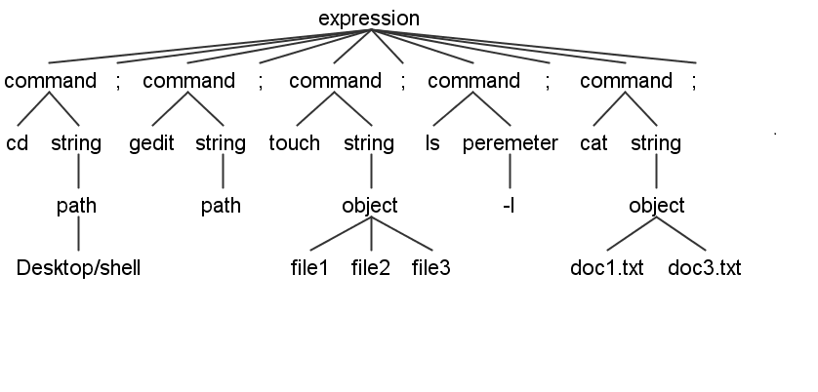

## **Key of the project:**

## As the project is developing software, C programming language is used to develop it.

**Running platform:**

It can only run in Unix based operating system like linux.

**Documentation:**

In Linux terminal this commands can be used to setup Powerpuff shell.

$ wget <https://github.com/shaykhsiddique/Powerpuff-UNIX-Shell/blob/master/powerpuff_unix_shell.c>

$ gcc powerpuff_unix_shell.c –o powerpuff

$ ./powerpuff

**Goals:** The goal of this software is to introduce a unix based shell with some simple command performing on Linux operating system.

 **East West University**

A project report on

"**Powerpuff** **Unix Shell**"

**Course Title:** Operating System

**Course Code:** CSE325

**Section: 04**

**Submitted To:**

Md. Ashraful Islam (Emon)

Lecturer

Department of Computer Science & Engineering

East West University, Bangladesh

**Submitted By:**

Shaykh Siddique

ID: 2016-1-60-053

Thajiba Tabassum

ID:2015-02-60-022 (Section-2)

S. M. Saikat Hossain

ID:2016-2-60-068

Md.Jadid Mostafiz

ID:2014-3-60-029

Shaik Md. Ibnay-Momen

2016-2-60-100

Jannatul Ferdous Sorna

2016-1-60-029