Bash Parsing

Md. Mobinul Hoque, Asif Zaman, Shaykh Siddique

2015-2-60-082, 2015-2-60-012, 2016-1-60-053

Department of Computer Science and Engineering, East West University, Dhaka-1212, Bangladesh.

Email: placidmobin@gmail.com, asifzaman71.az@gmail.com, 2016-1-60-053@std.ewubd.edu

**Abstract**

Now-a-days we see that student running behind to generate parsing tree from grammar. In internet the resource are not available too much. Using this application student can easily generate parsing tree from grammar.

Keywords—grammer; grammer to parsing tree; parsing tree; bash; bash parsing; ANTLR; expression to parsing tree.

# **Introduction**

In this project we have used Antlr software, Unix shell. In Unix shell we had write code which generate parsing tree from grammar.

ANTLR is a parser generator that uses LL(*) for parsing. ANTLR is the successor to the Purdue Compiler Construction Tool Set (PCCTS), first developed in 1989. It takes input as a grammar. By default, ANTLR reads a grammar and generates a recognizer for the language defined by the grammar. If there are no syntax errors, the default action is to simply exit without printing any message.

Bash is a, UNIX shell, command processor that typically runs in a text window where the user types commands that cause actions. Bash can also read and execute commands from a file, called a shell script.

A parse tree or parsing tree or derivation tree or concrete syntax tree is an ordered, rooted tree that represents the syntactic structure of a string according to some context-free grammar.

1. **BACKGROUND STUDY:**

In our project we have used Bash (Unix shell) to write code for the expression and compile it using Antlr software. In this course we have learned how to make a parsing tree from grammar. We have used those kind of rules. To get output we need some input as a grammar. For this we have used a txt file. After compiling the code in command line it will generate a parsing tree. If our input file grammar are not appropriate, then we can not get expected result.

1. **IMPLEMENTED WORK:**

Bash is very important to use Linux based OS. We used this to implement our project. As our aim is to generate parsing tree from grammar. So we have write an expression which generate all kinds of grammar parsing tree. We have write this code in unix shell:-

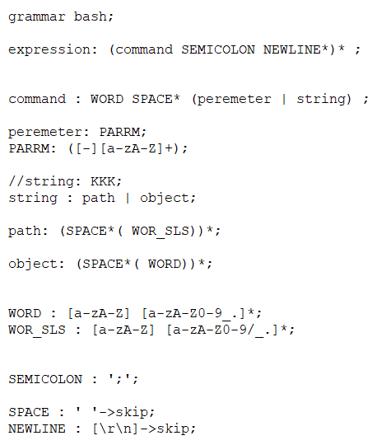

Here parameter start with dash (-), string has two types, path & object. If user write a grammar which contain back-slash (/) then compiler takes it as a path, otherwise object.

Our input.txt file is:---

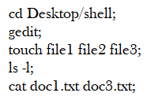

We can compile this bash file with some command. Those command are:---

* antlr bash.g4 (bash.g4 is our bash file)
* javac bash*.java
* grun bash expression input.txt –gui

Then it generate a parsing tree. The parsing tree is just like this:-

Yes

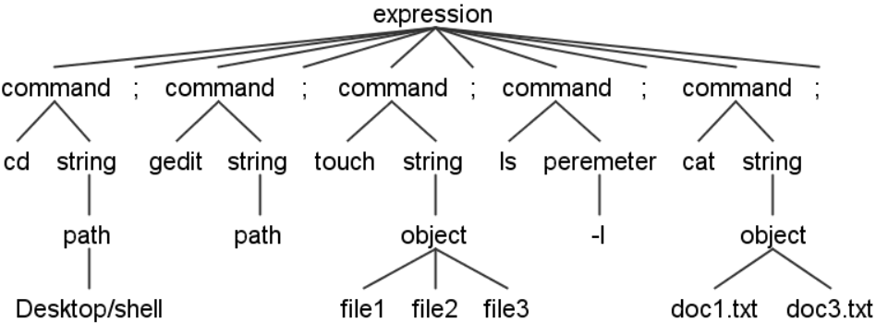

Figure-1: Parsing tree.

1. **CONCLUSION:**

Our application will work for generating parsing tree from grammar. That’s how this project aims to save students time and get perfect result.

**IV**. **REFERENCE**:

https://en.wikipedia.org/wiki/ANTLR

<https://en.wikipedia.org/wiki/Bash_(Unix_shell)>

<https://en.wikipedia.org/wiki/Parse_tree>