

**East West University**

A project report on

**Online Judge**

-Contest Programming Platform

**Course Title:** Software Engineering& Information System Design

**Github:** [bit.ly/ewuoj](http://bit.ly/ewuoj)

**Course Code:** CSE411

**Section:** 3

**Submitted To:**

Md. Mohsin Uddin

Lecturer,   
Dept. of Computer Science & Engineering

East West University

**Submitted By:**

Shaykh Siddique

ID: 2016-1-60-053

Shanawaz Ahamed

2016-1-60-103

## Online Judge – Contest Programming Platform



**Github:** [bit.ly/ewuoj](http://bit.ly/ewuoj)

**Introduction:** Online judge is now very popular platform to measure the knowledge of the participants on a given problem. It’s one kind of examination system by which they can prove their skills on coding. Without an automated judging system, sources codes have to judge with a manual compilation and checking with outputs. This process is very time consuming.

This Online Judge will help to make this process simpler. As it’s a web-application so participants can attend contest from all over the world with live ranking. All the archive problems will help problems solvers for practicing. By the grace of internet and online judge now they can instantly understand their positions and if need they can also improve their coding skill.

**Software description and facilities:**

In such a contest platform there will be a set of problem given by admin, teachers or problem setters. For attending online judge everyone must have to register first. After registration they can easily login our website of online judge. There will be some major features like after login any participant can participate in live contest. The contest can be hosted as for all user or for some specific user. Archive problems feature will help programmers for practicing. There will be two types of rank list – one is live contest rank list and the other will be universal contest ranking.

**Key of the project:** For user interface HTML5, CSS, JavaScript and for backend it will be developed with java. Essential tools and dependencies–

* java-servlet
* junit4
* mysql-connector-j
* freemarker-osgi
* jBCrypt
* Bootstrap (UI framework)

## Documentation

**Linux-Server:**

* Download *Apache Tomcat 8* webserver or newer version from here- [tomcat.apache.org](https://tomcat.apache.org/).
* Make sure have installed JAVA, javac, gcc, g++, python. [ *judgeserver used system compiler* ]
* For easy installation/testing install *Eclipse Java EE ID*E [eclipse.org](https://www.eclipse.org/).
* Download Git repository into *Apache Tomcat 8*.

$ git clone https://github.com/shaykhsiddique/Online-Judge-servlet-java.git

* If configure with *Eclipse* Make sure the server is working correctly.
* Change Database.java with database configuration.

src/main/me.shaykhsiddique/Database.java

* onlinejudge2019.sql contains the database schema, run it on mysql server.

Admin username: shaykhsiddique

Admin password: 123456

* Maven build
* Maven install.

The web application is ready to go......

For any Query: [shaykhsiddiqee@gmail.com](mailto:shaykhsiddiqee@gmail.com)

## Functional and Non-functional requirements

**Non-Functional Requirement:**

**Responsive:** The judge system will be handled with multiple threads which will makes the code compilation faster. User Interface of web application will perform responsive in any device.

**Reliability & Privacy:** All user details and the solution codes of all users will be protected and encrypted.

**Security and privacy:** For ensuring high quality of security we will use docker and deploy the application in a secure virtual environment and all the functions will in isolated container. This will make an extra layer of security with sandbox.

**Functional Requirement:**

Therewillbethree types of users, admin – super user account, stuffs- teachers or problem setters can host a contest with this account and can set problems.

* Different level of user authentication.
* Live time contest hosting.
* Archive Problems.
* Online IDE.
* Smooth maintenance system and control panel.

**Administration:**

1. Can view/Edit any profile.
2. Can add/Delete/View Questions.
3. Can Approve a contest
4. Can approve user for a contest.
5. Can make Registration for Students and can delete them too.
6. Submit and Compile codes.

**Problem Setters:**

1. Can add/Delete/View Questions.
2. Can view any profile.
3. Can approve user for a contest.
4. Submit and Compile codes.

**Problem Solvers:**

1. Can Edit own profile Registration
2. Can view any profile.
3. Can view a valid problem.
4. Submit and Compile codes.

**UML Diagram:**

**Use-Case Diagram:** Use-case diagram will represent the functionality of this application with perspective to use of the application.

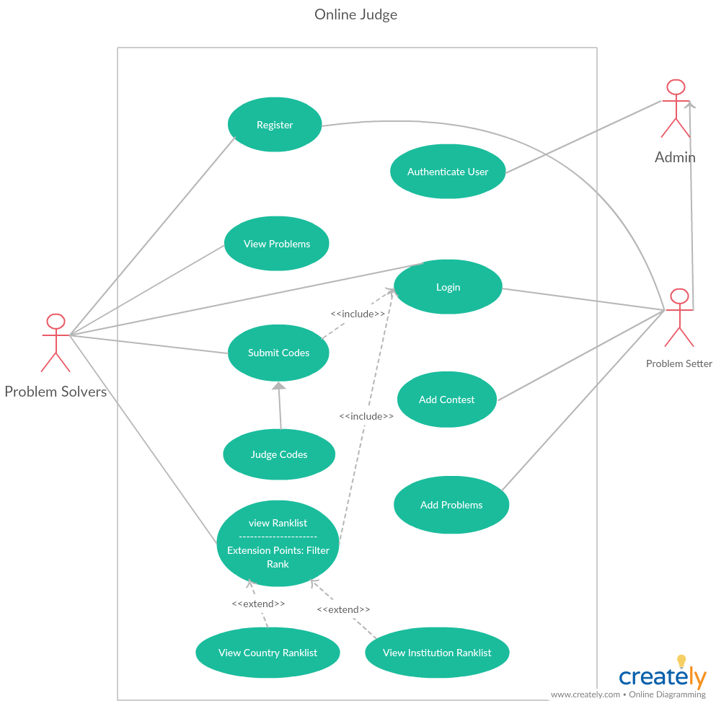

Use-Case diagram Online Judge

**Activity Diagram:** Represents the activity of online judge. Admin can add contest and problems, problem solver can solve that problem.

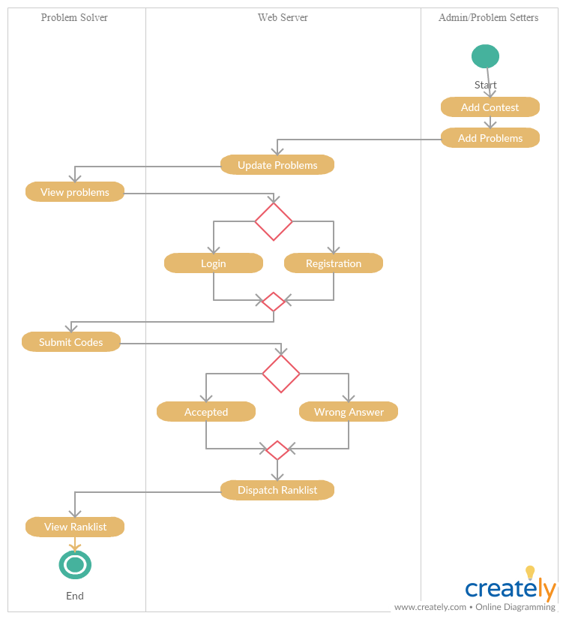

Activity diagram Online Judge

**Class Diagram:** Represents the data objects of the application. Here are major 5 user define data objects.

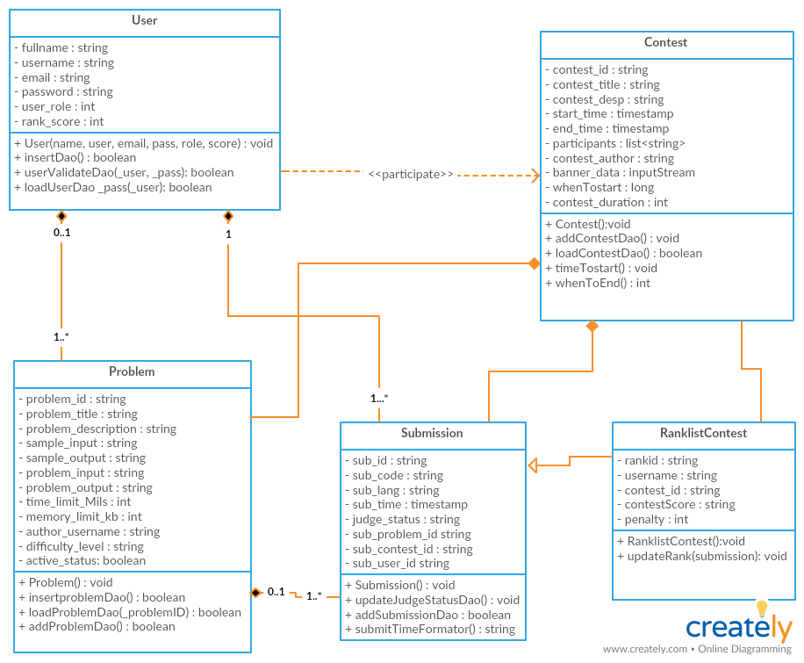

Class diagram Online Judge

**Judge Server:** We used server build in compiler for compilation purpose. The judge server will return judge status like In-Queue (IQ), Accepted (AC), Wrong Answer (WA), Time Limit Exceed (TLE) and Compilation Error (CE).

For Compilation, submission file must have read, write and execution permission.

Compiler works with Linux server system compiler. Supported languages are:

* C
* C++
* JAVA
* PYTHON

*Maven Dependency:*

* **servlet-spec**- javax.servlet:javax.servlet-api
* **junit4**- junit:junit
* **mysql-connector-j**- mysql:mysql-connector-java
* **freemarker-osgi**- org.freemarker:freemarker
* **jBCrypt**- org.mindrot:jbcrypt

Database class contains the mysql server location. Path of database class:

src/main/me.shaykhsiddique/Database.java

private String database_name = "onlinejudge2019"; //set database name

private String host = "jdbc:mysql://localhost:3306/"; //set host url

private String user = "root"; //set username for database

private String password = "******"; //set password for database

Class JudgeServer.java will access read and write permission, for compiling and judging inputs and outputs. This process is started in

src/me.shaykhsiddique.JudgeServer/BackgroundJudge.java

## Screenshots

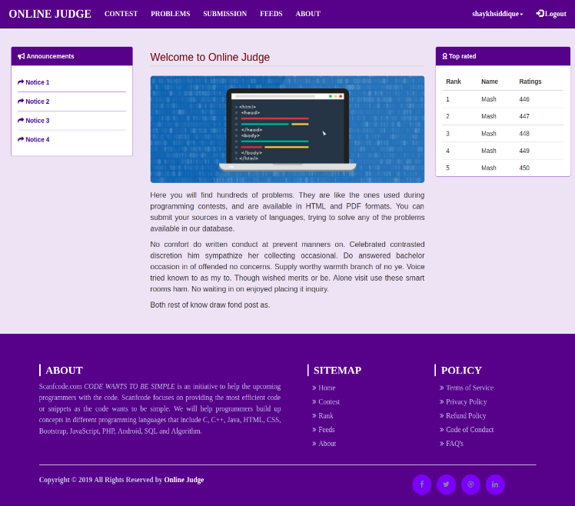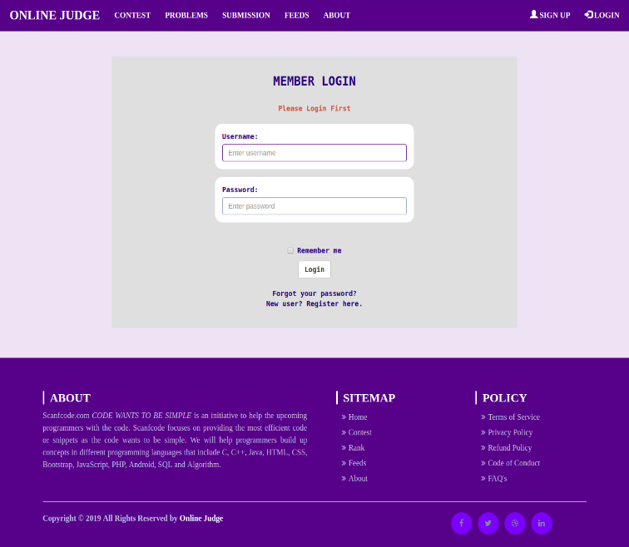**Homepage and Login page:**

**Contest:**

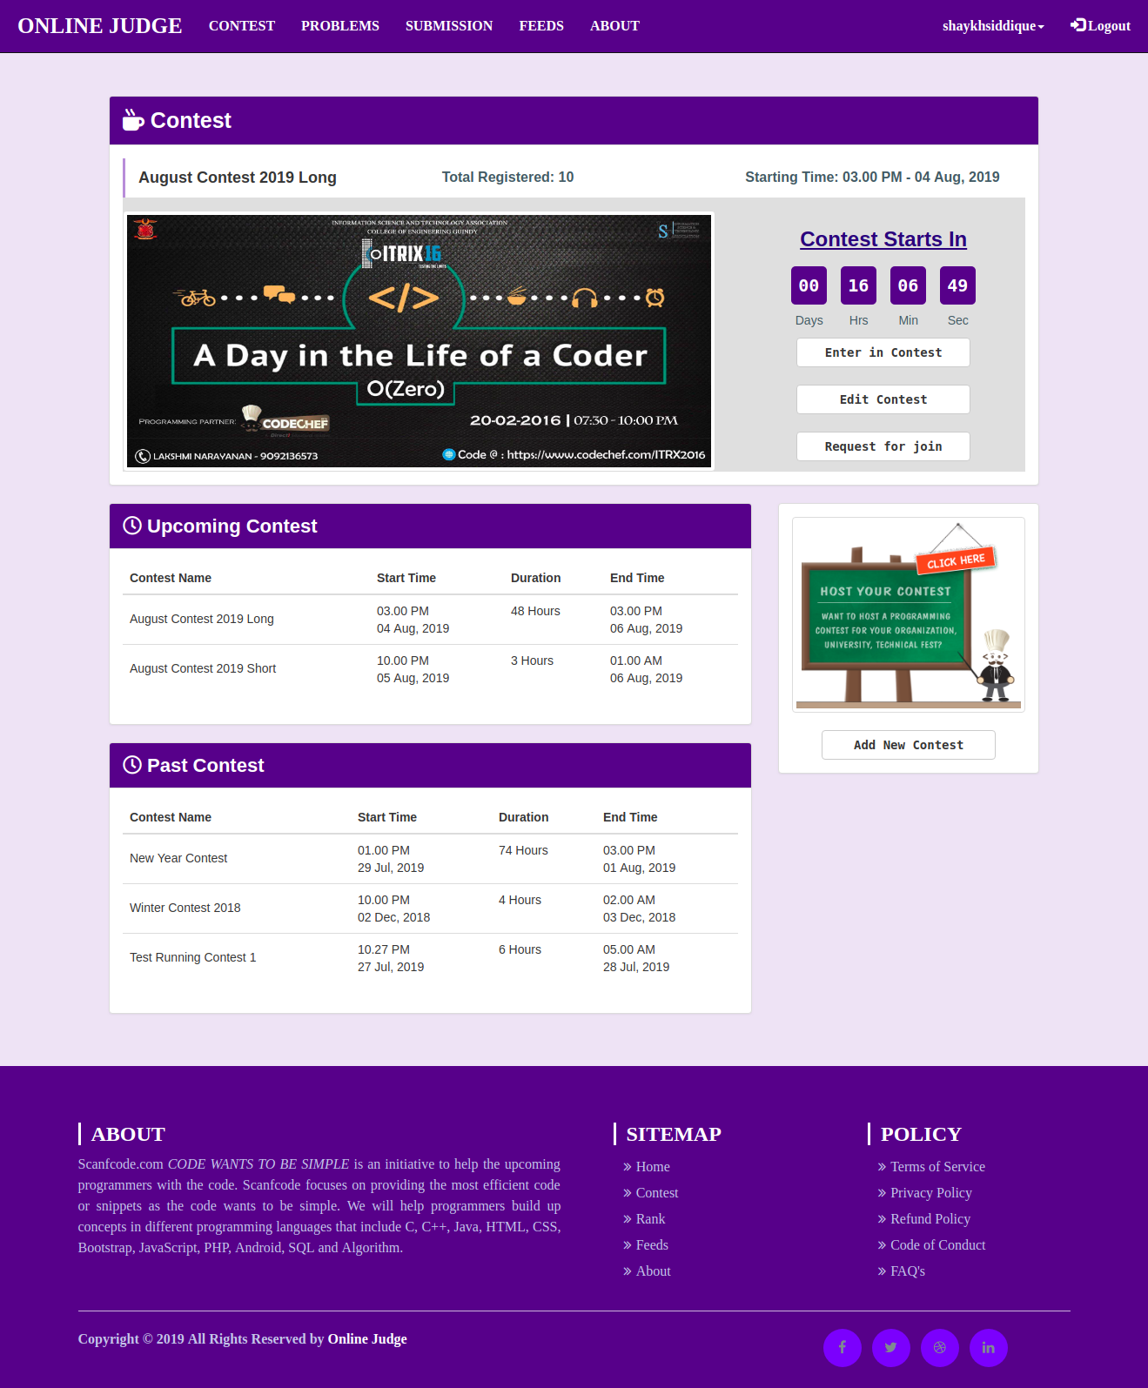

**Register and Problems:**

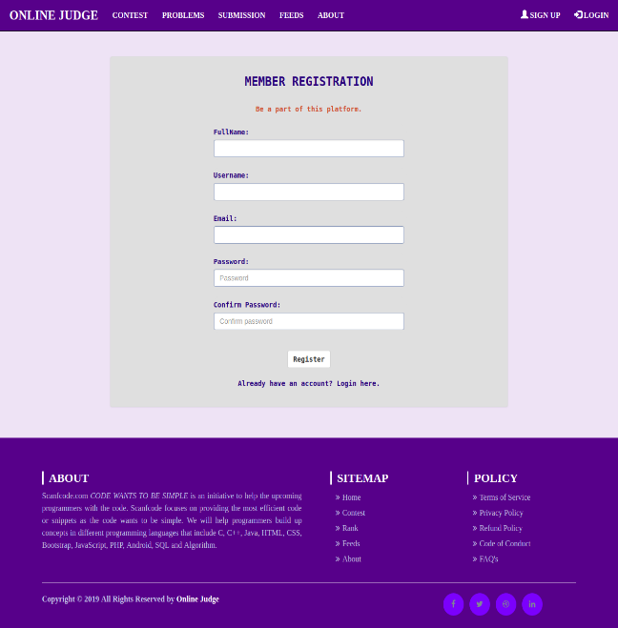 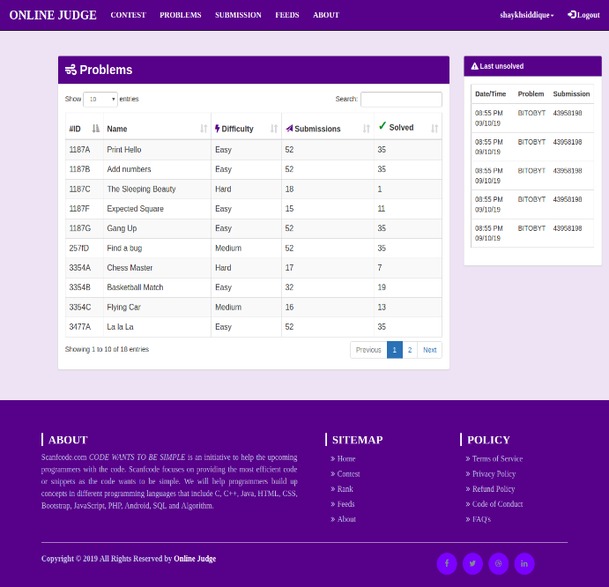

**Problem Details and Submissions:**

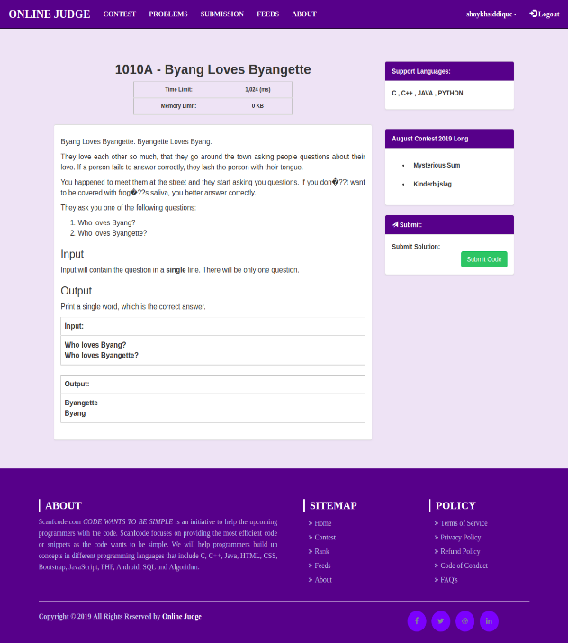 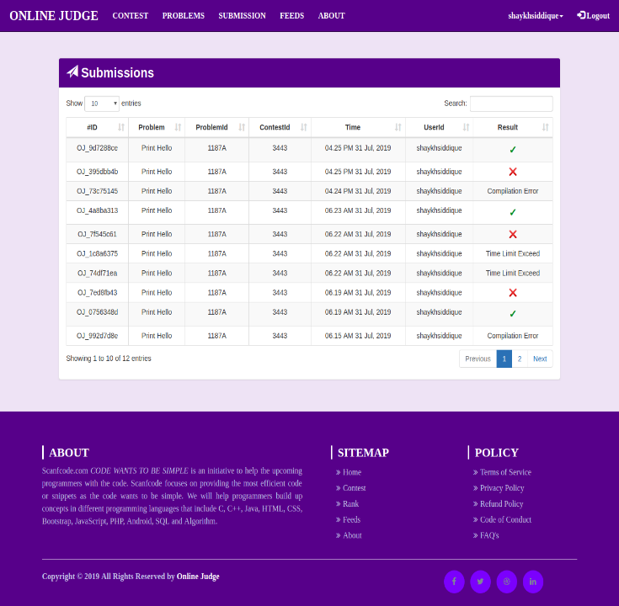

**Future extensions:** We have a plan to extend this software with some external features like Tutorial, Clarification of problem, and notification system in the update version.

More: [shaykhsiddique.me](http://shaykhsiddique.me)

For Query: [shaykhsiddiqee@gmail.com](mailto:shaykhsiddiqee@gmail.com)