Question 1: What is data mining? Describe using your own words. Do not provide the definition in the
textbook.
Ans: Searching lots of data points for storing usable data is data mining. To make the process efficient data mining use some algorithms(sometimes relevant with applied statistics).

Techniques those used by companies like Amazon, Facebook, Google to workout exactly what we want to buy and we amazed sometimes with their accuracy.

Question 2: Describe the steps involved in data mining when viewed as a process of knowledge discovery.
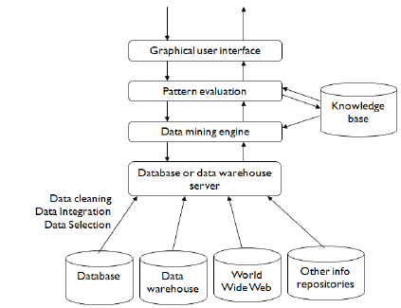
Ans: Model of knowledge discovery process :

The most important steps involved in data mining when viewed as a process of knowledge discovery:

Data Cleaning: Removes or transforms the noise into clean data.

Data Integration: After cleaning multiple data sources will be combined here.

Data Selection: Relevant data for the analysis task are retrieved from the database.

Data Mining: Processes where efficient and intelligent methods are applied in order to extract patterns.

Pattern Evaluation: A process that identifies the truly interesting patterns that representing the knowledge based.

Knowledge Presentation: Visualization and knowledge representation techniques are used to present the mined knowledge to the user.

Question 3: Define the following data mining functionalities such as characterization,
discrimination, association and correlation analysis, classification, regression, clustering, and
outlier analysis. Give examples of each data mining functionality, using a real-life database that
you are familiar with. Be specific as much as you can while providing examples.

Ans:

-Characterization: A summarization of the general characteristics or features of a target class of data. For example, the characteristics of products can be produced for generating a report on top selling products of last year, which may include such information as products price, quantity and other things.

-Discrimination: A comparison of the general features of target class data objects with the general features of objects from one or a set of contrasting classes. For example, the general features of products with high selling rate may be compared with the general features of products with low selling.

-Association and Correlation analysis: The discovery of association rules showing attribute-value conditions that occur frequently together in a given set of data.

Transactions | Products
T₁ | Cellphone, Back-cover, Headphone
T₂ | Cellphone, Back-cover
T₃ | Laptop, Speaker

I
+f a person buy Cellphone, then he will also buy back-cover. Data mining system may find association rules like -
buy(X, “Cellphone”) => buy(X, “Back-cover”)

Correlation is a statistical analysis used to measure and describe the relationship between two variables. If one product price goes up and another product price goes down then two products are corelated.

-Classification: Classification is used for predicting the class label of data objects and prediction is typically used for unknown class lebel. Predicting the product is profitable or not is a good example of classification.

-Regression: To predict a range of numeric values (also called continuous values), given a particular dataset. For example, regression might be used to predict the cost of a product or service by given other variables.

-Clustering: Grouping or categorizing the data set based on similarity. Generally, woolen cloths are profitable in winter season. So categorized those.

-Outlier analysis: In statistics, an outlier is a data point that differs significantly from other observations. If price of MacBook with 8GB ram is less than the MacBook with 4GB ram, then that product will create distance from the (Error Reporting).

Question 4: What are the major challenges of mining a huge amount of data (e.g. billions of tuples) in comparison with mining a small amount of data (e.g. a few hundred tuples)?

Ans: The major challenges of data mining regarding performance issues are the efficiency and scalability of data mining algorithms. For extracting large amount of data the algorithms must be effecient and scalable.

Using distributed, parallel and incremental processing of data mining algorithms for extrecting huge amount of data from different dasabases.

Question 5: "Data mining is a multidisciplinary field" - Justify the statement.

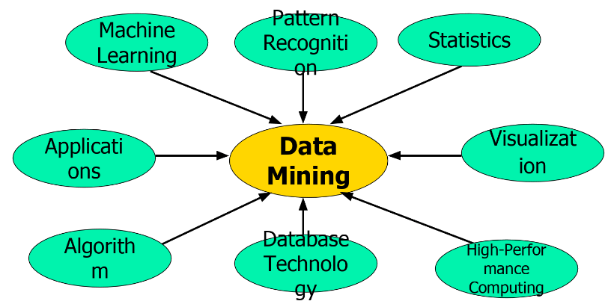
Ans: The most using disciplines in data mining:

We can see data minig use various techniques like Machine Learning, Pattern Recognition, Statistices, Visualization, High-Performance Computing, Database Technology, Algorithms and Applications. There is considerable overlap among these and it might be combined with data mining. So data mining is a multidisciplinary field,

