Assignment 02 Stage 4 SmartCare domain implementation workbook

1. UML to code trace
UML element | Python element | Implemented | Notes
Patient identity and name | Patient.patient_id; name | Yes | Read-only properties; constructor validates strings.
Patient ID matching | matches_id(patient_id) | Yes | Exact identifier match; FR-02.
Patient history | get_history(appointments) | Yes | Filters by patient ID; includes cancelled; FR-11.
Practitioner details | practitioner_id; name; specialty | Yes | Specialty is a Stage 4 Part C addition; non-blank string.
Recorded availability | recorded_availability; get_availability(day) | Yes | Public list/None contract; internal tuple and defensive copies; FR-05.
Daily schedule | get_schedule(day, appointments) | Yes | Filters practitioner ID and date; keeps status; FR-08.
Exact active booking | is_booked_at(time, appointments) | Yes | Calls is_active(); no duration overlap rule; FR-07.
Appointment identity and links | appointment_id; patient; practitioner | Yes | Read-only references to existing objects; FR-06.
Appointment time and validation | appointment_time; validate() | Yes | Requires datetime and valid linked object types; FR-03.
Appointment status | AppointmentStatus; status; is_active() | Yes | SCHEDULED value Booked; CANCELLED value Cancelled.
Cancellation and retention | cancel(); InvalidStatusTransition | Yes | Only SCHEDULED to CANCELLED; preserves object; FR-09, FR-10.
Associations and multiplicities | Patient/Practitioner references on Appointment | Yes | One of each per appointment; each person may have 0..* appointments.
All eight Week 6 business-operation stubs now have implementations. Global ID uniqueness, atomic booking coordination, and persistence remain outside these three entities; this does not claim that all system requirements are finished.

2. Domain invariants
Class | Invariant or rule | How protected
Patient | Non-empty string ID and name; stable identity. | _required_text trims and validates; properties have no setters. T02, T07.
Practitioner | Non-empty string ID, name and specialty. | Constructor validation and read-only properties. T03, T07.
Practitioner | Availability is unknown or valid datetime slots; external lists cannot corrupt it. | Type checks; internal tuple; fresh lists from getters. T03, T11, T12.
Appointment | One Patient and one Practitioner, non-empty ID and datetime. | validate() checks construction; references/time have no setters. T01, T04, T07.
Appointment | Starts SCHEDULED; only cancellation is supported. | No constructor status argument; enum plus guarded cancel. Repeat raises InvalidStatusTransition. T05–T07.
Appointment | Cancellation retains ID, patient, practitioner and time. | cancel() changes only _status; history keeps cancelled objects. T05, T08.

3. Composition and inheritance decisions
Relationship | Decision | Rationale
Appointment–Patient | Association | An appointment has a patient; it is not a patient. The patient exists independently.
Appointment–Practitioner | Association | A practitioner may have many appointments and survives cancellation.
Doctor–Practitioner | Hypothetical inheritance only | A doctor can be a kind of practitioner if substitution is valid. No Doctor subclass is needed now.
Clinic–Appointment | Association if later required | No lifecycle ownership rule supports composition; no Clinic class is implemented.
Appointment–AppointmentStatus | Enum-valued attribute | Status represents a finite value, not a parent entity or owned lifecycle.
InvalidStatusTransition inherits ValueError as a narrow exception specialisation. This is not inheritance between domain entities. Python underscore-prefixed fields protect the public API by convention, not against deliberate internal modification.

4. AI pair programming record
This record covers the Appointment implementation, behaviour checks, and review of the supplied tutorial candidate. The constrained Appointment prompt is recorded in Lab Part D.
AI contribution | Conforms | Decision | Reason | Verification
Appointment implementation and type hints | Yes | Accepted | Uses the same patient/practitioner links and operations. | T01, T04, T05
AppointmentStatus enum and protected cancel | Yes, with documented update | Accepted | SCHEDULED maps to Booked; repeated cancellation is illegal. | T05, T06, T07
Public fields carried over from v0.3 skeleton | Needs refinement | Modified | Read-only properties protect validated state; cancel is the transition entry point. | T07
Behaviour verification script | Yes | Accepted | Checks invalid input, retained history, encapsulation and exact-time queries. | T01–T12
SQL, notifications and PatientRecord inheritance in tutorial candidate | No | Rejected | Infrastructure and unrelated inheritance exceed the domain design. | Source review; tutorial Activity 4

5. Updated UML
The v0.3 baseline is retained with four explicit refinements. Practitioner adds a required specialty string because Stage 4 Part C requests it. Public attributes become read-only properties over underscore-prefixed fields, while availability is copied into an internal tuple and returned as a fresh list. Status becomes AppointmentStatus: SCHEDULED has value “Booked” to preserve the Week 5–6 terminology, and CANCELLED has value “Cancelled”. The Appointment constructor no longer accepts arbitrary initial status; cancel() enforces the only supported transition and raises InvalidStatusTransition on repetition. These are Stage 4 implementation choices, not evidence of new stakeholder approval.
The diagram on the next page shows the implementation’s public properties and operations. Each property uses an underscore-prefixed backing field; there are no public setters. The availability property returns a copy. Operation names and the original association multiplicities are unchanged. Long query parameters are abbreviated in the diagram; the Python signatures retain list[Appointment], date and datetime type hints.
The required specialty parameter is inserted before optional recorded_availability in Practitioner.__init__. Existing constructor calls therefore need a specialty argument. The finite lifecycle is limited to this stage; no Completed, No show, rescheduling or reopening transition is inferred.

Updated UML diagram
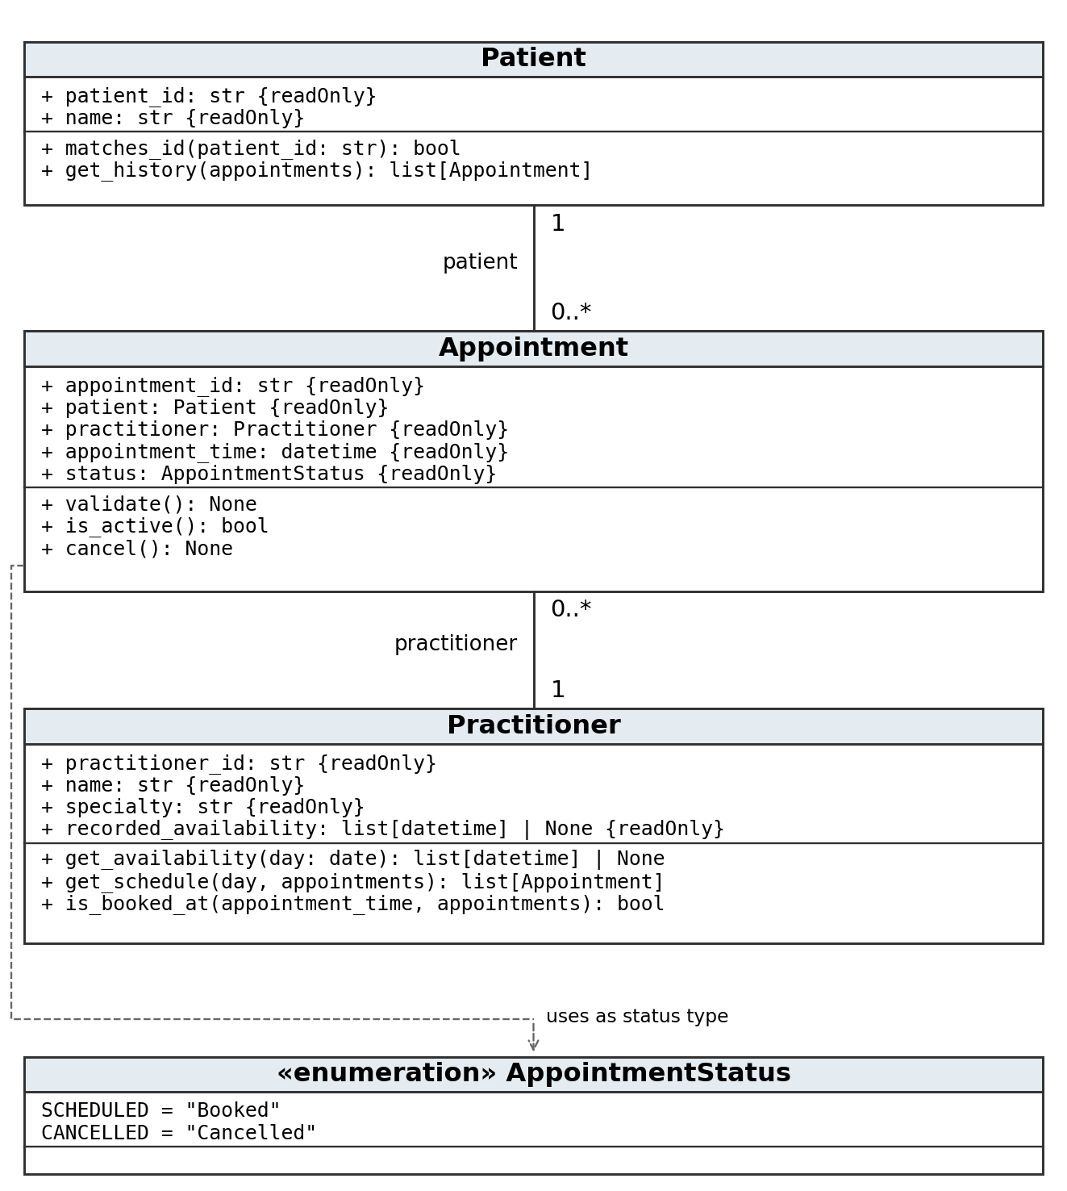
Plain lines show associations; the dashed arrow is a dependency on the enum. Read-only properties have no public setters; Appointment.cancel() may update its internal status. No composition diamond or domain inheritance is present.

