Assignment 02: Stage 3 SmartCare domain model workbook

1. Requirement-to-concept trace
Requirement | Concept | State and behaviour | Decision
FR-01 | Patient | patient_id, name; construction | Keep entity; ID policy remains A1.
FR-02 | Patient | matches_id(patient_id) | Keep predicate; collection search/no-match response belongs to the later application workflow.
FR-03 | Appointment | validate(); linked names and appointment_time | Keep validation responsibility. Parse raw input before construction in the later workflow; format remains A2.
FR-04 | Practitioner | practitioner_id, name; construction | Keep entity; unique registration is checked across records by the later workflow.
FR-05 | Practitioner | recorded_availability; get_availability(day) | Keep; list of offered start times is provisional A4. None means unknown, not free.
FR-06 | Appointment; Patient; Practitioner | patient, practitioner, appointment_time, status | Use associations to existing objects. Booked is provisional A3.
FR-07 | Practitioner; Appointment | is_booked_at(time, appointments); is_active() | Preserve exact-time check. Do not add duration/overlap rules.
FR-08 | Practitioner; Appointment | get_schedule(day, appointments) | Return matching appointments; later interface formats output.
FR-09 | Appointment | cancel(); status | Change Booked to Cancelled under provisional A3.
FR-10 | Appointment | Keep ID, links, time and cancelled status | No delete operation or cascading ownership; later storage must retain records.
FR-11 | Patient; Appointment | get_history(appointments) | Include cancelled appointments; derive history rather than duplicate it.
FR-12 | Appointment; Practitioner | Count date/time, practitioner and status | Derived report in a later application query; no Report entity needed.
NFR-01–04 | All three; later application/storage | Single-source rules; explicit method inputs | Separate domain logic from display/storage. Atomic saving and persistence remain later work.
NFR-05–06 | Later interface and performance tests | Task completion and response time | Do not turn quality targets into classes; targets still provisional.

2. CRC cards

Patient
Responsibilities | Collaborators
Maintain patient_id and name. | Appointment
Match an identifier; obtain this patient’s history from supplied appointments, including cancellations. | Appointment

Practitioner
Responsibilities | Collaborators
Maintain practitioner_id, name and recorded availability. | Appointment
Obtain the daily schedule; check exact-time active bookings from supplied appointments. | Appointment

Appointment
Responsibilities | Collaborators
Maintain appointment_id, patient/practitioner links, appointment_time and status; validate booking state. | Patient; Practitioner
Determine whether the slot is blocked; cancel by changing status while retaining the record. | Patient; Practitioner

Optional class
None selected. The three core classes cover the current domain entities. Reporting, storage and booking coordination are deferred application/infrastructure responsibilities; a Clinic or manager class is not added without a distinct need.

3. UML class diagram
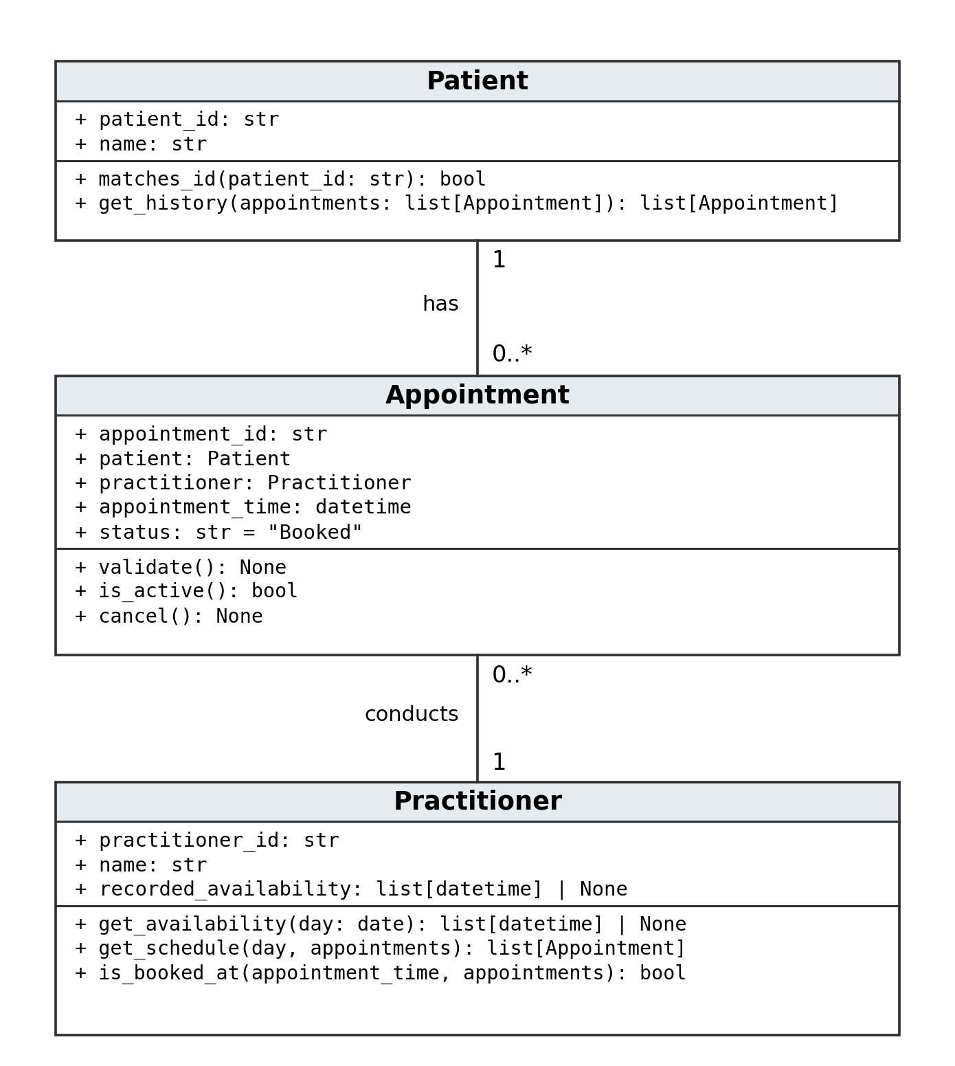
Plain lines are associations. Each appointment has exactly one patient and one practitioner; each patient/practitioner may have zero or many appointments. The reference attributes and lines describe the same links, not duplicate relationships.

4. Design rationale
Patient, Practitioner and Appointment have identity, state and behaviour supported by FR-01–11. Reception staff, clinic management and the developer remain stakeholders; no staff-account class is required. Name and status are attributes, while cancellation is an operation. A schedule, history and basic report are derived from appointments rather than stored as new entities.
Appointment stores references to the existing Patient and Practitioner objects. Patient and Practitioner receive the appointment collection as a method argument for history, schedule and duplicate checks. This avoids separate mutable lists on both sides of the relationships. The application will hold the collection; no global list is introduced in the skeleton.
Appointment validates its own booking state and changes its own status. Practitioner checks for an active appointment at the exact requested time. A later booking workflow must validate/parse input, find existing records, call these checks and add the booking only after success. Unique IDs, atomic storage and report aggregation belong to that later workflow, not to one patient object.
There is no inheritance or composition. Patient and Practitioner exist independently of an appointment; cancellation must not destroy either person or remove appointment history. IDs, the Booked/Cancelled lifecycle, time input format and availability representation retain the provisional status of A1–A4. Offered start times do not imply appointment duration, and an unknown availability record is not treated as an empty/free schedule.

5. AI design review record
AI suggestion | Evidence | Decision | Reason | Model change
Use Patient and Practitioner associations for Appointment. | FR-06 links existing records. | Accepted | A booking is not a kind of patient; references preserve identity. | Two associations with 1 and 0..* multiplicities.
Add a separate Cancellation class and delete the old booking. | FR-09, FR-10 require status change and retained history. | Modified | The supported need is cancellation; a new entity and deletion are unnecessary. | Use Appointment.cancel() and keep the original fields.
Introduce NotificationManager and SMS reminders. | No supporting requirement; Stage 2 excludes reminders. | Rejected | Adds unsupported functionality. | No notification class or operation.
Use ScheduleEngine with appointment duration and overlap checks. | FR-07 supports exact time only; A2 leaves duration open. | Modified | Need a duplicate check, not a scheduling subsystem or guessed duration. | Practitioner.is_booked_at() collaborates with Appointment.is_active().
Make Clinic composition-own every Patient and Appointment. | No lifecycle ownership requirement; FR-10 retains history. | Rejected | Composition implies a strong lifecycle rule that the brief does not establish. | No Clinic class or composition diamonds.
Add appointment_id for stable cancellation/history references. | AC-05 refers to A001; FR-09, FR-10 identify a retained appointment. | Accepted as design choice | Useful identity for a booking; not a new client-mandated field. | appointment_id: str; generation/uniqueness policy deferred.

