Assignment 02: Stage 3 lab activities

Part A: Requirements review
Category | Highlighted terms and supporting requirements
Nouns | Patient (FR-01, FR-02, FR-11); practitioner (FR-04, FR-05, FR-07, FR-08); appointment (FR-03, FR-06, FR-09, FR-10); identifier, name, date/time, status; availability; history; report.
Verbs | Create, register, find, validate, reject, record, display, cancel, retain, count and summarise (FR-01–12).
Business rules | One existing patient and practitioner per booking (FR-06); reject missing/invalid input (FR-03); reject the same practitioner at the exact active booking time (FR-07); cancel through status and retain history (FR-09, FR-10).
Unresolved rules | A1 IDs; A2 formats, duration and overlap; A3 lifecycle and slot reuse; A4 availability/report details; A5 storage/access; A6 quality targets remain provisional.

Part B: Candidate classes
Candidate | Requirements | State | Behaviour | Decision
Patient | FR-01, FR-02, FR-11 | patient_id, name | Match ID; return history. | Keep
Practitioner | FR-04, FR-05, FR-07, FR-08 | practitioner_id, name, recorded_availability | Return availability/schedule; check exact slot. | Keep
Appointment | FR-03, FR-06, FR-07, FR-09, FR-10 | appointment_id, patient, practitioner, appointment_time, status | Validate; test active status; cancel. | Keep
Name | FR-03 | name: str | Required-value validation. | Attribute
Status | FR-06, FR-09, FR-10; A3 | status: str | Active/cancellation rule on Appointment. | Attribute; enum may follow agreement
Cancellation | FR-09, FR-10 | Changed appointment status | Appointment.cancel(). | Operation
Clinic | Case-study setting | No separate clinic state required | No confirmed multi-clinic behaviour. | Omit
Database | NFR-02; A5 | Storage technology not chosen | Persist/load in later infrastructure. | Omit from domain
Schedule / history / report | FR-08, FR-11, FR-12 | Derived appointment collections/counts | Filter/group existing records. | Views or queries; no extra entity
Receptionist / manager / maintainer | Stakeholder analysis | No staff-account data specified | Use or maintain the system. | Actors, not automatic domain classes

Part C: CRC cards

Patient
Responsibilities | Collaborators
Maintain patient_id and name. | Appointment
Match an identifier; obtain this patient’s history from supplied appointments, including cancellations. | Appointment

Practitioner
Responsibilities | Collaborators
Maintain practitioner_id, name and recorded availability. | Appointment
Obtain the daily schedule; check exact-time active bookings from supplied appointments. | Appointment

Appointment
Responsibilities | Collaborators
Maintain appointment_id, patient/practitioner links, appointment_time and status; validate booking state. | Patient; Practitioner
Determine whether the slot is blocked; cancel by changing status while retaining the record. | Patient; Practitioner

Part D: UML model
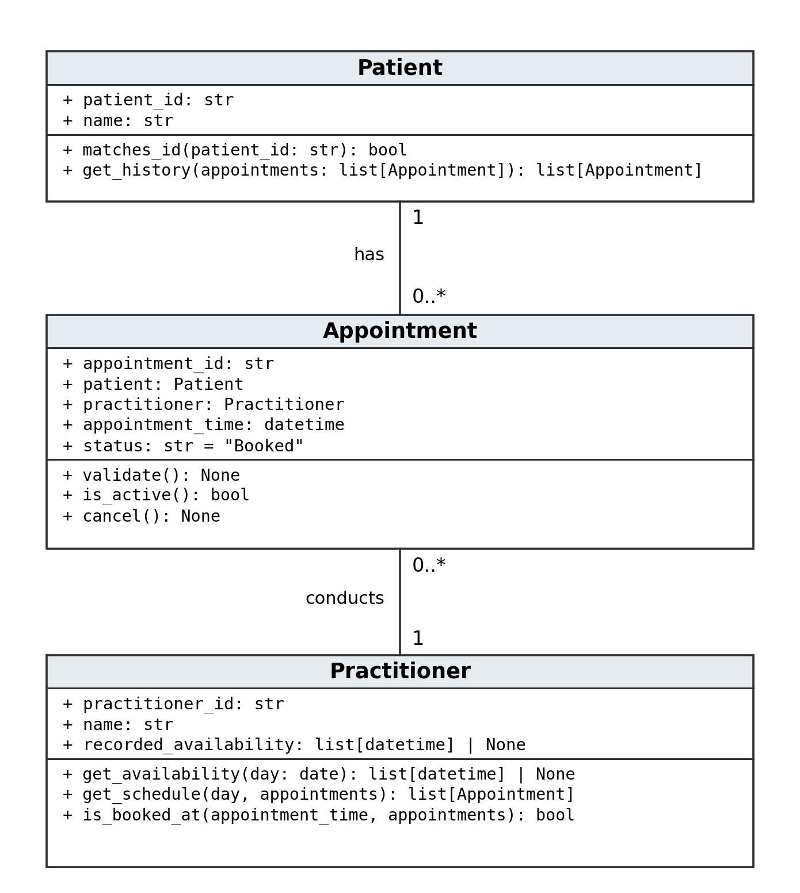
Plain lines are associations. Each appointment has exactly one patient and one practitioner; each patient/practitioner may have zero or many appointments. The reference attributes and lines describe the same links, not duplicate relationships.

Part E: AI design review
Prompt: Review the SmartCare v0.2 requirements and suggest domain classes and relationships using only confirmed requirements. Cite requirement IDs for every suggestion. Keep A1–A6 provisional. Identify unnecessary classes, misplaced responsibilities and incorrect inheritance/composition. Do not add features or implement behaviour.
Review findings: Patient, Practitioner and Appointment are supported by FR-01, FR-04, FR-06. FR-06 supports two associations, each with exactly one person per appointment. FR-09, FR-10 support a cancel operation and retained status rather than deletion. FR-07 supports an exact-time check, not an assumed interval-overlap engine. A Clinic owner and notifications have no supporting requirement.

Part F: Compare and decide

Accepted
Suggestion: Use Patient and Practitioner associations for Appointment.
Evidence: FR-06 links existing records.
Reason: A booking is not a kind of patient; references preserve identity.
Model change: Two associations with 1 and 0..* multiplicities.

Modified
Suggestion: Add a separate Cancellation class and delete the old booking.
Evidence: FR-09, FR-10 require status change and retained history.
Reason: The supported need is cancellation; a new entity and deletion are unnecessary.
Model change: Use Appointment.cancel() and keep the original fields.

Rejected
Suggestion: Introduce NotificationManager and SMS reminders.
Evidence: No supporting requirement; Stage 2 excludes reminders.
Reason: Adds unsupported functionality.
Model change: No notification class or operation.

Modified
Suggestion: Use ScheduleEngine with appointment duration and overlap checks.
Evidence: FR-07 supports exact time only; A2 leaves duration open.
Reason: Need a duplicate check, not a scheduling subsystem or guessed duration.
Model change: Practitioner.is_booked_at() collaborates with Appointment.is_active().

Rejected
Suggestion: Make Clinic composition-own every Patient and Appointment.
Evidence: No lifecycle ownership requirement; FR-10 retains history.
Reason: Composition implies a strong lifecycle rule that the brief does not establish.
Model change: No Clinic class or composition diamonds.

Accepted as design choice
Suggestion: Add appointment_id for stable cancellation/history references.
Evidence: AC-05 refers to A001; FR-09, FR-10 identify a retained appointment.
Reason: Useful identity for a booking; not a new client-mandated field.
Model change: appointment_id: str; generation/uniqueness policy deferred.

Part G: Python skeletons
The accompanying smartcare_v03.py contains the same three classes. Constructors only store state; business operations deliberately raise NotImplementedError.
from __future__ import annotations
from datetime import date, datetime
class Patient:
def __init__(self, patient_id: str, name: str):
self.patient_id = patient_id
self.name = name
def matches_id(self, patient_id: str) -> bool:
"""FR-02: report whether this record has the requested identifier."""
raise NotImplementedError("Stage 3 skeleton only")
def get_history(self, appointments: list[Appointment]) -> list[Appointment]:
"""FR-11: select this patient's appointments, including cancellations."""
raise NotImplementedError("Stage 3 skeleton only")
class Practitioner:
def __init__(self, practitioner_id: str, name: str,
recorded_availability: list[datetime] | None = None):
self.practitioner_id = practitioner_id
self.name = name
self.recorded_availability = recorded_availability
def get_availability(self, day: date) -> list[datetime] | None:
"""FR-05: return recorded slots; None means availability is unknown."""
raise NotImplementedError("Stage 3 skeleton only")
def get_schedule(self, day: date,
appointments: list[Appointment]) -> list[Appointment]:
"""FR-08: select this practitioner's appointments for the date."""
raise NotImplementedError("Stage 3 skeleton only")
def is_booked_at(self, appointment_time: datetime,
appointments: list[Appointment]) -> bool:
"""FR-07: check an exact-time active booking, not interval overlap."""
raise NotImplementedError("Stage 3 skeleton only")

Part G: Python skeletons continued
class Appointment:
def __init__(self, appointment_id: str, patient: Patient,
practitioner: Practitioner, appointment_time: datetime,
status: str = "Booked"):
self.appointment_id = appointment_id
self.patient = patient
self.practitioner = practitioner
self.appointment_time = appointment_time
self.status = status
def validate(self) -> None:
"""FR-03: validate names, required references and date/time state."""
raise NotImplementedError("Stage 3 skeleton only")
def is_active(self) -> bool:
"""FR-07/A3: determine whether this status blocks the exact slot."""
raise NotImplementedError("Stage 3 skeleton only")
def cancel(self) -> None:
"""FR-09/10: change status; preserve identity, links and time."""
raise NotImplementedError("Stage 3 skeleton only")

Part H: Consistency check
Check | Result
Classes and fields | The UML and Python contain the same three classes and attributes; constructors establish those fields.
Operations | Patient: matches_id/get_history; Practitioner: get_availability/get_schedule/is_booked_at; Appointment: validate/is_active/cancel. All signatures and returns align; long UML parameter types are abbreviated.
Associations and multiplicity | Appointment stores one Patient and one Practitioner reference. Multiple appointment objects can refer to either; no appointment is required for a person to exist. Type hints express the intended structure but do not enforce it at runtime.
Rules and retention | Exact-time checking, validation and cancellation are named but not implemented. No delete method, inheritance, composition, global list, database or GUI is added.
Verification | Python compiles; import and constructor smoke checks pass. Business-operation stubs raise NotImplementedError. This verifies the skeleton structure, not completed requirements.

Reflection
The hardest decision was where to place appointment checking without creating unnecessary manager classes. FR-07 requires an exact practitioner-and-time duplicate check, so Practitioner has an is_booked_at operation and Appointment provides is_active. The appointment collection is passed into the operation instead of being copied into several objects. This keeps the responsibilities clear while leaving the later booking workflow responsible for coordinating checks before saving.
The AI review considered a ScheduleEngine, a separate Cancellation class and Clinic ownership of every object. These proposals added machinery or lifecycle assumptions that the requirements did not justify. The scheduling suggestion was reduced to the existing exact-time rule, cancellation became an Appointment operation, and Clinic composition was rejected. NotificationManager was also rejected because reminders are outside the agreed draft scope.
The final choices were supported by FR-06, which links each appointment to a patient and practitioner, and FR-09–11, which require cancellation and retained history. The Stage 2 assumptions still matter: appointment duration, status details and availability rules have not been confirmed. The Python skeleton therefore represents the selected structure without pretending that those business rules or persistence have already been implemented.

