Assignment 02 Stage 5 SmartCare architecture workbook

Current architecture problems
The baseline is smartcare_v04.py from Week 7. It is already free of SQL and presentation code. The table distinguishes observed omissions from future dependency risks.
Problem | Evidence | Impact | Refactoring
Domain rules already isolated | v0.4 imports only datetime and Enum; no input(), print() or SQL. | No observed presentation/database mixing to remove. | Keep domain behaviour unchanged; relocate it to domain/models.py.
Single module organises all entities | Patient, Practitioner and Appointment share smartcare_v04.py. | No package boundary for later workflow and storage code. | Put related entities together in domain/; avoid one interface per entity.
Booking workflow absent | Appointment constructs valid state; Practitioner.is_booked_at only returns a predicate. | Callers could construct and collect conflicting bookings. | AppointmentService checks the predicate before repository.add().
Shared collection supplied by callers | History, schedule and conflict queries accept lists. | Future callers might use inconsistent collections. | Service obtains records through one injected repository.
Storage contract absent | v0.4 has no repository or save operation. | Workflow could become tied to a dictionary or SQL. | Define add, get_by_id, list_all and save.
Console workflow absent | Only classes and a test runner exist. | No staff-facing booking/cancellation route. | Add a small presentation menu and main.py wiring.
Persistence still deferred | No restart storage exists in v0.4 or the in-memory v0.5 adapter. | NFR-02 remains unimplemented. | Keep the storage boundary ready; defer a durable adapter without claiming restart support.

Layer responsibilities
Layer | Responsibilities | Must not contain
Presentation | Read menu input; resolve supplied fixture IDs; parse datetime; format results and errors. | SQL, repository construction, conflict or transition rules.
Service | Coordinate booking/cancellation; load records; invoke domain rules; request writes; expose history/schedule. | input(), print(), SQL, concrete adapter imports or duplicated transition logic.
Domain | Validate entity state; own cancellation and exact-time active-slot checks; preserve history semantics. | UI, services, repository dependencies or database access.
Repository | Declare the storage contract and missing/duplicate/save semantics. | SQL implementation, user messages or booking rules.
Persistence | Implement storage using a dictionary and detached copies; enforce appointment-key uniqueness. | Menu input, use-case orchestration or cancellation decisions.
main.py is the composition root outside the five layers: it constructs the in-memory adapter and service, supplies synthetic person fixtures and starts the console. The presentation may read domain values for formatting, but it cannot bypass the service to write to storage.

Architecture diagram
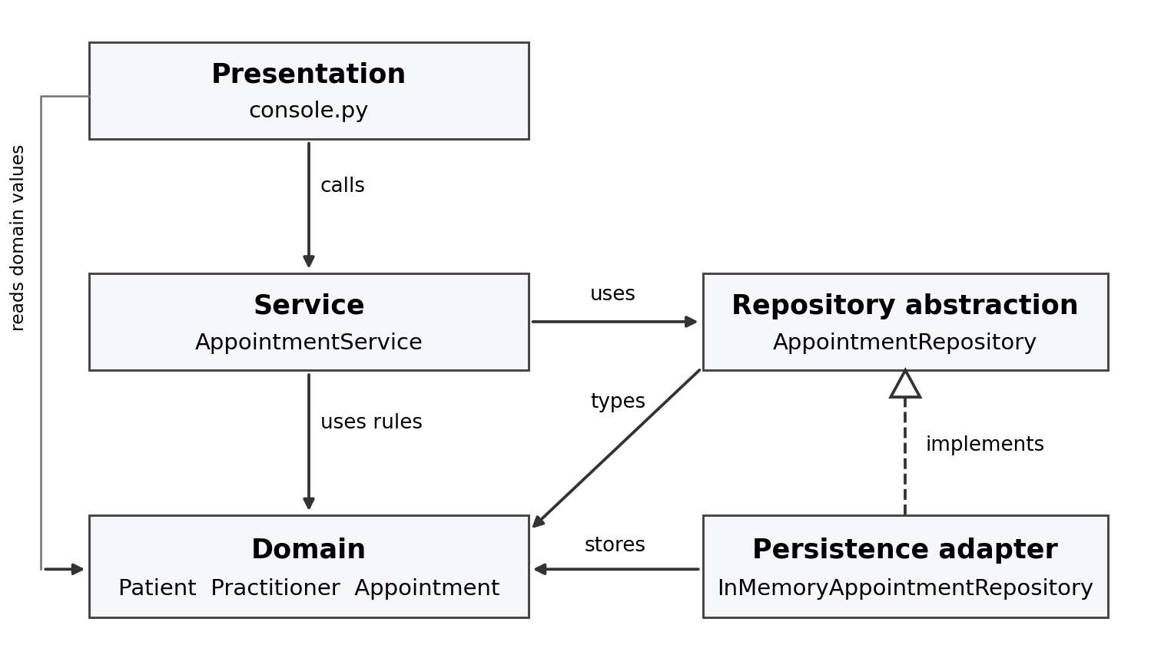
Arrows show source dependencies. The dashed hollow triangle means the storage adapter implements the repository contract. main.py constructs the concrete adapter and injects it into AppointmentService. Domain code imports none of the outer layers.

SOLID review
Principle | Relevant | Evidence | Decision
SRP | Yes | Domain owns rules; service owns orchestration; adapter owns storage; console owns interaction. | Separate reasons to change; keep AppointmentService limited to appointment use cases.
OCP | Yes at storage boundary | Service accepts AppointmentRepository; T23 substitutes a list-backed fake. | Allow a later adapter without rewriting service rules; do not add speculative plug-ins.
LSP | Yes for adapters | Reads return detached snapshots/None; duplicate add and missing save have defined exceptions. | Every adapter must preserve these behaviours, not merely method names.
ISP | Yes | Only add, get_by_id, list_all and save are required. | No unused delete, export, patient CRUD or generic query API.
DIP | Yes | Service imports the ABC; persistence implements it; main.py injects the concrete object. | Keep sqlite3 and concrete adapters out of services and domain.
SRP means Single Responsibility Principle; OCP, Open–Closed Principle; LSP, Liskov Substitution Principle; ISP, Interface Segregation Principle; DIP, Dependency Inversion Principle. They guide these specific boundaries rather than requiring a separate interface for every class.

Repository contract details
Operation | Required behaviour
add(appointment) | New appointment ID only; duplicate ID raises ValueError without overwriting.
get_by_id(id) | Detached Appointment or None; no printing or user-message decisions.
list_all() | Detached appointments including cancelled records; no inferred slot-availability rule.
save(appointment) | Replace existing ID; missing ID raises LookupError. A failed write leaves stored state unchanged.
Domain rules and enum values are unchanged: SCHEDULED displays Booked; CANCELLED displays Cancelled. Repository copies preserve stable IDs and data, not Python object identity. Patient/history and practitioner queries already compare identifiers, so this storage boundary does not require rewriting those domain methods.

AI architecture review
Suggestion | Observed problem | Decision | Reason | Verification
Introduce a small repository abstraction. | Workflow needs one source of records. | Accepted | Service depends on a contract, not dictionary storage. | T23, T26
Add a general 20-method repository. | Storage is needed; the broad API is not. | Modified | Limit the contract to four used operations. | D/E code; T13–T25
Move cancellation rules into the service. | A service must coordinate cancellation. | Modified | Service retrieves/saves; Appointment.cancel() still decides legality. | T05, T06, T17, T18
Return live stored objects to avoid copies. | Live mutation could change storage before save succeeds. | Modified | Return detached copies and require explicit save. | T22, T24
Introduce microservices and an event bus. | No distributed or asynchronous use case. | Rejected | Adds deployment, consistency and messaging complexity. | Single-process demo; T27
Add six interfaces and a DI framework. | One storage variation point needs substitution. | Deferred | Keep one repository ABC and manual constructor injection. | T23, T26

Verification evidence
python -m unittest discover -s tests -v: 28 tests passed. T01–T12 repeat the Week 7 domain checks. T13–T25 verify service/storage behaviour and substitution; T26 inspects imports and I/O boundaries; T27–T28 exercise the console. Full output is included in SmartCare_v05/test_results.txt.
python demo.py produced:
Booked: Booked
Duplicate active slot: rejected
Cancelled: Cancelled
Repeated cancellation: rejected
Rebooked: Booked
History: A001 Cancelled, A002 Booked

Scope retained
Reception staff, patients, practitioners, clinic management and developer/maintainer remain the stakeholders. No notifications, new clinical entities, duration-overlap rule or global ClinicManager is added. The in-memory adapter is a deliberate Stage 5 implementation; records are lost on restart, so NFR-02 and durable transactions remain future work. Conflict checking is valid for the single-process console and is not a concurrency guarantee.

