Assignment 02 Stage 5 lab activities

Part A: Inspect SmartCare v04
The Week 7 implementation already separates domain rules from I/O: it contains no menu, printing, SQL or database connection. The current issues are missing workflow/storage boundaries and single-module organisation, not an existing mixture of all four responsibilities.
Responsibility | Current evidence | Week 8 treatment
Domain | Patient validation/history; Practitioner availability/schedule/conflict predicate; Appointment validation/cancel. | Preserve these rules in domain/models.py.
Workflow | The caller supplies collections and must coordinate checking, construction and storage. No booking service exists. | Add AppointmentService; do not move domain rules into it.
Data access | No repository, lookup store or save abstraction exists. | Introduce a small ABC and an in-memory adapter.
Presentation | v0.4 has no staff console; tests exercise objects directly. | Add presentation/console.py for input, parsing and messages.

Part B: Propose architecture
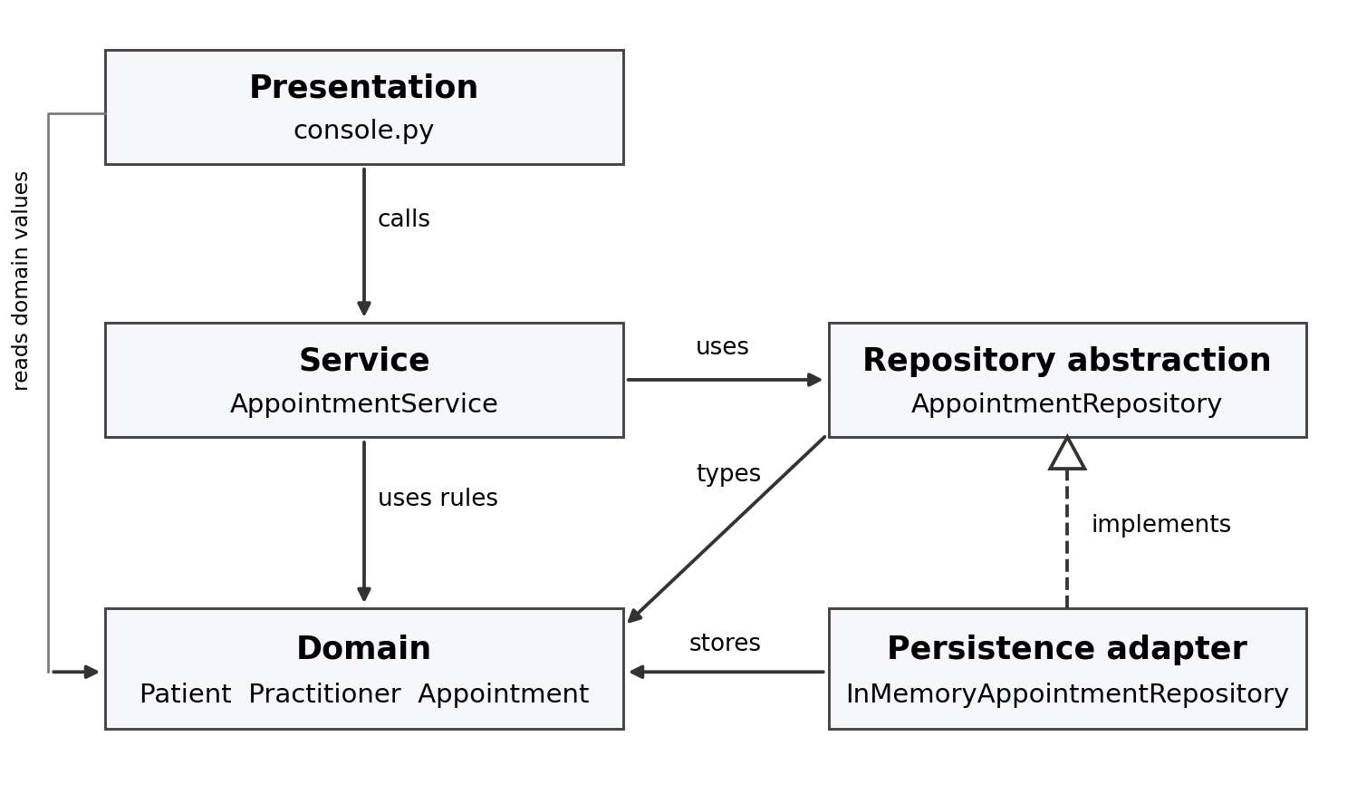
Arrows show source dependencies. The dashed hollow triangle means the storage adapter implements the repository contract. main.py constructs the concrete adapter and injects it into AppointmentService. Domain code imports none of the outer layers.
The existing stakeholders remain reception staff, patients, practitioners, clinic management and the developer/maintainer. The console demonstrates reception tasks; it does not introduce new stakeholder roles or staff-account entities.

Part C: Create package structure
Package or file | Implemented contents
domain/models.py | The three unchanged v0.4 domain classes, status enum, exception and validation helper.
services/appointment_service.py | AppointmentService coordinates booking, cancellation, lookup, listing, history and schedule.
repositories/appointment_repository.py | AppointmentRepository abstract contract.
persistence/in_memory_appointment_repository.py | Dictionary-backed adapter with detached snapshots.
presentation/console.py | Menu input, datetime parsing, confirmation/error formatting.
main.py; demo.py | Explicit dependency wiring and an interactive console; a repeatable demonstration.
tests/; README.md | 12 retained domain tests plus 16 new checks; setup and run instructions.
Each package has __init__.py. Related entities remain together in one domain module because the system is small. There is no framework or external package dependency.

Part D: Introduce AppointmentService
The service receives an AppointmentRepository through its constructor. It constructs a valid candidate, asks Practitioner about an exact-time conflict, then stores it. Cancellation loads a snapshot, calls Appointment.cancel() and saves the result. Core workflow methods are shown below; all methods are in the project.
class AppointmentService:
def __init__(self, repository: AppointmentRepository):
self._repository = repository

def book(self, appointment_id: str, patient: Patient,
practitioner: Practitioner, appointment_time: datetime) -> Appointment:
# The domain validates the candidate before any write occurs.
appointment = Appointment(appointment_id, patient, practitioner, appointment_time)
if practitioner.is_booked_at(appointment_time, self._repository.list_all()):
raise ValueError("Practitioner already has an active appointment at this time")
self._repository.add(appointment)
return appointment

def cancel(self, appointment_id: str) -> Appointment:
appointment = self.find(appointment_id)
if appointment is None:
raise LookupError(f"Appointment {appointment_id} was not found")
appointment.cancel() # Appointment owns the transition rule.
self._repository.save(appointment)
return appointment

Part E: Repository abstraction
Four operations serve current use cases. add() inserts a unique appointment ID; get_by_id() returns a record or None; list_all() supplies conflict/history/schedule queries; save() updates an existing appointment after cancellation. No delete operation is needed because cancelled records remain in history.
"""Storage contract owned by the application, independent of storage technology."""
from abc import ABC, abstractmethod
from domain.models import Appointment

class AppointmentRepository(ABC):
"""Single-process contract; reads return detached appointment snapshots.

add rejects duplicate IDs; save requires an existing ID. A failed write
must leave stored state unchanged. Neither operation checks booking rules.
"""

@abstractmethod
def add(self, appointment: Appointment) -> None:
"""Insert a new ID; raise ValueError if that ID already exists."""
raise NotImplementedError

@abstractmethod
def get_by_id(self, appointment_id: str) -> Appointment | None:
"""Return a detached snapshot, or None when no record matches."""
raise NotImplementedError

@abstractmethod
def list_all(self) -> list[Appointment]:
"""Return detached snapshots, including cancelled appointments."""
raise NotImplementedError

@abstractmethod
def save(self, appointment: Appointment) -> None:
"""Replace an existing ID; raise LookupError if it does not exist."""
raise NotImplementedError

The persistence package implements this contract in memory. Reads and writes use detached copies, so changing a retrieved object has no stored effect until save() succeeds. Duplicate IDs raise ValueError; saving an unknown ID raises LookupError. This adapter does not provide durable storage or concurrent-booking transactions.

Part F: AI architecture review
Review brief: check separation of concerns, cohesion, coupling and introductory SOLID principles. Identify concrete dependency risks and prefer the smallest change justified by current use cases.
Finding | Decision
Domain already has no I/O or SQL. | Retain the domain rules and move the module into domain/.
Service could become coupled to storage. | Inject a small repository contract; import the implementation only in main.py.
Cancellation logic could be duplicated. | Delegate to Appointment.cancel(); do not assign status in service or console.
Live stored objects can bypass explicit saving. | Use detached repository snapshots with an explicit save operation.
Broad interfaces, event buses and distributed deployment lack a current need. | Keep one ABC and manual wiring; reject/defer unnecessary machinery.

Part G: Refactor and verify
The refactoring relocates the existing domain module without changing its class bodies, adds the repository/service boundary, and keeps input and printing in presentation. The key code below shows the unchanged transition rule and the new storage/wiring boundary.

Domain cancellation remains on Appointment
def cancel(self) -> None:
if self.status is not AppointmentStatus.SCHEDULED:
raise InvalidStatusTransition("Only SCHEDULED appointments can be cancelled")
self._status = AppointmentStatus.CANCELLED

Existing records change through explicit save
def save(self, appointment: Appointment) -> None:
key = appointment.appointment_id
if key not in self._appointments:
raise LookupError(f"Appointment {key} was not found")
self._appointments[key] = deepcopy(appointment)

Manual dependency injection in main
repository = InMemoryAppointmentRepository()
service = AppointmentService(repository)
run(service, patients, practitioners)

Verification results
Executed from SmartCare_v05: python -m unittest discover -s tests -v. Result: 28 tests passed. The original 12 tests are retained with only their module import changed. Demo execution also confirmed booking, conflict rejection, retained cancellation, repeat rejection and slot reuse.
Checks | Coverage | Observed result
T01–T12 | Original domain regression checks | 12 passed; behaviour unchanged.
T13–T16 | Stored booking, conflict, duplicate ID and invalid input | Writes occur only after valid input and a clear slot.
T17–T19 | Cancel, retained history, slot reuse, repeat and missing ID | Expected status and error outcomes; no deletion.
T20–T21 | Schedule filtering and exact-time semantics | Correct practitioner/date; one minute later remains allowed.
T22–T25 | Failed save, alternate adapter and snapshot contract | Saved state retained on injected failure; explicit save required.
T26 | Import and input/output boundary checks | No forbidden layer imports or domain/service console calls.
T27–T28 | Console workflow and invalid time | Booking/cancellation works; invalid time stores nothing.
The tests verify this single-process prototype. Appointment IDs are unique within its repository; patient/practitioner fixtures are supplied by main.py. Restart persistence, full registration, report aggregation and concurrent access remain outside this stage.

Part H: Reflection

Accepted suggestion
A small repository abstraction was accepted because workflow coordination needs a consistent source of appointments. AppointmentService now receives the contract through its constructor, while main.py chooses the in-memory implementation. Test T23 substitutes another implementation without changing the service, and T26 checks dependency direction.

Modified suggestion
A broad repository API was reduced to add, get_by_id, list_all and save. These cover current booking, cancellation and query needs. Similarly, moving cancellation into the service was narrowed to coordination: the service retrieves and saves, while Appointment.cancel() remains responsible for deciding whether the transition is legal. This preserves the tested Week 7 behaviour.

Rejected or deferred suggestion
Microservices and an event bus were rejected because the current system is a small, single-process application without distributed or asynchronous requirements. Extra interfaces and a dependency-injection framework were deferred because direct constructor injection solves the current substitution need. A future durable repository remains possible, but the present in-memory adapter is not claimed to satisfy restart persistence.

Outcome
The main improvement is a clear place for each responsibility. The domain retains validation, cancellation and exact-time conflict rules; the service coordinates the use case; the repository specifies storage operations; the adapter performs them; and the console handles interaction. All 28 checks passed, including the 12 original domain checks, giving evidence that the architectural refactoring preserved existing behaviour.

