
Course Code: CSE 2204
Course Title: Numerical Methods Lab
Submitted to:
Md. Sabab Zulfiker
Lecturer
Department of Computer Science and Engineering
Kishoreganj University
Md. Harun Or Rashid
Lecturer
Department of Computer Science and Engineering
Kishoreganj University
Submitted By:
MD Tahmidul Alam Khan
Session: 2022-23
Student ID: 202223104023
Department of Computer Science and Engineering
Kishoreganj University

- Horner’s Rule:
Horner’s Rule is an efficient technique for evaluating polynomials by rewriting them in a nested form.
This reduces the total number of multiplications and makes computation faster.

A polynomial of degree 𝑛 is:

P(x) = aₙxⁿ + aₙ₋₁xⁿ⁻¹ + … + a₂x² + a₁x + a₀

Horner’s Rule rewrites the above polynomial as:
P(x) = (… ((aₙ x + aₙ-₁)x + aₙ₋₂)x + … + a₁ )x + a₀

- _{The code of Horner’s Rule:}
- 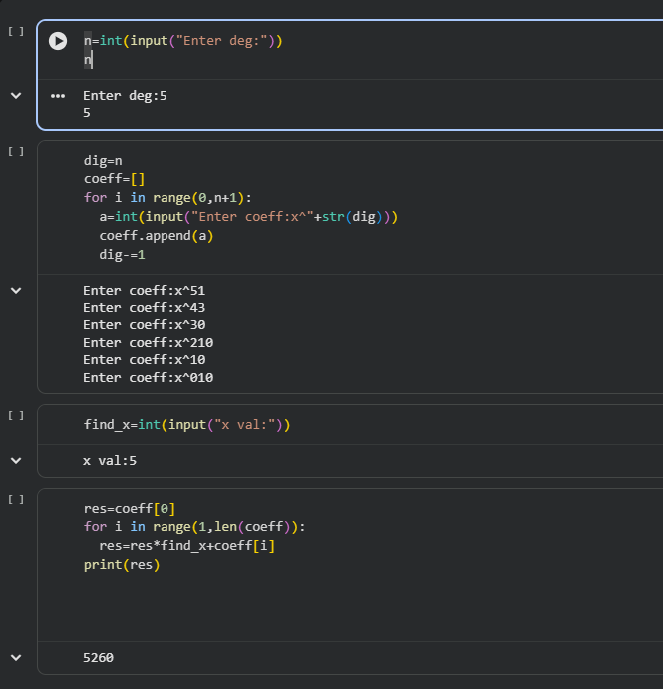

- _{Bisection Method:}
The Bisection Method is a numerical technique used to find the root of a function.
It works by choosing an interval [a,b][a, b][a,b] where the function changes sign. The interval is then repeatedly divided into two equal parts, and the sub-interval containing the sign change is selected. This process continues until the interval becomes very small, and the midpoint is taken as the approximate root.

_{Bisection Method :–}
_{Given f(a)·f(b) < 0}
_{Midpoint:}
_{x = (a + b) / 2}
_{Interval Update:}
If f(a)·f(m) < 0 → root in [a, x]
_{Else → root in [x, b]}
_{Root Approximation:}
_{x ≈ (a + b) / 2}

- _{The code of bisection method:}
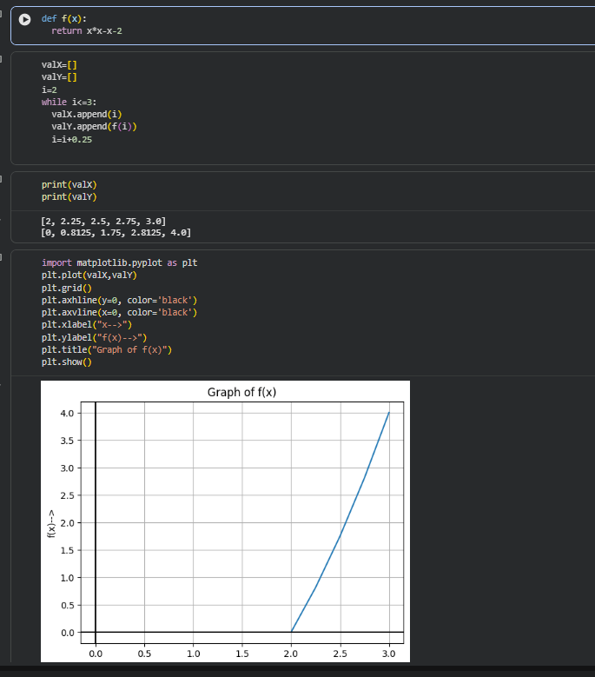
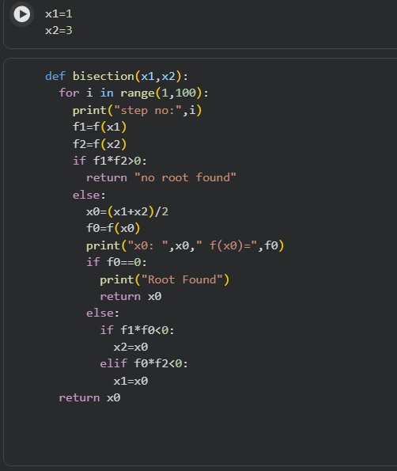
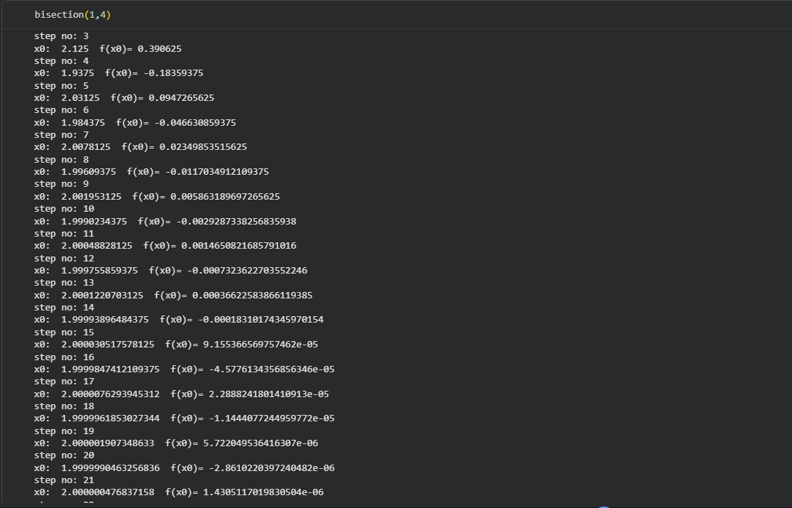
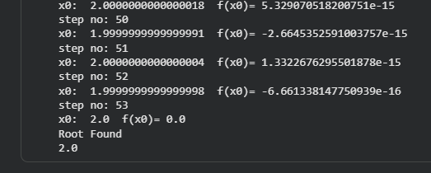

- _{False-Position Method:}
The False Position Method, also called the Regula Falsi Method, is a numerical technique for finding the root of a function.
_{False Position Method :–}

_{Given f(a)·f(b) < 0}
_{Root Approximation:}
x = (a·f(b) - b·f(a)) / (f(b) - f(a))
_{Interval Update:}
If f(a)·f(x) < 0 → root in [a, x]
_{Else → root in [x, b]}

- The code of false-position Method:
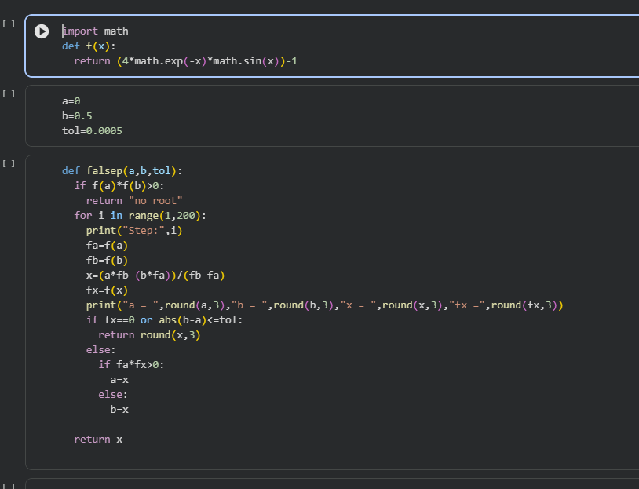
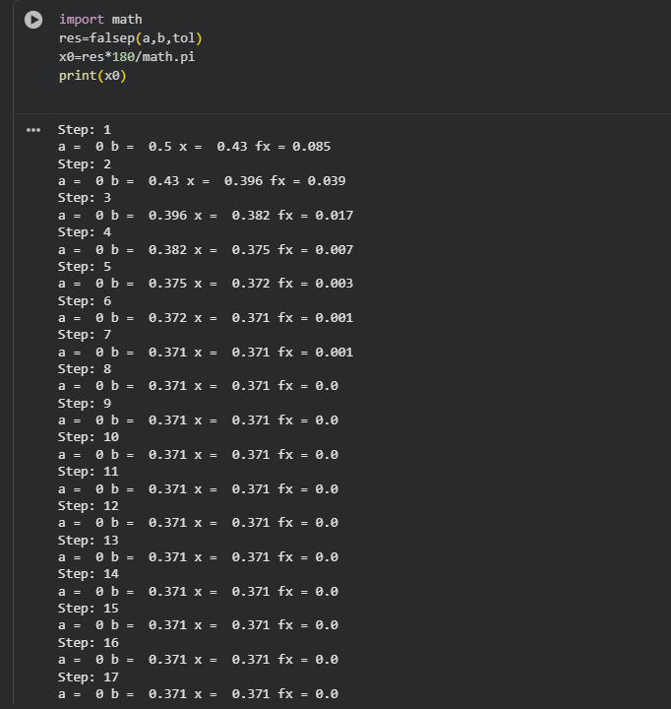
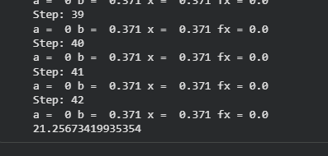

- Newton-Rapson Method:
The Newton–Raphson Method is a fast numerical technique used to find the root of a function. It starts with an initial guess and uses the tangent line at that point to estimate the next value. The process repeats until the value becomes accurate. This method converges quickly when the initial guess is close to the actual root.
Newton–Raphson Method – Formula

Next Approximation:
xₙ₊₁ = xₙ - f(xₙ) / f′(xₙ)

- The code of false-position Method:
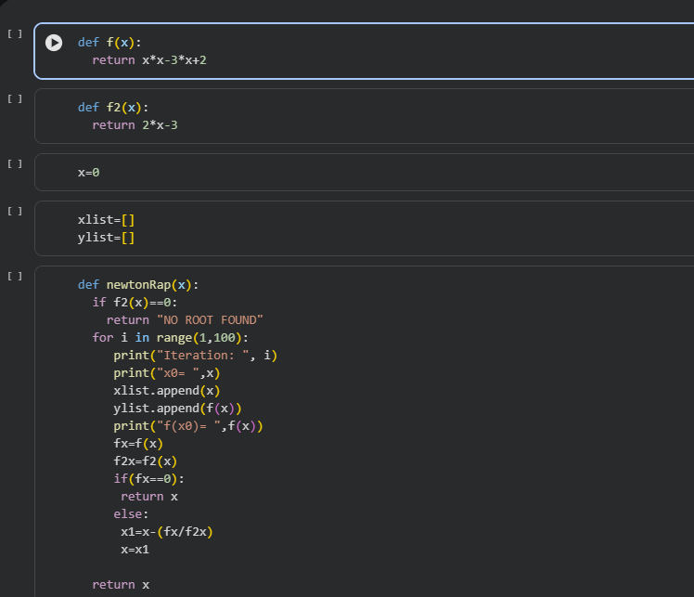
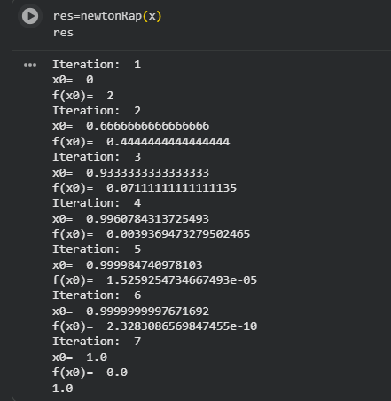
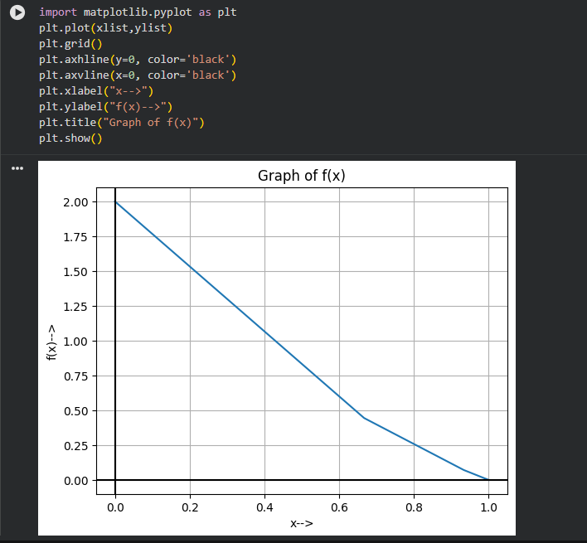

- Lagrange Interpolation:
Lagrange Interpolation is a method used to find a polynomial that passes exactly through a given set of data points.

Given three points:

(x0, y0), (x1, y1), (x2, y2)

Interpolation polynomial:

P(x) = y0 * L0(x) + y1 * L1(x) + y2 * L2(x)

Where,

L0(x) = (x - x1)(x - x2) / ((x0 - x1)(x0 - x2))

L1(x) = (x - x0)(x - x2) / ((x1 - x0)(x1 - x2))

L2(x) = (x - x0)(x - x1) / ((x2 - x0)(x2 - x1))
- The code of Lagrange Interpolation Method:
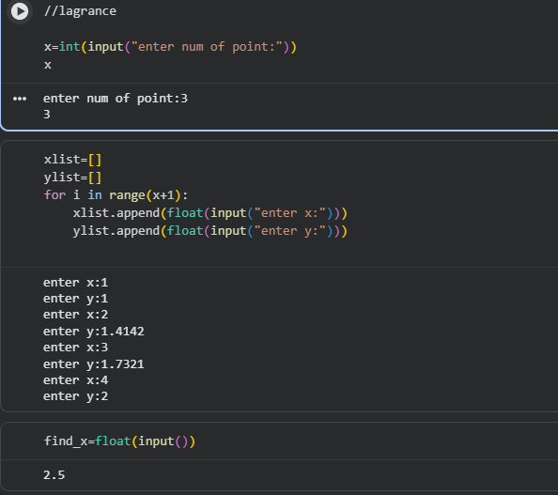

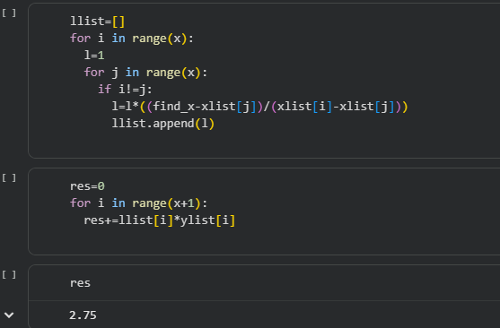

- The Least Squares Method:
The Least Squares Method is a technique used to find the best-fitting curve or line for a given set of data. It works by minimizing the total error between the observed values and the values predicted by the line or curve.

Least Squares Method :
Equation of line:
y = a + b*x
Formulas:
b = ( n*(sum of xy) - (sum of x)*(sum of y) )
/ ( n*(sum of x^2) - (sum of x)^2 )
a = ( (sum of y) - b*(sum of x) ) / n

- The code of Least Squares Method:

