
VILNIUS GEDIMINAS TECHNICAL UNIVERSITY
FACULTY OF FUNDAMENTAL SCIENCES
dEPARTMENT OF INFORMATION SYSTEMS

RESEARCH ON DECISION SUPPORT SYSTEM FOR DESIGNING CLOUD INFRASTRUCTURE

Master Graduation Thesis 2

Prepared by: Təhminə Bayramova, ISIfmu-24

Vilnius, 2025
VILNIUS GEDIMINAS TECHNICAL UNIVERSITY

FACULTY OF fundamental sciences
DEPARTMENT OF information systems

Təhminə Bayramova

RESEARCH ON DECISION SUPPORT SYSTEM FOR DESIGNING CLOUD INFRASTRUCTURE

Master ‘s degree Thesis

Information Systems Software Engineering study programme, state code 6211BX017
Not specified specialisation
Informatics Engineering study field

Supervisor: Dr. Kęstutis Normantas

Vilnius, 2025

Table of Contents
Introduction 6
Investigation Object 6
The Aim and Tasks of the Thesis 6
Novelty of the Topic 6
Relevance of the Topic 7
Research Methodology 7
Scientific Value of the Thesis 7
Main Results of the Thesis 7
Structure of the Work 8
1. Related Works Analysis 9
1.1 Introduction to Cloud Services 9
1.1.1. Types of Cloud Services 9
1.1.2 Characteristics Influencing Selection Criteria 9
1.2 Multi-Criteria Decision Analysis 10
1.2.1 Methods Based on Evaluating and Prioritizing 11
1.2.2 Methods Based on Outranking and Preference Modeling 11
1.3 Literature Review 12
1.4 Related Technologies Analysis 21
1.4.1 Python libraries for MCDA 21
1.4.2 MATLAB Toolboxes for MCDA. 23
1.4.3 Web-Based Tools for MCDA. 23
1.5 Main Results of the 2nd Section 24
2. Proposed approach 26
2.1 Purposed Solutions 26
2.2 Purposed Method 28
2.3 Cloud Service Selection Based on AHP Theory. 29
2.3.1 Introduction to AHP Theory 29
2.3.2 Cloud Service Selection Criteria Model 31
2.3.3 Hierarchical Analysis Model of Consumer-Centered Cloud Service Selection. 32
2.4 Computation Principles of AHP. 33
2.5 Introduction to TOPSIS 35
2.5.1 Traditional TOPSIS method 36
2.5.2. Different extensions of TOPSIS method 38
2.6 Introduction to ELECTRE 40
3. Conclucions 41
3.1 Further Works 42
4. References 43

List of Tables
Table 1.1. Summary of the Research Papers………………………………………………………………12
Table 2.1. The value of random index RI …………………………………………………………………27
Table 2.2. Cloud service selection criteria….………………………………………………………………28
Table 2.3. Object layers compare with criterion layer ……………………………………………………30
Table 2.4. Criterion layers compare with alternative layer …………………………………………………30
Table 2.5. Final Result……………………...………………………………………………………………31

List of Figures
Figure 1.1. Framework for selection of cloud service provider……………….…………………………….16
Figure 2.1. Proposed solution context diagram (C4 Model) ……....……………………………………...26
Figure 2.2. Purposed solution container diagram (C4 Model) ………………………. ……………….….27
Figure 2.3. BPMN diagram for Decision Support System ………………….…………………………….28
Figure 2.4. Sub-process for Collecting Cloud Requirements ……………….…………………………….29
Figure 2.5. Sub-process for Exporting Final design ………..……………….…………………………….29
Figure 2.6. Saaty’s pair-wise comparison scale, where 2, 4, 6, 8 is respectively intermediary number of its left and right (Niemcewicz, 2021) ……………………………………….…………………………….30
Figure 2.7. AHP model of cloud service selection ……………….……………………………………….32
Figure 2.8. Flowchart for TOPSIS methodology.(Pandey et al., 2023) …………………………….…….36

Abbreviations

Abbreviation | Definition
NFR | Non – Functional Requirement
SLA | Service Level Agreement
MCDM  AHP  DSS | Multi-Criteria Decision-Making  Analitical Hierarchy Process  Decision Support System
CSPM | Cloud Security Posture Management
ML | Machine Learning
QoS | Quality of Service
GRC | Governance, Risk Management, and Compliance
IT | InformationTechnologies
AI  ANN  q-ROFS  LLM  TOPSIS | Artificial Intelligence  Artificial Neural Networks  q-Rung Orthopair Fuzzy Sets  Large Language Models  Technique for Order of Preference by Similarity to Ideal Solution
ANP | Analytic Network Process

Introduction
Cloud computing has become a core support base for modern software systems, because of its natural flexibility, scalability, and economy. However, the rapid evolution of cloud service offerings, with frequent updates to pricing models, availability zones, performance, and Service Level Agreements (SLAs), poses significant challenges to software architects. Choosing cloud services that meet the non-functional requirements (NFRs) of software systems is a complex decision-making problem. Lacking systematic processes and decision-support mechanisms, architects usually face poorer outcomes, which have a negative impact on quality of service, operating expenses, and system performance.

Investigation Object
The Investigation Object is decision support methods that facilitate the selection of cloud infrastructure by applying multi-criteria evaluation techniques to address evolving technological, economic, and service-level complexities.

The Aim and Tasks of the Thesis
The aim of this research is to improve decision-making in cloud service selection by offering a structured approach and tool support that applies multi-criteria decision-making to ensure service conformity with non-functional software requirements.
Tasks:
1.To analyse related literature and existing tools for evaluating and selecting cloud services.
2.To propose a systematic approach that would leverage multi-criteria decision-making techniques.
3.To implement a supporting tool prototype and conduct an experimental evaluation to validate the proposed approach.

Novelty of the Topic
Cloud service selection is a critical and new area in cloud computing research. Current frameworks are not very supportive in handling dynamic variations in service attributes, such as real-time performance and price changes. Current research has proposed Multi-Criteria Decision-Making (MCDM) techniques to cloud service selection, but the majority of them consider only the static evaluation criteria without considering the dynamic and real-time nature of the service offerings proposing a novel framework combining MCDM methods with adaptive methods to assess cloud services holistically in order to ensure better correspondence with non-functional requirements (NFRs) (Abdessamaddkobi, n.d.).

Relevance of the Topic
The role of cloud computing in modern IT systems is bound to continue growing and will thus make the process of service selection optimization urgent. Recent research underlines structured and criteria-based approaches to making decisions in the domain. For instance, (Kumar et al.2021) addressed the challenge of evaluating cloud services within dynamic environments, while (Mostafa, 2021) underlined substantial drawbacks of existing MCDM methods when those are applied to evolving cloud service scenarios. Besides, (Liu et al. 2021) call for an integration of subjective and objective attributes to enhance decision-making accuracy. This research directly deals with these challenges, providing an extensive and practical solution toward improving cloud service selection processes.

Research Methodology
The analytical part of the work uses library research and comparative analysis. The logical induction, generalization of concepts, and conceptual modeling methods were used to summarize methods. Theories proposed in the work were validated in practice through the experimental analysis method.

Scientific Value of the Thesis
By applying multi-criteria decision-making techniques to the analysis of existing decision support methods, this study proposes an innovative approach to identify gaps and limitations in cloud service evaluation. This provides a new scientific basis for the development of adaptive and comprehensive cloud service selection frameworks.

Main Results of the Thesis
The results of the research demonstrate that the proposed multi-criteria decision making method and its supporting tools can significantly improve the efficiency and accuracy of cloud service selection. In the complex and dynamic cloud service offerings, proposed solutions show better decision-making capabilities by comparing services with non-functional requirements, optimizing system performance and reducing operational costs.

Structure of the Work
The first chapter introduces the problem of the research, stating the aim, tasks, novelty, relevance, and scientific value of the thesis; the second chapter analyzes the related literature and tools, indicating gaps and opportunities in existing approaches for cloud service evaluation; the third chapter presents the proposed systematic approach, including the description of its design, criteria, and metrics for evaluating cloud services; the fourth chapter describes the development and implementation of the supporting tool, including its architecture, features, and integration.

1. Related Works Analysis

1.1 Introduction to Cloud Services
Cloud services have become part and parcel of the modern IT infrastructure. They are a type of service that offers access to computing resources, such as storage, a pool of processing power, and software applications on demand. Such services will be able to support organizations in decreasing operational costs and enhancing scalability, thereby releasing themselves from too much time-wasting management of physical infrastructures. Cloud enables state-of-the-art solutions, adapted to the needs of a business customer, with flexibility and innovation.

1.1.1. Types of Cloud Services
The services of cloud computing can be categorized based on three different service models for different types of requirements.
1. Infrastructure as a Service (IaaS): IaaS provides virtualized computers over the internet and includes servers, storage, and networking. It helps organizations to build and manage their own IT environment without having any physical hardware, thus providing flexibility in business (Makwe et al., 2024).
2. Platform as a Service (PaaS): PaaS provides the platform that can be used by developers in building, deploying, and managing applications without bothering about the underlying infrastructure. This model quickens the pace of development and reduces time-to-market(Makwe et al., 2024).
3. Software as a Service (SaaS): SaaS provides completely managed software applications that are accessible through web browsers. Through this, users enjoy frequent updates, scalability, and little responsibility for maintenance, hence very ideal for end-users and businesses looking for ready-to-use solutions(Makwe et al., 2024).

1.1.2 Characteristics Influencing Selection Criteria
There are several key characteristics that influence the criteria for selecting cloud services:
1. Scalability: The scalability factor means resources can be changed in real time to correspond with fluctuating demands, especially in organizations that have periodic or unpredictable workloads (Rahimi et al., 2022).
2. Cost Efficiency: The signature of cloud services is indeed the pay-as-you-go pricing model, in which the business will only have to pay for what they use. However, this requires certain understanding regarding price structures and possible hidden costs in order to effectively make decisions.(Rahimi et al., 2022)
3. Performance: Latency, throughput, and availability are the key performance measures that affect user experience, going all the way to touch operational success. The choice of providers with good performance guarantees becomes essential.(Rahimi et al., 2022)
4. Security and Compliance: Security controls allow sensitive information to be protected through encryption of data, control of access, and conformance to industry standards, among others, for the fulfillment of regulatory requirements.(Rahimi et al., 2022)
5. Service Level Agreements (SLAs): SLAs define the level of service a provider commits to providing, such as uptime guarantees and response time of the support service. These agreements are important in the measurement of the reliability of the provider. (Rahimi et al., 2022)
By contrasting these characteristics, organizations can align their choice of cloud services with their specific non-functional characteristics and thereby realize optimal performance and value.

1.2 Multi-Criteria Decision Analysis
Multi-Criteria Decision Analysis (MCDA) is a structured approach to the evaluation of a set of options against multiple criteria, often with conflicting priorities. It is particularly indicated in complex decision-making environments, such as in cloud service selections where technical, economic, and performance considerations have to be balanced. MCDA provides a systematic framework for comparing alternatives that enables the decision-maker to come up with the best solutions that meet the organizational goals and requirements (Abdessamaddkobi, n.d.)

1.2.1 Methods Based on Evaluating and Prioritizing
One common categorization in MCDA comprises techniques which assign weights to individual criteria and measure alternatives on the basis of the given weights. Examples include:
1. Weighted Sum Model (WSM): WSM achieves an aggregated score for each alternative by weighing the scores of each criteria and the results by aggregating the results. This is a simple and quick method of solving the scenario in which criteria have an additive attribute (Deveci et al., 2023).
2. Analytic Hierarchy Process (AHP): AHP applies pairwise comparisons to obtain weights for criteria and rank alternatives. It assists decision-makers in breaking down difficult problems into hierarchical frameworks, which facilitates the assessment of trade-offs (Khan et al., 2024).
3. Technique for Order of Preference by Similarity to Ideal Solution (TOPSIS): TOPSIS selects the optimum alternative based on the distance of the alternative from an ideal solution and proximity to a negative ideal solution. TOPSIS is highly applied because it can manage numerous conflicting criteria (Khan et al., 2024).

1.2.2 Methods Based on Outranking and Preference Modeling
Another class of MCDA methods is outranking and preference modeling, which entails comparison of alternatives in an effort to create a preference ranking. Important methods include:
Elimination and Choice Translating Reality (ELECTRE): ELECTRE applies pairwise comparisons for determining alternatives that outrank others on the basis of thresholds set beforehand. ELECTRE may be used in decision problems involving trade-offs that need to be encountered (Abdessamaddkobi, n.d.).
Preference Ranking Organization Method for Enrichment Evaluations (PROMETHEE): PROMETHEE ranks alternatives based on preference flows, thus enabling decision-makers to strike a balance between qualitative and quantitative aspects. Its application is particularly significant when dealing with incomplete or imprecise data (Bommannavar et al., 2021).
Multi-Attribute Utility Theory (MAUT): MAUT builds a utility function with the objective of modeling the decision-maker's preference across multiple criteria. Alternatives are ranked in terms of their total utility values, thus enabling precise insights into trade-offs (Cloud Service Provider Selection: A Complex Multi-Criteria Decision Making Problem, 2024).
These approaches offer robust bases for the problem resolution of cloud service choice. MCDA enables decision-makers to evaluate the alternatives systematically, consider heterogeneous criteria, and make logical choices in line with organizational objectives and constraints.

1.3 Literature Review
This section emphasizes that while decision support systems offer immense potential for improving cloud infrastructure design, there is a pressing need for more scalable, interpretable, and standardized frameworks. Existing approaches, though effective in specific use cases, often struggle with integration into complex, dynamic cloud environments. These challenges underline the necessity of developing a robust decision-support framework that balances adaptability and efficiency. This thesis addresses these gaps by proposing a comprehensive framework, discussed in subsequent sections, to enhance decision-making in cloud architecture design.
Table 2.1 below provides a comprehensive summary of the research papers reviewed, highlighting their methodologies, application areas, etc., highlighting the progress made and remaining gaps in the field. It consists of the following elements: 1) References, which provides references to the papers analysed; 2) Main research question, which describes the main objective or problem in the study; 3) Methodology, which outlines the methodology and framework used; 4) Area of study/application, which specifies the application or area of study; 5) Dataset used, which identifies the data used in the analysis; 6) Attributes used for prediction, which details the considered characteristics or variables; 7) Methodological assessment, summarising the criteria or indicators used to assess the methodology; and 8) Results, highlighting the main findings or conclusions drawn from the study.

Table 1.1. Summary of research papers
Reference | Used approach | Problem domain studied | Data set used | Attributes used for prediction | Evaluation of the approach | Main Result
(Soori et al., 2024) | Machine learning and AI techniques | Industrial decision-making | Simulated industrial data |  | Experimental evaluation | Demonstrated improvement in decision efficiency and accuracy.
  Operational efficiency, resource allocation
(Baffo et al., 2023) | Multi-criteria decision-making (AHP, TOPSIS) | Sustainable development | Sustainability indices | Environmental, economic, and social indicators | Comparative analysis | Provided structured prioritization of sustainable solutions.
(Mumali, 2022) | Artificial Neural Networks (ANNs) | Manufacturing processes | Literature-based review | Process optimization, cost reduction | Systematic review | Identified key areas where ANN-based DSS improves manufacturing outcomes.
(Al-Surmi et al., 2022) |  |  |  |  |  | Showed the improvement in operational performance.
  Hybrid AI and optimization strategies
  Operational decision-making
  Real-world operational datasets
  Performance metrics, resource efficiency
  Case studies
(Deveci et al., 2023)
  Multi-criteria decision-making and simulation
  Urban transportation in Metaverse
  Simulated transportation data
  Sustainability, efficiency, user satisfaction
  Simulations and comparative studies
  Highlighted effective strategies for sustainable transport planning.
(Yang et al., 2024)
  Decision-making across domains
  World models and datasets
  Contextual decision factors
  Contextual decision factors
  Model-based evaluations
  Demonstrated utility of LLMs in complex decision scenarios.
(Rajashekar et al., 2024) | Human-AI interaction frameworks | Clinical decision support | Patient datasets | Medical symptoms, history, and diagnostics | Case studies and clinical trials | Improved diagnostic accuracy and user satisfaction.
(Mahdi et al., 2022) | Artificial Neural Networks (ANNs) | Intelligent decision-making | Training datasets | Training efficiency, accuracy | Experimental evaluations | Developed efficient training methods for ANN-based DSS.
(Charles Ochei et al., n.d.) | Decision support framework integrating isolation and performance metrics. | Cloud-hosted services and multitenancy. | Experimental data from multitenant systems. | Tenant workload, isolation levels, SLA compliance. | Analyzed tenant satisfaction and system performance under various scenarios. | Improved tenant isolation by 30% while maintaining low latency.
(Nadeem, 2020) | A framework integrating user preferences and quality of service metrics for multi-level ranking. | Cloud service usability and performance evaluation | User surveys and system performance data. | Response time, usability scores, customer satisfaction ratings. | Evaluated ranking accuracy and user satisfaction. | Improved user satisfaction by 15% through better service alignment.
(Makwe et al., 2024) | AHP, TOPSIS | Cloud service prioritization | Cloud service datasets | Cost, performance, scalability | Comparative analysis | Improved selection of cloud services based on prioritized criteria.
(Cloud Service Provider Selection: A Complex Multi-Criteria Decision Making Problem, 2024) | Multi-Criteria Decision Analysis (MCDA) | Cloud service provider selection | Cloud provider datasets | SLA, cost, reliability, security | Simulations and real-world validation | Provided comprehensive framework for cloud provider selection.
(Zhang & Chen, 2022) | Group decision-making frameworks (TOPSIS) | Decision-making under uncertainty | Simulated uncertain environments | Risk, benefit, feasibility | Comparative studies | Enhanced robustness in group decision-making under uncertainty.
(Liu et al., 2021) | Integrated MCDM methods (AHP, SAW) | Cloud service selection | Cloud performance datasets | QoS, cost-efficiency | Simulations and benchmarking | Simplified and optimized decision-making for cloud services.
(Abdelhafeez et al., 2023) | Integrated AHP and TOPSIS | Cloud service provider selection | Cloud service datasets | Security, cost, performance | Case studies | Demonstrated effectiveness of integrated framework in selecting providers.
(Pagano et al., 2021) | AHP | Emergency management | Water supply datasets | Resource allocation, risk factors | Real-world testing | Enhanced emergency management strategies for water systems.
(Ketut Ayu Purnama Sari, 2021) | AHP-SAW | Tourism village selection | Tourism data | Cultural significance, facilities, accessibility | Experimental evaluation | Improved tourism village ranking and selection process.
(Vahidnia et al., 2022) | Hybrid AHP and TOPSIS | Spatial decision-making | Geospatial datasets | Accessibility, risk, population density | Case studies | Optimized fire station site selection with spatial decision support.
(Niemcewicz, 2021) | AHP | Cloud provider selection | Cloud service datasets | Reliability, performance, cost | Comparative studies | Provided effective criteria for selecting cloud providers.
(Belusso et al., 2022) | Custom decision support methodology | IaaS service selection | Infrastructure datasets | Scalability, cost-efficiency, performance | Case studies | Enhanced methodology for selecting IaaS services.
(Khan et al., 2024) | Hybrid AHP and TOPSIS | Cloud data privacy | Cloud privacy datasets | Privacy, compliance, user satisfaction | Experimental evaluation | Improved prioritization of data privacy factors in cloud systems.
(Gyani et al., 2022) | Review of MCDM methods | Cloud service selection | Literature review | Cost, QoS, usability | Systematic review | Identified key prioritization methods for cloud services.
(Bommannavar et al., 2021) | AHP | Cloud service selection | Performance datasets | Latency, availability, throughput | Experimental analysis | Improved cloud service selection based on performance metrics.
(Gebre et al., 2021) | Review of MCDM methods | Water allocation problems | Literature review | Resource distribution, sustainability | Review and analysis | Highlighted effective MCDM methods for water allocation.
(Gupta et al., 2022) | Review of AI-based DSS | Operations research | Literature review | Optimization metrics, decision accuracy | Systematic review | Proposed future directions for AI in decision support systems.
(Abdessamaddkobi, n.d.) | Multi-Criteria Decision Analysis (MCDA) including AHP, TOPSIS | Decision support across various domains (e.g., transportation, urban planning) | Case studies presented in the book | Weights, preferences, trade-offs, QoS attributes | Comparative evaluations within case studies | Highlights the applicability of MCDA in solving complex decision-making problems.
(Rahimi et al., 2022) | Systematic Literature Review (SLR); Decision-making methods, meta-heuristic methods, and fuzzy-based methods | Service selection in cloud computing | 32 papers analyzed, categorized by decision-making, meta-heuristics, and fuzzy logic | Cost, time, scalability, efficiency, reliability | Comparative analysis of reviewed methods | Provides a comprehensive framework categorizing and assessing service selection methods with challenges and directions for future research.
(Pandey et al., 2023) | A hybrid method combining the cloud model with Monte Carlo simulation, and TOPSIS for ranking alternatives | Selection of the optimal tunnel excavation method under uncertainty in geotechnical engineering. | A realistic case representing a tunnel section in China, involving 5 alternative excavation methods evaluated against 16 decision criteria . | 16 criteria related to tunnel construction, such as geological adaptability, cost, safety, environmental impact, and operational performance. | The method applies Monte Carlo simulations to model uncertainty and global sensitivity. | The TBM (Tunnel Boring Machine) was identified as the optimal method.
(Canco et al., 2021) | Analyitical hierarchy process | Business problem | Sistematic literature review | realibility | Case studies | Business process solved
(Taherdoost & Madanchian, 2023b) | Literature review of ANP method/framework | MCDM domains: project mgmt, risk, supplier selection, product design | 100+ published case applications | Not applicable | Qualitative summary of literature | ANP handles interdependent criteria well but is complex and time-consuming
(Tavana et al., 2023) | Systematic review of AHP method & hybrids | Evolution of AHP in various MCDM fields | Literature survey over 30+ years | Not applicable | Comparative analysis | Hybrid AHP methods reduce judgment effort, preserve ranking quality
(Al Fozaie & Wahid, 2022) | Methodological guide integrating expert opinion + Fuzzy AHP | Composite index construction | No primary data; guidance paper | Weights of composite indices | Methodological validation via example | Fuzzy AHP yields more objective weights but may skew composite results
(Bhat, 2023) | Group AHP enhanced with neutrosophic trapezoidal numbers | Group decision problems | Real-world decision-making case | Pairwise judgments under uncertainty | Comparative case study | Revised model improves consistency and reciprocity in group decisions
(Xia et al., 2021) | AHP + fuzzy comprehensive evaluation | Usability of health app for elderly | Expert interviews, affinity groupings | Usability, learning, info processing, mental/physical needs | Fuzzy evaluation matrices | User learning and clear information are most critical attributes
(Essaber et al., 2021) | Hybrid: AHP + Root Cause Analysis + TRIZ | Lean‑green supply chain risk management | Single industrial case study | Risk factors affecting lean-green | Case application with structured tools | Provides systematic risk reduction method for lean-green performance
(Shi & Lai, 2023) | Fuzzy AHP applied to stakeholder survey | Talent concentration in high-tech sectors | Surveys of experts/organizations | Individual, organizational, environmental incentives | Statistical + Fuzzy AHP | Individual incentives rated more important than environmental ones
(Yazdi, 2022) | Fuzzy linguistic MCDM methods (e.g. bow-tie, 2-tuple) | System safety & reliability analysis | Multiple case studies across industries | Linguistic safety/risk factors | Case-based method demonstration | Demonstrates flexible fuzzy linguistic approaches for improved safety assessment

The research targets to address the complexity of cloud service selection and decision-making by applying various advanced methods, including MCDA, artificial intelligence, and optimization technology. The main themes under discussion include the priority of cloud services, cost-effectiveness, service reliability and privacy considerations. For instance, The Multi-Criteria Decision Support Approach describes several MCDA methods, like AHP and TOPSIS, and shows how these methods solve complicated decision-making problems in different areas. Another paper, titled On Toward the Efficient Service Selection Approaches in Cloud Computing, discusses systematic, metaheuristic, and fuzzy methods in depth and underlines scalability, cost, and reliability as the main issues while assessing cloud services. Together, these studies will improve the structured approach to the selection of cloud services by their optimization in respect of non-functional requirements.
In (Abdessamaddkobi, n.d.), a deep overview of MCDA methods and their applications to decision support systems within a wide area are provided. It gives an explanation of the key methodologies of MCDA, such as AHP, TOPSIS, and ELECTRE, pointing out their capabilities for solving complex decision-making problems with multiple, often conflicting, criteria. It also outlines a number of case studies in illustrative sectors: urban planning, resource management, and infrastructure, which have demonstrated the enabling of such techniques in performing a systematic evaluation and prioritization of alternatives. Further, the final chapter deals with strengths and weaknesses of each methodology thus relating it to its present application.
In (Rahimi et al., 2022), the most advanced methods of cloud service selection are systematically reviewed, focusing on decision-making, meta-heuristic methods and fuzzy techniques. The authors classified and analyzed 32 research papers to identify trends, challenges, and gaps in current methods. The main features considered include costs, scale, reliability and time efficiency. The paper emphasizes the need for a hybrid methodology that combines accuracy and adaptability and offers a future research agenda to develop a more robust and flexible service selection framework.
In (Baffo et al., 2023),the classification and analysis of the existing methods for cloud service selection are performed. It considers decision-making approaches-like AHP and TOPSIS-, meta-heuristics approaches, and fuzzy approaches-some of the main techniques in this area. The review underlined challenges about scalability, efficiency, cost optimization, and QoS measurement integration. This work presents existing problems and proposes the use of hybrid methods along with adaptive solutions in order to overcome the NP-hardness of cloud service selection. Finally, it provides some recommendations toward improving decision-making processes in cloud environments.
In (Niemcewicz, 2021), the critical methods for improving cloud service selection, real-time adaptability, and fulfilling user-centric requirements are reviewed. Techniques falling under AHP, fuzzy logic, and hybrid models are discussed. This study underlined the fact that functional and non-functional QoS attributes should be covered in decision-making. It highlights the lacuna of automation and integration in user feedback from existing approaches and advocates frameworks for more dynamic and scalable solutions. It also proposed the incorporation of optimization algorithms into the dynamics of cloud markets for better service allocation, cost management, or both.
In (Cloud Service Provider Selection: A Complex Multi-Criteria Decision Making Problem, 2024),author focuses on complex selection of CSPs where providers, services and pricing models are changing to gain market momentum. They recognise the selection process as a MCDM problem and explore MCDM techniques such as AHP, TOPSIS, ANP and fuzzy methods. It reviewed the available approaches and highlighted the strengths and limitations of each approach. It identifies major driving factors for selection: QoS parameters in terms of performance, reliability, security, and cost. Challenges brought out include the dynamic nature of QoS criteria, integrating newer MCDM methods being difficult, and more advanced fuzzy models like type-2 fuzzy sets are needed. It concludes with the identification of future research areas-developing integrated advanced MCDM techniques along with real-time monitoring and QoS prediction for improving the accuracy of the decision and security aspects.
In (Makwe et al., 2024), the framework for evaluating and selecting CSPs using the widely used MCDM technique VIKOR is presented. The framework is built on the basis of various criteria, including performance, scalability, cost, security, compliance and integration capabilities, to evaluate CSPs. The study identifies performance and reliability as the most important factors, while vendor lock-in is considered to be the least important. It points out the most relevant drivers that may affect the choice, relating those to QoS performance, reliability, security, and cost. The challenges discussed here are dynamic changes in QoS criteria, poor integration of new MCDM methods, and further requirements of more sophisticated fuzzy models, such as type-2 fuzzy sets. The paper is concluded by putting forward a research avenue where combining advanced MCDM techniques, including real-time monitoring and QoS prediction, would supply a better basis for decision-making and, of course, considering the security concerns.
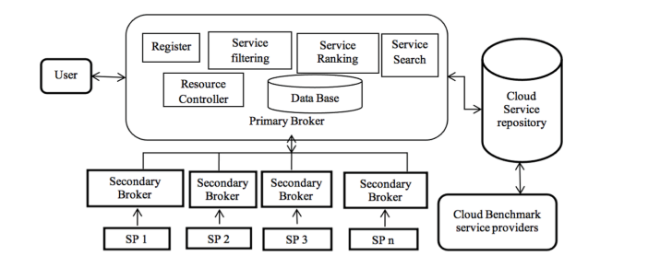
Figure 1.1. Framework for selection of cloud service provider,(Makwe et al., 2024) .

In (Soori et al., 2024), examined that the transformational role of AI-based decision support systems (DSS) in Industry 4.0. It focuses on the integration of technologies such as machine learning, deep learning and natural language processing into industrial processes to optimize operations, improve productivity and support predictive maintenance. It has identified applications like supply chain management, quality control, and energy optimization. The main challenges are data quality, integration of AI systems, and management of human-AI interactions. Future trends were also discussed, and an autonomous decision-making system was emphasized to enhance industrial competitiveness and efficiency.
In (Mumali, 2022), the systematic review synthesizes the role of artificial neural networks (ANN) in decision support systems (DSS) within manufacturing. ANN is known for handling complex and unstructured decision problems, applying to such areas as performance evaluation, product design, and predictive maintenance. Identification of the trend for ANN being combined with other intelligent tools, such as fuzzy logic and genetic algorithms in enhancing the performance. It also points to the key role ANN-based DSS will play in sustainable and intelligent manufacturing processes with regard to operational optimization challenges and resource use. The study recommends the need for further research in the area of exploring additional tools that would enrich ANN-based DSS​.
In (Al-Surmi et al., 2022), the study explores the role of the alignment between marketing and IT strategies in view of improved performance, combining structural equation modeling with artificial neural networks. Grounded on a sample of 242 managers from various industries, this paper will explain how marketing strategy mediates the influence of IT strategy on performance, under the contingent situation of both environmental and organizational contingencies. Based on the proposed ANN framework, forecasts and optimizations of the strategies for various sectors of business are done. This integration of AI in decision-making depicts a tremendous improvement in operational efficiency while offering practical tools for strategic alignment and performance enhancement.
In (Deveci et al., 2023), the paper integrated blockchain technology with the metaverse to improve service efficiency in public transport systems and data collection. It proposed a hybrid decision-making framework based on q-rung orthopair fuzzy sets (q-ROFS) for prioritizing sustainable urban transportation. The advanced aggregation and weighting models employed in this work have been presented to give a structured approach toward the optimization of transportation planning in virtual environments. A case study will sufficiently illustrate how this framework can handle uncertainties while considering multiple influences. This study further contextualizes the role of the metaverse driven by data analytics in public transportation by underlining the potentiality for sustainability via e-mobility solutions and sharing transportation models.
In (Yang et al., 2024), This paper investigates the use of Large Language Models (LLMs) as world models for decision-making tasks and conducts performance tests of verification of policies, proposition of actions, and policy planning in 31 diverse environments. The study also shows that GPT-4o outperforms GPT-4o-mini in many tasks, especially those involving domain knowledge, but both struggle with long-term stability in decision making. This research underlines that more robust mechanisms of action selection are still to be designed while pointing at different functionalities integrated into the world model, introducing disparities into performance. While evaluating LLM capabilities of state transition prediction and decision optimization, this research provides insight into potentialities and limits imposed by AI-driven autonomous planning systems ​.

1.4 Related Technologies Analysis

1.4.1 Python libraries for MCDA
scikit-criteria is one of the most comprehensive Python libraries for performing Multi-Criteria Decision Analysis (MCDA). It supports most of the techniques such as TOPSIS, VIKOR, ELECTRE, and MAUT. It is modular and pipeline-based, making it very compatible with pandas, and thus highly reproducible through transformations such as normalization, weighting, and ranking. Although it is an impressive suite of functionalities, it has a more-sophisticated learning curve than smaller libraries—users need to familiarize themselves with the DecisionMatrix object and apply transformers in sequence. Once mastered, however, scikit-criteria is an excellent tool for sophisticated decision tasks in research and real-world applications (Scikit-Criteria Documentation, 2024).
pyDecision is a user-friendly Python package with a wide range of MCDA methods such as AHP, TOPSIS, VIKOR, COPRAS, ARAS, and MOORA. It's ideal for users who would prefer to calculate different methods in a hurry without writing custom logic from the scratch. pyDecision is a function-based library and we can evaluate decisions by straightforward commands like topsis_method() or ahp_method() and give it plain lists or NumPy arrays. It is not as extensible as scikit-criteria, but it is robust in its simplicity and usability (Pereira et al., n.d.).
ahpy is a Python library that is specialized for use in the Analytic Hierarchy Process (AHP) and facilitates constructing pairwise comparison matrices, calculating criteria weights, and checking consistency of judgments using the Consistency Ratio (CR). It is class-based and makes it simple to specify hierarchies of decisions with sub-criteria and collapsing them together into a unified model. One of the library’s main strengths is that it is transparent and clear in its emphasis, producing simple-to-read results like priority vectors and CR values. With excellent documentation and user-friendly layout, ahpy is particularly convenient to use for academic pursuits and structured decision-making with the specific aim of AHP only (Pereira et al., n.d.).
pymcdm is a light library that supports standard decision-making methods like TOPSIS, VIKOR, WASPAS, and MOORA. pymcdm is made efficient and lightweight with a function-based mindset, where one supplies the decision matrix, criteria weights, and the method name to get the output right away. pymcdm is easy to use when adopting small-scale projects or demonstrational purposes but lacks much by way of flexibility when facing more complex workflows or tailored assessment rules. In contrast to more mature packages as scikit-criteria, pymcdm is updated less frequently and is not appropriate for extended or heavy usage but is still sufficient for quick experimenting and teaching (Kizielewicz et al., 2023).
pyMCDA is a minimalist library in its early stage of development that was developed to accommodate basic MCDA methods such as SAW (Simple Additive Weighting) and TOPSIS. It has very limited features and basically no official documentation, therefore it is not convenient for those who are not familiar with the source code. However, it can be helpful as a lightweight tool for simple university exercises or for studying the underlying logic of MCDA methods using code when necessary. Due to its poor support, lack of maintenance, and limited method coverage, it's typically only recommended for educational purposes or as a reference to create custom MCDA implementations (Boggia et al., 2018).

1.4.2 MATLAB Toolboxes for MCDA.
The MCDA Toolbox for MATLAB is a specialized toolkit specifically designed to assist the solution of the multi-criteria decision-making problems using conventional techniques such as TOPSIS, SAW, and AHP. The toolbox presents succinctly organized functions and graphical user interfaces which make it easier to model decision matrices, weights definition, data normalization, and ranking calculation. The integration with MATLAB’s computational engine, swift computing and easy observation of the results are allowed. It is particularly useful in research or academic environments where MATLAB is being used for engineering or optimization tasks as well. The toolbox itself is robust, but it does require prior experience with MATLAB scripting and environment setup.
AHP MATLAB Toolbox is specifically for the implementation of the Analytic Hierarchy Process (AHP). The toolbox enables users to build pairwise comparison matrices, calculate eigenvalues for weights in criteria, and verify consistency ratios to ensure rational consistency in judgments. The toolbox does much of the mathematics needed in AHP and can be applied to structured decision-making problems in engineering, project management, and system design. Although it does not have the visual interfaces of web resources such as Super Decisions, it provides accuracy and flexibility for individuals who can cope with MATLAB's programming interface.

1.4.3 Web-Based Tools for MCDA.
Expert Choice is a premium, business-oriented decision-support platform designed specifically for applying the Analytic Hierarchy Process (AHP) within business and policy-making contexts. It presents a professional interface with step-by-step guidance for building decision hierarchies, making pairwise comparisons, sensitivity analysis, and visualizing results. One of its most significant advantages is its focus on usability and decision transparency—it facilitates collaboration between teams, making decisions in real time, and ensuring that stakeholder input is accurately captured.
Super Decisions is academic-friendly software developed by Thomas Saaty's team to support AHP and Analytic Network Process (ANP) modelling. It possesses a graphical user interface to construct decision trees, running pairwise comparisons, calculate priorities, and testing model consistency. Since it does not require coding like MATLAB-based toolboxes, it is appropriate for non-programmers or interdisciplinary teams. Super Decisions is frequently used in university research and theses for decision modelling. But its interface will look dated, and some of its features require extra learning since non-standard UI conventions are adopted. Still, it remains among the most respected free AHP/ANP programs in education and research.

1.4.4. BPMN/dmn overview
To design and automate decision-support workflows effectively, it is essential to use tools that support both Business Process Model and Notation (BPMN) and Decision Model and Notation (DMN) standards. These technologies enable visual representation and logical integration of business processes and decision rules, ensuring transparency, standardization, and traceability throughout the system development lifecycle.
Among the most widely recognized tools is Camunda Modeler, an open-source modeling and automation platform that natively supports BPMN, DMN, and CMMN standards. It allows users to design process workflows and decision tables in a unified environment and deploy them directly to the Camunda Engine for execution. Its modular architecture makes it particularly suitable for cloud-based systems requiring both process orchestration and decision automation. Similarly, Signavio Process Manager provides a collaborative, web-based modeling environment with strong BPMN and DMN capabilities, version control, and governance features, making it ideal for large organizations managing complex business processes.
Flowable is another open-source platform that offers comprehensive support for BPMN, DMN, and CMMN modeling. It includes both a modeling environment and an execution engine, allowing developers and analysts to model workflows and decisions that can be directly executed through REST APIs or embedded within enterprise systems. Flowable’s microservice-oriented architecture makes it well suited for integration with distributed decision support systems such as the one proposed in this research.
In addition to workflow engines, Drools and KIE (Knowledge Is Everything) represent powerful rule-based and decision management frameworks within the Red Hat ecosystem. Drools provides a robust DMN-compliant decision engine capable of executing complex business rules, while KIE serves as an umbrella project offering tools for modeling, authoring, and managing BPMN and DMN artifacts in a unified interface. Together, Drools and KIE enable the creation of intelligent, rule-driven applications by integrating declarative decision logic directly into business processes.
Furthermore, Trisotech provides a commercial suite that integrates BPMN, DMN, and CMMN modeling with cloud execution and analytics capabilities. bpmn.io and DMN Modeler deliver lightweight, browser-based alternatives for creating and sharing BPMN and DMN diagrams, suitable for education, research, and small-scale prototyping.
In summary, selecting the right tool depends on the scope and integration requirements of the project. For the purposes of this thesis, tools that ensure seamless interoperability between BPMN and DMN, enable model validation and execution, and support open standards (XML or JSON exports) are most appropriate. These capabilities allow the proposed Decision Support System to bridge process design with automated execution, maintaining consistency between modeled decisions and real-time system behavior.

Product Name | License |  | DMN Support (Modeling / Execution) |  |  | Documentation
  BPMN Support (Modeling /Executio)
  Integration
  Extensibility
Flowable | Open-source (Apache 2.0) | Full BPMN 2.0 modeling and execution via Flowable Modeler and Engine | Supports DMN 1.1 modeling and execution through the Flowable Decision Engine | REST API, Java API, and Spring Boot integration | Highly extensible; allows invoking external services, custom scripts, and connectors | Extensive developer and user documentation; active open-source community
Drools / KIE | Open-source (Apache 2.0, Red Hat ecosystem) | Limited BPMN support (through jBPM module in KIE Workbench) | Full DMN modeling and execution; strong rule-based decision management | REST API, Java API, and KIE Server integration | Highly extensible with rule-based extensions, event listeners, and service invocation | Comprehensive Red Hat and community documentation, active support
Camunda | Open-source core + commercial enterprise edition | Full BPMN 2.0 modeling and execution using Camunda Modeler and Zeebe Engine | DMN 1.3 modeling and execution natively supported | REST API, gRPC, and cloud-based connectors | Extensible via external task handlers, microservices, and Java/Spring Boot integrations | Excellent documentation, tutorials, and enterprise-level training
Trisotech Digital Enterprise Suite | Commercial | BPMN 2.0 modeling with business/technical alignment; supports cloud execution | DMN 1.3 modeling and execution, integrates with decision engines | REST API, cloud integration, and Microsoft/Google connectors | Extensible through predefined connectors and API calls | Well-documented commercial support, training, and knowledge base
Signavio Process Manager (SAP Signavio) | Commercial | BPMN 2.0 modeling with collaboration, versioning, and governance | DMN support mainly for decision documentation, not full execution | Cloud APIs, integration with SAP and other enterprise systems | Limited extensibility (focuses on analysis and documentation) | Comprehensive enterprise documentation and customer support

1.5 Main Results of the 2nd Section
The second part discussed various approaches and strategies of cloud service choice with greater emphasis on decision models and their applications. The key findings are:
1. Diversity of Approaches: The methods utilized here vary from MCDA techniques like AHP, TOPSIS to meta-heuristics, to hybrid. Each of the above techniques does have some scalability issues, cost-effectiveness, and real-time flexibility, due to which it is preferred in a specific decision context (Abdessamaddkobi, n.d.).
2. Effectiveness of MCDA Methods: Multi-Criteria Decision Analysis (MCDA) methods have proven useful in formal decision-making situations where ranking cloud services against a set of criteria such as cost, performance, and security is acceptable. The research proves that the application of MCDA with adaptive models improves the precision of the decision-making process in dynamically evolving cloud environments (Gyani et al., 2022).
3. Integration Challenges: The overarching motif that was understood was an inadequate attention to the user-centric needs and real-time feedback within the current frameworks. Most proposed solutions continue to struggle to achieve the balance between automation and personalizedization in the context of dynamic cloud service delivery (Rahimi et al., 2022).
4. Emerging Trends: The most promising hybrid methods are multi-criteria decision analysis (MCDA) and optimization methods such as genetic algorithms and machine learning methods. These methods use the strengths of different methodologies to tackle the multi-dimensionality of cloud service selection (Abdessamaddkobi, n.d.).
5. Practical Contributions: The aforementioned works investigated pragmatic frameworks and models, i.e., cloud provider ranking mechanisms and resource allocation optimization algorithms. The research was validated through case studies, simulations, and empirical experiments, thus demonstrating the generalizability of the research in a variety of different industries (Abdessamaddkobi, n.d.).
6. Future Research Directions: It provided the impression of upcoming developments that are to be needed on automation, real-time flexibility, and scalability. In addition, this segment identified the shortcomings of this process in the aspects of incorporating user feedback and accommodating new technologies, including AI and big data analytics (Rahimi et al., 2022).
Together, these observations lead to better comprehension of methodologies for cloud service selection and provide a ground for further suggestions of advanced frameworks for decision-making.

2. Proposed approach

2.1 Purposed Solutions
This section provides the system context and internal container organization of the Cloud Infrastructure Design Support System. These diagrams are used to describe how the system is communicating with external actors and systems, and how its internal components are organized and functionally connected. The goal is to define clean software boundaries, roles, and dependencies that enable a scalable, maintainable, and service-oriented system for cloud infrastructure analysis and decision support.
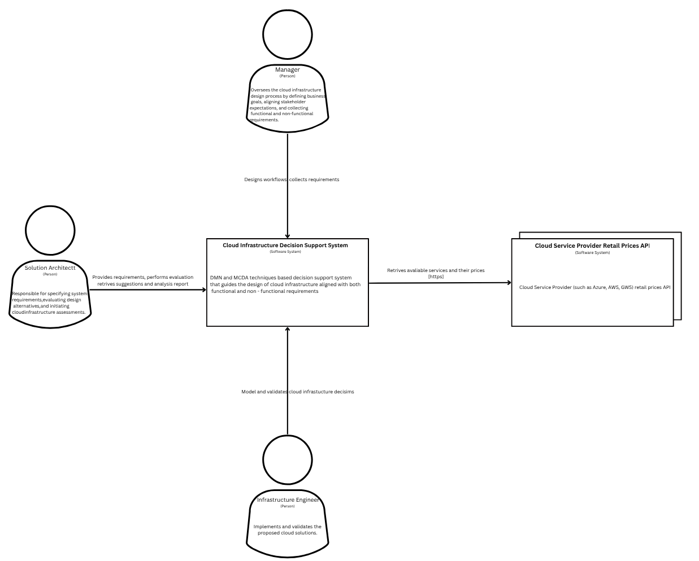
Figure 2.1. Proposed solution context diagram (C4 Model)
The initial diagram represents the system context for Cloud Infrastructure Design Support System and its engagement with human and software actors. Three user types can be differentiated: the Manager, who defines business-level requirements and workflows; the Solution Architect, who provides technical evaluation criteria and applies system-produced recommendations; and the Infrastructure Engineer, who checks and implements cloud infrastructure designs. In terms of software, the system is integrated with the Cloud Service Provider Retail Prices API, which retrieves live service offerings and prices from providers like AWS, Azure, and GCP.
The Cloud Infrastructure Design Support System is centrally located to receive requirements, inform decision-making with DMN and MCDA logic, and return tested alternatives. The diagram also shows the central direction of interactions, demonstrating that the system not only consumes external service data but also supports iterative refinement based on feedback from architects and engineers.
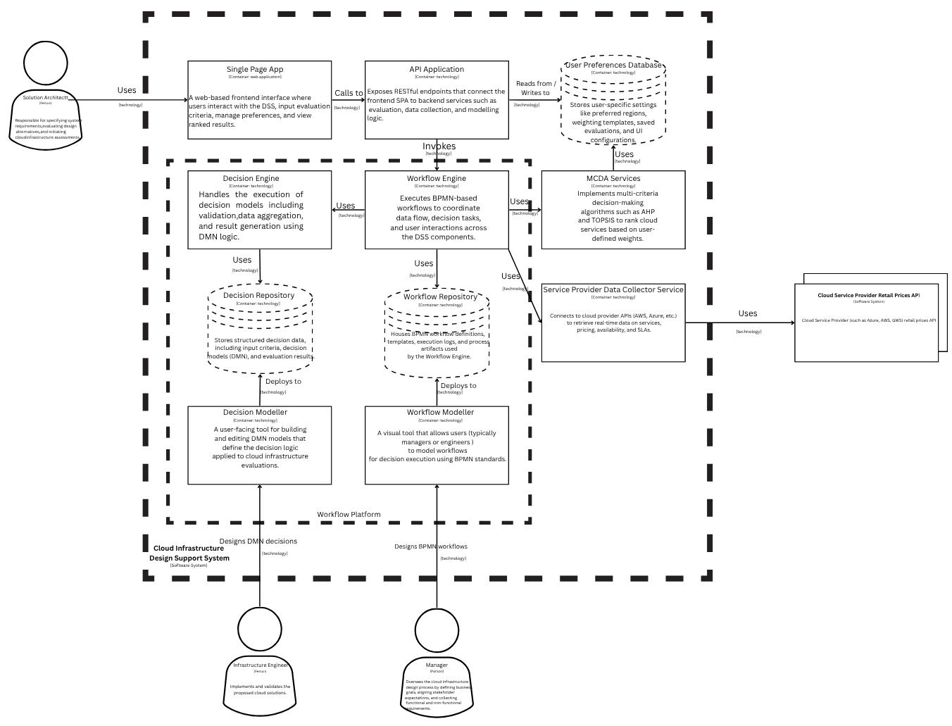
Figure 2.2. Proposed solution container diagram (C4 Model)
The second diagrame breaks down the CIDSS into its internal containers, which have some specific capability in the design. The frontend is developed as a Single Page Application (SPA) that communicates with the API Application backend using RESTful calls. The user preferences are handled using a separate User Preferences Database. A few of the key processing elements include the Decision Engine and Workflow Engine that run DMN decision logic and BPMN-based workflows, respectively. These engines make use of data from their respective repositories and are controlled by the API layer. The MCDA Services component responsible for running algorithms such as AHP and TOPSIS for ranking decisions, and the Service Provider Data Collector communicates with outside APIs to fetch up-to-date cloud service and price information. Users interact with Decision Modeller and Workflow Modeller tools to define decision logic and workflows. The tools allow non-technical users to contribute visually to system logic, making decision processes transparent and flexible. The architecture reflects a loosely coupled, modular system in accordance with microservices principles, facilitating high flexibility and easy future extension.

2.2 Proposed Method
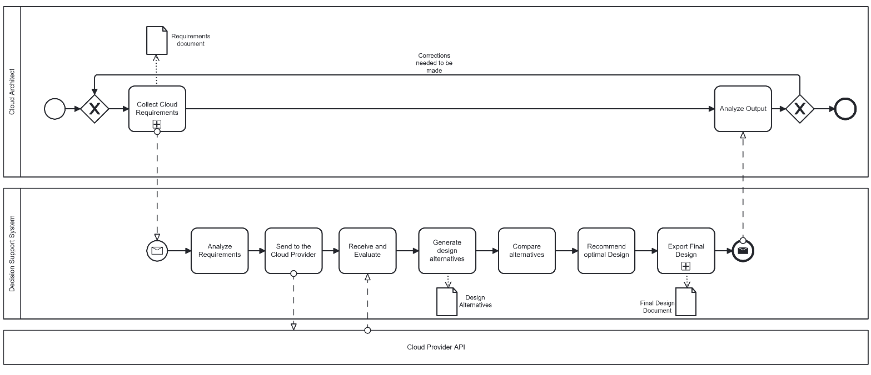
Figure 2.3. BPMN diagram for DSS
The BPMN diagram above shows the cloud infrastructure design process involving three roles which are, Cloud Architect starts the process by collecting the cloud requirements. Then send the requirements to the Decision Support System (DSS), which processes the requirements, submits them to the Cloud Provider API. It then compares the alternatives and recommends the best design. The architect gets the results and reviews the output. If there are any errors, the loop in the process repeats; otherwise, the process ends.
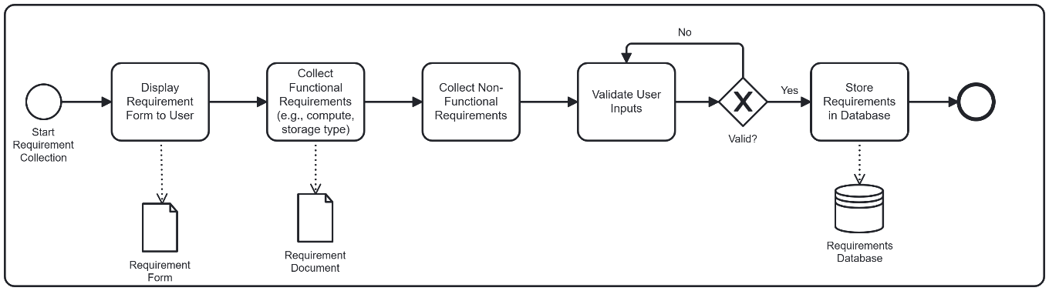
Figure 2.4. Sub-process for Collecting Cloud Requirements.
This BPMN diagram represents a sub-process for collecting software requirements from users. It illustrates the structured flow of activities involved in gathering, validating, and storing both functional and non-functional requirements.
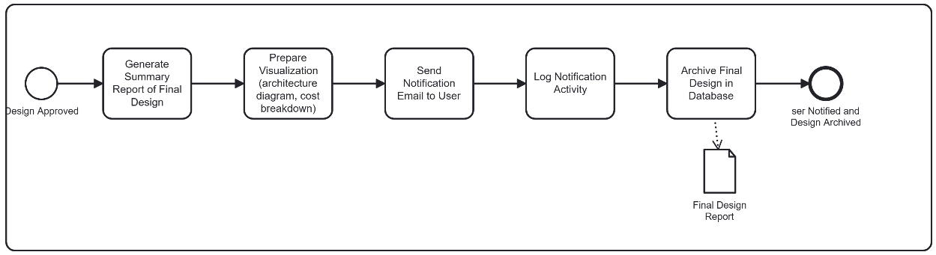
Figure 2.5. Sub-process for Exporting Final Design.
The BPMN diagram above represents a sub-process for exporting final design document. It illustrates the structured flow of activities involved in genarating summary of final design, preparing visualization, and sending to cloud architect.

2.3 Decision Model
The following decision model illustrates the key choices involved in designing a cloud infrastructure, breaking down the main decision into its fundamental components and sub-decisions.
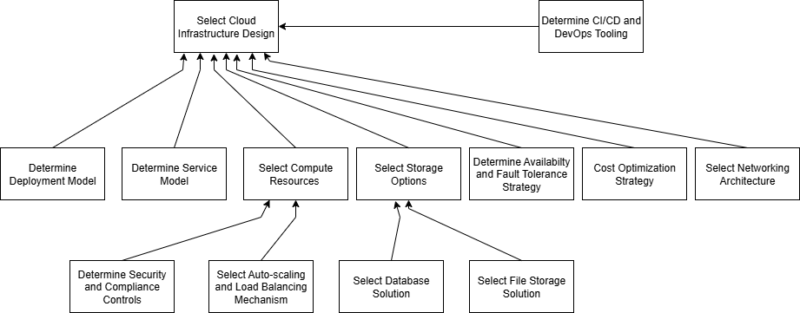
At the top level, the decision model centers around selecting the overall cloud infrastructure design. This high-level decision is supported by several critical choices that shape the final solution. Organizations must first determine their deployment model (public, private, hybrid, or multi-cloud) and the service model (IaaS, PaaS, SaaS) that best aligns with their business goals. From there, more technical aspects come into play, such as selecting the appropriate compute resources, storage options, and networking architecture, all of which influence scalability and performance.
Another major focus is on availability and fault tolerance strategies, ensuring that systems remain reliable and resilient under failures, as well as cost optimization strategies, which balance performance with budget constraints. Sub-decisions further refine the architecture: for example, compute resources require defining auto-scaling and load balancing mechanisms, while storage options branch into choices like database solutions and file storage solutions. Additionally, the model acknowledges the importance of security and compliance controls, which are embedded into deployment decisions, and the integration of CI/CD and DevOps tooling, which ensures smooth development and operational workflows.
Altogether, this model captures the layered and interconnected nature of cloud infrastructure design. Each decision cascades into others, demonstrating how strategic, technical, and operational considerations must work together to create an optimized, secure, and cost-effective cloud environment.

2.4 Cloud Service Selection Based on AHP Theory.

2.4.1 Introduction to AHP Theory
The analytic hierarchy process (AHP) is a multi-criteria decision-making method rooted in utility theory, developed by Thomas L. Saaty in the 1970s. It is useful for non-specialists needing expert insights, particularly in cloud computing. AHP breaks down complex decisions into a hierarchy of criteria, comparing options in pairs and prioritizing them. This method involves decomposing the problem into a hierarchy of criteria, comparing elements at each level, and composing the resulting priorities. Respondents define their preferences at each level after the structure is built. Pairwise comparisons are made using Saaty’s nine-point scale. In this ratio scheme, value equal to 1 stands for the equally important; 3 stands for moderately important; 5 stands for strongly important; 7 stands for the de monstrably important, and 9 stands for extremely important. At the same time, an intermediary number is feasible (such as 2, 4, 6, 8), it means an middle number of its neighbors, and a reciprocal value is used for a reverse comparison. (Niemcewicz, 2021)

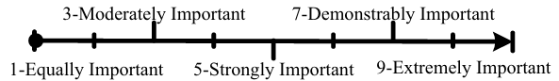
Figure 2.6. Saaty’s pair-wise comparison scale, where 2, 4, 6, 8 is respectively intermediary number of its left and right (Niemcewicz, 2021)
For a set of alternative services and a group of selection criterions, a complicated comparison matrix is used for each pair-wise comparison between two candidates or alternatives. Theoretically, a pair-wise comparison matrix $A_{n}={\left(a_{ij}\right)}_{n×n}$ has the following definitions and attributes:
Definition 1: Set matrix $A_{n}={\left(a_{ij}\right)}_{n×n}$ element $a_{ij}$satisfies following properties: (1) $a_{ij}>0$, where $ⅈ,j=1,2,…, n$; (2) $a_{ij}=1$where $ⅈ=j$ and $ⅈ,j=1,2,…, n$ ; (3) $a_{ij}=1/a_{ij}$ , where $ⅈ≠j$ and $ⅈ,j=1,2,…, n$. Matrix $A_{n}={\left(a_{ij}\right)}_{n×n}$is a reciprocal matrix.
Definition 2: Suppose that matrix $A_{n}={\left(a_{ij}\right)}_{n×n}$ is a reciprocal matrix, and satisfies the transitivity property $a_{ij} .a_{jk}=a_{ik}(i, j, k=1,2,…,n)$, then we call matrix $A_{n}={\left(a_{ij}\right)}_{n×n}$ is consistent matrix. Otherwise $A_{n}={\left(a_{ij}\right)}_{n×n}$ is a inconsistent matrix.
When a pair-wise comparison matrix $A$ is consistent, its eigenvector equals to a group of normalized weights associated with limited alternatives referential by matrix $A$. Otherwise, an approximate value of matrix $A$ by a consistent matrix is needed. In real life decision-making problems, pair-wise comparison matrixes are rarely or never consistent. Saaty proposed the following method for calculating the inconsistency of a pair-wise comparison matrix $A$ . Computing the largest eigenvalue $λ_{max}$ of matrix $A$ , he has shown that $λ_{max}≥n$ ,and established condition of equal sign is if and only if matrix $A$ is consistent matrix.
Definition 3: Suppose that matrix $A_{n}={\left(a_{ij}\right)}_{n×n}$ is a reciprocal matrix, $λ_{max}$is the largest eigenvalue of $A$, then consistency index(CI) defined by $CI=(λ_{max}-n)/(n-1)$ . Matrix $A_{n}={\left(a_{ij}\right)}_{n×n}$ is consistent matrix if and only if CI=0 .Here, since $λ_{max}≥n$, CI is always greater than zero or equal to zero. The less the value of CI , the better the consistent of matrix $A$.
In order to make sure the permissible scope of the degree of inconsistency in matrix $A$, Saaty introduced the concept of random index (RI) as a criterion to leveraging the degree of consistent of matrix $A$. The process of computing RI as follows: For a fixed number $n$, randomly construct reciprocal matrix $A^{'}=(a_{ij}^{'})_{n×n, }$ (each element $a_{ij}^{'}$ randomly chosen from scale 1, 2… 9 and 1, 1/2… 1/9). Take a sufficiently large sample random pair-wise comparison matrices of size $n×n$, computing the mean value of the largest eigenvalue as $λ_{max}^{'}$ , and defined $RI=(λ_{max}^{'}-n)/(n-1)$. For different number of $n$, Saaty recommended referred values of RI:
Table 2.1. The value of random index RI (Niemcewicz, 2021)
n | 1 | 2 | 3 | 4 | 5 | 6 | 7 | 8 | 9 | 10 | 11 | 12 | 13 | 14 | 15
RI | 0 | 0 | 0,58 | 0,90 | 1,12 | 1,24 | 1,32 | 1,41 | 1,45 | 1,49 | 1,52 | 1,54 | 1,56 | 1,58 | 1,59
n-matrix rank
The consistency ratio (CR) of a given pair-wise comparison matrix $A$ is defined by CR=CI/RI. Saaty concluded that an consistency ratio less than or equal to 0.1 may be considered acceptable.
AHP theory as a practical method for transforming cloud services parameters appointed in a qualitative way into a set of quantitative weight values in view of statistics.

2.4.2 Cloud Service Selection Criteria Model
It is clear from the literatures that many demands such as cost, time, availability, reliability etc., effect the selection of service requester in the cloud (Niemcewicz, 2021). In fact, different service providers in a cloud can provide similar services with overlap functionality but be equipped with different criteria. Consequently, the needs and the predilections of the consumers will be varying. In this section, criterions that effect the selection of the cloud consumer in a cloud have been provided. Costumers are supposed to be very good at one to one comparison according to QoS criteria provided by cloud service.
Performance and safety properties means that the provided cloud service is how performance is prominent and services is reliable. Cost property means the service price that can be cooperated with each cloud services no less than a whole system. From the cloud service properties, the criteria are important decision-making elements.
Table 2.2. Cloud service selection criteria.
Characteristic | Sub-Characteristic | Definition
Performance | Response time | Time form sending request to receiving response
Performance | Throughput | Ratio of service request completed in unit time
Safety | Availability | Whether a service exists and is available instantly
Safety | Reliability | Reliability degree for service
Cost | Cost | The price involved in using a service

2.4.3 Hierarchical Analysis Model of Consumer-Centered Cloud Service Selection.
In the model of cloud service selection, the top layer is the object layer of cloud service selection. It defines the scheduled goal of the problem. The intermediate layer is the criterion layer. It defines five secondary indexes, including response time, throughput, availability, reliability, and cost, for the evaluation of cloud services selection. The bottom layer contains a lot of available alternative services.
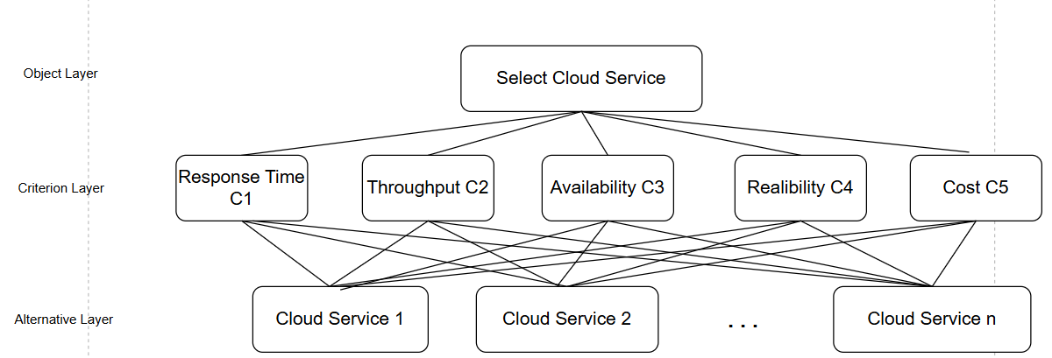
Figure 2.7. AHP model of cloud service selection.
In addition to defining the hierarchical structure of objectives, criteria, and alternatives, the hierarchical analysis model supports traceability and transparency of cloud service decision making. Each level of the model offers a focused view: the top level declares the overall selection goal, the middle level decomposes it into measurable and comparable sub-criteria, and the bottom level enumerates candidate services. This hierarchical structure facilitates sensitivity analysis, in which decision-makers can analyse how the ranking of alternatives varies as the weight of criteria is altered. Moreover, with problem decomposition, this model supports group decision-making by accommodating different stakeholders—technical teams, business managers, and compliance officers—to contribute inputs for the criteria in their area of expertise. This ensures that the final choice is not only optimized mathematically but also one that meets organizational needs and constraints.

2.5 Computation Principles of AHP.
The table below compares the importance of each criteria (e.g., Response Time, Cost, Throughput, Availability, Realiability) relative to one another in choosing a cloud service. Each row and column represents one of the five evaluation criteria. Every cell indicates how much more important the row criterion is compared to the column criterion. The numbers in the cells are pairwise comparisons using the Saaty scale. For example, a value of 6 under Availability vs. Response Time means Availability is strongly more important than Response Time or a reciprocal value (e.g., 0.1667 ≈ 1/6) is placed in the opposite position. In the last column, these are the normalized priority weights derived from the pairwise matrix. They show the relative importance of each criterion: Reliability: 44.40%, Availability: 37.91%, Cost: 9.47%, Response Time and Throughput: Much lower importance. Moreover, for the calculation, each value is normalized by dividing by the sum of its column, then, the average of each row in the normalized matrix gives the weight and, lastly, a Consistency Ratio (CR) is computed to validate the logical consistency of judgments.

Table 2.3. Criteria Comparison Table (Pairwise Comparison of Criteria).
CR=0.0944<0.1; Global Weight=1.0000; $λ_{max}$=5.4227
Select Cloud Services | Response Time | Throughput | Availability | Reliability | Cost | $$w_{i}$$
Response Time | 1 | 1 | 0.1667 | 0.125 | o.3333 | 0.045
Throughput | 1 | 1 | 0.1429 | 0.1111 | 0.16 67 | 0.0371
Availability | 6 | 7 | 1 | 1 | 7 | 0.379 1
Reliability | 8 | 9 | 1 | 1 | 9 | 0.444
Cost | 3 | 6 | 0.1429 | 0.1111 | 1 | 0.0947

In the following table we could see that each sub-criteria table corresponds to one main criterion from the main decision problem. Their purpose is to evaluate how well each alternative (CS1, CS2, CS3) performs with respect to that specific criterion. These tables are essential for computing the local priorities (weights) of alternatives under each criterion. The rows and columns represent the alternatives (Cloud Service 1, 2, and 3). The number in each cell reflects a judgment of how much better the row alternative is than the column one, with respect to the specific criterion. For example, a value of 5 means the row alternative is strongly better or a value of 0.2 (1/5) means the row alternative is strongly worse. Therefore, to calculate the local priority weights for each alternative, firstly, we normalize the matrix which means each cell is divided by the sum of its column and then, average each row in the normalized matrix — this gives the local weight (priority) of each alternative under that criterion.
Table 2.4. Criterion layer compare with alternative layer
CR=0.0036<0.1; Global Weight=0.0450; $λ_{max}$=3.0037
Response Time | CS1 | CS2 | CS3 | $$w_{i}$$
CS1 | 1 | 5 | 3 | 0.6483
CS2 | 0.2 | 1 | 0.5 | 0.122
CS3 | 0.3333 | 2 | 1 | 0.2297
CR=0.0904<0.1; Global Weight=0.0371; $λ_{max}$ =3.0940
Throughput | CS1 | CS2 | CS3 | $$w_{i}$$
CS1 | 1 | 0.2 | 4 | 0.1991
CS2 | 5 | 1 | 8 | 0.7334
CS3 | 0.25 | 0.125 | 1 | 0.0675
$$CR=0.0053<0.1; Global Weight=0.3791;λ_{max} =3.0055$$
Availability | CS1 | CS2 | CS3 | $$w_{i}$$
CS1 | 1 | 5 | 4 | 0.6908
CS2 | 0.2 | 1 | 1 | 0.1488
CS3 | 0.25 | 1 | 1 | 0.1603
CR=0.0707<0.1; Global Weight=0.4440; $λ_{max}$=3.0735
Reliability | CS1 | CS2 | CS3 | $$w_{i}$$
CS1 | 1 | 3 | 0.1667 | 0.1662
CS2 | 0.3333 | 1 | 0.125 | 0.0726
CS3 | 6 | 8 | 1 | 0.7612
CR=0.0000<0.1; Global Weight=0.0947; $λ_{max}$ =3.0000
Cost | CS1 | CS2 | CS3 | $$w_{i}$$
CS1 | 1 | 3 | 1 | 0.4286
CS2 | 0.3333 | 1 | 0.3333 | 0.1429
CS3 | 1 | 3 | 1 | 0.4286

The final ranking table combines the weights of each criterion with the local weights of each cloud service to calculate a final priority score for each alternative. For the computing, we multiply each criterion weight (from the criteria comparison table) by the local weight of each cloud service under that criterion and sum these products across all five criteria for each cloud service.
Table 2.5. Final result
Alternatives | Weight
Cloud Service 1 | 0.4129
Cloud Service 2 | 0.1349
Cloud Service 3 | 0.4522

As Value (CS3) >Value (CS1) >Value (CS2) (i.e. 0.4522>0.4129>0.1349), it is obviously seen that cloud service 3 is the most qualified cloud service.

2.6 Introduction to TOPSIS
The TOPSIS method is one of the most useful MCDM technique that was introduced by Hwang and Yoon (Hwang & Yoon, 1981). TOPSIS is an MCDM approach that ranks and chooses the appropriate alternative from a group of alternatives by using a number of criteria. This method ranks alternatives from best to worst. The best alternative among the available alternatives is the closest one to the positive ideal solution or the farthest one from the negative ideal solution. (Pandey et al., 2023)

2.6.1 Traditional TOPSIS method
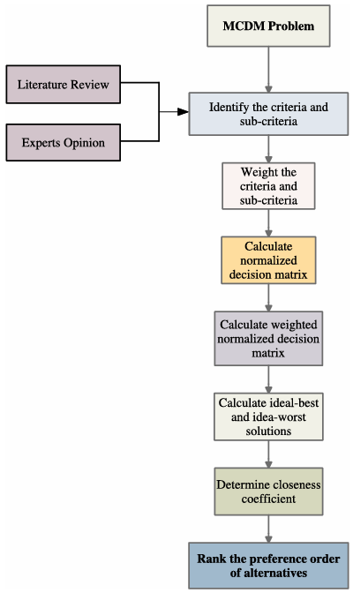
The traditional TOPSIS method, as shown in Figure.3.8, consists of the following procedural steps:
Figure 2.8. Flowchart for TOPSIS methodology.(Pandey et al., 2023)

Step1: Selection of alternatives and criteria for a MCDM problem: In the first phase, a collection of alternatives, criteria, and sub-criteria for the subsequent levels of a MCDM problem will be chosen. To select appropriate alternatives and criteria (benefit or cost type) for any MCDM problem, a detailed literature review is required for the concerned MCDM problem, which will be finalised with the help of experts and decision makers by following their opinions.
Step 2: Formulation of a MCDM problem: Data extraction will be performed based on the alternatives and criteria selected in step 1, and the retrieved information will be integrated with the opinions of experts and decision makers. The extracted information is maintained in the form of a decision matrix. To formulate the problem, let $\left\{A_{1,}A_{2},…,A_{m}\right\}$ represent a collection of $m$ alternatives that are being assessed using $n$-criteria denoted by $\left\{C_{1},C_{2}, …,C_{n}\right\}$ with a weight vector $\left\{w_{1}, w_{2}, …,w_{n}\right\}$ that satisfy the conditions $w_{j}∈\left[0, 1\right], j=1, 2, …, n$ and $∑_{j}^{n}=1 w_{j}=1$. Let $A={[a_{ij}]}_{m×n}$ be the decision matrix, where $a_{ij}$ is the extracted information of alternative $A_{i}$ for the criterion $C_{j}$in the form of a crisp number.
Step 3: Normalisation of the decision matrix is a critical step, and the final decision may depend on the method used for normalisation. In the present study, vector normalisation is used to normalise the decision matrix $A={[a_{ij}]}_{m×n}$ as obtained in step 2. The normalised matrix is denoted by $R={[r_{ij}]}_{m×n}$, where $r_{ij}= \frac{a_{ij}}{\sqrt{∑_{i=1}^{m}a_{ij}^{2}}} , i=1, 2, …, m;j=1, 2, …, n$.
Step 4: Calculate weighted normalised decision matrix $V= v_{ij}$, where $v_{j}=w_{j}r_{ij}$.
Step 5: Determine positive $(V^{+})$ and negative $(V^{-})$ ideal solutions defined as follows:
$V^{+}=\left[\left(\max{v_{ij} }, j∈J\right), \left(\min{v_{ij} }, j∈J^{'}\right), i=1,2, …, m\right]=\{v_{1}^{+}, v_{2}^{+}, …, v_{n}^{+}\}$
$V^{-}=\left[\left(\min{v_{ij} }, j∈J\right), \left(\max{v_{ij} }, j∈J^{'}\right), i=1,2, …, m\right]=\{v_{1}^{-}, v_{2}^{-}, …, v_{n}^{-}\}$
Here, $V^{+}$ and $V^{-}$ are the best and least favourable choices, while $J$ and $J^{'}$ are the benefit and cost type criteria sets.
Step 6: Evaluate the values of separation measures with the help of Euclidean distance. The separation values $D_{i}^{+}$ and $D_{i}^{-}$ for the $i^{th}$ alternative from $V^{+}$ and $V^{-}$, are given as follows:
$$S_{i}^{+}=\sqrt{\sum_{j=1}^{n}{{(v_{ij}-v_{j}^{+})}^{2}}} , i=1, 2, …, m$$
$$S_{i}^{-}=\sqrt{\sum_{j=1}^{n}{{(v_{ij}-v_{j}^{-})}^{2}}} , i=1, 2, …, m$$
Step 7: Evaluate the relative closeness coefficient $CC_{i}∈[0, 1]$ for $i^{th}$ alternative using the following equation, and then rank all the alternatives as per their $CC_{i}$ values in decreasing order.
$$CC_{i}= \frac{S_{i}^{-}}{S_{i}^{+}+S_{i}^{-}} , i=1, 2, …, m$$

2.6.2. Different extensions of TOPSIS method
The traditional TOPSIS method has been extended in various directions, including the application of different types of decision spaces, data normalisation methods, ranking processes, distance measures, etc. As an example, in the traditional TOPSIS method, the data extracted from various sources are represented as crisp numbers, which may have an uncertainty factor due to diverse reasons. To quantify this data uncertainty problem in decision-making, different theories, such as classical fuzzy set theory, intuitionistic fuzzy set theory, rough set theory, grey set theory, etc., have been developed and successfully integrated with the traditional TOPSIS method in a number of ways. Firstly,(Jahanshahloo et al., 2006) presented an extension of the traditional TOPSIS method by integrating it with fuzzy set theory, in which triangular fuzzy numbers are used to quantify data uncertainty and “α-cut” arithmetic operations are applied for computation purposes. For different perspectives, a few researchers integrated the TOPSIS method with triangular fuzzy number (TFN) (Sadabadi et al., 2022), interval-valued fuzzy numbers (IVFN) (Chen and Tsao 2008), and interval-valued intuitionistic fuzzy numbers (IVIFN) (Park et al., 2011) for different perspectives. Using intuitionistic fuzzy sets with the TOPSIS method,(Li et al., 2009) developed a fractional programming methodology for multi-attribute group decision-making. Some of the researchers used different weighting evaluation methods with the TOPSIS method. For example, (Vavrek, 2019) integrated TOPSIS with different weighting methods, while (Roy & Shaw, 2022) used fuzzy BWM for criteria weight evaluation and performed fuzzy TOPSIS to evaluate the ranking of alternatives. (Torfi et al., 2010) determined the relative weights of criteria using fuzzy AHP, while fuzzy TOPSIS is applied for the ranking of the alternatives. In decision-making, it is discovered that the weight established by the entropy technique can both strengthen the function of the attribute with the greatest diversity of attribute data (DAD) and degrade the function of the attribute with the lowest DAD. Utilising the advantage of entropy, (Chen, 2021) evaluated the economic development of 21 distinct cities on the basis of four criteria by adopting the entropy-based TOPSIS technique. (Chen, 2019)recommended vector normalisation in the entropy based TOPSIS approach rather than simple normalisation.
(García-Cascales & Lamata, 2012) highlighted the issue of rank reversal phenomenain the TOPSIS method due to the normalisation process and choices of positive and negative ideal solutions. Rank reversal is an issue in MCDM methods in which the ranking order is changed by adding or deleting any alternative from the set of alternatives. To overcome this rank reversal problem, they improvised the normalisation process and strategy to select positive and negative ideal solutions in the existing TOPSIS method. (Fares & Lloret, 2022) further highlighted some more issues related to the rank reversal problem in the TOPSIS method and proposed a novel R-TOPSIS method to encounter the highlighted issues. (Shih et al., 2007) provided lists of differ ent types of normalisation methods and distance measures. Using vector normalisation and Minkowski’s distance measure, they presented an extended TOPSIS method for group decision-making and concluded that the suggested method is quite easy to use, meaningful for aggregation, and will not add significantly more computational load than the original TOPSIS after checking the aggregations under various conditions. (Ren et al., 2007) introduced a modified TOPSIS (M-TOPSIS) method in which they used an optimised ideal reference point to find its distance from the positive and negative ideal solutions. Based on this distance, they rank the alternatives. They also conducted a comparative analysis between the traditional TOPSIS and M-TOPSIS methods and demonstrated the simplicity of the proposed M-TOPSIS method in terms of both the concept and the calculations. Contrary to (Ren et al., 2007), (Kuo, 2017) also proposed a modified TOPSIS method by adopting a different ranking index. (Susmaga et al., 2023) has introduced a new space based on mean (M) and standard deviation (SD), called MSD-space, to visualise the effect of calculated distances and the dependencies between mean and SD on different TOPSIS aggregations. MSD-space can be used to compare aggregations and visualise how different criteria values impact alternative ratings. MSD-space has the advantage that it can be illustrated on a plane regardless of the number of criteria describing alternatives. (de Lima Silva & de Almeida Filho, 2020) has proposed a TOPSIS based sorting method through characteristic profiles known as TOPSIS-Sort-C to prevent ranking reversals in TOPSIS and their impacts on sorting problems. While extending this, (de Lima Silva et al., 2023) proposed a TOPSIS-based sort ing method that learns from decision examples and makes assignments based on characteristic profiles called Prefer ence Disaggregation on TOPSIS-Sort-C (PDTOPSIS-Sort C),which is a variant of TOPSIS-Sort-C, where the definition parameters are inferred according to DM’s decision examples. (Corrente & Tasiou, 2023) extended the TOPSIS method by introducing a simulation-based normalisation technique that accommodates non-monotonic preferences and qualitative criteria. A hybrid Multiple Criteria Hierarchy Process–TOPSIS–Stochastic Multicriteria Acceptability Analysis (MCHP-TOPSIS-SMAA) method is applied in (Pandey et al., 2023). MCHP deals with problems where criteria are hierarchically structured, while SMAA avoids the choice of a single weight vector and deals with robustness concerns. (Jin, 2023) developed a direct and indirect uncertain MCDM methodology (called DI uncertain TOPSIS) based on failure mode and effect analysis (FMEA), DEMATEL, and TOPSIS methods to analyse the uncertainty of the real-world problem and determine the Risk Priority Number (RPN) for the MCDM criteria.

2.7 Introduction to ELECTRE
The ELECTRE (ELimination Et Choix Traduisant la REalite) method is a non-compensatory multi-attribute decision making (MADM) method that works based on alternatives’ comparison considering individual criteria. The main point that distinguishes the ELECTRE from compensatory method such as simple additive weighting (SAW) is that in the ELECTRE method, the weights are not criteria substitution rates instead the weights are coefficients of importance. Furthermore, in this method, it is not possible to offset a very bad value on a criterion with good ones on other criteria. It should be added that a few references consider the ELECTRE as a partially compensatory method and argued for placing it in the non-compensatory subgroup. (Taherdoost & Madanchian, 2023a)
The method was first proposed by Bernard Roy and his colleagues at SEMA consultancy company. A team at SEMA was working on the concrete, multiple criteria, real-world problem of how firms could decide on new activities and had encountered problems using a weighted sum technique. Roy was called in as a consultant and the group devised the ELECTRE method. As it was first applied in 1965, the ELECTRE method was to choose the best action(s) from a given set of actions, but it was soon applied to three main problems: choosing, ranking and sorting. The method became more widely known when a paper by B. Roy appeared in a French operations research journal (WIKIPEDIA). Then, different authors published manifold studies on this method based on similar theories to establish preference and outranking relations, and also to support decision-makers by making consistent exploration and analysis. Different ELECTRE versions were introduced by several scholars such as ELECTRE I, II, III, IV, IS, TRI, TRIB, and TRI-C. ELECTRE I was developed as one of the earlier versions of ELECTRE methods, and ELECTRE II was developed in 1971 by Roy and Bertier as an improved and promoted version of ELECTRE I. ELECTRE III was developed based on the main principles of ELECTRE II, but instead of classical true criteria, it applies the pseudo-criteria and makes the presentations of the outranking relations in a fuzzy form possible. These methods work based on selecting a desirable option between different alternatives meeting two separate demands including:
- Concordance preference above many evaluation benchmarks;
- Discordance preference under any optional benchmark.
The ELECTRE I method contains three concepts including a threshold value, concordance, and discordance indexes. In the ELECTRE II method, the concepts of concordance and discordance indexes incorporate weak and strong relationships that are extremely opposite relationships and result in two final rankings known as weak-ranking and strong-ranking. On the other hand, ELECTRE III outperforms the former ones as it can deal with uncertain, imprecise, and inaccurate data using the fuzzy concept. To sum up, although the ELECTRE method’s versions differ in several aspects, for example some are designed for utilization in selection problems (such as ELECTRE I) and some are applicable for ranking purposes (such as ELECTRE II and III), and even for assignment problems (using ELECTRE TRI) all of them are included in the outranking multi-criteria decision making (MCDM) methods’ family.

2.7.1. Principle of ELECTRE methods
In this method, a decision-making problem is considered including $m$ alternatives (known as $A_{i}:i=1, 2, …, m$) and $n$ criteria ($X_{j} :j=1, 2, …, n$) and $n$ weighting factors ($w_{j} :j=1, 2, …, n$). This can be shown as an $m ×n$ decision matrix (with $x_{ij}$ elements). Also in these methods $\sum_{j=1}^{n}{w_{j}=1}$. A decision problem aims to select the best alternative as a result. For this, the ELECTRE methods use outranking relations between each pair of alternatives. That is to say, these methods work based on preferring an alternative to another one. This concept is shown as:
$A_{i}→A_{k}$(or $A_{i}SA_{k}$) means $A_{i}$ is preferred to $A_{k}$. For this, $A_{i}$ should:
- Be at least as good as $A_{k}$ for the majority of the criteria;
- Not be significantly worse when other criteria are considered.
The second factor can be examined by using a predefined threshold. This process aims to detect the dominated and non-dominated alternatives, although it is problematic in complex problems and when the matrix does not have crisp data due to their uncertainties. For this, two kinds of comparison sets are required among the criteria in which:
- $X_{j}(A_{i})$ is superior to $X_{j}(A_{k})$;
- $X_{j}(A_{i})$ is not superior to $X_{j}(A_{k})$.
Therefore, this method separately investigates the criteria that vote and veto the preference of $A_{i}$ to $A_{k}$, and these sets are called concordance and discordance tests. Concordance tests are binary tests for ELECTRE I and II which use 0 and 1 index when the test is failed and passed; respectively. Consider a criterion that aims to minimize $A_{i}$, as an example. In this situation:
- If $A_{i}< A_{k}$ , results in a passed concordance test;
- If $A_{i}> A_{k}$ , results in a failed concordance test.
On the other hand, the outranking relations in the ELECTRE III method are fuzzy with the values between 0 and 1 based on how far an alternative is better than another when considering a criterion.
The second test known as discordance aims to evaluate the existence of a very high opposition between alternatives and to be intended for the criteria in which the performance of $A_{i}$ is worse compared to $A_{k}$. This test also can be binary or fuzzy in nature.
Both tests are necessary to gain a true outranking relation between pairs of alternatives. The results can be finalized as:
- $A_{i}$ is preferred to $A_{k}$ ($A_{i}→A_{k}$or $A_{i}SA_{k}$): If both tests are passed;
- $A_{i}$ is incomparable to $A_{k}$ ($A_{i}RA_{k}$): Neithter $A_{i}→A_{k}$ nor $A_{k}→A_{i}$;
- $A_{i}$ is indifferent to $A_{k}$ ($A_{i}IA_{k}$): One is not preferred over another alternative.
The main and fundamental concept of the ELECTRE methods is discussed above. However, there are some differences in the steps of conducting different versions of the ELECTRE due to the differences in their application of them in decision-making. For example, ELECTRE I is used for the selection problems, and ELECTRE II and III are designed for ranking purposes.

2.7.2. Process steps
Different ELECTRE methods can differ from each other in different aspects such as the process of determination of concordance and discordance matrices, the type of outranking relations (for example binary or fuzzy), etc.

2.7.2.1. ELECTRE I process steps
Step 1. Normalizing the Decision Matrix. The $n ×m$ decision matrix $X$ is shown in Equation (1):
$X= \left[\begin{matrix}x_{11} & ⋯ & x_{1m} \\ ⋮ & ⋱ & ⋮ \\ x_{n1} & ⋯ & x_{nm}\end{matrix}\right]$ (1)
This step is similar to the first step in The TOPSIS method, and the attributes with various scales are transformed into comparable scales using Equation (2). This makes all the attributes similar in terms of the unit length of the vector.
$r_{ij}= \frac{x_{ij}}{\sqrt{\sum_{j=1}^{m}{x_{ij}^{2}}}}$ (2)
Step 2. Weighting the Normalized Matrix (V). This step also is similar to TOPSIS, and aims to add the effect of weight to the decision matrix using the following method:
$V=\left(v_{ij}\right) n ×m$ (3) where $v_{ij}= w_{j}r_{ij}$ (4)
Step 3. Determining the Concordance and Discordance Set. This step aims to separate the decision criteria set into two distinct subsets ($C_{kl}$ (Concordance) and $D_{lk}$ (Discordance) : $l ≠k$) for each pair of alternatives. That is to say, when two alternatives are considered, the alternatives are compared considering the type of criteria (cost or benefit types), and then based on which one is better or worse, the concordance and discordance sets are determined. For example, in a 4 × 6 matric if all attributes are positive (benefit attributes), when $C_{12}=[3, 4, 5, 6]$, and $D_{12}=[1, 2]$, then it means:
- $v_{11}< v_{21}; v_{12}< v_{22};v_{13} ≥v_{23}; v_{14} ≥v_{24}; v_{15} ≥v_{25}; v_{16} ≥v_{26}$
Generally, the concordance and discordance sets are:
$$C_{kl}=\left\{j\right|v_{kj}≥v_{lj}\}$$
$$D_{kl}=\left\{j\right|v_{kj} <v_{lj}\}=J- C_{kl}$$
Step 4. Building the Concordance Matrix. After recognizing the concordance and discordance sets, in this step, the sum values of the weights associated with the concordance set are considered as the concordance index. Other equations are also recommended by different authors. Here a simple method is introduced:
$C_{kl}= \sum_{J∈C_{kl}}{w_{j}}$ (5) considering the example in the previous step, for instance, the sum of $w_{2}$, $w_{3}$, $w_{4}$, $w_{5}$ must be placed in the $c_{12}$ in the concordance matrix (C). This general (not symmetric) concordance matrix is shown as:
$C= \left[\begin{aligned}\begin{aligned}\begin{matrix}- & c_{12} & ⋯ \\ c_{21} & - & ⋯ \\ ⋮ & ⋮ & ⋱\end{matrix} \begin{matrix}c_{1n} \\ c_{2m} \\ ⋮\end{matrix} \\ c_{m1 }\begin{matrix}⋯ & c_{m(m-1)} & -\end{matrix} \end{aligned} \\ \end{aligned}\right]$ (6)
Step 5. Building the Discordance Matrix. In this step, the focus is especially on the degree to which an alternative is worse than the other one (considering the pairs of alternatives). For this the discordance index should be calculated using the following equation:
$D_{kl}= \frac{\max_{j ∈D_{kl}}|v_{kj}-v_{lj}|}{\max_{j∈J}|v_{kj}-v_{lj}|}$ (7) and then the discordance (D) matrix is built similarly to the concordance matrix:
$D= \left[\begin{aligned}\begin{matrix}- & d_{12} & ⋯ \\ d_{21} & - & \\ ⋮ & ⋮ & ⋱\end{matrix} \begin{matrix}d_{1n} \\ d_{2m} \\ ⋮\end{matrix} \\ \\ d_{m1} \begin{matrix}⋯ & d_{m(m-1)} & -\end{matrix} \end{aligned} \right]$ (8)
In this matrix, higher values of $d_{kl}$ show that $A_{k}$ is less favorable than $A_{l}$for the discordance criteria. In contrast, a lower value implies that $A_{k}$is favorable to $A_{l}$. In this matrix, the$d_{kl}$values are between 0 and 1.
Step 6. Determining the Concordance Index (Dominance) Matrix. In this step, a threshold value is considered for the concordance index. That is to say, based on a threshold value, it can be determined whether $A_{k}$ have the chance of dominating $A_{l}$ , when $C_{kl}$ exceeds at least a certain value for the threshold ($\overline{c}$). That is to say:
- $C_{kl} ≥$ $\overline{c}$
where the $\overline{c}$ can be determined in different ways. For example, it can be calculated as follows:
$$\overline{c}= \sum_{\begin{aligned}k=1 \\ k≠l\end{aligned}}^{m}{\sum_{\begin{aligned}l=1 \\ l≠k\end{aligned}}^{l}{\frac{c_{kl}}{m(m-1)}}}$$
But the threshold can be assumed 0.7 usually. Then a bloomlean matrix (F) must be constructed with the following elements:
- $f_{kl}=1;if c_{kl}≥\overline{c}$;
- $f_{kl}=0;if c_{kl}<\overline{c}$.
Each “one value” for the matrix elements means “the dominance of one alternative with respect to an other alternative”.
Step 7. Determining the Discordance Index (Dominance) Matrix. On the other hand, a similar process is conducted to build the discordance dominance matrix (G). A threshold value is considered here as well such as:
$$\overline{d}= \sum_{\begin{aligned}k=1 \\ k≠l\end{aligned}}^{m}{\sum_{\begin{aligned}l=1 \\ l≠k\end{aligned}}^{m}{\frac{d_{kl}}{m(m-1)}}}$$
Also, $\overline{d}$ can be assumed 0.3 usually. The elements of the matrix are:
- $g_{kl}=1;if d_{kl}≤\overline{d}$
- $g_{kl}=0;if d_{kl}>\overline{d}$
Step 8. Determining the Aggregate Dominance Matrix. This step aims to combine f and G matrices, and calculate the intersection of the F and G matrices called Aggregate Dominance Matrix (E) with $e_{kl}$ elements that is gained by the multiplication of $f_{kl}$ and $g_{kl}$ elements in the f and G matrices:
$$e_{kl}=f_{kl}×g_{kl}$$
So, the elements of the aggregate dominance matrix can have just zero or one value for k ≠ l.
Step 9. Eliminating the Less Favorable Alternatives. Now it is time to eliminate the less favorable alternatives. The alternatives’ partial-preference ordering is given in matrix E. That is to say:
- If $e_{kl}=1$; for both concordance and discordance criteria $A_{k}$ are preferred to $A_{i}$
But it is important to note that still $A_{k}$ can be dominated by other alternatives. Therefore, more comprehensive conditions must be considered to conclude that $A_{k}$ is not dominated in the whole ELECTRE procedure. These conditions are as follows:
- $e_{kl}=1;for at least one l;$
- $e_{kl}=0;for all i.$
In these conditions: $k≠l, i≠k, i≠l, l\&i=1, 2, …, m.$
Although applying this condition can appear difficult, E matrix can be easily used to identify the alternatives with the following method:
If at least one “element of 1” is existed in any column of the E matrix; it means that “the column is ‘ELECTREcally’ dominated by the corresponding row(s)”. Therefore, the column(s) with at least one element of 1 should be eliminated. In this step, a graphical representation of the over-ranking relationships can be also helpful to illustrate the relation shipsbetter. Consider the following $E_{example}$ matrix as the result of Step 8:
$$E_{example}= \left[\begin{aligned}\begin{matrix}- & 1 \\ 0 & - \\ 0 & 1\end{matrix} \begin{matrix}0 & 1 \\ 0 & 0 \\ - & 1\end{matrix} \\ \begin{matrix}0 & 1 \end{matrix}\begin{matrix}0 & -\end{matrix}\end{aligned}\right]$$
In this example, the graphical representation can be shown in Figure 1 considering the following relationships given as the result of $E_{example}$ matrix elements:
$$A_{1}→A_{2},A_{1}→A_{4},A_{3}→A_{2},A_{3}→A_{4},A_{4}→A_{2}$$
It can be concluded from the figure that $A_{2}$and $A_{4}$are dominated by $A_{1}$and $A_{3}$, although the preference relationship between $A_{1}$ and $A_{3}$cannot be obtained from this. These results also can be taken from the columns of the $E_{example}$matrix. As $A_{1}$ and $A_{3}$do not possess any element of 1

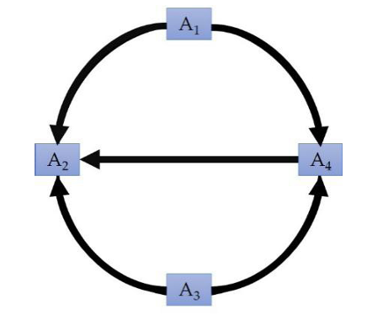
Figure. An example for over-ranking relationships

2.7.2.2. ELECTRE II process steps
ELECTRE II is similar to ELECTRE I, but the differences are related to the definitions of two out ranking relations called “strong outranking” and “weak outranking”. Strong outranking and weak outranking have solid bases and questionable grounds.
Strong outranking relies on solid bases, whereas weak outranking has questionable grounds. Therefore, the result is given as an outranking graph dichotomy in weak and strong outranking graphs. The process steps of the ELECTRE I were defined in the previous sub-section in detail. Here, as some steps are similar to the ELECTRE I (such as decision matrix formation), just the main steps of the ELECTRE II are listed. The main process steps are listed following:
Step 1. Outranking Relationships Definition. This method compares the alternatives pair to pair as discussed in the ELECTRE I. The aim of this step is to define whether $A_{k}$ outranks $A_{i}$ strongly. Three concordance thresholds ($∝$): high, medium, and low and two non-concordance thresholds (D)are used in this method. For this, the following conditions must be met:
$$\left\{\begin{aligned}c_{kl}≥∝^{+} \\ and \\ X_{j}{(A}_{k})- X_{j}\left(A_{l}\right)≤D_{1}\left(j\right),∀j \\ and \\ \frac{p^{+}(k, l)}{p^{-}(k,l)}≥1\end{aligned}\right.$$
and/or

$$\left\{\begin{aligned}c_{kl}≥∝^{0} \\ and \\ X_{j}{(A}_{k})- X_{j}\left(A_{l}\right)≤D_{2}\left(j\right),∀j \\ and \\ \frac{p^{+}(k, l)}{p^{-}(k,l)}≥1\end{aligned}\right.$$
Where:
- $p^{+}(k, l)$ is “the sum of criteria weighting of the k when it is preferable to l (considering the type of the criteria)”;
- $p^{-}(k, l)$ is “the sum of criteria weighting of the l when it is preferable to k (considering the type of the criteria)”;
- $p^{=}(k, l)$ is “the summation of criteria weighting of the k when the k equals to l ”.
- $∝^{+}≥∝^{0}$ (threshold vlues) and $D_{2}(j)≤D_{1}(j)$ (threshold of discordance).
The above definitions for P(k, l) are similar to Step 4 in the ELECTRE I. Considering these relations $A_{k}$ strongly outranks $A_{l}$ if:
- In Equation (12), the outranking equation is “strongly” concordant and “fairly” discordant;
- In Equation (13), it is “fairly” concordant and “weakly” discordant.
On the other hand, the following equation is used as the weak outranking relation to determine $A_{k}$ weak outranks $A_{l}$
$$\left\{\begin{aligned}c_{kl}≥α^{-} \\ and \\ X_{j}{(A)}_{k}{}_{}{}_{}{}_{}\end{aligned}\right.$$

3. Conclucions
1. During related work analysis, it was learned that cloud service selection is a multi-dimensional choice, and among the various involving varied criteria, few are to combine factors on such aspects as costs, performance, security, scalability, and several others. These methodologies majorly incorporate techniques relating to MCDA, such as AHP, TOPSIS, and their variants, for these complexities to be resolved. These methods remain highly effective on structured scenarios while mostly lacking their adaptability over dynamic cloud scenarios.
It was further observed that meta-heuristics comprising genetic algorithms and particle swarm optimization techniques are fast emerging as a choice to tackle optimization problems with big sizes. However, such methods have considerable computational overheads and are relatively not effective in integrating user-centric requirements.
The second conspicuous observation is the interest in hybrid methods, especially those integrated with MCDA and machine learning-fuzzy logic. The new techniques that are promising toward increasing decision accuracy and real-time adaptability, especially in the environment of ever-changing cloud offerings.
Moreover, current tool analysis showed that while there are many decision support systems on hand, they often lack in flexibility, transparency, or consumer-oriented customization. The majority of the tools offer either static selection models or inadequate integration with cloud service real-time information. These findings confirm a gap in current solutions: for a dynamic, modular, criteria-based tool that allows users to create, update, and analyse cloud services based on personalized priorities and constraints.
2. The purposed approach addresses the problems identified by creating a costumer-based decision support system. It utilizes Multi-Criteria Decision-Making (MCDM) techniques and combines workflow and decision modelling standarts like BPMN and DMN. In parallel, using the Analytic Hierarchy Process (AHP), it breaks down complex decision problems into a simple structure. Therefore, users can easily provide weights to non-functional requirements in a systematic way. Simultaneously, the TOPSIS method is used for ranking the cloud service alternatives based on their distance from ideal and negative-ideal solutions for choosing the most well-balanced alternative for all parameters.
The hierarchical structure of the evaluation model, combined with the capacity to input and adjust non - functional requirements, ensures flexibility and transparency to suit changing organizational needs. Furthermore, the design supports real-time collection of information from cloud providers and allows business users to create and manage decision workflows. By incorporating compliance checks, variable criteria weights, and visual modelling capabilities, the purposed approach improves the practical usability and accuracy of cloud infrastructure design decisions, providing a clear but also flexible solution for a highly - dynamic and complex domain.

3.1 Further Works
Future work, the literature review may be extended to more recent research works and approaches in cloud service selection. It would also be of value to develop better methods that combine decision-making techniques such as Analytical Hierarchy Process (AHP) and Technique for Order of Preference by Similarity to Ideal Solution (TOPSIS) with simpler automation tools. Theoretical development should be followed by practical testing of the methods on real datasets to ensure that they will work in dynamic environments. Involving user feedback in designing and validating the decision-making frameworks may lead to more usable and relevant decision-making frameworks.
By focusing on these areas, future research will be able to fill current gaps in cloud service selection, thus developing comprehensive, user-friendly, and adaptable decision support systems that evolve with technological and organizational needs.

4. References
Abdelhafeez, A., EI-Douh, A. A.-R., & Abdel-aziem, A. H. (2023). An Integrated Framework for Selecting Best Cloud Service Provider with Multi-Criteria Decision Making Methodology. Multicriteria Algorithms with Applications, 1, 11–18. https://doi.org/10.61356/j.mawa.2023.15961
Abdessamaddkobi, L. D. (n.d.). International Series in Operations Research & Management Science TheeMulti-Criteria Approach forrDecision Support An Introduction withhPractical Applications. http://www.springer.com/series/6161
Al Fozaie, M. T., & Wahid, H. (2022). A Guide to Integrating Expert Opinion and Fuzzy AHP When Generating Weights for Composite Indices. Advances in Fuzzy Systems, 2022. https://doi.org/10.1155/2022/3396862
Al-Surmi, A., Bashiri, M., & Koliousis, I. (2022). AI based decision making: combining strategies to improve operational performance. International Journal of Production Research, 60(14), 4464–4486. https://doi.org/10.1080/00207543.2021.1966540
Baffo, I., Leonardi, M., Bossone, B., Camarda, M. E., D’Alberti, V., & Travaglioni, M. (2023). A decision support system for measuring and evaluating solutions for sustainable development. Sustainable Futures, 5. https://doi.org/10.1016/j.sftr.2023.100109
Belusso, C. L. M., Sawicki, S., Basto-Fernandes, V., Frantz, R. Z., & Roos-Frantz, F. (2022). Selecting services in the cloud: a decision support methodology focused on infrastructure-as-a-service context. Journal of Supercomputing, 78(6), 7825–7860. https://doi.org/10.1007/s11227-021-04248-8
Bhat, S. A. (2023). An Enhanced AHP Group Decision-Making Model Employing Neutrosophic Trapezoidal Numbers. Journal of Operational and Strategic Analytics, 1(2), 81–89. https://doi.org/10.56578/josa010205
Boggia, A., Massei, G., Pace, E., Rocchi, L., Paolotti, L., & Attard, M. (2018). Spatial multicriteria analysis for sustainability assessment: A new model for decision making. Land Use Policy, 71, 281–292. https://doi.org/10.1016/j.landusepol.2017.11.036
Bommannavar, P. A., Shah, A., Singh, A., & Krishnan, R. (2021, April 2). Analyzing Performance Parameters for Cloud Service Selection usingAHP. 2021 6th International Conference for Convergence in Technology, I2CT 2021. https://doi.org/10.1109/I2CT51068.2021.9418148
Canco, I., Kruja, D., & Iancu, T. (2021). Ahp, a reliable method for quality decision making: A case study in business. Sustainability (Switzerland), 13(24). https://doi.org/10.3390/su132413932
Charles Ochei, L., Ogunsakin, R., & Ajienka, N. (n.d.). A Framework for a Decision Support System to Optimize Cloud-hosted Services for Multitenancy Isolation. International Journal of Applied Information Systems. www.ijais.org
Chen, P. (2019). Effects of normalization on the entropy-based TOPSIS method. Expert Systems with Applications, 136, 33–41. https://doi.org/10.1016/j.eswa.2019.06.035
Chen, P. (2021). Effects of the entropy weight on TOPSIS. Expert Systems with Applications, 168. https://doi.org/10.1016/j.eswa.2020.114186
Cloud Service Provider Selection: A Complex Multi-Criteria Decision Making Problem. (2024).
Corrente, S., & Tasiou, M. (2023). A robust TOPSIS method for decision making problems with hierarchical and non-monotonic criteria. Expert Systems with Applications, 214. https://doi.org/10.1016/j.eswa.2022.119045
de Lima Silva, D. F., & de Almeida Filho, A. T. (2020). Sorting with TOPSIS through boundary and characteristic profiles. Computers and Industrial Engineering, 141. https://doi.org/10.1016/j.cie.2020.106328
de Lima Silva, D. F., Ferreira, L., & de Almeida Filho, A. T. (2023). Preference disaggregation on TOPSIS for sorting applied to an economic freedom assessment. Expert Systems with Applications, 215. https://doi.org/10.1016/j.eswa.2022.119341
Deveci, M., Mishra, A. R., Gokasar, I., Rani, P., Pamucar, D., & Ozcan, E. (2023). A Decision Support System for Assessing and Prioritizing Sustainable Urban Transportation in Metaverse. IEEE Transactions on Fuzzy Systems, 31(2), 475–484. https://doi.org/10.1109/TFUZZ.2022.3190613
Essaber, F. E., Benmoussa, R., De Guio, R., & Dubois, S. (2021). A hybrid supply chain risk management approach for lean green performance based on AHP, RCA and TRIZ: A case study. Sustainability (Switzerland), 13(15). https://doi.org/10.3390/su13158492
Fares, N., & Lloret, J. (2022). An integrated SWOT-AHP-fuzzy TOPSIS approach for maturity management following the COVID-19 outbreak: lessons learned from fast fashion. Journal of Global Operations and Strategic Sourcing, 15(4), 510–533. https://doi.org/10.1108/JGOSS-09-2021-0072
García-Cascales, M. S., & Lamata, M. T. (2012). On rank reversal and TOPSIS method. Mathematical and Computer Modelling, 56(5–6), 123–132. https://doi.org/10.1016/j.mcm.2011.12.022
Gebre, S. L., Cattrysse, D., & Van Orshoven, J. (2021). Multi-criteria decision-making methods to address water allocation problems: A systematic review. In Water (Switzerland) (Vol. 13, Issue 2). MDPI AG. https://doi.org/10.3390/w13020125
Gupta, S., Modgil, S., Bhattacharyya, S., & Bose, I. (2022). Artificial intelligence for decision support systems in the field of operations research: review and future scope of research. Annals of Operations Research, 308(1–2), 215–274. https://doi.org/10.1007/s10479-020-03856-6
Gyani, J., Ahmed, A., & Haq, M. A. (2022). MCDM and Various Prioritization Methods in AHP for CSS: A Comprehensive Review. In IEEE Access (Vol. 10, pp. 33492–33511). Institute of Electrical and Electronics Engineers Inc. https://doi.org/10.1109/ACCESS.2022.3161742
Hwang, C., & Yoon, K. (1981). Methods for Multiple Attribute Decision Making.
Jahanshahloo, G. R., Lotfi, F. H., & Izadikhah, M. (2006). Extension of the TOPSIS method for decision-making problems with fuzzy data. Applied Mathematics and Computation, 181(2), 1544–1551. https://doi.org/10.1016/j.amc.2006.02.057
Jin, G. (2023). Selection of virtual team members for smart port development projects through the application of the direct and indirect uncertain TOPSIS method. Expert Systems with Applications, 217. https://doi.org/10.1016/j.eswa.2023.119555
Ketut Ayu Purnama Sari, N. (2021). Implementation of the AHP-SAW Method in the Decision Support System for Selecting the Best Tourism Village. In Jurnal Teknik Informatika C.I.T Medicom (Vol. 13, Issue 1).
Khan, M. Z., Shoaib, M., Husain, M. S., Ul Nisa, K., & Quasim, M. T. (2024). Enhanced mechanism to prioritize the cloud data privacy factors using AHP and TOPSIS: a hybrid approach. Journal of Cloud Computing, 13(1). https://doi.org/10.1186/s13677-024-00606-y
Kizielewicz, B., Shekhovtsov, A., & Sałabun, W. (2023). pymcdm—The universal library for solving multi-criteria decision-making problems. SoftwareX, 22. https://doi.org/10.1016/j.softx.2023.101368
Kuo, T. (2017). A modified TOPSIS with a different ranking index. European Journal of Operational Research, 260(1), 152–160. https://doi.org/10.1016/j.ejor.2016.11.052
Li, D. F., Wang, Y. C., Liu, S., & Shan, F. (2009). Fractional programming methodology for multi-attribute group decision-making using IFS. Applied Soft Computing Journal, 9(1), 219–225. https://doi.org/10.1016/j.asoc.2008.04.006
Liu, L., Lu, C., Xiao, F., Liu, R., & Xiong, N. N. (2021). A Practical, Integrated Multi-Criteria Decision-Making Scheme for Choosing Cloud Services in Cloud Systems. IEEE Access, 9, 88391–88404. https://doi.org/10.1109/ACCESS.2021.3089991
Mahdi, Q. A., Shyshatskyi, A., Symonenko, O., Protas, N., Trotsko, O., Kyvliuk, V. myr, Shulhin, A., Steshenko, P., Ostapchuk, E., & Holenkovska, T. (2022). DEVELOPMENT OF A METHOD FOR TRAINING ARTIFICIAL NEURAL NETWORKS FOR INTELLIGENT DECISION SUPPORT SYSTEMS. Eastern-European Journal of Enterprise Technologies, 1(9–115), 35–44. https://doi.org/10.15587/1729-4061.2022.251637
Makwe, A., Kanungo, P., Kautish, S., Madhu, G., Almazyad, A. S., Xiong, G., & Mohamed, A. W. (2024). Cloud service prioritization using a Multi-Criteria Decision-Making technique in a cloud computing environment. Ain Shams Engineering Journal, 15(7). https://doi.org/10.1016/j.asej.2024.102785
Mumali, F. (2022). Artificial neural network-based decision support systems in manufacturing processes: A systematic literature review. Computers and Industrial Engineering, 165. https://doi.org/10.1016/j.cie.2022.107964
Nadeem, F. (2020). A Unified Framework for User-Preferred Multi-Level Ranking of Cloud Computing Services Based on Usability and Quality of Service Evaluation. IEEE Access, 8, 180054–180066. https://doi.org/10.1109/ACCESS.2020.3027775
Niemcewicz, P. (2021). The use of the multi-criteria AHP method to select a cloud computing provider. Procedia Computer Science, 192, 2558–2567. https://doi.org/10.1016/j.procs.2021.09.025
Pagano, A., Giordano, R., & Vurro, M. (2021). A Decision Support System Based on AHP for Ranking Strategies to Manage Emergencies on Drinking Water Supply Systems. Water Resources Management, 35(2), 613–628. https://doi.org/10.1007/s11269-020-02741-y
Pandey, V., Komal, & Dincer, H. (2023). A review on TOPSIS method and its extensions for different applications with recent development. In Soft Computing (Vol. 27, Issue 23, pp. 18011–18039). Springer Science and Business Media Deutschland GmbH. https://doi.org/10.1007/s00500-023-09011-0
Park, J. H., Park, I. Y., Kwun, Y. C., & Tan, X. (2011). Extension of the TOPSIS method for decision making problems under interval-valued intuitionistic fuzzy environment. Applied Mathematical Modelling, 35(5), 2544–2556. https://doi.org/10.1016/j.apm.2010.11.025
Pereira, V., Pereira Basilio, M., Henrique, C., & Santos, T. (n.d.). Enhancing Decision Analysis with a Large Language Model: pyDecision a Comprehensive Library of MCDA Methods in Python. https://bit.ly/3tLFGtH,
Rahimi, M., Jafari Navimipour, N., Hosseinzadeh, M., Moattar, M. H., & Darwesh, A. (2022). Toward the efficient service selection approaches in cloud computing. Kybernetes, 51(4), 1388–1412. https://doi.org/10.1108/K-02-2021-0129
Rajashekar, N. C., Shin, Y. E., Pu, Y., Chung, S., You, K., Giuffre, M., Chan, C. E., Saarinen, T., Hsiao, A., Sekhon, J., Wong, A. H., Evans, L. V., Kizilcec, R. F., Laine, L., McCall, T., & Shung, D. (2024, May 11). Human-Algorithmic Interaction Using a Large Language Model-Augmented Artificial Intelligence Clinical Decision Support System. Conference on Human Factors in Computing Systems - Proceedings. https://doi.org/10.1145/3613904.3642024
Ren, L., Zhang, Y., Wang, Y., & Sun, Z. (2007). Comparative analysis of a novel M-TOPSIS method and topsis. Applied Mathematics Research EXpress, 2007. https://doi.org/10.1093/amrx/abm005
Roy, P. K., & Shaw, K. (2022). Developing a multi-criteria sustainable credit score system using fuzzy BWM and fuzzy TOPSIS. Environment, Development and Sustainability, 24(4), 5368–5399. https://doi.org/10.1007/s10668-021-01662-z
Sadabadi, S. A., Hadi-Vencheh, A., Jamshidi, A., & Jalali, M. (2022). An Improved Fuzzy TOPSIS Method with a New Ranking Index. International Journal of Information Technology and Decision Making, 21(2), 615–641. https://doi.org/10.1142/S0219622021500620
Scikit-Criteria Documentation. (2024).
Shi, J. lu, & Lai, W. hsiang. (2023). Fuzzy AHP approach to evaluate incentive factors of high-tech talent agglomeration. Expert Systems with Applications, 212. https://doi.org/10.1016/j.eswa.2022.118652
Shih, H. S., Shyur, H. J., & Lee, E. S. (2007). An extension of TOPSIS for group decision making. Mathematical and Computer Modelling, 45(7–8), 801–813. https://doi.org/10.1016/j.mcm.2006.03.023
Soori, M., Jough, F. K. G., Dastres, R., & Arezoo, B. (2024). AI-Based Decision Support Systems in Industry 4.0, A Review. Journal of Economy and Technology. https://doi.org/10.1016/j.ject.2024.08.005
Susmaga, R., Szczȩch, I., Zielniewicz, P., & Brzezinski, D. (2023). MSD-space: Visualizing the inner-workings of TOPSIS aggregations. European Journal of Operational Research, 308(1), 229–242. https://doi.org/10.1016/j.ejor.2022.12.003
Taherdoost, H., & Madanchian, M. (2023a). A Comprehensive Overview of the ELECTRE Method in Multi Criteria Decision-Making. Journal of Management Science & Engineering Research, 6(2), 5–16. https://doi.org/10.30564/jmser.v6i2.5637
Taherdoost, H., & Madanchian, M. (2023b). Analytic Network Process (ANP) Method: A Comprehensive Review of Applications, Advantages, and Limitations. Journal of Data Science and Intelligent Systems, 1(1), 12–18. https://doi.org/10.47852/bonviewjdsis3202885
Tavana, M., Soltanifar, M., & Santos-Arteaga, F. J. (2023). Analytical hierarchy process: revolution and evolution. Annals of Operations Research, 326(2), 879–907. https://doi.org/10.1007/s10479-021-04432-2
Torfi, F., Farahani, R. Z., & Rezapour, S. (2010). Fuzzy AHP to determine the relative weights of evaluation criteria and Fuzzy TOPSIS to rank the alternatives. Applied Soft Computing Journal, 10(2), 520–528. https://doi.org/10.1016/j.asoc.2009.08.021
Vahidnia, M. H., Vahidi, H., Hassanabad, M. G., & Shafiei, M. (2022). A Spatial Decision Support System Based on a Hybrid AHP and TOPSIS Method for Fire Station Site Selection. Journal of Geovisualization and Spatial Analysis, 6(2). https://doi.org/10.1007/s41651-022-00125-x
Vavrek, R. (2019). Evaluation of the Impact of Selected Weighting Methods on the Results of the TOPSIS Technique. International Journal of Information Technology and Decision Making, 18(6), 1821–1843. https://doi.org/10.1142/S021962201950041X
Xia, L. T., Ho, C. H., & Lin, X. M. (2021). Evaluation of the elderly health examination app based on the comprehensive evaluation method of AHP-fuzzy theory. Mathematical Biosciences and Engineering, 18(4), 4731–4742. https://doi.org/10.3934/mbe.2021240
Yang, C., Wang, X., Jiang, J., Zhang, Q., & Huang, X. (2024). Evaluating World Models with LLM for Decision Making. http://arxiv.org/abs/2411.08794
Yazdi, M. (Ed.). (2022). Linguistic Methods Under Fuzzy Information in System Safety and Reliability Analysis (Vol. 414). Springer International Publishing. https://doi.org/10.1007/978-3-030-93352-4
Zhang, L., & Chen, W. (2022). Multi-criteria group decision-making with cloud model and TOPSIS for alternative selection under uncertainty. Soft Computing, 26(22), 12509–12529. https://doi.org/10.1007/s00500-022-07189-3

