MultiCore Programming
Final Project

N-Body Problem

Tahmine Tavakoli | Elham Armin | Seyed Alireza Amini
9912762267 | 400126202 | 9912762610

About the problem
In physics, the n-body problem is the problem of predicting the individual motions of a group of celestial objects interacting with each other gravitationally. Solving this problem has been motivated by the desire to understand the motions of the Sun, Moon, planets, and visible stars. In the 20th century, understanding the dynamics of globular cluster star systems became an important n-body problem. The n-body problem in general relativity is considerably more difficult to solve due to additional factors like time and space distortions.

General formulation
The n-body problem considers n point masses mi (i = 1, 2, …, n), in an inertial reference frame in three dimensional space ℝ3, moving under the influence of mutual gravitational attraction. Each mass mi has a position vector qi. Newton's law of gravity says that the gravitational force felt on mass mi by a single mass mj is given by equation 1.

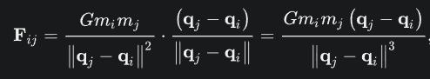
Equation 1.

In equation 1, G is the gravitational constant and ‖qj − qi‖ is the magnitude of the distance between qi and qj.
With every time step, positions of the bodies change (net force) due to other bodies.


Figure 1. This image represents approximately 10 billion bodies.

Brute force approach demands huge computational power and the complexity is O(n^2). The serial approach works well for a small number of bodies but when we have a big number, it simply fails. Thus we need a parallel approach to solve the problem taking advantage of the computational resources we have.

Techniques to solve the problem
1. All pairs
We calculate all possible combinations of interactive forces between the bodies.
◦ Most accurate solution
◦ Computationally intensive
◦ Choose variable time step schemes to calculate interaction
◦ Computational power and the complexity is O(n^2)

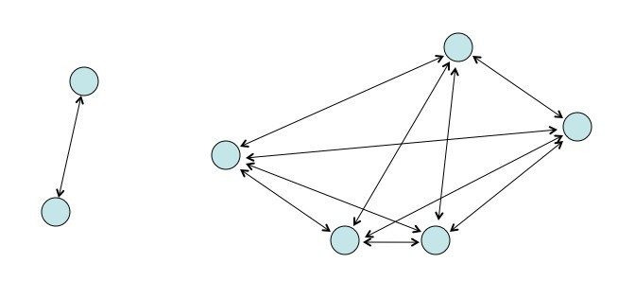
Figure 2. N-Body Simulation

2. Barnes Hut Algorithms
Barnes-Hut is an approximation technique used. The idea behind this is that for bodies which are farther away, instead of calculating all pairs interactive forces, the center of mass is calculated.
Barnes-Hut algorithm recursively divides the n bodies into groups by storing them in an octree (or a quad-tree in a 2D simulation). Each node in this tree represents a region of the three-dimensional space. The topmost node represents the whole space, and its eight children represent the eight octants of the space.
The space is recursively subdivided into octants until each subdivision contains 0 or 1 bodies (some regions do not have bodies in all of their octants).
There are two types of nodes in the octree: internal and external nodes. An external node has no children and is either empty or represents a single body. Each internal node represents the group of bodies beneath it, and stores the center of mass and the total mass of all its children bodies.
To calculate the net force on a particular body, the nodes of the tree are traversed, starting from the root. If the center of mass of an internal node is sufficiently far from the body, the bodies contained in that part of the tree are treated as a single particle whose position and mass is respectively the center of mass and total mass of the internal node. If the internal node is sufficiently close to the body, the process is repeated for each of its children.
Computational power and the efficiency is O(n log n).

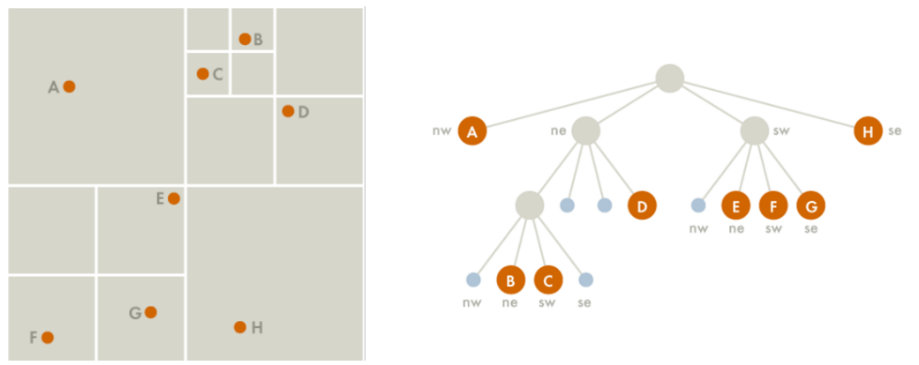
Figure 3. Barnes-Hut Algorithm

Serial Implementation
The N-body problem in physics and astrophysics involves predicting the individual motions of a group of celestial objects interacting with each other gravitationally. A serial implementation of the N-body problem in a programming context involves calculating the forces acting between each pair of objects and updating their positions and velocities over time.
Steps in Serial Implementation of the N-Body Problem:

1. Initialization
Define the positions, velocities, and masses of the N bodies.
Choose a time step for the simulation.

2. Force Calculation
For each body, calculate the gravitational force exerted by every other body.
Use Newton’s law of gravitation

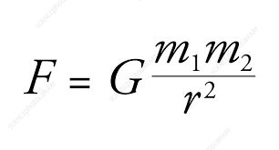
Equation 2.
Where G is the gravitational constant, m_1 and m_2 are the masses of the bodies, and r is the distance between bodies 1 and 2.

3. Update Velocities
Use the forces calculated to update the velocities of the bodies.
Apply Newton’s second law to compute the accelerations and velocities.

4. Update Positions
Update the positions of the bodies using the new velocities.

5. Repeat
Repeat the force calculation and update steps for each time step until the desired simulation time is reached.

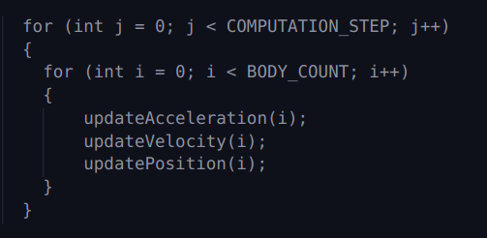
Algorithm 1. serial implementation of the N body problem

Parallel OpenMP Implementation
The parallel implementation of the N-body problem aims to accelerate the computation by distributing the workload across multiple processors. This can significantly reduce the time required for force calculations, which are O(N^2) in complexity.
Parallel Implementation Strategies:

• Domain Decomposition
Divide the space into subdomains and assign each subdomain to a different processor.
Each processor is responsible for calculating the interactions of bodies within its subdomain.

• Force Calculation
Each processor calculates the forces between bodies in its own subdomain.
Communication between processors is necessary to account for interactions between bodies in different subdomains.

• Data Parallelism
Distribute the bodies among processors so that each processor calculates the forces on a subset of bodies.
Each processor may need to know the positions of all bodies, leading to communication overhead.
We have implemented the parallelized version of the N-body problem using OpenMP in C++.

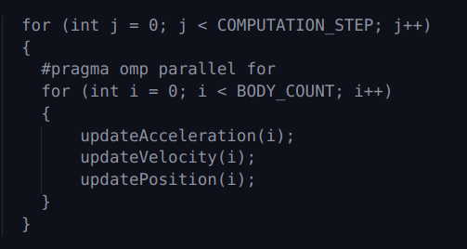
Algorithm 2. Parallel OpenMp implementation of the N body problem

Parallel Cuda Implementation

The CUDA implementation of the N-body problem takes advantage of the GPU’s ability to handle thousands of threads concurrently, making it well-suited for computations involving large numbers of particles. The primary goal is to reduce computation time by exploiting the parallel nature of GPUs.
Key Strategies in CUDA:

- Grid and Block Decomposition
  - The problem space is divided into a grid of thread blocks, each containing multiple threads.
  - Each thread within a block is responsible for computing the forces, velocities, and positions for a subset of bodies.
- Force Calculation with CUDA Kernels
  - The updatePhysics kernel is launched with a grid configuration that ensures each body is processed by a separate thread.
  - Each thread calculates the net force acting on its assigned body by iterating over all other bodies.
- Memory Management and Data Transfer
  - Memory for positions, velocities, accelerations, and masses of bodies is allocated on both the host (CPU) and the device (GPU).
  - Data is transferred from the host to the device before computation and back to the host after computation.
  - Efficient memory access patterns and coalesced memory access are used to optimize performance.
- Parallelism and Synchronization:
  - Each thread operates independently, allowing for massive parallelism.
  - Synchronization within blocks is minimized by ensuring that each thread works on separate data.
CUDA Implementation Functions:
- Host Functions:
  - compute: Manages memory allocation and data transfer, and launches the updatePhysics kernel iteratively to simulate multiple time steps.
- Kernel Function:
  - updatePhysics: A CUDA kernel that calls the above device functions for each body. Each thread computes the physics for a single body.
- Device Function:
  - updateAcceleration: Computes the gravitational forces and updates the acceleration of a body.
  - updateVelocity: Updates the velocity of a body based on its acceleration.
  - updatePosition: Updates the position of a body based on its velocity.
Algorithm 3. Host Function of the parallel Cuda implementation of the N body problem

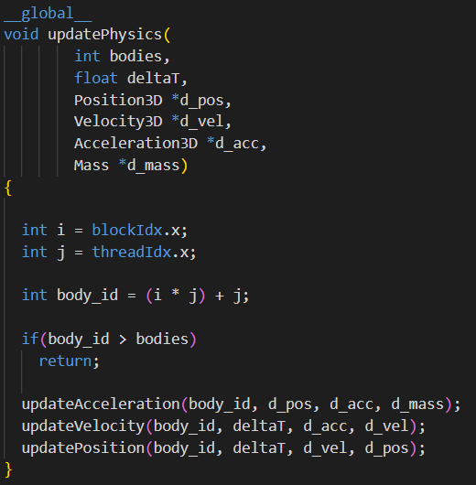
Algorithm 4. Kernel Function of the parallel Cuda implementation of the N body problem

Tiling: Tiling is a common optimization technique in parallel computing, where data is divided into smaller chunks (tiles) that fit into faster memory (like shared memory in CUDA) to reduce memory access times. However, tiling is not particularly effective for the N-body problem due to its specific computational characteristics:

1. All-to-All Interaction:
- In the N-body problem, each body interacts with every other body, resulting in an all-to-all communication pattern. This means that each thread needs to access data from all other bodies to compute the forces accurately. Tiling is most effective when there's a way to limit data access to a small subset of data (a tile), but in the N-body problem, each body needs access to the entire dataset.

2. High Memory Access Overhead:
- Even if you use tiling, each tile still needs to load data from global memory multiple times because each body needs data from all other bodies. This results in high memory access overhead, diminishing the benefits of tiling.

3. Complex Data Dependencies:
- The interactions between bodies create complex data dependencies, making it difficult to organize data into independent tiles that can be processed in parallel without frequent synchronization and data exchange between tiles.

4. Shared Memory Limitations:
- The amount of shared memory available per block is limited. Given that each thread requires data from all bodies, it's challenging to fit all the required data into the available shared memory. This limitation reduces the effectiveness of tiling, as only a small portion of the dataset can be loaded into shared memory at a time.

5. Synchronization Overhead:
- Implementing tiling in the N-body problem would require frequent synchronization between threads to ensure that all necessary data is available when needed. This synchronization can introduce significant overhead, negating the performance benefits of using shared memory.

Experimental results
Below are the results of the serial and parallel versions of the algorithm with different variations. The time step for the simulation is set to 100 for all experiments.

Table 1. Serial version with different number of bodies
Experiment | Number of Bodies | Size (kB) | Time (ms)
Serial | 600 | 65 | 1,082.197
Serial | 960 | 103 | 2,766.315
Serial | 1440 | 153 | 6,229.803
Serial | 2880 | 306 | 24,952.521
Serial | 5760 | 610 | 99,625.237
Serial | 11520 | 1247 | 402,476.433
Serial | 23040 | 2495 | 1608,650.585 ≈ 27 min

Table 1 represents the results of running the serial implementation of the code on a different number of bodies. Based on these results, the computation time increases as the number of bodies grows.

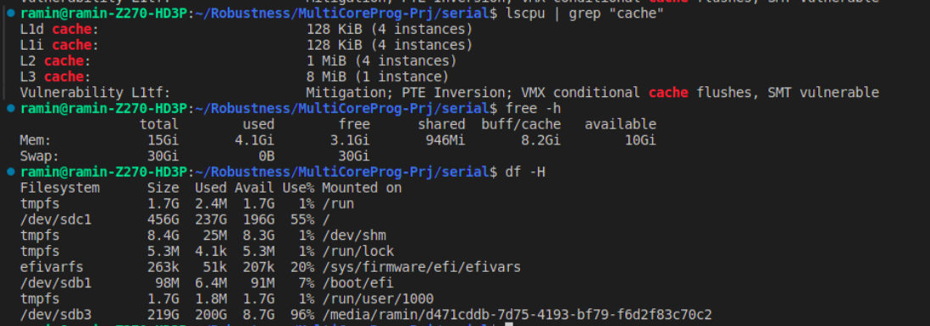
Figure 4. System properties

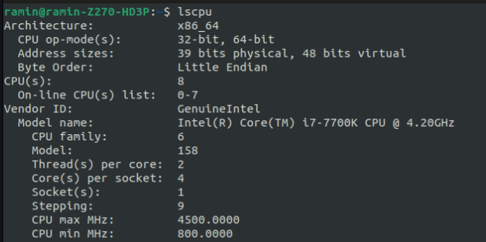
Figure 5. CPU architecture

Table 2. Parallel OpenMP version with different number of threads (# body = 600)

Experiment | Number of Threads | Number of Bodies | Time (ms)
OMP | 2 | 600 | 541.575934
OMP | 3 | 600 | 373.733389
OMP | 4 | 600 | 302.805393
OMP | 7 | 600 | 261.88397
OMP | 15 | 600 | 249.817228
OMP | 16 | 600 | 238.701163
OMP | 20 | 600 | 279.400413
OMP | 30 | 600 | 250.199123
OMP | 32 | 600 | 252.246021

Table 2 represents the results of running the parallel OpenMP implementation of the code on a different number of threads. The number of bodies is fixed to 600. The best computation time for 600 bodies is 238 ms, which is reached with 16 threads.
According to the results, the computation time decreases as the number of threads increases. This happens until we reach 16 threads. Afterwards, increasing the number of threads increases the computation time.
This behavior is quite common in parallel computing and can be attributed to several factors:
• Overhead of Thread Management
As the number of threads increases, the overhead associated with managing these threads also increases. This includes the time taken to create, destroy, and synchronize threads. Beyond a certain point, the overhead can outweigh the benefits of parallelization.
• Resource Contention
With more threads, there is increased contention for shared resources such as memory bandwidth, cache, and I/O. This contention can lead to bottlenecks, reducing the efficiency of parallel execution.
• False Sharing
When multiple threads modify variables that reside on the same cache line, cache coherence protocols can cause delays. This issue, known as false sharing, becomes more pronounced with more threads.
• Non-Uniform Memory Access (NUMA)
In systems with NUMA architecture, memory access times vary depending on the memory location relative to the processor. More threads can lead to less efficient memory access patterns, especially if threads are spread across multiple NUMA nodes.
• Diminishing Returns
The speedup from parallelization follows Amdahl's Law, which states that the maximum improvement to an overall system when only part of the system is improved is limited. If the serial portion of your code is significant, adding more threads yields diminishing returns.
• System Limits
The hardware itself may have limitations. For example, a CPU with 16 physical cores (without Hyper-Threading) might not benefit from more than 16 threads, as additional threads would be competing for the same physical cores.

Table 3 represents the results of running the parallel OpenMP implementation of the code with different setups. For each number of bodies, we run the program with a different number of threads. After choosing the best number of threads based on the computation time, we repeat that experiment with binding. The best computation time for each number of bodies is represented in bold.

Table 4 is the final comparison between the serial and the parallel OpenMP version. For each number of bodies, the setup for the parallel version is chosen from table 3.
In conclusion, the parallel OpenMP version can make the serial version more than 4.5 times faster.

Table 3. Parallel OpenMP version with different setups

Experiment | setup | Number of bodies | Time (ms)
OMP | 7 threads | 600 | 261.883
OMP | 16 threads | 600 | 238.701
OMP | 32 threads | 600 | 252.246
OMP | 16 threads - binding | 600 | 255.919
OMP | 7 threads | 2880 | 6,022.407
OMP | 16 threads | 2880 | 5,447.353
OMP | 32 threads | 2880 | 5,605.822
OMP | 16 threads - binding | 2880 | 5,287.960
OMP | 7 threads | 11520 | 94,969.562
OMP | 16 threads | 11520 | 85,055.596
OMP | 32 threads | 11520 | 84,112.597
OMP | 32 threads - binding | 11520 | 84,631.150
OMP | Dynamic Schedule  32 Threads– 1 Chunk | 11520 | 84,676.183
OMP | Dynamic Schedule  32 Threads – 2 Chunk | 11520 | 84,472.529
OMP | Dynamic Schedule  32 Threads – 4 Chunk | 11520 | 84,706.426
OMP | Dynamic Schedule  32 Threads – 10 Chunk | 11520 | 84,167.087
OMP | Dynamic Schedule  32 Threads – 20 Chunk | 11520 | 83,600.308
OMP | Dynamic Schedule  32 Threads – 30 Chunk | 11520 | 84,165.227
OMP | Dynamic Schedule  32 Threads – 40 Chunk | 11520 | 83,659.974
OMP | Dynamic Schedule  32 Threads – 80 Chunk | 11520 | 83,955.684
OMP | Dynamic Schedule  32 Threads – 128 Chunk | 11520 | 84,051.235
OMP | Dynamic Schedule  32 Threads – 256 Chunk | 11520 | 85,165.031
OMP | 7 threads | 23040 | 369,521.086
OMP | 16 threads | 23040 | 335,518.742
OMP | 32 threads | 23040 | 336,101.978
OMP | Dynamic Schedule  16 Threads – 2 Chunk | 23040 | 333,118.766

Table 4. Serial vs. parallel OpenMP

Number of Bodies | Size (kB) | Serial Time (ms) | Best OMP Time (ms) | Speed Up
600 | 65 | 1,082.197 | 238.701 | 4.533
2880 | 306 | 24,952.521 | 5,287.960 | 4.718
11520 | 1247 | 402,476.433 | 83,600.308 | 4.784
23040 | 2495 | 1608,650.585 | 335,518.742 | 4.794

Plot 1.
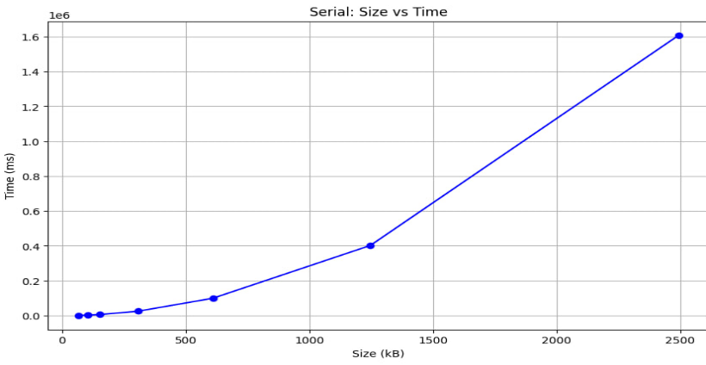

Plot 2.
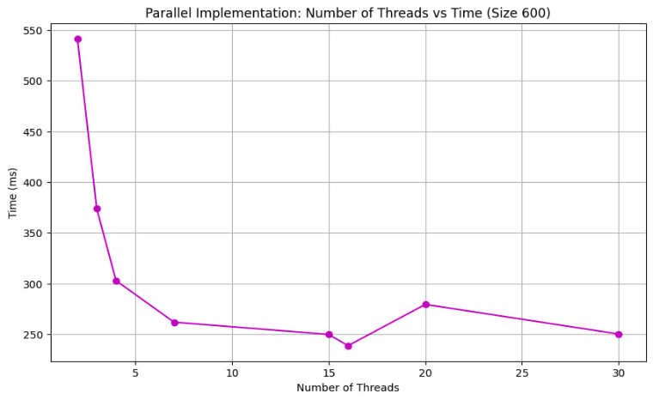

Plot 3.
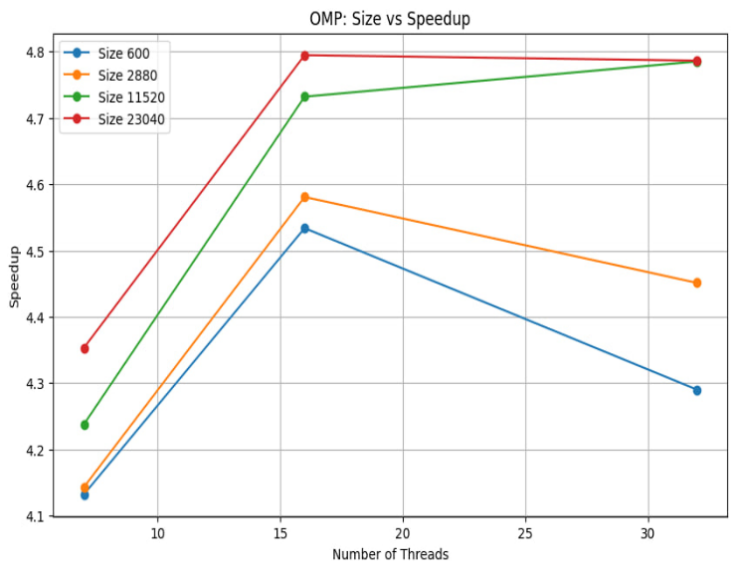

Plot 4.
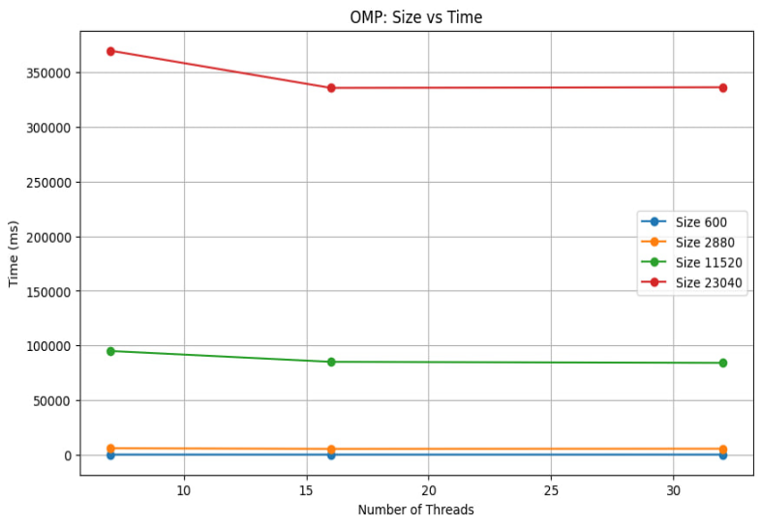

Plot 5.
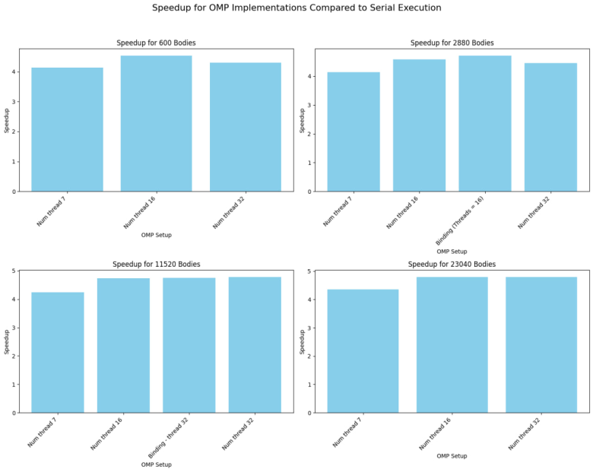

Plot 6.
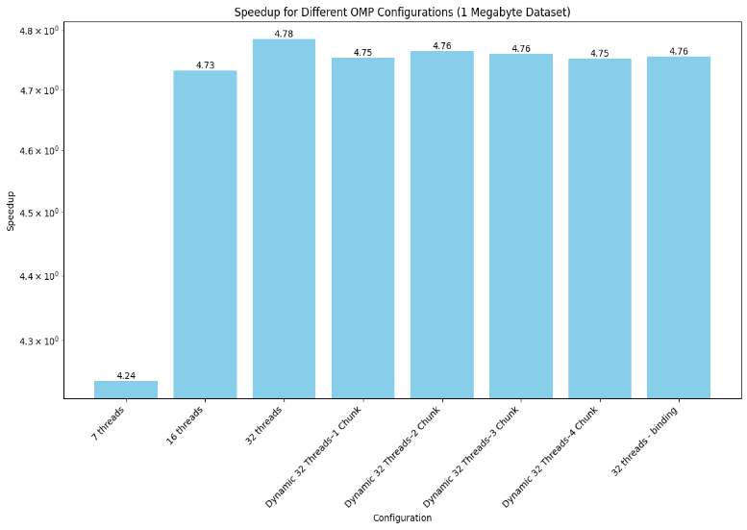

Plot 7.
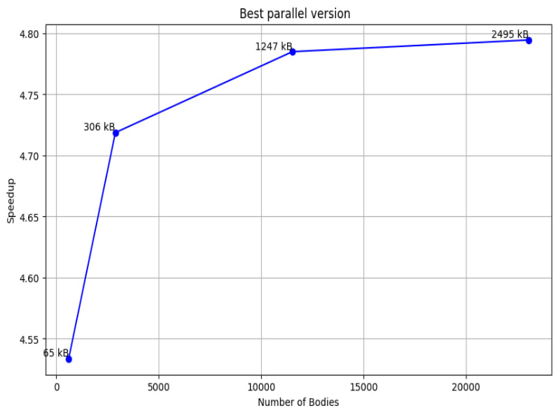

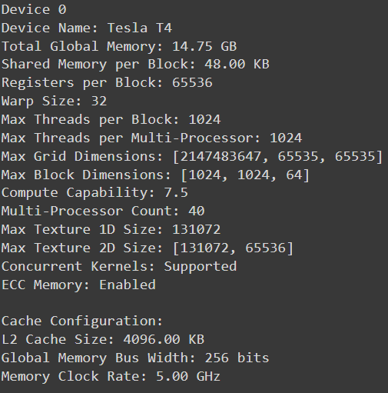
Figure 6. GPU Architecture

Table 5. Parallel CUDA version with different setups
Experiment | setup | Number of bodies | Time (ms)
CUDA | Block Size 16 | 600 | 673.287
CUDA | Block Size 32 | 600 | 511.666
CUDA | Block Size 64 | 600 | 555.038
CUDA | Block Size 128 | 600 | 596.572
CUDA | Block Size 16 | 2880 | 2,484.351
CUDA | Block Size 32 | 2880 | 1,627.396
CUDA | Block Size 64 | 2880 | 1,904.166
CUDA | Block Size 128 | 2880 | 1,864.272
CUDA | Block Size 16 | 11520 | 30,405.216
CUDA | Block Size 32 | 11520 | 15,161.601
CUDA | Block Size 64 | 11520 | 15,208.548
CUDA | Block Size 128 | 11520 | 18,241.501
CUDA | Block Size 16 | 23040 | 115,496.223
CUDA | Block Size 32 | 23040 | 61,749.649
CUDA | Block Size 64 | 23040 | 60,048.935
CUDA | Block Size 128 | 23040 | 60,095.977

Table 6: Serial vs. OMP vs. CUDA
Number of  Bodies | Size (kB) | Serial Time  (ms) | Best CUDA Time  (ms) | Serial Speed Up | OMP Speed Up
600 | 65 | 1,082.197 | 511.666 | 2.115 | 0.466
2880 | 306 | 24,952.521 | 1,627.396 | 15.332 | 3.249
11520 | 1247 | 402,476.433 | 15,161.601 | 26.545 | 5.513
23040 | 2495 | 1,608,650.585 | 60,048.935 | 26.788 | 5.587

Table 5 represents the results of running the parallel CUDA implementation of the code with different setups. For each number of bodies, we ran the program with different block sizes such as 16, 32, 64, and 128. The best computation time for each number of bodies is represented in bold. According to the results, for 600, 2880, and 11520 bodies, blocks with a size of 32 have the best performance among the other sizes. For 23040 bodies, kernels with blocks that contain 64 threads have the best computation time among the other sizes. So it can be concluded that by increasing the number of bodies, larger block sizes should be chosen.

Table 4 is the final comparison between the serial, OpenMP parallel, and CUDA parallel versions. For each number of bodies, the best setup of the CUDA parallel version is chosen from Table 5. The speedup of the CUDA version compared to both the serial and OpenMP versions has been calculated for each number of bodies. According to the results, for every number of bodies, the speedups of the CUDA version compared to the serial version are more than 1, indicating that the performance of the CUDA version is much better than the serial version. The computation time of the CUDA version is also better than the computation time of the OpenMP version except for the 600 bodies. Another point that can be concluded from the results is that by increasing the number of bodies, the speedup of the CUDA version compared to both serial and OpenMP versions increases, and the CUDA version has better efficiency for larger datasets.

Plot 8.
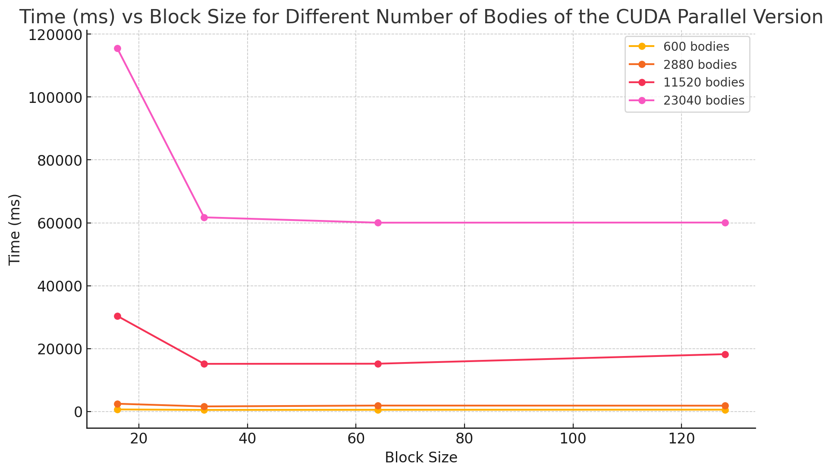
Plot 9.
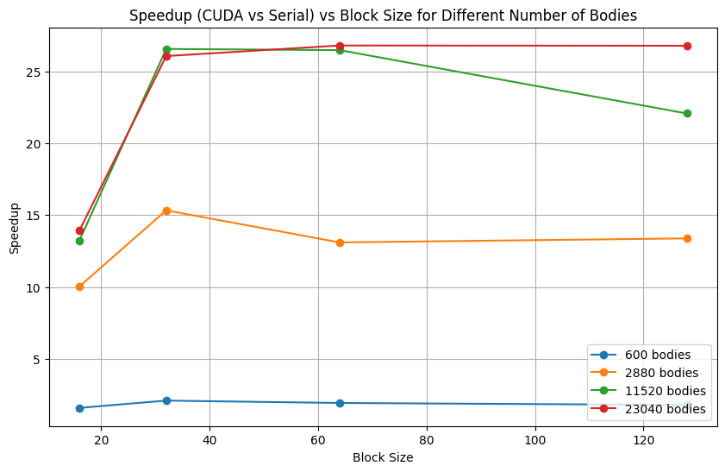

Plot 10.
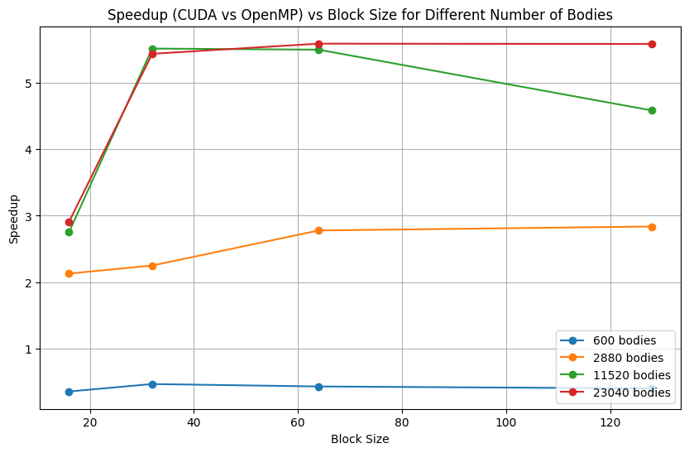

Plot 11.
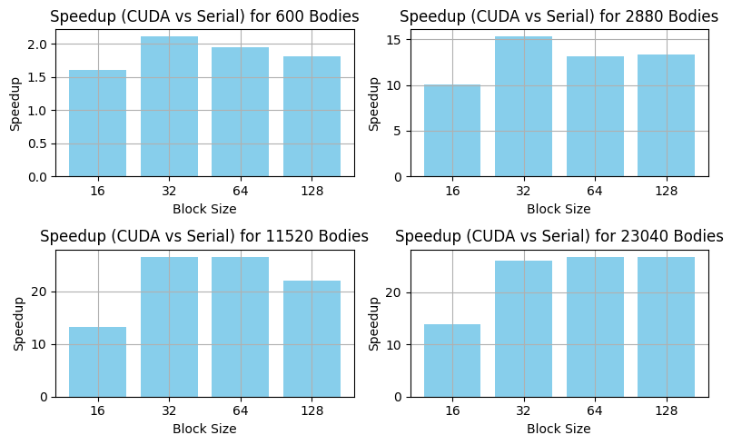

Plot 12.
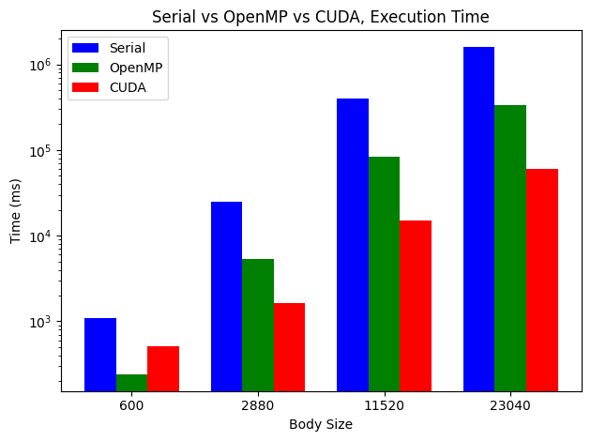
In conclusion, the parallel CUDA version can make the serial version more than 26.5 times faster (for large datasets), and its computation time is much better than the OpenMP parallel version. According to Plot 12, the OpenMP version is a good solution for small datasets and can significantly increase efficiency. However, for larger datasets, the CUDA version achieves better computation times than the OpenMP version and is the best solution for achieving parallelism.

Running the code

• To run the Serial version
$ cd serial/
$ g++ -o nbody_serial n_body.cpp -lm
$ ./nbody_serial

• To run the openMP version:
Pre-requisites: CUDA, openMP and openGL libraries should be present
$ cd openMp/
$ g++ -o nbody_omp n_body_omp.cpp -fopenmp
$ ./nbody_omp

- To run the CUDA version:
$ cd cuda/
$ nvcc -o nbody_cuda n_body_cuda.cu
$ ./nbody_cuda

