EXERCISE — FOR ACADEMIC / TRAINING PURPOSES ONLY (DSCSC 2026)
Copy No 1 of 1
Total Pages: __
AN APRC ON BRH OP IN GEN AREA BAUNIA 7140
For: GOC, 6 Inf Div Fmn/Unit: 8 Inf Bde
By: Brig Gen Reza, Comd 8 Inf Bde
At: 1700 hrs On: 07 Jul 2026
Ref: Ex Paper ME–BRH OP; Map Sheet 79 D/13 and Enlargement Gen Area BAUNIA (1 SQ = 1 KM)
Time Z Used Throughout the Aprc: FOXTROT
Format Note. Rewritten IAW the DSCSC precis 'Operational Appreciation, Orders and Briefings': aim with limitations; factors each closing in deductions ('so what'); en treated fm his own doctrine (WL/SOHB, played by RL); courses tested against the en's most probable COA; outline plan traceable to every deduction. After each para, a Note gives the doctrinal justification — fact → doctrinal implication → what the en/own force is therefore likely to do.
AIM
1. To estb a brH across River DANUBE in gen area BAUNIA 7140 ASP with a view to facilitating breakout of 9 Armd Bde towards the IB to annihilate the en, with fol limitations:
a. A Cl 50 br to be constr in the brH.
b. Axis DHAMRAI–SARAIL to be opened.
Note (Doctrinal Justification). GL: the aim is a single, attainable, mission-verb statement drawn fm the GOC's tasking (Narrative-1) with limitations that shape — not multiply — the aim. 'ASP' preserves the time imperative the GOC stressed ('time is the essence'). Both limitations are engr-driven and will later gate site selection (br constructability) and brH depth (axis opening).
FACTORS
Grd and Wx
2. Gen. The terr is flat, interspersed with numerous vills, BUAs, cultivated land and water features. Vills stand 4–6 ft, rds 6–8 ft and trs 3–4 ft above the surroundings. X country mov is poss except through water-logged and marshy areas; the rainy season has raised water levels. Rivs and khals flow gen N to S. Four Cl 80 A2, two Cl 50 A2 and two Cl 60 A1 rds serve the sector; all other rds are Cl 30 and below; brick-soled trs remain motorable but cannot take sustained tfc. Rivers DHALESHWARI and DANUBE are the maj obs. TONGI, JOYDEBPUR, KALIAKAIR, HEMAYETPUR, GORAI and SAVAR are the mentionable BUAs. BAUNIA guards the main rd and the (now dml) br over River DANUBE and is therefore the most imp obj.
Note (Doctrinal Justification). Fact: raised rds/vills on a flooded flat plain. Doctrinal implication (GL): mobility corridors are canalised onto embanked rds — mov tables and tfc con (CCO) become decisive staff work; def potential of vills means every obj is a QA (quick attack)/deliberate attk problem, not open-country mnvr. WL implication: SOHB def doctrine anchors coy posns on vills with interlocking MG arcs along linear obs — expect the en exactly where the APRC later assumes him.
3. Met.
a. Facts. First lt 0530; last lt 1830; moon 4th qtr 6th day; wx rainy.
b. Findings. ~13 hrs daylight, ~11 hrs ni; dark hrs throughout the ni (late, thin moonrise); rain likely daily.
c. Implications. (1) Dark hrs mask mov of large bodies incl boat carriage. (2) Rain restricts vis and makes C2 harder — simple plans, strict nav aids. (3) Rain covers mov noise incl OBM engines. (4) Current 2–3 m/s with rain: drift allowance for boats/rafts; swimmers/recce parties degraded.
Note (Doctrinal Justification). GL: an opposed X seeks surprise as the first principle; a moonless, rainy ni is the classic window — hence H Hr after full darkness (2000). WL: RL ni surv relies on LP/OPs, para-illum and pre-registered DFs rather than mass NVD (SOHB); blinding OPs and forcing him to fire unobserved illum wastes his arty and preserves surprise.
4. GTIs/Objs. BANANI, AMBAGAN, SAMPAN, PURBO PARA, FERRY GHAT, KHULNA, BAUNIA, VITARA, SRIPUR, ISLAMPUR, JOLSHIRI.
5. GTIs Dominating the Waterway. FERRY GHAT, PURBO PARA, SAMPAN, AMBAGAN, BARISHAL, BANANI, VITARA, BAUNIA, KHULNA.
Note (Doctrinal Justification). GL: GTIs are listed only to be fought over — each either protects a X site, dominates an exit, or hosts en fire. The far-bank GTIs (VITARA–BAUNIA–KHULNA arc plus SRIPUR–JOLSHIRI–ISLAMPUR depth) define the minimum brH: the brH line must run beyond en dir fire (Ph 1), dir obsn (Ph 2) and sustained observed indir fire (Ph 3) of the X sites — this three-ring logic is the doctrinal skeleton of the phasing.
6. Apps to River DANUBE. App 1: SALTA–KONABARI–PABNA–BHOLA–BANANI. App 2: SALTA–KONABARI–PABNA–BOALI–AMBAGAN. App 3: SALTA–KONABARI–NAIRA–NATORE.
7. Exits fm River DANUBE. Exit 1: VITARA–PANAM–NIDAL. Exit 2: BAUNIA–SRIPUR–ISLAMPUR–NIDAL. Exit 3: BIRULIA–TARABO–ISLAMPUR–NIDAL.
Note (Doctrinal Justification). GL: apps are valued by conceal­ment, cl of rd for br tn and separation (one app per aslt bn + one for CCO); exits by whether they lead onto the decisive obj without lateral mov under fire. App 1/2 pair with Exit 2 (BAUNIA–SRIPUR) — the axis the aim demands (DHAMRAI–SARAIL). Exit 3 serves the FERRY GHAT deception story.
8. Obs. River DANUBE: 150–200 m wide (narrowing to ~100 m at sandbar constrictions VITARA–FERRY GHAT), 3–5 m deep, 2–3 m/s — no fording; wet gaps 40–50 ft (canals) with soft beds inland; en mixed mfds SQ 7236/6940, A pers mfd SQ 6841, mixed mfd KHULNA 7138; improvised obs on poss X sites; dml brs at BAUNIA and MULADI.
Note (Doctrinal Justification). Fact→implication: a 150–200 m, 3–5 m deep gap is an aslt boat + raft + floating br problem (GL engr tables); the sandbar constriction halves exposure time but is exactly where WL doctrine sites its obs-fire trap (mfd 6841 + MG 681418 cover the BANANI narrows). Doctrinally the en has told us he expects us at BANANI — surprise must therefore come fm timing, suppression and deception, not fm site novelty alone.
9. Deductions (Grd and Wx).
a. Pri of Objs. BAUNIA astride the main rd and dml br: its capr makes VITARA and KHULNA untenable and opens the axis; then KHULNA, VITARA, SRIPUR, JOLSHIRI/ISLAMPUR.
b. Pri of X Sites. BANANI (least width, covered prep, shortest tp X time, tr to water, rd on far bank) → SAMPAN/AMBAGAN (raft capacity, dispersion) → FERRY GHAT (deception/contg).
c. Time of Attk. At ni (dark, rainy, moonless window).
d. Ph of Attk. Objs dispersed over ~8 km with intervening features — attk in phs.
e. Dir of Attk. Fm the front (east), the only dir the riv line allows; dir keeping simple in unreccied grd.
f. Deception. Multiple feasible sites permit depicting X at FERRY GHAT (live LP/OP audience) and dummy prep at SAMPAN.
Note (Doctrinal Justification). Each deduction is the 'so what' of paras 2–8 in GL appreciation drill. Pri of objs follows the GL rule that decisive terr = terr whose loss collapses the en's design (BAUNIA breaks WL mut sp between VITARA and KHULNA and severs the SAVAR–CHAMPA lateral). Phasing flows fm the three-ring brH logic at para 5's note. Deception exploits a WL known behaviour: LP/OPs report templates, and RL fire plans re-orient slowly once committed (SOHB).
En
10. Aim and Intention. Imm: defeat/delay any BL X of River DANUBE and retain capr terr. Ultimate: hold terr as a diplomatic bargaining chip — RL needs time, not ground.
Note (Doctrinal Justification). Fm Spl Idea/Narrative-1: VII Corps culminated, wdr under intl pressure, div (-) left to hold. WL doctrine for a force trading op-level time: deliberate def on the best obs with 'no wdr without orders'. Likely en conduct: fight fwd hard, C attk early, accept attrition — COA A behaviour.
11. Composn. Rft inf bn gp: inf (4 coys), armr (2 x tk tp), HAT pl, DS arty (fd bty + med bty assessed), engr (fd pl), EW det.
12. Disposn. Coys at VITARA, BAUNIA (+, astride dml br), KHULNA fwd; depth coy SRIPUR; contg posn prep JOLSHIRI; tk hide + TCVs JOLSHIRI; guns ISLAMPUR 6438; LP/OPs FERRY GHAT and S VITARA 6643; MG GR 681418/699400/715386; ATk GR 702395; mfds paras 8; digging SQ 6741/6939/6739 (live map marking at Anx A).
Note (Doctrinal Justification). WL bn def norms (SOHB): bn gp frontage on a water obs 6–8 km with three coys fwd on mut sp vills, one in depth 2–3 km back covering the main axis; tks held as mob det at the depth loc; HAT ambush sited on the armd app (GR 702395 covers the BANANI–BAUNIA exit onto the rd). Every reported fact fits the template — high-confidence disposn, which is itself an indicator of COA A (deliberate 'hold-fwd' def, not a delaying screen, which would show fewer mines and no depth digging).
13. Morale. Low — culminated offn, hy cas, home criticism, wdr of parent fmn; but dug-in tps with a survival stake fight stubbornly fm prep posns.
Note (Doctrinal Justification). GL int drill: morale is rated against behaviour, not sympathy — low strategic morale reduces C attk élan and ni patrol aggressiveness (opportunities for my recce and deception), but does not soften prepared def (fire fm trenches needs little morale). Plan takes the first, banks nothing on the second.
14. Res and Rft. Aval — bde-level res within the RL div (-); rft assessed one bn within 12–24 hrs of the riv line being breached.
Note (Doctrinal Justification). Spl Idea: 'this bn is likely the ME of the RL bde and likely to receive rft.' WL: rft flows to the pt of penetration once higher HQ confirms it — another argument for tempo: the brH must be past PL TOP GUN before RL divisional wheels turn.
15. Air. Sporadic RL raids on fwd bde posns since 08 Jul; BLAF holds a favourable air sit (16 FGA + 3 hel sorties/day to the Bde).
Note (Doctrinal Justification). GL: 'favourable' ≠ supremacy — daytime concentrations (veh WAs, br line) still need AD (SHORAD INSPUCM) and dispersal; ni X further discounts the RL air threat at the decisive hrs.
16. Reasonable Assumptions. a. Dug-in posns seen at VITARA, BAUNIA, KHULNA, SRIPUR → coy def posns there. b. Tks at KHULNA and ATk at BAUNIA → RL ATk def biased south. c. Mfds N BAUNIA, VITARA, S KHULNA → protective mfds all around def locs. d. RL fd arty bty likely ISLAMPUR (hy vehs 6438, gun-area digging SQ 6937).
Note (Doctrinal Justification). Assumption drill (GL): each assumption is anchored to an observed fact and would be invalidated by a nameable indicator — tasked to recce/SATA accordingly. The southern ATk bias (assumption b) is exploitable: the BANANI–VITARA (northern) X faces the thinner ATk arc in Ph 1, before tks matter.
17. Preferred Tac (WL/SOHB, played by RL). a. Contg posn prep at JOLSHIRI. b. Stiff resistance, fight till last; recapture lost GTIs by imm local C attk, or C attk basing on sit. c. Fwd def with MG/ATk, mfd, concertina and EW — designed to defeat the X at the water's edge.
Note (Doctrinal Justification). SOHB WL water-line def in one line: detect (LP/OP, EW) → engage on the water (MG, arty DFs) → contain the foothold (mfds, ATk) → destroy it (coy/bn C attk with tks fm depth within 1–2 hrs) → if penetration exceeds bn capacity, fall back on the contg posn (JOLSHIRI) and hold for bde C attk. My plan must break the chain at 'detect' (deception, ni, smoke, EW silence) and at 'destroy' (kill the mob det early), and must reach JOLSHIRI before it is manned as a coherent contg posn — the doctrinal argument for Ph 3's scope and the earliest poss B Hr.
18. Deductions (En). a. En arty (ISLAMPUR) can interfere with FUPs and all X sites → CB by MLRS and med arty fm H-15, SATA to acquire, peak fires at A Hr and br start. b. En tks with C attk role → X ATk wpns and F ech vehs imm after the first wave (ISR fm H+60), ATGM screen oriented SRIPUR–JOLSHIRI. c. En EW active → radio silence till H, line fwd of WCL, feint traffic on FERRY GHAT net. d. LP/OPs at FERRY GHAT and S VITARA → blind by smoke/fire at H-15; feed FERRY GHAT OP the deception. e. All previous deductions cfm.
Note (Doctrinal Justification). Every en deduction converts a WL behaviour into an own-force task with a timing — the GL test of a usable appreciation. The C attk window (1–2 hrs) sets the single most important number in the plan: ATk means must be on the far bank before H+2.
Relative Str
19. Tabulated below (ORBAT + Narrative-1 gp):
Ser | Item | Own | En | Ratio | Rmk
1 | Inf | 12 x coy (3 bns) + para coy (Div res) | 4 x coy | 3:1 | Aslt norm met at bde level
2 | Armr | 4 x tk tp (Sqn 6 H) | 2 x tk tp | 2:1 | Own tks X by raft fm A Hr
3 | Arty | 6 x fd bty, 3 x SP bty, 3 x med bty, 1 x MLRS bty | 1 x fd bty, 1 x med bty (assessed) | 6:1 | + SHORAD bty, SATA bty
4 | Engr | 2 x fd coy + 2 x br coy (Div INSPUCM), raft & aslt pl | 1 x fd pl | 6:1 | Pacing arm of the op
5 | ATGM/ATk | 1 x ATGM pl (+ bank gp ATk) | 1 x HAT pl | 1:1 | Parity — hence early X pri 1
6 | Air | 16 x FGA + 3 x hel/day | Sporadic raids | Fav | AD umbrella still reqr

20. Deductions (Relative Str). a. ATk parity → seek bank gp ATk fire fm home bank and X own ATGM at the fastest opportune moment (ISR/rafts). b. Raft and aslt pl + boat scales → aslt with 2 bns up is sustainable. c. Two fd coys → dev entry/exit routes at both X sites concurrently. d. 6:1 arty → afford simultaneous DF sp, CB and deception fire missions. e. All previous deductions cfm.
Note (Doctrinal Justification). GL force-ratio doctrine: 3:1 inf at the pt of aslt is the min for a deliberate attk on a prep posn; the X itself halves combat power until build-up, so the true insurance is fire superiority (6:1 arty) and tempo. WL will read the same arithmetic: expecting a 2-bn-up X, his arty will fire on both FUP areas — dispersal, digging in the FUP and short occupancy (<30 min) are therefore drills, not options.
Assessment of Tasks
21. Tabulated below:
Ser | Task | Tps Reqr | Tps Alot | Rmk
1 | Capr BAUNIA (Ph 1) | 4 x coy, 1 x tk tp | 29 Inf Bn (+): comp pl, ATGM sec; tks join later | ME axis
2 | Capr VITARA (Ph 1) | 4 x coy, 1 x tk tp | 19 Inf Bn (+): comp pl, ATGM pl (-); tks join later
3 | Capr SRIPUR (Ph 2) | 4 x coy, 1 x tk tp | 39 Inf Bn (+): Sqn 6 H (-), comp pl, ATGM pl (-) | Tks by raft
4 | Capr KHULNA, JOLSHIRI, ISLAMPUR (Ph 3) | 8 x coy, 1 x tk tp | 19 + 29 Inf Bn, tk tp + comp pl each | After reorg on PL TOP GUN
5 | Bank Gp | 4 x coy | 1 x bn gp ex 7 Inf Bde | Dmd cfm by Div
6 | Bank Master | 1 x pl per site | Ex aslt bns | Under CCO
7 | CCO | 1 x coy + | 6 Div Sp Bn (-) + 1 x inf coy (dmd to Div) | Incl TCPs, call-fwd areas
8 | Indir fire | 3 x fd regt, 1 x med regt, 1 x MLRS bty | As reqr — gp fm 6 Arty Bde
9 | AD | 1 x SHORAD bty | 1 x SHORAD bty (INSPUCM) | Over X sites/br
10 | Engr | 2 x fd coy, 2 x br coy | 2 x fd coy; 2 x br coy with CCO
11 | Res | 1 x coy + armr | 1 x inf coy, sp coy (-), 1 x fd pl; para coy Div res 30 min NTM

22. Deduction. Tps reqr (23 x coy eqvt) exceed own 12 x coy — hence: bank gp found by 7 Inf Bde (one bn gp); CCO manpower demanded fm Div (6 Div Sp Bn (-) + one inf coy); objs taken sequentially in phs with the fol-up bn recycled; res reconstituted each ph fm the uncommitted bn ('be prep' msns).
Note (Doctrinal Justification). GL troops-to-task drill legitimises phasing: when tasks exceed tps by ~2:1, doctrine offers only three levers — economy (bank gp fm a holding fmn), sequencing (phs), and higher-fmn augmentation (CCO, br coys, para coy). All three are used; none of the aslt power is mortgaged to rear-area tasks — a WL gunner counting coys on the water will still meet 3:1 at each obj in turn.
Time and Space
23. Fwd time cal (earliest H Hr):
Ser | Event | Time Reqr | Running Time
1 | Time now | — | 071700 Jul
2 | Initial plg, map recce | 12 hrs 30 min | 071700–080530
3 | Comd's recce + plan pres to GOC | ~4 days (incl this pres 120700) | 080530–121630
4 | Bde O Gp | 2 hrs | 121630–121830
5 | Marrying up, prep, boat trg | 12 hrs | 121830–130630
6 | Bn/coy comd recce, plg, orders | 6 hrs | 130630–131230
7 | Mov to Bde Assy A, final prep | 4 hrs | 131230–131630
8 | Mov to Bn Assy A | 1 hr | 131630–131730
9 | Collect boats (BOLP), mov to waterway | 2 hrs | 131730–131930
10 | Occupy FUP | 30 min | 131930–132000
11 | H HR (EARLIEST) | — | 132000 JUL
12 | Clear Ph 1 objs (ISR fm 2100) | 4 hrs | 132000–140001
13 | Consolidation / prep | 30 min | 140001–140030
14 | A HR (hy raft starts) | — | NB 140030
15 | Clear Ph 2 (br constr starts) | 4 hrs | 140030–140430
16 | Consolidation / prep | 30 min | 140430–140500
17 | B HR | — | NB 140500
18 | Clear Ph 3, expand to brH line | 4 hrs | 140500–140900
19 | 9 Armd Bde breakout | — | NB 140900

24. Deductions (T&S). a. Earliest H Hr 132000 Jul — full darkness, ~11 hrs of ni to fight Ph 1–2 and start the br before first lt (0530). b. Ph 3 runs into daylight → FGA umbrella and smoke programmed for 0500–0900. c. Br (6–8 hrs) completes ~1030–1230 under Ph-3 protection — brH line must be secure NLT 0900, hence B Hr cannot slip past 0500.
Note (Doctrinal Justification). GL backwards-planning: the br is the clock. Every timing above is derived by working back fm 'br open before RL rft (12–24 hrs) arrives' and fwd fm boat availability. WL: expect RL C attks at first lt (doctrinal preferred hr) — Ph 3's 0500 start deliberately pre-empts a dawn C attk by hitting JOLSHIRI first.
EN COURSES
25. Course A. Def with three coys up at VITARA, BAUNIA and KHULNA along River DANUBE and one coy in depth at SRIPUR; contg posn JOLSHIRI; tk hide JOLSHIRI; LP/OPs N/S VITARA and FERRY GHAT; guns ISLAMPUR; mixed mfds N BAUNIA and S KHULNA — fighting a decisive def btl opposing all probable X.
a. Likelihood. Most likely.
b. Eff. (1) Gds the most likely X sites. (2) Def depth compels own tps to clear in phs. (3) Main rd SAVAR–CHAMPA physically gd by two coys. (4) Res/rft inducted once the riv line is breached or a foothold estb — C attk against the immature brH is the decisive act.
Note (Doctrinal Justification). Indicator-matched to WL doctrine (para 17 note): digging, mfds, ATk siting, tk retention in depth and dml br all evidence 'hold fwd–strike early', and RL's strategic need (time/leverage) rewards it. Therefore treat COA A as the plg baseline, and weight the defeat mechanism against the C attk force, not the fwd coys alone.
26. Course B. Hold until the attk is launched; delay, harass, bring rft, conc arty on X sites, disorg the attk, then wdr fm successive posns preserving combat power.
a. Likelihood. Less likely.
b. Eff. Fewer own cas; area capr quicker; reorg easier; but en escapes destruction and re-forms on the next line.
Note (Doctrinal Justification). WL resorts to mob def/delay only when preserving force outweighs holding grd — here terr IS the bargaining chip, so wdr defeats RL's own purpose. Discount but not dismiss: if COA B materialises (indicator: thinning fires, veh mov west fm SRIPUR by ni), the para coy and armr exploit to PANAM–ISLAMPUR ahead of the phs — the plan's branches cover both.
27. En's Most Probable COA. Course A.
OWN COURSES
28. Course I. Aslt across River DANUBE in gen area BAUNIA at ni, two bns up (FUPs BANANI and AMBAGAN; Bde Assy A DHAMRAI; Bn Assy A KONABARI, MOHAKHALI, RATNA; VMA N DHAMRAI; A Veh WA PABNA; B Veh WA and BOLP MORAPARA and BOALI), estb brH along PANAM–ISLAMPUR in 3 phs: Ph 1 clr VITARA and BAUNIA to PL IRON FIST; Ph 2 clr SRIPUR to PL TOP GUN; Ph 3 clr KHULNA, JOLSHIRI and ISLAMPUR, reorg on PL HARD PUNCH.
29. Advtg. a. Most imp obj (BAUNIA) capr in Ph 1. b. Fol-up bn employable as res. c. Max fire sp concentrable on one X area. d. Good entry/exits; far-bank exits lead onto the objs. e. Shortest water exposure (BANANI narrows).
30. Disadv. a. All objs cannot be capr at a go. b. X at the most obvious site — risk of higher cas without effective suppression/deception.
31. Course II. As Course I but FUPs BARISHAL–AMBAGAN and SAMPAN, raft sites AMBAGAN and SAMPAN, br site AMBAGAN: Ph 1 clr BAUNIA and KHULNA (PL IRON DOME); Ph 2 SRIPUR and JOLSHIRI (PL TOM CAT); Ph 3 VITARA and ISLAMPUR (PL HARD).
32. Advtg. a. Rational objs each ph. b. Easy dir keeping. c. Good entry/exits at the riv.
33. Disadv. a. Fol-up bn must clr two objs. b. Still X at an obvious site (SAMPAN watched fm KHULNA). c. Aslt splits astride the riv bend onto divergent axes — mut sp between fwd bns lost. d. SAMPAN far bank hard/steeper — exit delay under fire. e. VITARA left alive on the north flank of the br site until Ph 3.
Note (Doctrinal Justification). GL COA comparison is fought on selection criteria drawn fm the deductions (surprise, mass at decisive pt, speed of build-up, protection of br site, simplicity). Course I wins four of five; Course II wins simplicity of dir keeping only. Decisive discriminator: Course II leaves VITARA (dominates BANANI/br site fm the north) uncleared until Ph 3 — doctrinally inadmissible once the br site is fixed at BANANI.
SELECTION OF OWN BEST COURSE
34. After comparing merits and demerits against the en's most probable COA, I select Course I.
Note (Doctrinal Justification). Stated as a comd's decision with the reasoning already argued — DSCSC style is decision-forward: the APRC has earned the one-line selection; the briefing (BM's brief Ser 6) carries the persuasion.
OUTLINE PLAN
35. Msn. 8 Inf Bde will estb a brH across River DANUBE in gen area BAUNIA 7140 ASP to facilitate breakout of 9 Armd Bde.
36. Execution. (Op Overlay Anx B; Gp Anx C.)
a. C of O. Three phs as Course I; adv to waterway per para 28 con by CCO; bank gp (bn gp ex 7 Inf Bde) secures home bank and wins the dir-fire fight; one Cl 50 br site BANANI, raft sites S BANANI and AMBAGAN; ME: Ph 1 — 19 Inf Bn, Ph 2 — 39 Inf Bn, Ph 3 — 29 Inf Bn; defeat mechanism destruction (blind → suppress → strike → dislocate → destroy, per BM's brief Ser 7); res per para 22; risks: day mov to FUP (mitigated: ni mov, AD, CB) and frontal aslt (mitigated: FSP, tempo, darkness).
b. 19 Inf Bn. Ph 1: aslt X, clr and secure VITARA; be prep asst 29 Bn at BAUNIA. Ph 2: be prep asst 39 Bn at SRIPUR. Ph 3: clr and secure ISLAMPUR (with JOLSHIRI shared as per bdry).
c. 29 Inf Bn. Ph 1: aslt X, clr and secure BAUNIA; be prep asst 19 Bn at VITARA. Ph 2: be prep asst 39 Bn. Ph 3: clr and secure KHULNA.
d. 39 Inf Bn. Ph 1: fol up, be prep asst fwd bns. Ph 2: aslt (ferried), clr and secure SRIPUR. Ph 3: be prep asst 19/29 Bn; find bde res coy.
e. Sqn 6 H. X by hy raft fm A Hr; Ph 2 with 39 Bn; Ph 3 tps to 19/29 Bn; be prep defeat armd C attk fwd of PL TOP GUN.
f. Arty. 6 Med Regt: fire sp + CB. 7, 8 Fd and 9 SP Regt: DS aslt bns per FSP. MLRS Bty: CB + interdiction JOLSHIRI. SHORAD Bty: AD over X sites and br. SATA: acquire ISLAMPUR guns.
g. Engr. Two fd coy: entry/exit dev, breaching with aslt bns, then survivability; br coys (with CCO): ISR fm H+60, hy rafts fm A Hr, Cl 50 br fm Ph 2 secure. Pri: mob — survivability — counter-mob.
h. Res. One inf coy + sp coy (-) + fd pl; Comd: Coy Comd 39 Bn; loc BARISHAL (Ph 1) then BAUNIA; tasks: asst clearing, defeat C attk, on order.
j. Coord Instr. H Hr 132000 Jul; A Hr NB 140030; B Hr NB 140500; Bde Assy A DHAMRAI; CCO net active fm 131600; EW silence till H; deception: feint FERRY GHAT (live traffic + dummy boat pkts), dummy raft prep SAMPAN; smoke on LP/OPs H-15; PLs as overlay; Ack instr per SOP.
37. Sv Sp. Fwd BAA: cen con, decen execution; ADS BOALI, sec BANANI; hel CASEVAC LZ BARISHAL; amn pri CB and smoke; boat/raft POL at BOLP; replen across riv on br open (emergency raft pkts by CCO pri).
38. Comd and Sig. Bde Tac with 29 Bn axis (far bank at A Hr); Main DHAMRAI; CCO net + line fwd of WCL; nicknames per X site; success codes by shuttle (red/green) until radio lifted at H.
Ack Instr: Ack.
REZA
Brig Gen
Comd 8 Inf Bde
Anx:
A. Live Map Marking — RL Disposn (NATO/APP-6).
B. Op Overlay — BrH Op (Course I).
C. Sketch — X Area / CCO / Bank Master Gp Layout.

ANX A TO APRC — LIVE MAP MARKING: RL DISPOSN
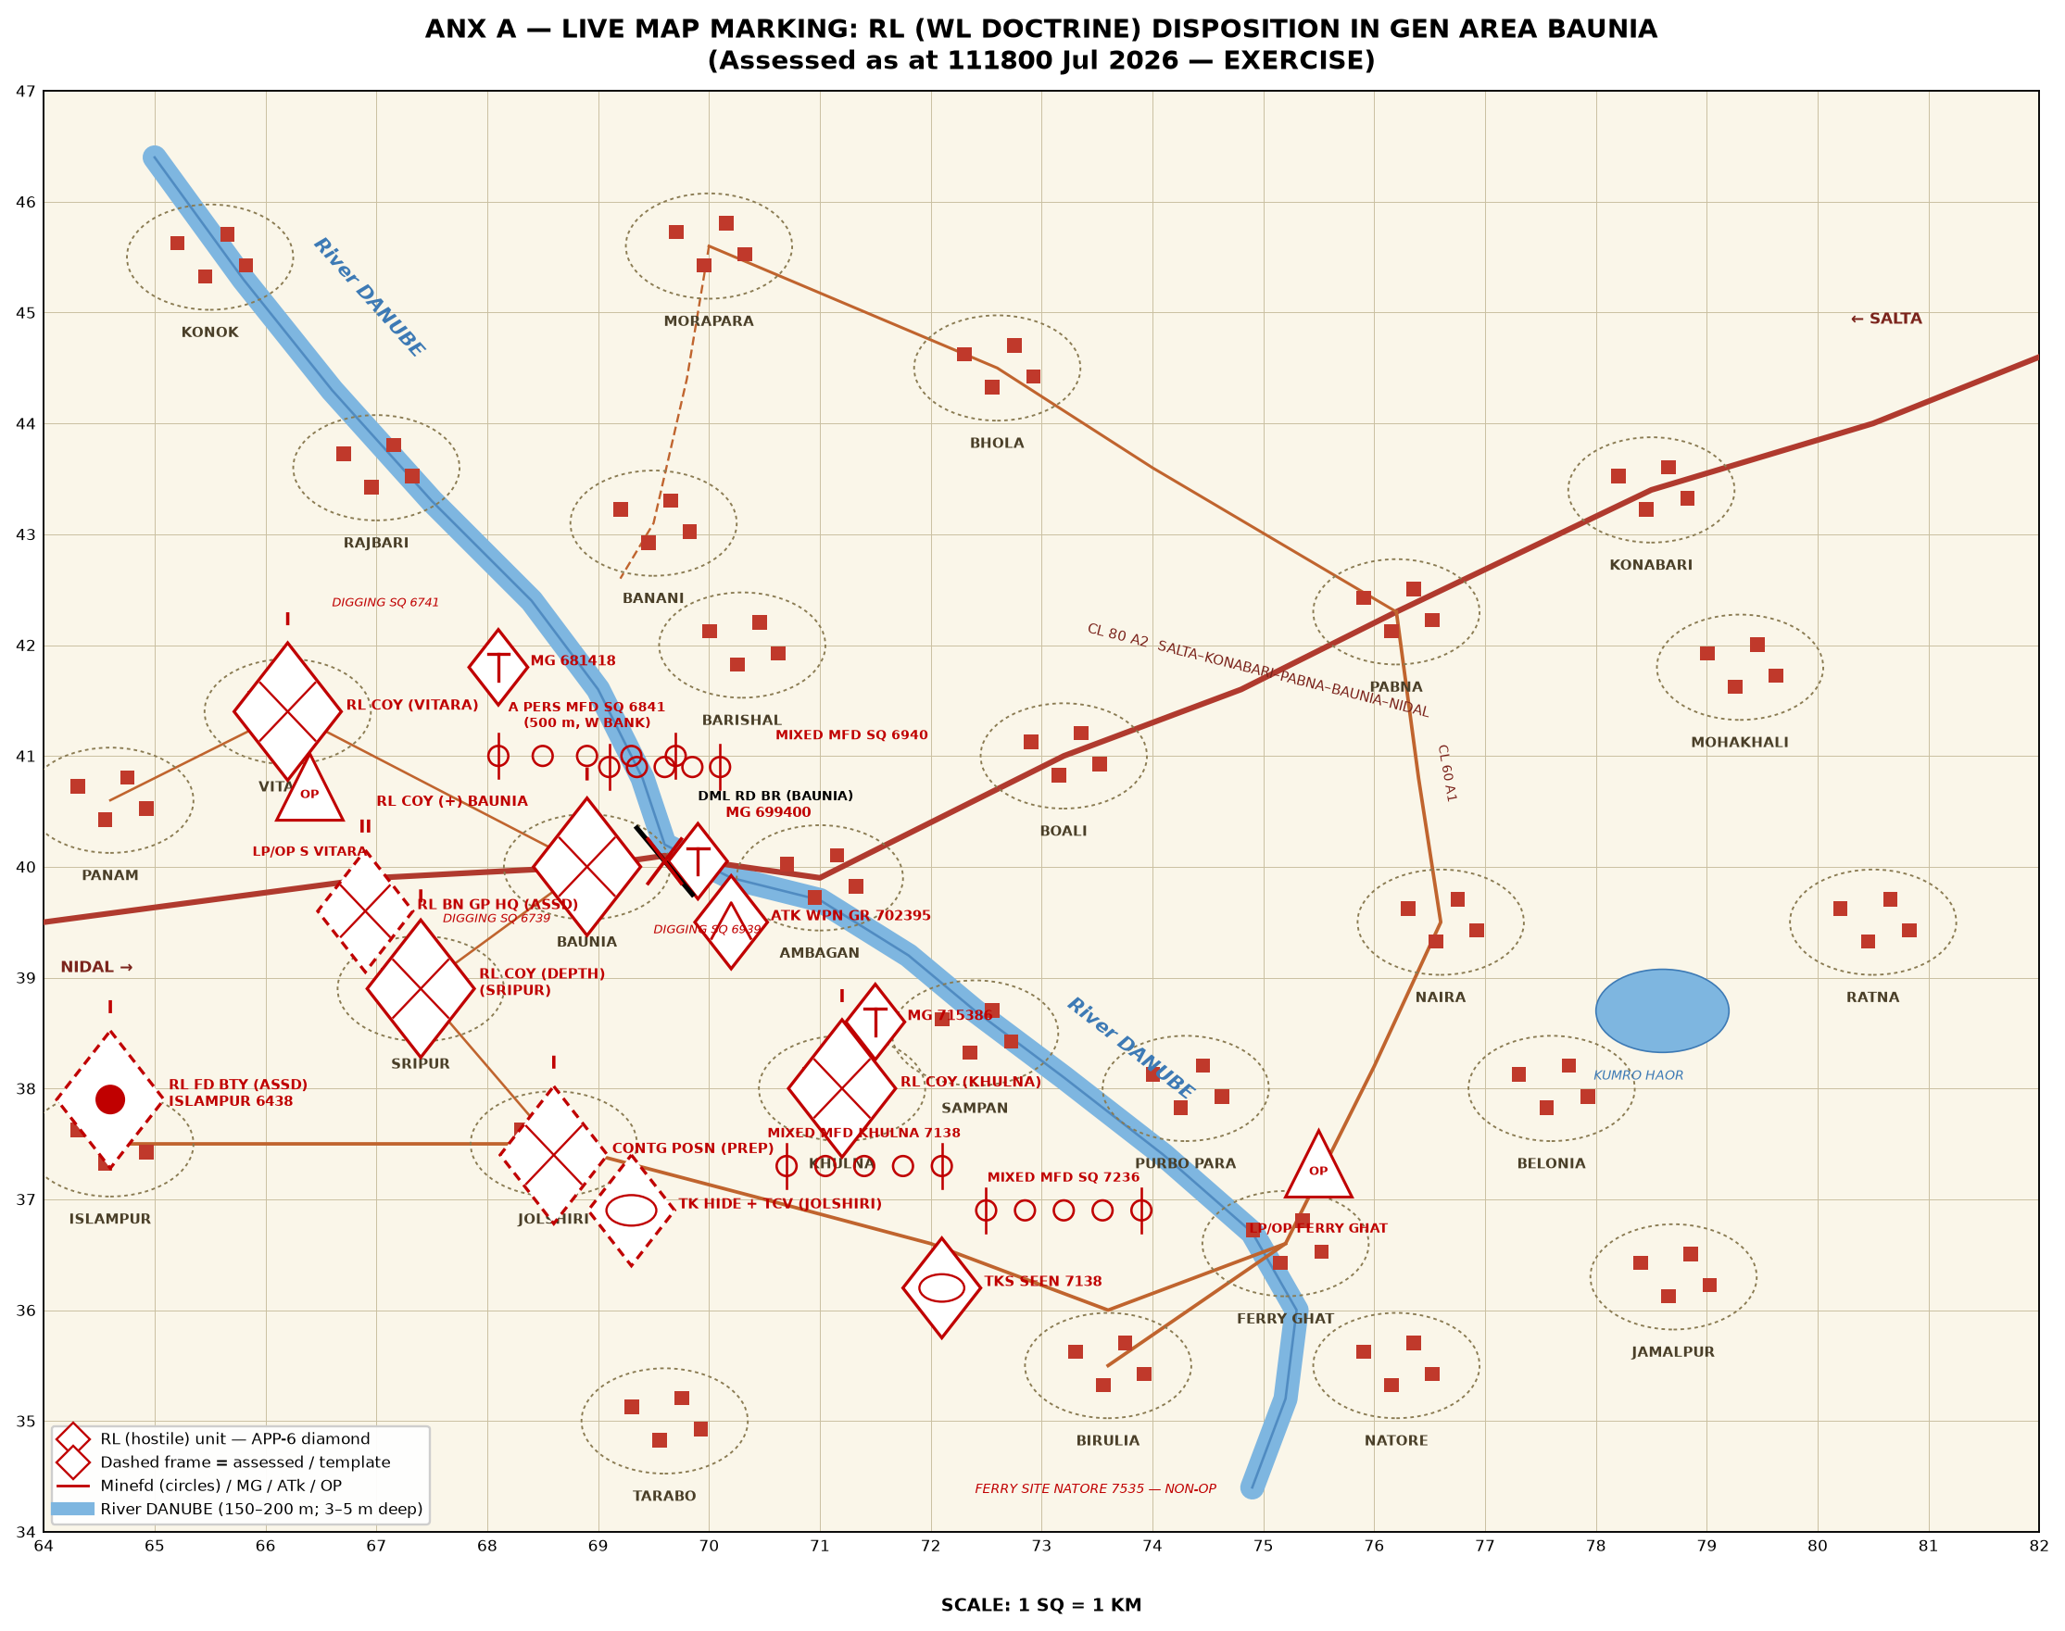

ANX B TO APRC — OP OVERLAY: BRH OP (COURSE I)
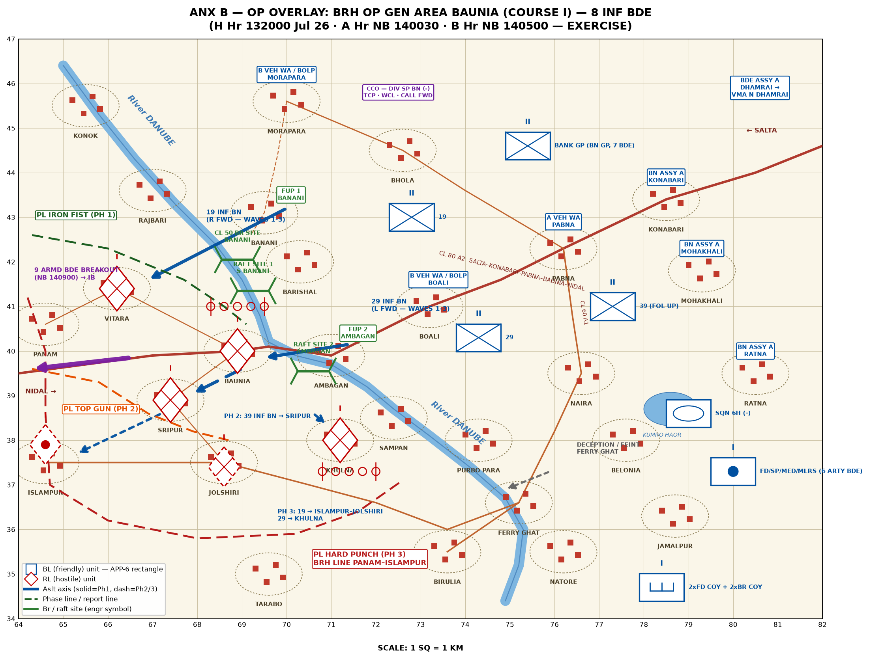

ANX C TO APRC — SKETCH: X AREA / CCO / BANK MASTER GP
