EXERCISE — FOR ACADEMIC / TRAINING PURPOSES ONLY (DSCSC 2026)
DSCSC — 2026
ME — BRH OP
PLAN PRESENTATION TO GOC 6 INF DIV
BRIEF BY BM, 8 INF BDE — BRH OP IN GEN AREA BAUNIA 7140
Presented at: HQ 6 Inf Div, SAVAR On: 120700 Jul 2026 Time Z: FOXTROT
Ref: Ex Paper ME–BRH OP (Ser 2–4 with Anx); SOHB (WL/RL Tactics); GL Precis — Aslt Riv Xing, The Attk, Op Appreciation, Orders and Briefings.
Format Note. Structure follows Anx E to Ser 4 (A Suggested Plan Pres Format, Ser 1–10). A DSCSC-standard BM's brief is delivered in first person on behalf of the Comd, is time-disciplined (20–25 min), runs from situation to plan in a single analytical thread, and — critically — argues every recommendation from ground, enemy and doctrine rather than asserting it. Each serial below ends with the doctrinal contrast (GL vs WL) that underpins the argument.
OPENING
1. Good morning, Sir. I am Maj [student], BM 8 Inf Bde. With your permission, I shall present Comd 8 Inf Bde's plan for the brH op in gen area BAUNIA 7140. The brief will take 25 mins and will fol the seq: latest sit and aval res; terr and implications; en's big picture; en's most likely COA; higher comd's intent; own courses and comparison incl X sites; broad outline plan; br and rafting plan; Bde and Div X plan in detail incl CCO; and log plan. Maps in use are SHEET 79 D/13 and the enlargement of gen area BAUNIA, 1 SQ = 1 KM. I shall refer to the live map marking at Anx A, the op overlay at Anx B and the X area sketch at Anx C. May I proceed, Sir?
SER 1 — LATEST SIT AND AVAL RESOURCES
2. Sit En. RL VII Corps has culminated and its bulk is wdr west, leaving a div (-) to retain capr terr. In our sector, a rft RL inf bn gp defends the western bank of River DANUBE in gen area BAUNIA astride the dml rd br. INTSUM 141800F and aerial recce cfm: ext digging along SQ 6741–6939–6739; MG/auto wpns at GR 681418, 699400 and 715386; ATk wpn at GR 702395; mixed minefds SQ 7236 and 6940, A pers minefd SQ 6841; tks seen KHULNA 7138, TCVs and tks JOLSHIRI; hy vehs and gun area activity ISLAMPUR 6438; LP/OPs FERRY GHAT and south VITARA. Arty and mor bombardment continues east of the riv, and sporadic air raids on 7 Inf Bde posns cont since 08 Jul.
3. Sit Own. 7 Inf Bde holds the home bank at BAUNIA; 15 Inf Bde is containing a delaying posn at SATURIA; 25 Inf Div ops on axis SAVAR–CHANDAN–KALIAKAIR–GORAI. 8 Inf Bde, presently concentrated in area DHAMRAI, is nominated for the aslt riv X.
4. Resources. In addition to normal affiliation, the Bde has: Sqn 6 H; one Sp Coy and one ATGM Pl of 6 Div Sp Bn (UC); two Fd Coy 6 Engr Bn (one INSPUCM); Br Coy 19 Aslt Engr Bn INSPUCM to Div (with Br Coy 6 Engr Bn — both gp with CCO for br and raft); one SHORAD Bty INSPUCM; 6 Arty Bde less DS regt and a MLRS Bty in sp; 16 FGA and 3 hel sorties per day; one para inf coy at 30 min NTM (Div res); Bank Gp of one bn gp fm 7 Inf Bde; CCO formulated on 6 Div Sp Bn (-).
GL (BL/own) Doctrine. GL doctrine treats an opposed river X as a deliberate op in four stages — prep, aslt, build-up and consolidation — demanding cen con of X means, a dedicated Bank Gp to win the fire fight fm the home bank, and a CCO to regulate call-fwd of veh and tps. Relative superiority of 3:1 at the pt of aslt and engr effort as the pacing item are the plg gates.
WL (RL/SOHB) Tactics. WL (SOHB) def doctrine on a water obs is 'hold fwd — strike early': coys dug in on the bank with mut sp, obs and fire integrated on likely X sites, a depth coy with a mob det (tk + TCV) tasked for imm C attk within 1–2 hrs of a foothold, arty pre-registered on X sites and FUPs, and wdr only on orders as terr is a bargaining chip.
So What (BM's Deduction). The race is between my build-up and his C attk clock. Every res above is therefore staged against one test: does it shorten the window between first wave landing and ATk/tk build-up on the far bank?
SER 2 — TERR AND IMPLICATIONS
5. River DANUBE, flowing NW–SE at 2–3 m/s, 150–200 m wide and 3–5 m deep, denies fording and compels a deliberate aslt X. Sandbars between VITARA and FERRY GHAT constrict the channel to about 100 m — halving water exposure but making my likely X sites predictable to RL. The home bank offers concealed FUPs and boat harbours in BANANI–BARISHAL–AMBAGAN and a rd/tr network adequate for br tn, though raised rds canalise the CCO flow and demand strict tfc con. The far bank SW of the dml br is open; movement away fm the riv is dominated by vill and rd junctions. BAUNIA, astride the CL 80 rd and the dml br, is the decisive terr: its capr collapses the mut sp between VITARA and KHULNA, opens axis DHAMRAI–SARAIL and unhinges the riv def. SRIPUR gives depth; ISLAMPUR–JOLSHIRI must be cleared to lift observed arty fire off the X sites and create mnvr space for 9 Armd Bde. X country mob for hy veh favours the NW of NAIRA and SAMPAN; the SE is soft.
6. Terr therefore dictates four imperatives: X where water exposure is shortest; seize BAUNIA early; expand faster than RL can mount his C attk; and gain depth to PANAM–ISLAMPUR before the Cl 50 br becomes the CG of the X system.
GL (BL/own) Doctrine. GL: site selection is a tac decision taken on the trinity of short exposure, concealed home-bank prep and far-bank exits onto the decisive obj — engr convenience alone never decides it. Night X with a moonless 4th-qtr sky and rain covers noise and mov.
WL (RL/SOHB) Tactics. WL: def economy dictates strength at the obvious sites; SOHB expects RL to accept gaps elsewhere and rely on obs (LP/OP), pre-planned arty DFs and the mob det to close them.
So What (BM's Deduction). Hence I attack the site the en can see but cannot hold once suppressed — BANANI — while depicting X at FERRY GHAT where his LP/OP will faithfully report my deception.
SER 3 — EN'S BIG PICTURE
7. RL's op reqr is time, not terr gain. Having culminated, RL needs the DANUBE line held long enough to convert occupied terr into diplomatic leverage (UNSC dialogue proposed 30 Jun). The BAUNIA bn gp is the tac gatekeeper: if it keeps the brH shallow and the Cl 50 br unbuilt, 9 Armd Bde cannot break out and RL wins its bargaining time. If BAUNIA falls and we reach PANAM–ISLAMPUR, the riv def is dislocated and RL loses both time and leverage. The bn gp is likely the ME of its bde and will be rft if the line is breached.
GL (BL/own) Doctrine. GL: the appreciation ties en intent to the op level — defeat mechanism must attack the en's purpose (time), not merely his posns; hence speed is my weapon.
WL (RL/SOHB) Tactics. WL: SOHB 'def of a riv line' — hold at all costs fwd, local C attks to restore the bank, fall back on contg posn (JOLSHIRI) only on orders; destruction of the def force is acceptable to buy time.
So What (BM's Deduction). My plan must therefore deny time wholesale: simultaneous suppression, night aslt, and armr across before first lt — not a sequential grind that plays to his clock.
SER 4 — EN'S MOST LIKELY COA
8. COA A (Most Likely) — Defeat the X at the riv line. Three coys fwd at VITARA, BAUNIA and KHULNA, one coy in depth at SRIPUR; contg posn prep at JOLSHIRI; tk hide and TCVs at JOLSHIRI; LP/OPs N VITARA/S VITARA and FERRY GHAT; gun posn ISLAMPUR; mixed minefds N BAUNIA and S KHULNA — fighting a decisive def btl by opposing all probable X, then committing tks/TCVs and rft against the first foothold before rafting matures. Indicators: dml br, deliberate digging, integrated minefds, ATk sited on the BANANI–BAUNIA exits, tks retained in depth.
9. COA B (Less Likely) — Trade space for time: engage the X with fire, delay fm successive posns BAUNIA–SRIPUR–JOLSHIRI, disrupt br constr, then wdr before destruction. Less likely because wdr surrenders the only card RL holds — retained terr.
10. Decisive Window. I assess the decisive period as H to H+6: fm first wave landing until ATk wpns, F ech and ldg tks are across. RL's local C attk (coy + tk tp fm JOLSHIRI via SRIPUR) can strike the BAUNIA foothold within 1–2 hrs of ident; his arty at ISLAMPUR can range every X site fm the outset.
GL (BL/own) Doctrine. GL: select en most probable COA on capability + indicators, then design the defeat mechanism against it — not against the worst case in the abstract.
WL (RL/SOHB) Tactics. WL: C attk norms — imm local C attk by depth pl/coy within 30–60 min at coy level, bn-level C attk with armr within 1–2 hrs, deliberate C attk (bde res) 4–6 hrs; arty concs pre-registered on X sites, FUPs and far-bank exits; EW to DF own comd nets.
So What (BM's Deduction). Defeat of COA A pivots on three acts: kill or fix the JOLSHIRI mob det early (FGA + MLRS + ATGM screen facing SRIPUR–JOLSHIRI), blind the LP/OPs before H, and silence ISLAMPUR guns by CB fm H-15.
SER 5 — HIGHER COMD'S INTENT
11. CAS intends 6 Inf Div to clear axes SAVAR–SATURIA–DAULATPUR and SAVAR–DHAMRAI–BAUNIA–SARAIL–CHAMPA and evict RL across the IB. GOC 6 Inf Div intends to maint momentum and deny RL time to consolidate along River DANUBE. 8 Inf Bde is tasked to estb a brH across River DANUBE in gen area BAUNIA ASP, allowing constr of a Cl 50 br and opening axis DHAMRAI–SARAIL, to facilitate breakout of 9 Armd Bde towards the IB. Key tasks: aslt riv X; destroy en con the selected X area; seize BAUNIA; expand through SRIPUR; clear KHULNA–JOLSHIRI–ISLAMPUR; protect X sites fm dir and observed indir fire; secure PANAM–ISLAMPUR line. End state: a secure brH of adequate depth, an op Cl 50 br, uninterrupted X of fol-up forces and mnvr space for 9 Armd Bde to break out without tac pause.
Note (Doctrinal Justification). The intent para in a DSCSC brief is deliberately two-up to one-up: CAS → GOC → own msn, proving nested purpose. Every phase of the outline plan must trace to one of the GOC's key tasks — the DS test is 'show me which key task this phase serves.'
SER 6 — OWN COURSES AND COMPARISON (INCL X SITES)
12. Comparison of X Sites.
Site | Crossing Value | Build-up Value | Threat / Limitation | Judgment
BANANI | Channel narrowed to ~100 m by sandbars; gentle banks both sides; tr to water, rd imm on far bank | Fastest foothold-to-brH transition; closest to BAUNIA (decisive obj); Cl 50 br site | Predictable — obvious suitability; covered by MG 681418 and mfd SQ 6841 | 1st pri — main aslt + br site
SAMPAN | Good entry; constricted channel; wh veh fording at places | Disperses aslt waves; second raft stream | Far bank hard, sandy, moderately steeper; off the decisive axis | 2nd pri — alt aslt / raft
FERRY GHAT | Suitable entry/exit, gentle banks | Rd west fm far bank for dispersal | Deepest water; far fm BAUNIA; LP/OP overwatches; ferry non-op | 3rd pri — deception / contg
BAUNIA RD BR | Excellent alignment, firm banks | Direct onto decisive axis once secure | Dml pillars obstruct floating br on same site; tactically obvious, covered by fire | Not for initial X — exploit after BAUNIA secure (br poss some dstn away)
PURBO PARA / AMBAGAN | Good entry; narrow channel (PURBO PARA); AMBAGAN gentle banks but deeper water | AMBAGAN feeds 2nd FUP; supports left fwd bn | PURBO PARA far bank steeper | AMBAGAN — 2nd aslt X site + raft site 2

13. Course I. Aslt at ni with two bns up fm FUPs BANANI and AMBAGAN (19 Inf Bn rt fwd → VITARA; 29 Inf Bn lf fwd → BAUNIA), 39 Inf Bn fol up → SRIPUR in Ph 2; Ph 3 clears KHULNA–JOLSHIRI–ISLAMPUR; brH line PANAM–ISLAMPUR. Advtg: decisive obj (BAUNIA) capr in Ph 1 by the shortest exposure X; fol-up bn husbanded as res; max fire sp concentrated on one X area; entry/exits align with objs. Disadv: not all objs at a go; X at the most obvious site.
14. Course II. Aslt at ni two bns up fm FUPs BARISHAL–AMBAGAN and SAMPAN → Ph 1 BAUNIA and KHULNA; Ph 2 SRIPUR–JOLSHIRI; Ph 3 VITARA–ISLAMPUR. Advtg: rational obj per ph; easy dir keeping. Disadv: splits the aslt astride the riv bend onto two divergent axes; fol-up bn must clear two objs; SAMPAN far bank steeper delays exit; BAUNIA and KHULNA together in Ph 1 dilutes 3:1 at the decisive pt.
15. Selection. I recommend Course I. It masses two bns and the whole FSP against the decisive obj in Ph 1, keeps both X sites within one CCO span, and shortens the vulnerable window at the pt where RL's C attk must come. The obviousness of BANANI is bought off by deception at FERRY GHAT, suppression of the near MG/mfd belt, and speed in darkness.
GL (BL/own) Doctrine. GL attk doctrine: mass at the pt of decision, one strong thrust rather than two weak ones; ME identified per ph; res constituted and re-constituted each ph.
WL (RL/SOHB) Tactics. WL: expects the main X at the best site and plans DFs accordingly — but SOHB also notes RL's rigidity: fire plans and C attks are triggered by templates and need higher clearance, lagging a fast-moving aslt.
So What (BM's Deduction). Course I deliberately collides with his template and beats it on tempo: his DFs will fall on a suppressed, dispersed, night-moving force while my deception feeds his template a second, false X.
SER 7 — BROAD OUTLINE PLAN (C OF O INCL GP AND FSP)
16. Msn. 8 Inf Bde will estb a brH across River DANUBE in gen area BAUNIA 7140 ASP to facilitate breakout of 9 Armd Bde.
17. Scheme of Mnvr — 3 Phs (Op Overlay Anx B).
a. Ph 1 (H Hr 132000 Jul). Aslt in waves fm BANANI and AMBAGAN; 19 Inf Bn clears VITARA, 29 Inf Bn clears BAUNIA, secure PL IRON FIST. Purpose: eliminate dir fire threat to X sites. ME: 19 Inf Bn. End state: VITARA–BAUNIA clear; ISR ferrying ATk/F ech; hy raft constr started.
b. Ph 2 (A Hr NB 140030). 39 Inf Bn (+ Sqn 6 H (-) by raft) clears SRIPUR, secures PL TOP GUN. Purpose: deny dir obsn of X sites; protect br constr fm observed fire. ME: 39 Inf Bn. End state: SRIPUR clear; Cl 50 br constr started at BANANI.
c. Ph 3 (B Hr NB 140500). 19 and 29 Inf Bn (each + tk tp, comp pl, ATGM) clear ISLAMPUR–JOLSHIRI and KHULNA, reorg on PL HARD PUNCH (brH line PANAM–ISLAMPUR). Purpose: lift sustained indir fire off the X; create mnvr space. ME: 29 Inf Bn. End state: brH secure; 9 Armd Bde build-up; breakout NB 140900.
18. Gp. 19 Inf Bn: one Comp Pl 6 Div Sp Bn, one ATGM Pl less sec. 29 Inf Bn: one Comp Pl, one ATGM sec. 39 Inf Bn (Ph 2): Sqn 6 H less two tps, one Comp Pl, ATGM Pl less sec. Ph 3: tk tp + comp pl + ATGM to each aslt bn. Res: inf coy + Div Sp elm + fd pl (Comd: Coy Comd 39 Bn; loc BARISHAL Ph 1, BAUNIA Ph 2–3); para inf coy remains Div res at 30 min NTM — dmd for JOLSHIRI blocking or FERRY GHAT exploitation.
19. FSP. Btlfd shaped fm H-30: FGA (16 sorties) on VITARA, BAUNIA, KHULNA, SRIPUR, JOLSHIRI and gun area ISLAMPUR; MLRS + Med on CB and JOLSHIRI mob det; 3 x Fd Regt + SP in DS of aslt bns with SOS/DF on far-bank exits; SHORAD over X sites and br; SATA acquiring ISLAMPUR guns; smoke to blind LP/OPs S VITARA and FERRY GHAT at H-15; Bank Gp (bn gp ex 7 Bde) wins the dir fire fight fm home bank and thins out only when brH bites.
20. Defeat Mechanism. Destruction, sequenced: blind (LP/OPs, EW silence, smoke) → suppress (FGA, arty on fwd coys, CB on ISLAMPUR) → strike (two-bn night aslt onto VITARA–BAUNIA) → dislocate (rapid SRIPUR–JOLSHIRI clearance denies the C attk BUP) → destroy in detail (armr + ATGM across by raft kill the mob det fwd of PL HARD PUNCH).
GL (BL/own) Doctrine. GL: defeat mechanism must name the mechanism (destruction/dislocation) and the sequence of effects, with the ME per phase carrying the purpose.
WL (RL/SOHB) Tactics. WL: the C attk force is the def's CG at bn level (SOHB); its destruction or fixing collapses the 'hold-fwd' design because fwd coys have no second act.
So What (BM's Deduction). Killing the JOLSHIRI tk/TCV det before it crosses PL TOP GUN is the single act on which Ph 2–3 hinge; FGA pri 1 and the ATGM screen orient there fm H+1.
SER 8 — BR AND RAFTING PLAN INCL TIMING
21. Engr Order of Effort (pacing item). Two Fd Coy 6 Engr Bn: entry/exit dev at BANANI and AMBAGAN, mfd breaching with aslt bns, then survivability in reorg. Br Coy 6 Engr Bn + Br Coy 19 Aslt Engr Bn (both with CCO): rafts then br.
Ser | Task | Site | Start | Complete (planned) | Rmk
1 | Aslt boats (waves 1–3, 2 bns) | BANANI + AMBAGAN | H (132000) | H+40 min first wave landed | Boats collected BOLP MORAPARA/BOALI fm 131730
2 | ISR (inf sp rafts) — ATk wpn, F ech | Both X sites | H+60 (2100) | Cont | Starts imm after 1st wave lands
3 | Cl 40/50 hy rafts x 2 | S BANANI + AMBAGAN | A Hr (140030) | A+2 (0230) first tk across | Sqn 6 H (-) by raft; comp pl vehs follow
4 | Cl 50 floating br (150–200 m) | BANANI (dstn fm dml br) | Ph 2 secure (~0430) | 0900–1000 (6–8 hrs constr) | Both br coys; SHORAD + smoke overhead; dml br site rejected (pillars obstruct)
5 | Alt br site recce/prep | AMBAGAN | Concurrent | — | Contg if BANANI interdicted

22. Addl Reqr fwd to Div: one addl br coy eqpt (~60 m reserve bays) to cover current loss and the AMBAGAN contg; assessed shortfall in aslt boats for simultaneous 2-bn waves met by pooling Div boat res with CCO by 131700.
GL (BL/own) Doctrine. GL: br constr begins only when the site is free of observed dir fire and sustained observed indir fire — hence br start is tied to Ph 2 (SRIPUR) not to a clock time; rafts bridge the armr gap in between.
WL (RL/SOHB) Tactics. WL: arty will re-register on a detected br line within 30–60 min; RL doctrine ranks br sites above tps as arty tgts.
So What (BM's Deduction). Therefore: CB wins the br, not the br coys. MLRS/Med CB program peaks at A Hr and again at br start; smoke and SHORAD are permanent over BANANI fm A Hr.
SER 9 — BDE AND DIV X PLAN IN DETAIL (CCO)
23. CCO (Sketch at Anx C). CCO on 6 Div Sp Bn (-): CCO HQ with Div tac; X area comd — CO 6 Engr Bn (tech con) with Bde rep; Bank Master Gp (one pl per X site, ex aslt bns) con boat stations, wave disciplines and site tfc; Waterway Con Line on the home bank tr line; TCPs 1–4 on CL 80 A2 (DHAMRAI–BOALI) and CL 60 A1 (PABNA–MORAPARA); call-fwd areas: Bde Assy A DHAMRAI → Bn Assy A KONABARI/MOHAKHALI/RATNA → A Veh WA PABNA / B Veh WA MORAPARA–BOALI → BOLP MORAPARA and BOALI → FUP. Comm: CCO net (VHF) + line to br site; nicknames per site; one-way tfc, dispersal 100 m, no lights, MP dets at TCPs.
24. Veh Pri Table (call fwd by CCO).
Pri | Serial | Means | Timing
1 | ATk/ATGM wpn vehs + mor F ech of aslt bns | ISR/lt raft | Fm H+60
2 | Tks Sqn 6 H (-) + OP/FOO vehs | Hy raft | Fm A Hr
3 | Comp Pl vehs, amb, sig veh, CP vehs | Hy raft | A+1 onwards
4 | 39 Bn F ech + res coy vehs | Raft/br | On br open
5 | 9 Armd Bde ldg elms (build-up) | Cl 50 br | NB 140900 (B+4)
6 | A ech, log pkts (Fwd BAA pull) | Br, by CCO call fwd | After breakout starts

25. Wave / Flight Plan (each aslt bn, 3 waves; boat station drill per GL pam). Wave 1: 2 x aslt coy (ldg coys) + engr breach parties + FOOs — silent paddling, H hr. Wave 2: remaining rifle coys + bn tac + MMG/mor det — H+20. Wave 3: sp coy bal + adm elm — H+40, motorised boats once surprise lifted. Bank Master Gp recycles boats; reserve boats 15% held at BOLP.
26. C2. Bde Tac with 29 Bn axis fm H+2 (far bank at A Hr); Bde Main DHAMRAI; Div CCO overlay issued as Anx to op O; success/failure criteria per site (red/green shuttle codes) to CCO net; EW silence till H, then deception traffic continues on FERRY GHAT feint net.
GL (BL/own) Doctrine. GL: the CCO is a comd instrument, not an engr convenience — it must be able to switch the point of main effort between sites without new orders (pre-designated alt priorities).
WL (RL/SOHB) Tactics. WL: RL EW will DF comd nets and cue arty; SOHB expects RL recce patrols/swimmers against boat harbours the night before.
So What (BM's Deduction). Hence radio silence to H, line + LO fwd of WCL, boat harbours guarded by Bank Gp standing patrols fm 121900, and the FERRY GHAT feint runs live traffic to give the DF bearings a false centre of mass.
SER 10 — LOG PLAN
27. Cen con, decen execution fm Fwd BAA (est DHAMRAI area): 1st line scales carried complete; 2 DOS amn dumped at gun areas pre-H; boat/raft POL at BOLP; ADS at BOALI with sec at BANANI home bank; amb relay posts at both X sites, hel CASEVAC LZ at BARISHAL (3 hel sorties); EME lt repair at B Veh WA; water pt BOALI. Amn pri: arty CB and smoke. Replen across river only on br open except emergency raft pkts under CCO pri 6.
28. Risks. (a) Daytime mov Assy A → FUP: mitigated by ni mov, AD umbrella, CB. (b) Frontal aslt through en surface: mitigated by coord FSP, tempo, darkness. (c) Br interdiction: mitigated by CB peak at br start, smoke/SHORAD, alt site AMBAGAN. Residual risk accepted, Sir, against the GOC's demand for momentum.
29. That completes my presentation, Sir. Subject to your approval of Course I, warning O is ready for issue and the Comd's recce completes by 121630. May I have your decision and any modifications, Sir?

ANX A TO BM'S BRIEF — LIVE MAP MARKING: RL DISPOSITION (NATO/APP-6 SYMBOLS)
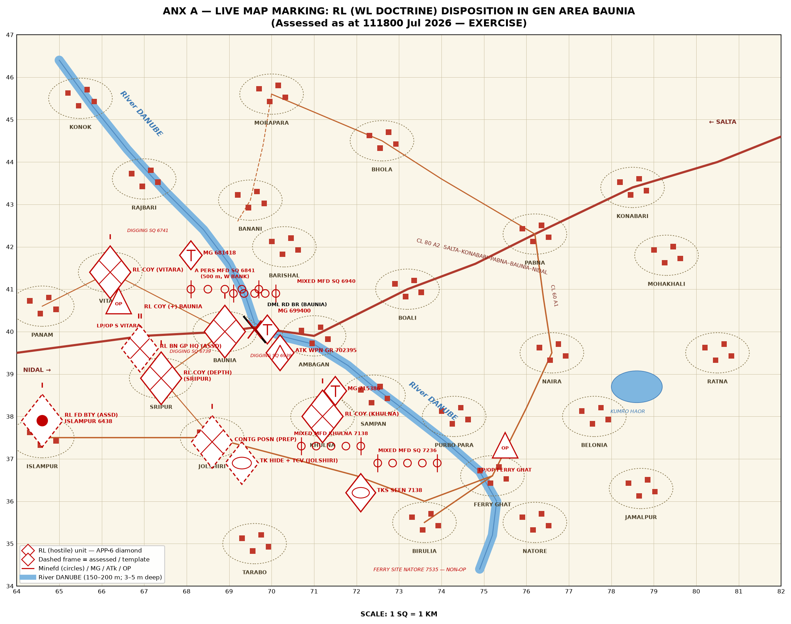
Live map marking — every reported/assessed RL loc plotted with APP-6 hostile symbology on the 1 SQ = 1 KM enlargement.

ANX B TO BM'S BRIEF — OP OVERLAY: BRH OP (COURSE I)
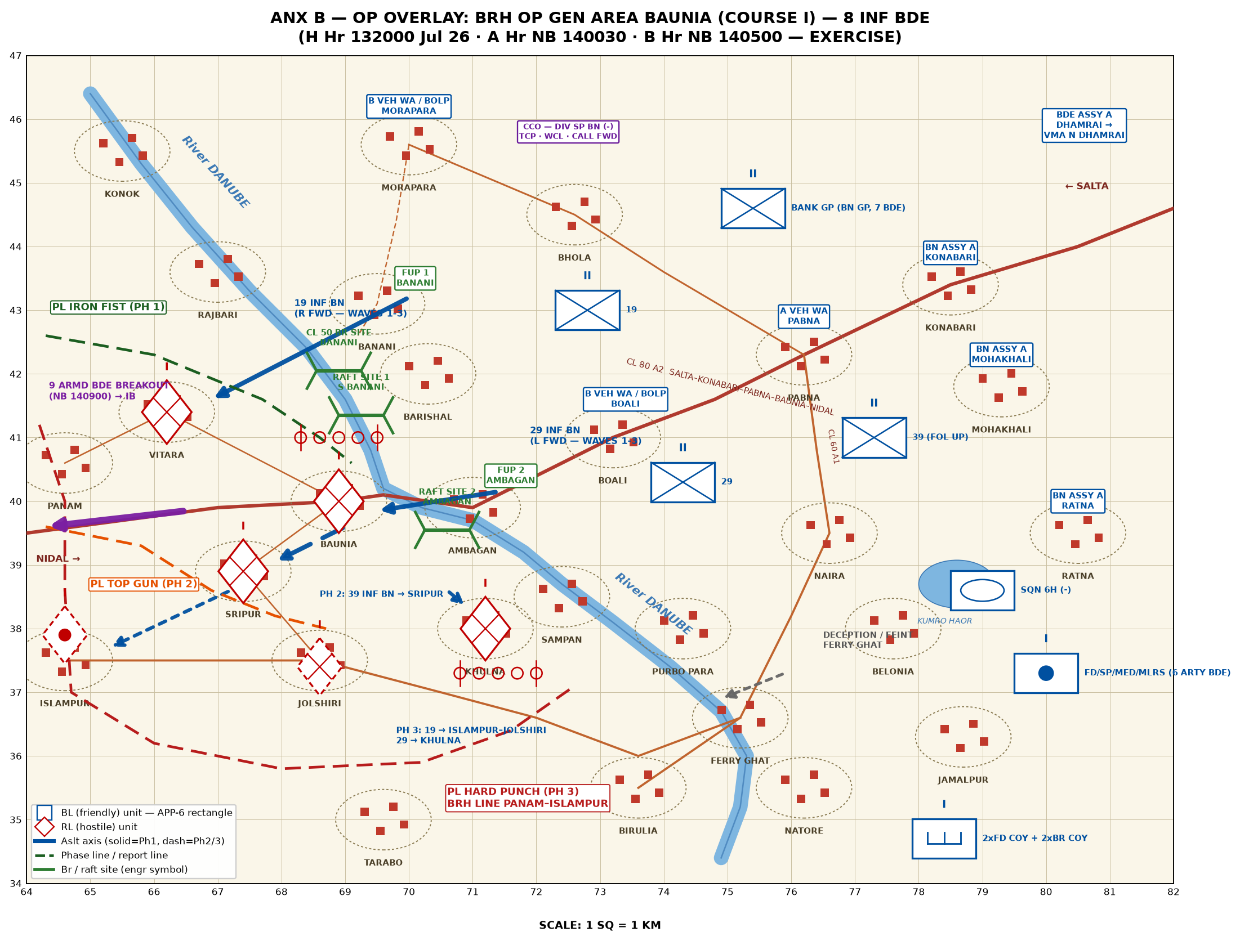
Op overlay — FUPs, X/br/raft sites, aslt axes by ph, PLs IRON FIST / TOP GUN / HARD PUNCH, CCO areas, 9 Armd Bde breakout.

ANX C TO BM'S BRIEF — SKETCH: X AREA / CCO / BANK MASTER GP LAYOUT
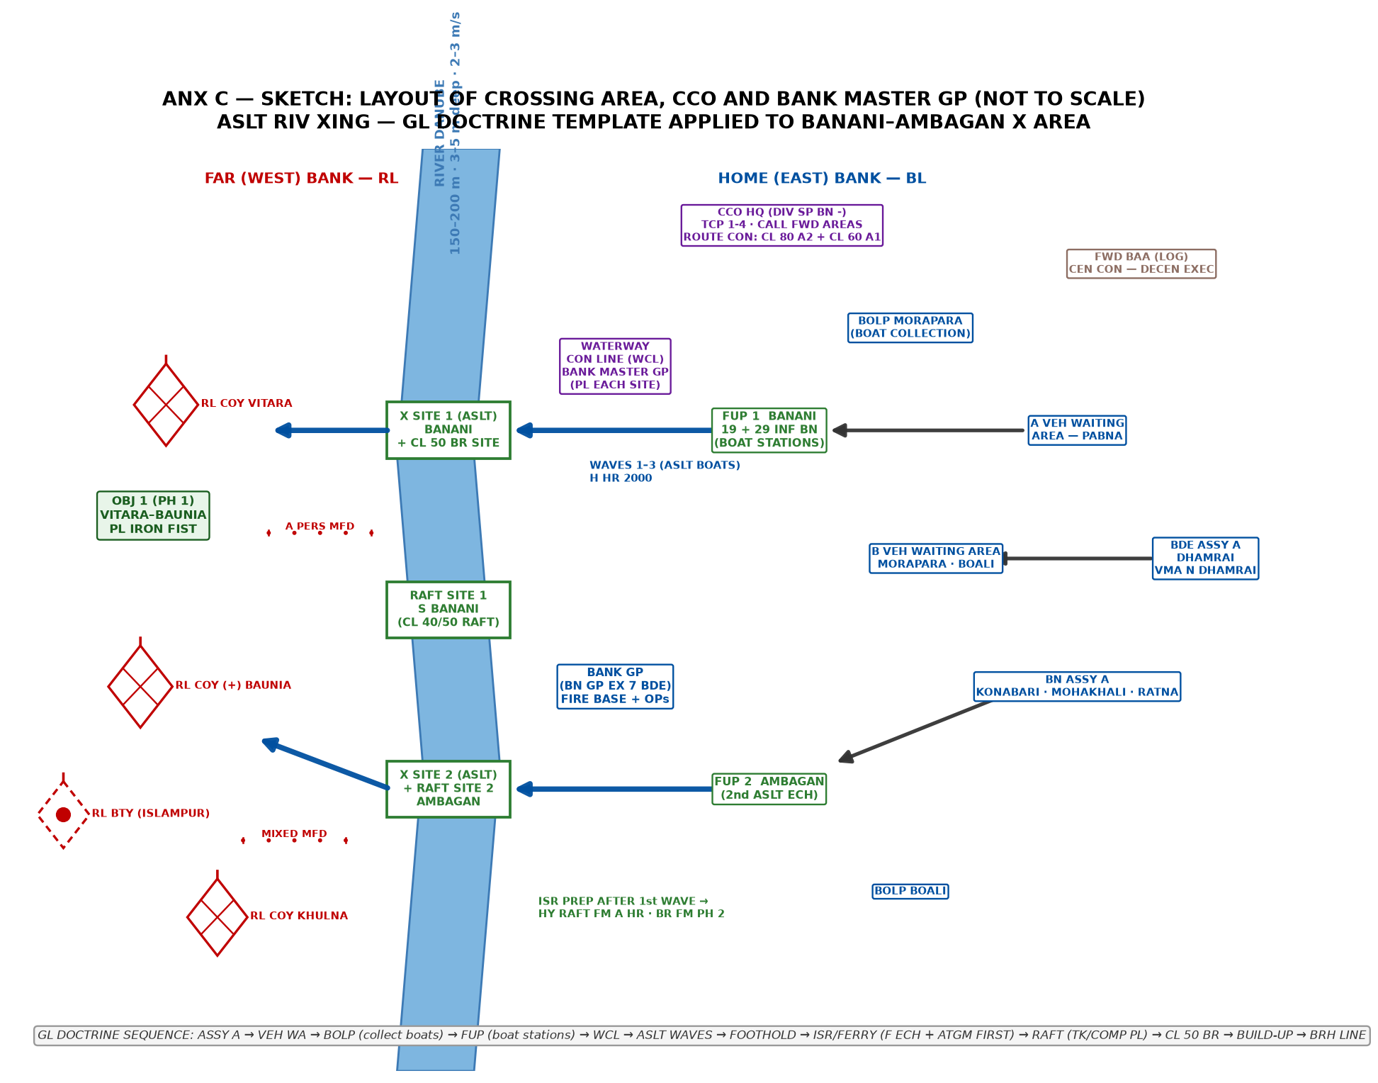
Schematic (not to scale) — GL doctrinal template of the X area applied to BANANI–AMBAGAN.

