
BANGLADESH ARMY
PARA COMMANDO BRIGADE
প্যারা কমান্ডো ব্রিগেড
LOGISTIC DOCTRINE
Sustainment of Special Forces Operations in the Bangladesh Context
FIRST EDITION · 2026
HEADQUARTERS PARA COMMANDO BRIGADE
Jalalabad Cantonment, Sylhet
The information given in this document is not to be communicated, either directly or indirectly, to the press or to any person not authorised to receive it.

Copy No [●] of [●]
Total Pages: 104

The information given in this document is not to be communicated, either directly or indirectly, to the press or to any person not authorised to receive it.
LOGISTIC DOCTRINE
PARA COMMANDO BRIGADE (SPECIAL FORCES)
Sustainment of Special Forces Operations in the Bangladesh Context
FIRST EDITION
By order of the Commander
[Name in Block Capitals]
Brigadier General
Commander
Para Commando Brigade
[●] 2026
Code No [●]
Letter No [●]
Headquarters Para Commando Brigade
Jalalabad Cantonment, Sylhet
Printed in Bangladesh for Bangladesh Army
INTRODUCTION TO THIS DOCTRINE
What is a Logistic Doctrine
Doctrine is the body of fundamental principles by which a force guides its actions: authoritative, but requiring judgement in application. A logistic doctrine states the principles, concepts and procedures by which a force is sustained, that is, how its supplies, equipment, transport, medical and personnel services are planned, provided and controlled, and why. In the Bangladesh Army, logistic doctrine is contained in Operations of War, Army Staff Duties in the Field and Infantry Battalion in Battle, and is taught through the "Q" précis (References A, B, C and F). This publication interprets that doctrine for special forces. It sits below Army regulations, scales and doctrine and the General Staff Policy of the Formation, and above Formation SOPs and administrative orders (Figure 1). The General Staff Policy states what the logistic policy of the Formation is; this doctrine explains how it is applied, and why.
Why it is Needed
Army logistic doctrine was written for divisions and brigades fighting along defined lines of communication. Special forces operate in small, dispersed groups, often beyond those lines, with specialised equipment, at short notice and with severe consequences of failure, in a country where rivers, floods, hills and seasons shape every movement. Research has identified manning, facility and coordination difficulties that bear directly on sustainment. A common doctrine ensures that commanders, staff, logisticians and operators share the same principles and procedures; that every provision is traceable to its doctrinal source (Annex B); that limitations are identified honestly and mitigated; and that the Formation's own consumption evidence builds, over time, into validated scales.
Historical Background
The sustainment of Bangladesh's special operations began in 1971, when the naval commandos of Operation Jackpot and the guerrillas of the Crack Platoon carried their own loads, hid their stores and relied on the people for support. Since 1st Para Commando Battalion was raised in 1992 and HQ Para Commando Brigade in 2016, the Formation has been sustained through Army channels by affiliation, while conducting counter-terrorism operations across the country and serving with the United Nations. This First Edition, a companion to the General Staff Policy, brings Army logistic doctrine, the experience of the Formation and the realities of Bangladesh's terrain and climate into one Logistic Doctrine.
BOARD OF OFFICERS: FIRST EDITION
This First Edition was compiled and edited by a Board of Officers convened by [convening authority] vide [letter No ● dated ●], with the following composition:
Ser | Appointment on Board | Rank, Name and Personal No | Appointment and Unit | Signature
1. | Patron | [●] | Commander, Para Commando Brigade
2. | President | [●] | [Appointment as nominated by the convening authority]
3. | Member | [●] | DAA&QMG, HQ Para Commando Brigade
4. | Member | [●] | Second-in-Command or Quartermaster, 1st Para Commando Battalion
5. | Member | [●] | Second-in-Command or Quartermaster, 2nd Para Commando Battalion
6. | Member | [●] | Staff Captain (A&Q), HQ Para Commando Brigade
7. | Member | [●] | Staff Captain (ST), HQ Para Commando Brigade
8. | Member | [●] | Ordnance representative (Brigade Ordnance Officer / JCO)
9. | Member | [●] | Formation Medical Officer / Field Ambulance representative
10. | Member | [●] | EME representative (affiliated Field Workshop Company)
11. | Member | [●] | ST representative (affiliated ST Company / Battalion)
12. | Member | [●] | Parachute maintenance / aerial delivery representative
13. | Member Secretary | [●] | [Staff officer as nominated]
14. | Advisers (co-opted) | [●] | AHQ (QMG's and MGO Branches, DGMS) and ARTDOC representatives
Note: Names, ranks and personal numbers are to be inserted, and the composition confirmed, by the convening authority.
AMENDMENT RECORD SHEET
Amendment List Number | Date | By Whom Amended | Date of Insertion | Initials
(a) | (b) | (c) | (d) | (e)
TABLE OF CONTENTS
PREFATORY PART
Title Page ii
Introduction to this Doctrine iii
Board of Officers: First Edition iv
Amendment Record Sheet v
Table of Contents vi
List of Figures ix
References x
MAIN TEXT
CHAPTER-I: GENERAL 1
Introduction 1
Scope and Applicability 1
Authority, Hierarchy and Method 2
Structure and Terminology 3
Responsibility and Amendment 3
CHAPTER-II: DOCTRINAL FOUNDATIONS OF LOGISTICS 5
The Nature of Logistics 5
Principles of Administration 5
Essential Ingredients of a Logistic System 6
Lines of Support and the Chain of Replenishment 6
Logistic Control 8
Methods of Replenishment 9
Lessons from Bangladesh Military History 9
CHAPTER-III: SPECIAL FORCES LOGISTICS: PHILOSOPHY AND TENETS 11
Characteristics of Special Forces Operations 11
The Special Forces Truths and Logistics 11
Categories of Support 12
Logistic Tenets of the Formation 12
Endurance and Self-Sufficiency 13
The Logistic Signature 14
Readiness and Logistics 14
CHAPTER-IV: ORGANISATION, COMMAND AND CONTROL OF LOGISTICS 16
Command Status and Logistic Affiliation 16
States of Command for Administration 16
Logistic Staff and Responsibilities 17
The Formation Logistic Cell 18
Logistic Organisation for Deployment 19
Logistic Battle Rhythm 20
CHAPTER-V: LOGISTIC PLANNING AND THE LOGISTIC ESTIMATE 21
Logistic Planning in the Decision Making Process 21
Preparatory Work 21
The Logistic Estimate 22
Planning Calculations 22
Staff Check 22
Logistic Risk 22
Orders and Instructions 22
Rehearsals and Synchronisation 23
CHAPTER-VI: AMMUNITION AND EXPLOSIVES 24
Principles of Ammunition Supply 24
Ammunition Holdings and Replenishment 24
Dumping, Pre-positioning and Caching of Ammunition 25
Special Natures, Demolitions and Explosives 26
Accounting, Safety and Disposal 26
Ammunition in Specific Tasks 27
CHAPTER-VII: RATIONS, WATER, FUEL AND POWER 28
Supply Principles 28
Rations and Nutrition 28
Water 28
Fuel, Oil and Lubricants 29
Electrical Power and Batteries 30
Other Supplies 30
CHAPTER-VIII: EQUIPMENT SUPPORT: ORDNANCE, MAINTENANCE, REPAIR AND RECOVERY 31
Ordnance Support 31
Equipment Maintenance and Repair 31
Re-examination for Special Forces 32
Parachute and Aerial Delivery Equipment 33
Diving and Maritime Equipment 33
CHAPTER-IX: HEALTH SERVICE SUPPORT AND CASUALTY EVACUATION 34
Principles of Medical Support 34
Re-examination for Special Forces 34
Casualty Evacuation Means 35
Disease and Non-Battle Injury 36
Medical Logistics 36
Specific Situations 37
CHAPTER-X: TRANSPORT, MOVEMENT AND DISTRIBUTION 38
Means of Transport 38
Road Movement 38
Air Movement and Air Resupply 39
Inland Water and Maritime Movement 39
Pre-positioning and Caching 40
Local Resources and Porters 40
Movement Control and Distribution 40
CHAPTER-XI: PERSONNEL SERVICE SUPPORT IN THE FIELD 42
Reinforcements 42
Casualty Administration 43
Prisoners of War and Detained Persons 43
Pay, Postal, Welfare and Discipline in the Field 43
CHAPTER-XII: LOGISTICS ACROSS SPECIAL FORCES TASKS AND PHASES 44
Logistics across the Phases of an Operation 44
Defence of the Nation 45
Counter-Terrorism and Hostage Rescue 45
Aid to Civil Power and Internal Security 45
Humanitarian Assistance and Disaster Relief 45
United Nations and Overseas Deployments 46
Training and Exercises 46
CHAPTER-XIII: TERRAIN, CLIMATE AND SEASONAL ANALYSIS 48
The Logistic Geography of Bangladesh 48
Terrain Regions and their Logistic Effects 49
Climate and Seasons 50
Deductions 51
CHAPTER-XIV: LOGISTIC LIMITATIONS, VULNERABILITIES AND MITIGATION 52
Approach 52
Structural Limitations 52
Resource Limitations 52
Infrastructure Limitations 52
Procedural and Information Limitations 53
Environmental Limitations 53
Vulnerabilities 53
CHAPTER-XV: FINANCE, PROCUREMENT, ACCOUNTING AND LEGAL DIRECTIVES 55
Financial Framework 55
Procurement 55
Accounting and Losses 55
Legal Directives Bearing on Logistics 55
CHAPTER-XVI: TRAINING, INFORMATION, READINESS AND DEVELOPMENT 57
Logistic Training 57
Logistic Information and Reporting 57
Logistic Readiness 57
Capability Development 57
Implementation and Review 58
ANNEXES
Annex A: Bibliography and Reference Cross-Index A-1
Annex B: Doctrinal Traceability Matrix B-1
Annex C: Glossary of Abbreviations and Terms C-1
Annex D: Format of the Formation Administrative Order for a Special Forces Operation D-1
Annex E: Logistic Reports and Returns: Formats E-1
Annex F: Pre-positioning and Caching Procedure F-1
Annex G: Mission Load and Mission Package Planning G-1
Annex H: Planning Factors and Calculation Methods H-1
Annex I: Logistic Responsibility Matrix I-1
Annex J: Framework of the Logistic Estimate and Staff Check J-1
Annex K: Formats of the Service Support Paragraph and the Road Movement Order K-1
Annex L: Task Logistic Checklists L-1
Annex M: Terrain and Season Logistic Matrix M-1
Annex N: Logistic Limitations and Mitigation Register N-1
LIST OF FIGURES
Figure 1 – Place of this doctrine in the hierarchy of direction 2
Figure 2 – Lines of support: the Bangladesh Army chain of replenishment and its adaptation for special forces 7
Figure 3 – Options for logistic control and their application to the Formation 8
Figure 4 – Levels of sustainment of a committed special forces element 13
Figure 5 – The limiting commodity sets the endurance of an element (schematic) 14
Figure 6 – Logistic command, control and support relationships of the Formation 18
Figure 7 – The logistic estimate within the Decision Making Process 21
Figure 8 – Ammunition replenishment: doctrinal flow and special forces adaptation 25
Figure 9 – Lines of repair and recovery, with the special forces operational float 32
Figure 10 – Casualty evacuation: the doctrinal chain and special forces adaptation 35
Figure 11 – Turn-round, circuit of activity and terminal time 39
Figure 12 – Methods of resupply available to the Formation and their characteristics 41
Figure 13 – Logistic activity across the phases of a special forces operation 44
Figure 14 – Logistic geography of Bangladesh: terrain regions, major rivers and straight-line distances from Jalalabad Cantonment 49
Figure 15 – Seasonal effects on logistic functions (assessment) 51
Figure 16 – Assessment of principal logistic risks to the Formation (qualitative) 54
REFERENCES
The following documents are referred to in the text as "Reference A", "Reference B" and so on (JSSDM 2022, Paragraph 0231); where a particular paragraph is relied on, it is cited with the reference. Full particulars of these and all other sources, with the paragraphs in which each is cited, are at Annex A.
A. Army Headquarters. Operations of War, Volume 1 (GSTP-0032): in particular Paragraphs 0718 (principles of administration), 0730 (logistics in 1971), 0736 (combat service support information), 0741 (reconstitution) and 0746 (logistic support to unconventional warfare forces). [Bibliography Ser 36]
B. Army Headquarters, Army Training and Doctrine Command. Army Staff Duties in the Field 2006 (ATP-0101), issued under No 1595/28/mt-7 (R&D), January 2017: in particular Paragraphs 0308, 0413-0417 and 0434-0438 and Chapter 5 (Sections 23 to 30). [Bibliography Ser 37]
C. Army Headquarters. Infantry Battalion in Battle (GSTP-2632). Dhaka: Chief of General Staff, September 2008: in particular Paragraph 0626 (methods of replenishment). [Bibliography Ser 38]
D. Administration in the Field: study compilation drawn from Infantry Battalion in Battle, Operations of War and associated précis (principles of administration, combat supplies, medical, EME, reinforcements, administrative areas, route classification and formats of AdminO and Road MovO) [Formation library copy]. [Bibliography Ser 39]
E. Armed Forces Division. Joint Services Staff Duties Manual 2022: Service Writing (JSP-001), Letter No 2402/OPS (PROJ)/SD-2. Dhaka: Prime Minister's Office, AFD, Operations and Plan Directorate, November 2022. [Bibliography Ser 19]
F. "G", "A" and "Q" Précis and Staff Duties Précis (ARTDOC/AHQ-approved editions in force). [Bibliography Ser 40]
G. Army Headquarters, QMG's Branch, Supply and Transport Directorate. Scales of rations (including special and combat rations), POL, water and transport, and supply procedures [No ● dated ●]. [Bibliography Ser 25]
H. Army Headquarters, MGO Branch, Ordnance Directorate. Scales of weapons, equipment and ammunition; controlled stores; ammunition storage and accounting instructions; war reserve policy [No ● dated ●]. [Bibliography Ser 27]
J. Army Headquarters, MGO Branch, EME Directorate. Maintenance, repair, recovery, inspection and technical instructions [No ● dated ●]. [Bibliography Ser 28]
K. Directorate General Medical Services. Instructions on medical support in the field, casualty evacuation, medical stores, controlled drugs, preventive medicine and special medical standards for parachuting and diving [No ● dated ●]. [Bibliography Ser 29]
L. Defence Services Regulations: Financial Regulations Part I (Army and Air Force). Controller General Defence Finance, cgdf.portal.gov.bd (accessed 2 October 2026). [Bibliography Ser 22]
M. Public Procurement Act, 2006 (Act No 24 of 2006) and the Public Procurement Rules in force. [Bibliography Ser 4]
N. The Explosives Act, 1884 (Act No IV of 1884) and The Explosive Substances Act, 1908 (Act No VI of 1908), with the rules made thereunder. [Bibliography Ser 2]
P. Army Headquarters, General Staff Branch, Military Operations Directorate. Policy and instructions on employment of Para Commando forces [No ● dated ●]. [Bibliography Ser 23]
Q. HQ Para Commando Brigade. General Staff Policy: Employment, Training, Administration and Sustainment of Special Forces, First Edition, 2026 (in particular Chapters III, VI and IX). [Bibliography Ser 47]
R. HQ Para Commando Brigade. Standing Orders and SOPs (current) [No ● dated ●]. [Bibliography Ser 48]
S. Ministry of Disaster Management and Relief. Standing Orders on Disaster, 2019. Dhaka: MoDMR, 2019. [Bibliography Ser 13]
T. United Nations. Manual on Policies and Procedures concerning the Reimbursement and Control of Contingent-Owned Equipment of Troop/Police Contributors Participating in Peacekeeping Missions (COE Manual) (latest edition). [Bibliography Ser 57]
U. Geneva Conventions I-IV of 12 August 1949 and Additional Protocols I and II of 8 June 1977 (in particular the protection of medical units and transports and the maintenance of prisoners of war). [Bibliography Ser 60]
V. Army Regulations (Rules) and Army Regulations (Instructions), as amended. [Bibliography Ser 21]

CHAPTER-I
GENERAL
Introduction
0101. Aim. The aim of this publication is to lay down the doctrine by which logistic support is planned, provided, controlled and sustained for the Para Commando Brigade (the Formation) in peace, crisis and war, within the framework of Bangladesh Army doctrine and directives, the logistic limitations of the Formation and the terrain and climate of Bangladesh.
0102. Background. Bangladesh Army logistic doctrine, as set out in Operations of War, Army Staff Duties in the Field and Infantry Battalion in Battle and taught through the administration in the field précis (References A, B, C and D), was written principally for divisions and brigades fighting along defined lines of communication and maintained through divisional and brigade administrative areas. Special forces operate in small, dispersed and often clandestine groups, frequently beyond those lines, with equipment and consumption patterns that differ from those of conventional units. The General Staff Policy of the Formation states the "Q" policy (Reference Q, Chapter IX); this doctrine explains how that policy is to be applied, and why.
0103. Nature of this Publication. This publication is doctrine. It states fundamental principles and the reasoning behind them; it is authoritative but requires judgement in application. It does not replace Army regulations, AHQ instructions, scales or the technical instructions of the Services. Where any provision of this doctrine appears to conflict with them, they prevail, and the conflict is to be reported to HQ Para Commando Brigade (DAA&QMG) for amendment of this publication.
Scope and Applicability
0104. Scope. This doctrine covers all logistic functions as understood in the Bangladesh Army: supply, transport, ordnance, equipment maintenance, repair and recovery, movement and works ("Q"), together with the medical and personnel service support ("A" in the field) needed to sustain the Formation. It applies across the range of tasks of the Formation: defence of the nation, counter-terrorism and hostage rescue, aid to civil power, humanitarian assistance and disaster relief, United Nations and overseas deployments, and training.
0105. Applicability. This doctrine applies to HQ Para Commando Brigade, the units and elements under its command, all elements attached to it and every Special Operations Task Group (SOTG) generated by it. Logistic units and installations that support the Formation by affiliation are requested to apply it in so far as it concerns that support.
0106. Exclusions. This doctrine does not lay down scales of rations, ammunition, POL, equipment or transport; these are authorised by AHQ (References G and H). It does not repeat the technical procedures of the Ordnance, EME and Medical Services, which remain governed by their directorates (References J and K). Classified operational detail is contained in Formation SOPs (Reference R).
Authority, Hierarchy and Method
0107. Place in the Hierarchy of Direction. This doctrine is subordinate to the law, Government orders, Army regulations and AHQ instructions, to Bangladesh Army doctrine and to the General Staff Policy of the Formation, and is superior to Formation SOPs, administrative orders and unit standing orders (Figure 1). Full particulars of every source are at Annex A.
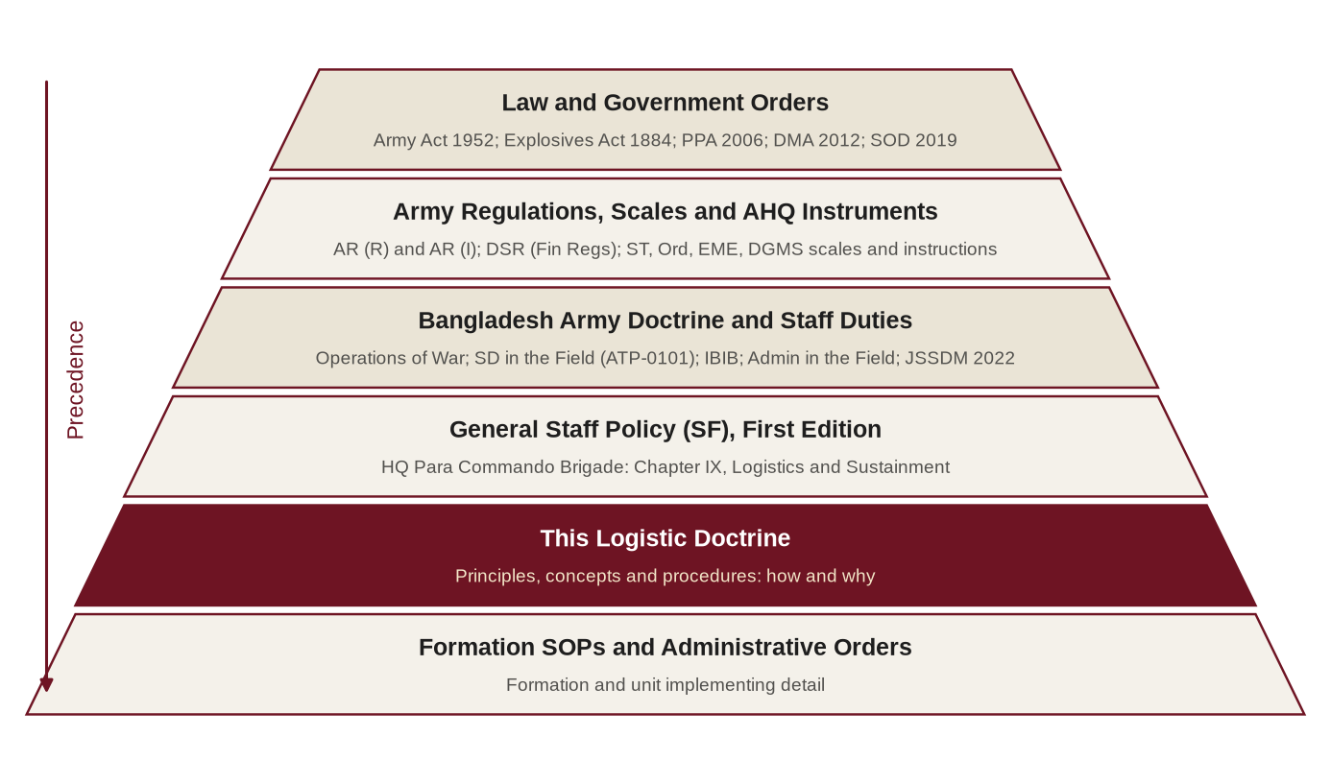
Figure 1: Place of this doctrine in the hierarchy of direction
0108. Method of Development: Re-examination. Every provision of this doctrine has been derived by the following method, so that the reasoning can be checked and challenged:
a. The relevant Bangladesh Army principle or procedure was identified, with its source paragraph.
b. It was tested against the characteristics of special forces operations (Chapter III).
c. It was tested against the terrain and climate of Bangladesh (Chapter XIII).
d. It was tested against the logistic limitations of the Formation (Chapter XIV).
e. It was tested against the legal and financial directives in force (Chapter XV).
f. It was then retained unchanged where it holds, adapted where special forces conditions differ, or supplemented only where Bangladesh Army doctrine is silent, drawing on allied practice for reference only. The resulting traceability matrix is at Annex B.
0109. Status of Allied Doctrine. Allied and foreign doctrine is cited for reference and professional study only. It is used only where Bangladesh Army doctrine is silent, and never to override it.
0110. Treatment of Scales and Planning Figures. No scale, rate or planning figure is stated in this doctrine unless it is taken from a cited Bangladesh Army source or a published standard. Where a figure is required but not authorised, it is shown as [●] and is to be inserted from the AHQ scale in force or from the Formation's own validated consumption data (Chapter XVI). Planning assumptions made in the absence of authorised figures are to be stated explicitly in the logistic estimate and validated after the operation or exercise.
Structure and Terminology
0111. Structure. Chapters I to III state the doctrinal foundation and the logistic philosophy of the Formation. Chapters IV and V deal with organisation, command and control and planning. Chapters VI to XI deal with the logistic functions in turn. Chapter XII applies them to the tasks and phases of special forces operations. Chapters XIII and XIV analyse terrain, climate and the limitations of the Formation. Chapter XV states the financial and legal directives, and Chapter XVI deals with training, information, readiness and development.
0112. Terminology. Abbreviations and terms follow Bangladesh Army usage and JSSDM 2022 (Reference E); a glossary is at Annex C. Two terms need care. In Bangladesh Army usage "administration" embraces both personnel ("A") and logistic ("Q") matters; and "maintenance" means both the sustainment of a force in the field (as in "maintenance of troops") and the upkeep and repair of equipment. Where the meaning is not clear from the context, this doctrine uses "sustainment" for the former and "equipment maintenance" for the latter.
0113. Definitions. For the purpose of this doctrine:
a. Logistics. The planning and execution of the movement and sustainment of forces: supply, transport, equipment support, movement, works, and associated medical and personnel services.
b. Combat Supplies. Ammunition, POL and rations, being the commodities whose supply to forward troops is the principal concern of the logistic staff (Reference B, Paragraph 0437). Within the Formation, water and batteries are planned as combat supplies (Paragraph 0708 and Paragraph 0716).
c. Common-User Item. An item provided through normal Army channels in accordance with establishment and scales (Reference Q).
d. Special Forces-Peculiar Item. An item provided on special scales authorised by AHQ for the Formation and managed by HQ Para Commando Brigade.
e. Days of Self-Sufficiency (DOS). The period for which an element can operate on the stocks it holds, without resupply, for a stated commodity and rate of consumption.
f. Limiting Commodity. The commodity whose holding, divided by its rate of consumption, gives the lowest DOS and therefore sets the endurance of an element.
g. Mission Package. A pre-assembled, inspected and documented set of equipment and stores held ready for a defined task at a defined notice to move.
h. Cache. A concealed store of supplies or equipment placed in advance for later recovery by a designated element.
j. Logistic Signature. The observable indicators of logistic activity from which an adversary or observer may deduce the presence, strength, intentions or timing of a force.
k. Forward Operating Base (FOB). A secured location from which an SOTG mounts, supports and recovers its teams, holding the stocks and services that a forward brigade administrative area would hold for a brigade.
Responsibility and Amendment
0114. Sponsor. The sponsor of this doctrine is the DAA&QMG (DQ), HQ Para Commando Brigade. It is issued by order of the Commander.
0115. Review and Amendment. This doctrine is to be reviewed annually and after every major operation or exercise. Amendments are to be issued and recorded in accordance with JSSDM 2022 (Reference E, Paragraph 0278).
0116. Proposals. Any officer may propose an amendment through the chain of command. Proposals are to be supported by evidence, ideally after-action reviews and consumption data, and are to state the doctrinal source that the amendment retains, adapts or supplements.
0117 – 0199. Reserved.

CHAPTER-II
DOCTRINAL FOUNDATIONS OF LOGISTICS
The Nature of Logistics
0201. Logistics and War. The administrative arrangements in every campaign must permit the implementation of the tactical plan; the complexity and quantity of modern equipment, the speed of movement of modern armies and the vulnerability of administrative installations are complicating factors (Reference D). Logistics therefore sets the limit of what is operationally possible: a plan that cannot be sustained is not a plan.
0202. Logistics and Special Forces. Special forces are small, but their logistics are not simply small; they are different. Volumes are lower, but the items are more specialised, the distances greater, the means of delivery more demanding and the consequences of failure more severe. A single unserviceable radio, a lost resupply bundle or an aircraft that cannot fly can end a special operation. The failure of the American hostage rescue attempt in Iran in 1980, aborted at its intermediate staging site when too few serviceable helicopters remained to continue, is the classic illustration that special operations hinge on mobility, maintenance and redundancy.
0203. Friction. Logistics is the function most exposed to friction: the accumulation of small difficulties (weather, breakdown, delay, error) that makes the simple difficult in war. The Formation's logistic system is to be designed to absorb friction through foresight, redundancy and simplicity rather than to assume its absence.
Principles of Administration
0204. The Principles. Bangladesh Army doctrine lays down the principles of administration that form the basis of sound administration (Reference A, Paragraph 0718; Reference D). Each is stated in its doctrinal sense, followed by its application to special forces:
a. Foresight. Doctrinally, foresight means anticipating the course of operations, forecasting the requirements of men and materiel, and planning their movement and maintenance; ensuring that the tactical plan is not hindered by the lack of an essential item that could have been foreseen; keeping in touch with present developments and future trends; and anticipating the difficulties that may upset the logistic plan (Reference D). For the Formation, foresight begins at the warning order, not at the order; it extends through extraction and reconstitution; and it requires stocks, packages and agreements to exist before the crisis, because they cannot be created after it.
b. Economy. Doctrinally, economy means the most efficient use of available manpower, materiel and movement resources, achieved through care and maintenance of vehicles and equipment, correct positioning of repair facilities, efficient recovery, and maximum use of local resources and improvisation (Reference D). For the Formation, economy is not parsimony. Special forces-peculiar items are scarce, costly and slow to replace; economy is achieved by standardisation, disciplined care and maintenance, strict accountability and, above all, by not loading the operator with anything the mission does not need. Weight is the economy of the soldier.
c. Flexibility. Doctrinally, flexibility is the ability to provide adequate administrative support under changing conditions, achieved through dispersion, balanced support, secure communications, delegation of control with alternate headquarters, and choice of movement agencies by land, water and air (Reference D). For the Formation, flexibility means more than one means of resupply for every committed element, modular packages that can be reconfigured, alternate caches and delivery points, and delegation of logistic authority to the SOTG commander.
d. Simplicity. Doctrinally, simplicity applies to the plan, the organisation and the procedure (Reference D). For the Formation, simplicity means standard load plans, standard formats and a small number of robust drills that work under stress, at night and in poor communications.
e. Cooperation. Doctrinally, cooperation is required between all branches and services and with civil agencies (Reference D). For the Formation, cooperation is decisive: the Formation depends on the Army logistic system, Army Aviation, the Bangladesh Air Force, the Bangladesh Navy, the police and the civil administration for much of its sustainment.
0205. Further Considerations. Bangladesh Army teaching also emphasises the integration of logistic planning with operational planning from the outset, improvisation when the system is disrupted, and continuity of support through every phase of an operation (References F and D). Logistic planning must be closely integrated with operational planning right from the beginning (Reference D).
0206. Relationship between the Principles. Foresight is the most important of the principles, because the others depend on it. The principles also pull against one another: flexibility (spare means, redundant stocks) costs economy; tailoring a package to a mission costs simplicity; and dispersion for protection costs control. The Commander resolves these tensions in each plan. This doctrine resolves them, as a default, in favour of foresight and flexibility for committed special forces elements, and in favour of economy and simplicity in the base.
Essential Ingredients of a Logistic System
0207. The Ingredients. A logistic system must be able to switch from peace to war with the least dislocation; be designed for the strategic requirement; be economical; have its installations within easy turn-round of second-line transport; provide continuous support; and be simple to control (Reference D).
0208. Re-examination for the Formation.
a. The Formation is at readiness in peace. Its logistic system must therefore be the same in peace and in operations, so that there is no switch to make: units are to train with the procedures, formats and packages they will use on operations.
b. The strategic requirement of the Formation is national: it may be committed anywhere in Bangladesh, at sea, or overseas. Its system must support deployment over the whole country at short notice.
c. The test of "easy turn-round of second-line transport" applies equally to aircraft and boats. Where a committed element is beyond road turn-round, the second line is the aircraft or the boat, and the turn-round is calculated for that means (Chapter X).
d. Continuous support to dispersed teams is achieved not by continuous delivery, which would create a signature, but by self-sufficiency to a declared endurance, scheduled resupply and an emergency resupply capability.
Lines of Support and the Chain of Replenishment
0209. The Chain of Replenishment. In Bangladesh Army doctrine the chain of replenishment has three stages: within the Communication Zone under AHQ control; from the Communication Zone to the division, by Army third-line and divisional second-line transport; and from the division to the fighting troops, by unit first-line transport collecting from commodity points in the divisional administrative area. The chain varies with location, distance, mode of transport, roads, the state of transport and enemy interference (Reference D). Figure 2 shows the chain and its adaptation for the Formation.
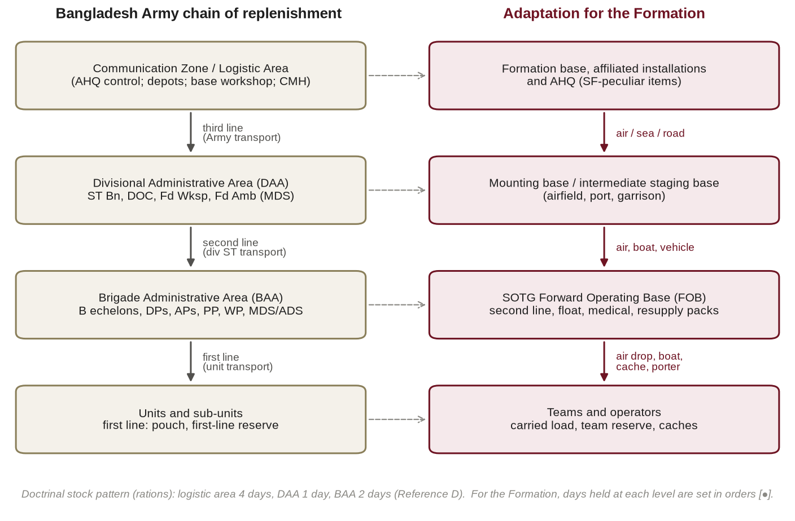
Figure 2: Lines of support: the Bangladesh Army chain of replenishment and its adaptation for special forces
0210. Administrative Areas. Logistic units and echelons are grouped in administrative areas: the Communication Zone and logistic area installations; the Divisional Administrative Area (DAA); the Brigade Administrative Area (BAA); and, where the tactical situation requires, a Forward BAA formed by detachments of affiliated logistic units under command of the brigade (Reference D; Reference B, Section 24). The BAA normally comprises unit B echelons, the Main Dressing Station (MDS), the Supply and Transport (ST) Company, the Field Workshop, the Field Post Office (FPO), the PW cage, a water point and an Ordnance store platoon; the Forward BAA comprises B echelons, an Advanced Dressing Station (ADS), delivery points holding combat supplies, a Forward Repair Team (FRT), an FPO, a PW collection point and an Ordnance store element (Reference D).
0211. Modernisation. Bangladesh Army logistic organisation is being modernised around a Central Logistic Base, Forward Logistic Bases and Division Maintenance Areas, and has been exercised in logistic command post and field training exercises. The Formation is to align its terminology and procedures with this structure as it is promulgated by AHQ.
0212. Distribution of Stocks. Doctrinally, rations are held in the order of two days in the BAA, one day in the DAA and four days in the logistic area; ammunition is held as first and second line in the BAA and one second-line lift in the DAA (Reference D). For the Formation, the "first line" is largely carried by the operator beyond the reach of any BAA; the SOTG FOB performs the function of the BAA; and the depth of stocks is held at the Formation base or in affiliated installations.
0213. Capacity of Logistic Sub-units. Doctrine notes that one platoon of an ST Company can operate three commodity points; that a Field Workshop Company can operate two Forward Repair Teams; and that a Field Ambulance can deploy one MDS and three ADS (Reference D). The deduction for the Formation is important: when it is dispersed to more locations than these sub-units can serve, which is the normal condition of special forces operations, ground-based conventional support cannot reach every element. The shortfall must be met by self-sufficiency, air and water delivery and caches (Chapter X).
0214. The Advanced Base. Doctrine observes that an advanced base may not be necessary in Bangladesh, because depots are located near the frontiers and the shortage of strategic depth keeps distances short (Reference D). This holds for conventional forces in Bangladesh. It does not hold for special forces operating in adversary depth, on offshore islands or overseas, where the function of the advanced base reappears as a forward mounting base or intermediate staging base (Paragraph 0417).
Logistic Control
0215. Options for Logistic Control. Doctrine recognises three options for logistic control (Figure 3) (Reference D; Reference B, Paragraph 2409):
a. Centralised Control and Centralised Execution. Logistic units remain under divisional control; the BAA forms part of the DAA, and the brigade draws on divisional commodity points.
b. Centralised Control and Decentralised Execution. Detachments of affiliated logistic units are sent forward under command of the brigade as a Forward BAA, which receives orders on administrative matters from brigade headquarters, while the BAA remains in the DAA under divisional control.
c. Decentralised Control and Decentralised Execution. Where a brigade operates independently, or at a distance from the DAA (doctrine cites the example of a brigade 130 km from the DAA), logistic units are placed under command of the brigade and receive orders from brigade headquarters; an officer, normally the Staff Captain, coordinates the defence and movement of the BAA; and if the brigade operates on a separate line of communication it may draw directly on third-line installations. The division normally retains at least one-third, and ideally two-thirds, of its logistic units under its own control (Reference D).
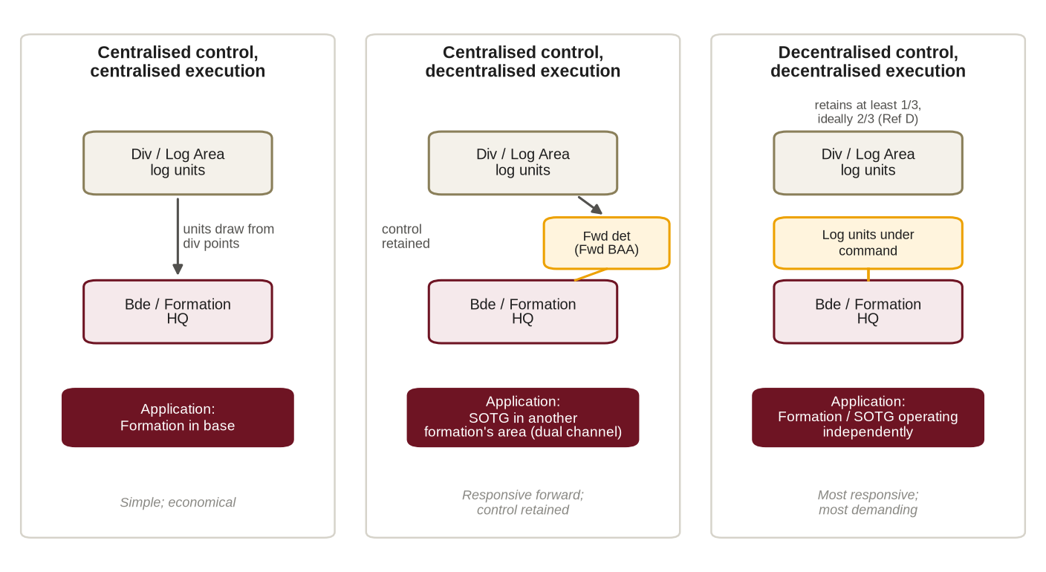
Figure 3: Options for logistic control and their application to the Formation
0216. Application to the Formation. The Formation must be able to operate under all three options and to change between them during an operation:
a. In Base. Centralised: common-user support is drawn from the station and the affiliated formation; special forces-peculiar support is controlled by HQ Para Commando Brigade.
b. SOTG within Another Formation's Area. A dual channel: common-user commodities are drawn from the supported formation (normally under command for daily maintenance, Paragraph 0404), while special forces-peculiar items, specialist personnel and technical control remain in the Formation channel.
c. Formation or SOTG Operating Independently. Decentralised: logistic detachments are placed under command, a FOB is established, and the Formation draws directly on third-line installations or AHQ for its requirements.
d. Statement in Orders. The option in force is to be stated in every administrative order (Annex D, paragraph 3).
Methods of Replenishment
0217. Push and Pull. Doctrine distinguishes "push" replenishment, in which supplies are sent forward automatically on the basis of forecast consumption, from "pull" replenishment, in which they are sent on demand (Reference C, Paragraph 0626). The principle that ammunition is passed automatically from rear to front is a push principle (Reference D).
0218. Push by Plan, Pull by Exception. For committed special forces elements the Formation applies push by plan and pull by exception:
a. Planned requirements are pushed as pre-assembled packages, on a schedule or into caches, without waiting for a demand that may be impossible or insecure to transmit.
b. Unforeseen requirements are pulled by a short, standard request (Annex E) against pre-packed emergency resupply packages held at the FOB or Formation base.
c. Push risks waste and a predictable signature; pull risks delay and dependence on communications. The SOTG logistic plan is to state which commodities are pushed, on what schedule, and how the schedule is varied to avoid a pattern.
0219. Methods of Delivery. Doctrine provides for delivery to commodity points from which units collect in their own transport (Reference D). The Formation also uses throughput delivery direct to the user by air or water; pre-positioning and caching (Annex F); and local procurement under the conditions at Paragraph 0706.
Lessons from Bangladesh Military History
0220. The Liberation War: Special Operations. The naval commandos of Operation Jackpot in August 1971 were trained outside the country, infiltrated overland with their limpet mines and equipment, and depended on guides, safe houses and local support to reach their targets; the guerrillas of the Crack Platoon in Dhaka were armed and sustained through an urban network of sympathisers and hidden stores. In both, the logistic burden was carried by the operator and by the people: small loads, concealment, caches and local resources. These remain the elements of logistic support to unconventional forces in current doctrine (Reference A, Paragraph 0746).
0221. The 1971 Campaign. In 1971 the Indian forces operated on exterior lines with stocks for about one month, while the Pakistani forces on interior lines stocked their forward positions with seven to fifteen days of ammunition and rations and their rear areas with fifteen to thirty days (Reference A, Paragraph 0730). Stocked positions could hold, but positions that were bypassed and isolated could neither manoeuvre nor be replenished, and the side able to cross rivers and bypass strongpoints set the tempo of the campaign. The lesson for the Formation is that in the delta, mobility across water and by air, not static stockpiles, decides sustainment.
0222. Internal Security and Counter-Terrorism. Operations in the Chittagong Hill Tracts have sustained dispersed camps by combinations of road convoy, waterborne transport, porters and helicopters, with heavy seasonal effects. The Formation's counter-terrorism operations since 2016 have shown that domestic tasks place a premium on rapid movement over long distances at short notice and on sustainment by the host garrison at the incident site.
0223. Deductions. From the doctrine and history in this chapter the following deductions underpin the rest of this publication:
a. Bangladesh Army principles of administration apply in full to the Formation, but their application differs (Paragraph 0204).
b. The Formation must be able to operate under centralised, dual-channel and decentralised logistic control (Paragraph 0216).
c. Conventional ground-based support cannot reach every dispersed special forces element; self-sufficiency, air, water and caches fill the gap (Paragraph 0213).
d. In Bangladesh, mobility across water and by air is the decisive enabler of sustainment.
e. Support to special forces depends on people (operators, logisticians, guides and partners) as much as on stocks.
0224 – 0299. Reserved.

CHAPTER-III
SPECIAL FORCES LOGISTICS: PHILOSOPHY AND TENETS
Characteristics of Special Forces Operations
0301. Characteristics and their Logistic Implications. The characteristics of special forces operations that drive logistic requirements are:
Ser | Characteristic | Logistic Implication
1. | Small, self-contained teams | Carrying capacity is small; weight is the binding constraint on every logistic decision.
2. | Dispersion over wide areas | Many delivery points; the capacity of conventional logistic sub-units is exceeded (Paragraph 0213).
3. | Distance and depth | Resupply by air, water or cache; long turn-round times; extended casualty evacuation times.
4. | Clandestinity and low signature | Logistic activity is an indicator to the adversary; resupply windows and methods are constrained.
5. | Wide range of duration | From hours (counter-terrorism) to weeks (special reconnaissance); endurance must be planned by commodity.
6. | High-technology, low-density equipment | Specialist maintenance, batteries and spares; few technicians; repair by replacement from a float.
7. | Joint and interagency dependence | Air, sea, police and civil support must be arranged and agreed in advance.
8. | Short notice | Pre-assembled packages, pre-positioned stocks and standing arrangements.
9. | High consequence of failure | Redundancy in critical items and in means of resupply and evacuation.
10. | Strategic and legal sensitivity | Strict accountability for weapons, ammunition, funds and every expenditure.

The Special Forces Truths and Logistics
0302. Logistic Reading of the Truths. The Formation has adopted the special forces truths as guiding tenets (Reference Q). Their logistic meaning is:
a. Humans are More Important than Hardware. Invest first in trained logisticians and in operators who can sustain themselves; equipment without trained users and maintainers is a liability.
b. Quality is Better than Quantity. Hold fewer items of higher quality, and maintain them properly; do not dilute scarce funds across too many types.
c. Special Forces cannot be Mass-Produced. Reinforcements cannot be drawn from the general pool (Chapter XI); casualties and losses of specialist equipment must be anticipated.
d. Competent Special Forces cannot be Created after Emergencies Occur. Stocks, packages, agreements and trained logisticians must exist before the crisis.
e. Most Special Operations Require Non-Special Forces Assistance. The Formation depends on the Army logistic system and on joint and civil partners; the interfaces must be defined in doctrine and practised in training.
Categories of Support
0303. Common-User and Special Forces-Peculiar Support. The Formation receives two categories of support (Reference Q), a distinction also drawn in allied doctrine:
a. Common-User Support. Rations, POL, standard ammunition, standard vehicles, general medical support, general stores and works are provided through normal Army channels in accordance with establishment and scales (References G and H).
b. Special Forces-Peculiar Support. Free-fall and specialist parachutes, oxygen equipment, diving equipment, special-purpose weapons and optics, night-vision and thermal devices, specialist demolition and breaching stores, specialist communications and special-purpose boats are provided on special scales authorised by AHQ, recorded in the Formation special forces-peculiar equipment register and managed by the DQ.
c. Items of Doubtful Category. Items whose category is in doubt are to be decided by the DQ in consultation with the AHQ directorate concerned, and recorded.
0304. The Dual Channel. The consequence is that the Formation operates two logistic channels at once: the Army channel for common-user items, normally through the affiliated or supported formation, and the Formation channel for special forces-peculiar items (Figure 6). The two must be coordinated by a single logistic staff, the Formation Logistic Cell (Paragraph 0413).
Logistic Tenets of the Formation
0305. The Tenets. The Formation applies the following logistic tenets, each derived from a Bangladesh Army principle (Paragraph 0204):
a. Integrated from the Outset. Derived from foresight and integration. The DQ is a member of the planning group from receipt of the warning order; no course of action is recommended until its supportability has been assessed.
b. Mission-Tailored and Modular. Derived from flexibility and economy. Packages are built from standard modules (Annex G) and tailored to the task, the terrain and the season.
c. Self-Contained to a Declared Endurance. Derived from foresight. Every committed element deploys with a stated DOS for each commodity, and the plan identifies the limiting commodity (Paragraph 0307).
d. Light Forward, Robust Rear. Derived from economy and flexibility. The minimum is carried forward; depth is held at the FOB and the Formation base and delivered by resupply.
e. Signature-Disciplined. Derived from flexibility (secure communications) and from the tactical requirement for security. Logistic actions are planned as part of operations security (Paragraph 0309).
f. Redundant in Critical Items. Derived from flexibility. Two means of resupply, two means of requesting it, and spares for mission-critical components.
g. Jointly Enabled. Derived from cooperation. Air, sea, police and civil support are arranged by standing agreement wherever possible, not negotiated afresh in each crisis.
h. Accountable. Derived from economy and from the law. Every weapon, round, item and Taka is accounted for, in operations as in peace.
j. Continuous through Reconstitution. Derived from continuity. Every plan includes extraction, recovery and reconstitution (Reference A, Paragraph 0741).
Endurance and Self-Sufficiency
0306. Levels of Sustainment. Endurance is built in four levels (Figure 4):
a. Level 1: the Individual. What the operator carries: the fighting load and the sustainment items for the period until the first planned resupply.
b. Level 2: the Team. Team stores carried or cached, and scheduled or emergency resupply; the team commander manages consumption.
c. Level 3: the SOTG. Stocks, services and repair at the FOB; the SOTG logistic element plans and executes resupply to teams.
d. Level 4: the Formation. Formation stocks, the operational float and the affiliated logistic installations; the Formation Logistic Cell sustains the SOTG.
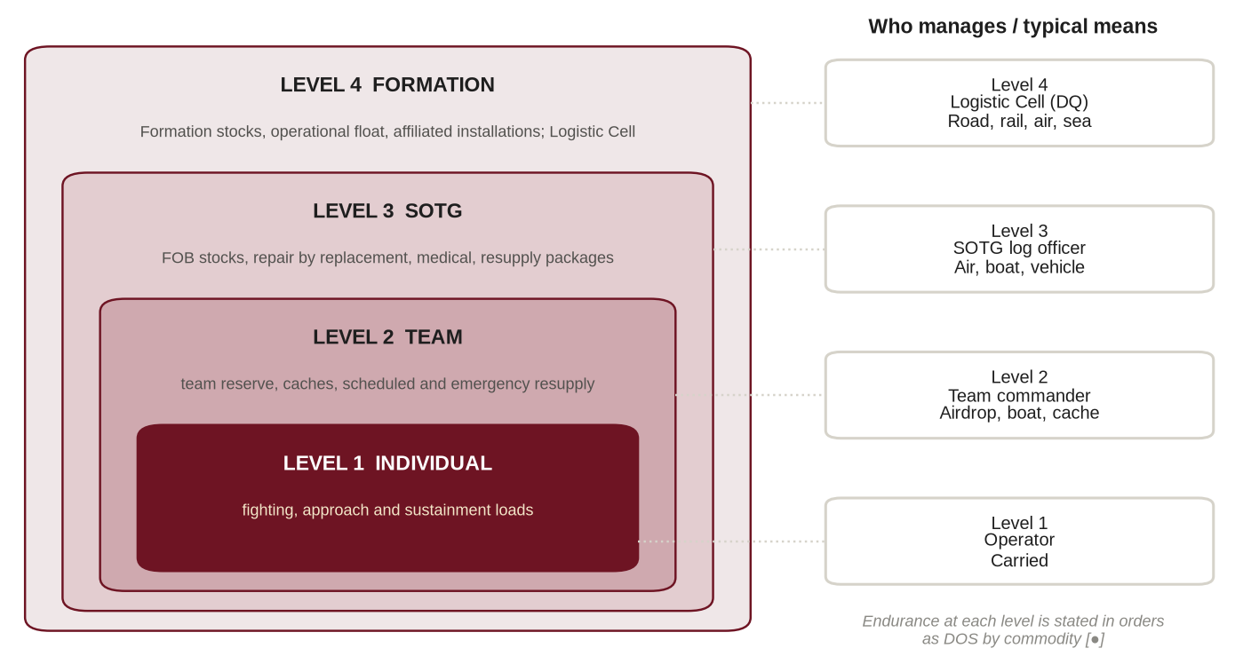
Figure 4: Levels of sustainment of a committed special forces element
0307. Days of Self-Sufficiency and the Limiting Commodity. Research in the Formation has identified the requirement for small groups to operate for up to two weeks without resupply. The DOS required for each task is to be set by the Commander in the operation order, not assumed. The endurance of an element is determined by the commodity that runs out first (Figure 5): for each commodity, DOS equals holding divided by daily consumption, and the endurance of the element is the lowest of these values (Annex H). It follows that:
a. Carrying more of a commodity that is not limiting adds weight without adding endurance; loads are to be balanced so that the DOS of the principal commodities are similar.
b. In Bangladesh conditions the limiting commodity is often not food but batteries, water purification consumables or, after a casualty, medical stores; after contact it is ammunition.
c. The limiting commodity is to be stated in every SOTG logistic plan and reported in every logistic report (Annex E).
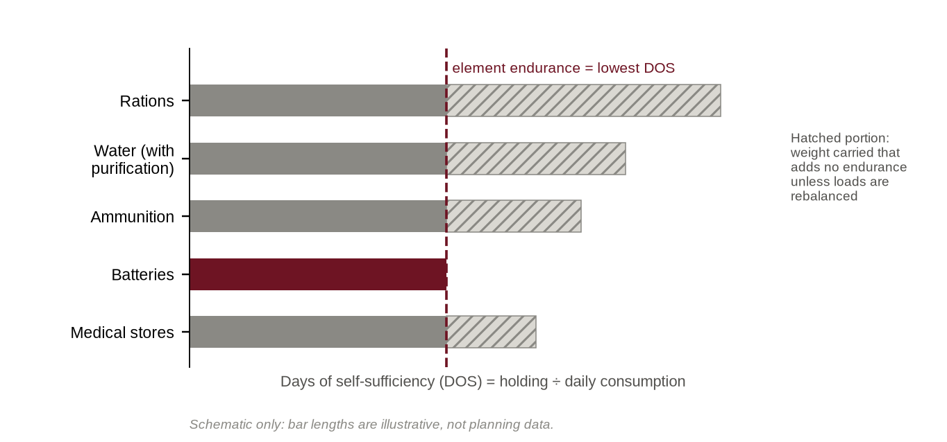
Figure 5: The limiting commodity sets the endurance of an element (schematic)
0308. Weight as the Binding Constraint. The load carried by the operator is the most important logistic variable in special forces operations: it governs speed, stealth, endurance, injury and the ability to fight. Loads are planned in three categories, the fighting load, the approach load and the sustainment load (Annex G). Load limits are to be set on medical advice and Formation evidence [●]; where a mission requires more, the excess is to be moved by other means (vehicle, boat, aircraft, porter or cache) rather than by the operator, or the Commander is to accept the risk explicitly.
The Logistic Signature
0309. Logistic Activity as an Indicator. Logistic activity reveals intention. Indicators include unusual procurement or local purchase; changes in drawing of ammunition, rations or fuel; vehicle, boat and aircraft movement; activity at airfields and jetties; packaging and waste left behind; caches and their servicing; and logistic radio or telephone traffic.
0310. Measures. To control the logistic signature:
a. Logistic preparation for an operation is to be planned within the operations security and cover plan of the operation.
b. Stores are to be drawn from normal sources at normal times wherever possible; unusual demands are to be covered by routine training activity.
c. Pre-positioning is to be completed before the operation, under cover of training or routine movement where appropriate.
d. All packaging and waste is to be carried out of operational areas; nothing that identifies the Formation is to be left behind.
e. Logistic reports are to use brevity codes and authorised means only (Annex E).
f. In domestic counter-terrorism, vehicles and stores at an incident site are to be screened from media and public view.
Readiness and Logistics
0311. Mission Packages. Elements held at readiness in accordance with the General Staff Policy (Reference Q, Chapter IV) are to hold mission packages for their designated tasks: complete, inspected, documented (including manifests and dangerous-goods declarations where required) and stored so that they can be loaded within the notice to move [●]. Shelf-life items are to be rotated and packages re-inspected at intervals laid down in Formation SOPs.
0312. Logistic Readiness. An element is logistically ready when its personnel are equipped and medically fit, its stocks and mission packages are complete, its vehicles are loaded and serviceable, its transport (including air and water) is arranged, and its movement and legal documentation is prepared. Logistic readiness is reported as part of the Formation readiness report (Chapter XVI).
0313 – 0399. Reserved.

CHAPTER-IV
ORGANISATION, COMMAND AND CONTROL OF LOGISTICS
Command Status and Logistic Affiliation
0401. Command Status and Affiliation. The command status of the Formation is as laid down by AHQ (Reference P) [confirm current arrangement]. In 2019 the Para Commando battalions were reported to be under command of AHQ (Military Operations Directorate) for operations, HQ 17 Infantry Division for logistics and AHQ (Military Training Directorate) for training. The current logistic affiliation of the Formation is to be confirmed by AHQ and recorded in Formation SOPs. In this doctrine, "the affiliated formation" means whichever formation or logistic area provides second- and third-line support to the Formation.
0402. Implications of Affiliation. Affiliation has three consequences that the Formation must manage:
a. The priorities of the affiliated formation may differ from those of the Formation, particularly when both are committed.
b. Special forces-peculiar items are not within the scales of the affiliated formation and must be provided through the Formation channel.
c. Elements of the Formation are frequently deployed far from the affiliated formation; they must then draw common-user support from the formation or station in whose area they are operating.
0403. Standing Arrangements. The DQ is to seek, through AHQ, a standing logistic support instruction that defines the support to be provided to the Formation by the affiliated formation and by stations in which its elements may be deployed, so that these arrangements exist before a crisis rather than being negotiated during it.
States of Command for Administration
0404. States of Command. The administrative state of every element attached to or detached from the Formation is to be stated in orders, using the terms of the Bangladesh Army administrative order :
Ser | State | Meaning for Logistics | Normal Use in the Formation
1. | Under Command (UC) | The gaining commander is responsible for the element's operations and administration. | Elements placed fully under command for an operation.
2. | Under Command for Administration (UCADMIN) | The gaining formation is responsible for all "A" and "Q" administration. | Long-term attachments, including attachments to the Formation.
3. | UCADMIN less Routine "A" Matters | The gaining formation provides logistics; routine personnel administration remains with the parent. | SOTG attached for an extended operation.
4. | Under Command for Daily Maintenance (UCDM) | The gaining formation provides combat supplies and daily maintenance only; all else remains with the parent. | Default for SOTG operating in another formation's area; special forces-peculiar support retained by the Formation.

Logistic Staff and Responsibilities
0405. The Commander. The Commander is responsible for the sustainment of the Formation, sets logistic priorities, approves the administrative order and accepts logistic risk.
0406. DAA&QMG (DQ). The DQ is the senior coordinating staff officer to the Commander on administrative and logistic matters and the logistic planner of the Formation. The DQ maintains close and continuous coordination with the Brigade Major for the support of operations, formulates the administrative plan and supervises its execution, and bears the primary staff responsibility for personnel, combat supply, maintenance and transportation (Reference B, Paragraph 0437a). In the Formation the DQ is, in addition:
a. A member of the special operations planning group from receipt of the warning order.
b. Responsible for the logistic estimate and the logistic risk assessment of every operation.
c. The controller of special forces-peculiar items and of the operational float.
d. Head of the Formation Logistic Cell and the Formation point of contact with AHQ directorates, the affiliated formation and joint partners on logistic matters.
0407. Staff Captain (A&Q). The Staff Captain (A&Q) is understudy to the DQ for personnel and maintenance. The Staff Captain (A&Q) normally commands the BAA, from which these responsibilities are coordinated and executed, and specifically looks after the health state, battle casualties and reinforcements, pay and allowances in the field, welfare and amenities, burial and graves, discipline, the staff table, movement and traffic control, the officers' location board and routine field returns (Reference B, Paragraph 0437b). In the Formation the Staff Captain (A&Q) commands the Formation logistic base or the logistic element of a deployed FOB when so ordered.
0408. Staff Captain (ST). The Staff Captain (ST) is understudy to the DQ for combat supply and transport. The Staff Captain (ST) deals with all Army Service Corps matters; ensures the supply and reserves of POL, rations and ammunition; handles routine field returns; ensures second-line lifts; arranges local purchase of supplies; hires civil transport during operations; and drafts the supply and transport paragraph of the administrative order (Reference B, Paragraph 0437c). In the Formation the Staff Captain (ST) also coordinates air and water resupply requests.
0409. Ordnance. The brigade Ordnance JCO advises on all Ordnance matters; in an independent brigade the appointment may be held by a Brigade Ordnance Officer (Reference B, Paragraph 0438). Given the volume of special forces-peculiar equipment and ammunition, the Formation is to have an officer or JCO designated for Ordnance and ammunition accounting [confirm establishment].
0410. Medical Adviser. The Commanding Officer of the affiliated Field Ambulance, or the Formation Medical Officer, is the adviser on health (Reference B, Paragraph 0437a) and is responsible for the medical plan of every operation (Chapter IX).
0411. Units, SOTGs and Teams. Within units, the Commanding Officer is responsible for unit logistics, assisted by the Second-in-Command, Quartermaster, Motor Transport Officer, Regimental Medical Officer, armourer and unit repair organisation. Every SOTG is to have a designated logistic officer or JCO [●], and every team a designated logistic NCO and medic. Responsibilities are summarised at Annex I.
0412. Advisers from Affiliated Services. The Officers Commanding the affiliated ST Company and Field Workshop Company, the Commanding Officer of the Field Ambulance and the Ordnance representative advise the DQ on planning and execution on the ground (Reference B, Paragraph 0437).
The Formation Logistic Cell
0413. Requirement. Doctrine provides that logistic support to unconventional warfare forces is controlled by their own logistic cell (Reference A, Paragraph 0746). The Formation is therefore to establish a Logistic Cell within HQ Para Commando Brigade, headed by the DQ and comprising the Staff Captains, the Ordnance and medical representatives, a signals representative and clerical staff, manned throughout operations.
0414. Functions. The Logistic Cell:
a. Prepares the logistic estimate and the administrative order.
b. Receives and consolidates logistic reports and maintains the logistic picture (LOGPLOT) (Reference B, Section 29).
c. Coordinates resupply requests, including air and water tasking requests, and the medical evacuation plan.
d. Manages special forces-peculiar stocks, the operational float and the register of caches.
e. Tracks casualties, reinforcements and equipment casualties.
f. Maintains liaison with the affiliated formation, AHQ directorates, Army Aviation, the Bangladesh Air Force, the Bangladesh Navy and civil agencies.
g. Records consumption and logistic lessons for analysis (Chapter XVI).
0415. Liaison. A logistic representative is to accompany the special forces liaison officer to any supported or joint headquarters. In disaster response and aid to civil power, liaison is to be established with the Deputy Commissioner and the Upazila Nirbahi Officer concerned; in counter-terrorism, with the logistic staff of the police at the Joint Command Post.
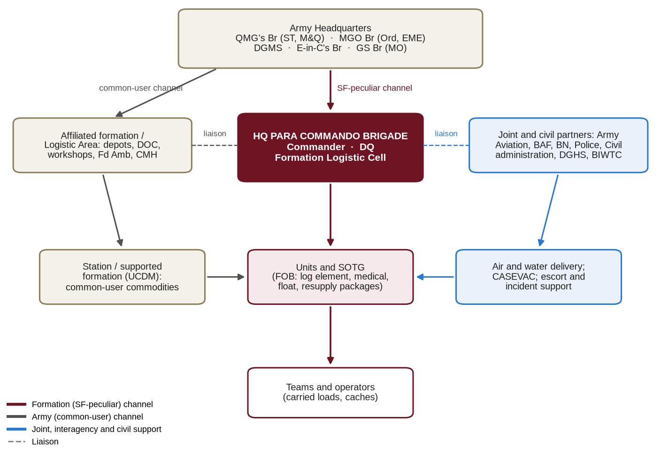
Figure 6: Logistic command, control and support relationships of the Formation
Logistic Organisation for Deployment
0416. Logistic Grouping. Logistic elements are grouped by task, and the grouping is stated in the administrative order . The SOTG logistic element is tailored to the mission and may include a logistic officer or JCO, medics with medical stores, an armourer or technician, a signals technician, a parachute rigger, a boat mechanic and drivers, with detachments from affiliated logistic units (ST, EME Forward Repair Team, medical) as required. No fixed composition is prescribed [●].
0417. Logistic Nodes. Special forces logistic nodes correspond to, but are not identical with, the administrative areas of conventional doctrine:
Ser | Node | Description | Conventional Equivalent
1. | Formation Base | Home station of the Formation, holding Formation stocks, the operational float and base services. | Logistic area / station
2. | Mounting Base | Location (often an airfield or port) where an SOTG completes final preparation, isolation and loading. | Concentration area
3. | Intermediate Staging Base | Location between the mounting base and the operational area, used for staging, refuelling and holding reserves. | Advanced base
4. | Forward Operating Base (FOB) | Secured location from which the SOTG supports its teams. | BAA / Forward BAA
5. | Team Base or Hide | Temporary location of a team in the operational area. | Unit echelon
6. | Cache | Concealed store for later recovery. | Dump

0418. Siting of Logistic Nodes. The doctrinal factors for siting administrative areas apply: defensive potential; adequate space; tracks for circuits and dispersion; suitability for signal communications; cover, concealment and hard standing; access to main supply routes and depots; proximity to landing sites; cleanliness and hygiene; and location within turn-round of first- and second-line transport (Reference D). For the Formation, the following are added:
a. Security and concealment from the population and from observation.
b. Access to a helicopter landing site, drop zone or jetty, with an alternate.
c. Elevation above the expected flood level for the season (Chapter XIII).
d. More than one route of entry and exit, by land or water.
0419. Protection of Logistic Nodes. Administrative units are responsible for their own protection, but they face particular problems: their manpower is fully engaged in their primary work; dispersion forces them to occupy large areas; replenishment is carried out by night when protection is most needed; and their internal communications are limited. Measures include a defence SOP, division of the area into sectors, a central mobile reserve, concealment, early warning, coordination of air and anti-tank defence and of fire, and obstacles (Reference D). For the Formation, the deduction is that operators are not to be tied to the protection of a FOB; protection is to be provided by attached conventional troops, by the supported formation or, in domestic operations, by the police, and is to be requested in the administrative order.
Logistic Battle Rhythm
0420. Routine in Operations. The logistic routine is to be synchronised with the General Staff battle rhythm and stated in orders:
a. Logistic reports from SOTGs at times laid down in orders [●].
b. Reinforcement demands from units daily, not later than 2000 hours, consolidated by Formation headquarters and signalled to the AHQ reinforcement cell not later than 2359 hours (Reference D).
c. Resupply request cut-off times for planned resupply [●].
d. Opening times of delivery, ammunition and petrol points, which normally open by night (Reference D).
e. A daily administrative conference chaired by the DQ.
0421 – 0499. Reserved.

CHAPTER-V
LOGISTIC PLANNING AND THE LOGISTIC ESTIMATE
Logistic Planning in the Decision Making Process
0501. Integration. The logistic estimate is made concurrently with the operational estimate, not after it; logistic planning must be closely integrated with operational planning right from the beginning (Reference D). Figure 7 shows the contribution of the DQ at each step of the Decision Making Process.
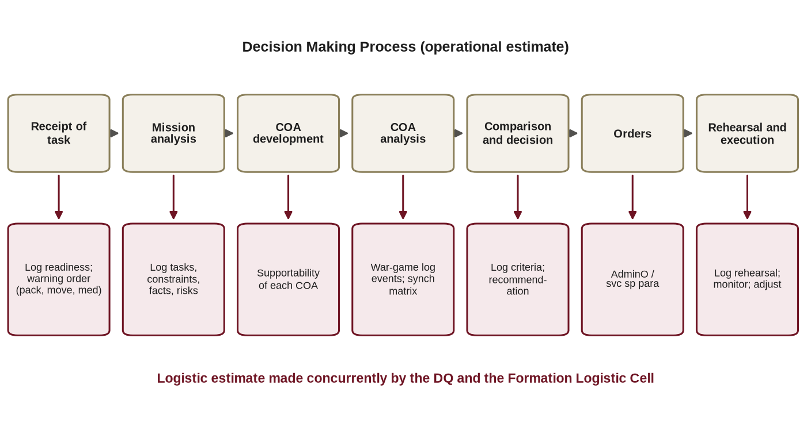
Figure 7: The logistic estimate within the Decision Making Process
0502. Contribution of the DQ. At each step of the Decision Making Process the DQ is to:
a. Receipt of the Task. Report logistic readiness; issue logistic instructions in the warning order (packing, movement, medical preparation).
b. Mission Analysis. Identify specified and implied logistic tasks, constraints, facts and assumptions, logistic risks and logistic information requirements.
c. Course of Action Development. Assess the supportability of each course of action and propose logistic means.
d. Course of Action Analysis. War-game logistic events (resupply, casualty evacuation, equipment casualties) and build the logistic synchronisation matrix.
e. Comparison and Decision. Provide logistic criteria and a recommendation.
f. Orders. Produce the administrative order or the service support paragraph.
g. Rehearsal and Execution. Conduct the logistic rehearsal; monitor and adjust the plan.
Preparatory Work
0503. Information Required. The Logistic Cell is to maintain at all times the information needed for planning (Reference B, Paragraph 2504): the staff table, including the current state of manpower, weapons and vehicles; stock states and consumption data; the location and capacity of logistic installations, military and civil medical facilities, airfields, landing sites and jetties; route classifications; transport availability; terrain and seasonal data; and local resources. Combat service support information is a responsibility of the logistic staff and is to be collected deliberately (Reference A, Paragraph 0736).
The Logistic Estimate
0504. Contents. The logistic estimate follows the framework of Army staff duties (Reference B, Paragraph 2507), adapted for special forces at Annex J. It considers, in turn: the aim; the situation and mission; the threat to logistics; ground and weather; time and space; own forces and logistic resources; requirements by commodity; means of delivery; medical; personnel; protection of logistic nodes; legal and financial constraints; and from these, deductions, courses open and the recommended plan.
0505. Method. Every factor is to be carried through to a deduction, and every deduction to a task, a requirement or a constraint. The estimate is to be quantitative wherever the information exists, and every planning assumption is to be stated (Paragraph 0110).
Planning Calculations
0506. Requirement. The requirement for a commodity is calculated as strength, multiplied by the daily scale, multiplied by the number of days, plus reserves and an allowance for loss. The daily scale is the AHQ scale [●] or, where none exists for the Formation's conditions, the Formation's validated consumption figure. Worked methods are at Annex H.
0507. Lift. The number of loads is the requirement divided by the usable payload of the means of delivery. The number of vehicles, boats or sorties required is the number of loads multiplied by the turn-round time and divided by the time available. Turn-round time is the time to complete the circuit of activity plus terminal time at both ends and maintenance halts (Reference D) (Chapter X).
0508. Endurance. The endurance of an element is the lowest DOS among its principal commodities (Paragraph 0307).
0509. Medical Planning. The medical plan is based on the size and deployment of the force, the theatre, the casualty estimate, the methods of evacuation and the assistance available from civil and allied services (Reference D). Evacuation capacity is compared with the expected casualty rate, and evacuation time with the medical standards (Chapter IX).
0510. Personnel Planning. Reinforcement requirements are based on the casualty estimate and on the specialist trades of the element (Chapter XI).
Staff Check
0511. Staff Check. When time does not permit a full estimate, a staff check is made (Reference B, Section 26): what is required, what is available, the deficiency, how it can be made good and by when. An outline is at Annex J.
Logistic Risk
0512. Assessment and Acceptance. Logistic risks, such as failure of resupply, unflyable weather, unavailability of casualty evacuation, failure of critical equipment, or compromise of a cache, are to be identified, assessed for likelihood and impact, mitigated and presented to the Commander, who alone accepts residual risk. Where a medical standard cannot be met (Paragraph 0905), the risk is to be stated explicitly. The principal logistic risks of the Formation are assessed in Chapter XIV.
Orders and Instructions
0513. Types of Order. At unit level general administrative instructions form part of the operation order; at brigade level and above an administrative order is normally issued separately, because there are more service support units, the work is more elaborate and its inclusion in the operation order would confuse subordinate commanders (Reference D). The Formation uses:
a. The Formation administrative order (format at Annex D).
b. The service support paragraph of SOTG and unit operation orders, and the road movement order (formats at Annex K).
c. Administrative instructions for continuing or non-tactical matters.
d. Dumping, pre-positioning and caching instructions (Reference B, Section 28).
e. The air resupply plan and the medical plan, as annexes to the administrative order.
0514. Security of Logistic Orders. Administrative orders reveal intention through their detail. They are to be classified appropriately, distributed on a need-to-know basis and, where required, use code words (Annex D, paragraph 7).
Rehearsals and Synchronisation
0515. Synchronisation. A logistic synchronisation matrix, phased in time against each commodity and node, is to be produced for every SOTG operation and checked against the operational synchronisation matrix.
0516. Logistic Rehearsal. Resupply, casualty evacuation, cache recovery and aerial delivery recovery drills are to be rehearsed as part of mission preparation. "Logistics must be played, not assumed": no exercise is to assume away a logistic event that would occur on operations.
0517 – 0599. Reserved.

CHAPTER-VI
AMMUNITION AND EXPLOSIVES
Principles of Ammunition Supply
0601. Definition. Ammunition is any substance designed to explode or to cause fire, and includes mines, explosives and grenades (Reference D). In this doctrine it also includes demolition and breaching stores, initiation systems, pyrotechnics and signal stores.
0602. The Principles. An ammunition supply system must be sufficiently elastic to meet the varying conditions of war and must observe the following principles (Reference D):
a. Ammunition is passed automatically from rear to front to replace what has been expended.
b. All expenditure from ammunition echelons is replaced immediately.
c. In mobile operations, vehicles provided for ammunition are never diverted from that function.
d. In an emergency any formation or unit may receive ammunition on demand from any echelon carrying the type required.
e. No indent is required.
0603. Re-examination for Special Forces. Each principle holds for the Formation, with the following adaptations:
a. Automatic Replenishment. Holds between the Formation base and the FOB. It cannot hold to a clandestine team, which is replenished by plan, by cache or by emergency resupply.
b. Immediate Replacement. Applies as far as communications and means of delivery permit; teams must therefore conserve ammunition and report their state.
c. Dedicated Transport. For the Formation the dedicated means is often an aircraft or boat. An emergency resupply load and the means to deliver it are to be earmarked for every committed element.
d. Emergency Issue from Any Echelon. This principle works only if the Formation uses natures that other echelons hold. The Formation is therefore to use standard Army calibres and natures wherever the task allows, and to justify every non-standard nature. This is a strong argument for standardisation.
e. No Indent. Retained for operations. Training ammunition is drawn against authorised scales (Paragraph 0616).
Ammunition Holdings and Replenishment
0604. Replenishment within Units. Within a unit (Reference D):
a. The first-line pouch remains with the individual; the first-line reserve remains under control of the sub-unit (company or platoon headquarters); and the second line is held at battalion headquarters, the number of second lines being laid down by higher headquarters.
b. When 30 per cent of the first-line pouch has been expended, a replenishment request is passed to battalion headquarters; immediate replenishment is made from the first-line reserve, which is itself replenished from the second line, and the second line from the ammunition point (AP).
c. In operations ammunition replenishment is a "G" matter handled by the Adjutant; within a company the CSM dispatches ammunition to platoon sergeants, who send it to section commanders.
d. Replenishment is always from rear to front; personnel in forward locations do not go back for ammunition.
0605. Scales. First- and second-line scales are laid down by AHQ (Reference H) [●]. The second line is normally of the order of half the first line, carried on wheels (Reference D). Scales for special forces natures are to be authorised by AHQ on the recommendation of the Formation [●].
0606. Holdings in Special Forces Operations. For committed special forces elements the doctrinal lines are translated as follows (Figure 8):
a. Operator. Carries the first line, including mission-specific natures, as laid down in the load plan.
b. Team. Holds a team reserve, carried or cached, in place of the first-line reserve.
c. SOTG FOB. Holds the second line for the SOTG and the pre-packed emergency resupply loads.
d. Formation. Holds a Formation reserve of special forces natures [●] and draws common natures from the Ordnance depot through the affiliated formation.
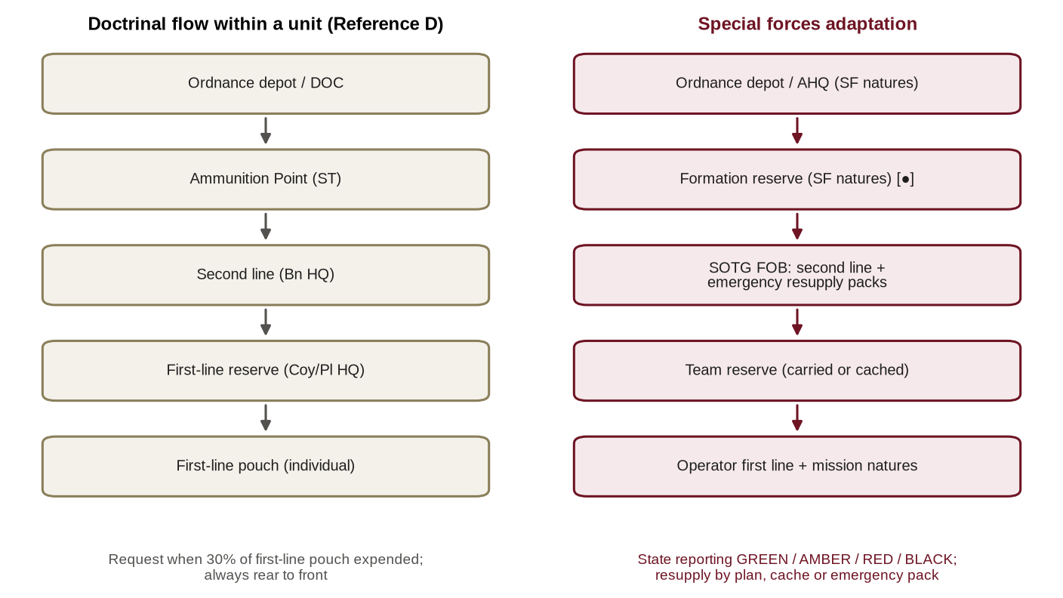
Figure 8: Ammunition replenishment: doctrinal flow and special forces adaptation
0607. Ammunition State Reporting. Because a percentage trigger is meaningless to a team that cannot be replenished at will, committed elements report their ammunition state in four categories, with thresholds set for each mission in the SOTG logistic plan [●]:
a. Green. Sufficient for the mission.
b. Amber. Below the mission requirement but sufficient to break contact; planned replenishment required.
c. Red. Insufficient to break contact; emergency resupply required.
d. Black. Critical; the element cannot continue the mission.
Dumping, Pre-positioning and Caching of Ammunition
0608. Doctrinal Guidelines. Doctrine lays down that dumps for an attack should be of sufficient size that no sudden demand has to be met unexpectedly by second-line transport, sufficiently close to enable units to draw in their own transport, and so arranged that dumping does not jeopardise surprise; in defence, additional second-line lifts may be dumped in the main position as decided by higher command, dug in, camouflaged and dispersed (Reference D). Dumping is planned, ordered, executed and controlled in accordance with Army staff duties (Reference B, Section 28).
0609. Application to Caching. When ammunition is cached for special forces elements (Annex F):
a. Packaging is to protect against moisture, heat and termites, which in Bangladesh are the principal causes of deterioration.
b. Detonators and initiation systems are never to be cached with main charges; compatibility rules are to be observed .
c. Every cache is to be recorded, inspected at intervals and recovered or destroyed on completion; an unrecovered ammunition cache is a danger to the public and remains on the Formation account until cleared.
Special Natures, Demolitions and Explosives
0610. Special Forces Natures. Special forces natures include precision and suppressed ammunition, natures suited to close-quarter battle in built-up areas, breaching charges and stores, distraction devices, demolition explosives and initiation systems, pyrotechnics and markers, and signal stores for aircraft and boats. They are provisioned on special scales [●]. Lead times are long, often because they must be imported, and requirements are therefore to be forecast at least one budget cycle in advance.
0611. Storage and Handling. Explosives are to be stored, handled and transported in accordance with the Explosives Act, 1884 (Reference N) and AHQ instructions (Reference H): in authorised magazines, segregated by compatibility, under a nominated custodian and handled only by qualified personnel, with records of every receipt, issue and return.
0612. Transport. Ammunition and explosives carried by air are dangerous goods. They are to be packed, documented and loaded in accordance with the international technical instructions for dangerous goods and Air Force instructions, by qualified personnel, with the consent of the aircraft commander. In boats they are to be secured, protected from water and separated from fuel. In vehicles they are to be marked, escorted where required and separated from sources of ignition.
Accounting, Safety and Disposal
0613. Accounting. Ammunition is accounted for by ledger, by lot and batch. Every expenditure in training is supported by a certificate; in operations, expenditure is reported in the logistic report and reconciled after the operation within [●] days. Losses are investigated by Court of Inquiry in accordance with regulations (Reference V).
0614. Safety. Blinds, misfires and suspected defective lots are to be reported immediately through Ordnance channels; affected lots are to be suspended from use pending technical inspection. Unexploded ordnance from training or operations is to be cleared by qualified personnel.
0615. Effects of Climate. Heat and humidity degrade ammunition, explosives and pyrotechnics. Magazines are to be ventilated and inspected at intervals laid down by the Ordnance Directorate [●]; stocks are to be rotated so that older lots are used in training first, subject to Ordnance instructions.
0616. Training Ammunition. Training ammunition is drawn at the enhanced scales authorised for the Formation (Reference Q, Chapter IX) [●]. War reserve is not to be drawn down for training without AHQ authority.
Ammunition in Specific Tasks
0617. Counter-Terrorism and Hostage Rescue. Ammunition is issued from mission packages on deployment. After an incident, discharged ammunition may be the subject of inquiry or judicial proceedings; lot records are therefore to be preserved, expenditure is to be recorded by individual, and spent cases and other material are to be preserved where investigators so direct.
0618. United Nations Deployments. Ammunition for UN deployment is held in accordance with the memorandum of understanding and the contingent-owned equipment arrangements (Reference T), including its export, storage in the mission area and return.
0619. Humanitarian Assistance and Disaster Relief. Only the ammunition required for self-protection, if any, is to be carried. Explosives are used for obstacle clearance only by qualified personnel on the authority of the commander.
0620 – 0699. Reserved.

CHAPTER-VII
RATIONS, WATER, FUEL AND POWER
Supply Principles
0701. Definition. Supplies include food, forage, hospital nutritional requirements, disinfectants, insecticides, water, chemicals, coal and fuel (Reference D).
0702. Principles. Under all circumstances units should have with them, or within easy reach, one day's emergency ration; and stocks should be replenished daily by delivery at a point within easy reach of the troops (Reference D). Supplies are procured by the supply depot, collected by the ST Battalion, brought to delivery points at a prearranged time and place (normally open by night) and collected by units in their own transport for daily issue (Reference D).
0703. Re-examination. For the Formation the emergency ration principle is retained and extended: every operator carries an emergency ration in addition to the mission ration. Daily delivery is retained for the Formation base and the FOB, but committed teams are supplied for a declared DOS and replenished by plan, not daily.
Rations and Nutrition
0704. Categories. Rations are fresh (in base and at the FOB), dry, combat ration packs and emergency rations, at the scales authorised by AHQ, including special scales for the Formation (Reference G) [●].
0705. Special Forces Considerations. In planning rations the Formation considers:
a. Energy expenditure, which is high in load carriage, swimming and prolonged immersion.
b. The ratio of energy to weight, and the water needed to prepare dehydrated items.
c. Shelf life and packaging in a hot, humid climate.
d. The signature of preparation (smoke, smell and waste).
e. Religious and dietary requirements.
f. Medical advice on supplements, given through the Formation human performance arrangements (Reference Q).
0706. Local Procurement. Local purchase is arranged by the Staff Captain (ST) (Reference B, Paragraph 0437c) within delegated financial powers (Reference L). In special forces operations local procurement is constrained by four considerations: it creates a signature; it carries a hygiene risk, so food is to be inspected on medical advice; it must be paid for at a fair price against a receipt; and it must not deprive the population of what it needs. "Living off the land" is neither cost-free nor unorganised (Reference A, Paragraph 0746).
0707. Stockholding. The doctrinal distribution of ration stocks is shown at Paragraph 0212. In administrative orders it has been the practice to deploy with two days' dry rations . For the Formation, the days carried by teams and held at the FOB are to be stated in the SOTG logistic plan [●].
Water
0708. Water as a Combat Supply. Water is the heaviest commodity a team carries; a litre weighs about a kilogram. Requirements vary with climate, work rate and acclimatisation, and are to be planned at the scales authorised on medical advice [●]. In humanitarian operations the published minimum standard for basic survival, drinking and hygiene needs of an affected population is 15 litres per person per day.
0709. The Bangladesh Water Paradox. Water in Bangladesh is abundant but frequently unsafe:
a. Groundwater in large parts of the country contains arsenic above both the national standard of 50 micrograms per litre and the World Health Organization guideline value of 10 micrograms per litre.
b. Surface water is commonly contaminated by faecal matter, and contamination increases during floods.
c. Surface and groundwater in the coastal belt is affected by salinity.
d. In haor, char and riverine areas surface water carries heavy silt in the monsoon.
e. In disasters, urban water supplies are interrupted and contaminated.
0710. Deductions. No source is to be treated as potable without testing or treatment. Every operator and team is to carry means of purification, and the consumables (filters and chemicals) are to be planned and reported as part of the water supply. At the FOB a water point is to be established, sited and tested on medical advice. Water discipline is enforced as a health measure (Paragraph 0911).
0711. Purification. Methods include filtration, chemical treatment, boiling, ultraviolet treatment and, at FOB or disaster-relief scale, mobile purification plants [●]. The choice depends on the source, the threat (chemical contamination such as arsenic is not removed by boiling or chlorination) and the logistic burden of consumables.
Fuel, Oil and Lubricants
0712. Definition. POL includes petrol of various grades, octane, diesel, lubricating oils, kerosene, greases and graphite, which are supply items of the Army Service Corps; oil and lubricants for weapons, battery acid and distilled water are Ordnance items (Reference D).
0713. Principles and Replenishment. At the start of any move or operation all vehicle tanks are to be full and unit reserves complete; adequate reserves are to be held within reach of units; all reserves are to be replenished immediately after any move or operation, and tanks filled at the end of each day's work. Units refill from their first-line reserves, which are replenished from a petrol point or second-line vehicles; second-line vehicles refill from the depot or refilling point; and for long moves a mobile petrol point may be attached (Reference D).
0714. Special Forces Fuel Users. In addition to vehicles, the Formation uses fuel for boats and outboard motors (using the fuel and oil mixtures specified by the manufacturer), generators and chargers, and cooking and heating. Aviation fuel for helicopter operations, including any forward refuelling point, is coordinated with Army Aviation or the Air Force [●].
0715. Fuel in the Field. Fuel in caches and forward stocks deteriorates, and its containers leak and create fire and pollution hazards; cached fuel is to be inspected and rotated at intervals laid down in Formation SOPs. The quality of fuel bought locally cannot be assured; it is to be tested where possible and used only when necessary. Fuel spills are to be prevented and cleaned up .
Electrical Power and Batteries
0716. Batteries as a Combat Supply. The capability of special forces depends on radios, satellite communications, night-vision and thermal devices, laser and positioning equipment, unmanned aircraft and medical devices, all of which depend on batteries, and batteries are frequently the limiting commodity (Paragraph 0307). Within the Formation, batteries and electrical power are therefore planned, reported and replenished as a combat supply, alongside ammunition, POL, rations and water. This does not change the supply responsibility for batteries, which are Ordnance items held by the Divisional Ordnance Company (DOC) (Reference D).
0717. Power Management. Power is managed as follows:
a. The number of battery types in service is to be kept to the minimum by standardisation of equipment.
b. The choice between rechargeable and primary batteries is to be made per mission, weighing weight, endurance, charging means and signature.
c. An energy budget is to be made for each mission: the sum of each device's consumption multiplied by its hours of use, compared with the capacity carried, derated for heat and age (Annex H).
d. Charging is provided at the FOB by generators or solar equipment.
e. Expended batteries are never to be left in the field or in caches; they are a signature and a pollutant, and are to be disposed of in accordance with environmental law .
Other Supplies
0718. Hygiene and Vector Control. Disinfectants, insecticides and repellents are supply items (Reference D). In Bangladesh, where vector-borne and water-borne disease cause more casualties than the enemy in most conditions, they are to be planned as essential stores (Chapter IX).
0719. Clothing and Personal Equipment. Clothing and personal equipment are issued at authorised scales. In the monsoon and in riverine operations, wear and rot are rapid and replacement is to be planned accordingly [●]; quick-drying clothing, footwear suited to immersion and waterproof containers for equipment are mission-critical.
0720. Field and Engineer Stores. Defence and field stores for FOBs (sandbags, wire, shelters and lighting) are demanded through the engineer paragraph of the administrative order.
0721 – 0799. Reserved.

CHAPTER-VIII
EQUIPMENT SUPPORT: ORDNANCE, MAINTENANCE, REPAIR AND RECOVERY
Ordnance Support
0801. Controlled Stores. Certain stores, such as vehicles, weapon systems, small arms and heavy weapons, are known as controlled stores because their issue is controlled owing to their scarcity, security value or high cost of replacement. They are issued with the permission of the controlling authority, and lists are published and revised from time to time (Reference D). The DOC holds selected items such as machine guns, recoilless rifles, sub-machine guns, wireless sets, dry batteries and telephone cable (Reference D).
0802. Demand Procedure in Operations. For a controlled store lost in action, the unit demands a replacement by signal to brigade headquarters; brigade headquarters submits a combined demand to divisional headquarters through the Ordnance branch; the item is released from the local Ordnance depot; and the unit representative collects it (Reference D). For special forces-peculiar items not held by the local depot, the demand is passed by HQ Para Commando Brigade to AHQ (Ordnance Directorate). To avoid this delay in operations the Formation holds an operational float (Paragraph 0809).
0803. Management of Special Forces-Peculiar Equipment. Special forces-peculiar equipment is managed by serial number in the Formation register (Reference Q), with nominated custodians, life and usage records, technical inspections, configuration control of software and firmware, and, for communications security equipment, the procedures of the Signals Directorate.
0804. Provisioning and Procurement. Requirements for new equipment are raised as Statements of Requirement through the Weapons, Equipment and Statistics Directorate and procured through the Directorate General Defence Purchase or by local purchase within delegated powers, in accordance with procurement law (Reference M). No equipment is to be accepted without its support package: spares, tools, technical documentation, training for operators and maintainers, and warranty and through-life support terms.
Equipment Maintenance and Repair
0805. Classes of Repair. Repairs are classified according to their extent and complexity as unit repairs (by the unit repair organisation or Light Aid Detachment), field repairs (by the Field Workshop Company) and base repairs (complete overhaul, by the Base Workshop) (Reference D).
0806. Lines of EME Support. First-line support is organic to the unit, provided by its repair organisation, which carries out unit repairs of all equipment and limited field repairs of vehicles. Second-line support is provided by mobile workshop companies, each brigade generally being supported by one workshop company. Third-line support is provided by the Base Workshop, which is static and largely civilian. Repair units comprise unit repair organisations, Light Aid Detachments and workshop sections, field workshop companies, station and other static workshops, and the Base Workshop (Reference D).
0807. Condition of Equipment. The condition of equipment is assessed at inspection as: S, serviceable; A, slight fault, to be kept under observation; B, repairable by unit repairs; C, repairable by field repairs; D, repairable by base repairs; and U/S, unserviceable. Equipment that cannot practicably be repaired in a field workshop, perhaps for lack of time, is sentenced Beyond Local Repair (BLR) and backloaded, which authorises a demand for replacement; equipment not worth repairing is sentenced Beyond Economical Repair (BER) (Reference D).
0808. Recovery. Equipment casualties are classed X (repairable by the unit), Y (repairable by the field workshop) and Z (repairable only at base). First-line recovery moves the casualty to the workshop section or Equipment Collecting Point (ECP); second-line recovery moves it to the second-line workshop or Formation Backloading Point (BLP); and third-line recovery backloads it to the base. Units recover what they can tow; beyond that, a casualty report is sent to the workshop or recovery post by message, Military Police traffic control net or despatch rider. The extent of repair at each stage is specified by the senior EME officer in accordance with operational requirements (References D and J) (Figure 9).
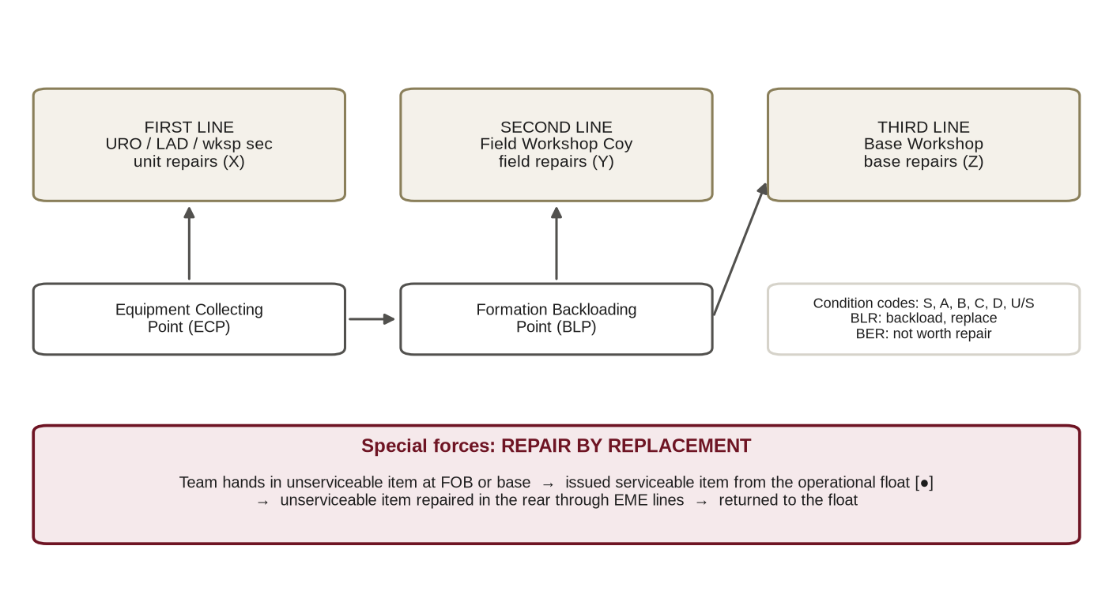
Figure 9: Lines of repair and recovery, with the special forces operational float
Re-examination for Special Forces
0809. Repair by Replacement and the Operational Float. Much special forces equipment is high-technology and low-density: night-vision and thermal devices, satellite communications, specialist optics, parachutes, diving sets, outboard motors and special vehicles. Technicians are few, spares are often imported, and the equipment may not be within normal EME repair scales. Repair forward is usually impossible for a committed team. The Formation therefore applies repair by replacement: an unserviceable item is exchanged at the FOB or Formation base from an operational float, and the unserviceable item is repaired in the rear. The composition and size of the float for each class of critical equipment are to be authorised by AHQ on the Formation's recommendation [●]; the float is managed by the Ordnance officer with EME advice.
0810. Operator Maintenance. Every operator is trained in first-level maintenance of personal and team equipment. Daily and weekly checks are to be enforced. In the Bangladesh climate particular attention is required to humidity (desiccants and sealed containers), fungal growth on optics in the monsoon, and corrosion after immersion in salt or brackish water, after which equipment is to be flushed and dried at the first opportunity.
0811. Boats and Outboard Motors. Boats and outboard motors are maintained to a planned schedule by trained mechanics, flushed with fresh water after salt-water use, and supported by a stock of critical spares. Recovery of boats is planned for every waterborne operation.
0812. Vehicles. Formation vehicles, including any special or modified vehicles, are supported by EME. In haor, char and monsoon conditions, fording, mud and soft ground cause frequent casualties; recovery means are to accompany vehicle moves, and local recovery means (tractors, labour) may be hired in accordance with financial rules.
0813. Cannibalisation. Cannibalisation is permitted only on the authority of the commander laid down in Formation SOPs, only from equipment sentenced BER or in operational emergency, and is to be recorded.
0814. Calibration and Test Equipment. Equipment requiring calibration (weapon sights, measuring instruments, diving gauges and medical devices) is to be calibrated at the intervals prescribed by the technical authority [●].
Parachute and Aerial Delivery Equipment
0815. Parachutes. Parachutes are packed, inspected, stored and maintained only by qualified personnel, with individual equipment records, and are withdrawn on expiry of service life or failure of inspection (Reference Q). Storage is to be climate-controlled against humidity, and drying facilities are to be available after water landings. The training facilities required for the parachute system in service, including the mock tower, were reported in 2019 as not yet established and remain a capability priority (Chapter XIV).
0816. Aerial Delivery Equipment. Containers, harnesses and cargo parachutes for aerial delivery are accounted for by serial number. Their recovery and return after a delivery are to be planned; equipment that cannot be recovered without compromising the operation is written off on the certificate of the commander.
0817. Oxygen and Free-Fall Equipment. Oxygen and free-fall equipment is inspected and serviced in accordance with technical instructions in coordination with the Air Force, including the quality of breathing oxygen.
Diving and Maritime Equipment
0818. Diving Equipment. Diving equipment, cylinders and breathing gases are tested and certified at prescribed intervals jointly with the Bangladesh Navy (Reference Q) [●]. Compressors are to be maintained so that breathing air meets the prescribed quality standard. Access to recompression facilities is to be arranged for every diving operation and exercise (Paragraph 0911).
0819 – 0899. Reserved.

CHAPTER-IX
HEALTH SERVICE SUPPORT AND CASUALTY EVACUATION
Principles of Medical Support
0901. The Principles. The principles for the deployment of medical units are (References D and K):
a. Every casualty is to be seen by a medical officer within four hours of being wounded.
b. Casualties are to receive surgical treatment as soon as possible, never more than twelve hours after wounding.
c. The medical plan must conform to the "G" plan.
d. Medical units can work or move but cannot do both at once; one ADS or MDS must always be functioning while others pack or move.
e. There must be adequate reserves at all levels.
f. Control is centralised, so that medical resources can be distributed as needed.
0902. The Field Ambulance. The role of the Field Ambulance is the collection and immediate treatment of casualties from units in battle and their speedy evacuation. A Field Ambulance can deploy one MDS and three ADS at a time, with a mobile surgical team functioning with the MDS; it can run a 50-bed hospital and deal with a maximum of 150 battle casualties a day. The casualty collection post is part of the operational commander's plan at every level (Reference D).
0903. Stages of Evacuation. Within the unit, casualties are moved by stretcher-bearers through the casualty collection post to the Regimental Aid Post (RAP); from the RAP to the ADS by Field Ambulance transport; and from the ADS to the MDS by ambulance car. Any stage may be cut short when the situation permits and air transport is available, so that a serious casualty may be flown from the RAP to the MDS or even to hospital (Reference D).
0904. Siting and Planning. Medical units are sited with regard to communications (road, rail, water and air terminals), hard standing and cover; they should be in a shady, quiet and comparatively safe place where casualties cannot be seen from the road, and have first priority for covered accommodation (Reference D). The medical plan is based on the size and deployment of the force, the theatre, the casualty estimate, the methods of evacuation and the assistance available from civil and allied services (Reference D).
Re-examination for Special Forces
0905. The Time-Distance Problem. The four-hour and twelve-hour standards assume a chain of evacuation behind the fighting troops. Special forces teams operate beyond that chain, in remote hills, haor, chars and coastal islands, where ground evacuation may take longer than four hours. The standards can be met only by air evacuation, by forward surgical capability, or by extended care at team level until evacuation is possible. Allied doctrine plans to a more demanding "10-1-2" timeline: immediate life-saving first aid within ten minutes, advanced resuscitation within one hour and damage-control surgery within two hours of wounding; and special forces medical practice has developed extended field care for situations in which evacuation is delayed. The doctrinal chain and its adaptation are shown at Figure 10. The Formation therefore requires that:
a. Every operation has an explicit casualty evacuation plan, stating the means, the expected time to a medical officer and to surgery, and an alternate.
b. Where the four-hour or twelve-hour standard cannot be met, this is stated in the logistic risk assessment and accepted by the Commander (Paragraph 0512).
c. Teams are trained and equipped to hold a casualty for the period until evacuation can be made.
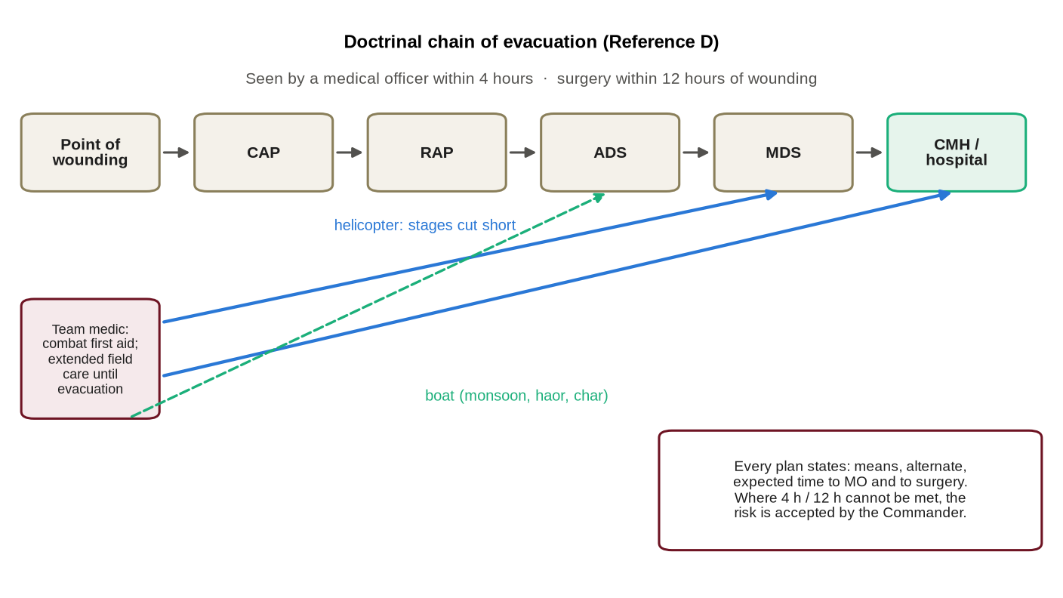
Figure 10: Casualty evacuation: the doctrinal chain and special forces adaptation
0906. Team Medical Capability. Every operator is trained in combat first aid to a Formation standard [●]. Every team includes at least one qualified special forces medic trained to the extended level authorised by DGMS (Reference K). Medical kit is held in modules (individual, team and SOTG), and controlled drugs are held and accounted for in accordance with the Narcotics Control Act, 2018 and DGMS instructions.
0907. SOTG Medical Support. A medical officer is to accompany every SOTG committed to operations. For high-risk operations a forward resuscitation or surgical team is to be requested from the affiliated medical unit or DGMS [●]. Any provision for blood and blood products is as authorised by DGMS; none is assumed in this doctrine.
Casualty Evacuation Means
0908. Means. Casualty evacuation in Bangladesh uses:
a. Hand Carriage. By stretcher or improvised means; slow and manpower-intensive, especially in hills and marsh.
b. Vehicle. Ambulances and other vehicles where roads permit; subject to monsoon flooding, ferries and traffic.
c. Boat. In the monsoon, many populated places in haor and char areas are reachable only by water; military and hired boats are to be planned as ambulances, with stretchers and life jackets.
d. Helicopter. Army Aviation and Air Force helicopters, requested through Formation headquarters in accordance with joint procedures [●]; limited by weather, darkness, range and availability.
e. Civil Resources. In domestic operations, civil ambulances and hospitals under the Directorate General of Health Services, pre-identified in the medical plan.
0909. Request and Landing Sites. Casualty evacuation requests are made in the standard format at Annex E. Landing sites are selected, recorded and marked in advance, with alternates. Winter fog and low monsoon cloud frequently prevent flying; a ground or water alternate is always to be planned.
0910. Receiving Facilities. The receiving Combined Military Hospital and designated civil hospitals, with their capabilities (including surgery and antivenom), are to be confirmed and stated in the medical plan for every operation.
Disease and Non-Battle Injury
0911. Hazards in Bangladesh. In most conditions in Bangladesh disease and non-battle injury cause more casualties than enemy action. The principal hazards and the logistic measures they require are:
Ser | Hazard | Where and When | Prevention and Logistic Implication
1. | Malaria | Chittagong Hill Tracts and border hills | Chemoprophylaxis and vector control as directed by DGMS; nets, repellents, protective clothing; rapid diagnostic tests and treatment in medical stores.
2. | Dengue | Urban areas, particularly in and after the monsoon | Vector control at bases; repellents; awareness.
3. | Water- and food-borne disease | Everywhere, especially during floods | Water purification and testing (Paragraph 0709); food hygiene; inspection of local purchases.
4. | Snakebite | Rural areas; incidence in rural Bangladesh is high | Prevention training; immobilisation and rapid evacuation; confirm antivenom at receiving facilities.
5. | Skin infection, leeches and immersion injury | Haor, marsh, jungle and monsoon operations | Foot care; dry clothing; limits on immersion; skin care stores.
6. | Heat illness | Pre-monsoon heat and humidity; heavy loads | Acclimatisation, work-rest cycles and water discipline; cooling and rehydration stores.
7. | Drowning | All riverine, coastal and flood operations | Swimming standards; life jackets; boat safety drills.
8. | Parachuting and diving injury | Training and operations | Medical cover at drop zones and dive sites; arranged access to recompression facilities.

Medical Logistics
0912. Medical Stores. Medical stores are demanded through medical channels (Reference K). Holdings at Formation, unit, SOTG and team level are as authorised [●]. Items requiring a cold chain (certain vaccines, drugs and antivenom) require refrigeration and power at the FOB. Pre-packed medical resupply modules are to be held for delivery by air or boat.
Specific Situations
0913. Counter-Terrorism and Hostage Rescue. At an incident site the Formation provides its own team medics and medical officer, and coordinates with the police, fire service and the Directorate General of Health Services for ambulances, designated hospitals and the triage and evacuation of hostages and civilians. A mass casualty plan is to be prepared for every incident.
0914. Mass Casualties. Mass casualty plans state triage responsibilities, casualty collection points, the allocation of evacuation means and the receiving hospitals, and are to be rehearsed.
0915. Combat Stress. Medical support includes the prevention and management of combat and operational stress, including post-incident decompression, in accordance with DGMS guidance.
0916. Handling of the Dead. Own dead are to be recovered wherever possible, identified, and buried or repatriated with the religious rites due to them. Burial and graves are a responsibility of the Staff Captain (A&Q) (Reference B, Paragraph 0437b), and a burial ground is designated in the administrative order. The dead of the adversary are to be treated in accordance with the Geneva Conventions (Reference U).
0917. Protection and the Emblem. Medical units and transports marked with the protective emblem are protected under the Geneva Conventions and must not be used for combat purposes (Reference U). Formation medics who are also combatants do not enjoy the protected status of medical personnel exclusively engaged in medical duties; the protective emblem is to be used only as authorised.
0918 – 0999. Reserved.

CHAPTER-X
TRANSPORT, MOVEMENT AND DISTRIBUTION
Means of Transport
1001. Lines of Transport. Doctrinally, first-line transport is unit transport, second-line transport is divisional (ST) transport and third-line transport is Army or logistic area transport (Reference D). Movement agencies include road, rail, inland water, sea and air, and the choice between them is a source of flexibility (Reference D).
1002. National Coordination. The Movement and Quartering Directorate of AHQ arranges rolling stock, road and water transport in coordination with Bangladesh Railway, the Bangladesh Road Transport Corporation and the Bangladesh Inland Water Transport Corporation, and keeps the Army Embarkation Unit functional for the shipment of stores (Reference B, Paragraph 0308). Within the Formation, the Staff Captain (ST) arranges second-line lifts and hires civil transport in operations (Reference B, Paragraph 0437c) in accordance with Government instructions.
Road Movement
1003. Route Classification. Routes are classified by load class (the first figure), by type (A, all-weather; L, limited all-weather; F, fair-weather) and by the number of lanes (the last figure); for example, "80 A2" is a Class 80, all-weather, two-lane route. The lowest class encountered on a route determines the class of the route; a main supply route (MSR) is normally Class 100 or at least 60 (Reference D). The number of MSRs depends on the enemy's capability to block routes, the frontage of operations, the engineer resources available to maintain routes and the road network (Reference D).
1004. Roads in Bangladesh. In Bangladesh road movement is governed less by distance than by the crossing of rivers, by bridges and ferries, by seasonal flooding and by congestion in and around the cities. In haor areas some roads are built to be submerged in the monsoon, so that a route open in the dry season may be under water for months. Route information is therefore to be confirmed for the season before every move.
1005. Turn-Round. Turn-round is the time a transport echelon takes to move forward, deliver its load, return to the replenishment area, refill and return to its starting point; it is the time to complete the circuit of activity plus terminal time. The circuit of activity is the distance between the point of loading and the point of delivery; terminal time is the time for loading and unloading at both ends. Turn-round is affected by loading and unloading time, distance, speed (itself affected by the state of roads, vehicles and training, weather, enemy action, traffic density and whether movement is by day or night), and time for maintenance, rest and feeding, and must equal the rate at which replenishment is required. For planning, a circuit of activity of the order of 80 miles (about 130 km) and a turn-round of about eight hours are the guide figures (Reference D) (Figure 11).
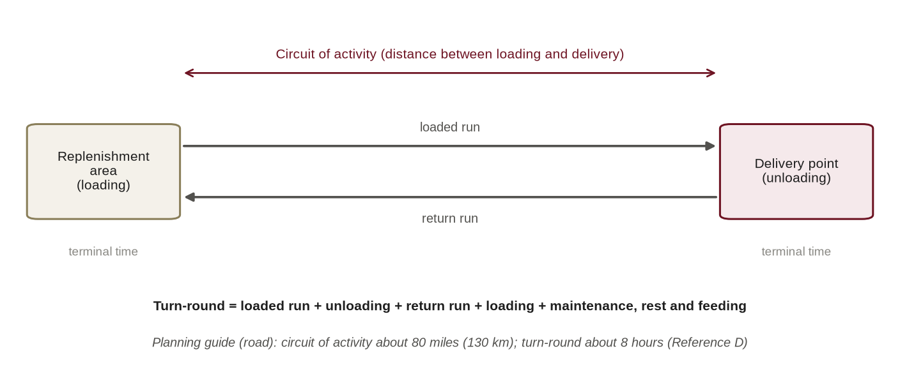
Figure 11: Turn-round, circuit of activity and terminal time
1006. Application to Air and Water. The same concept applies to aircraft and boats. For an aircraft the turn-round includes loading, flight to and from the delivery point, refuelling and crew limits; for a boat it includes tide and current, which may confine movement to particular windows.
1007. Road Movement Orders and Convoys. Road moves are ordered by road movement order (outline at Annex K). Convoy discipline, protection and traffic control are planned with the Military Police, whose duties include traffic control, the prevention and detection of crime and the enforcement of discipline (Reference D).
Air Movement and Air Resupply
1008. Air Assets and Tasking. Air movement and resupply are provided by Army Aviation and the Bangladesh Air Force. Requirements are stated as planned tasks in the administrative order or as immediate requests, and tasked in accordance with AHQ and joint procedures [●]. Air movement requires load manifests, dangerous-goods documentation , weight and balance data, palletised or netted loads, loading teams and a prepared airfield or landing site.
1009. Methods of Air Resupply. Air resupply may be air-landed at an airfield or landing site; delivered by helicopter, internally or as an underslung load; or delivered by parachute. Drop zones are selected for the terrain and season, secured, marked and cleared after use, and the recovery of loads and aerial delivery equipment is planned. Loads are rigged only by qualified personnel. Air resupply is requested in the format at Annex E.
1010. Planning Considerations in Bangladesh. Air operations in Bangladesh are constrained by low cloud and heavy rain in the monsoon, by fog on winter mornings, and by storms in the pre-monsoon and cyclone seasons. Flights within national airspace are coordinated with civil aviation authorities, and flights near the international borders require particular care. In the monsoon, dry drop zones in haor and char areas are scarce; water landings and the recovery of loads from water are to be practised.
Inland Water and Maritime Movement
1011. The Riverine Nation. Bangladesh is crossed by an extensive network of navigable rivers and channels. Navigability is seasonal: in the monsoon rivers widen and currents strengthen; in the dry season channels become shallow and chars shift and emerge; in the south, movement is governed by the tide. Country boats are everywhere, which gives special forces the advantage that boat movement can blend in with normal activity.
1012. Means. The Formation uses its own boats, hired country boats and engine boats, Bangladesh Navy and Coast Guard craft and, for heavy lifts, inland water transport ferries. Loads are waterproofed and secured; every person afloat wears a life jacket; man-overboard drills are rehearsed; and refuelling is planned for the whole circuit.
1013. Riverine Resupply. Riverine resupply is conducted by rendezvous at a time and place stated in orders, with recognition signals, an abort procedure and an alternate rendezvous. Tide tables are to be consulted for coastal and estuarine movement.
Pre-positioning and Caching
1014. Concept. Doctrine provides for pre-stocking at selected places for unconventional forces (Reference A, Paragraph 0746), and administrative orders have provided caches for such forces . Pre-positioning places stocks in secure locations (bases, FOBs and installations) before they are needed; caching conceals stocks for recovery by a designated element; emergency caches provide a reserve for teams that cannot be resupplied.
1015. Principles of Caching. Caching is governed by the following principles; the procedure and report format are at Annex F:
a. Every cache has a defined purpose, a designated recovering element and a recovery or destruction plan.
b. The site is identifiable to the recovering element without being conspicuous, is accessible by day and night, and is away from routes of habitual local movement.
c. In Bangladesh, the site is above the maximum expected flood level for the period of use, and not on land likely to be cultivated or excavated, including char land that may be cultivated after the floods recede.
d. Contents are packed against moisture, heat, termites and rodents.
e. The cache is recorded precisely and the record is classified and held on a need-to-know basis.
f. Caches are inspected and rotated, and are recovered or destroyed on completion; they remain on the account of the Formation until cleared.
g. Caching complies with the law, including the law on explosives and on private land.
Local Resources and Porters
1016. Local Transport and Labour. Porters, pack animals, boats, tractors and other local means may be hired where the situation requires, particularly in the hills and in riverine areas. They are hired in accordance with financial rules, paid fairly against a receipt, and vetted for security. Civilians are not combatants and are not to be exposed to danger. The use of local resources is part of the logistic signature (Paragraph 0309).
Movement Control and Distribution
1017. Movement Control. Movement is controlled by timings, density, priority and allocation of road space, enforced through Military Police traffic control posts. In counter-terrorism operations, movement through urban areas is coordinated with the police for escort and route clearance.
1018. The Distribution Plan. The distribution plan states who delivers what, where, when and by what means. For conventional distribution it fixes the opening times of delivery points, ammunition points, petrol points and water points, which normally open by night (Reference D). For special forces it also states rendezvous, recognition signals, abort criteria and alternates. The methods available to the Formation are summarised at Figure 12.
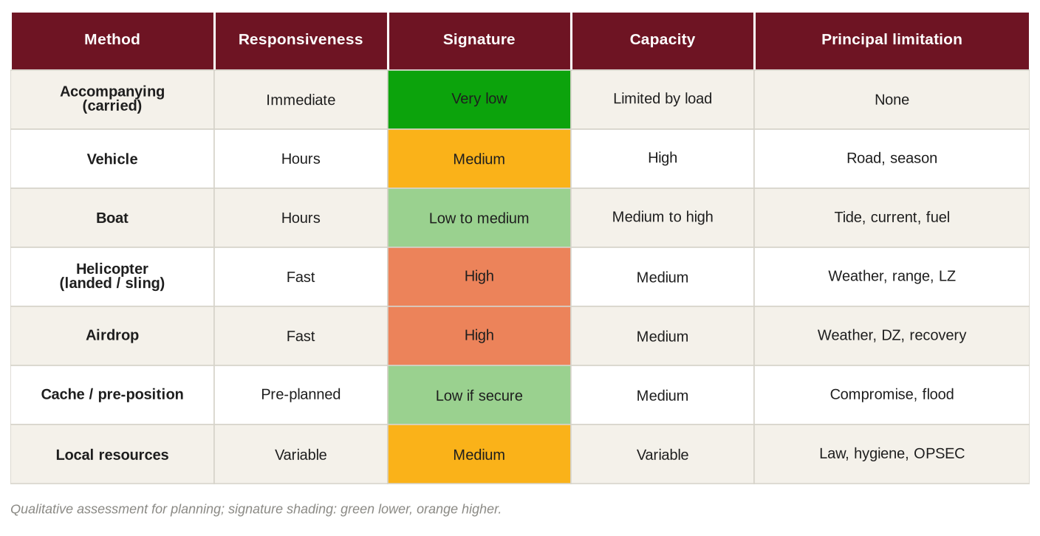
Figure 12: Methods of resupply available to the Formation and their characteristics
1019 – 1099. Reserved.

CHAPTER-XI
PERSONNEL SERVICE SUPPORT IN THE FIELD
Reinforcements
1101. The Doctrinal Procedure. The Bangladesh Army reinforcement system in war operates as follows (Reference D):
a. Personnel are collected and dispatched through reporting centres. A reinforcement section in the Adjutant General's Branch at AHQ coordinates demands and allocation. Reinforcement camps raised under logistic area, area or formation arrangements maintain fifteen days' reinforcements at all times, and seven days' reinforcements are held by formations, either in the DAA or in units.
b. Reinforcements are demanded for deaths; casualties evacuated beyond the MDS; personnel captured or believed to be prisoners of war; personnel missing in action; personnel posted to authorised extra-regimental employment; personnel undergoing detention in a military prison; and personnel overstaying leave by more than fifteen days.
c. Demands specify trade and rank; are not repeated in the next demand once placed; are normally made once a day; take account of reinforcements dispatched but not yet taken on strength; and carry no serial number.
d. Field units submit demands daily by signal to formation headquarters or independent brigade headquarters not later than 2000 hours; formation headquarters consolidates and signals the AHQ reinforcement cell not later than 2359 hours; the cell requisitions from reinforcement camps, and officers' demands are placed on the Military Secretary's Branch.
e. Drafts of not less than ten move under a JCO or NCO, fully clothed, armed, equipped and documented. On arrival, units check clothing and equipment, allow reinforcements to write to their next of kin, brief them on the operation and the unit's responsibilities, and rest them before they join their platoons.
1102. Priority of Deficiencies. The order of priority for making good deficiencies of manpower is: deficiencies against establishment; war increment; seven days' reinforcements for units; war raisings and units in suspended animation; fifteen days' reinforcements with reinforcement camps; and reinforcements with regimental centres (Reference D).
1103. Re-examination for Special Forces. The general reinforcement system cannot supply special forces, because qualified commandos and parachutists cannot be drawn from the general pool and take years to train (Reference Q). The Formation therefore applies the following:
a. A Formation reinforcement pool of qualified personnel (from training staff, personnel on courses and personnel in non-operational appointments) is identified in advance and kept current [●].
b. Reinforcement is planned by trade and qualification as well as by number: medic, signaller, sniper, parachute rigger, diver and boat operator replacements are identified individually.
c. The casualty estimate of every operation is translated into a reinforcement requirement by trade.
d. The doctrinal seven-day and fifteen-day holdings are applied to qualified personnel only; unqualified reinforcements are used to replace non-special forces appointments, releasing qualified personnel for operations.
e. Where losses make piecemeal reinforcement ineffective, teams are withdrawn and reconstituted as teams, by reorganising, breaking up or regenerating them (Reference A, Paragraph 0741).
Casualty Administration
1104. Casualty Reporting. Casualties are reported in accordance with AHQ procedures . Because the identity of special forces personnel employed in counter-terrorism may need protection, casualty information is released only through authorised channels.
Prisoners of War and Detained Persons
1105. Prisoners of War. Prisoners of war are entitled to maintenance (food, water, shelter, clothing and medical care) under the Geneva Conventions (Reference U), which is a logistic burden to be planned. Prisoners of war are held at a collection point in the Forward BAA and at the cage in the BAA, and evacuated to the divisional cage (Reference D); the layout of a cage is laid down in doctrine (Reference D). Special forces teams cannot hold prisoners for long; their evacuation is to be planned in the operation order.
1106. Persons Apprehended in Domestic Operations. In counter-terrorism and aid to civil power, persons apprehended are to be handed over to the police as soon as possible in accordance with the law. Until handover they are to be held securely, given food, water and medical attention as required, and documented; any form of ill-treatment is prohibited by law.
Pay, Postal, Welfare and Discipline in the Field
1107. Pay. Field pay arrangements are made through the field pay office organised by the Army Education Corps in war (Reference D). Operational allowances are as sanctioned [●]. Cash in the field is kept to the minimum and is accounted for in accordance with financial regulations (Chapter XV).
1108. Postal and Communications with Families. Field Post Offices are located in the BAA and Forward BAA (Reference D). For special forces, mail and private communications, including mobile telephones and social media, are subject to operations security instructions; welfare communications with families are arranged through the unit.
1109. Welfare and Amenities. Welfare and amenities in the field are the responsibility of the Staff Captain (A&Q) (Reference B, Paragraph 0437b). Liaison with families during operations is maintained by the rear party.
1110. Provost and Discipline. Military Police provide traffic control, the prevention and detection of crime and the enforcement of discipline (Reference D). Pilferage and diversion of stores, particularly weapons, ammunition, fuel and controlled items, are to be prevented by custody, checks and supervision.
1111. Burial and Graves. The handling of the dead is dealt with at Paragraph 0916.
1112 – 1199. Reserved.

CHAPTER-XII
LOGISTICS ACROSS SPECIAL FORCES TASKS AND PHASES
Logistics across the Phases of an Operation
1201. The Phases. Logistic support is planned across five phases (Figure 13):
a. Preparation and Mounting. Issue of mission packages, final preparation, isolation, packing and rigging, manifests, rehearsal stores, medical screening and documentation at the mounting base.
b. Insertion. Movement by aircraft, parachute, helicopter, boat, vehicle or on foot, with loads configured for the method; accompanying supplies carried and follow-on supplies scheduled.
c. Execution. Resupply in accordance with the plan; servicing of caches; casualty evacuation; replacement of equipment casualties; reporting.
d. Extraction. Recovery of equipment and caches or their destruction; accountability; removal of all waste and traces from the operational area.
e. Recovery and Reconstitution. Medical screening; inspection and repair of equipment; ammunition reconciliation; write-offs; after-action review and capture of consumption data; restoration of mission packages and readiness within the time laid down [●].
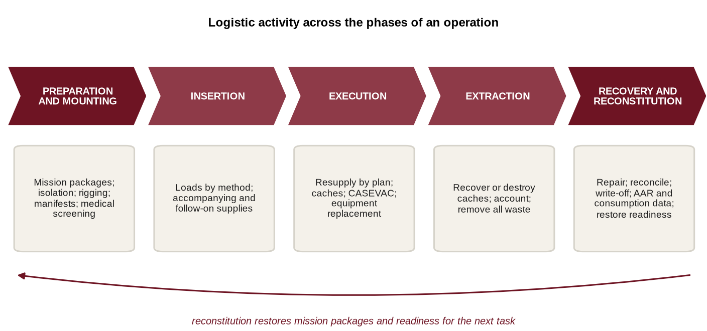
Figure 13: Logistic activity across the phases of a special forces operation
1202. Mounting. The mounting base provides accommodation, rations, communications, security and an isolation facility for the SOTG (Reference Q). Loads are checked against manifests and rigged by qualified personnel, and documentation for air movement and dangerous goods is completed.
1203. Reconstitution. After an operation an element is reconstituted by reorganising within its own resources, by breaking up and redistributing elements, or by regeneration with external resources (Reference A, Paragraph 0741). For the Formation, reconstitution is not complete until mission packages are restored, consumption data are recorded and the lessons of the operation are captured.
Defence of the Nation
1204. Special Forces in War. In war the Formation may conduct special reconnaissance and direct action in adversary depth, support conventional formations and conduct or support unconventional warfare. Doctrine for logistic support to unconventional warfare forces provides for (Reference A, Paragraph 0746):
a. A logistic cell of their own.
b. Pre-stocking at selected places.
c. Replenishment from central or forward bases over unspecified lines of communication, across country and through difficult terrain.
d. Airdrop of important items.
e. Use of indigenous transport, including riverine transport.
f. The recognition that living off the land is neither cost-free nor unorganised.
1205. Preparation in Peace. Because these arrangements cannot be made after war begins, the Formation is, subject to AHQ approval and security, to identify in peace the likely areas of employment, potential cache sites, local resources, landing sites, drop zones and waterways, and to plan the pre-positioning of stocks. When elements operate in the area of a conventional formation, they draw common-user support from its administrative areas under command for daily maintenance.
Counter-Terrorism and Hostage Rescue
1206. Characteristics. Domestic counter-terrorism operations are urban, at very short notice, often far from the home station, under civil primacy, and of uncertain duration from hours to days. Support is provided largely by the host garrison and the civil authority.
1207. Logistic Requirements. The Formation provides from its own resources the counter-terrorism mission package: weapons, specialist ammunition, breaching and climbing equipment, ballistic protection, night-vision and thermal devices and communications. At the incident site it arranges, through the Joint Command Post and the host garrison, a holding and forward assembly area, rest, food and water, lighting and power, ambulances and medical support, explosive ordnance disposal and fire service support, building plans and materials for rehearsal, and replacement of expended stores. Post-incident accounting is treated as evidence (Paragraph 0617). A checklist is at Annex L.
Aid to Civil Power and Internal Security
1208. Aid to Civil Power. Aid to civil power and internal security operations, including in the Chittagong Hill Tracts, are of long duration, use dispersed camps and are heavily affected by the seasons, including landslides in the monsoon. Support is normally provided by the area formation and the station, under command for daily maintenance, with special forces-peculiar support retained in the Formation channel.
Humanitarian Assistance and Disaster Relief
1209. Framework and Role. Disaster response is conducted in accordance with the Disaster Management Act, 2012 and the Standing Orders on Disaster (Reference S), on the requisition of the civil authority. The Formation's particular contribution lies in boats, divers and swimmers, insertion by parachute or helicopter into isolated areas, medical teams and communications.
1210. Logistic Principles in Disaster Relief. In disaster relief the Formation:
a. Deploys self-sufficient, so as not to consume the scarce resources of the affected population.
b. Plans water purification and boat fuel as priority commodities.
c. Applies published minimum humanitarian standards when distributing relief.
d. Accounts for any relief materials it handles, the civil administration remaining responsible for relief.
e. Coordinates through the Deputy Commissioner and the disaster management committees, with the Navy and Air Force, and through the Armed Forces Division for international assistance.
United Nations and Overseas Deployments
1211. Framework. United Nations deployments are governed by the memorandum of understanding and the contingent-owned equipment arrangements, including wet and dry lease and self-sustainment (Reference T), and by AHQ instructions. The Formation's special forces contingent has served with the United Nations in the Central African Republic.
1212. Logistic Requirements. Logistic preparation includes pre-deployment inspection of equipment, shipment through the Army Embarkation Unit (Reference B, Paragraph 0308), customs documentation, maintenance and spares in the mission area, ammunition, medical support at the levels provided by the mission, reimbursement documentation and repatriation. A checklist is at Annex L.
Training and Exercises
1213. Training Logistics. Training generates its own logistic demand: ranges and ammunition, aircraft, drop zones and recovery for parachuting, diving, boats, and training areas such as the coastal training area and drop zone at Swarno Dweep. Exercises, including combined exercises such as Tiger Lightning-2025, are to be used to rehearse operational logistics: logistics is to be played, not assumed, and consumption is to be recorded (Chapter XVI).
1214. Summary. The logistic characteristics of the principal tasks are summarised:
Ser | Task | Typical Duration | Principal Means of Resupply | Key Logistic Risk | Principal Support
1. | Special reconnaissance | Days to weeks | Cache, airdrop, riverine | Compromise of resupply; limiting commodity | Formation channel
2. | Direct action | Hours to days | Accompanying supplies; FOB | Casualty evacuation | Formation and supported formation
3. | Counter-terrorism | Hours to days | Mission package; host garrison | Short notice; distance | Host garrison and civil authority
4. | Aid to civil power | Weeks to months | Area formation; road, water, air | Seasonal disruption | Area formation (UCDM)
5. | Disaster relief | Days to weeks | Boat, helicopter | Fuel and water; access | Civil administration, joint
6. | UN deployment | Months | Mission and national lines | Spares; reimbursement | AHQ and UN mission
7. | Unconventional warfare | Weeks to months | Pre-stocking, indigenous | Sustainability; security | Formation logistic cell

1215 – 1299. Reserved.

CHAPTER-XIII
TERRAIN, CLIMATE AND SEASONAL ANALYSIS
The Logistic Geography of Bangladesh
1301. Overview. Bangladesh is a deltaic plain formed by the Ganges (Padma), Brahmaputra (Jamuna) and Meghna river systems and crossed by a dense network of rivers and channels, with hills only in the north-east and south-east, a long coastline with offshore islands and the Sundarbans mangrove forest in the south-west. Population is dense, and roads and railways cross the rivers by bridges and ferries. Doctrine notes the shortage of strategic depth (Reference D). The logistic consequence is that distances in Bangladesh are short in kilometres but long in time; and rivers are both obstacles to road movement and highways for water movement.
1302. Distances from the Home Station. The Formation is based in the north-east of the country. Straight-line distances from Jalalabad Cantonment to the principal areas of possible employment are shown at Figure 14 and in the table. Road distances are greater, and road travel times depend on bridges, ferries, season and traffic; they are to be determined for each move. Straight-line distance is the relevant figure for the planning of air movement.
Ser | Area | Straight-Line Distance (km, rounded) | Principal Terrain
1. | Sunamganj | 50 | Haor
2. | Mymensingh | 150 | Floodplain
3. | Cumilla | 180 | Floodplain and low hills
4. | Dhaka | 190 | Urban
5. | Khagrachhari | 200 | Hills
6. | Rangamati | 260 | Hills and lake
7. | Chattogram | 290 | Urban, port and coastal
8. | Hatiya | 300 | Offshore island
9. | Bandarban | 310 | Hills
10. | Khulna | 330 | Coastal, tidal
11. | Rajshahi | 340 | Barind tract
12. | Mongla | 360 | Port and Sundarbans fringe
13. | Cox's Bazar | 390 | Coastal and hills
14. | Teknaf | 460 | Coastal and border
Note: Distances are great-circle distances computed from approximate coordinates (Jalalabad Cantonment taken as 24.95° N, 91.87° E) and rounded to the nearest 10 km.
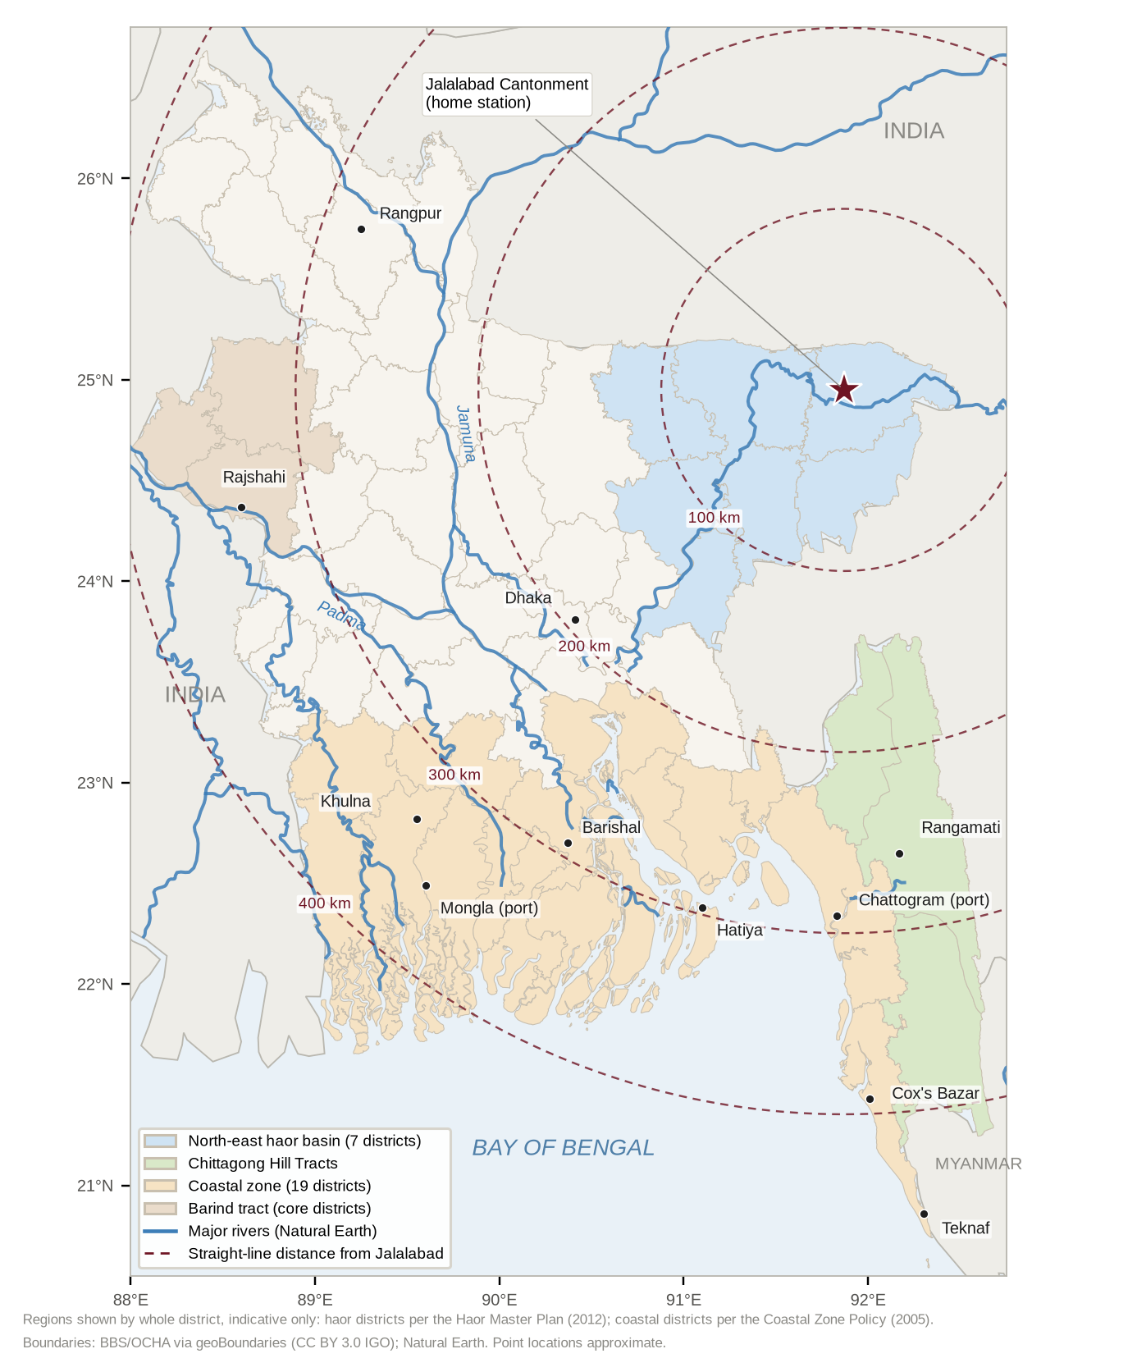
Figure 14: Logistic geography of Bangladesh: terrain regions, major rivers and straight-line distances from Jalalabad Cantonment
Terrain Regions and their Logistic Effects
1303. North-Eastern Haor Basin and Sylhet Hills. The home region of the Formation contains the haor basin, a system of seasonal wetlands, together with the hills, tea gardens and border jungle of Sylhet and Moulvibazar. Pre-monsoon flash floods, from about April, can inundate the haor within days; in the monsoon the haor becomes an inland sea in which villages stand as islands and the boat is the primary means of transport, and roads built to be submerged disappear. In the dry season the haor is a wide, open, cultivated plain. Logistic effects: boats and boat fuel are mission-critical for half the year; FOBs and caches must be sited above flood level; dry drop zones are scarce in the monsoon; water purification is essential; skin and immersion injuries are common.
1304. Chittagong Hill Tracts. The Chittagong Hill Tracts are steep, forested hills with few roads, large lakes and long international borders. Roads are cut by landslides in the monsoon, malaria is endemic, and movement off roads is slow and exhausting. Logistic effects: helicopters, porters and lake transport supplement road convoys; loads must be light; medical prophylaxis and evacuation planning are critical; camps require stocking before the monsoon.
1305. Coastal Belt, Offshore Islands and Sundarbans. The coastal belt is tidal and exposed to cyclones; surface and groundwater are affected by salinity; offshore islands are reachable only by water or air; and the Sundarbans are a roadless mangrove forest of tidal channels with wildlife hazards. Logistic effects: movement is governed by tide and weather; drinking water must be carried or desalinated; equipment corrodes rapidly; cyclone warnings dictate the timing of operations and the protection of stocks.
1306. Central Floodplain and Chars. The floodplains of the major rivers contain shifting sand islands (chars), seasonally inundated land and the strategic bridges and ferry crossings on which road movement depends. Logistic effects: crossings are bottlenecks and potential single points of failure; chars are accessible mainly by boat; char land may be cultivated or eroded between seasons, which affects caches and landing sites.
1307. North-West and the Barind Tract. The north-west, including the Barind tract, is higher and drier, with a better road network and greater seasonal heat and dry-season water scarcity. Logistic effects: vehicle movement is easier; water must be planned in the dry season; heat illness is a risk.
1308. Urban Areas. Dhaka, Chattogram and other cities are densely built up and congested, with high-rise buildings and complex utilities. Logistic effects: response times for counter-terrorism are governed by traffic and escort; assembly areas, parking and power are scarce; water and power are available but must be secured; media attention is constant.
Climate and Seasons
1309. The Seasons. The climate of Bangladesh is tropical and monsoonal. For logistic planning the year is divided into four seasons (Figure 15):
a. Pre-Monsoon (March to May). Heat and humidity; violent local storms; haor flash floods; cyclones may occur in May.
b. Monsoon (June to September). Heavy rain, river floods, landslides in the hills, low cloud and very high humidity; roads cut and the haor inundated.
c. Post-Monsoon (October to November). Receding floods; the principal cyclone season.
d. Winter (December to February). Dry, with morning fog that restricts flying and cold nights in the north; low river levels; the best season for movement on land.
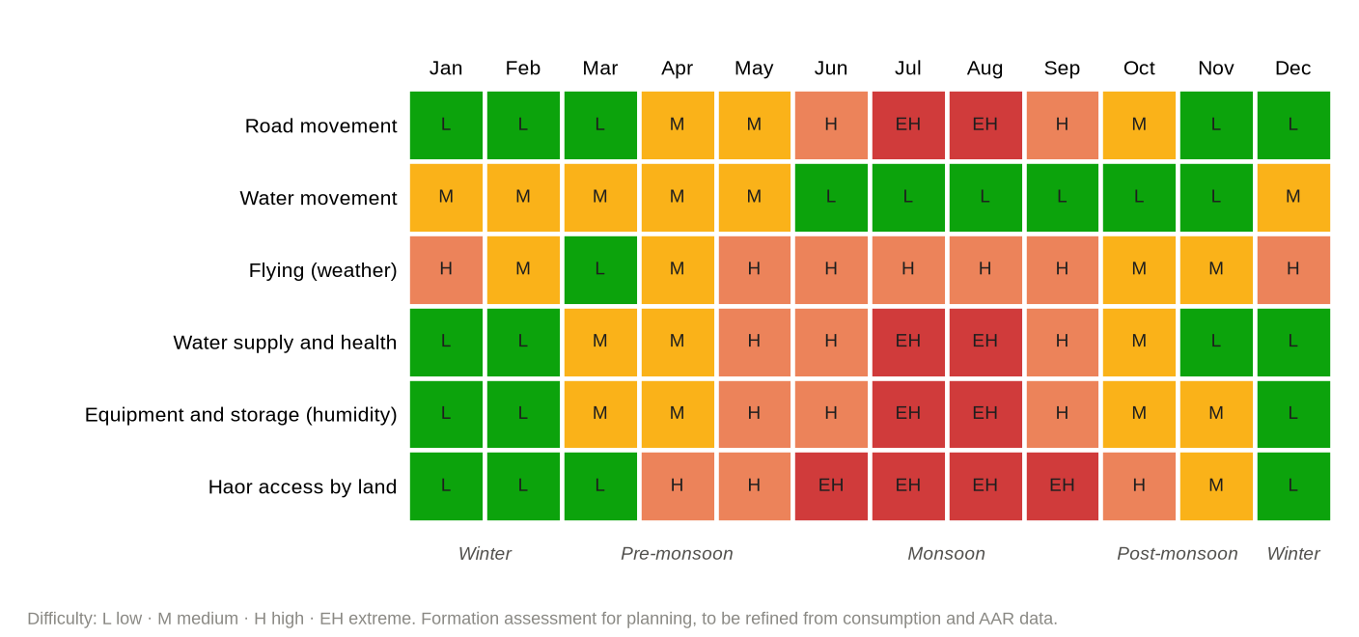
Figure 15: Seasonal effects on logistic functions (assessment)
1310. Effects by Function. The effects of season on each logistic function are assessed at Annex M. The most important are the closure of roads and the dominance of water movement in the monsoon; the limitation of flying by monsoon cloud and winter fog; the deterioration of equipment, ammunition and rations in heat and humidity; and the seasonal pattern of disease.
1311. Forecasting and Warning. The Logistic Cell monitors the forecasts and warnings of the Bangladesh Meteorological Department and the Flood Forecasting and Warning Centre. Formation SOPs are to lay down trigger actions, such as moving stocks above flood level, securing boats and aircraft loads, and pre-positioning medical and water stores, on the issue of flood or cyclone warnings.
Deductions
1312. Deductions. The principal deductions from the analysis of terrain and climate are:
a. Water mobility (boats, fuel, mechanics and boat-handling skills) is a core logistic capability of the Formation, not an occasional one.
b. Logistic plans and stocks are to be prepared for each season, and pre-positioning in likely areas is to be completed before the monsoon.
c. Every team is to be self-sufficient in water purification.
d. Humidity management of equipment, ammunition and rations is a continuous requirement.
e. Every air resupply and casualty evacuation plan is to have a weather alternate.
f. FOBs, caches and stocks are to be sited above the expected flood level.
g. Medical prophylaxis and vector control are to be planned by region and season.
h. Local resources (boats, porters and labour) are to be surveyed in advance in likely areas of employment.
1313 – 1399. Reserved.

CHAPTER-XIV
LOGISTIC LIMITATIONS, VULNERABILITIES AND MITIGATION
Approach
1401. Purpose. The candid identification of limitations is the first step to mitigating them. Limitations are grouped as structural, resource, infrastructure, procedural and information, and environmental. Each is analysed for its effect on special forces operations, and assigned a doctrinal mitigation and a responsible authority. The register is at Annex N and is reviewed annually.
Structural Limitations
1402. Dependence on Affiliation. The Formation depends on an affiliated formation for second- and third-line support [confirm integral logistic establishment], and the priorities of that formation may differ from its own (Paragraph 0401). Mitigation: a standing AHQ logistic support instruction; the Formation Logistic Cell; under command for daily maintenance arrangements with stations; and, for AHQ consideration, an integral logistic element for the Formation sized to its tasks.
1403. Division of Responsibility. The reported division of responsibility for operations, logistics and training among AHQ, a division and AHQ directorates creates friction in coordination. Mitigation: a single logistic point of contact (the DQ) and a periodic logistic coordination conference with the affiliated formation and AHQ directorates [●].
Resource Limitations
1404. Manpower. Manning below establishment has been reported, and special forces-qualified logisticians are scarce. Mitigation: cross-training of operators in logistic skills; dedicated logistic appointments in units and SOTGs; training of logistic staff (Chapter XVI).
1405. Funds and Financial Powers. Delegated financial powers for local purchase may be insufficient for urgent operational requirements. Mitigation: pre-approved contingency procurement arrangements and operational funds as sanctioned by AHQ [●] (Chapter XV).
1406. Equipment and Spares. Much special forces equipment is imported, with long lead times, currency and supplier constraints and risk of obsolescence. Mitigation: through-life support in every contract; standardisation; the operational float; more than one source of supply where possible.
1407. Training Ammunition. Training ammunition scales designed for conventional units do not meet special forces requirements (Reference Q). Mitigation: authorised enhanced scales [●]; use of simulation; efficient programming of range time.
1408. Air Lift. The Formation depends on Army Aviation and the Air Force for air movement, resupply and casualty evacuation, and their aircraft are subject to competing priorities and weather. Mitigation: standing tasking arrangements agreed in advance; ground and water alternates in every plan; regular joint training.
Infrastructure Limitations
1409. Training and Storage Facilities. The training facilities for the parachute system in service, including the mock tower, were reported in 2019 as not established. Climate-controlled storage for parachutes and electronics, magazines, boat sheds and deployable FOB equipment are also required. Mitigation: inclusion in the Formation master infrastructure plan (Reference Q) and priority bids through AHQ (Engineer-in-Chief's Branch).
Procedural and Information Limitations
1410. Accounting and Data. Accounting is largely manual, and the Formation has had no systematic record of its own consumption, so that planning has relied on scales designed for conventional units. Mitigation: a digital inventory system and the consumption database (Chapter XVI).
1411. Doctrine. Until this publication, Army logistic doctrine has not been interpreted for special forces. Mitigation: this doctrine, with feedback through after-action reviews and annual review.
Environmental Limitations
1412. Terrain and Climate. Floods, cyclones, heat, humidity and disease (Chapter XIII) impose seasonal limits on movement, flying, storage and health. Mitigation: seasonal plans, pre-positioning, water mobility and the measures at Paragraph 0911.
Vulnerabilities
1413. Logistic Vulnerabilities. The principal vulnerabilities of the Formation's logistic system, assessed at Figure 16, are:
a. Logistic Signature. Logistic activity may compromise operations (Paragraph 0309).
b. Logistic Nodes. FOBs, landing sites and caches may be attacked or compromised.
c. Single Points of Failure. One serviceable helicopter, one bridge or ferry, one supplier or one technician on which an operation depends.
d. Information Systems. Logistic data and communications may be intercepted or disrupted.
e. Insider Threat. Pilferage or diversion of weapons, ammunition, fuel and controlled items.
f. Civil Dependence. Dependence on civil fuel, telecommunications, transport and hospitals, which may fail in disaster or crisis.
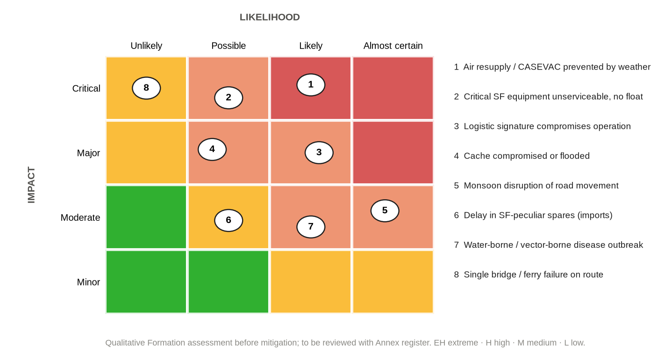
Figure 16: Assessment of principal logistic risks to the Formation (qualitative)
1414. Principles of Mitigation. The Formation mitigates logistic limitations and vulnerabilities by redundancy, pre-positioning, standardisation, standing agreements, training, data and regular review.
1415 – 1499. Reserved.

CHAPTER-XV
FINANCE, PROCUREMENT, ACCOUNTING AND LEGAL DIRECTIVES
Financial Framework
1501. Regulations. Logistic expenditure is governed by the Defence Services Regulations (Financial Regulations) (Reference L), Government financial rules and the delegation of financial powers, and AHQ instructions, under the audit of the Controller General Defence Finance and the defence audit authorities.
1502. Budget. The DQ prepares the annual forecast of the Formation's logistic requirements, including training ammunition, parachute and diving consumables, batteries, medical stores, life-cycle replacements and a contingency for operations, and staffs it to AHQ through the prescribed channel.
1503. Operational Expenditure. Expenditure in operations is incurred only from funds sanctioned for the purpose [●] and within delegated powers. Cash is handled in accordance with regulations; local purchases are supported by receipts; payments to civilians for hire of transport, labour or services are made at fair and documented rates; and claims for compensation for damage are processed in accordance with regulations.
Procurement
1504. Procurement Law and Practice. Procurement is conducted in accordance with the Public Procurement Act, 2006 and the rules in force (Reference M), through the Directorate General Defence Purchase or by local purchase within delegated powers. Requirements are technically evaluated by qualified boards; conflicts of interest are declared; documentation is complete; and through-life support is included in every contract (Chapter VIII).
Accounting and Losses
1505. Accounting. Stores are accounted for in ledgers by nominated custodians and verified by boards of officers at the prescribed intervals. Sensitive items are checked in full at the intervals laid down in the General Staff Policy (Reference Q).
1506. Losses in Operations. Losses in operations are documented promptly after the operation, while evidence is fresh, by a certificate of the commander concerned and, where required, a Court of Inquiry or board of officers in accordance with regulations (Reference V), and written off by the competent financial authority.
Legal Directives Bearing on Logistics
1507. Arms and Explosives. The storage, transport and use of arms and explosives are governed by the Explosives Act, 1884 (Reference N), the Arms Act, 1878 and AHQ instructions (Reference H).
1508. International Humanitarian Law. The Geneva Conventions (Reference U) protect medical units and transports bearing the emblem and require the maintenance of prisoners of war. Civilians employed as porters or labour are not combatants. Pillage is prohibited, and in foreign territory requisitions in kind are made only under the conditions laid down by law, against payment or receipt.
1509. Domestic Operations. In aid to civil power and counter-terrorism, the use of private property and the hire of civil resources are governed by Government instructions; damage is compensated in accordance with regulations; and persons apprehended are treated and handed over in accordance with the law.
1510. Environment. Batteries, fuel, lubricants and waste are disposed of, and ranges and training areas cleared, in accordance with environmental law.
1511. Dangerous Goods. Ammunition, explosives, fuel, batteries and compressed gases transported by air are packed and documented in accordance with the international technical instructions for dangerous goods and Air Force instructions.
1512. Customs. The export and re-import of equipment for overseas deployment and the import of special forces equipment comply with customs law and the arrangements of the United Nations where applicable.
1513. Controlled Drugs. Controlled drugs held for medical purposes are procured, held, issued and accounted for in accordance with the Narcotics Control Act, 2018 and DGMS instructions.
1514 – 1599. Reserved.

CHAPTER-XVI
TRAINING, INFORMATION, READINESS AND DEVELOPMENT
Logistic Training
1601. Every Operator a Sustainer. Every operator is to be trained in: load carriage and load planning; water purification; ration and battery management; combat first aid; first-level maintenance of personal and team equipment; caching; drop zone marking and recovery of aerial delivery loads; boat handling and outboard motor first-level maintenance; and accounting for the stores in personal custody.
1602. Logistic Staff and Specialists. Logistic staff and specialists (staff captains, Quartermasters, parachute riggers and packers, armourers, technicians, special forces medics, boat mechanics and logistic NCOs) are to be trained on the courses of the relevant Services [●] and in the special forces application of their trades within the Formation.
1603. Collective Training. Logistics is to be played in every exercise. The Formation is to conduct an annual logistic command post and field training exercise, in line with Army practice; rehearse resupply and casualty evacuation drills; rehearse mounting; exercise with Army Aviation, the Air Force and the Navy; and train in the monsoon and in the haor, not only in the dry season.
Logistic Information and Reporting
1604. Reports and Returns. Logistic reports and returns are made in the formats at Annex E: the logistic report (LOGSTAT); the ammunition state; the equipment casualty report; the casualty evacuation request; the reinforcement demand; the cache report; and the air resupply request. The Logistic Cell maintains the logistic picture (LOGPLOT) in accordance with Army staff duties (Reference B, Section 29).
1605. The Consumption Database. AHQ scales are derived from the needs of conventional units. The Formation is therefore to record its actual consumption of every principal commodity in every exercise and operation, by task, terrain and season, analyse it annually and use it to propose scales to AHQ. This is the means by which the [●] in this doctrine will, over time, be replaced by validated figures (Paragraph 0110).
1606. Information Security and Digitalisation. Logistic information is classified according to its content, held on authorised systems with backup, and protected against intrusion. The Formation is to move to a digital inventory and reporting system as resources permit.
Logistic Readiness
1607. Standards and Reporting. Logistic readiness standards are linked to the readiness tiers of the General Staff Policy (Reference Q): mission packages, vehicles, air and water transport arrangements and documentation. Logistic readiness is reported in the Formation readiness report at the frequency laid down by AHQ [●].
1608. Inspections. The DQ conducts logistic inspections of units at intervals laid down in Formation SOPs [●]; technical inspections are carried out by the Ordnance, EME and Medical Services; findings are tracked to completion.
Capability Development
1609. Process. Capability gaps identified from after-action reviews and the limitation register are developed into Statements of Requirement through the Weapons, Equipment and Statistics Directorate and progressed through the procurement process.
1610. Priority Areas. The following are proposed for consideration by AHQ; they are proposals, not decisions:
Ser | Area | Proposal
1. | Logistic organisation | Review of the logistic establishment of the Formation, including an integral logistic element and an Ordnance and ammunition accounting appointment.
2. | Aerial delivery | Parachute maintenance and storage facilities, the mock tower and an aerial delivery capability with trained riggers.
3. | Medical | Extended field care training and equipment for special forces medics; agreed forward surgical support.
4. | Power | Standardisation of batteries and charging equipment across the Formation.
5. | Riverine mobility | Boats, outboard motors, maintenance facilities and mechanics sufficient for operations in the monsoon.
6. | Information | A digital logistic information and inventory system.
7. | Joint arrangements | Standing tasking and support arrangements with Army Aviation, the Air Force and the Navy.
8. | Scales | Review of scales on the evidence of the consumption database.

Implementation and Review
1611. Implementation. Units are to review and amend their standing orders and SOPs in accordance with this doctrine within [●] of its issue. The DQ is to issue the templates of the administrative order and logistic reports, and to include this doctrine in the training of logistic staff.
1612. Review. This doctrine is to be reviewed annually and after every major operation or exercise, and amended in accordance with JSSDM 2022 (Reference E).
1613. The Formation can achieve nothing that it cannot sustain. Its value to the nation rests on the readiness of its operators and on a logistic system that delivers the right support, to the right place, at the right time, without betraying the operation, whatever the terrain or season. This doctrine provides the common framework through which commanders, staff, logisticians and operators are to achieve it.
1614 – 1699. Reserved.

Annexes:
A. Bibliography and Reference Cross-Index.
B. Doctrinal Traceability Matrix.
C. Glossary of Abbreviations and Terms.
D. Format of the Formation Administrative Order for a Special Forces Operation.
E. Logistic Reports and Returns: Formats.
F. Pre-positioning and Caching Procedure.
G. Mission Load and Mission Package Planning.
H. Planning Factors and Calculation Methods.
I. Logistic Responsibility Matrix.
J. Framework of the Logistic Estimate and Staff Check.
K. Formats of the Service Support Paragraph and the Road Movement Order.
L. Task Logistic Checklists.
M. Terrain and Season Logistic Matrix.
N. Logistic Limitations and Mitigation Register.

Distribution:
External:
Action:
1st Para Commando Battalion
2nd Para Commando Battalion
[● other units and elements under command, as per ORBAT]
Information:
Army Headquarters, Quartermaster General's Branch (Supply and Transport, and Movement and Quartering Directorates) and Master General of Ordnance Branch (Ordnance and EME Directorates)
Army Headquarters, General Staff Branch (Military Operations, Military Training, Staff Duties, and Weapons, Equipment and Statistics Directorates), Adjutant General's Branch and Engineer-in-Chief's Branch
Directorate General Medical Services
HQ ARTDOC
[Affiliated formation / Logistic Area HQ]
School of Infantry and Tactics (Special Warfare Wing); Army Airborne School
Internal:
Commander; BM; DQ; Staff Captain (A&Q); Staff Captain (ST); Ordnance Officer / JCO; Formation MO; Logistic Cell; Master file

ANX A TO
LOG DOCTRINE (SF) 1ST EDN
DT [●] 2026
BIBLIOGRAPHY AND REFERENCE CROSS-INDEX
1. General. This annex is the Bibliography of the doctrine (JSSDM 2022, Paragraph 0277). It lists every source consulted, grouped by category. The column "Ref" gives the letter under which a source appears in the References in the prefatory part (cited in the text as "Reference X"); all other sources are cited by footnote. The column "Cited at" is the cross-index: it lists the paragraphs (by number) and annexes in which each source is cited, so that every provision can be traced to its authority and every authority to the provisions that apply it.
2. Status of Sources. Government and AHQ instruments are binding. Bangladesh Army doctrine and précis are authoritative. Allied and foreign doctrine and academic literature are for reference and professional study only. Research, health, geographical and online sources are cited for factual information and should be verified against official records before quotation. Particulars shown as [●] are to be inserted from the Formation master file before issue.
Ser | Source | Ref | Cited at
Constitutional and Statutory Instruments (Government of the People's Republic of Bangladesh)
1. | The Army Act, 1952 (Act No XXXIX of 1952), as amended. | – | Bibliography only
2. | The Explosives Act, 1884 (Act No IV of 1884) and The Explosive Substances Act, 1908 (Act No VI of 1908), with the rules made thereunder. | N | 0611, 1507, Anx F
3. | The Arms Act, 1878 (Act No XI of 1878). | – | 1507
4. | Public Procurement Act, 2006 (Act No 24 of 2006) and the Public Procurement Rules in force. | M | 0804, 1504
5. | Disaster Management Act, 2012 (Act No 34 of 2012). | – | 1209
6. | Narcotics Control Act, 2018 (controlled drugs held for medical purposes). | – | 0906, 1513
7. | The Code of Criminal Procedure, 1898 (Act No V of 1898), Sections 127 to 132. | – | 1106, 1509
8. | Torture and Custodial Death (Prevention) Act, 2013 (Act No 50 of 2013). | – | 1106, 1509
9. | Bangladesh Environment Conservation Act, 1995 (Act No 1 of 1995) and the rules made thereunder. | – | 0715, 0717, 1510
10. | Customs legislation in force (import and re-export of contingent-owned and special equipment). | – | 1212, 1512
National Policy, Government Orders and Joint Publications
11. | Government of the People's Republic of Bangladesh. National Defence Policy, 2018. | – | Bibliography only
12. | Forces Goal 2030 (as revised). | – | Bibliography only
13. | Ministry of Disaster Management and Relief. Standing Orders on Disaster, 2019. Dhaka: MoDMR, 2019. | S | 1209
14. | General Economics Division, Planning Commission. Bangladesh Delta Plan 2100. Dhaka: Planning Commission, 2018. | – | 0709, 1301, 1305
15. | Ministry of Water Resources. Coastal Zone Policy, 2005. Dhaka: MoWR, 2005. | – | 0709, 1305
16. | Bangladesh Haor and Wetland Development Board. Master Plan of Haor Area. Dhaka: Ministry of Water Resources, 2012. | – | 1303
17. | Government financial rules and delegation of financial powers to the Armed Forces [No ● dated ●]. | – | 1501
18. | Government instructions on hiring and requisition of civil transport and services by the Armed Forces in operations and emergencies [No ● dated ●]. | – | 1002, 1509
19. | Armed Forces Division. Joint Services Staff Duties Manual 2022: Service Writing (JSP-001), Letter No 2402/OPS (PROJ)/SD-2. Dhaka: Prime Minister's Office, AFD, Operations and Plan Directorate, November 2022. | E | 0112, 0115, 1612, Anx C, Anx D
20. | Armed Forces Division. Standing Operating Procedure of Bangladesh Multinational Coordination Centre (MNCC). Dhaka: AFD, Prime Minister's Office. | – | 1210
Army Regulations and Army Headquarters Instruments
21. | Army Regulations (Rules) and Army Regulations (Instructions), as amended. | V | 0613, 1506
22. | Defence Services Regulations: Financial Regulations Part I (Army and Air Force). Controller General Defence Finance, cgdf.portal.gov.bd (accessed 2 October 2026). | L | 0706, 1501
23. | Army Headquarters, General Staff Branch, Military Operations Directorate. Policy and instructions on employment of Para Commando forces [No ● dated ●]. | P | 0401
24. | Army Headquarters, General Staff Branch, Staff Duties Directorate. Establishments (TO&E) of HQ Para Commando Brigade and Para Commando battalions, current editions [No ● dated ●]. | – | Bibliography only
25. | Army Headquarters, QMG's Branch, Supply and Transport Directorate. Scales of rations (including special and combat rations), POL, water and transport, and supply procedures [No ● dated ●]. | G | 0106, 0303, 0704, Anx H
26. | Army Headquarters, QMG's Branch, Movement and Quartering Directorate. Instructions on movement by rail, road, inland water and air, and coordination with Bangladesh Railway, BRTC and BIWTC [No ● dated ●]. | – | 1002
27. | Army Headquarters, MGO Branch, Ordnance Directorate. Scales of weapons, equipment and ammunition; controlled stores; ammunition storage and accounting instructions; war reserve policy [No ● dated ●]. | H | 0106, 0303, 0605, 0611, 1507, Anx H
28. | Army Headquarters, MGO Branch, EME Directorate. Maintenance, repair, recovery, inspection and technical instructions [No ● dated ●]. | J | 0106, 0808
29. | Directorate General Medical Services. Instructions on medical support in the field, casualty evacuation, medical stores, controlled drugs, preventive medicine and special medical standards for parachuting and diving [No ● dated ●]. | K | 0106, 0901, 0906, 0912, Anx H
30. | Army Headquarters, Adjutant General's Branch. Casualty reporting, reinforcement and next-of-kin procedures [No ● dated ●]. | – | 1104
31. | Army Headquarters, Engineer-in-Chief's Branch. Works policy and MES procedures [No ● dated ●]. | – | 1409
32. | Army Headquarters, Overseas Operations Directorate. UN deployment and contingent logistics instructions [No ● dated ●]. | – | 1211
33. | Army Headquarters, Weapons, Equipment and Statistics Directorate. Procedure for Statements of Requirement and GSQR [No ● dated ●]. | – | 0804, 1609
34. | Army Headquarters. Training Instructions 1/2026, dated 15 December 2025. | – | Bibliography only
35. | Directorate General Defence Purchase. Procurement procedures for the Armed Forces (current) [No ● dated ●]. | – | 0804, 1504
Bangladesh Army Doctrine, Précis, Staff Publications and Formation Instruments
36. | Army Headquarters. Operations of War, Volume 1 (GSTP-0032): in particular Paragraphs 0718 (principles of administration), 0730 (logistics in 1971), 0736 (combat service support information), 0741 (reconstitution) and 0746 (logistic support to unconventional warfare forces). | A | Prefatory, 0102, 0204, 0220, 0221, 0305, 0413, 0503, 0706, 1014, 1103, 1203, 1204
37. | Army Headquarters, Army Training and Doctrine Command. Army Staff Duties in the Field 2006 (ATP-0101), issued under No 1595/28/mt-7 (R&D), January 2017: in particular Paragraphs 0308, 0413-0417 and 0434-0438 and Chapter 5 (Sections 23 to 30). | B | Prefatory, 0102, 0113, 0210, 0215, 0406, 0407, 0408, 0409, 0410, 0412, 0414, 0503, 0504, 0511, 0513, 0608, 0706, 0916, 1002, 1109, 1212, 1604, Anx C, Anx J
38. | Army Headquarters. Infantry Battalion in Battle (GSTP-2632). Dhaka: Chief of General Staff, September 2008: in particular Paragraph 0626 (methods of replenishment). | C | Prefatory, 0102, 0217
39. | Administration in the Field: study compilation drawn from Infantry Battalion in Battle, Operations of War and associated précis (principles of administration, combat supplies, medical, EME, reinforcements, administrative areas, route classification and formats of AdminO and Road MovO) [Formation library copy]. | D | 0102, 0201, 0204, 0205, 0207, 0209, 0210, 0212, 0213, 0214, 0215, 0217, 0219, 0418, 0419, 0420, 0501, 0507, 0509, 0513, 0601, 0602, 0604, 0605, 0608, 0701, 0702, 0712, 0713, 0716, 0718, 0801, 0802, 0805, 0806, 0807, 0808, 0901, 0902, 0903, 0904, 1001, 1003, 1005, 1007, 1018, 1101, 1102, 1105, 1107, 1108, 1110, 1301, Anx D, Anx H, Anx K
40. | "G", "A" and "Q" Précis and Staff Duties Précis (ARTDOC/AHQ-approved editions in force). | F | Prefatory, 0205, Anx C
41. | Defence Services Command and Staff College. Decision Making Process (DMP) Précis and Advance Sheet (Army Wing). Mirpur: DSCSC. | – | 0501
42. | Defence Services Command and Staff College. Staff Officers' Handbook (SOHB) (précis). Mirpur: DSCSC. | – | Bibliography only
43. | Bangladesh Army logistic modernisation concept (Central Logistic Base, Forward Logistic Base and Division Maintenance Area; logistic command post and field training exercises), as reflected in staff course study material, 2022. | – | 0211, 1603
44. | HQ 20 Infantry Division. Administrative Order No 3/09 (training exercise), and HQ 81 Infantry Brigade AdminO No 1 (précis model): formats of the formation administrative order. | – | 0404, 0416, 0707, 1014, Anx D
45. | School of Infantry and Tactics. Exercise SHAMOR PROSHASHON (UCSC-28): narrative and administrative setting of an infantry brigade operating semi-independently in the Sylhet region. | – | Bibliography only
46. | School of Infantry and Tactics, Special Warfare Wing. Army Commando course précis; and Army Airborne School parachute and free-fall course précis (latest editions). | – | Bibliography only
47. | HQ Para Commando Brigade. General Staff Policy: Employment, Training, Administration and Sustainment of Special Forces, First Edition, 2026 (in particular Chapters III, VI and IX). | Q | 0102, 0113, 0302, 0303, 0311, 0616, 0705, 0803, 0815, 0818, 1103, 1202, 1407, 1409, 1505, 1607
48. | HQ Para Commando Brigade. Standing Orders and SOPs (current) [No ● dated ●]. | R | 0106, Anx E
Bangladesh Research, Health and Geographical Sources
49. | Bari, Mohammad Rafiqul (Major). "Difficulties in Imparting Proper Training to Members of Para Commando Battalion of Bangladesh Army: Ways Forward." Individual Research Paper, Defence Services Command and Staff College, Mirpur Cantonment, December 2019. | – | Prefatory, 0307, 0401, 0815, 1213, 1403, 1404, 1409
50. | Asiatic Society of Bangladesh. Banglapedia: National Encyclopedia of Bangladesh, 2nd edition. Dhaka, 2012 (entries on haor, Chittagong Hill Tracts, char lands, Sundarbans, floods, cyclones and inland water transport). | – | 1011, 1301, 1303, 1304
51. | Bangladesh Meteorological Department. Climate of Bangladesh and seasonal outlooks (bmd.gov.bd) (accessed 2 October 2026). | – | 1010, 1309, 1311
52. | Bangladesh Water Development Board, Flood Forecasting and Warning Centre. Flood bulletins and forecasts (ffwc.gov.bd) (accessed 2 October 2026). | – | 1311
53. | Bangladesh Inland Water Transport Authority. Inland waterway classification, navigation routes and tide tables (biwta.gov.bd) (accessed 2 October 2026). | – | 1011
54. | Smith, Allan H., Elena O. Lingas and Mahfuzar Rahman. "Contamination of drinking-water by arsenic in Bangladesh: a public health emergency." Bulletin of the World Health Organization 78, no. 9 (2000): 1093-1103. | – | 0709
55. | Rahman, Ridwanur, M. A. Faiz, Shahjada Selim and others. "Annual Incidence of Snake Bite in Rural Bangladesh." PLoS Neglected Tropical Diseases 4, no. 10 (2010): e860. | – | 0911
56. | Directorate General of Health Services. National Malaria Elimination and Aedes Transmitted Diseases Control Programme: malaria and dengue surveillance and guidelines (current). | – | 0911
United Nations, International Law and International Standards
57. | United Nations. Manual on Policies and Procedures concerning the Reimbursement and Control of Contingent-Owned Equipment of Troop/Police Contributors Participating in Peacekeeping Missions (COE Manual) (latest edition). | T | 0618, 1211, Anx L
58. | United Nations, Department of Peacekeeping Operations and Department of Field Support. United Nations Peacekeeping Missions Military Special Forces Manual. New York: UN, 2015. | – | Bibliography only
59. | United Nations. United Nations Infantry Battalion Manual (latest edition). | – | Bibliography only
60. | Geneva Conventions I-IV of 12 August 1949 and Additional Protocols I and II of 8 June 1977 (in particular the protection of medical units and transports and the maintenance of prisoners of war). | U | 0916, 0917, 1105, 1508
61. | Hague Convention (IV) Respecting the Laws and Customs of War on Land and its annexed Regulations, 18 October 1907 (Articles 47 and 52: pillage and requisitions). | – | 1508
62. | United Nations Office for Disarmament Affairs. International Ammunition Technical Guidelines (IATG), latest edition. | – | 0609
63. | International Civil Aviation Organization. Technical Instructions for the Safe Transport of Dangerous Goods by Air (Doc 9284), current edition. | – | 0612, 1008, 1511
64. | Sphere Association. The Sphere Handbook: Humanitarian Charter and Minimum Standards in Humanitarian Response, 4th edition. Geneva, 2018. | – | 0708, 1210, Anx H
65. | World Health Organization. Guidelines for Drinking-water Quality, 4th edition incorporating the first and second addenda. Geneva: WHO, 2022. | – | 0709
Allied and Foreign Doctrine (Reference Only)
66. | NATO. AJP-4, Allied Joint Doctrine for Logistics (latest edition). | – | 0109
67. | NATO. AJP-4.10, Allied Joint Doctrine for Medical Support (latest edition). | – | 0905
68. | NATO. AJP-3.5, Allied Joint Doctrine for Special Operations (latest edition). | – | Bibliography only
69. | US Joint Chiefs of Staff. JP 4-0, Joint Logistics. Washington DC: JCS, 2019 (incorporating change 1, 2019). | – | 0109
70. | US Joint Chiefs of Staff. JP 3-05, Special Operations. Washington DC: JCS, 2020 (support to special operations: Service-common and SOF-peculiar support). | – | 0303
71. | Headquarters, Department of the Army. ADP 3-05, Army Special Operations (2019); and FM 3-18, Special Forces Operations (2014). | – | Bibliography only
72. | Committee on Tactical Combat Casualty Care. TCCC Guidelines (current edition); and Prolonged Casualty Care guidance (current). | – | 0905
Strategic, Conceptual and Professional Literature
73. | Thorpe, George C. Pure Logistics: The Science of War Preparation. Kansas City: Franklin Hudson, 1917 (reprinted Washington DC: National Defense University Press, 1986). | – | 0201
74. | Eccles, Henry E. Logistics in the National Defense. Harrisburg, PA: Stackpole, 1959. | – | 0201
75. | van Creveld, Martin. Supplying War: Logistics from Wallenstein to Patton. Cambridge: Cambridge University Press, 1977. | – | 0201
76. | Clausewitz, Carl von. On War. Edited and translated by Michael Howard and Peter Paret. Princeton: Princeton University Press, 1976 (Book I, Chapter 7, "Friction in War"). | – | 0203
77. | Collins, John M. United States and Soviet Special Operations. Washington DC: US Government Printing Office, 1987 (origin of the "SOF Truths"). | – | 0302
78. | Joint Special Operations University. Special Operations Forces Reference Manual (4th edition). MacDill AFB: JSOU Press, 2015. | – | 0302
79. | McRaven, William H. Spec Ops: Case Studies in Special Operations Warfare: Theory and Practice. Novato, CA: Presidio Press, 1996. | – | Bibliography only
80. | Special Operations Review Group (Holloway Commission). Rescue Mission Report. Washington DC, August 1980. | – | 0202
Historical Sources (Bangladesh)
81. | Rahman, Hasan Hafizur (ed.). Bangladesher Swadhinata Juddha: Dalilpatra (Documents of the War of Independence). Dhaka: Ministry of Information, 1982. | – | 0220
82. | Safiullah, K. M. Bangladesh at War. Dhaka: Academic Publishers, 1989. | – | 0221
83. | Liberation War Museum, Dhaka. Archival material on Operation Jackpot and the Crack Platoon. | – | Prefatory, 0220
84. | Army Headquarters, Military Operations Directorate. Operation Uttoron instructions (Chittagong Hill Tracts) [No ● dated ●]. | – | 0222
85. | HQ Para Commando Brigade. Operational records, exercise reports and After Action Reviews (classified) [●]. | – | 0222
86. | Islam, Md Tahminul (Major). The Maroon Line / মেরুন রেখা (2nd edition, 2026) [publication particulars to be confirmed]. | – | Bibliography only
Online Sources
87. | Wikipedia. "Para Commando Brigade (Bangladesh)." en.wikipedia.org/wiki/Para_Commando_Brigade_(Bangladesh) (accessed 2 October 2026). | – | Prefatory
88. | Inter Services Public Relations Directorate. "Closing Ceremony of Exercise Tiger Lightning (TL)-2025 Held." 30 July 2025, ispr.gov.bd (accessed 2 October 2026). | – | 1213
89. | United Nations Peacekeeping. "Protection of civilians and special operations recognized to the Bangladesh Special Force in MINUSCA." peacekeeping.un.org (accessed 2 October 2026). | – | 1211
90. | geoBoundaries. Bangladesh ADM2 boundaries (source: Bangladesh Bureau of Statistics / OCHA), CC BY 3.0 IGO; and Natural Earth 1:10m rivers and 1:50m admin boundaries (public domain) (accessed 2 October 2026). | – | Bibliography only

ANX B TO
LOG DOCTRINE (SF) 1ST EDN
DT [●] 2026
DOCTRINAL TRACEABILITY MATRIX
1. Purpose. This matrix records the re-examination by which this doctrine was derived (Paragraph 0108). For each Bangladesh Army provision it states the source, the result of re-examination against special forces characteristics, terrain, limitations and directives, the outcome (Retained, Adapted or Supplemented) and the paragraph of this doctrine that applies it.
Ser | Source | Doctrinal Provision | Re-examination | Outcome | Para
Foundations
1. | Ref A 0718; Ref D | Principles of administration: foresight, economy, flexibility, simplicity, cooperation. | All hold; application differs (weight as economy; multiple resupply means as flexibility; joint dependence as cooperation). | Retained, applied | Paragraph 0204
2. | Ref D | Essential ingredients of a logistic system. | Peace and war system must be identical for a force at readiness; turn-round applies to air and boat. | Adapted | Paragraph 0207
3. | Ref D | Chain of replenishment; first, second and third lines. | Teams operate beyond BAA reach; FOB replaces BAA; air, boat and cache supplement lines. | Adapted | Paragraph 0209
4. | Ref D | Capacities: ST platoon three commodity points; Fd Wksp two FRTs; Fd Amb one MDS and three ADS. | Dispersion exceeds these capacities; self-sufficiency, air, water and caches required. | Retained; deduction drawn | Paragraph 0213
5. | Ref D | Advanced base not normally necessary in Bangladesh. | Holds for conventional forces; not for depth, island or overseas operations. | Adapted | Paragraph 0417
6. | Ref D; Ref B 2409 | Three options of logistic control. | Formation must operate all three and a dual channel. | Adapted | Paragraph 0216
7. | Ref C 0626 | Push and pull replenishment. | Push by plan, pull by exception; signature and communications considered. | Adapted | Paragraph 0217
8. | Ref A 0730 | Logistics in 1971. | Mobility across water and by air decides sustainment in the delta. | Retained as lesson | Paragraph 0209
9. | Ref A 0746 | Logistic support to unconventional warfare forces. | Basis for Logistic Cell, pre-stocking, caches, airdrop, indigenous transport. | Retained, expanded | Paragraph 1204
Organisation and Planning
10. | Ref B 0437 | DAA&QMG, Staff Captain (A&Q), Staff Captain (ST) responsibilities. | Additional SF responsibilities: planning group, SF-peculiar control, Logistic Cell. | Retained, supplemented | Paragraph 0406
11. | Ref B 0438 | Brigade Ordnance Officer in an independent brigade. | Volume of SF-peculiar items requires a designated Ordnance and ammunition appointment. | Adapted | Paragraph 0406
12. | AdminO format | States of command for administration. | UCDM default for SOTG in another formation's area; SF-peculiar support retained. | Adapted | Paragraph 0404
13. | Ref D | Siting and protection of administrative areas. | Added: concealment, alternate LS/DZ/jetty, flood level, multiple exits; operators not tied to FOB protection. | Supplemented | Paragraph 0417
14. | Ref B 25-26 | Logistic estimate and staff check. | Framework adapted for SF: limiting commodity, signature, weather alternates. | Adapted | Paragraph 0504
15. | Ref D | AdminO issued separately at brigade level. | Retained; SF annexes added (air resupply, caches, CASEVAC plan). | Retained, supplemented | Paragraph 0513
Functions
16. | Ref D | Principles of ammunition supply. | Automatic replenishment stops at FOB; standard natures enable emergency issue. | Adapted | Paragraph 0603
17. | Ref D | Ammunition within units; 30 per cent trigger. | Replaced for teams by ammunition state reporting. | Adapted | Paragraph 0607
18. | Ref D | Supply principles: one day emergency ration; daily replenishment. | Emergency ration retained; teams supplied for declared DOS. | Adapted | Paragraph 0702
19. | Ref D | Water as a supply item. | Abundant but unsafe water in Bangladesh; purification consumables planned as supply. | Supplemented | Paragraph 0709
20. | Ref D | Principles of POL supply. | Boats, OBMs, generators and aviation fuel added; cached fuel deterioration. | Supplemented | Paragraph 0713
21. | Ref D | Dry batteries as Ordnance items held by DOC. | Batteries planned as a combat supply within the Formation. | Supplemented | Paragraph 0716
22. | Ref D | Controlled stores; demand procedure. | SF-peculiar items demanded through Formation to AHQ; operational float. | Adapted | Paragraph 0802
23. | Ref D | Classes of repair; lines of EME support; X/Y/Z; ECP/BLP. | Repair by replacement from a float for low-density items. | Adapted | Paragraph 0809
24. | Ref D | Medical principles: MO in 4 hours; surgery in 12 hours. | Not attainable by ground for remote teams; explicit CASEVAC plan and risk acceptance. | Adapted | Paragraph 0905
25. | Ref D | Field Ambulance capacity and stages of evacuation. | Air and boat evacuation cut stages; team extended care. | Retained, supplemented | Paragraph 0905
26. | Ref D | Route classification; MSR; turn-round. | Seasonal route validity in haor; turn-round applied to air and boat. | Retained, supplemented | Paragraph 1005
27. | Ref B 0308 | National movement coordination (BR, BRTC, BIWTC). | Riverine movement a core capability. | Retained, supplemented | Paragraph 1011
28. | Ref D; AdminO | Pre-stocking and caches for UCW forces. | Principles of caching for Bangladesh terrain (flood, char, termites). | Supplemented | Paragraph 1015
29. | Ref D | Reinforcement procedure and priorities. | SF cannot be reinforced from general pool; Formation pool by trade. | Adapted | Paragraph 1103
30. | Ref A 0741 | Reconstitution: reorganise, break up, regenerate. | Includes restoration of mission packages and data capture. | Retained, supplemented | Paragraph 1203
Directives
31. | Ref N | Explosives Act, 1884. | Storage, caching and transport of explosives. | Retained | Paragraph 0606
32. | Ref L; Ref M | Financial regulations and procurement law. | Local purchase and operational expenditure in the field. | Retained | Paragraph 0706
33. | Ref U | Geneva Conventions. | Medical protection; status of SF medics; PW maintenance. | Retained | Paragraph 0916
34. | Ref S; DMA 2012 | Disaster management framework. | Self-sufficient deployment; Sphere standards; civil responsibility for relief. | Retained, supplemented | Paragraph 1209
35. | Ref T | UN COE Manual. | Contingent logistics and reimbursement. | Retained | Paragraph 1211

ANX C TO
LOG DOCTRINE (SF) 1ST EDN
DT [●] 2026
GLOSSARY OF ABBREVIATIONS AND TERMS
1. Abbreviations. The following abbreviations are used in this doctrine in addition to those in common Bangladesh Army use (Reference E):
Abbreviation | Meaning | Abbreviation | Meaning
A | "A" (personnel) matters | FOB | Forward Operating Base
AAR | After Action Review | FPO | Field Post Office
ADS | Advanced Dressing Station | FRT | Forward Repair Team
AdminO | Administrative Order | G | "G" (general staff) matters
AHQ | Army Headquarters | HADR | Humanitarian Assistance and Disaster Relief
AP | Ammunition Point | HLS | Helicopter Landing Site
BAA | Brigade Administrative Area | IBIB | Infantry Battalion in Battle
BAF | Bangladesh Air Force | ISB | Intermediate Staging Base
BER | Beyond Economical Repair | LAD | Light Aid Detachment
BIWTA | Bangladesh Inland Water Transport Authority | LOGPLOT | Logistic plot (picture)
BIWTC | Bangladesh Inland Water Transport Corporation | LOGSTAT | Logistic state report
BLP | Backloading Point | MDS | Main Dressing Station
BLR | Beyond Local Repair | MO | Medical Officer
BN | Bangladesh Navy | MSR | Main Supply Route
BRTC | Bangladesh Road Transport Corporation | NTM | Notice to Move
CASEVAC | Casualty Evacuation | OBM | Outboard Motor
CCP | Casualty Collection Post | OOW | Operations of War
CMH | Combined Military Hospital | Ordep | Ordnance Depot
COA | Course of Action | POL | Petrol, Oil and Lubricants
COE | Contingent-Owned Equipment | PP | Petrol Point
DAA | Divisional Administrative Area | PW | Prisoner of War
DAA&QMG (DQ) | Deputy Assistant Adjutant and Quartermaster General | Q | "Q" (logistic) matters
DGDP | Directorate General Defence Purchase | RAP | Regimental Aid Post
DGHS | Directorate General of Health Services | SC | Staff Captain
DGMS | Directorate General Medical Services | SF | Special Forces
DMP | Decision Making Process | SOTG | Special Operations Task Group
DNBI | Disease and Non-Battle Injury | SOP | Standing Operating Procedure
DOC | Divisional Ordnance Company | ST | Supply and Transport
DOS | Days of Self-Sufficiency | UCADMIN | Under Command for Administration
DP | Delivery Point | UCDM | Under Command for Daily Maintenance
DZ | Drop Zone | URO | Unit Repair Organisation
ECP | Equipment Collecting Point | UCW | Unconventional Warfare
EME | Electrical and Mechanical Engineers | WP | Water Point

2. Terms. Terms defined for the purpose of this doctrine are at Paragraph 0113. Other terms have the meanings given in Bangladesh Army doctrine and staff duties publications (References B and F).

ANX D TO
LOG DOCTRINE (SF) 1ST EDN
DT [●] 2026
FORMAT OF THE FORMATION ADMINISTRATIVE ORDER FOR A SPECIAL FORCES OPERATION
1. General. This format follows the Bangladesh Army administrative order (Reference D) and JSSDM 2022 (Reference E), with additions for special forces operations shown in italics. Entries in square brackets are to be completed for each operation.
Copy No [●] of [●]
Total Pages: [●]
HQ Para Commando Brigade
[Place]
[Ident Ref] [DTG of signature]
ADMINO No [●]
Related OpO [●]
Refs:
A. Maps [series, sheets, edition].
B. [Relevant documents].
Time Zone used throughout the order: [●]
1. SITUATION.
a. Enemy Forces. [INTSUM reference.] Threat to logistics: to nodes, routes, caches, aircraft and boats; ability to detect the logistic signature.
b. Friendly Forces.
(1) Affiliated formation and installations: supply depot, Ordnance depot / DOC, EME workshop and recovery post, CMH [locations].
(2) Supported formation or station providing common-user support (UCDM).
(3) Air (Army Aviation / BAF), naval and Coast Guard support; police and civil administration.
(4) Civil medical facilities designated to receive casualties.
c. Attachments and Detachments. [Elements, with effective time and state: UC / UCADMIN / UCADMIN less routine A matters / UCDM.]
2. MISSION.
[To maintain SOTG [●] during Operation [●] from [●] to [●].]
3. GENERAL.
a. Concept of Logistic Support. Control option in force (centralised / dual channel / decentralised); push and pull; DOS by commodity; limiting commodity; phasing.
b. Logistic Nodes. Formation base, mounting base, ISB, FOB; layout at Annex [●]; caches (by reference to the classified cache register only).
c. Logistic Grouping. Annex [●].
d. Movement. Movement table at Annex [●].
e. Traffic Circuit and Routes. [MSR, alternate routes, classification valid for the season.]
4. MATERIAL AND SERVICES.
a. Ammunition. [APs: serial, type, location, time, for whom, remarks.] Natures and scales; ammunition state thresholds; emergency resupply packs.
b. POL. [PPs.] Boat and OBM fuel; generator fuel; aviation fuel coordination.
c. Rations. [DPs, times.] Days carried and held; local purchase authority.
d. Water. [WPs.] Purification means and consumables; testing.
e. Batteries and Power. Types, quantities, charging, energy budget, disposal.
f. Transport.
(1) Echelons.
(2) Second line: composition and tasks.
(3) Air movement and air resupply plan: Annex [●].
(4) Boats: own, hired, BN / Coast Guard.
(5) Hired civil transport.
g. Engineer. [Field and defence stores; FOB construction.]
h. Ordnance. SF-peculiar items; operational float; demand procedure.
j. Repair, Recovery and Backloading. Repair by replacement; FRT; recovery means.
k. Postal.
5. MEDICAL.
a. Evacuation. Chain and means; expected time to MO and to surgery; alternate.
b. CASEVAC. Request procedure; HLS and boat landing points with alternates.
c. Receiving Facilities. [CMH and civil hospitals, with capabilities.]
d. Preventive Measures. Prophylaxis, vector control, water discipline, heat.
e. Handling of the Dead. [Burial ground; procedure.]
6. PERSONNEL.
a. Provost.
b. PWs and Detained Persons. [Collection point; cage; handover to police.]
c. Reinforcements. By trade and qualification.
d. Returns and Reports. [LOGSTAT times; formats at Annex [●] to this doctrine.]
7. COMMAND AND SIGNAL.
a. Locations. [Main HQ; Logistic Cell; FOB; DP RVs.]
b. Logistic Reporting. Times and means; brevity codes.
c. Electronic Silence.
d. Code Words.
Acknowledge instructions: [●]
[Name in Block Capitals]
Brigadier General
Commander
Authentication: [Name, Rank, Appointment]
Annexes: [Logistic grouping; layout of nodes; movement table; air resupply plan; medical plan; ●]
Distribution: [with copy numbers]

ANX E TO
LOG DOCTRINE (SF) 1ST EDN
DT [●] 2026
LOGISTIC REPORTS AND RETURNS: FORMATS
1. General. Reports are rendered by the means and at the times laid down in orders, using brevity codes. Lines that do not apply are reported "nil". Each format below lists the minimum content; Formation SOPs may add lines but are not to remove them (Reference R).
2. Logistic Report (LOGSTAT).
Line | Item | Content
A | Unit / element and DTG
B | Strength | Present; casualties since last report.
C | Ammunition state | Green / Amber / Red / Black by nature (Paragraph 0607).
D | Rations | Days held.
E | Water | Litres held; purification consumables state.
F | POL | By type; boat fuel.
G | Batteries and power | By type; charging state.
H | Medical stores | State; critical deficiencies.
J | Equipment casualties | Item, condition code, action requested.
K | Limiting commodity | Commodity and DOS remaining.
L | Requests | Resupply required, by when.
M | Remarks

3. Casualty Evacuation Request.
Line | Item | Content
A | Pick-up location | Grid; HLS or boat landing point identifier.
B | Communications | Frequency / call sign at pick-up site.
C | Number and precedence | Urgent / priority / routine.
D | Special equipment | Hoist, stretcher, oxygen, ventilator.
E | Number by type | Stretcher / walking.
F | Security at pick-up site | No enemy / possible / enemy in area / armed escort required.
G | Marking | Panel, light, smoke, signal.
H | Status of casualties | Own / civilian / detained person / other.
J | Terrain and obstacles | Including water, wires, slope; weather.

4. Equipment Casualty Report.
Line | Item | Content
A | Item and serial number
B | Location
C | Condition | S, A, B, C, D, U/S; X / Y / Z.
D | Cause
E | Action requested | Repair forward; replacement from float; recovery.
F | Security | Sensitive or COMSEC item: action taken.

5. Reinforcement Demand.
Line | Item | Content
A | Unit
B | Trade, qualification and rank | One line per individual for specialist trades.
C | Reason | Death; evacuated beyond MDS; PW; MIA; ERE; detention; overstayed leave.
D | Previously demanded / dispatched not taken on strength

6. Air Resupply Request.
Line | Item | Content
A | Requesting element and DTG
B | Delivery method | Air-landed / helicopter internal / underslung / parachute.
C | Location | DZ / HLS grid and identifier; alternate.
D | Time window | Earliest / latest.
E | Load | Package identifiers from mission package lists.
F | Marking and recognition
G | Security and threat
H | Recovery of equipment | Recover / abandon.

7. Cache Report.
Line | Item | Content
A | Cache identifier | Classified register number.
B | Location | Grid; description; reference points; sketch and photographs attached.
C | Contents | Itemised, with lot and serial numbers.
D | Packaging
E | Emplaced by and date
F | Recovering element
G | Inspection and rotation schedule
H | Recovery or destruction instruction
J | Status | Emplaced / inspected / recovered / destroyed / compromised.

ANX F TO
LOG DOCTRINE (SF) 1ST EDN
DT [●] 2026
PRE-POSITIONING AND CACHING PROCEDURE
1. Authority. Caches are emplaced only on the authority of the Commander, or of the SOTG commander within authority delegated in orders, in accordance with the principles at Paragraph 1015. Caching of explosives complies with the Explosives Act, 1884 (Reference N).
2. Planning.
a. Define the purpose, contents, recovering element, period of use and recovery or destruction plan.
b. Select primary and alternate sites by map, imagery and local knowledge.
c. Check flood levels for the season, land use and ownership.
d. Plan the emplacement as a tactical task, with security and deception.
3. Site Selection.
a. Identifiable by the recovering element by day and night without being conspicuous.
b. Away from routes of habitual local movement, settlements and grazing.
c. Above the expected maximum flood level for the period; not on char land likely to be cultivated or eroded.
d. Soil and drainage suited to burial, or a natural or built concealment.
e. Clear of utilities, cultivation and areas likely to be developed.
4. Packing.
a. Waterproof, sealed containers; desiccant inside.
b. Protection against termites and rodents.
c. Detonators and initiation systems never with main charges.
d. Contents list sealed inside; no Formation markings on external packaging.
5. Emplacement and Recording.
a. Emplace by night or under cover; restore the site.
b. Record grid, description, reference points, sketch and photographs on the cache report (Annex E).
c. Enter in the classified cache register held by the Logistic Cell.
6. Inspection and Rotation. Caches are inspected and their contents rotated at intervals laid down in orders [●], and immediately after floods or cyclones in the area.
7. Recovery, Destruction and Compromise.
a. Recover on completion of the task, or destroy in accordance with orders where recovery is not possible.
b. If a cache is suspected to be compromised, it is not approached until cleared, and the Logistic Cell is informed immediately.
c. A cache remains on the Formation account until recovered or destroyed and the register closed.

ANX G TO
LOG DOCTRINE (SF) 1ST EDN
DT [●] 2026
MISSION LOAD AND MISSION PACKAGE PLANNING
1. Load Categories. Loads carried by the operator are planned in three categories:
a. Fighting Load. Weapon, ammunition, protective equipment, communications, night-vision and the items needed to fight and survive for a short period.
b. Approach Load. The fighting load plus the items needed for movement to the objective or area of operations (water, rations, shelter, navigation and mission equipment).
c. Sustainment Load. The approach load plus the items needed to sustain the operator until the first planned resupply.
2. Planning Method. For each operator: list every item with its weight; total by category; compare with the load limit set on medical advice and Formation evidence [●]; where the limit is exceeded, remove, redistribute, move by other means or seek the Commander's acceptance of the risk. Balance the DOS of the principal commodities (Annex H).
3. Team and SOTG Modules. Team and SOTG stores are assembled from standard modules so that packages can be built, inspected and delivered quickly:
Ser | Module | Typical Content (scales [●])
1. | Ammunition | Natures by weapon; emergency resupply pack.
2. | Demolition and breaching | Charges, initiation systems (packed separately), tools.
3. | Communications and power | Radios, satellite terminals, batteries, chargers, solar equipment.
4. | Surveillance and optics | Night-vision, thermal, optics, cameras, spares.
5. | Medical | Individual, team and SOTG medical modules; CASEVAC equipment.
6. | Water and rations | Purification means and consumables; rations by days.
7. | Maritime | Boats, OBMs, fuel, life jackets, spares, waterproofing.
8. | Airborne | Parachutes, oxygen, containers, DZ marking and recovery equipment.
9. | Field living | Shelter, sleeping equipment, hygiene, vector-control stores.
10. | Maintenance | Tools, spares, cleaning and drying materials.

4. Mission Packages by Task. Mission packages are built from the modules according to the task:
Ser | Task | Principal Modules | Special Considerations
1. | Counter-terrorism / hostage rescue | 1, 2, 3, 4, 5 | Short NTM; urban; evidence accounting.
2. | Special reconnaissance | 3, 4, 5, 6, 9 | Long duration; limiting commodity often batteries or water.
3. | Direct action | 1, 2, 3, 5 | Short, intense; CASEVAC priority.
4. | Maritime and riverine | 1, 3, 5, 6, 7 | Corrosion; fuel; tide.
5. | Airborne insertion | 8 plus task modules | Rigging by qualified personnel; DZ recovery.
6. | Disaster relief | 3, 5, 6, 7, 9 | Self-sufficiency; water purification at scale.

ANX H TO
LOG DOCTRINE (SF) 1ST EDN
DT [●] 2026
PLANNING FACTORS AND CALCULATION METHODS
1. General. This annex gives the methods of calculation used in the logistic estimate. In accordance with Paragraph 0110, the only figures given are those from cited Bangladesh Army sources; all scales are [●] and are to be inserted from AHQ scales or validated Formation data.
2. Requirement. For each commodity:
a. Requirement (R) = N × S × D + Rv + W, where N is strength (or number of weapons, vehicles, boats or devices), S the daily scale [●], D the number of days, Rv the reserve to be held and W the allowance for loss and wastage.
b. Where consumption depends on activity (ammunition in contact, fuel by distance, batteries by hours of use), S is calculated from the planned activity, not from a flat daily figure.
3. Lift.
a. Number of loads = R ÷ (payload × utilisation), where utilisation allows for loads that cannot fill the vehicle, boat or aircraft by weight because of their volume.
b. Turn-round time (T) = time for the loaded run + unloading + return run + loading + maintenance, rest and feeding (Reference D).
c. Vehicles (or boats, or sorties) required = number of loads × T ÷ time available.
4. Endurance.
a. DOS for commodity i = holding of i ÷ daily consumption of i.
b. Endurance of the element = the lowest DOS (the limiting commodity).
c. Balanced load: adjust holdings so that the DOS of the principal commodities are similar, removing weight that adds no endurance.
5. Energy Budget.
a. Daily energy requirement = Σ (power consumption of each device × hours of use per day).
b. Capacity carried = Σ (battery capacity × number) × derating factor for heat and age [●].
c. Battery DOS = capacity carried ÷ daily energy requirement.
6. Water.
a. Requirement = strength × scale [●] × days, plus water for rations, medical use and hygiene.
b. Purification consumables = volume to be treated ÷ capacity per filter or tablet, plus reserve.
c. In disaster relief, the published minimum for an affected population is 15 litres per person per day.
7. Medical.
a. Compare the casualty estimate with evacuation capacity (casualties per lift × lifts per day) and with the receiving capacity of facilities.
b. Calculate, for each team location, the expected time to a medical officer and to surgery, by each means, and compare with the standards (4 hours and 12 hours) (Reference D).
8. Doctrinal Guide Figures. The following figures are given in Bangladesh Army doctrine and teaching (Reference D) and may be used for planning unless superseded by AHQ instructions:
Ser | Subject | Guide Figure
1. | Ammunition replenishment trigger | Request when 30 per cent of the first-line pouch has been expended.
2. | Second-line ammunition | Normally about half the first line, carried on wheels.
3. | Distribution of ration stocks | BAA 2 days; DAA 1 day; logistic area 4 days.
4. | Emergency ration | One day with or within easy reach of units.
5. | Turn-round (road) | Circuit of activity about 80 miles (about 130 km); turn-round about 8 hours.
6. | Main supply route | Normally Class 100, or at least Class 60.
7. | Location of DAA | Well forward when an advance is planned (8 to 10 miles); well to the rear in defence or when withdrawal is contemplated (20 miles or more).
8. | Logistic control | Division retains at least one-third, ideally two-thirds, of logistic units when decentralising.
9. | Field Ambulance | One MDS and three ADS; 50 beds; maximum 150 battle casualties a day.
10. | Medical standards | Seen by MO within 4 hours; surgery within 12 hours.
11. | Sub-unit capacities | ST platoon: three commodity points; Field Workshop Company: two FRTs.
12. | Reinforcements | 7 days with formations; 15 days with reinforcement camps.
13. | Reinforcement demands | Units by 2000 hours; formation to AHQ by 2359 hours; drafts of not less than ten.
14. | Overstaying of leave | Reinforcement demanded after more than 15 days.

9. Data to be Inserted. The following data are required for planning and are to be inserted from AHQ scales or Formation data:
Ser | Data | Source | Value
1. | Ration scales (fresh, dry, combat, special) | AHQ (ST Dte) (Reference G) | [●]
2. | Water scale by climate and work rate | DGMS / ST Dte | [●]
3. | First- and second-line ammunition by weapon, including SF natures | AHQ (Ord Dte) (Reference H) | [●]
4. | Training ammunition scales for the Formation | AHQ | [●]
5. | Fuel consumption by vehicle, boat, OBM and generator | EME / ST data; Formation data | [●]
6. | Battery consumption by device | Manufacturer data; Formation data | [●]
7. | Payloads of vehicles, boats and aircraft | Technical data; Army Aviation / BAF | [●]
8. | Load limits for operators | Medical advice; Formation data | [●]
9. | Operational float by equipment class | AHQ on Formation recommendation | [●]
10. | Medical holdings by level | DGMS (Reference K) | [●]

ANX I TO
LOG DOCTRINE (SF) 1ST EDN
DT [●] 2026
LOGISTIC RESPONSIBILITY MATRIX
1. Key. R: responsible for doing the work; A: accountable (approves); C: consulted; I: informed. The matrix is a guide; orders for an operation take precedence.
Ser | Function | Comd | DQ | SC (A&Q) | SC (ST) | Ord Offr / JCO | Fmn MO | Unit (CO / QM) | SOTG Log Offr | Team | Affiliated Fmn / Svcs
1. | Logistic estimate and AdminO | A | R | C | C | C | C | C | C | – | C
2. | Logistic risk acceptance | A | R | I | I | I | C | I | C | – | I
3. | Combat supplies (ammunition, POL, rations) | I | A | C | R | C | – | R | R | I | R
4. | Water and purification | I | A | C | R | – | C | R | R | R | C
5. | Batteries and power | I | A | – | C | R | – | R | R | R | C
6. | SF-peculiar equipment register | I | A | C | – | R | – | R | C | I | –
7. | Operational float | I | A | C | – | R | – | C | C | – | C
8. | Repair and recovery | I | A | R | – | C | – | R | C | R | R
9. | Medical plan and CASEVAC | A | C | C | C | – | R | C | C | R | C
10. | Air and water resupply requests | I | A | C | R | C | – | C | R | C | C
11. | Caches and pre-positioning | A | R | C | C | C | – | C | R | R | –
12. | Movement and hired transport | I | A | C | R | – | – | C | C | – | C
13. | Reinforcements | I | A | R | – | – | – | R | C | – | C
14. | Burial and graves | I | A | R | – | – | C | R | C | – | C
15. | PWs and detained persons | A | C | R | C | – | C | R | C | R | C
16. | Local purchase and operational funds | A | R | C | R | – | – | R | C | – | –
17. | Accounting and losses | A | R | C | C | R | – | R | C | C | –
18. | Logistic reports (LOGSTAT) | I | A | C | C | C | C | R | R | R | I
19. | Consumption database | I | A | C | R | R | C | R | R | C | –
20. | Logistic training | A | R | C | C | C | C | R | R | R | C

ANX J TO
LOG DOCTRINE (SF) 1ST EDN
DT [●] 2026
FRAMEWORK OF THE LOGISTIC ESTIMATE AND STAFF CHECK
1. Logistic Estimate. The logistic estimate follows Army staff duties (Reference B, Section 25), adapted for special forces. For each factor, the questions are asked and the deductions recorded:
Ser | Factor | Questions | Typical Deductions
1. | Aim | What logistic support must be provided, to whom, for how long? | Statement of the logistic aim.
2. | Situation and mission | What are the specified and implied logistic tasks? What constraints apply? | Tasks; constraints; assumptions.
3. | Threat to logistics | Can the adversary detect, attack or interdict nodes, routes, aircraft, boats or caches? | Protection; signature measures; alternates.
4. | Ground and weather | Which routes, waterways, LS and DZ are usable in this season? What are the forecasts? | Means of delivery; weather alternates; siting above flood level.
5. | Time and space | What are the distances and turn-round times by each means? What notice is available? | Number of lifts; timings; pre-positioning.
6. | Own forces and resources | What stocks, transport, aircraft, boats, technicians and medical resources are available? | Deficiencies; requests to AHQ and partners.
7. | Requirements | What is required of each commodity, including batteries and water? What is the limiting commodity? | DOS by commodity; load balance; resupply plan.
8. | Means of delivery | Push or pull? By what means, on what schedule, with what alternate? | Distribution plan; air and water requests.
9. | Medical | What is the casualty estimate? What are the times to MO and surgery? Are standards met? | CASEVAC plan; risk to be accepted.
10. | Personnel | What reinforcements by trade? PW and detainee arrangements? | Reinforcement plan; holding arrangements.
11. | Legal and financial | What authorities, funds and legal constraints apply? | Delegations; funds; legal advice required.
12. | Courses open | What logistic courses support each operational COA? | Supportability; recommended course.

2. Staff Check. When time is short, a staff check is made (Reference B, Section 26):
Ser | Item | Entry
1. | Requirement | What is required, where and by when.
2. | Availability | What is held and what can be obtained in time.
3. | Deficiency | Requirement less availability.
4. | Means of making good | Redistribution, request, local purchase, substitution.
5. | Time | Can it be done in the time available? If not, what is the effect on the plan?

ANX K TO
LOG DOCTRINE (SF) 1ST EDN
DT [●] 2026
FORMATS OF THE SERVICE SUPPORT PARAGRAPH AND THE ROAD MOVEMENT ORDER
1. Service Support Paragraph of an SOTG or Unit Operation Order. At unit and SOTG level, administrative instructions form a paragraph of the operation order (Reference D):
4. SERVICE SUPPORT.
a. General. Control option; DOS by commodity; limiting commodity; FOB location.
b. Combat Supplies. Ammunition (natures, state thresholds, emergency resupply); rations; water and purification; POL; batteries.
c. Resupply. Planned resupply (means, schedule, RV, recognition, abort); emergency resupply; caches (by register reference).
d. Equipment. Repair by replacement; float items held at FOB; recovery.
e. Medical. Team medics; CASEVAC means, HLS and alternates; receiving facility; time to MO and surgery.
f. Personnel. Reinforcements; detained persons; handling of the dead.
g. Reports. LOGSTAT times and means.
2. Road Movement Order. The outline of the road movement order is (Reference D):
Copy No [●] of [●]; issuing HQ; place of issue; ident ref; DTG of signature; Road MovO No [●]; references; time zone.
1. SITUATION.
a. Enemy Forces. b. Friendly Forces. c. Attachments and Detachments. d. Commander's Evaluation.
2. MISSION.
3. EXECUTION.
a. General Outline. b. Grouping.
c. Coordinating Instructions: order of march; routes, including route signs; density; speed; method of movement; defence on the move; start, release and other critical points; convoy control; harbour area; instructions for halts; lighting.
d. Details of Timing.
4. SERVICE SUPPORT.
a. Air support. b. Traffic control. c. Recovery. d. Medical. e. POL. f. Water.
5. COMMAND AND SIGNAL.
a. Command. b. Communications. c. Position of key vehicles.
Acknowledge instructions; signature block; authentication; annexes; distribution.

ANX L TO
LOG DOCTRINE (SF) 1ST EDN
DT [●] 2026
TASK LOGISTIC CHECKLISTS
1. Use. These checklists are aids to memory for the logistic staff. They do not replace the estimate.
2. Mounting.
a. Mission packages drawn, inspected and complete.
b. Loads weighed and balanced; DOS by commodity confirmed; limiting commodity stated.
c. Parachutes and aerial delivery loads rigged by qualified personnel.
d. Manifests and dangerous-goods documentation complete.
e. Medical screening complete; prophylaxis issued.
f. Isolation facility supported (accommodation, rations, communications, security).
g. Emergency resupply packs and delivery means earmarked.
h. CASEVAC plan, HLS and receiving facilities confirmed.
3. Counter-Terrorism and Hostage Rescue Incident.
a. Mission package and vehicles dispatched within NTM.
b. Host garrison and Joint Command Post logistic contact established.
c. Holding area and forward assembly area allocated; rest, food and water arranged.
d. Lighting, power and generators.
e. Ambulances, team medics and designated hospitals; mass casualty plan.
f. EOD and fire service support confirmed.
g. Building plans and rehearsal materials obtained.
h. Replacement of expended stores.
j. Post-incident accounting of ammunition and equipment as evidence.
4. Disaster Relief.
a. Requisition and tasking confirmed through the civil authority.
b. Self-sufficiency for the declared period: rations, water, fuel, power.
c. Boats, OBMs, fuel, life jackets and spares.
d. Water purification at the required scale.
e. Medical teams and stores; disease prevention.
f. Coordination with Deputy Commissioner, disaster management committees, BN and BAF.
g. Accounting for relief materials handled.
5. United Nations Deployment.
a. COE inspected against the memorandum of understanding (Reference T).
b. Shipment through the Army Embarkation Unit; customs documentation.
c. Spares, consumables and ammunition for the mission.
d. Medical preparation and documentation.
e. Reimbursement documentation and verification reports.
f. Repatriation plan.
6. Extraction and Reconstitution.
a. Equipment and caches recovered or destroyed; register updated.
b. All waste removed from the operational area.
c. Medical screening and treatment.
d. Equipment inspected; repair and float replacement initiated.
e. Ammunition reconciled within [●] days.
f. Losses documented and write-off initiated.
g. After-action review held; consumption data recorded.
h. Mission packages restored; readiness reported.

ANX M TO
LOG DOCTRINE (SF) 1ST EDN
DT [●] 2026
TERRAIN AND SEASON LOGISTIC MATRIX
1. Basis. This matrix is an assessment by the Formation for planning, derived from the analysis in Chapter XIII, and is to be refined from after-action reviews and consumption data. It does not replace a specific estimate for each operation.
Ser | Region | Movement | Water Supply | Health | Equipment | Air Operations | Key Mitigation
1. | North-east haor basin | Boat dominant in monsoon; submersible roads; open plain in dry season | Silt; contamination in floods | Skin and immersion injury; water-borne disease | Corrosion; boat and OBM wear | Few dry DZs in monsoon | Boats and fuel; sites above flood level
2. | Chittagong Hill Tracts | Few roads; landslides in monsoon; lake transport | Streams; seasonal shortage on ridges | Malaria; heat; injury | Humidity; fungus | Limited LS; low cloud | Helicopter, porters, prophylaxis; pre-monsoon stocking
3. | Coastal belt and islands | Tide-dependent water movement; islands by sea or air only | Salinity; carry or desalinate | Water-borne disease; heat | Salt corrosion | Cyclone and storm limits | Tide tables; cyclone triggers; carried water
4. | Sundarbans | Roadless; tidal channels | Saline | Wildlife hazards; drowning | Salt corrosion | Very limited LS | Boats; navigation; wildlife precautions
5. | Central floodplain and chars | Bridges and ferries as bottlenecks; chars by boat | Arsenic in groundwater; contamination | Water-borne disease | Mud; fording damage | Char DZs shift seasonally | Alternate crossings; purification
6. | North-west and Barind | Better roads | Dry-season scarcity | Heat illness | Dust; heat | Fog in winter | Water planning; acclimatisation
7. | Urban areas | Congestion; escort needed | Available; must be secured | Dengue | Generally good | Restricted airspace | Police coordination; pre-allocated areas

2. Seasonal Effects. The effect of the seasons on logistic functions is assessed at Figure 15 in Chapter XIII. Trigger actions on the issue of flood and cyclone warnings are to be laid down in Formation SOPs.

ANX N TO
LOG DOCTRINE (SF) 1ST EDN
DT [●] 2026
LOGISTIC LIMITATIONS AND MITIGATION REGISTER
1. Use. This register is maintained by the DQ and reviewed annually. "Status" is to be completed at each review [●].
Ser | Limitation | Effect on Operations | Mitigation | Responsibility | Para | Status
1. | Dependence on affiliated formation for second- and third-line support | Priority conflicts; delay | Standing AHQ support instruction; Logistic Cell; UCDM arrangements; review of establishment | DQ; AHQ | Paragraph 0401 | [●]
2. | Division of responsibility for operations, logistics and training | Coordination friction | Single logistic point of contact; periodic coordination conference | DQ | Paragraph 1401 | [●]
3. | Manning below establishment; few SF-qualified logisticians | Logistic tasks fall on operators | Cross-training; dedicated logistic appointments | Units; DQ | Paragraph 1601 | [●]
4. | Limited financial powers for urgent requirements | Delay in procurement | Contingency procurement; operational funds as sanctioned | DQ; AHQ | Paragraph 1401 | [●]
5. | Imported equipment and spares | Long lead times; obsolescence | Through-life support; standardisation; float; multiple sources | DQ; Ord | Paragraph 0809 | [●]
6. | Training ammunition scales | Reduced training realism | Enhanced scales; simulation | BM; DQ; AHQ | Paragraph 0616 | [●]
7. | Dependence on Army Aviation and BAF | Resupply and CASEVAC at risk | Standing arrangements; ground and water alternates | BM; DQ | Paragraph 1009 | [●]
8. | Parachute training and storage facilities | Training and equipment life affected | Master infrastructure plan; priority bids | DQ; E-in-C | Paragraph 1401 | [●]
9. | Manual accounting; no consumption data | Planning on conventional scales | Digital inventory; consumption database | DQ | Paragraph 1605 | [●]
10. | Floods, cyclones, heat, humidity, disease | Seasonal limits on movement, flying, storage and health | Seasonal plans; pre-positioning; water mobility; prophylaxis | DQ; Fmn MO | Paragraph 1309 | [●]
11. | Logistic signature | Compromise of operations | OPSEC measures in logistic planning | DQ; SOTG | Paragraph 0309 | [●]
12. | Single points of failure (aircraft, bridge, supplier, technician) | Mission failure | Redundancy; alternates; cross-training | DQ | Paragraph 1413 | [●]


সমরে আমরা, শান্তিতে আমরা, সর্বত্র আমরা দেশের তরে
In war, in peace, we are everywhere for our country
HEADQUARTERS PARA COMMANDO BRIGADE · JALALABAD CANTONMENT · SYLHET
Printed in Bangladesh for Bangladesh Army

NATO. AJP-4, Allied Joint Doctrine for Logistics (latest edition). [Bibliography Ser 66] US Joint Chiefs of Staff. JP 4-0, Joint Logistics. Washington DC: JCS, 2019 (incorporating change 1, 2019). [Bibliography Ser 69]
Eccles, Henry E. Logistics in the National Defense. Harrisburg, PA: Stackpole, 1959. [Bibliography Ser 74] Thorpe, George C. Pure Logistics: The Science of War Preparation. Kansas City: Franklin Hudson, 1917 (reprinted Washington DC: National Defense University Press, 1986). [Bibliography Ser 73] van Creveld, Martin. Supplying War: Logistics from Wallenstein to Patton. Cambridge: Cambridge University Press, 1977. [Bibliography Ser 75]
Special Operations Review Group (Holloway Commission). Rescue Mission Report. Washington DC, August 1980. [Bibliography Ser 80]
Clausewitz, Carl von. On War. Edited and translated by Michael Howard and Peter Paret. Princeton: Princeton University Press, 1976 (Book I, Chapter 7, "Friction in War"). [Bibliography Ser 76]
Bangladesh Army logistic modernisation concept (Central Logistic Base, Forward Logistic Base and Division Maintenance Area; logistic command post and field training exercises), as reflected in staff course study material, 2022. [Bibliography Ser 43]
Liberation War Museum, Dhaka. Archival material on Operation Jackpot and the Crack Platoon. [Bibliography Ser 83] Rahman, Hasan Hafizur (ed.). Bangladesher Swadhinata Juddha: Dalilpatra (Documents of the War of Independence). Dhaka: Ministry of Information, 1982. [Bibliography Ser 81]
Safiullah, K. M. Bangladesh at War. Dhaka: Academic Publishers, 1989. [Bibliography Ser 82]
Army Headquarters, Military Operations Directorate. Operation Uttoron instructions (Chittagong Hill Tracts) [No ● dated ●]. [Bibliography Ser 84]
HQ Para Commando Brigade. Operational records, exercise reports and After Action Reviews (classified) [●]. [Bibliography Ser 85]
Collins, John M. United States and Soviet Special Operations. Washington DC: US Government Printing Office, 1987 (origin of the "SOF Truths"). [Bibliography Ser 77] Joint Special Operations University. Special Operations Forces Reference Manual (4th edition). MacDill AFB: JSOU Press, 2015. [Bibliography Ser 78]
US Joint Chiefs of Staff. JP 3-05, Special Operations. Washington DC: JCS, 2020 (support to special operations: Service-common and SOF-peculiar support). [Bibliography Ser 70]
Bari, Mohammad Rafiqul (Major). "Difficulties in Imparting Proper Training to Members of Para Commando Battalion of Bangladesh Army: Ways Forward." Individual Research Paper, Defence Services Command and Staff College, Mirpur Cantonment, December 2019. [Bibliography Ser 49]
Bari, Mohammad Rafiqul (Major), Difficulties in Imparting Proper Training…. [Bibliography Ser 49]
HQ 20 Infantry Division. Administrative Order No 3/09 (training exercise), and HQ 81 Infantry Brigade AdminO No 1 (précis model): formats of the formation administrative order. [Bibliography Ser 44]
HQ 20 Infantry Division, Administrative Order No 3/09 (training…. [Bibliography Ser 44]
Defence Services Command and Staff College. Decision Making Process (DMP) Précis and Advance Sheet (Army Wing). Mirpur: DSCSC. [Bibliography Ser 41]
United Nations Office for Disarmament Affairs. International Ammunition Technical Guidelines (IATG), latest edition. [Bibliography Ser 62]
International Civil Aviation Organization. Technical Instructions for the Safe Transport of Dangerous Goods by Air (Doc 9284), current edition. [Bibliography Ser 63]
HQ 20 Infantry Division, Administrative Order No 3/09 (training…. [Bibliography Ser 44]
Sphere Association. The Sphere Handbook: Humanitarian Charter and Minimum Standards in Humanitarian Response, 4th edition. Geneva, 2018. [Bibliography Ser 64]
Smith, Allan H., Elena O. Lingas and Mahfuzar Rahman. "Contamination of drinking-water by arsenic in Bangladesh: a public health emergency." Bulletin of the World Health Organization 78, no. 9 (2000): 1093-1103. [Bibliography Ser 54] World Health Organization. Guidelines for Drinking-water Quality, 4th edition incorporating the first and second addenda. Geneva: WHO, 2022. [Bibliography Ser 65]
General Economics Division, Planning Commission. Bangladesh Delta Plan 2100. Dhaka: Planning Commission, 2018. [Bibliography Ser 14] Ministry of Water Resources. Coastal Zone Policy, 2005. Dhaka: MoWR, 2005. [Bibliography Ser 15]
Bangladesh Environment Conservation Act, 1995 (Act No 1 of 1995) and the rules made thereunder. [Bibliography Ser 9]
Bangladesh Environment Conservation Act, 1995 (Act No 1 of 1995) and the rules made thereunder.. [Bibliography Ser 9]
Army Headquarters, Weapons, Equipment and Statistics Directorate. Procedure for Statements of Requirement and GSQR [No ● dated ●]. [Bibliography Ser 33]
Directorate General Defence Purchase. Procurement procedures for the Armed Forces (current) [No ● dated ●]. [Bibliography Ser 35]
Bari, Mohammad Rafiqul (Major), Difficulties in Imparting Proper Training…. [Bibliography Ser 49]
NATO. AJP-4.10, Allied Joint Doctrine for Medical Support (latest edition). [Bibliography Ser 67]
Committee on Tactical Combat Casualty Care. TCCC Guidelines (current edition); and Prolonged Casualty Care guidance (current). [Bibliography Ser 72]
Narcotics Control Act, 2018 (controlled drugs held for medical purposes). [Bibliography Ser 6]
Directorate General of Health Services. National Malaria Elimination and Aedes Transmitted Diseases Control Programme: malaria and dengue surveillance and guidelines (current). [Bibliography Ser 56]
Rahman, Ridwanur, M. A. Faiz, Shahjada Selim and others. "Annual Incidence of Snake Bite in Rural Bangladesh." PLoS Neglected Tropical Diseases 4, no. 10 (2010): e860. [Bibliography Ser 55]
Army Headquarters, QMG's Branch, Movement and Quartering Directorate. Instructions on movement by rail, road, inland water and air, and coordination with Bangladesh Railway, BRTC and BIWTC [No ● dated ●]. [Bibliography Ser 26]
Government instructions on hiring and requisition of civil transport and services by the Armed Forces in operations and emergencies [No ● dated ●]. [Bibliography Ser 18]
International Civil Aviation Organization, Technical Instructions for the Safe…. [Bibliography Ser 63]
Bangladesh Meteorological Department. Climate of Bangladesh and seasonal outlooks (bmd.gov.bd) (accessed 2 October 2026). [Bibliography Ser 51]
Bangladesh Inland Water Transport Authority. Inland waterway classification, navigation routes and tide tables (biwta.gov.bd) (accessed 2 October 2026). [Bibliography Ser 53] Asiatic Society of Bangladesh. Banglapedia: National Encyclopedia of Bangladesh, 2nd edition. Dhaka, 2012 (entries on haor, Chittagong Hill Tracts, char lands, Sundarbans, floods, cyclones and inland water transport). [Bibliography Ser 50]
HQ 20 Infantry Division, Administrative Order No 3/09 (training…. [Bibliography Ser 44]
Army Headquarters, Adjutant General's Branch. Casualty reporting, reinforcement and next-of-kin procedures [No ● dated ●]. [Bibliography Ser 30]
The Code of Criminal Procedure, 1898 (Act No V of 1898), Sections 127 to 132. [Bibliography Ser 7]
Torture and Custodial Death (Prevention) Act, 2013 (Act No 50 of 2013). [Bibliography Ser 8]
Disaster Management Act, 2012 (Act No 34 of 2012). [Bibliography Ser 5]
Sphere Association, The Sphere Handbook: Humanitarian Charter…. [Bibliography Ser 64]
Armed Forces Division. Standing Operating Procedure of Bangladesh Multinational Coordination Centre (MNCC). Dhaka: AFD, Prime Minister's Office. [Bibliography Ser 20]
Army Headquarters, Overseas Operations Directorate. UN deployment and contingent logistics instructions [No ● dated ●]. [Bibliography Ser 32]
United Nations Peacekeeping. "Protection of civilians and special operations recognized to the Bangladesh Special Force in MINUSCA." peacekeeping.un.org (accessed 2 October 2026). [Bibliography Ser 89]
Customs legislation in force (import and re-export of contingent-owned and special equipment). [Bibliography Ser 10]
Bari, Mohammad Rafiqul (Major), Difficulties in Imparting Proper Training…. [Bibliography Ser 49]
Inter Services Public Relations Directorate. "Closing Ceremony of Exercise Tiger Lightning (TL)-2025 Held." 30 July 2025, ispr.gov.bd (accessed 2 October 2026). [Bibliography Ser 88]
Asiatic Society of Bangladesh, Banglapedia: National Encyclopedia of Bangladesh…. [Bibliography Ser 50] General Economics Division, Planning Commission, Bangladesh Delta Plan 2100. Dhaka…. [Bibliography Ser 14]
Bangladesh Haor and Wetland Development Board. Master Plan of Haor Area. Dhaka: Ministry of Water Resources, 2012. [Bibliography Ser 16] Asiatic Society of Bangladesh, Banglapedia: National Encyclopedia of Bangladesh…. [Bibliography Ser 50]
Asiatic Society of Bangladesh, Banglapedia: National Encyclopedia of Bangladesh…. [Bibliography Ser 50]
Ministry of Water Resources, Coastal Zone Policy, 2005. Dhaka…. [Bibliography Ser 15] General Economics Division, Planning Commission, Bangladesh Delta Plan 2100. Dhaka…. [Bibliography Ser 14]
Bangladesh Meteorological Department, Climate of Bangladesh and seasonal…. [Bibliography Ser 51]
Bangladesh Meteorological Department, Climate of Bangladesh and seasonal…. [Bibliography Ser 51] Bangladesh Water Development Board, Flood Forecasting and Warning Centre. Flood bulletins and forecasts (ffwc.gov.bd) (accessed 2 October 2026). [Bibliography Ser 52]
Bari, Mohammad Rafiqul (Major), Difficulties in Imparting Proper Training…. [Bibliography Ser 49]
Bari, Mohammad Rafiqul (Major), Difficulties in Imparting Proper Training…. [Bibliography Ser 49]
Bari, Mohammad Rafiqul (Major), Difficulties in Imparting Proper Training…. [Bibliography Ser 49]
Army Headquarters, Engineer-in-Chief's Branch. Works policy and MES procedures [No ● dated ●]. [Bibliography Ser 31]
Government financial rules and delegation of financial powers to the Armed Forces [No ● dated ●]. [Bibliography Ser 17]
Directorate General Defence Purchase, Procurement procedures for the Armed…. [Bibliography Ser 35]
The Arms Act, 1878 (Act No XI of 1878). [Bibliography Ser 3]
Hague Convention (IV) Respecting the Laws and Customs of War on Land and its annexed Regulations, 18 October 1907 (Articles 47 and 52: pillage and requisitions). [Bibliography Ser 61]
Government instructions on hiring and requisition of civil transport and services by the Armed Forces in operations and emergencies [No ● dated ●].. [Bibliography Ser 18]
The Code of Criminal Procedure, 1898 (Act No V of 1898), Sections 127 to 132.. [Bibliography Ser 7] Torture and Custodial Death (Prevention) Act, 2013 (Act No 50 of 2013).. [Bibliography Ser 8]
Bangladesh Environment Conservation Act, 1995 (Act No 1 of 1995) and the rules made thereunder.. [Bibliography Ser 9]
International Civil Aviation Organization, Technical Instructions for the Safe…. [Bibliography Ser 63]
Customs legislation in force (import and re-export of contingent-owned and special equipment).. [Bibliography Ser 10]
Narcotics Control Act, 2018 (controlled drugs held for medical purposes).. [Bibliography Ser 6]
Bangladesh Army logistic modernisation concept (Central Logistic Base, Forward Logistic Base and Division Maintenance Area; logistic command post and field training exercises), as reflected in staff course study material, 2022.. [Bibliography Ser 43]
Army Headquarters, Weapons, Equipment and Statistics Directorate, Procedure for Statements of Requirement…. [Bibliography Ser 33]
Bari, Mohammad Rafiqul (Major), Difficulties in Imparting Proper Training…. [Bibliography Ser 49]
Liberation War Museum, Dhaka, Archival material on Operation Jackpot…. [Bibliography Ser 83]
Wikipedia. "Para Commando Brigade (Bangladesh)." en.wikipedia.org/wiki/Para_Commando_Brigade_(Bangladesh) (accessed 2 October 2026). [Bibliography Ser 87]
HQ 20 Infantry Division, Administrative Order No 3/09 (training…. [Bibliography Ser 44]
Sphere Association, The Sphere Handbook: Humanitarian Charter…. [Bibliography Ser 64]

