
BANGLADESH ARMY
PARA COMMANDO BRIGADE
প্যারা কমান্ডো ব্রিগেড
GENERAL STAFF POLICY
Employment, Training, Administration and Sustainment of Special Forces
FIRST EDITION · 2026
HEADQUARTERS PARA COMMANDO BRIGADE
Jalalabad Cantonment, Sylhet
The information given in this document is not to be communicated, either directly or indirectly, to the press or to any person not authorised to receive it.

Copy No [●] of [●]
Total Pages: 106

The information given in this document is not to be communicated, either directly or indirectly, to the press or to any person not authorised to receive it.
GENERAL STAFF POLICY
PARA COMMANDO BRIGADE (SPECIAL FORCES)
Employment, Training, Administration and Sustainment of Special Forces
FIRST EDITION
By order of the Commander
[Name in Block Capitals]
Brigadier General
Commander
Para Commando Brigade
[●] 2026
Code No [●]
Letter No [●]
Headquarters Para Commando Brigade
Jalalabad Cantonment, Sylhet
Printed in Bangladesh for Bangladesh Army
INTRODUCTION TO THIS POLICY
What is a General Staff Policy
A General Staff (GS) Policy is a commander's standing written direction, issued through the General Staff of a headquarters, that translates the Constitution, the law, Government orders and Army Headquarters policy into the enduring rules by which a formation is commanded, employed and trained. In the Bangladesh Army's "G", "A" and "Q" staff system, "G" matters (operations, intelligence, training and staff duties) belong to the General Staff; this formation GS Policy also gathers the associated "A" (personnel) and "Q" (logistics) direction so that a single document governs the whole Formation. It sits below AHQ policy, regulations and doctrine and above Formation SOPs and unit standing orders (Figure 2). Unlike an operation order it is enduring; unlike an SOP it states policy (what and why) rather than drills (how).
Why it is Needed
Special forces are a scarce national asset whose employment carries strategic, legal and political consequences, whose training is the most hazardous in the Army, and whose manning, equipment and sustainment differ from those of conventional units. The guidance that governs them has been dispersed across many instruments, and research has identified recurring difficulties in manning, training realism, facilities and competing commitments. A consolidated policy gives commanders and staff one authoritative reference; ensures continuity across frequent changes of command and staff; standardises practice between the battalions and the training wing; provides the baseline for inspection, evaluation and audit; and ties every provision to its legal and doctrinal authority (Annex A).
Historical Background
Bangladesh's special operations heritage was born in the Liberation War of 1971, in the naval commandos of Operation Jackpot and the Crack Platoon of Dhaka. The Army established the Special Warfare Wing at SI&T in 1976, began the Army Commando Course in 1980 and the Army Airborne School in 1988, and raised 1st Para Commando Battalion on 30 June 1992. HQ Para Commando Brigade and 2nd Para Commando Battalion followed in 2016. The Formation proved itself in Operations Thunderbolt (2016), Twilight (2017) and Mayurpankhi (2019) and in UN service with MINUSCA (Chapter I and Figure 1). This First Edition brings that experience together with the law, Army policy and doctrine into one General Staff Policy.
BOARD OF OFFICERS: FIRST EDITION
This First Edition was compiled and edited by a Board of Officers convened by [convening authority] vide [letter No ● dated ●], with the following composition:
Ser | Appointment on Board | Rank, Name and Personal No | Appointment and Unit | Signature
1. | Patron | [●] | Commander, Para Commando Brigade
2. | President | [●] | [Commanding Officer, 1st Para Commando Battalion]
3. | Member | [●] | Commanding Officer, 2nd Para Commando Battalion
4. | Member | [●] | Brigade Major, HQ Para Commando Brigade
5. | Member | [●] | DAA&QMG, HQ Para Commando Brigade
6. | Member | [●] | [Officer Commanding, Formation Training Wing / Special Warfare Wing representative]
7. | Member | [●] | GSO-2 (Int), HQ Para Commando Brigade
8. | Member | [●] | Signal Officer, HQ Para Commando Brigade
9. | Member | [●] | Formation Medical Officer
10. | Member (Legal) | [●] | JAG Branch representative
11. | Member Secretary | [●] | GSO-3 (Ops), HQ Para Commando Brigade
12. | Advisers (co-opted) | [●] | AHQ (MO and MT Directorates) and ARTDOC representatives
Note: Names, ranks and personal numbers are to be inserted, and the composition confirmed, by the convening authority.
AMENDMENT RECORD SHEET
Amendment List Number | Date | By Whom Amended | Date of Insertion | Initials
(a) | (b) | (c) | (d) | (e)
TABLE OF CONTENTS
PREFATORY PART
Title Page ii
Introduction to this Policy iii
Board of Officers: First Edition iv
Amendment Record Sheet v
Table of Contents vi
List of Figures viii
References ix
MAIN TEXT
CHAPTER-I: GENERAL 1
Introduction 1
Aim 2
Scope 2
Applicability, Precedence and Conventions 3
CHAPTER-II: STRATEGIC AND CONCEPTUAL FRAMEWORK 5
Constitutional, Legal and Policy Foundation 5
Bangladesh Army Institutional Framework 6
Strategic Environment 7
Conceptual Foundations of Special Operations 10
Mission, Roles and Tasks of the Formation 12
CHAPTER-III: COMMAND, CONTROL AND ORGANISATION 14
Command Status and Employment Authority 14
Command and Control in Counter-Terrorism Incidents 14
Organisation and Staff 15
CHAPTER-IV: OPERATIONS 18
Operational Philosophy 18
Readiness 18
Planning and Conduct of Operations 19
Joint and Interagency Integration 20
Specific Operational Contexts 21
Operational Reporting and Records 22
CHAPTER-V: INTELLIGENCE AND SECURITY 24
Intelligence 24
Security 25
CHAPTER-VI: TRAINING 27
Training Philosophy 27
Training Responsibilities 27
Training System 28
Selection and Assessment 28
Qualification and Specialist Training 29
Individual and Collective Training 30
Leadership Development and Professional Military Education 31
Training Resources, Realism and Evaluation 32
CHAPTER-VII: DOCTRINE, CAPABILITY DEVELOPMENT AND COMMUNICATIONS 34
Doctrine 34
Capability Development 34
Communications and Information Systems 35
CHAPTER-VIII: PERSONNEL AND ADMINISTRATION ("A") 36
Manning 36
Career Management 36
Conditions of Service 36
Discipline and Conduct 37
Welfare 38
Medical and Health Services 38
Casualty Administration, Honours and Transition 39
CHAPTER-IX: LOGISTICS AND SUSTAINMENT ("Q") 40
Logistic Principles 40
Supply and Services 40
Weapons, Equipment and Ammunition 40
Transport and Movement 41
Works and Infrastructure 41
Finance and Accounting 41
Deployment Sustainment 42
CHAPTER-X: LEGAL, CIVIL-MILITARY, MEDIA AND INFORMATION 43
Legal Framework 43
Civil-Military Relations 44
Media and Information 44
CHAPTER-XI: SAFETY, RISK MANAGEMENT, INSPECTION AND AUDIT 45
Safety and Risk Management 45
Inspection, Audit and Performance Management 45
CHAPTER-XII: IMPLEMENTATION, RESPONSIBILITIES AND REVIEW 46
Responsibilities 46
Implementation and Review 46
Conclusion 46
ANNEXES
Annex A: Bibliography and Reference Cross-Index A-1
Annex B: Abbreviations and Definitions B-1
Annex C: Outline Organisation and Staff Functions (Illustrative) C-1
Annex D: Strategic-Conceptual Framework and Historical Case Studies D-1
Annex E: Command Relationships, Employment Authority and Readiness Matrix E-1
Annex F: Selection and Assessment Policy F-1
Annex G: Qualification Training Pipeline and Course Matrix G-1
Annex H: Annual Training Cycle and Model Training Calendar H-1
Annex I: Training Standards, Readiness Validation and Key Performance Indicators I-1
Annex J: Training Safety and Risk Management J-1
Annex K: Special Operations Mission Planning Sequence and After Action Review Format K-1
Annex L: Legal Framework, Rules of Engagement Principles and Aid to Civil Power Checklist L-1
Annex M: Security, OPSEC and Identity Protection Instructions M-1
Annex N: Personnel ("A") Policy Matrix and Code of Conduct N-1
Annex O: Logistics ("Q") Policy Matrix O-1
Annex P: Responsibility Matrix P-1
Annex Q: Implementation Timeline and Review Mechanism Q-1
Annex R: Bangladesh Army Policy and Précis Linkage Matrix R-1
LIST OF FIGURES
Figure 1 – Heritage and development of the Para Commando Brigade, 1971–2026 2
Figure 2 – Hierarchy of authority governing this policy 3
Figure 3 – Army Headquarters branches and their "G", "A" and "Q" linkage to the Formation 6
Figure 4 – Bangladesh: Formation location, Army institutions, Formation operations and areas of special interest 8
Figure 5 – Relative superiority: the area of vulnerability and the six principles (conceptual, after McRaven) 11
Figure 6 – Phases of command and control at a terrorist incident 15
Figure 7 – Outline organisation of the Formation (illustrative) 16
Figure 8 – Graduated readiness tiers and the readiness cycle 18
Figure 9 – The Decision Making Process adapted for special operations 20
Figure 10 – The F3EAD operations-intelligence cycle 24
Figure 11 – Selection and qualification pipeline 29
Figure 12 – Model annual training calendar (adjust to AHQ Training Instructions each year) H-1
Figure 13 – Risk assessment matrix J-1
REFERENCES
The following documents are referred to in the text as "Reference A", "Reference B" and so on (JSSDM 2022, Paragraph 0231). Full particulars of these and all other sources, with the paragraphs in which each is cited, are at Annex A.
A. The Constitution of the People's Republic of Bangladesh (as amended). Dhaka: Legislative and Parliamentary Affairs Division, Ministry of Law, Justice and Parliamentary Affairs. [Bibliography Ser 1]
B. The Army Act, 1952 (Act No XXXIX of 1952), as amended. Laws of Bangladesh, bdlaws.minlaw.gov.bd/act-248.html (accessed 1 October 2026). [Bibliography Ser 2]
C. The Army Rules, 1954, as amended. [Bibliography Ser 3]
D. Army Regulations (Rules) and Army Regulations (Instructions), as amended. [Bibliography Ser 36]
E. Armed Forces Division. Joint Services Staff Duties Manual 2022: Service Writing (JSP-001), Letter No 2402/OPS (PROJ)/SD-2. Dhaka: Prime Minister's Office, AFD, Operations and Plan Directorate, November 2022. [Bibliography Ser 34]
F. Government of the People's Republic of Bangladesh. National Defence Policy, 2018. [Bibliography Ser 22]
G. Forces Goal 2030 (as revised). [Bibliography Ser 23]
H. The Code of Criminal Procedure, 1898 (Act No V of 1898), Sections 127 to 132. [Bibliography Ser 5]
J. The Penal Code, 1860 (Act No XLV of 1860), Sections 96 to 106 (right of private defence). [Bibliography Ser 4]
K. Anti-Terrorism Act, 2009, as amended in 2012 and 2013 and by the Anti-Terrorism (Amendment) Ordinance, 2025 (enacted by Parliament in 2026). [Bibliography Ser 7]
L. The Official Secrets Act, 1923 (Act No XIX of 1923). [Bibliography Ser 8]
M. Cyber Security Ordinance, 2025 (Ordinance No 25 of 2025), which repealed the Cyber Security Act, 2023. [Bibliography Ser 9]
N. Disaster Management Act, 2012. [Bibliography Ser 14]
P. Ministry of Disaster Management and Relief. Standing Orders on Disaster, 2019. Dhaka: MoDMR, 2019. [Bibliography Ser 24]
Q. Ministry of Public Administration. Notifications conferring special executive magistracy powers on commissioned officers of the Armed Forces, 17 September 2024 and subsequent extensions [No ● dated ●]. [Bibliography Ser 28]
R. Army Headquarters, General Staff Branch, Military Operations Directorate. Policy and instructions on employment of Para Commando forces [No ● dated ●]. [Bibliography Ser 41]
S. Army Headquarters. Training Instructions 1/2026, dated 15 December 2025. [Bibliography Ser 40]
T. Army Headquarters. Operations of War, Volume 1 (GSTP-0032). [Bibliography Ser 67]
U. "G", "A" and "Q" Précis and Staff Duties Précis (ARTDOC/AHQ-approved editions in force). [Bibliography Ser 75]
V. School of Infantry and Tactics, Special Warfare Wing. Army Commando and Counter-Insurgency course précis; and Army Airborne School parachute and free-fall course précis (latest editions). [Bibliography Ser 76]
W. United Nations, Department of Peacekeeping Operations and Department of Field Support. United Nations Peacekeeping Missions Military Special Forces Manual. New York: UN, 2015. [Bibliography Ser 83]
X. Geneva Conventions I–IV of 12 August 1949 and Additional Protocols I and II of 8 June 1977. [Bibliography Ser 90]
Y. HQ Para Commando Brigade. Standing Orders and SOPs (current) [No ● dated ●]. [Bibliography Ser 79]

CHAPTER-I
GENERAL
Introduction
0101. Background.
a. Heritage. Special operations are an integral part of the military heritage of Bangladesh. During the Liberation War of 1971, the Mukti Bahini, organised in eleven sectors and the "Z", "K" and "S" Forces, used small, highly motivated and specially trained groups to achieve effects out of all proportion to their size. Operation Jackpot (15/16 August 1971), in which naval commandos simultaneously struck shipping at Chattogram, Mongla, Chandpur and Narayanganj, and the actions of the Crack Platoon in Dhaka under Sector 2, demonstrated that precise and audacious action by a few can shape the strategic course of a war. This legacy, expressed in the Army's motto "সমরে আমরা, শান্তিতে আমরা, সর্বত্র আমরা দেশের তরে" (In war, in peace, we are everywhere for our country), is the moral foundation of the Para Commando Brigade (প্যারা কমান্ডো ব্রিগেড, hereafter "the Formation").
b. Evolution. Special operations training in the Bangladesh Army began with the establishment of the Special Warfare Wing at the School of Infantry and Tactics (SI&T), Jalalabad Cantonment, Sylhet in 1976. The Army commando and counter-insurgency courses commenced in 1980; the Army Airborne School was established at Sylhet Cantonment in 1988 and the first parachute course was conducted in 1989. 1st Para Commando Battalion was raised at Jalalabad Cantonment on 30 June 1992 (flag raised in May 1993) and has since been awarded the National Standard. HQ Para Commando Brigade was raised on an ad hoc basis on 4 September 2016 together with 2nd Para Commando Battalion, which was formally raised in 2019 and received its flag on 5 November 2020. The Formation wears the maroon beret and has developed consistent with the force-modernisation framework of Forces Goal 2030 (Reference G). [Dates compiled from open sources; verify against Formation records before issue.]
c. Operational Record. The Formation's operational record includes Operation Thunderbolt (Holey Artisan Bakery, Gulshan, Dhaka, 2 July 2016), in which 13 hostages were rescued; Operation Twilight (Atia Mahal, Shibbari, Sylhet, 25 to 28 March 2017), in which 78 civilians were evacuated from a building occupied by terrorists; and Operation Mayurpankhi (Shah Amanat International Airport, Chattogram, 24 February 2019), in which the attempted hijacking of Biman flight BG147 was terminated in about eight minutes with all passengers and crew safe. The Bangladesh Special Force (BANSF) commando company has served with MINUSCA in the Central African Republic since 3 May 2016, including Operation BEKPA-2 at Bambari, and special forces elements have served in UN missions in Côte d'Ivoire, South Sudan, Darfur, Haiti and Mali. The Formation has also supported aid to civil power and national disaster response, and hosts bilateral training such as Exercise Tiger Lightning with the US Army Pacific. [Insert further record as held on Formation files.]
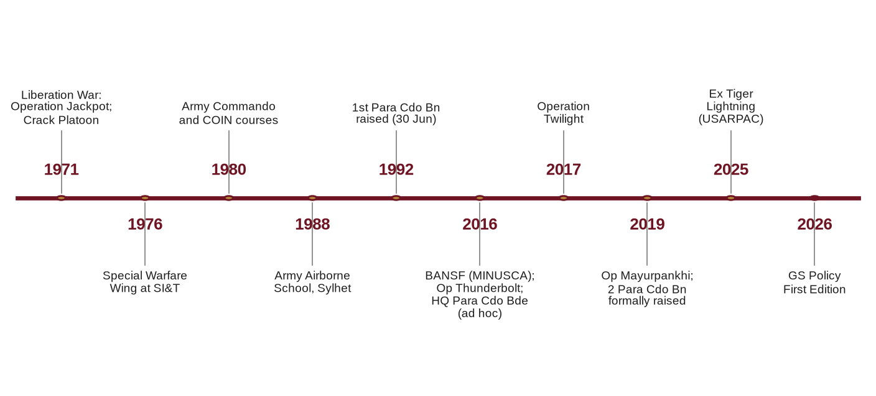
Figure 1: Heritage and development of the Para Commando Brigade, 1971–2026
0102. Need for a Consolidated Policy. Special forces operate at the intersection of the strategic, operational and tactical levels of war. Their employment carries high physical, legal and political risk; their training is the most hazardous in the Army; and their personnel, equipment and sustainment requirements differ markedly from those of conventional units. A DSCSC study of the Para Commando battalions found that manning shortfalls, manifold employment, non-training commitments, shortage of training areas and facilities, and lack of realism were degrading training, while the governing guidance remains dispersed across Acts, Rules, Government orders, AHQ policies, ARTDOC doctrine, "G", "A" and "Q" précis, course précis and unit standing orders. This policy consolidates and harmonises that guidance into a single General Staff reference, and integrates the associated "A" (personnel and administration) and "Q" (logistics) policy, so that the Formation is commanded, trained, administered and sustained as one coherent system.
Aim
0103. The aim of this policy is to lay down the General Staff policy, together with the associated "A" and "Q" policy, for the command, employment, training, administration and sustainment of the Para Commando Brigade, in order to generate and sustain a strategically responsive, legally compliant and professionally superior special forces capability for the Bangladesh Army.
Scope
0104. This policy is arranged in the following chapters:
a. Chapter I : General.
b. Chapter II : Strategic and Conceptual Framework.
c. Chapter III : Command, Control and Organisation.
d. Chapter IV : Operations.
e. Chapter V : Intelligence and Security.
f. Chapter VI : Training.
g. Chapter VII : Doctrine, Capability Development and Communications.
h. Chapter VIII : Personnel and Administration ("A").
j. Chapter IX : Logistics and Sustainment ("Q").
k. Chapter X : Legal, Civil-Military, Media and Information.
l. Chapter XI : Safety, Risk Management, Inspection and Audit.
m. Chapter XII : Implementation, Responsibilities and Review.
0105. The annexes listed at the end of Chapter XII form part of this policy. An annex that is completed with operational detail (names, locations, notice-to-move times, target data) is to be re-graded and handled in accordance with its content as laid down at Annex M.
Applicability, Precedence and Conventions
0106. Applicability. This policy applies to HQ Para Commando Brigade and to all units, sub-units, training wings and detachments under command, and to all personnel posted, attached, or undergoing selection or qualification training with the Formation. Personnel of other Arms, Services or agencies attached for operations or training are bound by it to the extent specified in their attachment orders.
0107. Precedence. This policy is subordinate to the Constitution, Acts of Parliament, Rules, Government orders and Army Headquarters (AHQ) policy (References A, B and D). In the event of conflict, the higher authority prevails and the discrepancy is to be reported to HQ Para Commando Brigade (BM) for resolution. Where AHQ policy is silent, this policy governs. Unit standing orders and SOPs are to conform to this policy. The hierarchy is shown at Figure 2.
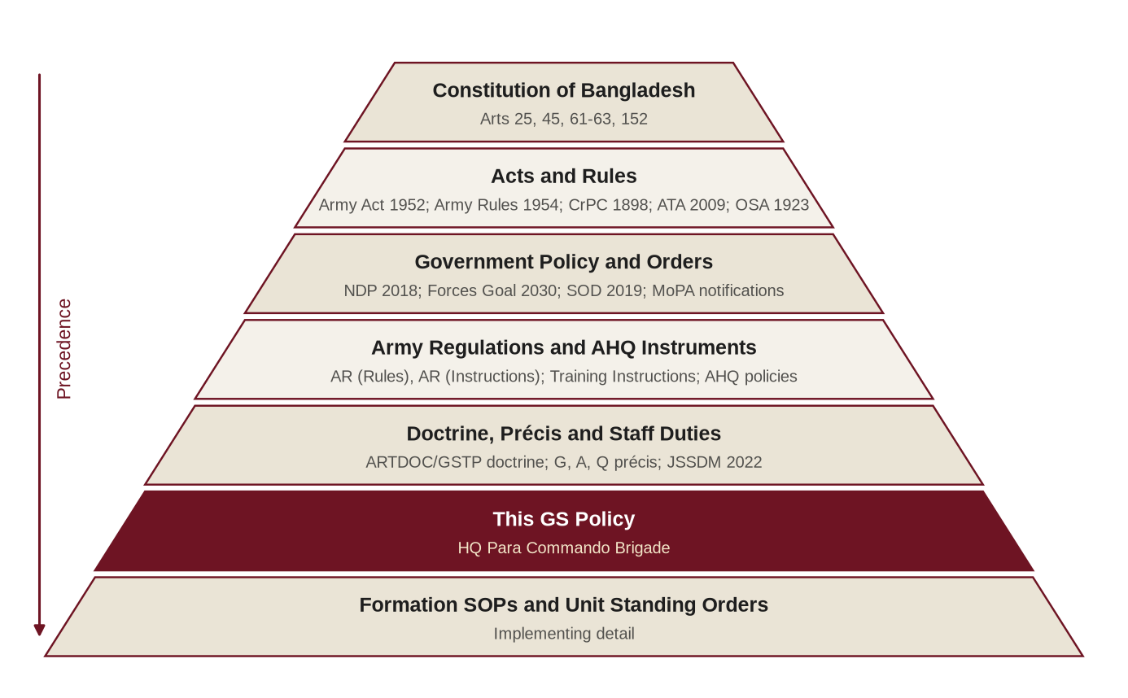
Figure 2: Hierarchy of authority governing this policy
0108. Definitions and Abbreviations. Definitions and abbreviations used in this policy are at Annex B. Where a term is not defined, its meaning in AHQ and ARTDOC publications applies.
0109. Staff Duties and Citation Conventions. This policy is written in accordance with the Joint Services Staff Duties Manual 2022 (Reference E). Documents listed under "References" in the prefatory part are cited in the text as "Reference A", "Reference B" and so on; other sources are cited by numbered footnote. Full particulars of every source, and a cross-index of the paragraphs in which each is cited, are at Annex A (Bibliography). Paragraphs are numbered by chapter, and unused paragraph numbers at the end of each chapter are marked "Reserved".
0110 – 0199. Reserved.

CHAPTER-II
STRATEGIC AND CONCEPTUAL FRAMEWORK
Constitutional, Legal and Policy Foundation
0201. Constitutional Basis. The Formation derives its authority from the Constitution of the People's Republic of Bangladesh (Reference A):
a. Article 61 vests the supreme command of the defence services in the President, its exercise being regulated by law.
b. Article 62 provides that Parliament shall by law provide for the raising and maintenance of the defence services, the grant of commissions, the appointment of Chiefs of Staff and the discipline and other matters relating to the defence services.
c. Article 63 provides that war shall not be declared, nor shall the Republic participate in any war, except with the assent of Parliament.
d. Article 45 saves the operation of disciplinary law relating to members of the disciplined forces, and Article 152 includes the defence services within the disciplined forces.
e. Article 25 sets out the principles of State policy in international relations, which underpin the Formation's contribution to United Nations peace operations and defence cooperation.
0202. Statutory Framework. The Army Act, 1952 and the Army Rules, 1954 govern the discipline, administration and legal liability of every member of the Formation (References B and C). Employment in aid to civil power is governed by the Code of Criminal Procedure, 1898 (Sections 127 to 132) and the Anti-Terrorism Act, 2009 (as amended) (References H and K), together with Government and AHQ instructions. The right of private defence is governed by the Penal Code, 1860 (Sections 96 to 106) (Reference J); protection of classified information by the Official Secrets Act, 1923 (Reference L). The complete statutory framework is listed at Annex A and summarised for operational use at Annex L.
0203. National Policy Guidance. Bangladesh's foreign policy principle of "friendship to all, malice towards none", rooted in Article 25 of the Constitution, frames its defence posture as defensive and its international engagement as cooperative. The National Defence Policy, 2018 and Forces Goal 2030 (References F and G), under which new infantry divisions were raised at Sylhet, Ramu and Barishal and a Special Forces division has been envisaged, provide the policy and force-development framework within which the Formation is raised, equipped and employed. The roles of the Army, as laid down in Government and AHQ policy, from which the Formation's roles derive, may be summarised as follows:
a. Primary Role. Defence of the sovereignty and territorial integrity of Bangladesh against external aggression.
b. Secondary Roles. Aid to civil power when lawfully requisitioned, including counter-terrorism and internal security operations; humanitarian assistance and disaster response under the Disaster Management Act, 2012 and the Standing Orders on Disaster, 2019 (References N and P); and participation in nation-building activities as directed by the Government.
c. International Role. Contribution to United Nations peace operations and defence diplomacy as directed by the Government.
Bangladesh Army Institutional Framework
0204. Army Headquarters. Army Headquarters functions under the Chief of Army Staff through the branches of the Principal Staff Officers: the General Staff (GS) Branch, the Adjutant General's (AG's) Branch, the Quartermaster General's (QMG's) Branch, the Master General of Ordnance (MGO) Branch, the Engineer-in-Chief's (E-in-C's) Branch, the Military Secretary's (MS) Branch and the Judge Advocate General's (JAG) Branch. In this policy, "G" matters correspond to the GS Branch; "A" matters to the AG's, MS and JAG Branches; and "Q" matters to the QMG's, MGO and E-in-C's Branches (Figure 3). The Armed Forces Division (AFD) coordinates inter-service matters and the employment of the Armed Forces in aid to civil administration, disaster response and United Nations operations.
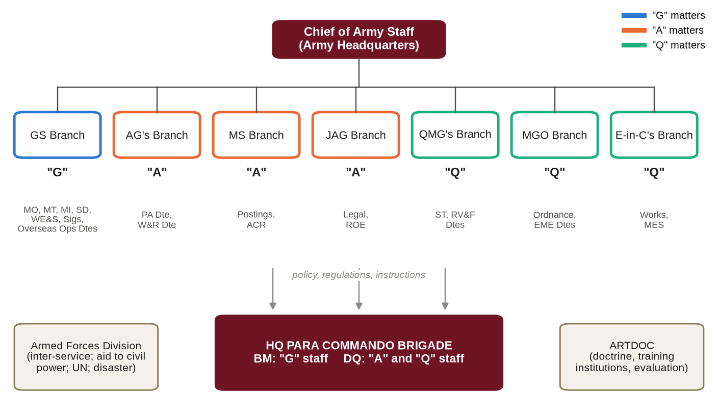
Figure 3: Army Headquarters branches and their "G", "A" and "Q" linkage to the Formation
0205. ARTDOC and Training Institutions. The Army Training and Doctrine Command (ARTDOC), raised on 25 July 2007 with its headquarters at Momenshahi Cantonment, Mymensingh, oversees training evaluation and reform, concept and doctrine development and modernisation, and the Army's training institutions. Institutions directly relevant to the Formation include SI&T and its Special Warfare Wing (Jalalabad Cantonment) and the Army Airborne School (Sylhet Cantonment) for commando and parachute training (Reference V); the Bangladesh Institute of Peace Support Operation Training (BIPSOT), Rajendrapur; the Defence Services Command and Staff College and the National Defence College, Mirpur; the Military Institute of Science and Technology; and the centres and schools of the Arms and Services for specialist courses.
0206. Army Regulations, Instructions and Directives. Within the framework of the Army Act and Army Rules, the Army is administered through the Army Regulations (Rules) and Army Regulations (Instructions) (Reference D), the Army Leave Rules, the Defence Services Regulations (including the Financial Regulations), the Army Dress Regulations, Army Instructions and Orders, AHQ policy letters and the AHQ Training Instructions (Reference S). This policy applies those instruments to the special requirements of the Formation; it neither replaces nor relaxes any of them.
0207. Précis and Doctrine. The "G", "A" and "Q" précis and the Staff Duties précis (Reference U), the DSCSC Decision Making Process précis and Staff Officers' Handbook, and Army doctrine such as Operations of War (Reference T) provide the common staff and doctrinal language of this policy. The linkage between each policy area, the responsible AHQ branch or directorate, the governing Army instrument, the relevant précis and the Formation document is at Annex R.
0208. Location and Area Relationships. The Formation is located at Jalalabad Cantonment, Sylhet, in the area of HQ 17 Infantry Division. Proximity to Osmani International Airport facilitates air movement, while distance from Dhaka, Chattogram and other high-risk areas has implications for response time that are addressed in Chapter IV. The Formation, its training institutions and its principal areas of interest are shown at Figure 4.
Strategic Environment
0209. Strategic Setting. Bangladesh, with a population of some 170 million, occupies a geostrategically significant position at the head of the Bay of Bengal, sharing land borders with India and Myanmar. The settlement of its maritime boundaries with Myanmar (2012) and India (2014) secured a maritime area of about 118,800 square kilometres and its offshore resources. National critical infrastructure, including the Rooppur Nuclear Power Plant, the Padma Bridge, the Karnaphuli Tunnel, the ports of Chattogram, Mongla, Payra and Matarbari, the international airports, export processing zones and the diplomatic enclave of Gulshan and Baridhara, presents high-value targets. Deltaic and riverine terrain, the haor wetlands of the north-east, the hills and forests of the Chittagong Hill Tracts (CHT), the Sundarbans and dense urban centres shape the character of every operation.
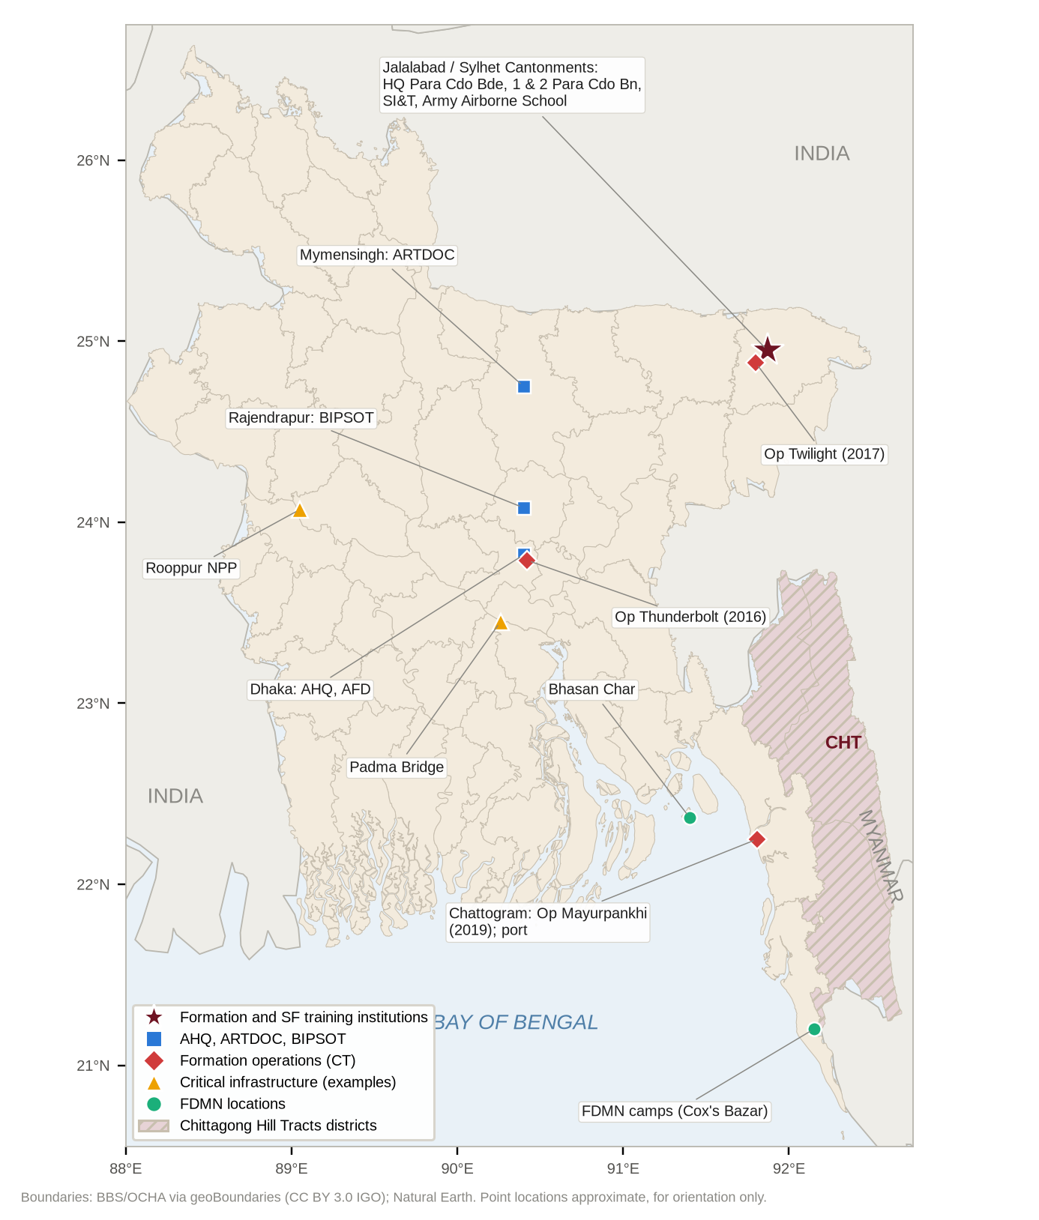
Figure 4: Bangladesh: Formation location, Army institutions, Formation operations and areas of special interest
0210. Threat Spectrum. The Formation must be prepared to operate across the full spectrum of threats, including:
a. Conventional and Hybrid Threats. Threats to sovereignty and territorial integrity, including combinations of conventional, irregular, cyber and information methods.
b. Terrorism and Violent Extremism. Bangladesh has experienced countrywide terrorist attacks, including the serial bombings of 17 August 2005 in 63 of the 64 districts and the Holey Artisan Bakery attack of 1 July 2016. Residual and transnational extremist networks, online radicalisation and complex attacks (including hostage-taking and incidents involving aircraft) against soft targets, foreign nationals, places of worship and critical infrastructure remain threats.
c. Myanmar Border and FDMN. Instability in Rakhine State, where a non-state armed group has controlled the entire 271-kilometre Bangladesh–Myanmar border since December 2024; the presence of more than one million Forcibly Displaced Myanmar Nationals (FDMN) in Cox's Bazar and Bhasan Char, with continuing arrivals; and the activity of armed and criminal groups in and around the camps.
d. Chittagong Hill Tracts. Armed groups and inter-group violence in the CHT, where the Army continues to support the civil administration under Operation Uttoron (since 2001), including joint operations in Bandarban after the bank robberies at Ruma and Thanchi in April 2024.
e. Transnational Crime. Trafficking in arms, explosives, narcotics (notably methamphetamine across the south-eastern border) and persons.
f. Maritime Threats. Piracy, armed robbery and threats to ports, shipping and offshore installations in the Bay of Bengal.
g. Internal Security. Periods of serious public disorder requiring prolonged deployment of the Armed Forces in aid to civil power, as from July and August 2024, when commissioned officers were also conferred special executive magistracy powers by Government notification (Reference Q).
h. Cyber, Electronic and Information Threats. Disinformation targeting the Armed Forces, and hostile exploitation of the personal data and digital footprint of special forces personnel and their families (Reference M).
j. Natural and Climate-Induced Disasters. Cyclones (e.g., Sidr 2007, Amphan 2020, Remal 2024), monsoon and flash floods (e.g., Sylhet 2022 and the eastern districts 2024), landslides in the hill districts, earthquake risk to Dhaka and Sylhet, and structural collapse (e.g., Rana Plaza, 2013).
0211. Technological Trends. The proliferation of small unmanned aircraft systems, commercial satellite imagery, encrypted communications, night-vision devices, artificial intelligence and pervasive surveillance (including facial recognition and social-media geolocation) is eroding the traditional advantages of special forces while offering new opportunities. The Formation's doctrine, training and equipment policy must account for both.
0212. Implications for the Formation. The environment demands a special forces capability that is:
a. Strategically Responsive. Deployable at short notice by air, land and water throughout the national territory and, when mandated, abroad.
b. Intelligence-Led and Precise. Able to apply discriminate force with minimum collateral effect.
c. Legitimate. Operating strictly within the law, with an accountability that sustains public trust.
d. Joint and Interagency. Integrated with the Navy, Air Force, Army Aviation, law-enforcement and intelligence agencies.
e. Resilient. Protected against physical, cyber and information threats to its people and their families.
Conceptual Foundations of Special Operations
0213. Nature of Special Operations. For the purposes of this policy, special operations are military activities conducted by specially designated, selected, organised, trained and equipped forces, using distinct techniques and modes of employment, to achieve objectives of strategic or operational significance, frequently in hostile, denied or politically sensitive environments and at high physical and political risk. They differ from conventional operations in their degree of risk, their independence from friendly support, their reliance on detailed intelligence and their dependence on the quality of individual operators.
0214. The Special Operations Forces Truths. The following universally accepted truths are adopted as guiding tenets for all command, staff and administrative decisions in the Formation; their practical implications for manning, training and sustainment are at Annex D:
a. Humans are more important than hardware.
b. Quality is better than quantity.
c. Special operations forces cannot be mass-produced.
d. Competent special operations forces cannot be created after emergencies occur.
e. Most special operations require non-special operations forces assistance.
0215. Theory of Relative Superiority. A small force can gain a decisive advantage over a larger or well-defended enemy at the pivotal moment of an engagement ("relative superiority"), provided that the mission is planned and executed in accordance with six principles (Figure 5). These principles are to be reflected in every operational plan, rehearsal and after action review (Annexes D and K):
a. Simplicity. Limited objectives, good intelligence and innovation.
b. Security. Denying the enemy any advantage from foreknowledge of the operation.
c. Repetition. Rehearsal until actions become instinctive.
d. Surprise. Catching the enemy off guard through deception, timing and exploitation of vulnerabilities.
e. Speed. Reaching and completing the objective as quickly as possible, thereby reducing the "area of vulnerability".
f. Purpose. Understanding and executing the prime objective of the mission regardless of emerging obstacles, supported by personal commitment.
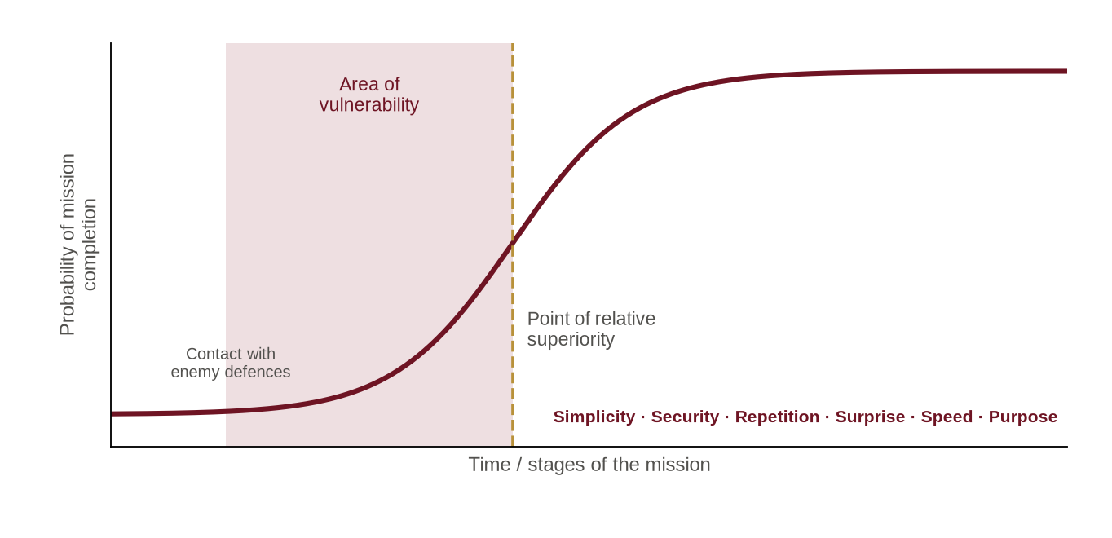
Figure 5: Relative superiority: the area of vulnerability and the six principles (conceptual, after McRaven)
0216. Strategic Utility. Special forces offer the national leadership economy of force and an expansion of strategic choice, providing options between inaction and large-scale military commitment. Among the conditions for success are clear policy demand, political tolerance and support, feasible objectives and superior tactical competence and flexibility. Commanders and staff must therefore guard against both under-employment (holding the capability in reserve until it atrophies) and misemployment (using it for tasks that conventional forces can perform).
0217. Special Forces Qualities. The value of special forces lies in their ability to overcome the friction of war through the quality of their people: elite warriors possessing creativity and flexibility. The Formation's selection, training and personnel policies (Chapters VI and VIII) are designed to produce and retain such individuals.
0218. Principles of War. The principles of war taught in Bangladesh Army doctrine and précis (References T and U) apply fully to special operations; the indirect approach and the use of deception and surprise are especially relevant. Their particular application to special forces is at Annex D.
0219. Mission Command. The Formation adopts mission command as its command philosophy. Commanders state their intent and the purpose of the mission, allocate resources and set constraints, and allow subordinates maximum freedom of action in how they achieve the result. Mission command depends on mutual trust, shared understanding, disciplined initiative and rigorous training. It does not relieve commanders of the responsibility to supervise, nor subordinates of the duty to act within the law and the commander's intent.
0220. Ethos and Values. Every member of the Formation is to embody the core values of the Bangladesh Army [as laid down by AHQ], reinforced by the following special forces ethos:
a. Courage. Physical and moral, including the courage to report error and to refuse a manifestly unlawful order.
b. Integrity. Absolute honesty in reporting, accounting and personal conduct.
c. Discipline. Self-discipline that does not depend on supervision.
d. Humility and Discretion. Quiet professionalism that does not seek public recognition.
e. Excellence. Relentless pursuit of mastery of skills and standards.
f. Loyalty and Selflessness. To the nation, the Constitution, the chain of command and comrades.
Mission, Roles and Tasks of the Formation
0221. Mission. [To be aligned with the AHQ-approved Charter of Duties (Reference R).] Proposed mission statement: "To provide the Bangladesh Army and, when directed, the Government with a strategically responsive special forces capability to conduct special reconnaissance, direct action, counter-terrorism including hostage rescue, and other special operations in peace, crisis and war, within Bangladesh and, when mandated, abroad."
0222. Core Tasks. The Formation is to be organised, trained and equipped to conduct the following core tasks, consistent with the tasks and capabilities identified for the Para Commando battalions and with allied and UN practice:
a. Special Reconnaissance (SR). Reconnaissance and surveillance in hostile, denied or sensitive areas to collect or verify information of strategic or operational significance, including target acquisition and post-strike assessment.
b. Direct Action (DA). Short-duration strikes and other small-scale offensive actions (raids, ambushes, sabotage and demolition, seizure, destruction, capture or recovery) against high-value targets, including deep inside adversary territory.
c. Counter-Terrorism (CT) including Hostage Rescue (HR). Intervention in terrorist incidents in buildings, vehicles, trains, aircraft and, with the Bangladesh Navy, ships and offshore installations, when employed in aid to civil power on lawful requisition (References H and K).
d. Irregular and Resistance Operations in National Defence. Organising, training and supporting stay-behind and resistance activity in areas temporarily under adversary control, within the concept of total national defence and as directed by AHQ.
e. Airborne and Special Insertion Operations. Insertion by parachute (including military free-fall), helicopter, boat, swimming and land infiltration in support of the Army and of field formations.
f. Military and Security Force Assistance. Training, advising and assisting friendly forces and, when directed, national security agencies.
g. Personnel Recovery and Non-Combatant Evacuation. Recovery of isolated personnel and support to non-combatant evacuation operations (NEO) as directed by the Government.
h. Special Operations in United Nations Peace Operations. Employment as a UN-mandated special forces unit, principally for special reconnaissance, surveillance and targeted operations in support of the mandate, including the protection of civilians (Reference W).
0223. Supporting Tasks.
a. Specialised support to humanitarian assistance and disaster response: swift-water and flood rescue, collapsed-structure and high-angle access, parachute insertion into isolated areas and communications in disrupted areas.
b. Close protection and specialised security tasks during events of national importance, as directed by AHQ.
c. Conduct of special forces and commando training for the Army and, as directed, for other services and agencies.
d. Test, evaluation and development of special forces doctrine, tactics, techniques and procedures (TTPs) and equipment.
0224. Employment Constraints. Special forces are a scarce national asset that cannot be mass-produced. They are not to be employed on tasks that conventional forces can perform, including static guard duties, routine patrolling, crowd control or general internal security duties, except in extremis on the specific orders of AHQ. Requests for such employment are to be referred to HQ Para Commando Brigade, which will advise the requesting authority and AHQ on appropriate alternatives.
0225 – 0299. Reserved.

CHAPTER-III
COMMAND, CONTROL AND ORGANISATION
Command Status and Employment Authority
0301. Command Status. The Formation's command status is as laid down in the AHQ Order of Battle and employment policy (Reference R) [confirm current arrangement]. In 2019 the Para Commando battalions were reported to be under command of AHQ (Military Operations Directorate) for operations, HQ 17 Infantry Division for logistics, and AHQ (Military Training Directorate) for training, a division of responsibility that the Formation headquarters now coordinates. For operations, command relationships will be specified in the relevant AHQ operation order or instruction. Command relationship terms are defined at Annex E.
0302. Employment Authority. Operational employment of the Formation or any of its elements requires the authority of AHQ (GS Branch, Military Operations Directorate), subject to the following; the employment authority matrix is at Annex E:
a. Aid to Civil Power. Only on the lawful requisition of the civil authority, processed through the channels laid down by the Government (Armed Forces Division) and AHQ (Reference H).
b. United Nations and Overseas Deployment. Only on Government approval, through the Armed Forces Division and AHQ (Overseas Operations Directorate).
c. Disaster Response. In accordance with the Standing Orders on Disaster, 2019 and AHQ instructions (Reference P).
d. Immediate Response. Nothing in this policy restricts the right of private defence (Reference J) or the duty to save life in an emergency. Any such action is to be reported to HQ Para Commando Brigade and AHQ immediately.
0303. Retention of Special Forces Command. Special forces are most effective when commanded by special forces commanders. When elements of the Formation support another formation or agency, they will normally be placed under operational or tactical control of the supported commander for a specified task, time and area, while command, administration and technical control are retained through the special forces chain. A special forces liaison officer (SFLO) is to be provided to every supported headquarters.
0304. Task Organisation. For operations the Formation will generate task-organised groups: Special Operations Task Groups (SOTG) built around a Para Commando battalion headquarters, with Special Operations Task Units and teams below them, and enablers (intelligence, communications, medical, explosive ordnance disposal (EOD), aviation liaison, military working dogs and logistics) tailored to the mission.
Command and Control in Counter-Terrorism Incidents
0305. Civil Primacy. In domestic counter-terrorism, primacy rests with the civil authority and law-enforcement agencies. The Formation is employed only when the Government decides that an incident is beyond the capacity of the police and a lawful requisition has been made (References H and K).
0306. Phases of Command. Command and control at a terrorist incident will follow the phases at Figure 6; the details are to be laid down in the Formation CT/HR SOP:
a. Containment. The police and other agencies establish the outer and inner cordons, gather information and open negotiation. On deployment the Formation places a reconnaissance and liaison element with the civil incident commander and prepares an emergency action plan from the moment of arrival.
b. Handover. On Government decision, the designated civil authority hands over control of the incident site to the special forces commander in writing, specifying the time, area and purpose. Negotiation remains a civil responsibility.
c. Resolution. The special forces commander plans and executes the intervention. An emergency action may be executed before a deliberate plan is authorised only if the lives of hostages are in imminent danger and within the authority delegated at handover.
d. Handback. On completion of the intervention and clearance (including EOD clearance), control of the site is handed back to the civil authority in writing for investigation, forensic examination and restoration.
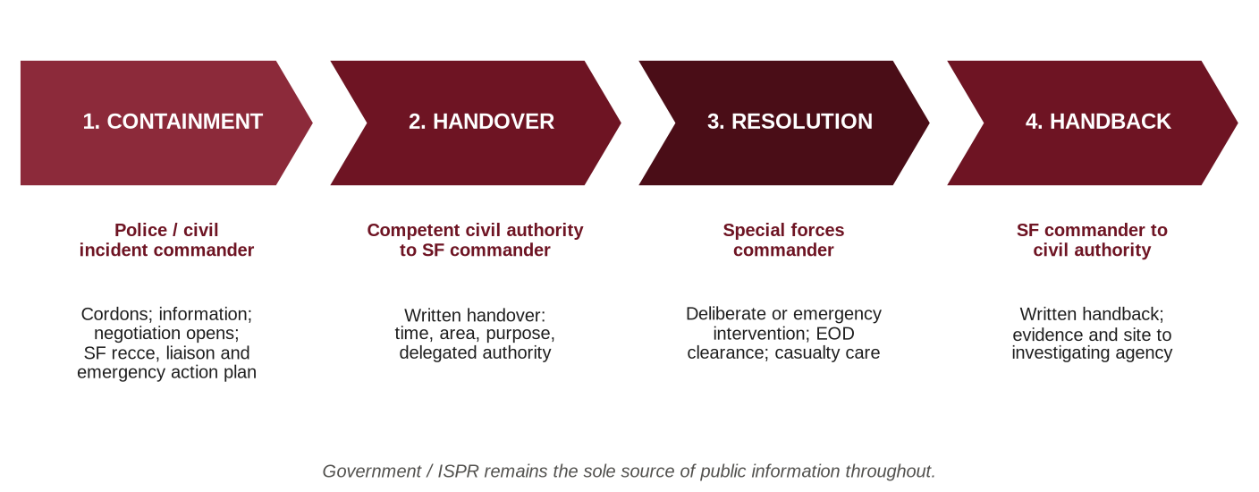
Figure 6: Phases of command and control at a terrorist incident
0307. Joint Command Post. A Joint Command Post co-located with the civil incident commander will integrate the Formation, police, intelligence agencies, fire service, medical services and other agencies. Public information on the incident will be released only by the Government or, for the Armed Forces, by the Inter Services Public Relations Directorate (ISPR).
Organisation and Staff
0308. Organisation. The Formation comprises a Headquarters, Para Commando battalions, training elements, and combat support and combat service support elements as authorised in the establishments approved by AHQ (illustrative outline at Figure 7 and Annex C). Proposals for amendment of establishments are to be initiated by units, consolidated by HQ Para Commando Brigade (BM) and forwarded to AHQ (Staff Duties Directorate) with full justification.
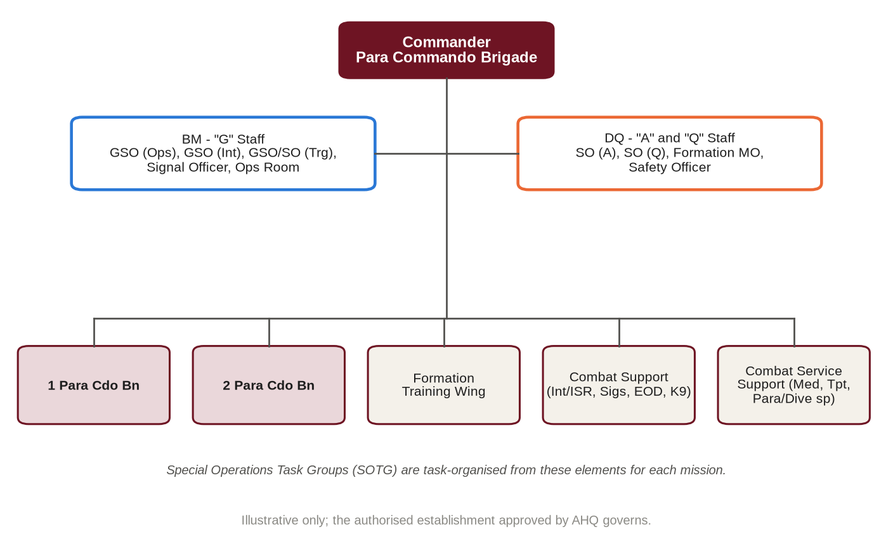
Figure 7: Outline organisation of the Formation (illustrative)
0309. Headquarters Staff Functions. Within HQ Para Commando Brigade, staff functions follow Army staff duties in the field:
a. The Commander is responsible to AHQ for the readiness, employment, training, discipline, administration and welfare of the Formation.
b. The Brigade Major (BM) is the principal General Staff officer, responsible for operations, intelligence, training, staff duties, communications and doctrine, and for coordinating the work of the headquarters.
c. The DAA&QMG (DQ) is responsible for personnel administration ("A") and logistics ("Q"), including discipline, welfare, medical, supply, transport, equipment, ammunition, works and finance.
d. The General Staff Officers (Operations, Intelligence and Training), the Signal Officer, the Formation Medical Officer and other specialist staff support the BM and DQ as detailed at Annex C and in the responsibility matrix at Annex P.
0310. Battle Rhythm and Staff Procedures. The headquarters will maintain the following routine:
a. Daily. Operations and readiness update in the Operations Room.
b. Weekly. Commander's conference covering G, A and Q matters.
c. Monthly. Training and administrative conference; Operational Readiness Report (ORR) to AHQ [format and due date as per AHQ instructions].
d. Quarterly. Commander's review of Key Performance Indicators (Annex I), safety review and security review.
e. Annually. Formation validation exercise, command inspection and review of this policy.
f. Staff Work. All staff work is to conform to JSSDM 2022 (Reference E) and AHQ instructions on correspondence, filing and records management.
0311 – 0399. Reserved.

CHAPTER-IV
OPERATIONS
Operational Philosophy
0401. Principles of Employment. Operations by the Formation will be governed by the following principles:
a. Intelligence-Led. No operation without the best available intelligence and a continuous intelligence update.
b. Legality and Legitimacy. Every operation must have a lawful basis, approved rules of engagement (ROE) and legal review.
c. Precision and Discrimination. Force must be necessary, proportionate and directed only at legitimate targets.
d. Surprise, Speed and Simplicity. In accordance with the theory of relative superiority.
e. Centralised Direction, Decentralised Execution. AHQ approves the mission; the Formation commands its execution.
f. Jointness. Integrated planning with supporting services and agencies from the outset.
g. Force Protection. Including the protection of operators' identities and families.
Readiness
0402. Graduated Readiness. The Formation will maintain graduated readiness in three tiers (Figure 8 and Annex E):
a. Tier 1 : Immediate Response Force (IRF). Validated CT/HR-capable team(s) with enablers at a Notice to Move (NTM) of [●].
b. Tier 2 : Follow-on Force. At an NTM of [●].
c. Tier 3 : Deliberate Force. The remainder of the Formation at an NTM of [●].
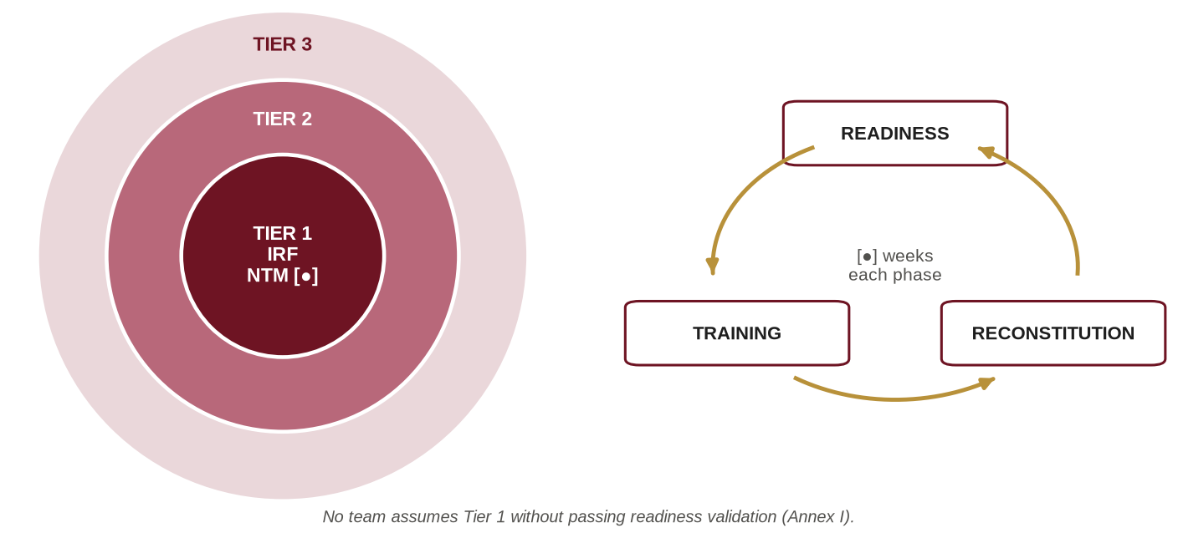
Figure 8: Graduated readiness tiers and the readiness cycle
0403. Readiness Cycle. Units will rotate through a readiness cycle of Readiness, Training and Reconstitution phases of [●] weeks each, so that Tier 1 is continuously filled by a validated team without degrading the training of the Formation. No team is to assume Tier 1 without passing the readiness validation laid down at Annex I.
0404. Positioning of Readiness Forces. The location of Tier 1 and Tier 2 elements, including any forward-based quick reaction element in or near Dhaka (such an element was in place by 2019), Chattogram or other high-risk areas, will be as approved by AHQ. The deployment of commandos by air from Sylhet to Dhaka during Operation Thunderbolt underlines the need to plan for response time, pre-designated air and road movement, and pre-positioned mission equipment.
0405. Readiness Reporting. Readiness will be reported in the monthly ORR and immediately on any change affecting Tier 1 or Tier 2 (manning, equipment, transport, communications or medical cover).
0406. Alert, Recall and Activation. Alert, recall and activation procedures, code words, pre-packed mission kits, loading plans and movement (road, air and water) are to be laid down in the Formation Operations Room SOP and exercised at least [●] times a year, including at least one unannounced activation.
Planning and Conduct of Operations
0407. Planning Process. Operations will be planned using the Army's Decision Making Process (DMP) as taught at DSCSC (mission analysis including intelligence preparation of the battlefield; course of action development; course of action analysis and comparison by wargaming; decision and execution), adapted for special operations as shown at Figure 9 and Annex K. The following are mandatory:
a. Target and environment analysis (e.g., CARVER for targets; PMESII and ASCOPE for the operating environment).
b. Commander's Critical Information Requirements (CCIR), abort criteria and go/no-go points.
c. An emergency action plan prepared at the earliest stage of any hostage-rescue operation.
d. Isolation of the mission team for planning where security and time permit.
e. A briefback to the approving commander.
f. Rehearsals, full-scale wherever possible, to achieve the principle of repetition.
g. Casualty evacuation, personnel recovery, communications (PACE) and contingency plans.
h. Legal review of the plan and confirmation of the ROE.
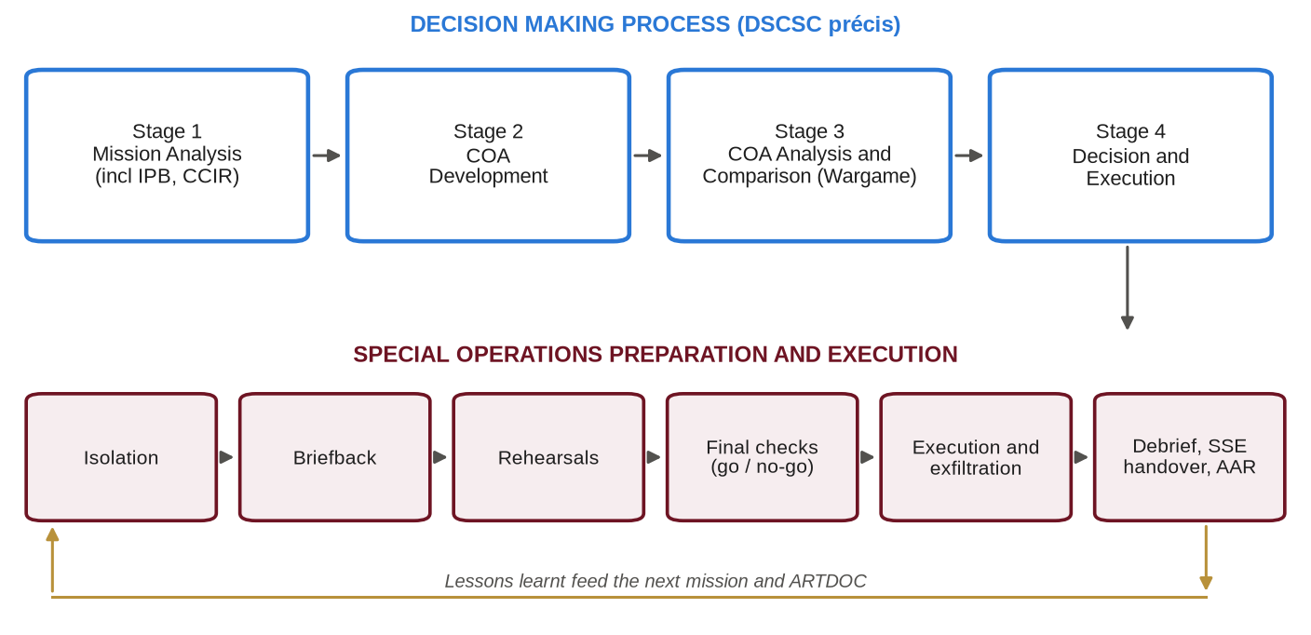
Figure 9: The Decision Making Process adapted for special operations
0408. Execution. Commanders at every level are to position themselves to influence the decisive point, maintain communications with the next higher headquarters and report through the prescribed formats. Deviation from the approved plan beyond a commander's delegated authority requires reference to the approving authority, unless lives are in imminent danger.
0409. Post-Operation Activities.
a. Hot debrief within [●] hours of return.
b. Post-operation report to AHQ within [●].
c. After Action Review (AAR) within [●] days in the format at Annex K, with lessons forwarded to ARTDOC.
d. Critical incident stress support for all personnel involved (Chapter VIII).
e. Accounting of weapons, ammunition and sensitive equipment; use-of-force reports; legal review.
f. Recommendations for honours and awards (Chapter VIII).
Joint and Interagency Integration
0410. Joint Integration. The Formation will develop habitual working relationships with:
a. Army. Army Aviation (insertion, extraction, casualty evacuation and ISR), Artillery (fire support), Engineers (EOD and mobility), Signals, Army Medical Corps, Corps of Military Police, Remount Veterinary and Farm Corps (military working dogs) and intelligence units.
b. Bangladesh Navy. Special Warfare Diving and Salvage (SWADS) for maritime counter-terrorism, combat diving, boarding operations and riverine/coastal insertion; and naval platforms for maritime movement.
c. Bangladesh Air Force. Airlift, parachute and air-delivery operations, casualty evacuation and ISR.
d. Joint SOPs. Joint SOPs are to be developed with each service and exercised at least once a year.
0411. Interagency Integration. Effective counter-terrorism and national-emergency response requires habitual relationships with the Bangladesh Police (including the Counter Terrorism and Transnational Crime unit, the Anti-Terrorism Unit, SWAT and Special Branch), Rapid Action Battalion, Border Guard Bangladesh, Bangladesh Coast Guard, Bangladesh Ansar and Village Defence Party, Fire Service and Civil Defence, the Ministry of Disaster Management and Relief and its Department of Disaster Management (including the National Disaster Response Coordination Centre), the Civil Aviation Authority of Bangladesh and airport security authorities, port authorities, health services and intelligence agencies (DGFI, NSI and DMI). Multinational disaster assistance will be coordinated through the Multinational Coordination Centre arrangements of the Armed Forces Division.
Specific Operational Contexts
0412. Operations in Defence of the Nation. In war, the Formation is a strategic and operational asset employed under AHQ direction (Reference T). Tasks may include special reconnaissance in adversary depth; direct action against critical nodes (command and control, logistics, air defence, communications and crossings); support to stay-behind and resistance activity within the concept of total national defence; target acquisition for long-range fires; personnel recovery; and support to deception. Special forces operating areas and fire support coordination measures are to be established with supported formations to prevent fratricide.
0413. Counter-Terrorism in Aid to Civil Power. In addition to the command arrangements in Chapter III:
a. The legal basis, requisition and delegated authority are to be confirmed in writing before commitment (Annex L) (References H and K).
b. Minimum force consistent with the safety of hostages, the public and the force is to be applied.
c. The incident site is to be treated as a crime scene: evidence is to be preserved and a documented chain of custody maintained for handover to the investigating agency.
d. Released hostages are to be received, identified, medically triaged and handed over to the designated civil authority.
e. Apprehended persons are to be handed over to the police without delay. Formation personnel will not conduct interrogation beyond immediate tactical questioning necessary for the safety of life.
f. All use of force, casualties and damage are to be recorded and reported.
g. Aircraft incidents are to be planned with the Civil Aviation Authority, airport authorities, the operator concerned and BAF, drawing on the lessons of Operation Mayurpankhi, including threat assessment, aircraft familiarisation and coordination of the airport security perimeter.
0414. Operations in the Chittagong Hill Tracts. Formation elements employed in the CHT will operate under the command arrangements designated by AHQ and the instructions governing Operation Uttoron, in support of the civil administration. They are to respect the roles of the CHT Regional Council, the Hill District Councils and traditional institutions under the CHT Peace Accord, 1997 and related laws; avoid harm to the local population and its property; and coordinate with BGB, police and civil authorities.
0415. United Nations Peace Operations. Bangladesh is among the largest contributors to UN peace operations, and the Formation has provided the Bangladesh Special Force (BANSF) to MINUSCA since 2016. Elements deployed on UN missions will be organised, trained and equipped in accordance with the UN Military Special Forces Manual (Reference W), the mission's mandate, ROE and Memorandum of Understanding, and AHQ instructions. Pre-deployment training will include the UN Core Pre-Deployment Training Materials conducted through BIPSOT, mission-specific SF training, protection of civilians, and conduct and discipline including zero tolerance of sexual exploitation and abuse. Selection of UN contingents is not to reduce Tier 1 and Tier 2 readiness below the approved level.
0416. Humanitarian Assistance and Disaster Response. The Formation will support disaster response in accordance with the Disaster Management Act, 2012, the Standing Orders on Disaster, 2019 and AHQ instructions (References N and P), in coordination with the Armed Forces Division and the National Disaster Response Coordination Centre, contributing specialised capabilities: swift-water rescue in haor and riverine areas, as required in the Sylhet floods of 2022; high-angle and collapsed-structure access, as required at Rana Plaza in 2013; parachute insertion; pathfinding for air delivery; and communications in disrupted areas.
0417. Airborne Operations. All parachute operations, including military free-fall, will be conducted under the Formation Parachute Operations SOP (Reference Y), which is to specify authorisation levels, qualified jumpmaster and drop zone safety officer requirements, weather and wind limits, currency requirements, equipment inspection and packing standards, aircraft clearances (with BAF and Army Aviation), and medical, oxygen and physiological training requirements for high-altitude operations.
0418. Maritime and Riverine Operations. Given the deltaic character of Bangladesh, every team is to be proficient in riverine movement, boat handling and waterborne insertion. Combat diving and maritime counter-terrorism will be conducted jointly with Bangladesh Navy (SWADS) under a joint SOP covering qualification, dive supervision, equipment certification, recompression support and safety.
0419. Operations in Special Terrain. Units are to maintain proficiency in the principal terrain types in which Para Commandos are expected to operate: riverine areas, offshore islands and chars, swampy and waterlogged areas, jungles and hills, and dense urban areas, including the hills and jungle of the south-east, high-rise buildings, and coastal and mangrove areas such as the Sundarbans. Terrain-specific TTPs are to be included in Formation SOPs.
Operational Reporting and Records
0420. Reports and Returns. Operational reports (situation, contact, casualty, intelligence and spot reports) will be rendered in the formats and at the timings laid down by AHQ. The Formation Operations Room SOP is to reproduce these formats and the associated communication channels.
0421. Operational Records. Operations logs, orders, briefing materials, ROE, use-of-force reports and AARs are to be retained as classified records for the period laid down in AHQ records-management instructions [●], and are not to be destroyed while any inquiry or legal proceeding is pending.
0422 – 0499. Reserved.

CHAPTER-V
INTELLIGENCE AND SECURITY
Intelligence
0501. Intelligence Philosophy. Special operations are both intelligence-driven and intelligence-generating. The Formation will apply an integrated operations and intelligence cycle (Find, Fix, Finish, Exploit, Analyse, Disseminate: F3EAD, Figure 10) in which the exploitation of every operation feeds the next. Intelligence staff are to be embedded in planning from the receipt of a warning order.
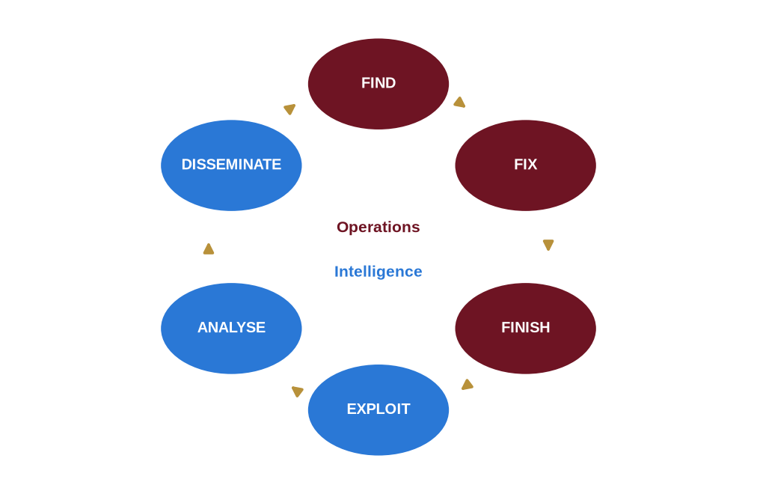
Figure 10: The F3EAD operations-intelligence cycle
0502. Intelligence Organisation and Liaison. The Formation intelligence staff (GSO-2 Int) will direct unit intelligence sections and maintain liaison with AHQ (Military Intelligence Directorate) and, through authorised channels, with DGFI, NSI, police Special Branch and CTTC. Intelligence requirements are to be submitted through the prescribed AHQ channel. Formation elements are not to establish independent liaison with foreign or domestic agencies except as authorised.
0503. Collection. Formation elements collect information primarily through special reconnaissance, surveillance, sensitive-site exploitation and organic ISR (including small unmanned aircraft systems), and receive intelligence from designated agencies. The following constraints apply:
a. Human sources are to be handled only by personnel and agencies authorised by AHQ.
b. Collection within Bangladesh is to be conducted only for authorised operational purposes and strictly within the law (Reference A). Surveillance of citizens outside lawful authority is prohibited.
c. Open-source research is to be conducted only on authorised systems and in a manner that does not expose the identity of personnel or the Formation's interest.
d. Captured material and data are to be handled with a documented chain of custody to preserve evidential value.
0504. Area and Target Intelligence. The Formation will maintain current area studies, target intelligence packages, imagery and mapping for designated areas and potential incident sites (including critical infrastructure, diplomatic enclaves, airports, ports and venues of national importance), prepared in coordination with the relevant agencies and reviewed at least [●] a year.
0505. Intelligence Training. All team leaders and above are to be trained in intelligence preparation of the operating environment, target analysis, sensitive-site exploitation and evidence handling. Designated personnel will be trained as intelligence specialists (Annex G).
Security
0506. Security Policy. The Formation is a high-value target for hostile intelligence services and for terrorist and criminal organisations. Security is a command responsibility at every level and is to be implemented in accordance with AHQ security instructions, the Official Secrets Act, 1923 (Reference L) and the instructions at Annex M.
0507. Personnel Security.
a. All personnel are to be security vetted before selection and re-vetted every [●] years or on any significant change of circumstances.
b. Personnel are to report foreign contacts, foreign travel, significant financial difficulty and any approach by unknown persons seeking information.
c. Commanders at all levels are to be trained to recognise insider-threat indicators; concerns are to be reported through the intelligence staff without delay.
d. Withdrawal of security clearance entails removal from the Formation.
0508. Identity Protection.
a. Names, photographs and personal details of Formation personnel are not to be released to the media or public, or published on any platform, without the approval of AHQ through ISPR.
b. Personnel are not to post photographs in uniform or of equipment, training, locations or activities, nor identify their unit, on social media. Geotagging is prohibited.
c. Families are to be briefed on identity protection and social-media risks.
d. During operations in public view, operators' faces are to be covered where the situation permits.
0509. Information and Communications Security.
a. Classified information is to be graded, marked, stored, transmitted, accounted for and destroyed in accordance with AHQ security instructions and JSSDM 2022 (Paragraphs 0205 to 0213).
b. Only authorised, security-accredited devices and networks are to be used for classified information. Personal mobile phones and smart devices are prohibited in operations rooms, isolation facilities, armouries and briefing areas.
c. Cyber hygiene (authorised software only, removable-media control, strong authentication, periodic audit by Signals) is mandatory for all users (Reference M). Units are to conduct periodic information security awareness and intrusion resilience exercises, including controlled phishing exercises, on the model of the ISAIRE SOP.
0510. Physical Security. Unit lines, armouries, magazines, the Operations Room and the isolation facility are to be protected by access control, key control, intrusion detection where authorised, guard orders and periodic security audits, in accordance with AHQ instructions.
0511. Operations Security (OPSEC). Every unit is to appoint an OPSEC officer and apply the OPSEC process (identify critical information; analyse threats; analyse vulnerabilities; assess risk; apply countermeasures) to all operations, exercises, movements and foreign engagements. Details are at Annex M.
0512. Security Breaches. Any actual or suspected security breach (loss of classified material, weapons, ammunition or sensitive equipment, or unauthorised disclosure) is to be reported immediately to HQ Para Commando Brigade and, within [●] hours, to AHQ. A Court of Inquiry will be convened in accordance with the Army Rules, 1954, and disciplinary action taken under the Army Act, 1952 and, where applicable, the Official Secrets Act, 1923 (References C, B and L).
0513 – 0599. Reserved.

CHAPTER-VI
TRAINING
Training Philosophy
0601. Philosophy. Training is the Formation's principal peacetime activity and the foundation of its operational credibility. The Formation trains to standards, not to time; realism is achieved safely; and every commander is the trainer of the command. Training will be conducted in accordance with the AHQ Training Instructions (Reference S) and Army training doctrine.
0602. Principles of Training. In accordance with the Army doctrine of "train as you will fight", the following principles apply:
a. Train as You Fight. Realistic, mission-focused, stressful and, wherever safe, live.
b. Mastery of Fundamentals. Physical fitness, marksmanship, fieldcraft, navigation, communications and combat medicine before advanced skills.
c. Progressive and Standards-Based. Individual, group, collective, joint and interagency, with progression only on meeting the prescribed standard.
d. Leader-Led. Commanders plan, conduct and evaluate training personally.
e. Integrated Law and Ethics. International humanitarian law, human rights, ROE and ethics integrated into scenarios, not taught in isolation.
f. Safety. Risk managed, never ignored (Chapter XI and Annex J).
g. Adaptive. Training reflects current threats and lessons learnt.
h. Joint and Interagency. Train with those alongside whom the Formation will operate.
Training Responsibilities
0603. Responsibilities.
a. AHQ (MT Dte). Overall training direction through the Training Instructions (Reference S); approval of courses, foreign training and training scales.
b. ARTDOC. Doctrine, training standards and external evaluation.
c. SI&T (Special Warfare Wing) and Army Airborne School. Army Commando, counter-insurgency, parachute and associated courses as per AHQ policy (Reference V). The Special Warfare Wing is a branch of SI&T answerable to the MT Directorate and SI&T, and also conducts parachute training for the para infantry battalions; the Formation is to coordinate instructor and training-aid support with it through SI&T.
d. HQ Para Commando Brigade. Selection; special forces qualification and specialist training; group, collective, joint and interagency training; readiness validation.
e. Units. Individual training (cadres), group and unit collective training, and maintenance of currency.
Training System
0604. Categories of Training. The training of the Para Commando battalions is organised in three broad categories:
a. Individual Training. Comprising courses, run by training institutions over several months, and cadres, run by the Formation or units over about a month. Cadres are promotion-related (to be qualified before appearing for the next rank and conducted by the Para Commando battalions), specialist (special equipment and tactics) or utility cadres.
b. Group Training. Conducted by sub-units as intact bodies; the training year is divided into four training cycles, and companies are scheduled so that every member takes part in at least one.
c. Collective Training. Involving the whole unit to evaluate operational and administrative efficiency: Summer Collective Training, Winter Collective Training (the Army Winter Exercise) and joint training, together with training with friendly foreign forces and expeditions.
0605. Training Objectives. The training objectives of the Para Commando battalions are to prepare them to:
a. Conduct special operations behind adversary lines, on own territory or beyond, using any mode of insertion.
b. Conduct special operations in riverine areas, offshore islands, waterlogged areas, jungles and hills, and in deserts and mountains in UN environments.
c. Conduct small-group operations without supply or support from own or friendly forces for up to two weeks.
d. Support the special operations needs of conventional forces (air insertion, deep target neutralisation, deep reconnaissance and coup de main operations).
e. Plan and conduct special counter-terrorism operations.
f. Prepare for counter-insurgency, post-conflict and overseas peace support operations.
g. Develop the human dimension of the special forces soldier.
h. Qualify every commando in at least one foreign language besides English.
Selection and Assessment
0606. Principles of Selection.
a. Voluntary. No individual is to be nominated for selection without a written volunteer statement.
b. Merit-Based and Transparent. Objective, recorded assessment against published criteria.
c. Holistic. Physical, mental, psychological, ethical and security suitability are all assessed.
d. Humane and Lawful. Selection is to be demanding but safe; ill-treatment, humiliation and unsanctioned punishment are prohibited.
0607. Eligibility and Process. Eligibility criteria, stages of selection, assessment attributes and administrative instructions are at Annex F. In summary, selection comprises unit screening, Formation preliminary screening, the selection course, a selection board presided over by the Commander or a nominated officer, and a probationary period after qualification (Figure 11).
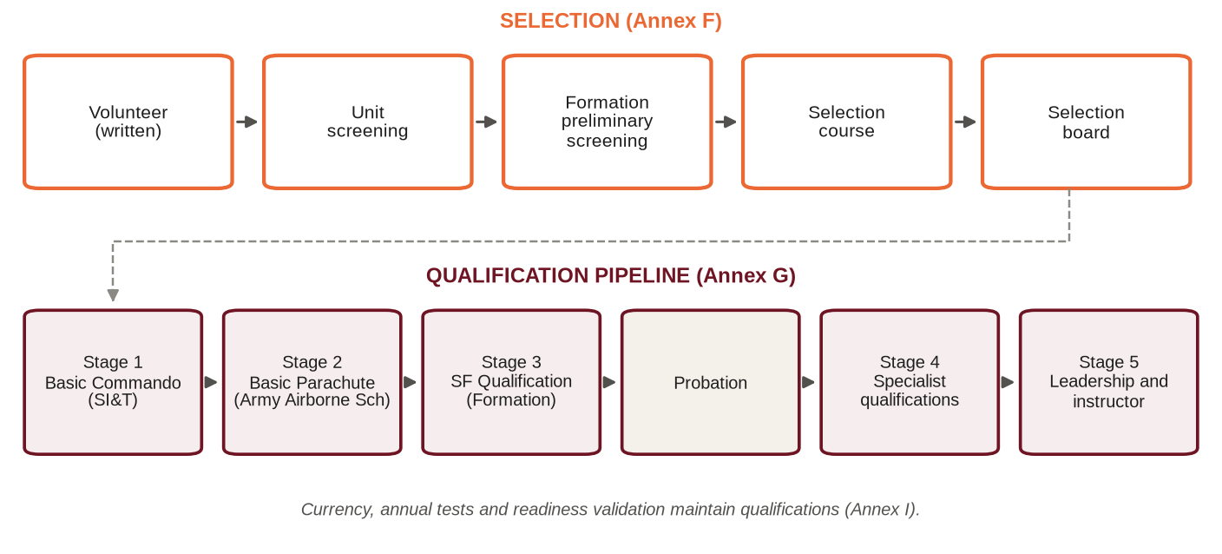
Figure 11: Selection and qualification pipeline
0608. Outcomes.
a. Successful candidates proceed to qualification training (Annex G).
b. A candidate may withdraw voluntarily at any stage without prejudice.
c. A candidate withdrawn on medical grounds may re-attempt after full recovery, subject to [●].
d. A candidate who fails to meet the standard is returned to the parent unit with a fair report; no adverse entry is to be made except for misconduct.
e. The maximum number of attempts is [●].
0609. Selection Data. The Formation will maintain selection data (attrition by stage and cause, injury rates and subsequent performance) to validate and refine the selection process annually, in consultation with ARTDOC and military psychologists.
Qualification and Specialist Training
0610. Qualification Pipeline. No individual is to be employed as a special forces operator until qualified through the pipeline at Annex G (Reference V):
a. Stage 1. Army Commando Course (SI&T, Jalalabad Cantonment); reported in 2019 to be of about six months' duration.
b. Stage 2. Basic Parachute Course (Army Airborne School, Sylhet Cantonment).
c. Stage 3. Special Forces Qualification (Formation): individual and team special forces skills, close-quarter battle (CQB), SR, DA and CT fundamentals, special forces communications and combat medicine.
d. Stage 4. Specialist qualifications as required by the establishment, selected by the Special Warfare Wing or the unit so that the required number of specialists is always available.
e. Stage 5. Leadership and instructor qualifications.
0611. Specialist Skills. Each team is to hold, within its establishment, qualified specialists in sniping and observation; special forces combat medicine (tactical combat casualty care and prolonged field care); demolitions, breaching and improvised explosive device awareness; communications and ISR (including unmanned aircraft systems); fire support coordination and terminal attack control; military free-fall; combat diving and maritime operations (with Bangladesh Navy SWADS); mountain and high-angle operations; jungle and riverine operations; intelligence and sensitive-site exploitation; and designated foreign languages.
0612. Currency and Re-certification. Qualifications are perishable. Currency requirements (minimum parachute descents, dives, live-fire CQB and marksmanship practices within prescribed periods) and re-certification intervals are at Annexes G and I. Personnel who lose currency are not to be employed in that skill until re-qualified.
Individual and Collective Training
0613. Individual Training. Each year every member of the Formation is to complete the following individual training requirements and the annual tests at Annex I:
a. Physical fitness: Army tests (BPET and PPT) and the Formation special forces fitness assessment.
b. Marksmanship in accordance with the Sena Operation Shooting Nirdeshika (SOSN), including group, basic and advanced commando skill firing, CT firing, jungle lane shooting and pistol firing.
c. Swimming and water survival.
d. Navigation by day and night, with and without satellite navigation.
e. Tactical combat casualty care and first aid.
f. Communications and ISR equipment handling.
g. Survival, evasion, resistance and escape (as per the AHQ-approved syllabus).
h. International humanitarian law, human rights, ROE and the Code of Conduct.
j. OPSEC, identity protection and cyber hygiene.
k. Driving and boat handling as per role.
0614. Collective Training.
a. Group (Team and Sub-Unit). CT/HR drills (buildings, vehicles, trains and aircraft), SR and DA battle drills and live-fire, in the four training cycles.
b. Unit and Formation. SR and DA exercises, raids, long-range insertion and extraction, sustained small-group operations, SOTG exercises, command post exercises and an annual validation exercise.
c. Summer and Winter Collective Training. Summer Collective Training as programmed, and the Army's annual winter outdoor exercise (normally about four weeks in December and January) as per AHQ instructions. Para Commando elements are, wherever possible, to join field formations during their collective training to rehearse the special operations they would conduct in war.
d. Joint. With Army Aviation, BAF and Bangladesh Navy (SWADS): a minimum of [●] exercises a year.
e. Interagency. CT exercises with the police and civil agencies: a minimum of [●] a year, including at least one full-scale incident exercise rehearsing the handover and handback procedures.
f. With Friendly Foreign Forces. Bilateral and multilateral exercises approved by AHQ, such as Exercise Tiger Lightning with the US Army Pacific, conducted at Jalalabad Cantonment in July 2025 with a focus on counter-terrorism, jungle warfare and medical evacuation.
0615. Annual Training Cycle. The Formation training year follows the AHQ Training Instructions (Reference S). A model annual cycle and calendar, integrating the readiness cycle and seasonal conditions, is at Annex H. Units are to submit their annual training programmes to HQ Para Commando Brigade by [●] each year.
0616. Language Training. Every commando is to learn at least one foreign language besides English from those designated by the Formation (for example Hindi, Burmese, French or Arabic), with proficiency tested periodically (Annex G).
Leadership Development and Professional Military Education
0617. Officers.
a. Officers continue on Army career courses as per MS Branch policy. Special forces service is not to disadvantage their career progression.
b. Special forces officer development is to include special operations planning using the Decision Making Process, joint and interagency operations, operational law, strategic communication and special forces command.
c. A professional reading programme (Annex A), annual study days and historical studies, including the special operations of 1971 and the Formation's own operations, are to be conducted.
0618. JCOs and NCOs. JCOs and NCOs are to complete Army leadership courses, promotion-related cadres and the Formation team leader and instructor courses. Every team leader is to be formally mentored by an experienced JCO or officer during the first [●] months in appointment.
0619. Foreign Courses and Exercises.
a. Foreign courses and bilateral or multilateral exercises are to be undertaken only with AHQ approval.
b. Nomination is to be on merit through the Formation selection board.
c. A pre-departure security briefing is mandatory.
d. A post-course report is to be submitted within [●] days, and the knowledge gained is to be transferred through train-the-trainer sessions.
e. Formation SOPs and classified material are not to be shared without AHQ authority.
0620. Training Support to Other Agencies. The Formation may provide training to other services and agencies only with AHQ approval, on an agreed syllabus that does not disclose classified TTPs. Records of all such training are to be maintained.
Training Resources, Realism and Evaluation
0621. Training Areas and Facilities. The Formation will develop and maintain, through a master infrastructure plan (Chapter IX), 360-degree live-fire CQB facilities; urban training facilities; multipurpose ranges in which commandos engage targets from varying positions amid built-up and jungle settings with smoke and sound, rather than only fixed practices; parachute training facilities including the mock tower (about 34 feet) required for the current parachute system; drop zones; a swimming and dive training facility; climbing and high-angle facilities; an obstacle and endurance course; and a strength and conditioning centre. The use of Swarno Dweep (Hatiya, Noakhali) as a special forces training area and drop zone, particularly in the monsoon, is to be pursued with AHQ (MT Dte).
0622. Realism and Simulation. Commandos are to be familiarised, through authorised visits and replica structures in the training area, with the types of real targets on which they may be required to operate (airports, aircraft, prisons, headquarters and similar installations). Simulation (including dismounted soldier simulation and a Formation mini wargame centre) is to be developed to supplement live training and to overcome the shortage of training areas.
0623. Human Performance. A Formation Human Performance Cell will deliver strength and conditioning, nutrition, sleep management, injury prevention (including physiotherapy), and mental skills and resilience training, and will monitor performance data to optimise training loads and reduce injury.
0624. Management of Non-Training Commitments. Non-training events, including games and sports conducted under the Games and Sports Policy of Bangladesh Army, are to be balanced against training and readiness. To that end:
a. The Formation is to obtain and circulate the forecast of non-training events to units by November of the preceding year.
b. Major sports events are to be spread across training cycles, and no individual is normally to be committed to more than one event in a training year.
c. Commanding Officers may recommend withdrawal from non-training events when operational or training commitments so require.
0625. Training Evaluation. Training will be evaluated against prescribed conditions and standards. Internal evaluation will be conducted by the Formation; external evaluation by ARTDOC and AHQ (MT Dte) as directed. Training KPIs are at Annex I.
0626. Training Records. Every individual's qualifications, currency, test results, cadres and courses are to be recorded in a Formation training database, protected as personal and classified data, and certificates of qualification are to be signed by the Commander or a nominated officer.
0627. Lessons Learnt. A Formation Lessons Learnt Cell under the BM will collect, analyse, validate and disseminate lessons from operations, exercises, accidents and foreign engagements, maintain a lessons database, and forward doctrinal lessons to ARTDOC.
0628 – 0699. Reserved.

CHAPTER-VII
DOCTRINE, CAPABILITY DEVELOPMENT AND COMMUNICATIONS
Doctrine
0701. Doctrinal Hierarchy. The Formation operates within the hierarchy at Figure 2: national policy; Army capstone and operational doctrine (Reference T); special operations doctrine (to be developed and updated by ARTDOC with Formation input); Formation TTPs, SOPs and battle drills; and unit standing orders and drills.
0702. Formation SOPs. The Formation is to maintain, review annually and issue under the Commander's authority the following SOPs as a minimum (Reference Y): Operations Room; Special Operations Planning; CT/HR; Parachute Operations; Diving and Maritime Operations; Range and Live-Fire Safety; Demolitions and Breaching; Selection and Assessment; Communications (including PACE and COMSEC); Medical and Casualty Evacuation; Security and OPSEC; Media and Identity Protection; and Logistics and Mission Kits.
0703. Use of Foreign Doctrine. Foreign and allied doctrine listed at Annex A is used for reference and professional study only. It is to be adapted to Bangladesh law, conditions and resources, and is not to be adopted as Formation doctrine without ARTDOC approval.
Capability Development
0704. Framework. Capability development will be managed across the lines of Doctrine, Organisation, Training, Materiel, Leadership, Personnel, Facilities and Policy (DOTMLPF-P). Gaps identified through operations, exercises, lessons and threat analysis are to be recorded in a Formation capability register reviewed quarterly.
0705. Procedure. Requirements for new or improved equipment are to be staffed through AHQ (GS Branch) with a Statement of Requirement or General Staff Qualitative Requirement in the prescribed format. The Formation will conduct user trials and evaluation as directed and will support indigenous development with Bangladesh Ordnance Factories and other national defence industries where feasible.
0706. Priority Areas. Current priority areas for capability development are:
a. Night-fighting and all-weather capability.
b. Organic ISR, including small unmanned aircraft systems, and counter-unmanned aircraft systems.
c. Secure, lightweight tactical communications and data networks.
d. Precision weapons, breaching and specialised ammunition.
e. Personal protection and load carriage.
f. Tactical mobility on land and water.
g. Prehospital and prolonged field care.
h. Simulation and synthetic training.
j. Human performance.
k. Electronic signature management and cyber awareness.
0707. Legal Review of New Weapons. In accordance with Article 36 of Additional Protocol I to the Geneva Conventions (Reference X), new weapons, means or methods of warfare proposed for the Formation are to be subject to legal review through AHQ (JAG Branch) before introduction into service.
0708. Innovation. A Formation Innovation Board chaired by the BM will consider proposals from all ranks for improvements to TTPs, equipment and processes, and will recommend trials within delegated authority.
Communications and Information Systems
0709. Principles. Formation communications are to be secure, reliable, redundant, interoperable and lightweight. Every mission is to have a Primary, Alternate, Contingency and Emergency (PACE) communications plan.
0710. COMSEC and Spectrum Management. Only approved cryptographic equipment and key material are to be used, under the key management procedures of the Signals Directorate. Frequency allocation is to be obtained through the Signals Directorate. Emission control procedures are to be specified for every operation.
0711. Interoperability. Joint communications plans and gateway arrangements are to be established with Army Aviation, BAF, Bangladesh Navy and the police for training and operations, and are to be tested in every joint and interagency exercise.
0712. Information Systems. Command and control, blue-force tracking, ISR downlink and data systems are to be accredited by the Signals Directorate before use (Reference M). Commercial devices and applications are not to be used for operational information.
0713. Maintenance and Training. Signals and EME are to support first- and second-line maintenance. Every operator is to be trained on team communications equipment; designated specialists are to be trained to maintain and configure them.
0714 – 0799. Reserved.

CHAPTER-VIII
PERSONNEL AND ADMINISTRATION ("A")
Manning
0801. Manning Policy.
a. The Formation is to be manned to its authorised establishment with the priority accorded by AHQ [●]. Experience shows that UN commitments, attachments, courses, pre-retirement training and long leave can reduce held strength in the battalions to about 45 per cent; manning priority and replacement planning are therefore to be sought from AHQ accordingly.
b. Personnel (officers; JCOs, namely Master Warrant Officers, Senior Warrant Officers and Warrant Officers; NCOs, namely Sergeants, Corporals and Lance Corporals; and Sainiks) are drawn from volunteers of all Arms and Services who meet the eligibility criteria at Annex F.
c. Postings of officers are made by AHQ (MS Branch), and postings of JCOs and other ranks by AHQ (AG's Branch), on the recommendation of HQ Para Commando Brigade.
d. A monthly manning state is to be rendered to AHQ, highlighting deficiencies in qualified operators and critical specialists.
0802. Tenure. Minimum tenures are to be sufficient to recover the training investment: officers [●] years and JCOs/other ranks [●] years, extendable on merit. Repeat tours by experienced personnel are to be encouraged to preserve institutional expertise.
0803. Specialist and Critical Appointments. A register of critical appointments and specialist qualifications is to be maintained, with succession plans ensuring that no critical skill depends on a single individual.
Career Management
0804. Career Progression. Service in the Formation is not to disadvantage any individual's career. The Formation will coordinate with MS Branch and AG's Branch to schedule career courses, ensure fair representation on promotion boards and plan subsequent appointments that make use of special forces experience.
0805. Performance Appraisal. Annual Confidential Reports and other appraisals are to be initiated through the special forces chain of command in accordance with AHQ instructions, and are to reflect the demands of special forces service.
0806. Badges and Recognition. Qualification badges, wings, the maroon beret and insignia are to be worn only as authorised in the Army Dress Regulations and AHQ instructions.
Conditions of Service
0807. Allowances and Entitlements. Special allowances (such as commando, parachute, diving or risk allowances) and entitlements are payable only as sanctioned by the Government. Units are to ensure timely and accurate processing and are to verify entitlements against qualifications and currency.
0808. Insurance, Compensation and Benevolence. Death and disability compensation, group insurance and benevolent fund entitlements are governed by Government and AHQ rules [●]. Every individual is to be briefed on these entitlements on joining.
0809. Leave. Leave is to be granted as per the Army Leave Rules and Army Regulations (Instructions) (Reference D). Leave planning is to ensure that Tier 1 and Tier 2 manning is never reduced below the approved level, and recall arrangements are to be maintained for all personnel on leave. The Formation will examine, for recommendation to AHQ, the segmentation of long privilege leave to reduce its effect on training and manning.
Discipline and Conduct
0810. Standards. Members of the Formation are subject to the Army Act, 1952, the Army Rules, 1954 and the Army Regulations (References B, C and D), and are held to the highest standards of discipline and conduct. The possession of special skills and equipment increases, rather than reduces, the obligation of restraint.
0811. Code of Conduct. The Formation Code of Conduct is at Annex N and is to be signed by every member on joining and reaffirmed annually.
0812. Prohibited Conduct. Without prejudice to the Army Act, 1952, the following are strictly prohibited:
a. Any use of special forces skills, weapons or equipment for unauthorised or personal purposes.
b. Torture, cruel, inhuman or degrading treatment of any person.
c. Corruption, abuse of authority or misuse of Government property.
d. Sexual harassment, exploitation or abuse.
e. Use, possession or trafficking of narcotics.
f. Involvement in political activity.
g. Unauthorised disclosure of information, including through social media.
h. Ill-treatment or humiliation of candidates or subordinates.
0813. Substance Misuse. Periodic and random drug testing will be conducted in accordance with AHQ policy. A positive result will be dealt with under the Army Act, 1952 and will entail removal from the Formation.
0814. Disciplinary Procedure. Offences are to be investigated and disposed of in accordance with the Army Act, 1952 and the Army Rules, 1954 (References B and C), with advice from the JAG Branch where required. Commanding officers are to ensure prompt, fair and consistent disposal.
0815. Removal from the Formation. An individual may be returned to the parent unit for misconduct, loss of security clearance, medical unfitness, persistent failure to meet standards or unsuitability. Except in cases of medical unfitness, the individual is to be informed of the grounds in writing and given an opportunity to be heard before the Commander decides.
Welfare
0816. Welfare Philosophy. The demands of special forces service fall heavily on families. Welfare is a command responsibility and a component of operational capability.
0817. Family Support.
a. Family welfare arrangements, including a family support focal point in each unit, are to be established.
b. Priority for married accommodation and schooling is to be sought through the station and AHQ within existing policy.
c. Families are to be kept informed, within security limits, during deployments.
d. Casualty notification is to be made in person by a designated notification officer, followed by the appointment of a family liaison officer.
e. Financial literacy and debt counselling are to be available to all ranks.
f. Family welfare activities are to be conducted in coordination with Sena Paribar Kalyan Samity (SPKS); post-service welfare and resettlement are to be facilitated through the AHQ Welfare and Rehabilitation Directorate, Sena Kalyan Sangstha and the Bangladesh Army Welfare Trust.
0818. Religious, Cultural and Recreational. Religious observance through the Religious Teachers, cultural activities, sports and adventure training are to be supported as integral to morale and resilience, within the balance laid down in Chapter VI.
Medical and Health Services
0819. Medical Standards. Entry and annual medical examinations are to apply the special standards laid down by AHQ and DGMS for special forces, parachuting, diving and high-altitude operations, including dental, vision and hearing assessment.
0820. Operational Medical Support.
a. Unit medical officers and special forces medics are to be trained in prehospital trauma care, tactical combat casualty care and prolonged field care.
b. Every operation and high-risk training activity is to have a written casualty evacuation plan, coordinated with Army Aviation or BAF where air evacuation is required, and with the nearest Combined Military Hospital (CMH).
c. Blood group and relevant medical data of all personnel are to be recorded and available to medical staff for every operation.
0821. Mental Health and Resilience. Resilience training is to be provided to all ranks. Post-incident support is to be provided after every operation or serious incident, with confidential access to military psychiatric services at CMH and other designated Armed Forces medical facilities. Commanders are to eliminate the stigma attached to seeking help.
0822. Occupational Health. Exposure to noise, blast (including repeated breaching), hyperbaric and hypoxic environments and heat is to be monitored, recorded and managed under medical supervision.
0823. Injury Management and Rehabilitation. Injured personnel are to receive early physiotherapy and rehabilitation, with structured return-to-duty protocols. A temporary medical downgrading is not in itself a reason for removal from the Formation.
Casualty Administration, Honours and Transition
0824. Casualty Administration. Casualty reporting will follow AHQ procedures. Next-of-kin information, nominations and emergency contact details are to be verified every [●] months and before every deployment. The families of those killed or disabled in service are to receive sustained support from the Formation.
0825. Honours and Awards. Recommendations for gallantry, distinguished service and other awards, and for commendations, are to be initiated promptly after an operation in accordance with the relevant Government award rules and AHQ instructions. Citations are to be factual and verified. A Formation Roll of Honour is to be maintained.
0826. Records and Data Protection. Personnel records of Formation members are to be maintained with restricted access. Personal data are not to be stored on unauthorised systems or disclosed without authority.
0827. Employment of Female Personnel. Employment of female personnel in the Formation will be as per AHQ policy [●]. Roles in intelligence, medical, communications and CT support (including search of female suspects and care of female hostages) are to be identified and provided for.
0828. Transition and Post-Service Obligations. On leaving the Formation, every individual is to undergo an exit debrief, return all equipment and classified material, and sign a non-disclosure acknowledgement under the Official Secrets Act, 1923 (Reference L). Publication of material relating to the Formation, and employment in training foreign or private security entities, after leaving the Formation or the service, is subject to the rules in force and to prior approval where required.
0829 – 0899. Reserved.

CHAPTER-IX
LOGISTICS AND SUSTAINMENT ("Q")
Logistic Principles
0901. Principles. Logistic support to the Formation is to be responsive, simple, flexible, economical, accountable and sustainable, and is to be planned with foresight. Mission-critical equipment is to be maintained at the highest achievable state of serviceability.
0902. Categories of Materiel.
a. Common-User Items. Provided through normal Army channels in accordance with establishment and scales.
b. Special Forces-Peculiar Items. Provided on special scales authorised by AHQ, recorded in a Formation SF-peculiar equipment register and managed by the DQ.
Supply and Services
0903. Rations and Nutrition. Rations are to be drawn at the scales authorised for Para Commando units, including combat rations for operations and field training. Supplementary nutrition within authorised scales is to be managed on the advice of the Human Performance Cell.
0904. Fuel, Lubricants and Water. Fuel and lubricants for vehicles, boats and generators, and water purification and storage for field operations, are to be provided through Army Service Corps channels. Pre-positioned reserves for Tier 1 and Tier 2 are to be maintained at [●] days.
0905. Clothing and Personal Equipment. Clothing and personal equipment are to be issued at authorised scales, with replacement on condemnation. Personal equipment is to be inspected monthly by sub-unit commanders.
Weapons, Equipment and Ammunition
0906. Scales and Procurement. Weapons and equipment are held according to establishment and special scales. Procurement is to be conducted through the Directorate General Defence Purchase or local purchase within delegated financial powers, in accordance with the Public Procurement Act, 2006, the Public Procurement Rules in force and AHQ instructions.
0907. Maintenance and Life-Cycle Management. All equipment is to be inspected, maintained and calibrated in accordance with EME and Ordnance technical instructions. Life-limited items are to be tracked and withdrawn at the end of their life.
0908. Parachute and Aerial Delivery Equipment. Parachutes and aerial delivery equipment are to be packed, inspected, stored and maintained only by qualified personnel, with individual equipment records, and are to be withdrawn from use on expiry of service life or on failure of inspection. The jumping platform and mock tower required for the parachute system in service are to be provided as a priority.
0909. Diving and Maritime Equipment. Diving equipment and breathing gases are to be tested and certified at prescribed intervals jointly with Bangladesh Navy. Boats and outboard motors are to be maintained under a planned maintenance schedule.
0910. Sensitive and Controlled Items. Night-vision devices, optics, communications security equipment, weapons and similar items are to be accounted for by serial number, checked at every change of custody and verified 100% [monthly].
0911. Ammunition and Explosives.
a. Training ammunition is to be drawn at the enhanced scales authorised for Para Commando units [●].
b. Storage is to comply with magazine regulations, the Explosives Act, 1884 and AHQ instructions.
c. Accounting is to be by ledger with daily checks of holdings in use and periodic verification by boards of officers.
d. Every expenditure is to be supported by a certificate signed by the officer conducting the practice.
e. Loss or unexplained discrepancy is to be reported immediately and investigated by Court of Inquiry.
f. Explosives and demolition stores are to be held by a nominated custodian and handled only by qualified personnel.
Transport and Movement
0912. Vehicles, Boats and Mobility Platforms. Vehicles, motorcycles, boats and other mobility platforms are held on establishment or special scales and are to be driven or operated only by licensed and qualified personnel. Mission vehicles for Tier 1 and Tier 2 are to be kept loaded and serviceable at all times.
0913. Air Movement. Air movement is to be coordinated with Army Aviation and BAF. Loads are to be prepared in accordance with air transportation and dangerous-goods regulations, with certified load manifests.
Works and Infrastructure
0914. Infrastructure Development. A Formation master infrastructure plan covering training facilities, armouries, magazines, the Operations Room and isolation facility, parachute packing and drying facilities, the parachute mock tower, dive facilities, accommodation and married quarters is to be maintained and progressed through AHQ (E-in-C's Branch) and the Military Engineer Services.
0915. Maintenance. Maintenance priorities are to be set annually by the DQ, with safety-critical facilities (ranges, CQB facilities, towers, magazines and dive facilities) given first priority and inspected at prescribed intervals.
Finance and Accounting
0916. Budget. The Formation budget is to be prepared annually by the DQ, based on unit forecasts submitted by [●], and staffed to AHQ through the prescribed channel.
0917. Financial Propriety. Expenditure is to be incurred only within sanctioned budgets and delegated financial powers, in accordance with the Defence Services Regulations (Financial Regulations), Government financial rules and procurement law, and under the audit of the Controller General Defence Finance and defence audit authorities.
0918. Accounting and Audit. Stores are to be accounted for through ledgers (manual or digital) and verified annually by boards of officers. Losses and write-offs are to be processed in accordance with regulations. Audit observations are to be answered within the prescribed time.
Deployment Sustainment
0919. Mission Sustainment. Tier 1 and Tier 2 elements are to hold self-sustainment packages for [●] days, and small groups are to be prepared to operate without resupply for up to two weeks (Chapter VI). Beyond that period, sustainment will be provided by the supported formation or as directed by AHQ.
0920. United Nations Deployments. Contingent-owned equipment, self-sustainment and logistic arrangements for UN deployments are to comply with the UN Contingent-Owned Equipment Manual and the relevant Memorandum of Understanding, as directed by AHQ (Overseas Operations Directorate).
0921. Environmental Stewardship. Ranges and training areas are to be cleared of unexploded ordnance and residues after use; batteries and electronic waste are to be disposed of as per regulations.
0922 – 0999. Reserved.

CHAPTER-X
LEGAL, CIVIL-MILITARY, MEDIA AND INFORMATION
Legal Framework
1001. Rule of Law. Every action of the Formation must have a lawful basis (References A and B). Commanders are personally responsible for ensuring that their orders are lawful and that their subordinates understand the law applicable to each operation. A manifestly unlawful order is not to be obeyed and is to be reported through the chain of command.
1002. Rules of Engagement. ROE are issued by the competent authority for each operation. They are to be taught to every participant, issued on cards where appropriate, and rehearsed as part of mission rehearsals. ROE never restrict the inherent right of self-defence.
1003. Use of Force in Aid to Civil Power. Force is to be used only when necessary, in the minimum degree and for the shortest time required to achieve the lawful objective, and only in accordance with the requisition, the Code of Criminal Procedure, 1898, the Anti-Terrorism Act, 2009 and ROE (References H and K). Every use of force is to be recorded and reported (Annex L).
1004. Special Executive Magistracy Powers. Where the Government confers special executive magistracy powers on commissioned officers of the Armed Forces (Reference Q) (as by Ministry of Public Administration notification from 17 September 2024, as extended), Formation officers exercising such powers will act strictly within the scope, area and period of the notification and the Code of Criminal Procedure, 1898; coordinate with the civil administration and police; record every exercise of power; and report to HQ Para Commando Brigade. Such powers do not extend the Formation's tasks beyond those authorised by AHQ.
1005. Law of Armed Conflict. In armed conflict the Formation is bound by the Geneva Conventions of 1949, their Additional Protocols and customary international humanitarian law (Reference X), including the principles of distinction, proportionality, precaution, military necessity and humanity. Perfidy, including the improper use of protected emblems and of civilian clothing to feign protected status for the purpose of killing, injuring or capturing an adversary, is prohibited.
1006. Human Rights. In all operations, the Formation will respect the fundamental rights guaranteed by the Constitution (Reference A) and Bangladesh's obligations under the international human rights instruments to which it is a party.
1007. Apprehension, Detention and Handover. Persons apprehended during operations in aid to civil power are to be treated humanely, searched, documented and handed over to the police without delay. During UN operations, detention will follow the mission's standard operating procedures and the Secretary-General's Bulletin on observance of international humanitarian law.
1008. Legal Advice and Accountability. Legal advice will be obtained through AHQ (JAG Branch) for the planning of operations, ROE and legal training. Allegations of misconduct during operations are to be reported and investigated promptly.
Civil-Military Relations
1009. Relations with Civil Authorities and the Public. The Formation will maintain respectful and cooperative relations with civil authorities and the public. Damage to civilian property during training or operations is to be recorded and compensation processed in accordance with the rules in force.
1010. Chittagong Hill Tracts. In the CHT, the Formation will respect the institutions and arrangements established under the CHT Peace Accord, 1997 and related laws, and the customs of the local communities.
Media and Information
1011. Media Policy. ISPR is the sole authority for release of information to the media on behalf of the Army. No member of the Formation is to give an interview, statement or briefing to the media, or permit filming, without ISPR authority. At incident sites, media liaison will be conducted only through the designated spokesperson.
1012. Social Media. Social media conduct is to comply with AHQ policy, the Cyber Security Ordinance, 2025 (or any law replacing it) (Reference M) and the identity-protection instructions at Annex M.
1013. Information Environment. The Formation is to remain aware of hostile information activities targeting the Armed Forces and its personnel, and is to report such activities through intelligence channels. Any information activity by the Formation is to be conducted only as authorised by AHQ.
1014. Public Access to Information. Requests for information concerning the Formation are to be referred to AHQ, bearing in mind the exemptions for security-related information under the Right to Information Act, 2009.
1015 – 1099. Reserved.

CHAPTER-XI
SAFETY, RISK MANAGEMENT, INSPECTION AND AUDIT
Safety and Risk Management
1101. Safety Culture. Special forces training is inherently hazardous, but accidents are not an acceptable cost of realism. The Formation will foster a culture in which every individual has the authority and duty to stop an unsafe activity, and in which honest reporting of errors and near misses is encouraged, while negligence remains accountable.
1102. Risk Management Process. Risk management is to be applied to all training and operations through five steps: identify hazards; assess hazards; develop controls and make risk decisions; implement controls; and supervise and evaluate. The risk assessment matrix and risk acceptance authorities are at Annex J.
1103. High-Risk Activities. Live-fire CQB, parachuting (including military free-fall), diving, demolitions and breaching, work at height, waterborne training and activities in extreme heat are designated high-risk activities. They require a written risk assessment, qualified supervisors and safety officers, medical cover and a casualty evacuation plan, as detailed at Annex J.
1104. Safety Organisation. A Formation Safety Officer is to be appointed and supported by unit safety officers. Qualified range, jump, dive and demolition safety officers are to be appointed for every activity requiring them.
1105. Accident and Incident Reporting. Accidents, injuries and near misses are to be reported immediately. Serious accidents are to be investigated by Court of Inquiry in accordance with the Army Rules, 1954 (Reference C), and lessons disseminated through the Lessons Learnt Cell.
Inspection, Audit and Performance Management
1106. Inspections. The Commander will conduct an annual command inspection of each unit covering G, A and Q matters. Units will also be subject to inspections by AHQ, ARTDOC, technical inspections and audits as directed. Units are to conduct self-assessment using checklists issued by HQ Para Commando Brigade.
1107. Performance Management. Performance will be measured through KPIs covering readiness, manning, training, equipment serviceability, discipline, safety and welfare (Annex I), reviewed quarterly by the Commander.
1108 – 1199. Reserved.

CHAPTER-XII
IMPLEMENTATION, RESPONSIBILITIES AND REVIEW
Responsibilities
1201. Responsibility Matrix. Responsibilities for implementation of this policy are allocated in the matrix at Annex P. In summary:
a. Commander. Overall responsibility; approval of SOPs, risk acceptance at the prescribed level and recommendations to AHQ.
b. BM. Coordination of G matters, SOPs, training, readiness, security and lessons learnt.
c. DQ. Coordination of A and Q matters, finance, infrastructure and welfare.
d. Commanding Officers. Implementation within their units, unit standing orders consistent with this policy, and reporting.
Implementation and Review
1202. Implementation. This policy will be implemented in phases as per the timeline at Annex Q: dissemination and orientation; alignment of unit standing orders and SOPs; full implementation; and review.
1203. Review and Amendment. This policy is to be reviewed annually and whenever there is a change in AHQ policy, Government orders or major lessons. Amendments will be issued as numbered amendment lists, recorded on the Amendment Record Sheet, side-lined in the text and marked "CHANGE" on the amended pages in accordance with JSSDM 2022 (Paragraph 0278) (Reference E).
1204. Supersession. This is the First Edition of this policy. It supersedes [●].
1205. Queries. Queries on this policy are to be addressed to HQ Para Commando Brigade (BM).
Conclusion
1206. The value of the Formation to the nation rests on the quality of its people, the rigour of its training, the lawfulness and discipline of its conduct and the responsiveness of its support. This policy provides a single framework through which G, A and Q staff and commanders at every level will generate and sustain a special forces capability worthy of the heritage of 1971 and of the trust placed in it by the nation.
1207 – 1299. Reserved.

Annexes:
A. Bibliography and Reference Cross-Index.
B. Abbreviations and Definitions.
C. Outline Organisation and Staff Functions (Illustrative).
D. Strategic-Conceptual Framework and Historical Case Studies.
E. Command Relationships, Employment Authority and Readiness Matrix.
F. Selection and Assessment Policy.
G. Qualification Training Pipeline and Course Matrix.
H. Annual Training Cycle and Model Training Calendar.
I. Training Standards, Readiness Validation and Key Performance Indicators.
J. Training Safety and Risk Management.
K. Special Operations Mission Planning Sequence and After Action Review Format.
L. Legal Framework, Rules of Engagement Principles and Aid to Civil Power Checklist.
M. Security, OPSEC and Identity Protection Instructions.
N. Personnel ("A") Policy Matrix and Code of Conduct.
O. Logistics ("Q") Policy Matrix.
P. Responsibility Matrix.
Q. Implementation Timeline and Review Mechanism.
R. Bangladesh Army Policy and Précis Linkage Matrix.

Distribution:
External:
Action:
1st Para Commando Battalion
2nd Para Commando Battalion
[● other units and elements under command, as per ORBAT]
Information:
Army Headquarters, General Staff Branch (Military Operations, Military Training, Military Intelligence, Staff Duties, WE&S, Signals and Overseas Operations Directorates)
Army Headquarters, Adjutant General's Branch, Military Secretary's Branch, Judge Advocate General's Branch, Quartermaster General's Branch, Master General of Ordnance Branch and Engineer-in-Chief's Branch
HQ ARTDOC
HQ 17 Infantry Division
School of Infantry and Tactics (Special Warfare Wing); Army Airborne School
BIPSOT
Internal:
Commander; BM; DQ; GSO (Ops), GSO (Int), GSO/SO (Trg); Signal Officer; Formation MO; Formation Safety Officer; Master file

ANX A TO
GS POLICY (SF) 1ST EDN
DT [●] 2026
BIBLIOGRAPHY AND REFERENCE CROSS-INDEX
1. General. This annex is the Bibliography of the policy (JSSDM 2022, Paragraph 0277). It lists every source consulted, grouped by category. The column "Ref" gives the letter under which a source appears in the References in the prefatory part (cited in the text as "Reference X"); all other sources are cited by footnote. The column "Cited at" is the cross-index: it lists the paragraphs (by number) and annexes in which each source is cited, so that every policy provision can be traced to its authority and every authority to the provisions that apply it.
2. Status of Sources. Government and AHQ instruments are binding. Allied and foreign doctrine and academic literature are for reference and professional study only (Chapter VII). Online and research sources are cited for factual and historical information and should be verified against official records before quotation. Particulars shown as [●] are to be inserted from the Formation master file before issue.
Ser | Source | Ref | Cited at
Constitutional and Statutory Instruments (Government of the People's Republic of Bangladesh)
1. | The Constitution of the People's Republic of Bangladesh (as amended). Dhaka: Legislative and Parliamentary Affairs Division, Ministry of Law, Justice and Parliamentary Affairs. | A | 0107, 0201, 0503, 1001, 1006, Anx L
2. | The Army Act, 1952 (Act No XXXIX of 1952), as amended. Laws of Bangladesh, bdlaws.minlaw.gov.bd/act-248.html (accessed 1 October 2026). | B | 0107, 0202, 0512, 0810, 0814, 1001, Anx L
3. | The Army Rules, 1954, as amended. | C | 0202, 0512, 0810, 0814, 1105
4. | The Penal Code, 1860 (Act No XLV of 1860), Sections 96 to 106 (right of private defence). | J | 0202, 0302, Anx L
5. | The Code of Criminal Procedure, 1898 (Act No V of 1898), Sections 127 to 132. | H | 0202, 0222, 0302, 0305, 0413, 1003, Anx L
6. | The Evidence Act, 1872 (Act No I of 1872). | – | 0413
7. | Anti-Terrorism Act, 2009, as amended in 2012 and 2013 and by the Anti-Terrorism (Amendment) Ordinance, 2025 (enacted by Parliament in 2026). | K | 0202, 0222, 0305, 0413, 1003, Anx L
8. | The Official Secrets Act, 1923 (Act No XIX of 1923). | L | 0202, 0506, 0512, 0828
9. | Cyber Security Ordinance, 2025 (Ordinance No 25 of 2025), which repealed the Cyber Security Act, 2023. | M | 0210, 0509, 0712, 1012
10. | The Arms Act, 1878 (Act No XI of 1878). | – | Bibliography only
11. | The Explosives Act, 1884 (Act No IV of 1884) and The Explosive Substances Act, 1908 (Act No VI of 1908). | – | 0911
12. | Torture and Custodial Death (Prevention) Act, 2013. | – | 0812
13. | Narcotics Control Act, 2018. | – | 0812
14. | Disaster Management Act, 2012. | N | 0203, 0416, Anx L
15. | Right to Information Act, 2009 (Section 7 exemptions). | – | 1014
16. | Public Procurement Act, 2006 and the Public Procurement Rules in force. | – | 0906
17. | Border Guard Bangladesh Act, 2010. | – | 0411
18. | Bangladesh Coast Guard Act, 2016. | – | 0411
19. | Armed Police Battalions Ordinance, 1979, as amended. | – | 0411
20. | Chittagong Hill Tracts Regional Council Act, 1998 and the Hill District Council Acts, 1989. | – | 0414, 1010
21. | Rules of Business, 1996 and Allocation of Business among the Ministries and Divisions. | – | Bibliography only
National Policy, Government Orders and Joint Publications
22. | Government of the People's Republic of Bangladesh. National Defence Policy, 2018. | F | 0203
23. | Forces Goal 2030 (as revised). | G | 0101, 0203
24. | Ministry of Disaster Management and Relief. Standing Orders on Disaster, 2019. Dhaka: MoDMR, 2019. | P | 0203, 0302, 0416, Anx L
25. | Ministry of Disaster Management and Relief. National Plan for Disaster Management 2021–2025. Dhaka: MoDMR. | – | 0210, 0416
26. | General Economics Division, Planning Commission. Bangladesh Delta Plan 2100. Dhaka: Planning Commission, 2018. | – | 0209
27. | Chittagong Hill Tracts Peace Accord, 2 December 1997. | – | 0414, 1010
28. | Ministry of Public Administration. Notifications conferring special executive magistracy powers on commissioned officers of the Armed Forces, 17 September 2024 and subsequent extensions [No ● dated ●]. | Q | 0210, 1004, Anx L
29. | Government instructions on the employment of the Armed Forces in aid to civil power [No ● dated ●]. | – | 0202, 0302
30. | Government sanction of special allowances for commando, parachute and diving personnel [No ● dated ●]. | – | 0807
31. | Government award rules for gallantry and service awards [No ● dated ●]. | – | 0825
32. | Government financial rules and delegation of financial powers to the Armed Forces [No ● dated ●]. | – | 0917
33. | Armed Forces Division. Instructions on UN deployment and inter-service coordination [No ● dated ●]. | – | 0204, 0302
34. | Armed Forces Division. Joint Services Staff Duties Manual 2022: Service Writing (JSP-001), Letter No 2402/OPS (PROJ)/SD-2. Dhaka: Prime Minister's Office, AFD, Operations and Plan Directorate, November 2022. | E | 0109, 0310, 1203
35. | Armed Forces Division. Standing Operating Procedure of Bangladesh Multinational Coordination Centre (MNCC). Dhaka: AFD, Prime Minister's Office (validated during Exercise Coordinated Response, 2019). | – | 0204, 0411, 0416
Army Regulations and Army Headquarters Instruments
36. | Army Regulations (Rules) and Army Regulations (Instructions), as amended. | D | 0107, 0206, 0809, 0810
37. | Army Leave Rules, as amended. | – | 0206, 0809
38. | Defence Services Regulations: Financial Regulations Part I (Army and Air Force). Controller General Defence Finance, cgdf.portal.gov.bd (accessed 1 October 2026). | – | 0206, 0917
39. | Army Dress Regulations, as amended. | – | 0206, 0806
40. | Army Headquarters. Training Instructions 1/2026, dated 15 December 2025. | S | 0206, 0601, 0603, 0615
41. | Army Headquarters, General Staff Branch, Military Operations Directorate. Policy and instructions on employment of Para Commando forces [No ● dated ●]. | R | 0221, 0301
42. | Army Headquarters, Military Operations Directorate. Operation Uttoron instructions (Chittagong Hill Tracts) [No ● dated ●]. | – | 0210, 0414
43. | Army Headquarters, Military Training Directorate. Winter Exercise instructions [year] [No ● dated ●]. | – | 0614
44. | Army Headquarters. Sena Operation Shooting Nirdeshika (SOSN) and AHQ musketry policy [No ● dated ●]. | – | 0613
45. | Army Headquarters, Military Training Directorate. Physical training policy (BPET and PPT) [No ● dated ●]. | – | 0613
46. | Army Headquarters, Military Training Directorate. Parachute training and swimming policy [No ● dated ●]. | – | 0417
47. | Army Headquarters, Military Training Directorate. Foreign training and exercises policy [No ● dated ●]. | – | 0614, 0619
48. | Army Headquarters, Military Training Directorate. Games and Sports Policy of Bangladesh Army. Dhaka: AHQ, 2011. | – | 0624
49. | Army Headquarters, Military Intelligence Directorate. Security instructions, vetting and social media instructions [No ● dated ●]. | – | 0506, 1012
50. | Army Headquarters, General Staff Branch. Table of Organisation and Equipment, 1st Para Commando Battalion. Dhaka: AHQ, 1992; and current establishments (Staff Duties Directorate) [No ● dated ●]. | – | 0308
51. | Army Headquarters, Weapons, Equipment and Statistics Directorate. Procedure for Statements of Requirement and GSQR [No ● dated ●]. | – | 0705
52. | Army Headquarters, Signals Directorate. COMSEC and frequency management instructions [No ● dated ●]. | – | 0710
53. | Army Headquarters, Overseas Operations Directorate. UN deployment policy [No ● dated ●]. | – | 0302
54. | Army Headquarters, Adjutant General's Branch, Personnel Administration Directorate. Posting, tenure and leave policy for JCOs and other ranks [No ● dated ●]. | – | 0801
55. | Army Headquarters, Adjutant General's Branch. Discipline and drug-testing policies [No ● dated ●]. | – | 0813
56. | Army Headquarters, Adjutant General's Branch, Welfare and Rehabilitation Directorate. Welfare and rehabilitation policy [No ● dated ●]. | – | 0817
57. | Army Headquarters, Adjutant General's Branch. Casualty reporting and next-of-kin procedures [No ● dated ●]. | – | 0824
58. | Army Headquarters, Judge Advocate General's Branch. Legal instructions, ROE guidance and legal review [No ● dated ●]. | – | 0814, 1008
59. | Army Headquarters, Military Secretary's Branch. Officers' career management and ACR instructions [No ● dated ●]. | – | 0617, 0801, 0804
60. | Directorate General Medical Services. Medical classification and special standards for special forces, parachuting and diving [No ● dated ●]. | – | 0819
61. | Army Headquarters, QMG's Branch, Supply and Transport Directorate. Ration (including special scales), POL and transport scales [No ● dated ●]. | – | 0903
62. | Army Headquarters, QMG's Branch, Remount, Veterinary and Farm Directorate. Military working dog instructions [No ● dated ●]. | – | Bibliography only
63. | Army Headquarters, MGO Branch, Ordnance Directorate. Scales of weapons, equipment and ammunition; accounting instructions [No ● dated ●]. | – | 0902, 0906
64. | Army Headquarters, MGO Branch, EME Directorate. Maintenance and technical instructions [No ● dated ●]. | – | 0907
65. | Army Headquarters, Engineer-in-Chief's Branch. Works policy and MES procedures [No ● dated ●]. | – | 0914
66. | Inter Services Public Relations Directorate. Media policy for the Armed Forces [No ● dated ●]. | – | 0307, 1011
Bangladesh Army Doctrine, Précis and Training Publications
67. | Army Headquarters. Operations of War, Volume 1 (GSTP-0032). | T | 0207, 0218, 0412, 0701
68. | Army Headquarters. Army Staff Duties in the Field 2006. | – | 0309, 0407
69. | Army Headquarters, Military Training Directorate. Organisation and Conduct of Training Exercises in the Army (GSTP-0034). Dhaka: MT Directorate, 1989. | – | 0601
70. | Army Headquarters. Infantry Battalion in Battle (GSTP-2632). Dhaka: Chief of General Staff, September 2008. | – | Bibliography only
71. | Army Training and Doctrine Command. Bangladesh Army doctrinal publications and draft Army Training Doctrine (latest editions) [pub ●]. | – | 0601, 0701
72. | Defence Services Command and Staff College. Decision Making Process (DMP) Précis and Advance Sheet (Army Wing). Mirpur: DSCSC. | – | 0207, 0407, 0617, Anx K
73. | Defence Services Command and Staff College. Staff Officers' Handbook (SOHB) (précis). Mirpur: DSCSC. | – | 0207, 0617
74. | Defence Services Command and Staff College. Para Military Forces (précis). Mirpur: DSCSC, 2017–2018. | – | 0222, 0412
75. | "G", "A" and "Q" Précis and Staff Duties Précis (ARTDOC/AHQ-approved editions in force). | U | 0207, 0218
76. | School of Infantry and Tactics, Special Warfare Wing. Army Commando and Counter-Insurgency course précis; and Army Airborne School parachute and free-fall course précis (latest editions). | V | 0205, 0417, 0603, 0610
77. | Bangladesh Institute of Peace Support Operation Training. Pre-deployment training materials (latest). | – | 0415
78. | HQ 33 Infantry Division. Information Security Awareness and Intrusion Resilience Exercise (ISAIRE) SOP, dated 24 December 2025 (model practice). | – | 0509
79. | HQ Para Commando Brigade. Standing Orders and SOPs (current) [No ● dated ●]. | Y | 0417, 0702
Bangladesh Research Papers and Journals
80. | Bari, Mohammad Rafiqul (Major). "Difficulties in Imparting Proper Training to Members of Para Commando Battalion of Bangladesh Army: Ways Forward." Individual Research Paper, Defence Services Command and Staff College, Mirpur Cantonment, December 2019. | – | Prefatory, 0101, 0102, 0203, 0222, 0301, 0404, 0419, 0602, 0603, 0604, 0605, 0610, 0613, 0614, 0616, 0621, 0622, 0624, 0801, 0809, 0908
81. | Hossain, M. M. "Simulation Based Training for Bangladesh Army." Bangladesh Army Journal (2017): 124–132 (as cited in Bari, 2019). | – | 0622
82. | Army Headquarters. "Swarno Dweep – A Treasure Island for Bangladesh Army." Bangladesh Army Journal 13 (2016) (as cited in Bari, 2019). | – | 0621
United Nations and International Law
83. | United Nations, Department of Peacekeeping Operations and Department of Field Support. United Nations Peacekeeping Missions Military Special Forces Manual. New York: UN, 2015. | W | 0222, 0415
84. | United Nations. United Nations Infantry Battalion Manual (latest edition). | – | Bibliography only
85. | United Nations. Core Pre-Deployment Training Materials (latest). | – | 0415
86. | United Nations. Manual on Policies and Procedures concerning the Reimbursement and Control of Contingent-Owned Equipment (COE Manual) (latest). | – | 0920
87. | United Nations. Human Rights Due Diligence Policy on United Nations Support to Non-United Nations Security Forces, 2011. | – | Bibliography only
88. | United Nations. Secretary-General's Bulletin ST/SGB/1999/13, Observance by United Nations Forces of International Humanitarian Law, 6 August 1999. | – | 1007
89. | United Nations. Secretary-General's Bulletin ST/SGB/2003/13, Special Measures for Protection from Sexual Exploitation and Sexual Abuse, 9 October 2003. | – | 0415
90. | Geneva Conventions I–IV of 12 August 1949 and Additional Protocols I and II of 8 June 1977. | X | 0707, 1005, Anx L
91. | Hague Convention (IV) Respecting the Laws and Customs of War on Land and its annexed Regulations, 18 October 1907. | – | 1005
92. | Henckaerts, Jean-Marie and Louise Doswald-Beck. Customary International Humanitarian Law. Cambridge: Cambridge University Press/ICRC, 2005. | – | 1005
93. | International Committee of the Red Cross. International Rules Governing Military Operations. Geneva: ICRC, 2013. | – | 1005
94. | International Institute of Humanitarian Law. Sanremo Handbook on Rules of Engagement. Sanremo: IIHL, 2009. | – | 1002
95. | United Nations. Basic Principles on the Use of Force and Firearms by Law Enforcement Officials, 1990. | – | 1003
96. | United Nations. Code of Conduct for Law Enforcement Officials, General Assembly Resolution 34/169, 1979. | – | 1003
97. | Convention against Torture and Other Cruel, Inhuman or Degrading Treatment or Punishment, 1984. | – | 0812, 1006
Allied and Foreign Doctrine (Reference Only)
98. | NATO. AJP-01, Allied Joint Doctrine (latest edition). | – | 0303
99. | NATO. AJP-3.5, Allied Joint Doctrine for Special Operations (latest edition). | – | 0213, 0222, 0303, 0703
100. | US Joint Chiefs of Staff. JP 3-05, Special Operations. Washington DC: JCS, 2020. | – | 0213, 0703
101. | US Joint Chiefs of Staff. JP 3-26, Joint Combating Terrorism (latest edition). | – | Bibliography only
102. | US Joint Chiefs of Staff. JP 3-50, Personnel Recovery; and JP 3-68, Noncombatant Evacuation Operations (latest editions). | – | 0222
103. | US Joint Chiefs of Staff. JP 5-0, Joint Planning. Washington DC: JCS, 2020. | – | Bibliography only
104. | Headquarters, Department of the Army. ADP 3-05, Army Special Operations (2019); and FM 3-18, Special Forces Operations (2014). | – | 0703
105. | Headquarters, Department of the Army. ADP 6-0, Mission Command: Command and Control of Army Forces. Washington DC, 2019. | – | 0219
106. | Headquarters, Department of the Army. ATP 5-19, Risk Management. Washington DC, 2014. | – | 1102, Anx J
107. | Committee on Tactical Combat Casualty Care. TCCC Guidelines (current edition). | – | 0611, 0820
108. | UK Ministry of Defence. JDP 0-01, UK Defence Doctrine (6th edition). Shrivenham: DCDC, 2022. | – | 0219
109. | UK Ministry of Defence. ADP Land Operations. Warminster: Land Warfare Development Centre, 2017. | – | Bibliography only
110. | Joint Special Operations University. Special Operations Forces Reference Manual (4th edition). MacDill AFB: JSOU Press, 2015. | – | 0214
111. | Special Operations Review Group (Holloway Commission). Rescue Mission Report. Washington DC, August 1980. | – | Anx D
Strategic, Conceptual and Professional Literature
112. | Sun Tzu. The Art of War. Translated by Lionel Giles. London: Luzac, 1910. | – | 0218
113. | Clausewitz, Carl von. On War. Edited and translated by Michael Howard and Peter Paret. Princeton: Princeton University Press, 1976. | – | 0217
114. | Liddell Hart, B. H. Strategy: The Indirect Approach. London: Faber and Faber, 1954 (2nd revised edition, 1967). | – | 0218
115. | Collins, John M. United States and Soviet Special Operations. Washington DC: US Government Printing Office, 1987 (origin of the "SOF Truths"). | – | 0214, 0224
116. | McRaven, William H. Spec Ops: Case Studies in Special Operations Warfare: Theory and Practice. Novato, CA: Presidio Press, 1996. | – | 0215, 0401, Anx D
117. | Spulak, Robert G., Jr. A Theory of Special Operations: The Origin, Qualities, and Use of SOF. JSOU Report 07-7. Hurlburt Field, FL: JSOU Press, 2007. | – | 0217
118. | Gray, Colin S. Explorations in Strategy. Westport, CT: Greenwood Press, 1996. | – | 0216
119. | Gray, Colin S. "Handfuls of Heroes on Desperate Ventures: When Do Special Operations Succeed?" Parameters 29, no. 1 (Spring 1999). | – | 0216
120. | Cohen, Eliot A. Commandos and Politicians: Elite Military Units in Modern Democracies. Cambridge, MA: Harvard University Center for International Affairs, 1978. | – | 0216
121. | Kiras, James D. Special Operations and Strategy: From World War II to the War on Terrorism. London: Routledge, 2006. | – | 0216
122. | Marquis, Susan L. Unconventional Warfare: Rebuilding U.S. Special Operations Forces. Washington DC: Brookings Institution Press, 1997. | – | Anx D
123. | Adams, Thomas K. US Special Operations Forces in Action. London: Frank Cass, 1998. | – | Bibliography only
124. | Galula, David. Counterinsurgency Warfare: Theory and Practice. New York: Praeger, 1964. | – | Bibliography only
125. | Kitson, Frank. Low Intensity Operations. London: Faber and Faber, 1971. | – | Bibliography only
126. | Kilcullen, David. The Accidental Guerrilla. New York: Oxford University Press, 2009. | – | Bibliography only
127. | McChrystal, Stanley, Tantum Collins, David Silverman and Chris Fussell. Team of Teams. New York: Portfolio/Penguin, 2015. | – | 0501
Historical Sources (Bangladesh)
128. | Rahman, Hasan Hafizur (ed.). Bangladesher Swadhinata Juddha: Dalilpatra (Documents of the War of Independence). Dhaka: Ministry of Information, 1982. | – | 0101, 0617, Anx D
129. | Safiullah, K. M. Bangladesh at War. Dhaka: Academic Publishers, 1989. | – | 0101, Anx D
130. | Liberation War Museum, Dhaka. Archival material on Operation Jackpot and the Crack Platoon. | – | 0101, Anx D
131. | Inter Services Public Relations Directorate. Press releases and briefings on Operation Thunderbolt (2 July 2016), Operation Twilight (March 2017) and Operation Mayurpankhi (24 February 2019). | – | 0101, 0210
132. | HQ Para Commando Brigade. Operational records and After Action Reviews (classified) [●]. | – | Bibliography only
133. | Islam, Md Tahminul (Major). The Maroon Line / মেরুন রেখা (2nd edition, 2026) [publication particulars to be confirmed]. | – | 0617
Online Sources
134. | Wikipedia. "Para Commando Brigade (Bangladesh)." en.wikipedia.org/wiki/Para_Commando_Brigade_(Bangladesh) (accessed 1 October 2026). | – | 0101, 0404
135. | Wikipedia. "Bangladesh Army." en.wikipedia.org/wiki/Bangladesh_Army (accessed 1 October 2026). | – | 0101, 0203, 0204
136. | Wikipedia. "ARTDOC." en.wikipedia.org/wiki/ARTDOC (accessed 1 October 2026). | – | 0205
137. | Wikipedia. "Operation Uttaran." en.wikipedia.org/wiki/Operation_Uttaran (accessed 1 October 2026). | – | 0210
138. | United Nations Peacekeeping. "Protection of civilians and special operations recognized to the Bangladesh Special Force in MINUSCA." peacekeeping.un.org (accessed 1 October 2026). | – | 0101, 0415
139. | Bangladesh Sangbad Sangstha. "Army gets magistracy power for 60 days." 17 September 2024. bssnews.net/news-flash/210244 (accessed 1 October 2026). | – | 0210, 1004
140. | The Business Standard. "Now Air Force, Navy officers get magistracy powers as well." 29 September 2024. tbsnews.net (accessed 1 October 2026). | – | 0210, 1004
141. | The Daily Star. "Biman Bangladesh Airlines plane 'hijacker' killed at Chattogram airport." 24 February 2019. thedailystar.net (accessed 1 October 2026). | – | 0101, 0413
142. | Dhaka Tribune. "Govt issues gazette of Cyber Security Ordinance." May 2025. dhakatribune.com (accessed 1 October 2026). | – | Bibliography only
143. | The Daily Star. "Banning party activities: Govt amends anti-terror law." May 2025; and The Business Standard, report on passage of the Anti-Terrorism (Amendment) Bill, April 2026 (accessed 1 October 2026). | – | Bibliography only
144. | Prothom Alo. "Arakan army takes control of Maungdaw, fear of Rohingya influx." December 2024; and RSIS, "Rohingya Crisis Escalates as the Arakan Army Expands Its Control" (accessed 1 October 2026). | – | 0210
145. | The Business Standard. "Bangladesh Army holds winter outdoor training." tbsnews.net (accessed 1 October 2026). | – | 0614
146. | Inter Services Public Relations Directorate. "Closing Ceremony of Exercise Tiger Lightning (TL)-2025 Held." 30 July 2025, ispr.gov.bd; and Dhaka Tribune, "Bangladesh, US armies launch 6-day joint exercise Tiger Lightning in Sylhet" (accessed 1 October 2026). | – | 0101, 0614
147. | Wikipedia. "Sena Kalyan Sangstha" and "Bangladesh Army Welfare Trust" (accessed 1 October 2026). | – | 0817

ANX B TO
GS POLICY (SF) 1ST EDN
DT [●] 2026
ABBREVIATIONS AND DEFINITIONS
1. Abbreviations. The following abbreviations are used in this policy:
Abbreviation | Meaning
A | "A" matters (personnel and administration)
AAR | After Action Review
ACR | Annual Confidential Report
AFD | Armed Forces Division
AG | Adjutant General
AHQ | Army Headquarters
AMC | Army Medical Corps
AP I / AP II | Additional Protocols I and II to the Geneva Conventions
ARTDOC | Army Training and Doctrine Command
ASCOPE | Areas, Structures, Capabilities, Organisations, People, Events
ATU | Anti-Terrorism Unit (Bangladesh Police)
BAF | Bangladesh Air Force
BANSF | Bangladesh Special Force (UN SF contingent)
BGB | Border Guard Bangladesh
BIPSOT | Bangladesh Institute of Peace Support Operation Training
BM | Brigade Major
BN | Bangladesh Navy
BPET | Battle Physical Efficiency Test
CAAB | Civil Aviation Authority of Bangladesh
CARVER | Criticality, Accessibility, Recuperability, Vulnerability, Effect, Recognisability
CASEVAC | Casualty Evacuation
CCIR | Commander's Critical Information Requirements
CGDF | Controller General Defence Finance
CHT | Chittagong Hill Tracts
CMH | Combined Military Hospital
CO | Commanding Officer
COE | Contingent-Owned Equipment
COI | Court of Inquiry
COMSEC | Communications Security
CPX | Command Post Exercise
CQB | Close-Quarter Battle
CT | Counter-Terrorism
CTTC | Counter Terrorism and Transnational Crime (unit of Bangladesh Police)
DA | Direct Action
DAA&QMG (DQ) | Deputy Assistant Adjutant and Quartermaster General
DDM | Department of Disaster Management
DGDP | Directorate General Defence Purchase
DGFI | Directorate General of Forces Intelligence
DGMS | Directorate General Medical Services
DMI | Directorate of Military Intelligence
DOTMLPF-P | Doctrine, Organisation, Training, Materiel, Leadership, Personnel, Facilities, Policy
DSR | Defence Services Regulations
DZ | Drop Zone
E-in-C | Engineer-in-Chief
EME | Electrical and Mechanical Engineers
EOD | Explosive Ordnance Disposal
F3EAD | Find, Fix, Finish, Exploit, Analyse, Disseminate
FDMN | Forcibly Displaced Myanmar Nationals
G | "G" matters (operations, intelligence, training, staff duties)
GSO | General Staff Officer
GSQR | General Staff Qualitative Requirement
HADR | Humanitarian Assistance and Disaster Response
HAHO / HALO | High Altitude High Opening / High Altitude Low Opening
HR | Hostage Rescue
IHL | International Humanitarian Law
IRF | Immediate Response Force
ISPR | Inter Services Public Relations Directorate
ISR | Intelligence, Surveillance and Reconnaissance
JAG | Judge Advocate General
JCO | Junior Commissioned Officer
JSSDM | Joint Services Staff Duties Manual
KPI | Key Performance Indicator
LOAC | Law of Armed Conflict
MES | Military Engineer Services
MFF | Military Free-Fall
MGO | Master General of Ordnance
MI / MO / MT | Military Intelligence / Military Operations / Military Training
MINUSCA | UN Multidimensional Integrated Stabilization Mission in the Central African Republic
MoD | Ministry of Defence
MoDMR | Ministry of Disaster Management and Relief
MoHA | Ministry of Home Affairs
MoPA | Ministry of Public Administration
MS | Military Secretary
NCO | Non-Commissioned Officer
NDRCC | National Disaster Response Coordination Centre
NEO | Non-Combatant Evacuation Operation
NSI | National Security Intelligence
NTM | Notice to Move
OPCOM / OPCON | Operational Command / Operational Control
OPSEC | Operations Security
ORBAT | Order of Battle
ORR | Operational Readiness Report
PA Dte | Personnel Administration Directorate
PACE | Primary, Alternate, Contingency, Emergency
PMESII | Political, Military, Economic, Social, Information, Infrastructure
PPT | Physical Proficiency Test
PR | Personnel Recovery
Q | "Q" matters (logistics)
QMG | Quartermaster General
RAB | Rapid Action Battalion
ROE | Rules of Engagement
RV&F / RVFC | Remount, Veterinary and Farm (Directorate / Corps)
SD | Staff Duties
SERE | Survival, Evasion, Resistance and Escape
SF | Special Forces
SFLO | Special Forces Liaison Officer
SI&T | School of Infantry and Tactics
SKS | Sena Kalyan Sangstha
SOF | Special Operations Forces
SOP | Standing Operating Procedure
SOR | Statement of Requirement
SOTG | Special Operations Task Group
SPKS | Sena Paribar Kalyan Samity
SR | Special Reconnaissance
SSE | Sensitive-Site Exploitation
ST | Supply and Transport
SWADS | Special Warfare Diving and Salvage (Bangladesh Navy)
SWAT | Special Weapons and Tactics (Bangladesh Police)
TACOM / TACON | Tactical Command / Tactical Control
TCCC | Tactical Combat Casualty Care
TTP | Tactics, Techniques and Procedures
UAS | Unmanned Aircraft System
UN | United Nations
VDP | Village Defence Party
WE&S | Weapons, Equipment and Statistics

2. Definitions. The following definitions apply for the purposes of this policy:
Term | Definition
Special Operations | As defined in Chapter II of this policy.
Special Forces Operator | A member of the Formation who has completed Stages 1 to 3 of the qualification pipeline (Annex G) and is current in mandatory skills.
Special Reconnaissance | Reconnaissance and surveillance conducted as a special operation in hostile, denied or sensitive environments to collect or verify information of strategic or operational significance.
Direct Action | Short-duration strikes and other small-scale offensive actions conducted as a special operation to seize, destroy, capture, exploit, recover or damage designated targets.
Emergency Action Plan | A plan, prepared immediately on arrival at a hostage incident, for intervention at short notice if the lives of hostages come under imminent threat.
Deliberate Action | A fully planned and rehearsed intervention executed on the decision of the competent authority.
Handover / Handback | The written transfer of control of an incident site from the civil authority to the special forces commander, and its return on completion.
Isolation | Separation of a mission team from outside contact during planning and preparation in order to protect operational security.
Briefback | A presentation by the mission team to the approving commander of its understanding of the mission and its detailed plan.
Notice to Move (NTM) | The time within which an element must be ready to move from its location after receipt of the order.
Readiness Validation | A formal assessment confirming that an element meets the standards required to assume a readiness tier.
Currency | The condition of having completed, within a prescribed period, the minimum practice required to remain employable in a qualified skill.
Relative Superiority | The condition that exists when an attacking force, generally smaller, gains a decisive advantage over a larger or well-defended enemy (McRaven).
Area of Vulnerability | The period during an operation from first contact with the enemy's defences until relative superiority is achieved (McRaven).
Special Forces-Peculiar Equipment | Equipment, materiel and services required for special forces activities for which there is no common-user requirement in the Army.
High-Risk Activity | An activity designated at Annex J that requires a written risk assessment, qualified supervision and medical cover.
Near Miss | An event that could have resulted in injury, damage or loss but did not.
Risk Acceptance Authority | The commander authorised to accept a given level of residual risk (Annex J).

ANX C TO
GS POLICY (SF) 1ST EDN
DT [●] 2026
OUTLINE ORGANISATION AND STAFF FUNCTIONS (ILLUSTRATIVE)
1. General. The organisation in this annex (shown graphically at Figure 7) is illustrative. It is to be read with the establishments authorised by AHQ and does not create or authorise any appointment, element or scale.
2. Outline Organisation.
Element | Composition (Illustrative) | Principal Functions
HQ Para Commando Brigade (Jalalabad Cantonment, Sylhet; raised ad hoc 4 September 2016) | Commander  G Staff: BM; GSO (Ops); GSO (Int); GSO/SO (Trg); Signal Officer  A and Q Staff: DQ; staff officers (A) and (Q)  Specialist staff: Formation MO; Safety Officer; Lessons/Doctrine Officer  Operations Room; Signal element | Command, control, planning, readiness management, training direction, administration and sustainment of the Formation.
Para Commando Battalions (1 Para Cdo Bn, raised 30 June 1992; 2 Para Cdo Bn, raised ad hoc 2016 and formally 2019; others as per ORBAT) | Battalion HQ  Para Commando sub-units and teams  Support and administrative elements as per establishment | Execution of core tasks; individual, team and unit training; readiness rotation.
Formation Training Wing | Selection and qualification cadre  Specialist training cadre  Human Performance Cell | Selection, SF qualification, specialist and leadership courses, human performance.
Combat Support Elements | Intelligence and ISR (including UAS)  Signals  EOD and breaching  Military working dogs (RVFC)  Aviation liaison | Enabling support to SOTGs.
Combat Service Support Elements | Medical  Transport and boats  Ordnance and EME detachments  Parachute packing and maintenance  Dive support | Sustainment, maintenance and medical support.
Note: Unit designations and composition to be verified against the current AHQ ORBAT and establishments.
3. Functions of Principal Appointments.
Appointment | Principal Responsibilities
Commander | Readiness, employment, training, discipline, administration and welfare of the Formation; approval of SOPs; risk acceptance at the prescribed level; advice to AHQ on employment of special forces.
BM | Principal General Staff officer; operations, intelligence, training, staff duties, communications, doctrine and lessons; coordination of the headquarters; chairman of the Innovation Board.
GSO (Ops) | Readiness management; Operations Room; operational planning and orders; joint and interagency coordination; ORR.
GSO (Int) | Intelligence, area studies and target packages; security, vetting and OPSEC; liaison with intelligence agencies through authorised channels.
GSO/SO (Trg) | Annual training programme; selection and qualification courses; training records; foreign training; training KPIs.
Signal Officer | Communications plans (PACE), COMSEC, spectrum management, information systems and interoperability.
DQ | Personnel administration, discipline, welfare, medical coordination; supply, equipment, ammunition, transport, works and finance.
Formation MO | Medical standards, operational medical support, CASEVAC planning, occupational health, mental health and rehabilitation.
Safety Officer | Risk management system, safety audits, accident reporting and safety training.
Lessons/Doctrine Officer | Lessons learnt database, SOP review, liaison with ARTDOC.
Commanding Officers | Implementation of this policy in their units; unit standing orders; readiness, training, discipline, administration and welfare of their units.

ANX D TO
GS POLICY (SF) 1ST EDN
DT [●] 2026
STRATEGIC-CONCEPTUAL FRAMEWORK AND HISTORICAL CASE STUDIES
1. Purpose. This annex translates the conceptual foundations at Chapter II into practical implications for command, staff and training, and provides case studies for professional study.
2. Special Operations Forces Truths : Implications.
SOF Truth | Implication for Formation Policy
Humans are more important than hardware | Investment priority to selection, training, retention, welfare and human performance; equipment procured to serve the operator.
Quality is better than quantity | Selection standards are not to be lowered to meet manning targets; manning shortfalls are to be reported, not filled with unqualified personnel.
SOF cannot be mass-produced | Minimum tenures, repeat tours and succession planning protect training investment; expansion must be phased to training capacity.
Competent SOF cannot be created after emergencies occur | Continuous readiness, validation and currency; Tier 1 never left unfilled.
Most special operations require non-SOF assistance | Habitual joint and interagency relationships; joint SOPs and exercises every year.

3. Principles of Relative Superiority : Application.
Principle | Planning Application | Evidence in Rehearsal and AAR
Simplicity | Limit objectives; seek the best intelligence; innovate to overcome obstacles. | Plan understood by every member at briefback; minimal dependencies.
Security | Need-to-know; isolation; OPSEC measures that do not compromise timing. | No indication of compromise; security incidents reviewed.
Repetition | Full-scale rehearsals on replica or similar objectives; routine battle drills. | Rehearsal record; drill timings achieved.
Surprise | Deception, timing, unexpected approach; exploit enemy vulnerabilities. | Point of relative superiority achieved before enemy reaction.
Speed | Shortest route to and through the objective; reduce area of vulnerability. | Actual versus planned timings.
Purpose | Clear statement of prime objective; commander's intent understood by all. | Actions of individuals consistent with intent when plan changed.

4. Principles of War : Application to Special Operations. The principles in the following table are as commonly enumerated in the précis in force [confirm against the current ARTDOC list]:
Principle | Application to Special Operations
Selection and Maintenance of the Aim | A single, clearly defined objective of strategic or operational value; avoid mission creep.
Maintenance of Morale | Selection of motivated volunteers; cohesion; family support; recognition.
Offensive Action | Seizing the initiative with small forces at decisive points.
Security | OPSEC, identity protection, deception.
Surprise | Achieved through secrecy, speed, deception and unconventional approach.
Concentration of Force | Concentration of effect, not mass, at the decisive point and time.
Economy of Effort | Small force producing disproportionate effect; not wasted on conventional tasks.
Flexibility | Adaptable plans, contingencies and mission command.
Cooperation | Joint and interagency integration.
Administration | Responsive sustainment, medical support and recovery planning.

5. Historical Case Studies. The following case studies are to be included in the Formation professional development programme. Key lessons are stated in general terms for study; Formation operations are to be studied from the classified AARs.
Operation | Date | Key Lessons for Study
Bangladesh
Operation Jackpot (naval commandos, Mukti Bahini) | Aug 1971 | Simultaneous strikes on dispersed targets; secrecy and covert signalling; specialised training; strategic and psychological effect on the adversary's maritime logistics.
Crack Platoon (Dhaka, Sector 2) | 1971 | Urban guerrilla action by small cells; local knowledge; psychological and international effect of operations in the capital.
Operation Thunderbolt (Holey Artisan Bakery, Gulshan, Dhaka) | Jul 2016 | Interagency command arrangements; deployment from distant bases; emergency action planning; casualty handling; evidence preservation; media management. [Study from Formation classified AAR.]
Operation Twilight (Atia Mahal, Shibbari, Sylhet) | Mar 2017 | Prolonged clearance of an occupied multi-storey building; evacuation of 78 civilians; IED threat; security of outer cordon and crowd control. [Study from Formation classified AAR.]
Operation Mayurpankhi (Biman BG147, Shah Amanat International Airport, Chattogram) | Feb 2019 | Rapid aircraft intervention (about eight minutes) with all passengers and crew safe; threat assessment under uncertainty; coordination with CAAB and airport authorities; aviation security screening lessons.
BANSF, Operation BEKPA-2 (Bambari, MINUSCA) | Since 2016 | Special operations under a UN mandate; protection of civilians; national caveats and mission ROE; sustainment far from home base.
Serial bombings (country-wide) | Aug 2005 | Scale and simultaneity of a domestic terrorist network; the need for nationwide CT readiness and intelligence integration (context study).
Rana Plaza collapse, Savar | Apr 2013 | Prolonged collapsed-structure rescue under Army coordination; specialist access, medical and casualty-handling capabilities.
Sylhet floods | Jun 2022 | Flash-flood rescue in the Formation's home region; boats, swift-water capability and air delivery.
Operation Uttoron (CHT) | Since 2001 | Long-duration support to civil administration; operations against armed groups in difficult terrain; respect for local institutions.
Nationwide deployment in aid to civil power | 2024 onward | Lawful use of force, exercise of special magistracy powers, human rights compliance and documentation in sustaining public trust.
International
Son Tay Raid (USA) | Nov 1970 | Excellent rehearsal and execution negated by intelligence failure: the need for current intelligence up to the point of execution.
Entebbe (Israel) | Jul 1976 | Long-range planning, deception, rehearsal, speed and surprise.
Mogadishu (GSG 9, Germany) | Oct 1977 | Aircraft intervention; diplomatic facilitation of an overseas CT operation.
Iranian Embassy, London (UK) | May 1980 | Police primacy with formal written handover to the military and handback on completion.
Eagle Claw (USA) | Apr 1980 | Consequences of ad hoc organisation, inadequate joint integration and rehearsal; the Holloway Report and later joint SOF reforms.
Moscow Theatre (Russia) | Oct 2002 | Medical planning as an integral part of hostage rescue; mass-casualty preparedness.
Beslan (Russia) | Sep 2004 | Unified command, cordon control and the danger of armed civilians and crowds at an incident site.
Mumbai (India) | Nov 2008 | Multiple simultaneous attacks; response time of centrally located forces; live media coverage exploited by attackers; multi-site command and control.
Abbottabad (USA) | May 2011 | Intelligence fusion; rehearsal on replica; contingency planning for loss of an aircraft.
In Amenas (Algeria) | Jan 2013 | Attacks on remote critical infrastructure; international dimension of foreign hostages.

ANX E TO
GS POLICY (SF) 1ST EDN
DT [●] 2026
COMMAND RELATIONSHIPS, EMPLOYMENT AUTHORITY AND READINESS MATRIX
1. Command Relationship Terms. The following terms (adapted from NATO AJP-01 and in harmony with Bangladesh Army usage) apply. Where an AHQ definition exists, it prevails.
Term | Meaning | Authority Conferred
Full Command | The military authority and responsibility of a commander to issue orders to subordinates, covering every aspect of military operations and administration. | All aspects; retained within the national/Army chain.
Operational Command (OPCOM) | Authority to assign missions or tasks, deploy units, reassign forces and retain or delegate operational or tactical control. | Missions, tasks, deployment and reassignment; not administration.
Operational Control (OPCON) | Authority to direct forces to accomplish specific missions or tasks, usually limited by function, time or location, and to retain or assign tactical control. | Specified missions within limits; no change of mission or separate employment of components.
Tactical Command (TACOM) | Authority to assign tasks to forces for the accomplishment of a mission assigned by higher authority. | Tasks within the assigned mission.
Tactical Control (TACON) | Detailed direction and control of movements or manoeuvres within an area to accomplish missions or tasks assigned. | Local direction of movement and manoeuvre.
Under Command | Bangladesh Army usage: placement of a unit or element under a commander for operations and, as specified, administration. | As specified in the order.
In Support / In Direct Support | An element supports another without change of command; priorities of support set by the supported commander. | Request and priority of support only.
Administrative Control | Direction or exercise of authority over subordinate organisations in respect of administration and support. | A and Q matters.

2. Employment Authority Matrix.
Type of Employment | Initiation | Approving Authority | Channel | Remarks
National defence operations | AHQ | Government / AHQ | AHQ (MO Dte) to Formation | In accordance with national defence plans.
CT in aid to civil power | Requisition by competent civil authority | Government; AHQ | MoHA / AFD to AHQ (MO Dte) to Formation | Written handover and handback (Chapter III).
Other aid to civil power | Requisition by competent civil authority | Government; AHQ | MoHA / AFD to AHQ (MO Dte) to Formation | Only tasks appropriate to SF (Chapter II).
Disaster response | Civil administration / Ministry of Disaster Management and Relief | AHQ, per Standing Orders on Disaster | AFD to AHQ to Formation | Tier 1 not degraded without AHQ approval.
UN deployment | UN request | Government | AFD to AHQ (Overseas Ops Dte) | Pre-deployment training and selection per Chapter IV.
Specialised security tasks | Requesting ministry or agency | AHQ | AHQ (MO Dte) | Specified task, area and time.
Training support to other agencies | Requesting agency | AHQ (MT Dte) | AHQ to Formation | Agreed syllabus; no classified TTPs.
Foreign exercises and courses | AHQ / partner | Government / AHQ | AHQ (MT Dte / Overseas Ops Dte) | Security briefing mandatory.
Immediate life-saving action / private defence | Situation | Inherent right / duty | Report to Formation HQ and AHQ immediately | Penal Code, 1860, Sections 96 to 106.

3. Readiness Tiers.
Tier | Composition | NTM | Validation Requirement | Rotation | Remarks
Tier 1 : IRF | Validated CT/HR team(s) with enablers (medical, EOD, communications, K9, liaison) [●] | [●] | Annex I readiness validation within previous [●] months | [●] weeks | Never unfilled; mission kits packed; transport earmarked.
Tier 2 : Follow-on Force | Sub-unit(s) with enablers [●] | [●] | Unit validation | [●] weeks | Reinforces or relieves Tier 1.
Tier 3 : Deliberate Force | Remainder of Formation | [●] | Annual Formation validation | As per cycle | Training, courses, reconstitution.
Note: NTM, composition and rotation periods are to be inserted as approved by AHQ; the completed table is to be graded as per its content.

ANX F TO
GS POLICY (SF) 1ST EDN
DT [●] 2026
SELECTION AND ASSESSMENT POLICY
1. Purpose. This annex lays down the eligibility criteria, stages, assessment attributes and administrative instructions for selection to the Formation. Numerical standards are to be inserted from current AHQ (MT Dte) and SI&T standards and are not to be varied without the Commander's approval and AHQ concurrence where required.
2. Eligibility Criteria.
Criterion | Officers | JCOs, NCOs and Other Ranks | Remarks
Rank | [●] | [●] | As per AHQ policy.
Age (on first day of selection) | [●] | [●]
Minimum service | [●] | [●]
Medical category | [●] (fit for all duties, parachuting and diving) | [●] | Special standards per AHQ/DGMS.
BPET and PPT | Current pass at [●] standard | Current pass at [●] standard
Swimming | [●] | [●] | Tested at preliminary screening.
Disciplinary record | No conviction in the last [●] years | No conviction in the last [●] years | Pending disciplinary cases disqualify.
Performance appraisal | [●] | [●] | Last [●] reports.
Education | [●] | [●]
Security | Satisfactory vetting | Satisfactory vetting | Initiated at unit screening.
Volunteer statement | Mandatory | Mandatory | Signed by candidate; countersigned by CO.
CO's recommendation | Mandatory | Mandatory | On prescribed format.

3. Stages of Selection.
Stage | Conducted by | Duration | Content | Output
1. Unit Screening | Parent unit CO | [●] | Verification of eligibility and documents; interview; volunteer statement; preliminary fitness check. | Nomination to HQ Para Cdo Bde.
2. Preliminary Screening | Formation Training Wing | [●] | Medical examination; fitness and swimming tests; psychological screening; security vetting confirmation. | Candidate list for selection course.
3. Selection Course | Formation Training Wing | [●] weeks | Progressive physical and mental endurance (loaded marches, navigation by day and night, water confidence); team tasks and problem-solving under fatigue; psychological assessment; for officers and JCOs, leadership and planning tasks. | Individual assessment reports.
4. Selection Board | Commander or nominated officer | [●] | Review of all assessment reports, medical and psychological findings. | Decision: selected / not selected / deferred.
5. Probation | Unit | [●] months after qualification | Performance, conduct and suitability in a team. | Confirmation or return to unit.

4. Assessment Attributes.
Attribute | Indicators | Method of Assessment
Physical robustness | Endurance under load; recovery; resistance to injury. | Timed events; medical monitoring.
Mental resilience | Persistence under fatigue, discomfort and uncertainty. | Directing staff observation; psychological assessment.
Integrity | Honesty in reporting; adherence to rules when unobserved. | Observation; controlled tasks.
Teamwork | Support to others; contribution to team tasks. | Peer and directing staff assessment.
Adaptability and intelligence | Problem-solving; learning from feedback. | Problem-solving tasks; tests.
Motivation | Self-drive without external reward. | Interview; observation.
Emotional stability | Composure under stress; appropriate aggression. | Psychological assessment.
Leadership (officers and JCOs) | Planning, decision-making and influence. | Leadership tasks; planning exercises.

5. Administrative Instructions.
a. Safety. Medical cover is to be present throughout the selection course. Heat-illness prevention (Annex J), hydration and injury reporting are mandatory. Any candidate may be withdrawn by the Medical Officer.
b. Dignity. Candidates are to be treated with dignity. Humiliation, ill-treatment and unsanctioned punishment are prohibited and will be dealt with under the Army Act, 1952.
c. Records. All assessments are to be recorded on prescribed forms and retained for [●] years.
d. Confidentiality. Psychological reports are medical-in-confidence and are to be accessed only by authorised persons.
e. Representation. A candidate may submit a representation to the Commander within [●] days of the result.

ANX G TO
GS POLICY (SF) 1ST EDN
DT [●] 2026
QUALIFICATION TRAINING PIPELINE AND COURSE MATRIX
1. General. This annex lists the qualification and specialist courses required by the Formation. Durations, venues and frequencies are to be inserted from the current AHQ/ARTDOC course catalogue and Formation Training Wing programme. Courses not conducted by the Formation require AHQ (MT Dte) allotment.
2. Course Matrix.
Ser | Course | Stage | Eligibility | Duration | Venue | Frequency | Certifying Authority | Currency / Re-certification
Basic Qualification
1. | Basic Commando Course | 1 | Selected candidates | [●] | SI&T, Jalalabad Cantonment | Per AHQ | SI&T | Skills maintained through annual tests (Annex I).
2. | Basic Parachute Course | 2 | Stage 1 qualified | [●] | Army Airborne School, Sylhet Cantonment | Per AHQ | Army Airborne School | Minimum [●] descents in [●] months.
3. | Special Forces Qualification Course | 3 | Stages 1 and 2 qualified | [●] | Formation Training Wing | [●] | Commander | Annual readiness validation.
Specialist Qualification
4. | CQB and Hostage Rescue Operator | 4 | SF qualified | [●] | Formation | [●] | Commander | Live-fire CQB [●] per month.
5. | Sniper and Observation | 4 | SF qualified; marksman | [●] | [●] | [●] | [●] | Qualification shoot every [●] months.
6. | SF Medic (TCCC and prolonged field care) | 4 | SF qualified | [●] | [●] | [●] | Formation MO / AMC | Re-certification every [●] years.
7. | Demolitions and Breaching | 4 | SF qualified | [●] | [●] | [●] | [●] | Practical currency every [●] months.
8. | SF Communications and ISR (including UAS operator) | 4 | SF qualified | [●] | [●] | [●] | Signals / Formation | Annual re-certification.
9. | Fire Support Coordination / Terminal Attack Control | 4 | SF qualified | [●] | [●] | [●] | [●] | Controls every [●] months.
10. | Military Free-Fall (HAHO/HALO) | 4 | Parachute qualified; medical category | [●] | Army Airborne School [confirm] | [●] | [●] | Minimum [●] free-fall descents in [●] months; hypoxia training every [●] years.
11. | Combat Diver | 4 | SF qualified; dive medical | [●] | With BN (SWADS) | [●] | BN / Formation | Minimum [●] dives in [●] months; annual dive medical.
12. | Maritime CT and Boarding | 4 | Combat diver or as designated | [●] | With BN (SWADS) | [●] | [●] | Annual joint exercise.
13. | Mountain and High-Angle Operations | 4 | SF qualified | [●] | [●] | [●] | [●] | Every [●] years.
14. | Jungle and Riverine Operations | 4 | SF qualified | [●] | [●] | [●] | [●] | Every [●] years.
15. | Intelligence and Sensitive-Site Exploitation | 4 | Team leaders and designated | [●] | [●] | [●] | [●] | Every [●] years.
16. | Survival, Evasion, Resistance and Escape | 4 | SF qualified | [●] | [●] | [●] | [●] | As per AHQ-approved syllabus.
17. | Foreign Language | 4 | Designated | [●] | [●] | [●] | [●] | Proficiency test every [●] years.
18. | Military Working Dog Handler | 4 | Designated | [●] | RVFC training establishment | [●] | RVFC | Handler and dog certified annually.
Leadership, Instructor and Technical
19. | Team Leader Course | 5 | Selected NCOs and JCOs | [●] | Formation | [●] | Commander | Mentored first appointment.
20. | Special Operations Planning / SF Officers' Course | 5 | Officers | [●] | Formation / as allotted | [●] | [●]
21. | Instructor Courses (commando, CQB, range safety) | 5 | Experienced operators | [●] | [●] | [●] | [●] | Every [●] years.
22. | Jumpmaster and Drop Zone Safety Officer | 5 | Parachute qualified | [●] | Army Airborne School [confirm] | [●] | [●] | Currency every [●] months.
23. | Parachute Rigger / Packer | Tech | Designated | [●] | [●] | [●] | [●] | Annual check.
24. | Dive Supervisor | 5 | Combat diver | [●] | With BN (SWADS) | [●] | BN | Every [●] years.
25. | Driver / Boat Operator | Tech | Designated | [●] | [●] | [●] | [●] | Licence validity.

ANX H TO
GS POLICY (SF) 1ST EDN
DT [●] 2026
ANNUAL TRAINING CYCLE AND MODEL TRAINING CALENDAR
1. General. The calendar below is a model integrating the AHQ training year, the readiness cycle and seasonal conditions. It is to be adjusted each year to the AHQ Annual Training Directive and operational commitments.
2. Continuous Activities. Throughout the year: Tier 1 readiness rotation; physical and human performance training; marksmanship; currency maintenance (parachuting, diving, CQB); specialist courses as allotted; professional education; and unannounced activation drills.
3. Model Calendar. The model calendar is shown graphically at Figure 12 and in detail below.
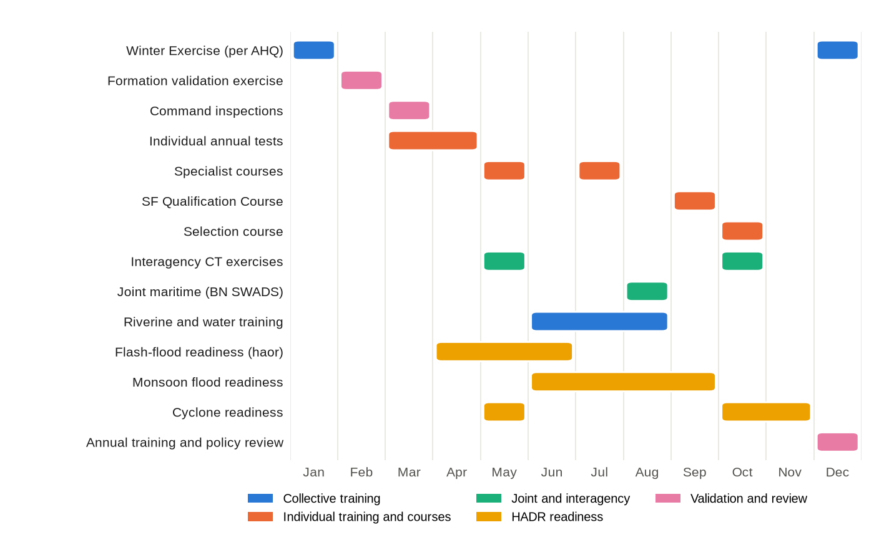
Figure 12: Model annual training calendar (adjust to AHQ Training Instructions each year)
Month | Season | Primary Focus | Key Events
Jan | Winter | Winter Exercise (continued); parachute operations. | Army Winter Exercise as per AHQ (normally December to January).
Feb | Winter | Formation SOTG and validation exercise; joint training. | Annual Formation validation exercise; joint exercise with Army Aviation and BAF.
Mar | Pre-monsoon | Command inspections; individual annual tests begin. | Command inspections.
Apr | Pre-monsoon (hot) | Annual tests (heat precautions); urban and CQB training. | Flash-flood readiness for the haor areas of the north-east from April.
May | Hot / cyclone | Specialist courses; interagency CT. | Interagency CT exercise (1); coastal cyclone readiness.
Jun | Monsoon | Riverine and water operations; diving; indoor CQB. | Flood HADR readiness.
Jul | Monsoon | Swift-water rescue; specialist courses. | HADR standby as required.
Aug | Monsoon | Maritime CT with BN (SWADS). | Joint maritime exercise.
Sep | Late monsoon | Special Forces Qualification Course; individual qualification. | Unit training programmes for next year drafted.
Oct | Post-monsoon / cyclone | Selection course; interagency CT. | Selection course; interagency CT exercise (2); cyclone readiness.
Nov | Early winter | Team and sub-unit collective training; military free-fall. | Preparation for the Winter Exercise; cyclone readiness.
Dec | Winter | Winter Exercise; annual review. | Winter Exercise begins (per AHQ); annual training and policy review; programmes submitted by [●].

ANX I TO
GS POLICY (SF) 1ST EDN
DT [●] 2026
TRAINING STANDARDS, READINESS VALIDATION AND KEY PERFORMANCE INDICATORS
1. Individual Annual Tests. Standards are to be inserted from current AHQ (MT Dte) policy and Formation SOPs. Failure in any mandatory test requires re-test within [●] days; a second failure is to be reported to the CO for decision on employment.
Ser | Test | Periodicity | Standard | Authority
1. | Battle Physical Efficiency Test (BPET) | As per AHQ | As per AHQ | AHQ (MT Dte) policy
2. | Physical Proficiency Test (PPT) | As per AHQ | As per AHQ | AHQ (MT Dte) policy
3. | SF Fitness Assessment (loaded march, run, strength, swim) | Biannual | [●] | Formation SOP
4. | Swimming and water survival | Annual | [●] | Formation SOP
5. | Personal weapon classification | Annual | [●] | AHQ musketry policy
6. | Close-quarter marksmanship | Quarterly | [●] | Formation SOP
7. | Night firing | Annual | [●] | Formation SOP
8. | Navigation (day and night) | Annual | [●] | Formation SOP
9. | TCCC skills | Annual | [●] | Formation MO
10. | Communications equipment | Annual | [●] | Signal Officer
11. | IHL, ROE and Code of Conduct | Annual | [●] | JAG guidance / Formation
12. | Parachute currency | Continuous | [●] descents / [●] months | Parachute Ops SOP
13. | Diving currency | Continuous | [●] dives / [●] months | Diving SOP
14. | Annual medical examination | Annual | As per AHQ/DGMS | Formation MO

2. Tier 1 Readiness Validation. No team is to assume Tier 1 until the BM certifies that it has met the following criteria within the preceding [●] months:
Ser | Criterion | Standard
1. | Manning | Team at establishment with qualified and current operators and specialists [●].
2. | Equipment | 100% of mission-critical equipment serviceable, packed and inspected.
3. | Activation | NTM achieved in an unannounced activation drill.
4. | CT/HR live-fire | Pass in validation serials under the CT/HR SOP criteria.
5. | Communications | PACE plan tested with Formation HQ, AHQ and interagency partners.
6. | Medical | Qualified and current medic; CASEVAC plan current; medical data verified.
7. | Legal and ROE | All members tested on ROE and use of force.
8. | Intelligence | Area studies and target packages current.

3. Key Performance Indicators. The KPIs in the following table are reviewed quarterly by the Commander. Targets marked [●] are to be set annually.
Domain | KPI | Target | Frequency | Lead
Readiness | Percentage of time Tier 1 filled by a validated team | 100% | Monthly | BM
Manning | Percentage of establishment filled with qualified personnel | [●] | Monthly | DQ
Training | Percentage of personnel current in all mandatory qualifications | [●] | Quarterly | GSO (Trg)
Selection | Pass rate and attrition by stage and cause | Trend | Per course | OC Trg Wing
Equipment | Serviceability of mission-critical equipment | [●] | Monthly | DQ
Ammunition | Accounting discrepancies | Nil | Monthly | DQ
Safety | Training injuries per 1,000 training days; serious accidents | Reducing / Nil | Quarterly | Safety Officer
Discipline | Offences and positive drug tests | Nil tolerance | Quarterly | DQ
Security | Security breaches and OPSEC incidents | Nil | Quarterly | GSO (Int)
Health | Medical downgrades; return-to-duty rate after injury; mental health referrals | Trend | Quarterly | Formation MO
Lessons | AARs completed on time; lessons closed | 100% | Quarterly | BM
Welfare | Outstanding welfare cases and family support actions | Trend | Quarterly | DQ

ANX J TO
GS POLICY (SF) 1ST EDN
DT [●] 2026
TRAINING SAFETY AND RISK MANAGEMENT
1. Risk Management Process. Risk management is to be applied to every activity in five steps: identify hazards; assess hazards; develop controls and make risk decisions; implement controls; and supervise and evaluate. The written risk assessment is to be approved at the level shown in the risk acceptance table before the activity begins.
2. Risk Assessment Matrix. Adapted from US ATP 5-19. Risk levels: EH = Extremely High; H = High; M = Medium; L = Low (Figure 13).
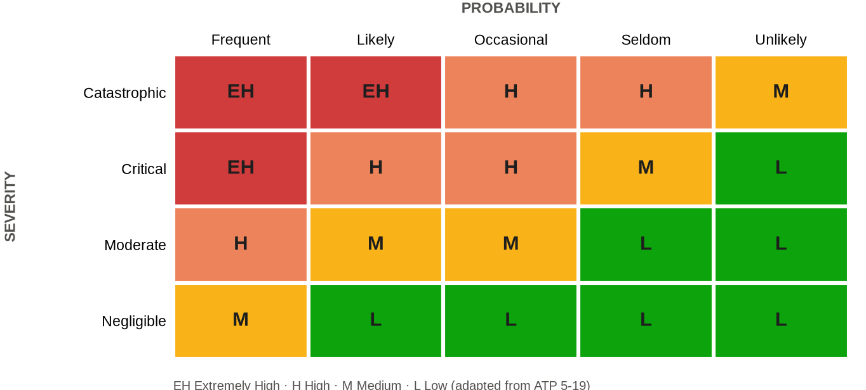
Figure 13: Risk assessment matrix
Severity \ Probability | Frequent | Likely | Occasional | Seldom | Unlikely
Catastrophic (death, permanent disability, loss of major equipment) | EH | EH | H | H | M
Critical (serious injury, major damage) | EH | H | H | M | L
Moderate (minor injury, minor damage) | H | M | M | L | L
Negligible (first aid, negligible damage) | M | L | L | L | L

3. Risk Acceptance Authority. Proposed levels, subject to confirmation against AHQ training safety instructions:
Residual Risk | Acceptance Authority
Low | Team leader / Officer Commanding
Medium | Commanding Officer
High | Commander, Para Commando Brigade
Extremely High | AHQ [confirm]; not to be accepted for training without AHQ approval

4. Mandatory Controls for High-Risk Activities.
Activity | Principal Hazards | Mandatory Controls | Supervision
Live-fire CQB | Fratricide, ricochet, blast overpressure | Approved facility; progression walk-through, dry, blank, live; eye, ear and body protection; ammunition control; medical cover on site; "Stop" authority for all. | Qualified conducting officer and safety officer
Parachuting (static line and MFF) | Malfunction, landing injury, aircraft emergency, hypoxia | Weather and wind limits; equipment inspection; currency check; DZ medical cover; oxygen and physiology training for high altitude; aircraft clearance. | Jumpmaster and DZ safety officer
Diving | Drowning, decompression illness, gas toxicity | Dive plan; buddy system; gas analysis; recompression access plan with BN; medical fitness. | Qualified dive supervisor
Demolitions and breaching | Blast, fragmentation, misfire | Minimum safe distances; misfire drills; explosive custody; overpressure exposure monitoring. | Qualified demolitions supervisor
Work at height (climbing, abseiling, fast-rope) | Falls | Certified equipment; back-up systems; pre-use inspection. | Qualified instructor
Water and boat training | Drowning, capsize | Life jackets; safety boat; current and weather assessment; qualified swimmers on standby. | Safety officer
Endurance activities and selection | Heat illness, exertional collapse | Heat index monitoring; work-rest and hydration schedule; acclimatisation; cooling facilities; medic present; stop criteria. | Medical Officer and course officer
Vehicle and boat movement | Collision, fatigue | Licensed drivers; speed limits; fatigue management; night-driving controls. | Transport officer

5. Accident Reporting. Serious accidents are to be reported immediately by the fastest means to HQ Para Commando Brigade and within [●] hours to AHQ, followed by a written report within [●] days. A Court of Inquiry will be convened in accordance with the Army Rules, 1954. Near misses are to be reported to the Formation Safety Officer within [●] hours.

ANX K TO
GS POLICY (SF) 1ST EDN
DT [●] 2026
SPECIAL OPERATIONS MISSION PLANNING SEQUENCE AND AFTER ACTION REVIEW FORMAT
1. Planning Sequence. The following sequence adapts the Army Decision Making Process and orders process to special operations (Figure 9). Time is to be allocated so that subordinate levels receive at least two-thirds of the available planning time.
Step | Activity | Output | Lead
1. | Receipt of mission; time appreciation; warning order | Warning order to units | BM / CO
2. | Mission analysis: tasks, constraints, legal basis, ROE, CCIR | Mission statement; CCIR | Planning team
3. | Intelligence preparation: operating environment (PMESII/ASCOPE) and target analysis (CARVER) | Intelligence estimate; target package | Intelligence staff
4. | Course of action development; relative superiority analysis | At least two courses of action | Planning team
5. | Wargaming, risk assessment and contingencies | Risk assessment; abort criteria; contingency plans | Planning team / Safety
6. | Decision and approval | Commander's decision; AHQ approval where required | Commander
7. | Orders (Situation, Mission, Execution, Service Support, Command and Signal) | Operation order | Commander
8. | Isolation and detailed team planning | Team plan; load plan; PACE plan | Team leader
9. | Briefback | Approval to proceed | Team leader
10. | Rehearsals (full-dress, day and night, contingencies) | Rehearsal record | Team leader
11. | Final inspection and intelligence update | Go / no-go decision | Commander
12. | Execution, exfiltration and recovery | Mission accomplished; force recovered | Team leader
13. | Hot debrief and handover of material | Debrief record; chain-of-custody documents | Intelligence staff
14. | After Action Review and lessons | AAR report; lessons to ARTDOC | BM

2. CARVER Target Analysis.
Factor | Question Addressed
Criticality | How important is the target to the adversary's system or operation?
Accessibility | Can the force reach, act on and withdraw from the target?
Recuperability | How long will the adversary take to replace, repair or bypass the effect?
Vulnerability | Does the force have the means to achieve the desired effect?
Effect | What are the military, political, economic and civilian consequences, including collateral effects?
Recognisability | Can the target be positively identified under the expected conditions?

3. Emergency and Deliberate Action in Hostage Rescue. In every hostage incident, the emergency action plan is to be ready as the first planning priority and continuously refined; the deliberate action plan is developed in parallel. The authority to execute each is to be defined in writing at handover (Chapter III).
4. After Action Review Format. AARs are conducted under non-attribution, with participation of all ranks involved, and are recorded in the following format:
a. Introduction. Mission, participants and ground rules.
b. What Was Planned. Intent, plan and key assumptions.
c. What Happened. Chronology from all perspectives.
d. Why It Happened. Analysis of causes, including relative superiority, intelligence, command, communications and support.
e. What We Will Sustain and Improve. Strengths to reinforce and weaknesses to correct.
f. Lessons and Actions. Tabulated in the following format and forwarded to the Lessons Learnt Cell and ARTDOC.
Ser | Observation | Lesson | Action Required | Responsibility | Target Date
1.
2.
3.

ANX L TO
GS POLICY (SF) 1ST EDN
DT [●] 2026
LEGAL FRAMEWORK, RULES OF ENGAGEMENT PRINCIPLES AND AID TO CIVIL POWER CHECKLIST
1. Legal Basis by Type of Operation.
Type of Operation | Principal Legal Basis | Key Obligations
National defence | Constitution (Article 63); Army Act, 1952; Geneva Conventions and Additional Protocols; customary IHL (References A, B and X) | Distinction, proportionality, precautions; humane treatment of prisoners and civilians; prohibition of perfidy.
CT and aid to civil power | Code of Criminal Procedure, 1898 (Sections 127 to 132); Anti-Terrorism Act, 2009 (as amended up to 2026); Penal Code, 1860 (private defence); Government instructions; fundamental rights in the Constitution (References H, K and J) | Lawful requisition; minimum necessary force; handover of apprehended persons to police; evidence preservation; accountability.
Special executive magistracy powers | Ministry of Public Administration notification (from 17 September 2024, as extended); Code of Criminal Procedure, 1898 (References Q and H) | Exercise only within the notified scope, area and period; coordination with civil administration and police; record of every exercise.
CHT operations (Operation Uttoron) | AHQ instructions; aid to civil power framework; CHT Peace Accord, 1997 and related laws | Support to civil administration; respect for local institutions; minimum force; protection of the population.
UN peace operations | UN Security Council mandate; Status of Forces/Mission Agreement; Memorandum of Understanding; mission ROE and directives; ST/SGB/1999/13 and ST/SGB/2003/13 | Mandate compliance; protection of civilians; conduct and discipline; national caveats.
Disaster response | Disaster Management Act, 2012; Standing Orders on Disaster, 2019 (References N and P) | Civil lead; coordination with disaster management authorities.
Training | Army Act, 1952 and Army Rules, 1954; Explosives Act, 1884; AHQ safety instructions | Safety of personnel and public; custody of explosives; compensation for damage.

2. Principles of ROE and Use of Force.
a. Self-Defence. Nothing in ROE limits the inherent right and obligation of self-defence.
b. Necessity. Force is used only when other means are ineffective or without promise of achieving the lawful objective.
c. Proportionality. The force used is proportionate to the threat and the lawful objective.
d. Minimum Force. In aid to civil power, the minimum force necessary for the shortest time.
e. Distinction. Force is directed only at those who pose the threat or are lawful targets.
f. Warning. A warning is given where practicable and where it does not endanger life.
g. Accountability. Every use of force is recorded, reported and open to review.
3. Aid to Civil Power : Pre-Commitment Checklist. To be completed by the commander of the committed element and retained with the operations log:
Ser | Item | Yes / No | Remarks
1. | Written requisition from the competent civil authority received
2. | Government / AHQ authority for employment received
3. | Competent civil authority (magistrate) present or designated, as required
4. | Mission, area and duration defined in writing
5. | ROE issued, briefed and understood; cards issued
6. | Written handover of incident site received (CT)
7. | Responsibility for negotiation confirmed with the civil authority
8. | Legal adviser consulted
9. | Medical and CASEVAC plan covers force, hostages and public
10. | Evidence preservation and chain-of-custody arrangements agreed with investigating agency
11. | Arrangements for handover of apprehended persons to police confirmed
12. | Media handling through Government / ISPR confirmed
13. | Use-of-force log opened
14. | Written handback procedure agreed

4. Use-of-Force Report. Each incident of use of force is to be reported within [●] hours, stating: date, time and location; unit and individuals involved; the threat faced; warnings given; the force used (weapon, rounds, other means); the results (casualties, damage); medical aid rendered; witnesses; and the commander's assessment.

ANX M TO
GS POLICY (SF) 1ST EDN
DT [●] 2026
SECURITY, OPSEC AND IDENTITY PROTECTION INSTRUCTIONS
1. Security Grading. Information is to be graded TOP SECRET, SECRET, CONFIDENTIAL or RESTRICTED in accordance with AHQ security instructions, which also govern marking, storage, transmission, reproduction, accounting and destruction. The following guidance applies to Formation documents:
Category of Information | Minimum Grading (Guide)
This policy (main body and uncompleted annexes) | RESTRICTED
Completed readiness matrix (NTM, composition), ORBAT details and nominal rolls | [● : as per AHQ instructions]
Operational plans, target packages, CT/HR SOP details | [● : as per AHQ instructions]
AARs of operations | [● : as per AHQ instructions]
Identities of operators and their families | [● : as per AHQ instructions]

2. Critical Information. The following are designated critical information to be protected by OPSEC measures:
a. Identities, photographs and addresses of Formation personnel and their families.
b. Readiness states, NTM, locations and movement of teams.
c. SOPs, TTPs and equipment capabilities and limitations.
d. Operational plans, target information and intelligence sources.
e. Travel of personnel, especially abroad.
f. Casualty information before next of kin are informed.
3. Social Media and Personal Conduct.
Do | Do Not
Use maximum privacy settings on all personal accounts. | Post photographs in uniform, of equipment, training or locations.
Brief family members on identity protection. | Identify the Formation or unit in profiles or posts.
Report suspicious approaches online or in person. | Enable geotagging or location sharing.
Keep personal devices out of secure areas. | Discuss operations, training or readiness on messaging applications.
Verify contacts before accepting requests. | Engage with media or unknown journalists.

4. OPSEC Process. For every operation, exercise, movement or foreign engagement, the unit OPSEC officer will: identify critical information; analyse threats; analyse vulnerabilities; assess risk; and recommend countermeasures to the commander.
5. Security Breach Procedure.
a. Contain the breach and secure remaining material.
b. Report immediately to the CO and HQ Para Commando Brigade (GSO Int).
c. Report to AHQ within [●] hours.
d. Assess the damage and implement mitigating measures, including protection of affected personnel.
e. Convene a Court of Inquiry as directed.
6. Foreign Travel. All personnel proceeding abroad (on duty or leave) are to receive a security briefing before departure and a debrief on return, and are to report any approach or incident.

ANX N TO
GS POLICY (SF) 1ST EDN
DT [●] 2026
PERSONNEL ("A") POLICY MATRIX AND CODE OF CONDUCT
1. "A" Policy Matrix.
Subject | Policy Summary | Governing Reference | Staff Lead
Manning and postings | Volunteers meeting Annex F criteria; officers through MS Branch, JCOs and other ranks through AG's Branch. | AHQ (MS / AG's Branch) policies [●] | DQ
Tenure | Officers [●] years; JCOs and other ranks [●] years; extendable on merit; repeat tours encouraged. | AHQ policy [●] | DQ
Return to unit | On grounds at Chapter VIII; right to be heard except medical. | This policy; Army Act, 1952 | DQ
Performance appraisal | Through SF chain of command. | AHQ ACR instructions [●] | DQ
Career courses | Scheduled without disadvantage to SF personnel. | MS Branch / MT Dte policy [●] | DQ / GSO (Trg)
Allowances | Only as sanctioned by Government; verified against qualifications. | Government sanction [●] | DQ
Leave | As per regulations; Tier 1 and 2 manning protected. | Army Leave Rules; Army Regulations (Instructions) | DQ
Discipline | Highest standards; prompt and fair disposal. | Army Act, 1952; Army Rules, 1954; Army Regulations (Rules) | DQ
Drug testing | Periodic and random testing. | AHQ policy [●]; Narcotics Control Act, 2018 | DQ / Formation MO
Welfare and families | Family support focal points; notification and liaison officers; coordination with SPKS; post-service welfare through SKS and the Army Welfare Trust. | AHQ welfare policy [●] | DQ
Medical standards | Special standards for SF, parachuting and diving. | AHQ / DGMS [●] | Formation MO
Mental health | Resilience training; post-incident support; confidential access. | AHQ / DGMS [●] | Formation MO
Casualty and next of kin | Verification every [●] months and before deployment. | AHQ casualty procedures [●] | DQ
Honours and awards | Prompt, factual, verified recommendations. | Government award rules [●] | DQ
Records and data | Restricted access; no unauthorised storage. | AHQ security instructions [●] | DQ / GSO (Int)
Female personnel | Roles as per AHQ policy. | AHQ policy [●] | DQ
Transition | Exit debrief; OSA acknowledgement; return of equipment. | Official Secrets Act, 1923 | DQ / GSO (Int)

2. Code of Conduct. Every member of the Formation affirms:
a. I will serve the nation and uphold the Constitution with loyalty and honour.
b. I will obey lawful orders and will not commit or tolerate any unlawful act.
c. I will use force only as authorised by law and ROE, and only to the extent necessary.
d. I will treat every person, including an adversary, a detainee or a hostage, with humanity; I will never torture or ill-treat any person.
e. I will protect classified information, the identities of my comrades and the security of the Formation.
f. I will not use my skills, weapons or equipment for any unauthorised or personal purpose.
g. I will not seek publicity for myself or the Formation.
h. I will remain free of narcotics, corruption and political involvement.
j. I will report honestly, including my own errors, and will accept responsibility for my actions.
k. I will care for my comrades and their families, and will never leave a comrade behind.
I, (Number) ............ (Rank) ............ (Name) ................................, have read, understood and affirm this Code of Conduct.
Signature: ........................ Date: ................ Countersigned (CO): ........................

ANX O TO
GS POLICY (SF) 1ST EDN
DT [●] 2026
LOGISTICS ("Q") POLICY MATRIX
1. "Q" Policy Matrix.
Subject | Policy Summary | Governing Reference | Staff Lead
Rations | Special scales for Para Commando units; combat rations for operations and field training. | AHQ (ST Dte) scales [●] | DQ
Fuel and water | Pre-positioned reserves of [●] days for Tier 1 and 2. | AHQ (ST Dte) instructions [●] | DQ
Clothing and personal equipment | Authorised scales; monthly inspection. | Ordnance scales [●] | DQ
Weapons and equipment | Establishment and special scales; SF-peculiar register. | Ordnance scales [●] | DQ
Procurement | Through DGDP or local purchase within delegated powers. | Public Procurement Act, 2006; Rules in force; AHQ instructions [●] | DQ
Maintenance | Per EME and Ordnance technical instructions; life-limited items tracked. | EME / Ordnance instructions [●] | DQ
Parachute equipment | Packed and inspected by qualified personnel; individual records. | Parachute Ops SOP; technical instructions [●] | DQ
Diving equipment and gases | Tested and certified jointly with BN. | Diving SOP; BN instructions [●] | DQ
Sensitive items | Serial-number accounting; 100% verification [monthly]. | Ordnance accounting instructions [●] | DQ
Ammunition and explosives | Enhanced training scale; magazine regulations; ledger accounting; expenditure certificates. | Explosives Act, 1884; AHQ instructions [●] | DQ
Transport and boats | Licensed operators; Tier 1 and 2 vehicles loaded and serviceable. | AHQ transport instructions [●] | DQ
Air movement | Coordinated with Army Aviation and BAF; dangerous-goods compliance. | Air movement instructions [●] | GSO (Ops) / DQ
Works | Master infrastructure plan through E-in-C's Branch and MES. | E-in-C's Branch policy [●] | DQ
Finance | Within sanction and delegated powers; audit by CGDF. | DSR (Financial Regulations Chapter I : Army and Air Force); Government financial rules [●] | DQ
Boards and write-offs | Annual stock verification; losses processed per regulations. | Army Regulations [●] | DQ
UN logistics | COE and self-sustainment per MOU. | UN COE Manual; MOU | DQ

2. Maintenance and Inspection Intervals. Intervals are to be inserted from technical instructions:
Equipment Category | User Check | Technical Inspection | Authority
Weapons and optics | Before and after use | [●] | EME / Ordnance
Night-vision and electro-optical devices | Before and after use | [●] | EME
Communications and COMSEC equipment | Daily when in use | [●] | Signals
Parachutes and aerial delivery equipment | Before each use | [●] | Qualified rigger
Diving equipment | Before each dive | [●] | BN / Dive supervisor
Climbing and height equipment | Before each use | [●] | Qualified instructor
Vehicles and boats | Daily | [●] | EME
Ammunition and explosives | On issue and return | [●] | Ordnance

ANX P TO
GS POLICY (SF) 1ST EDN
DT [●] 2026
RESPONSIBILITY MATRIX
1. Legend. R = Responsible (does the work); A = Accountable (approves and answers for the outcome); C = Consulted; I = Informed. Appointments are as per establishment; where an appointment does not exist, the responsibility rests with the officer detailed by the Commander.
Task | Comd | BM | DQ | GSO Ops | GSO Int | GSO Trg | Sig Offr | Fmn MO | Safety Offr | COs | OC Trg Wg
Readiness management and Tier 1 validation | A | R | C | R | C | C | C | C | I | R | I
Operational planning and orders | A | R | C | R | R | I | C | C | C | R | I
Operations Room SOP and activation drills | A | R | C | R | I | I | C | I | I | R | I
Intelligence, area studies and target packages | A | C | I | C | R | I | I | I | I | C | I
Security, vetting and OPSEC | A | R | C | C | R | I | C | I | I | R | I
Selection and assessment | A | C | C | I | C | R | I | C | C | C | R
Qualification and specialist training | A | C | C | I | I | R | C | C | C | R | R
Annual training programme | A | R | C | C | C | R | C | C | C | R | C
Joint and interagency exercises | A | R | C | R | C | R | C | C | C | R | I
Foreign training and exercises | A | R | C | I | C | R | I | I | I | C | I
SOP review and doctrine | A | R | C | C | C | C | C | C | C | C | C
Capability development and trials | A | R | C | C | C | C | C | C | C | C | C
Communications, COMSEC and information systems | A | C | C | C | C | I | R | I | I | R | I
Manning, postings and tenure | A | C | R | I | C | I | I | I | I | C | I
Discipline and conduct | A | I | R | I | C | I | I | I | I | R | R
Welfare and family support | A | I | R | I | I | I | I | C | I | R | I
Medical standards and mental health | A | I | C | I | I | I | I | R | C | R | C
Casualty administration and next of kin | A | I | R | C | I | I | I | C | I | R | I
Honours and awards | A | C | R | C | I | I | I | I | I | R | I
Supply, rations and clothing | A | I | R | I | I | I | I | C | I | R | I
Weapons, equipment and sensitive items accounting | A | I | R | I | C | I | C | I | I | R | I
Ammunition and explosives | A | C | R | I | I | C | I | I | C | R | C
Transport and air movement | A | C | R | R | I | I | I | I | C | R | I
Infrastructure and works | A | C | R | I | I | C | C | I | C | C | C
Budget and finance | A | C | R | I | I | C | I | I | I | C | I
Legal review and ROE | A | R | C | R | C | C | I | I | I | R | I
Media and identity protection | A | R | C | C | R | I | I | I | I | R | I
Risk management and safety | A | C | C | C | I | C | I | C | R | R | R
Lessons learnt | A | R | C | C | C | C | C | C | C | R | C
Inspections and KPI review | A | R | R | C | C | C | C | C | C | R | C
Review of this policy | A | R | R | C | C | C | C | C | C | C | C

ANX Q TO
GS POLICY (SF) 1ST EDN
DT [●] 2026
IMPLEMENTATION TIMELINE AND REVIEW MECHANISM
1. Implementation Timeline. D is the date of issue of this policy.
Phase | Activities | Responsibility | Timeline
1. Dissemination and Orientation | Issue of policy; orientation of all officers and JCOs by the Commander; unit briefings to all ranks; Code of Conduct signed. | BM / COs | D to D+[●]
2. Alignment | Review of unit standing orders and SOPs; update of Formation SOPs; reporting of gaps and resource requirements to HQ. | BM / DQ / COs | By D+[●]
3. Full Implementation | Application of all provisions; first quarterly KPI review; first readiness validations under this policy. | All | By D+[●]
4. Review | First annual review; incorporation of feedback and lessons; issue of amendment. | BM / DQ | D + 12 months

2. Review Mechanism.
a. Units are to forward recommended amendments, with justification, to HQ Para Commando Brigade (BM) at any time and in any case by [●] each year.
b. The BM and DQ will consolidate recommendations and present them at the Commander's annual review.
c. Amendments requiring AHQ approval will be forwarded through the prescribed channel.
d. Approved amendments will be issued as numbered amendment lists and recorded on the Amendment Record Sheet.
The Amendment Record Sheet is in the prefatory part of this policy.

ANX R TO
GS POLICY (SF) 1ST EDN
DT [●] 2026
BANGLADESH ARMY POLICY AND PRÉCIS LINKAGE MATRIX
1. Purpose. This matrix links each policy area of this policy to the responsible AHQ branch or directorate, the governing Bangladesh Army instrument, the relevant précis and the Formation document that implements it. References marked [●] are to be completed from the Formation master file.
Ser | Policy Area (Chapter) | AHQ Branch / Directorate | Governing Instrument | Précis | Formation Document
"G" Matters
1. | Employment and readiness (III, IV) | GS Branch (MO Dte) | AHQ employment policy [●]; AFD instructions | "G" | Operations Room SOP; readiness matrix (Annex E)
2. | CT in aid to civil power (III, IV, X) | GS Branch (MO Dte); JAG | CrPC, 1898; Anti-Terrorism Act, 2009; Government and AHQ instructions [●] | "G"; military law | CT/HR SOP; Annex L checklist
3. | CHT operations (IV) | GS Branch (MO Dte) | Operation Uttoron instructions [●]; CHT Peace Accord, 1997 | "G" | Mission orders; Annex L
4. | UN operations (IV) | GS Branch (Overseas Ops Dte); AFD | AHQ UN deployment policy [●]; UN SF Manual; MOU | "G" | Pre-deployment training programme
5. | Intelligence and security (V) | GS Branch (MI Dte) | AHQ security instructions [●]; Official Secrets Act, 1923; Cyber Security Ordinance, 2025 | "G" | Security and OPSEC SOP; Annex M
6. | Training and Winter Exercise (VI) | GS Branch (MT Dte); ARTDOC | Annual Training Directive [●]; Winter Exercise instructions [●] | "G" | Annual training programme; Annex H
7. | Musketry and physical training (VI) | GS Branch (MT Dte) | AHQ musketry and PT (BPET/PPT) policies [●] | "G" | Range SOP; Annex I
8. | Selection and courses (VI) | GS Branch (MT Dte); SI&T; Army Airborne School | AHQ course policy [●]; course précis | "G" | Selection SOP; Annexes F and G
9. | Doctrine and lessons (VII) | ARTDOC | Bangladesh Army Doctrine [●] | "G" | Formation SOPs; lessons database
10. | Organisation and establishment (III) | GS Branch (SD Dte) | Approved establishments [●] | Staff Duties | Annex C
11. | Capability development (VII) | GS Branch (WE&S Dte) | SOR/GSQR procedure [●] | "G" | Capability register
12. | Communications (VII) | GS Branch (Signals Dte) | COMSEC and frequency instructions [●] | "G" | Communications SOP
"A" Matters
13. | Officer postings and careers (VIII) | MS Branch | MS Branch policies; ACR instructions [●] | "A" | Manning state; succession plan
14. | JCO and OR postings and tenure (VIII) | AG's Branch (PA Dte) | AHQ posting policy [●] | "A" | Manning state
15. | Discipline (VIII) | AG's Branch; JAG | Army Act, 1952; Army Rules, 1954; Army Regulations (Rules) | "A"; military law | Code of Conduct (Annex N)
16. | Leave (VIII) | AG's Branch | Army Leave Rules; Army Regulations (Instructions) | "A" | Leave plan protecting Tier 1 and 2
17. | Allowances and entitlements (VIII) | AG's Branch; CGDF | Government sanctions [●]; DSR | "A" | Entitlement verification register
18. | Welfare (VIII) | AG's Branch | AHQ welfare policy [●]; SPKS, SKS and Army Welfare Trust schemes | "A" | Unit family support plan
19. | Medical and mental health (VIII) | DGMS / AMC | Medical classification and special standards [●] | "A" | Medical and CASEVAC SOP
20. | Casualty administration and awards (VIII) | AG's Branch; MS Branch | AHQ casualty procedures [●]; Government award rules [●] | "A" | Casualty SOP; Roll of Honour
"Q" Matters
21. | Rations, POL and transport (IX) | QMG's Branch (ST Dte) | Ration and transport scales [●] | "Q" | Logistics SOP; mission kits
22. | Military working dogs (IX) | QMG's Branch (RV&F Dte) | RV&F instructions [●] | "Q" | K9 employment instructions
23. | Weapons, equipment and ammunition (IX) | MGO Branch (Ordnance Dte) | Ordnance scales and accounting instructions [●]; Explosives Act, 1884 | "Q" | SF-peculiar equipment register; magazine orders
24. | Maintenance (IX) | MGO Branch (EME Dte) | EME technical instructions [●] | "Q" | Maintenance schedules (Annex O)
25. | Works and infrastructure (IX) | E-in-C's Branch; MES | Works policy [●] | "Q" | Master infrastructure plan
26. | Finance and procurement (IX) | AHQ finance channels; CGDF; DGDP | DSR (Financial Regulations); Public Procurement Act, 2006 and Rules | "Q" | Annual budget; procurement files
Legal and Media
27. | Legal review, ROE and magistracy powers (X) | JAG | CrPC, 1898; MoPA notifications [●]; Geneva Conventions | Military law | ROE cards; Annex L
28. | Media and identity protection (X) | ISPR | ISPR media policy [●] | "G" | Media and Identity Protection SOP


সমরে আমরা, শান্তিতে আমরা, সর্বত্র আমরা দেশের তরে
In war, in peace, we are everywhere for our country
HEADQUARTERS PARA COMMANDO BRIGADE · JALALABAD CANTONMENT · SYLHET
Printed in Bangladesh for Bangladesh Army

Rahman, Hasan Hafizur (ed.). Bangladesher Swadhinata Juddha: Dalilpatra (Documents of the War of Independence). Dhaka: Ministry of Information, 1982. [Bibliography Ser 128] Safiullah, K. M. Bangladesh at War. Dhaka: Academic Publishers, 1989. [Bibliography Ser 129] Liberation War Museum, Dhaka. Archival material on Operation Jackpot and the Crack Platoon. [Bibliography Ser 130]
Wikipedia. "Bangladesh Army." en.wikipedia.org/wiki/Bangladesh_Army (accessed 1 October 2026). [Bibliography Ser 135]
Wikipedia. "Para Commando Brigade (Bangladesh)." en.wikipedia.org/wiki/Para_Commando_Brigade_(Bangladesh) (accessed 1 October 2026). [Bibliography Ser 134] Bari, Mohammad Rafiqul (Major). "Difficulties in Imparting Proper Training to Members of Para Commando Battalion of Bangladesh Army: Ways Forward." Individual Research Paper, Defence Services Command and Staff College, Mirpur Cantonment, December 2019. [Bibliography Ser 80]
Inter Services Public Relations Directorate. Press releases and briefings on Operation Thunderbolt (2 July 2016), Operation Twilight (March 2017) and Operation Mayurpankhi (24 February 2019). [Bibliography Ser 131] Wikipedia, Para Commando Brigade (Bangladesh)." en.wikipedia.org/wiki/Para_Commando_Brigade_(Bangladesh)… [Bibliography Ser 134] The Daily Star. "Biman Bangladesh Airlines plane 'hijacker' killed at Chattogram airport." 24 February 2019. thedailystar.net (accessed 1 October 2026). [Bibliography Ser 141]
United Nations Peacekeeping. "Protection of civilians and special operations recognized to the Bangladesh Special Force in MINUSCA." peacekeeping.un.org (accessed 1 October 2026). [Bibliography Ser 138]
Inter Services Public Relations Directorate. "Closing Ceremony of Exercise Tiger Lightning (TL)-2025 Held." 30 July 2025, ispr.gov.bd; and Dhaka Tribune, "Bangladesh, US armies launch 6-day joint exercise Tiger Lightning in Sylhet" (accessed 1 October 2026). [Bibliography Ser 146]
Bari, Mohammad Rafiqul (Major), Difficulties in Imparting Proper Training… [Bibliography Ser 80]
Government instructions on the employment of the Armed Forces in aid to civil power [No ● dated ●]. [Bibliography Ser 29]
Wikipedia, Bangladesh Army." en.wikipedia.org/wiki/Bangladesh_Army (accessed 1… [Bibliography Ser 135] Bari, Mohammad Rafiqul (Major), Difficulties in Imparting Proper Training… [Bibliography Ser 80]
Wikipedia, Bangladesh Army." en.wikipedia.org/wiki/Bangladesh_Army (accessed 1… [Bibliography Ser 135]
Armed Forces Division. Instructions on UN deployment and inter-service coordination [No ● dated ●]. [Bibliography Ser 33] Armed Forces Division. Standing Operating Procedure of Bangladesh Multinational Coordination Centre (MNCC). Dhaka: AFD, Prime Minister's Office (validated during Exercise Coordinated Response, 2019). [Bibliography Ser 35]
Wikipedia. "ARTDOC." en.wikipedia.org/wiki/ARTDOC (accessed 1 October 2026). [Bibliography Ser 136]
Army Leave Rules, as amended. [Bibliography Ser 37] Defence Services Regulations: Financial Regulations Part I (Army and Air Force). Controller General Defence Finance, cgdf.portal.gov.bd (accessed 1 October 2026). [Bibliography Ser 38] Army Dress Regulations, as amended. [Bibliography Ser 39]
Defence Services Command and Staff College. Decision Making Process (DMP) Précis and Advance Sheet (Army Wing). Mirpur: DSCSC. [Bibliography Ser 72] Defence Services Command and Staff College. Staff Officers' Handbook (SOHB) (précis). Mirpur: DSCSC. [Bibliography Ser 73]
General Economics Division, Planning Commission. Bangladesh Delta Plan 2100. Dhaka: Planning Commission, 2018. [Bibliography Ser 26]
Inter Services Public Relations Directorate, Press releases and briefings on… [Bibliography Ser 131]
Prothom Alo. "Arakan army takes control of Maungdaw, fear of Rohingya influx." December 2024; and RSIS, "Rohingya Crisis Escalates as the Arakan Army Expands Its Control" (accessed 1 October 2026). [Bibliography Ser 144]
Wikipedia. "Operation Uttaran." en.wikipedia.org/wiki/Operation_Uttaran (accessed 1 October 2026). [Bibliography Ser 137] Army Headquarters, Military Operations Directorate. Operation Uttoron instructions (Chittagong Hill Tracts) [No ● dated ●]. [Bibliography Ser 42]
Bangladesh Sangbad Sangstha. "Army gets magistracy power for 60 days." 17 September 2024. bssnews.net/news-flash/210244 (accessed 1 October 2026). [Bibliography Ser 139] The Business Standard. "Now Air Force, Navy officers get magistracy powers as well." 29 September 2024. tbsnews.net (accessed 1 October 2026). [Bibliography Ser 140]
Ministry of Disaster Management and Relief. National Plan for Disaster Management 2021–2025. Dhaka: MoDMR. [Bibliography Ser 25]
NATO. AJP-3.5, Allied Joint Doctrine for Special Operations (latest edition). [Bibliography Ser 99] US Joint Chiefs of Staff. JP 3-05, Special Operations. Washington DC: JCS, 2020. [Bibliography Ser 100]
Collins, John M. United States and Soviet Special Operations. Washington DC: US Government Printing Office, 1987 (origin of the "SOF Truths"). [Bibliography Ser 115] Joint Special Operations University. Special Operations Forces Reference Manual (4th edition). MacDill AFB: JSOU Press, 2015. [Bibliography Ser 110]
McRaven, William H. Spec Ops: Case Studies in Special Operations Warfare: Theory and Practice. Novato, CA: Presidio Press, 1996. [Bibliography Ser 116]
Gray, Colin S. Explorations in Strategy. Westport, CT: Greenwood Press, 1996. [Bibliography Ser 118]
Gray, Colin S. "Handfuls of Heroes on Desperate Ventures: When Do Special Operations Succeed?" Parameters 29, no. 1 (Spring 1999). [Bibliography Ser 119]
Cohen, Eliot A. Commandos and Politicians: Elite Military Units in Modern Democracies. Cambridge, MA: Harvard University Center for International Affairs, 1978. [Bibliography Ser 120] Kiras, James D. Special Operations and Strategy: From World War II to the War on Terrorism. London: Routledge, 2006. [Bibliography Ser 121]
Spulak, Robert G., Jr. A Theory of Special Operations: The Origin, Qualities, and Use of SOF. JSOU Report 07-7. Hurlburt Field, FL: JSOU Press, 2007. [Bibliography Ser 117] Clausewitz, Carl von. On War. Edited and translated by Michael Howard and Peter Paret. Princeton: Princeton University Press, 1976. [Bibliography Ser 113]
Sun Tzu. The Art of War. Translated by Lionel Giles. London: Luzac, 1910. [Bibliography Ser 112] Liddell Hart, B. H. Strategy: The Indirect Approach. London: Faber and Faber, 1954 (2nd revised edition, 1967). [Bibliography Ser 114]
Headquarters, Department of the Army. ADP 6-0, Mission Command: Command and Control of Army Forces. Washington DC, 2019. [Bibliography Ser 105] UK Ministry of Defence. JDP 0-01, UK Defence Doctrine (6th edition). Shrivenham: DCDC, 2022. [Bibliography Ser 108]
Bari, Mohammad Rafiqul (Major), Difficulties in Imparting Proper Training… [Bibliography Ser 80]
NATO, AJP-3.5, Allied Joint Doctrine for… [Bibliography Ser 99]
Defence Services Command and Staff College. Para Military Forces (précis). Mirpur: DSCSC, 2017–2018. [Bibliography Ser 74]
US Joint Chiefs of Staff. JP 3-50, Personnel Recovery; and JP 3-68, Noncombatant Evacuation Operations (latest editions). [Bibliography Ser 102]
Collins, John M, United States and Soviet Special… [Bibliography Ser 115]
Bari, Mohammad Rafiqul (Major), Difficulties in Imparting Proper Training… [Bibliography Ser 80]
Government instructions on the employment of the Armed Forces in aid to civil power [No ● dated ●]. [Bibliography Ser 29]
Armed Forces Division, Instructions on UN deployment and… [Bibliography Ser 33] Army Headquarters, Overseas Operations Directorate. UN deployment policy [No ● dated ●]. [Bibliography Ser 53]
NATO. AJP-01, Allied Joint Doctrine (latest edition). [Bibliography Ser 98] NATO, AJP-3.5, Allied Joint Doctrine for… [Bibliography Ser 99]
Inter Services Public Relations Directorate. Media policy for the Armed Forces [No ● dated ●]. [Bibliography Ser 66]
Army Headquarters, General Staff Branch. Table of Organisation and Equipment, 1st Para Commando Battalion. Dhaka: AHQ, 1992; and current establishments (Staff Duties Directorate) [No ● dated ●]. [Bibliography Ser 50]
Army Headquarters. Army Staff Duties in the Field 2006. [Bibliography Ser 68]
McRaven, William H, Spec Ops: Case Studies in… [Bibliography Ser 116]
Bari, Mohammad Rafiqul (Major), Difficulties in Imparting Proper Training… [Bibliography Ser 80]
Wikipedia, Para Commando Brigade (Bangladesh)." en.wikipedia.org/wiki/Para_Commando_Brigade_(Bangladesh)… [Bibliography Ser 134]
Defence Services Command and Staff College, Decision Making Process (DMP) Précis… [Bibliography Ser 72] Army Headquarters, Army Staff Duties in the… [Bibliography Ser 68]
Armed Police Battalions Ordinance, 1979, as amended. [Bibliography Ser 19] Border Guard Bangladesh Act, 2010. [Bibliography Ser 17] Bangladesh Coast Guard Act, 2016. [Bibliography Ser 18]
Armed Forces Division, Standing Operating Procedure of Bangladesh… [Bibliography Ser 35]
Defence Services Command and Staff College, Para Military Forces (précis). Mirpur… [Bibliography Ser 74]
The Evidence Act, 1872 (Act No I of 1872). [Bibliography Ser 6]
The Daily Star, Biman Bangladesh Airlines plane 'hijacker'… [Bibliography Ser 141]
Army Headquarters, Military Operations Directorate, Operation Uttoron instructions (Chittagong Hill… [Bibliography Ser 42]
Chittagong Hill Tracts Peace Accord, 2 December 1997. [Bibliography Ser 27] Chittagong Hill Tracts Regional Council Act, 1998 and the Hill District Council Acts, 1989. [Bibliography Ser 20]
United Nations Peacekeeping, Protection of civilians and special… [Bibliography Ser 138]
United Nations. Core Pre-Deployment Training Materials (latest). [Bibliography Ser 85] Bangladesh Institute of Peace Support Operation Training. Pre-deployment training materials (latest). [Bibliography Ser 77]
United Nations. Secretary-General's Bulletin ST/SGB/2003/13, Special Measures for Protection from Sexual Exploitation and Sexual Abuse, 9 October 2003. [Bibliography Ser 89]
Ministry of Disaster Management and Relief, National Plan for Disaster Management… [Bibliography Ser 25] Armed Forces Division, Standing Operating Procedure of Bangladesh… [Bibliography Ser 35]
Army Headquarters, Military Training Directorate. Parachute training and swimming policy [No ● dated ●]. [Bibliography Ser 46] School of Infantry and Tactics, Special Warfare Wing. Army Commando and Counter-Insurgency course précis; and Army Airborne School parachute and free-fall course précis (latest editions). [Bibliography Ser 76]
Bari, Mohammad Rafiqul (Major), Difficulties in Imparting Proper Training… [Bibliography Ser 80]
McChrystal, Stanley, Tantum Collins, David Silverman and Chris Fussell. Team of Teams. New York: Portfolio/Penguin, 2015. [Bibliography Ser 127]
Army Headquarters, Military Intelligence Directorate. Security instructions, vetting and social media instructions [No ● dated ●]. [Bibliography Ser 49]
HQ 33 Infantry Division. Information Security Awareness and Intrusion Resilience Exercise (ISAIRE) SOP, dated 24 December 2025 (model practice). [Bibliography Ser 78]
Army Headquarters, Military Training Directorate. Organisation and Conduct of Training Exercises in the Army (GSTP-0034). Dhaka: MT Directorate, 1989. [Bibliography Ser 69] Army Training and Doctrine Command. Bangladesh Army doctrinal publications and draft Army Training Doctrine (latest editions) [pub ●]. [Bibliography Ser 71]
Bari, Mohammad Rafiqul (Major), Difficulties in Imparting Proper Training… [Bibliography Ser 80]
Bari, Mohammad Rafiqul (Major), Difficulties in Imparting Proper Training… [Bibliography Ser 80]
Bari, Mohammad Rafiqul (Major), Difficulties in Imparting Proper Training… [Bibliography Ser 80]
Bari, Mohammad Rafiqul (Major), Difficulties in Imparting Proper Training… [Bibliography Ser 80]
Bari, Mohammad Rafiqul (Major), Difficulties in Imparting Proper Training… [Bibliography Ser 80]
Committee on Tactical Combat Casualty Care. TCCC Guidelines (current edition). [Bibliography Ser 107]
Army Headquarters, Military Training Directorate. Physical training policy (BPET and PPT) [No ● dated ●]. [Bibliography Ser 45]
Army Headquarters. Sena Operation Shooting Nirdeshika (SOSN) and AHQ musketry policy [No ● dated ●]. [Bibliography Ser 44]
Bari, Mohammad Rafiqul (Major), Difficulties in Imparting Proper Training… [Bibliography Ser 80]
The Business Standard. "Bangladesh Army holds winter outdoor training." tbsnews.net (accessed 1 October 2026). [Bibliography Ser 145] Army Headquarters, Military Training Directorate. Winter Exercise instructions [year] [No ● dated ●]. [Bibliography Ser 43]
Bari, Mohammad Rafiqul (Major), Difficulties in Imparting Proper Training… [Bibliography Ser 80]
Inter Services Public Relations Directorate, Closing Ceremony of Exercise Tiger… [Bibliography Ser 146] Army Headquarters, Military Training Directorate. Foreign training and exercises policy [No ● dated ●]. [Bibliography Ser 47]
Bari, Mohammad Rafiqul (Major), Difficulties in Imparting Proper Training… [Bibliography Ser 80]
Army Headquarters, Military Secretary's Branch. Officers' career management and ACR instructions [No ● dated ●]. [Bibliography Ser 59]
Defence Services Command and Staff College, Decision Making Process (DMP) Précis… [Bibliography Ser 72] Defence Services Command and Staff College, Staff Officers' Handbook (SOHB) (précis)… [Bibliography Ser 73]
Rahman, Hasan Hafizur (ed.), Bangladesher Swadhinata Juddha: Dalilpatra (Documents… [Bibliography Ser 128] Islam, Md Tahminul (Major). The Maroon Line / মেরুন রেখা (2nd edition, 2026) [publication particulars to be confirmed]. [Bibliography Ser 133]
Army Headquarters, Military Training Directorate, Foreign training and exercises policy… [Bibliography Ser 47]
Bari, Mohammad Rafiqul (Major), Difficulties in Imparting Proper Training… [Bibliography Ser 80]
Army Headquarters. "Swarno Dweep – A Treasure Island for Bangladesh Army." Bangladesh Army Journal 13 (2016) (as cited in Bari, 2019). [Bibliography Ser 82] Bari, Mohammad Rafiqul (Major), Difficulties in Imparting Proper Training… [Bibliography Ser 80]
Bari, Mohammad Rafiqul (Major), Difficulties in Imparting Proper Training… [Bibliography Ser 80]
Hossain, M. M. "Simulation Based Training for Bangladesh Army." Bangladesh Army Journal (2017): 124–132 (as cited in Bari, 2019). [Bibliography Ser 81]
Army Headquarters, Military Training Directorate. Games and Sports Policy of Bangladesh Army. Dhaka: AHQ, 2011. [Bibliography Ser 48]
Bari, Mohammad Rafiqul (Major), Difficulties in Imparting Proper Training… [Bibliography Ser 80]
Army Training and Doctrine Command, Bangladesh Army doctrinal publications and… [Bibliography Ser 71]
NATO, AJP-3.5, Allied Joint Doctrine for… [Bibliography Ser 99] US Joint Chiefs of Staff, JP 3-05, Special Operations. Washington… [Bibliography Ser 100] Headquarters, Department of the Army. ADP 3-05, Army Special Operations (2019); and FM 3-18, Special Forces Operations (2014). [Bibliography Ser 104]
Army Headquarters, Weapons, Equipment and Statistics Directorate. Procedure for Statements of Requirement and GSQR [No ● dated ●]. [Bibliography Ser 51]
Army Headquarters, Signals Directorate. COMSEC and frequency management instructions [No ● dated ●]. [Bibliography Ser 52]
Bari, Mohammad Rafiqul (Major), Difficulties in Imparting Proper Training… [Bibliography Ser 80]
Army Headquarters, Military Secretary's Branch, Officers' career management and ACR… [Bibliography Ser 59] Army Headquarters, Adjutant General's Branch, Personnel Administration Directorate. Posting, tenure and leave policy for JCOs and other ranks [No ● dated ●]. [Bibliography Ser 54]
Army Headquarters, Military Secretary's Branch, Officers' career management and ACR… [Bibliography Ser 59]
Army Dress Regulations, as amended. [Bibliography Ser 39]
Government sanction of special allowances for commando, parachute and diving personnel [No ● dated ●]. [Bibliography Ser 30]
Army Leave Rules, as amended. [Bibliography Ser 37]
Bari, Mohammad Rafiqul (Major), Difficulties in Imparting Proper Training… [Bibliography Ser 80]
Torture and Custodial Death (Prevention) Act, 2013. [Bibliography Ser 12] Convention against Torture and Other Cruel, Inhuman or Degrading Treatment or Punishment, 1984. [Bibliography Ser 97]
Narcotics Control Act, 2018. [Bibliography Ser 13]
Army Headquarters, Adjutant General's Branch. Discipline and drug-testing policies [No ● dated ●]. [Bibliography Ser 55]
Army Headquarters, Judge Advocate General's Branch. Legal instructions, ROE guidance and legal review [No ● dated ●]. [Bibliography Ser 58]
Army Headquarters, Adjutant General's Branch, Welfare and Rehabilitation Directorate. Welfare and rehabilitation policy [No ● dated ●]. [Bibliography Ser 56] Wikipedia. "Sena Kalyan Sangstha" and "Bangladesh Army Welfare Trust" (accessed 1 October 2026). [Bibliography Ser 147]
Directorate General Medical Services. Medical classification and special standards for special forces, parachuting and diving [No ● dated ●]. [Bibliography Ser 60]
Committee on Tactical Combat Casualty Care, TCCC Guidelines (current edition)… [Bibliography Ser 107]
Army Headquarters, Adjutant General's Branch. Casualty reporting and next-of-kin procedures [No ● dated ●]. [Bibliography Ser 57]
Government award rules for gallantry and service awards [No ● dated ●]. [Bibliography Ser 31]
Army Headquarters, MGO Branch, Ordnance Directorate. Scales of weapons, equipment and ammunition; accounting instructions [No ● dated ●]. [Bibliography Ser 63]
Army Headquarters, QMG's Branch, Supply and Transport Directorate. Ration (including special scales), POL and transport scales [No ● dated ●]. [Bibliography Ser 61]
Public Procurement Act, 2006 and the Public Procurement Rules in force. [Bibliography Ser 16] Army Headquarters, MGO Branch, Ordnance Directorate, Scales of weapons, equipment and… [Bibliography Ser 63]
Army Headquarters, MGO Branch, EME Directorate. Maintenance and technical instructions [No ● dated ●]. [Bibliography Ser 64]
Bari, Mohammad Rafiqul (Major), Difficulties in Imparting Proper Training… [Bibliography Ser 80]
The Explosives Act, 1884 (Act No IV of 1884) and The Explosive Substances Act, 1908 (Act No VI of 1908). [Bibliography Ser 11]
Army Headquarters, Engineer-in-Chief's Branch. Works policy and MES procedures [No ● dated ●]. [Bibliography Ser 65]
Defence Services Regulations: Financial Regulations Part I (Army and Air Force), Controller General Defence Finance, cgdf.portal.gov.bd… [Bibliography Ser 38] Government financial rules and delegation of financial powers to the Armed Forces [No ● dated ●]. [Bibliography Ser 32]
United Nations. Manual on Policies and Procedures concerning the Reimbursement and Control of Contingent-Owned Equipment (COE Manual) (latest). [Bibliography Ser 86]
International Institute of Humanitarian Law. Sanremo Handbook on Rules of Engagement. Sanremo: IIHL, 2009. [Bibliography Ser 94]
United Nations. Basic Principles on the Use of Force and Firearms by Law Enforcement Officials, 1990. [Bibliography Ser 95] United Nations. Code of Conduct for Law Enforcement Officials, General Assembly Resolution 34/169, 1979. [Bibliography Ser 96]
Bangladesh Sangbad Sangstha, Army gets magistracy power for… [Bibliography Ser 139] The Business Standard, Now Air Force, Navy officers… [Bibliography Ser 140]
Hague Convention (IV) Respecting the Laws and Customs of War on Land and its annexed Regulations, 18 October 1907. [Bibliography Ser 91] Henckaerts, Jean-Marie and Louise Doswald-Beck. Customary International Humanitarian Law. Cambridge: Cambridge University Press/ICRC, 2005. [Bibliography Ser 92] International Committee of the Red Cross. International Rules Governing Military Operations. Geneva: ICRC, 2013. [Bibliography Ser 93]
Convention against Torture and Other Cruel, Inhuman or Degrading Treatment or Punishment, 1984. [Bibliography Ser 97]
United Nations. Secretary-General's Bulletin ST/SGB/1999/13, Observance by United Nations Forces of International Humanitarian Law, 6 August 1999. [Bibliography Ser 88]
Army Headquarters, Judge Advocate General's Branch, Legal instructions, ROE guidance and… [Bibliography Ser 58]
Chittagong Hill Tracts Peace Accord, 2 December 1997. [Bibliography Ser 27] Chittagong Hill Tracts Regional Council Act, 1998 and the Hill District Council Acts, 1989. [Bibliography Ser 20]
Inter Services Public Relations Directorate, Media policy for the Armed… [Bibliography Ser 66]
Army Headquarters, Military Intelligence Directorate, Security instructions, vetting and social… [Bibliography Ser 49]
Right to Information Act, 2009 (Section 7 exemptions). [Bibliography Ser 15]
Headquarters, Department of the Army. ATP 5-19, Risk Management. Washington DC, 2014. [Bibliography Ser 106]
Bari, Mohammad Rafiqul (Major), Difficulties in Imparting Proper Training… [Bibliography Ser 80]
Rahman, Hasan Hafizur (ed.), Bangladesher Swadhinata Juddha: Dalilpatra (Documents… [Bibliography Ser 128] Liberation War Museum, Dhaka, Archival material on Operation Jackpot… [Bibliography Ser 130]
Safiullah, K, M. Bangladesh at War. Dhaka… [Bibliography Ser 129]
McRaven, William H, Spec Ops: Case Studies in… [Bibliography Ser 116]
Special Operations Review Group (Holloway Commission). Rescue Mission Report. Washington DC, August 1980. [Bibliography Ser 111] Marquis, Susan L. Unconventional Warfare: Rebuilding U.S. Special Operations Forces. Washington DC: Brookings Institution Press, 1997. [Bibliography Ser 122]
Headquarters, Department of the Army, ATP 5-19, Risk Management. Washington… [Bibliography Ser 106]
Defence Services Command and Staff College, Decision Making Process (DMP) Précis… [Bibliography Ser 72]

