Business Template

Real estate agency
Logo / Image

Contents
1 Business Description 3
1.1 Business background 3
1.2 Problems. Current Situation 3
1.3 The benefits of implementing a database. Project Vision 3
2 Model description 3
2.1 Definitions & Acronyms 3
2.2 Logical Scheme 3
2.3 Objects 3

Business Description

Business background
We’re a real estate agency that prides itself on helping clients find their perfect homes or investment properties. Whether it’s a first-time buyer, a seasoned landlord, or a business looking for commercial space, we provide tailored services that meet the unique needs of each client. Over the years, we’ve built strong relationships with both buyers and sellers, and we’re committed to offering not just properties, but solutions. Our mission is to simplify the often complex process of real estate transactions with integrity, transparency, and dedication.

Problems. Current Situation
Currently, we’re facing challenges with how we manage and track the growing volume of data related to our clients, agents, properties, and transactions. We store a lot of this information manually, which can lead to mistakes and inefficiencies. For example, it’s difficult to get accurate, real-time updates on property availability or transaction statuses. This makes it hard for our team to quickly respond to clients and makes it harder to offer personalized service. As we continue to grow, these issues are only becoming more apparent and could limit our ability to serve clients effectively.

the Benefits of implementing a database. Project Vision
By setting up a structured database system, we’ll be able to centralize all client, property, and transaction data in one accessible, organized space. This means fewer errors, faster responses, and a much smoother overall workflow. Our team will be able to access the most up-to-date information on properties and transactions at any time, which will help improve decision-making and enhance client satisfaction. In the long run, this database will not only save time but also support the growth of our agency by providing actionable insights that help us make smarter business choices and deliver even better service.

Model description

Definitions & Acronyms
Client: A person or business who engages with the agency to either buy, sell, rent, or manage property. Clients can be buyers, sellers, tenants, or landlords.

Agent: A licensed professional who represents the agency and works directly with clients to buy, sell, rent, or manage properties. Agents help guide clients through the entire process and handle transactions.

Property: Any residential or commercial real estate that is listed for sale, rent, or managed by the agency. This includes homes, apartments, office spaces, and more.

Transaction: A completed agreement between a buyer and seller or landlord and tenant, facilitated by an agent. This may involve the exchange of property for money, or the leasing of a property.

Market Data: Information about the real estate market, including property values, trends, neighborhood information, and other factors that can influence property prices.

Tenant: An individual or business who rents or leases property from a landlord.

Landlord: An individual or business that owns and rents out properties to tenants.

Buyer: An individual or business interested in purchasing a property.

Seller: An individual or business looking to sell a property.

Financerecord: The financial details related to each transaction, including agent commission, agency fees, expenses, and other costs associated with closing a sale or lease.

Logical Scheme
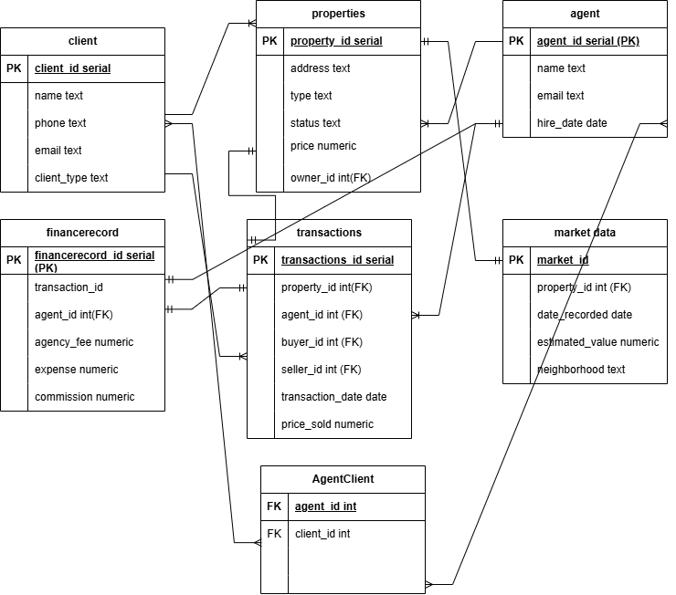

Objects

Table Description
<description>

Table Name | Field Name | Field Description | Data Type
client | client_id | Unique identifier for each client, automatically generated. | SERIAL (Primary Key)
 | name | Name of the client. | TEXT
 | phone | Phone number of the client. | TEXT
 | email | Email address of the client. | TEXT
 | client_type | Type of client (Buyer, Seller, Tenant, or Landlord). | TEXT (Check)
agent | agent_id | Unique identifier for each agent, automatically generated. | SERIAL (Primary Key)
 | name | Name of the agent. | TEXT
 | email | Email address of the agent. | TEXT
 | hire_date | Date when the agent was hired. | DATE
agentclient | agent_id | Foreign key referencing agent_id in the agent table. | INT (Foreign Key)
 | client_id | Foreign key referencing client_id in the client table. | INT (Foreign Key)
properties | property_id | Unique identifier for each property, automatically generated. | SERIAL (Primary Key)
 | address | Address of the property. | TEXT
 | type | Type of property (e.g., apartment, house, land). | TEXT
 | status | Current status of the property (Available, Sold, Rented). | TEXT (Check)
 | price | Price of the property. | NUMERIC(12,2)
 | owner_id | Foreign key referencing client_id in the client table (owner of the property). | INT (Foreign Key)
transactions | transaction_id | Unique identifier for each transaction, automatically generated. | SERIAL (Primary Key)
 | property_id | Foreign key referencing property_id in the properties table. | INT (Foreign Key)
 | agent_id | Foreign key referencing agent_id in the agent table. | INT (Foreign Key)
 | buyer_id | Foreign key referencing client_id in the client table (buyer). | INT (Foreign Key)
 | seller_id | Foreign key referencing client_id in the client table (seller). | INT (Foreign Key)
 | transaction_date | Date when the transaction took place. | DATE
 | price_sold | Final price at which the property was sold. | NUMERIC(12,2)
financerecord | financerecord_id | Unique identifier for each financial record, automatically generated. | SERIAL (Primary Key)
 | transaction_id | Foreign key referencing transaction_id in the transactions table. | INT (Foreign Key)
 | agent_id | Foreign key referencing agent_id in the agent table. | INT (Foreign Key)
 | agency_fee | Fee charged by the agency for the transaction. | NUMERIC(12,2)
 | expense | Expenses incurred during the transaction. | NUMERIC(12,2)
 | commission | Commission earned by the agent. | NUMERIC(12,2)
market_data | market_id | Unique identifier for each market data entry, automatically generated. | SERIAL (Primary Key)
 | property_id | Foreign key referencing property_id in the properties table. | INT (Foreign Key)
 | date_recorded | Date when the market data was recorded. | DATE
 | estimated_value | Estimated value of the property on the given date. | NUMERIC(12,2)
 | neighborhood | Neighborhood where the property is located. | TEXT

Comments on table relationships

Example with data

client_id name phone email client_type
1 Alice Smith 555-1234 alice@example.com Buyer
2 Bob Johnson 555-2345 bob@example.com Seller
3 Carol White 555-3456 carol@example.com Tenant
4 David Lee 555-4567 david@example.com Landlord
5 Eva Green 555-5678 eva@example.com Buyer
6 Frank Stone 555-6789 frank@example.com Seller

agent_id name email hire_date
1 Agent One agent1@agency.com 2022-05-01
2 Agent Two agent2@agency.com 2023-01-15
3 Agent Three agent3@agency.com 2024-03-10
4 Agent Four agent4@agency.com 2021-09-25
5 Agent Five agent5@agency.com 2023-11-07
6 Agent Six agent6@agency.com 2022-06-30

agent_id client_id
1 1
1 2
2 3
2 4
3 5
3 6

property_id address type price owner_id
1 123 Elm St House 250000.00 2
2 456 Oak Ave Apartment 180000.00 6
3 789 Pine Rd Condo 300000.00 4
4 101 Maple Ln Townhouse 220000.00 2
5 202 Birch Blvd House 275000.00 6
6 303 Cedar Ct Apartment 200000.00 4

transaction_id property_id agent_id buyer_id seller_id transaction_date price_sold
1 1 1 1 2 2025-03-15 248000.00
2 2 2 5 6 2025-04-10 182000.00
3 3 3 1 4 2025-05-01 299000.00
4 4 1 5 2 2025-05-05 219500.00
5 5 2 1 6 2025-03-20 273000.00
6 6 3 5 4 2025-04-25 198000.00

financerecord_id transaction_id agent_id agency_fee expense commission
1 1 1 7000.00 1000.00 3000.00
2 2 2 6500.00 800.00 2500.00
3 3 3 7500.00 950.00 3200.00
4 4 1 7100.00 870.00 3100.00
5 5 2 7300.00 920.00 3300.00
6 6 3 6800.00 860.00 2800.00

market_id property_id date_recorded estimated_value neighborhood
1 1 2025-03-10 249000.00 Downtown
2 2 2025-04-05 181000.00 Midtown
3 3 2025-04-30 298500.00 Uptown
4 4 2025-05-02 220000.00 Suburbs
5 5 2025-03-18 274000.00 Downtown
6 6 2025-04-20 199000.00 Midtown

